AskPaisley.com Website Project Outline | Scope of Work Document

V2 11/20/2024 By: Steve Hundley

Project Overview
The project aims to develop and design the branding and sales landing page for the AskPaisley.com website. This includes creating assets for marketing Paisley, a suite of TheGenie.ai systems focused on attracting listings and engaging visitors to become Paisley Super Fans.

Objectives
- Brand Creation:
  - Develop the branding for Paisley.
- Website Design:
  - Design the sales landing page for AskPaisley.com.
- Marketing Asset Design (Second RFP):
  - Social Ads
  - Banner Ads
  - Facebook Header
  - Social Ad Template
  - PowerPoint
  - Video assets
  - Promotional Handouts for Title Reps

Website Primary Goals
- Announce Paisley as the invisible assistant.
- Demonstrate Paisley's management capabilities for TheGenie.ai systems.
- Inspire visitors to become Paisley Super Fans.
- Include animations and videos of Paisley in action.
- Feature comments from early users.
- Offer a prompt for a free account for the first 100 agents.

Target Audience
- Mega Team Leaders (listing over 24 homes per year)
- Mega Agents (listing over 10 homes per year)
- Boutique brokerage firms looking for a competitive edge
- Real estate influencers (on a separate page)
- Title reps and title companies

Branding and Design Requirements
- Modern, minimalistic, fun, smart, and clean
- Convey the AI products effectively

Content Requirements
- Single Landing Page
- Demonstrate management of TheGenie.ai systems
- Inspire visitors to become Super Fans
- Include animations, videos, comments from early users, and a free account prompt

Functional Requirements
- Sign-up form for a free account
- Form fields based on user type (Mega Team, Realtor, Broker, Affiliate)
- Multi-step form based on the user type
- The form will collect essential user information

Technical Requirements
- Design only project
- Integration into GoHighLevel by client's team

User Experience
- Motivating landing page to learn more about Paisley
- FOMO marketing elements (e.g., limited number of free accounts)
- A well-designed "Apply for a Free Account" section
- Log in button/text leading to Paisley branded Genie login
- Footer section for customer service

UI/UX Specifics
- Clean, modern, advanced, professional, simple, polished
- Designer's creative freedom with color schemes and fonts

AskPaisley.com Website Project | Request for Proposal (RFP)

V1. 6/29/2024 by: Steve Hundley

Introduction
We are seeking proposals from qualified vendors to design and develop the branding and sales landing page for AskPaisley.com. This project will serve as a pivotal tool in promoting Paisley, our innovative AI assistant, and engaging our target audience.

Project Scope
- Branding Creation:
  - Develop the branding for our Paisley IA - Invisible Assistant
- Website Design:
  - Design the AskPaisley.com sales landing page.
  - Need some marketing help? Just “AskPaisley.com”
- Refresh the Paisley section within TheGenie.ai ):
  - Redesign the layout and navigation of the Paisley section of TheGenie.ai
  - Paisley’s Current Menu of Agent Services to UI/UX redesign – adopt the Ask Paisley theme
    - General Intelligence:
    - Listing Prospecting Focused: Any property,
    - MLS Listing Focused: Active, Pending, Sold promotion & circle targets

    - Farm Area Focused: Show Saved Areas – Optimized first
      - Area Package, FB Ad, IG Reel, Market Plan,Blog Post, Area Guide, Area email, Newsletter, Text Message, Create Listicle
    - Engagement Focused
    - Business & Branding Focus
    - Follow Up Focus

Deliverables
- Branding:
  - Logos, color schemes, fonts, and branding style guide
- Website:
  - Single landing page ready to slice, style and integrate
  - The design will:
    - Incorporate animations demonstrating TheGenie.ai systems
    - Encourage Super Fan inspiration
    - Show User Testimonials
    - Promote an APPLY for a Free
    - Assets for website
    - Assets for Dashboard design
- Marketing Assets (Second RFP):
  - Design and deliver the required marketing materials

Target Audience
- Mega Team Leaders
- Mega Agents
- Boutique brokerage firms
- Real estate influencers
- Title reps and title companies

Design and Aesthetics
- Modern, minimalistic, fun, smart, clean
- Effective conveyance of AI product features

Functional Requirements
- Multi-step sign-up form
- Categorization of user types (Mega Team, Realtor, Broker, Affiliate)
- Collect essential user information

Technical Requirements
- Design only project
- Integration into GoHighLevel by client's team

Proposal Requirements
- Company background and qualifications
- Examples of similar projects
- Detailed project plan and timeline
- Cost estimate
- References

Submission Guidelines
- Proposals must be submitted by [insert deadline].
- Please send your proposal to [insert contact email or submission portal].

Evaluation Criteria
- Relevant experience and past performance
- Quality of the proposal
- Understanding of project scope and objectives
- Proposed timeline and cost
- References and testimonials

Contact Information
For any questions or further information, please contact:
- Steve Hundley
- Steve.hundley@1parkplace.com
- 619.507.4404

Screens to Redesign:

- Current Genie on Mobile
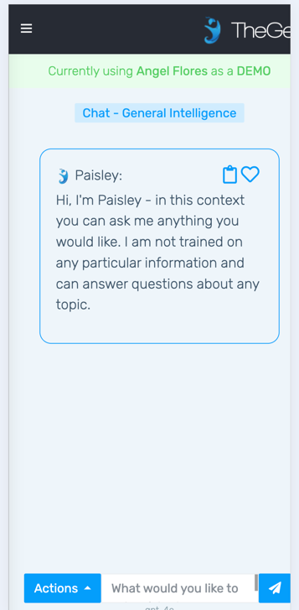
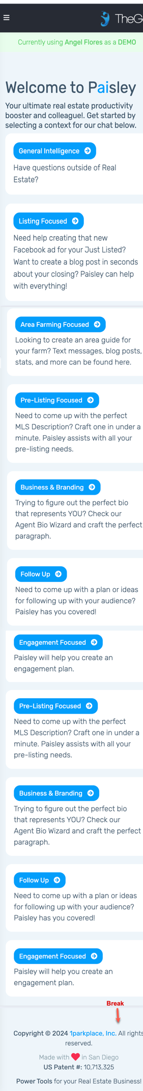

Listing Focus screens

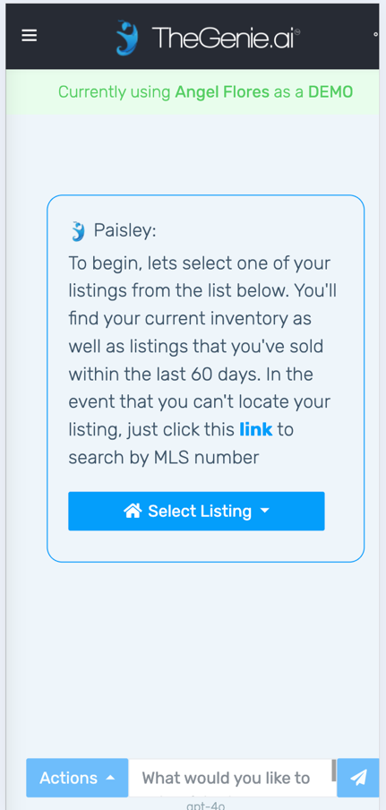
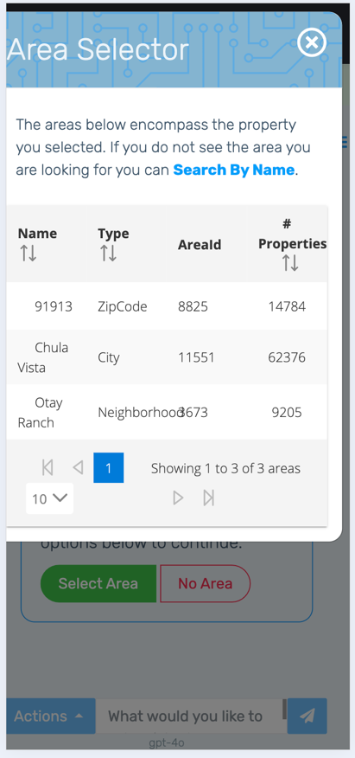
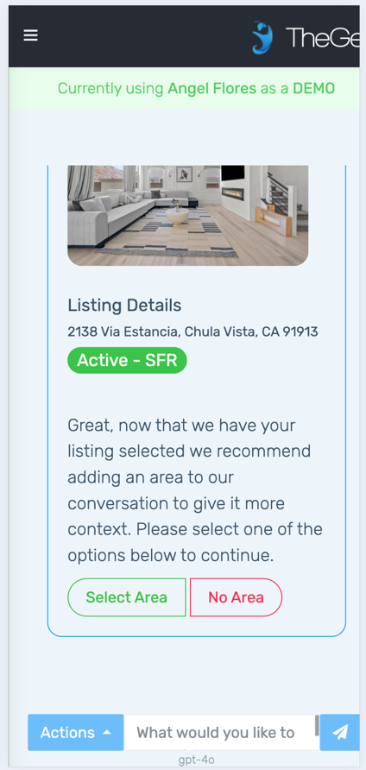

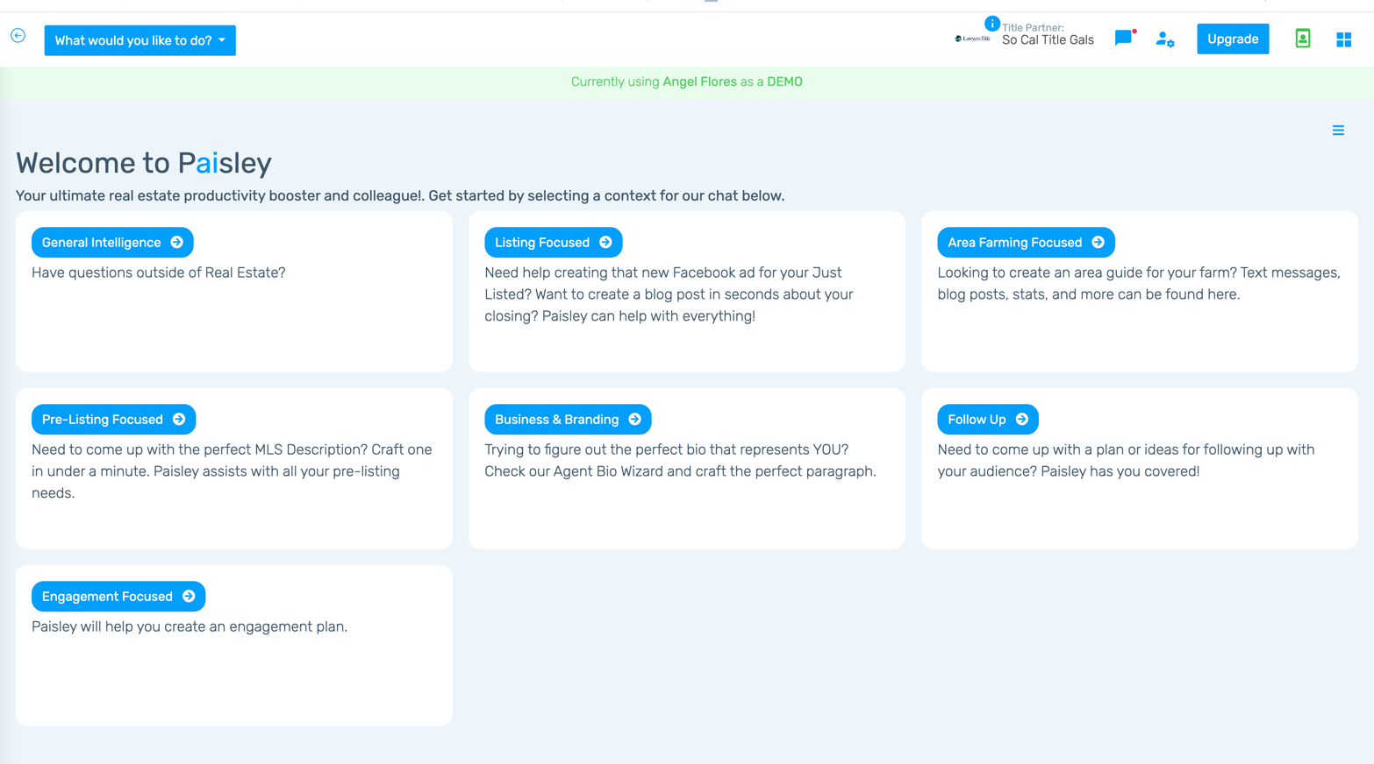

Design a new Paisley version that promotes the value and excites users to log in
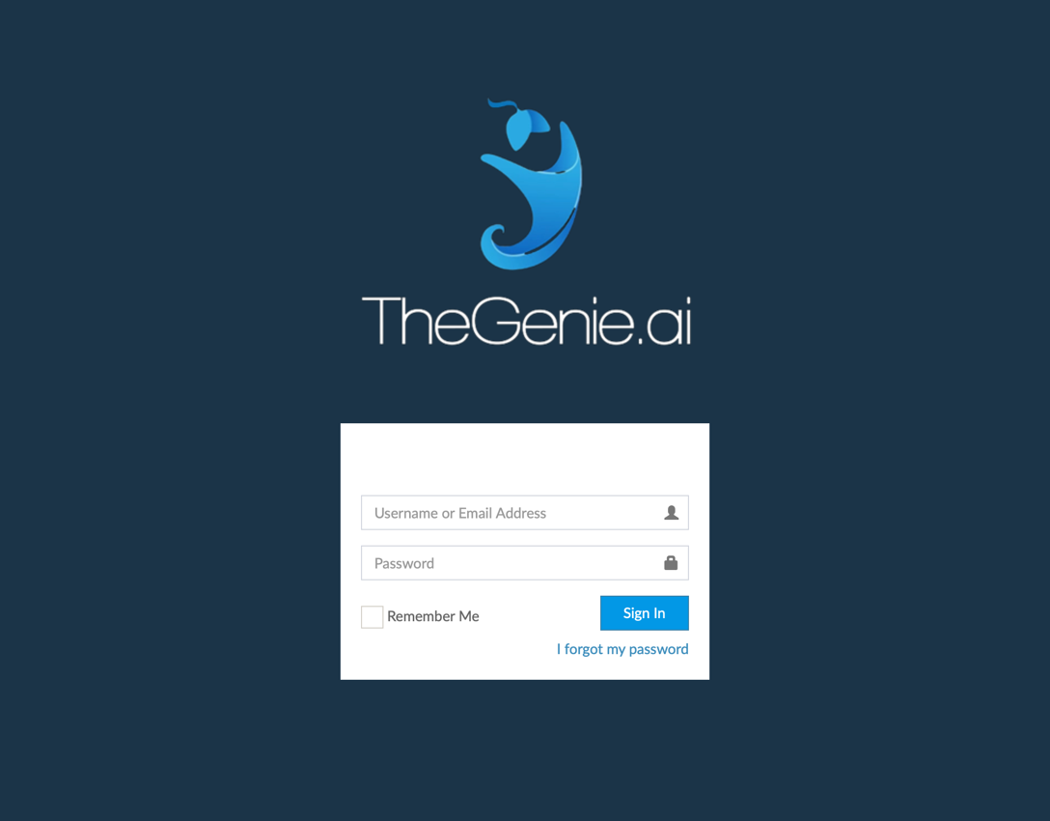

Marketing Asset Design (Second RFP):
  - Social Ads
  - Banner Ads
  - Facebook Header
  - Social Ad Template
  - PowerPoint
  - Video assets
  - Promotional Handouts for Title Reps

    - Expireds, FSBO, Bank Owned
– include Pre meeting, Listing preso, Coming Soon & CMAs

