**Program 6**

**Create two files of XML and JSON type with values for City_Name, Latitude, Longitude, Temperature, and Humidity. Develop an application to create an activity with two buttons to parse the XML and JSON files which when clicked should display the data in their respective layouts side by side.**

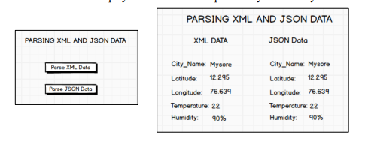

**Procedure**

**Creating Assets Folder in Android**

Right Click on app folder → New → Folder → Assets Folder → Press Finish Button

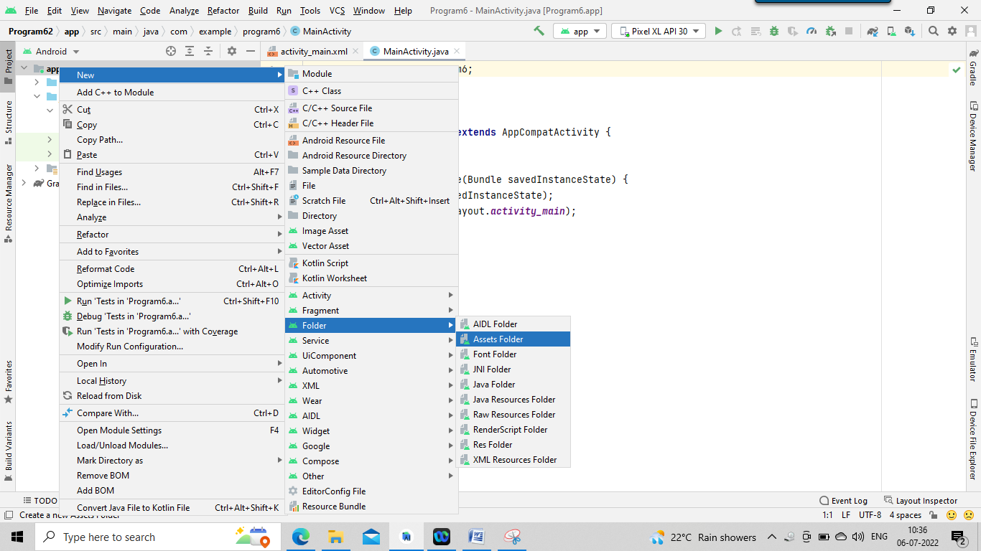

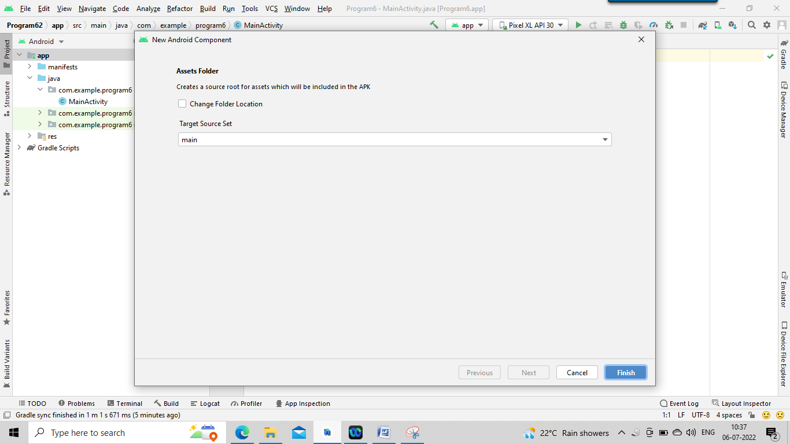

**Creating File in assets Folder:**

Right Click on assets folder → New → File

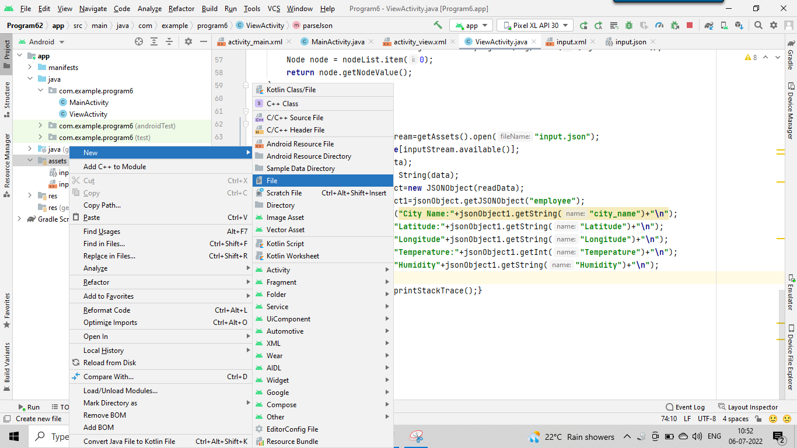

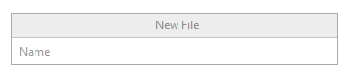

Enter filename with extension (Eg: abc.xml)

**Save the file as input.xml in assest folder and paste the below code in it.**

*<?***xml version="1.0"***?>*<**records**>  
 <**employee**>  
 <**city_name**>Mysore</**city_name**>  
 <**Latitude**>12.295</**Latitude**>  
 <**Longitude**>76.639</**Longitude**>  
 <**Temperature**>22</**Temperature**>  
 <**Humidity**>90%</**Humidity**>  
 </**employee**>  
</**records**>

**Save the file as input.json in assest folder and paste the below code in it.**

{  
 **"employee"**: {  
 **"city_name"**: **"Mysore"**,  
 **"Latitude"**: **"12.295"**,  
 **"Longitude"**: **"76.639"**,  
 **"Temperature"**: 22,  
 **"Humidity"**: **"90%"** }  
}

**Procedure**

**1. Create a New Android Project with Empty Activity.**

**2. Open activity_main.xml file from res→ layout folder, check/add ConstraintLayout as the root view.**

**3. Create the layout design using Drag and Drop framework.**

**4. Add Listeners to Button Click Event:**

**• Create a class which implements OnClickListener interface.**

**• Override onClick() method of OnClickListener Interface.**

**• Register the button for click event by calling setOnClickListener() method of View class and pass the object of the class that implemented OnClickListener Interface.**

**5. Create assets folder (Refer Section Android Studio Tutorial)**

**6. Create input.xml file inside assets folder and paste the below Xml Data**

*<?***xml version="1.0"***?>*<**records**>  
 <**employee**>  
 <**city_name**>Mysore</**city_name**>  
 <**Latitude**>12.295</**Latitude**>  
 <**Longitude**>76.639</**Longitude**>  
 <**Temperature**>22</**Temperature**>  
 <**Humidity**>90%</**Humidity**>  
 </**employee**>  
</**records**>

**7. Create input.json file inside assets folder and paste the below**

{  
 **"employee"**: {  
 **"city_name"**: **"Mysore"**,  
 **"Latitude"**: **"12.295"**,  
 **"Longitude"**: **"76.639"**,  
 **"Temperature"**: 22,  
 **"Humidity"**: **"90%"** }  
}

**8. Read the XML and Json Data in the files and display on screen**

**activity_main.xml code**

*<?***xml version="1.0" encoding="utf-8"***?>*<**androidx.constraintlayout.widget.ConstraintLayout xmlns:android="http://schemas.android.com/apk/res/android"  
 xmlns:app="http://schemas.android.com/apk/res-auto"  
 xmlns:tools="http://schemas.android.com/tools"  
 android:layout_width="match_parent"  
 android:layout_height="match_parent"  
 tools:context=".MainActivity"**>  
  
 <**Button  
 android:id="@+id/btn_parsexml"  
 android:layout_width="wrap_content"  
 android:layout_height="wrap_content"  
 android:layout_marginTop="80dp"  
 android:text="Parse XML Data"  
 app:layout_constraintEnd_toEndOf="parent"  
 app:layout_constraintStart_toStartOf="parent"  
 app:layout_constraintTop_toBottomOf="@+id/textView4"** />  
  
 <**Button  
 android:id="@+id/btn_parsejson"  
 android:layout_width="wrap_content"  
 android:layout_height="wrap_content"  
 android:layout_marginTop="80dp"  
 android:text="Parse Json Data"  
 app:layout_constraintEnd_toEndOf="parent"  
 app:layout_constraintStart_toStartOf="parent"  
 app:layout_constraintTop_toBottomOf="@+id/btn_parsexml"** />

<**TextView  
 android:id="@+id/textView4"  
 android:layout_width="wrap_content"  
 android:layout_height="wrap_content"  
 android:layout_marginTop="40dp"  
 android:text="PARSING XML AND JSON DATA"  
 android:textSize="20dp"  
 app:layout_constraintEnd_toEndOf="parent"  
 app:layout_constraintStart_toStartOf="parent"  
 app:layout_constraintTop_toTopOf="parent"** />

</**androidx.constraintlayout.widget.ConstraintLayout**>

**activity_main.java code**

**package** com.example.program6;  
  
**import** androidx.appcompat.app.AppCompatActivity;  
**import** android.content.Intent;  
**import** android.os.Bundle;  
**import** android.view.View;  
**import** android.widget.Button;  
**public class** MainActivity **extends** AppCompatActivity **implements** View.OnClickListener {  
 Button **btnParseXml**,**btnParseJson**;  
@Override  
**protected void** onCreate(Bundle savedInstanceState) {  
 **super**.onCreate(savedInstanceState);  
 setContentView(R.layout.***activity_main***);  
 **btnParseXml**=(Button)findViewById(R.id.***btn_parsexml***);  
 **btnParseJson**=(Button)findViewById(R.id.***btn_parsejson***);  
 **btnParseJson**.setOnClickListener(**this**);  
 **btnParseXml**.setOnClickListener(**this**);  
 }  
 @Override  
 **public void** onClick(View v) {  
 **if**(v.equals(**btnParseJson**))  
 {  
 Intent it=**new** Intent(**this**,ViewActivity.**class**);  
 it.putExtra(**"mode"**,1);  
 startActivity(it);  
 }  
 **else if**(v.equals(**btnParseXml**))  
 {  
 Intent it=**new** Intent(**this**,ViewActivity.**class**);  
 it.putExtra(**"mode"**,2);  
 startActivity(it);  
 }  
 }  
}

**Create a new Xml file in the same project:**

**Right Click on app 🡪 New 🡪Activity 🡪EmptyActivity**

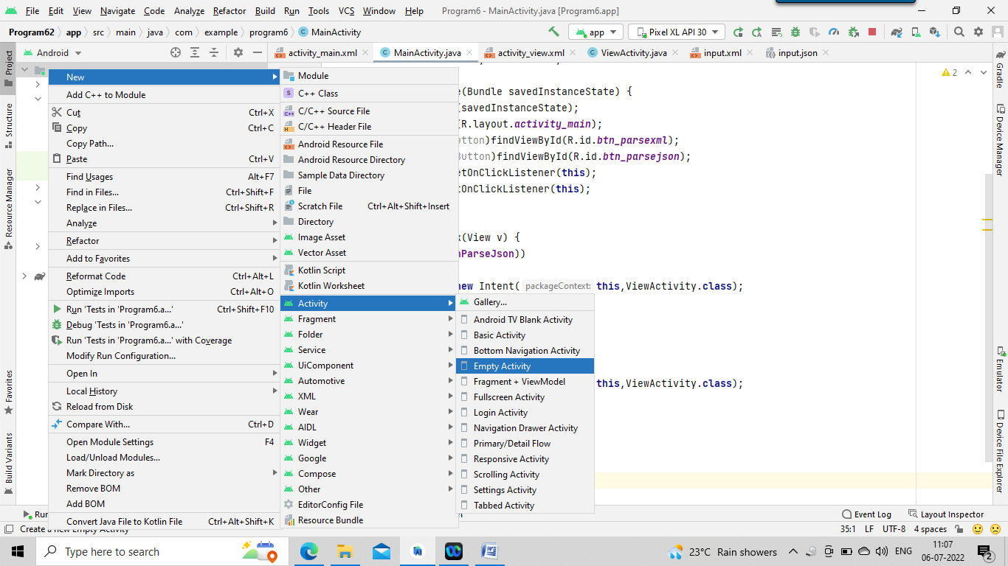

**Name the file as ViewActivity**

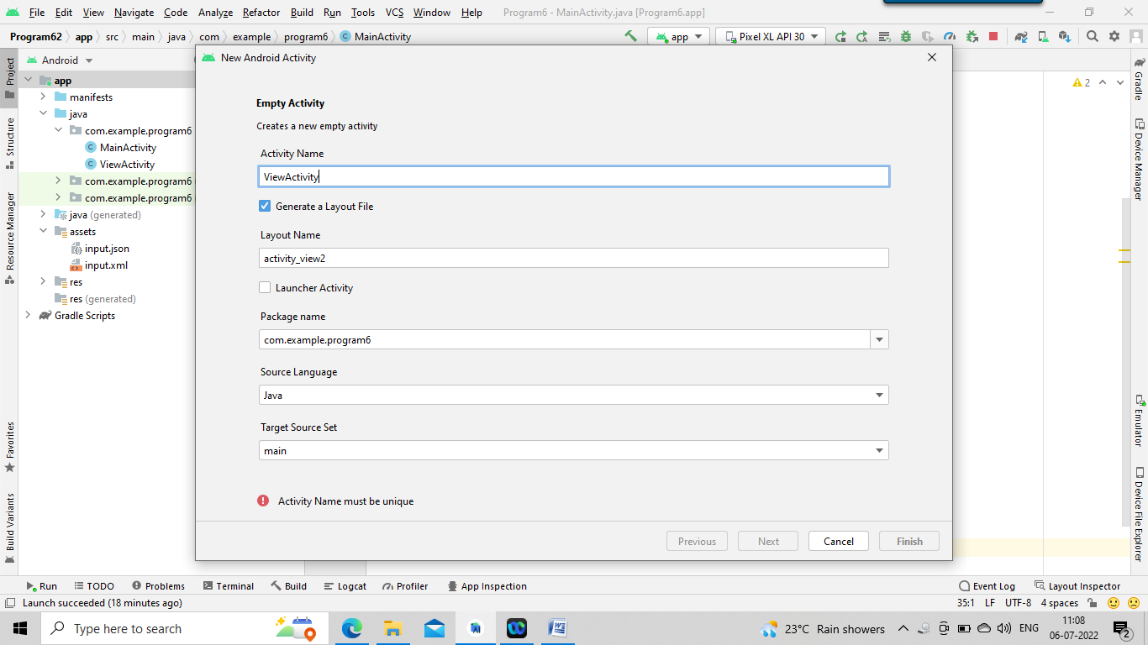

**ViewActivity.xml**

*<?***xml version="1.0" encoding="utf-8"***?>*<**androidx.constraintlayout.widget.ConstraintLayout xmlns:android="http://schemas.android.com/apk/res/android"  
 xmlns:app="http://schemas.android.com/apk/res-auto"  
 xmlns:tools="http://schemas.android.com/tools"  
 android:layout_width="match_parent"  
 android:layout_height="match_parent"  
 tools:context=".ViewActivity"**>  
  
 <**TextView  
 android:id="@+id/lbl_xml_data"  
 android:layout_width="wrap_content"  
 android:layout_height="wrap_content"  
 android:layout_marginTop="30dp"  
 android:text="Xml Data"  
 app:layout_constraintStart_toStartOf="@+id/textView2"  
 app:layout_constraintTop_toBottomOf="@+id/textView2"** />  
  
 <**TextView  
 android:id="@+id/textView"  
 android:layout_width="wrap_content"  
 android:layout_height="wrap_content"  
 android:layout_marginTop="40dp"  
 android:text="PARSING XML AND JSON DATA"  
 android:textSize="20dp"  
 app:layout_constraintEnd_toEndOf="parent"  
 app:layout_constraintStart_toStartOf="parent"  
 app:layout_constraintTop_toTopOf="parent"** />  
  
 <**TextView  
 android:id="@+id/textView2"  
 android:layout_width="wrap_content"  
 android:layout_height="wrap_content"  
 android:layout_marginStart="40dp"  
 android:layout_marginTop="20dp"  
 android:text="XML DATA"  
 app:layout_constraintStart_toStartOf="parent"  
 app:layout_constraintTop_toBottomOf="@+id/textView"** />  
  
 <**TextView  
 android:id="@+id/textView3"  
 android:layout_width="wrap_content"  
 android:layout_height="wrap_content"  
 android:layout_marginTop="20dp"  
 android:layout_marginEnd="40dp"  
 android:text="JSON DATA"  
 app:layout_constraintEnd_toEndOf="parent"  
 app:layout_constraintTop_toBottomOf="@+id/textView"** />  
  
 <**TextView  
 android:id="@+id/lbl_json_data"  
 android:layout_width="wrap_content"  
 android:layout_height="wrap_content"  
 android:layout_marginTop="30dp"  
 android:text="Json Data"  
 app:layout_constraintEnd_toEndOf="@+id/textView3"  
 app:layout_constraintTop_toBottomOf="@+id/textView3"** />  
   
</**androidx.constraintlayout.widget.ConstraintLayout**>

**ViewActivity.java**

**package** com.example.program6;  
  
**import** androidx.appcompat.app.AppCompatActivity;  
**import** android.os.Bundle;  
**import** android.widget.TextView;  
**import** org.json.JSONObject;  
**import** org.w3c.dom.Document;  
**import** org.w3c.dom.Element;  
**import** org.w3c.dom.Node;  
**import** org.w3c.dom.NodeList;  
**import** java.io.InputStream;  
**import** javax.xml.parsers.DocumentBuilder;  
**import** javax.xml.parsers.DocumentBuilderFactory;  
  
**public class** ViewActivity **extends** AppCompatActivity {  
 TextView **lblXmlData**,**lblJsonData**;  
 **int mode**=0;  
 @Override  
 **protected void** onCreate(Bundle savedInstanceState) {  
 **super**.onCreate(savedInstanceState);  
 setContentView(R.layout.***activity_view***);  
 **lblXmlData**=(TextView)findViewById(R.id.***lbl_xml_data***);  
 **lblJsonData**=(TextView)findViewById(R.id.***lbl_json_data***);  
 **mode**=getIntent().getIntExtra(**"mode"**,0);  
 **if**(**mode**==1)  
 parseJson();  
 **else** parseXmlDocument();  
 }  
 **public** String parseXmlDocument()  
 {  
 **try** {  
 InputStream is = getAssets().open(**"input.xml"**);  
 DocumentBuilderFactory dbFactory = DocumentBuilderFactory.*newInstance*();  
 DocumentBuilder dBuilder = dbFactory.newDocumentBuilder();  
 Document doc = dBuilder.parse(is);  
 Element element=doc.getDocumentElement();  
 element.normalize();  
 NodeList nList = doc.getElementsByTagName(**"employee"**);  
 **for** (**int** i=0; i<nList.getLength(); i++) {  
 Node node = nList.item(i);  
 **if** (node.getNodeType() == Node.***ELEMENT_NODE***) {  
 Element element2 = (Element) node;  
 **lblXmlData**.setText(**"City Name : "** + *getValue*(**"city_name"**, element2)+**"\n"**);  
 **lblXmlData**.append(**"Latitude : "** + *getValue*(**"Latitude"**, element2)+**"\n"**);  
 **lblXmlData**.append(**"Longitude : "** + *getValue*(**"Longitude"**, element2)+**"\n"**);  
 **lblXmlData**.append(**"Temperature : "** + *getValue*(**"Temperature"**, element2)+**"\n"**);  
 **lblXmlData**.append(**"Humidity : "** + *getValue*(**"Humidity"**, element2)+**"\n"**);  
 }  
 }  
 }  
 **catch** (Exception e) {e.printStackTrace();}  
 **return null**;  
 }  
 **private static** String getValue(String tag, Element element) {  
 NodeList nodeList = element.getElementsByTagName(tag).item(0).getChildNodes();  
 Node node = nodeList.item(0);  
 **return** node.getNodeValue();  
 }  
 **public void** parseJson()  
 {  
 **try** {  
 InputStream inputStream=getAssets().open(**"input.json"**);  
 **byte**[] data=**new byte**[inputStream.available()];  
 inputStream.read(data);  
 String readData=**new** String(data);  
 JSONObject jsonObject=**new** JSONObject(readData);  
 JSONObject jsonObject1=jsonObject.getJSONObject(**"employee"**);  
 **lblJsonData**.setText(**"City Name:"**+jsonObject1.getString(**"city_name"**)+**"\n"**);  
 **lblJsonData**.append(**"Latitude:"**+jsonObject1.getString(**"Latitude"**)+**"\n"**);  
 **lblJsonData**.append(**"Longitude"**+jsonObject1.getString(**"Longitude"**)+**"\n"**);  
 **lblJsonData**.append(**"Temperature:"**+jsonObject1.getInt(**"Temperature"**)+**"\n"**);  
 **lblJsonData**.append(**"Humidity"**+jsonObject1.getString(**"Humidity"**)+**"\n"**);  
 }  
 **catch** (Exception e) {e.printStackTrace();}  
 }  
}

**Output:**

