CLIP-CAT: Vision-Language Fusion Framework for Ordinal Cataract Grading on Few-Shot Data
Shuang Wang¹ ,Zhida Pang¹
¹ School of Computer Science and Engineering, Northeastern University, Shenyang, China
Abstract. Cataract is the leading cause of reversible blindness worldwide, yet automated grading remains challenging due to limited labeled data, severe class imbalance, and the inherently ordinal progression of the disease. Existing CNN-based approaches commonly treat cataract grading as a nominal classification task, overlooking the ordinal disease structure and under-utilizing medical prior knowledge. To address these challenges, we propose CLIP-CAT, a vision language modal that leverages medical text prompts to alleviate data scarcity and improve grading performance. Our approach combines language-guided global semantic representations and localized fine-grained feature learning in a unified framework. To mitigate the limitations of global encoders in detecting subtle lesions, we introduce Adaptive Patching for enhanced local representation. In addition, we design a Bidirectional Rank-Aware Loss that encourages unimodal probability distributions, effectively modeling the inherent ordinality of the task. Experiments on 2,000 images demonstrate that CLIP-CAT achieves 86.76% accuracy and 0.42 MSE, significantly outperforming baselines by aligning with human diagnostic logic.
Keywords: Cataract Grading, Vision-Language Models, Few-Shot Learning
- Introduction
While cataracts are the primary cause of reversible blindness worldwide, current diagnostic workflows rely heavily on subjective manual grading[1,2]. This labor-intensive approach is increasingly unsustainable given the rising prevalence of the disease and the scarcity of ophthalmologists in developing regions. Consequently, developing objective Computer-Aided Diagnosis systems is no longer just an option but a necessity to standardize grading and prevent avoidable blindness.
Despite the success of deep learning in binary tasks, fine-grained clinical grading remains challenging due to three limitations. First, standard classification losses treat ordinal disease stages as independent classes, ignoring the progressive nature of severity (e.g., Grade 0 < Grade 5). Second, the inherent long-tailed distribution of medical data biases models toward majority classes, compromising sensitivity for rare, severe cases. Third, most black box models rely on low-level feature statistics rather than semantic reasoning, lacking the clinical priors necessary for robust generalization and interpretability[3-6].
To address these challenges, we propose CLIP-CAT, a vision-language framework that mimics the clinical diagnostic workflow. The main contributions of this study are three-fold:
- A Multi-Granularity Vision-Language Framework: We introduce a novel synergy mechanism that fuses global semantic anchors with local adaptive patching. This approach mimics the global-scan, local-focus strategy of human experts, enhancing the model's ability to detect subtle lesions missed by traditional encoders.
- Ordinal-Aware Optimization Objective: We propose a Bidirectional Rank-Aware Constraint that redefines the classification loss. By enforcing unimodal probability distributions and penalizing distance-based errors, we ensure predictions respect the strict logical progression of disease severity (e.g., Grade 0 < Grade 5).
- Robustness to Long-Tailed Distributions: We design a Prototype Smoothing Initialization strategy combined with prompt tuning. This enables the model to generalize effectively on small, imbalanced clinical datasets, significantly outperforming standard CNN architectures in few-shot scenarios.
- Related Work
  - Deep Learning for Cataract Grading
Cataract grading evolved from hand-crafted features to deep learning. While CNNs improved feature extraction, they introduce ImageNet-induced domain bias, and Vision Transformers struggle with overfitting in limited-data regimes. Crucially, most existing methods treat grading as nominal multi-class classification, overlooking the intrinsic ordinal nature of disease severity[7-10].
  - Vision-Language Models in Medicine
VLMs like CLIP represent a shift to multimodal alignment, with efficient tuning methods facilitating downstream adaptation. Despite successes in radiology, ophthalmic applications are scarce. Crucially, standard contrastive losses lack the capacity to preserve the intrinsic ordinal topology of cataract severity. This study bridges this gap by integrating ordinal logic into vision-language alignment[11,12].
- Methodology
  - Problem Definition and Notation
As illustrated in Fig. 1, the proposed CLIP-CAT framework is designed to mimic the cognitive workflow of clinical ophthalmologists: Global Assessment $→$ Local Refinement $→$ Semantic Reasoning. The architecture consists of three synergistic components:
- Dual-Stream Visual Encoder: Integrating a global CLIP-based branch to capture anatomical structure with a local Adaptive Patching branch to isolate subtle lesion details. These streams are fused dynamically via an attention mechanism.
- Medical Prompt Engineering: Unlike traditional one-hot labels, we utilize expert clinical descriptions as semantic anchors. This projects visual features into a language-aligned space, enabling the model to understand medical severity.
- Bidirectional Rank-Aware Optimization: To address the ordinal nature of cataracts, we introduce a specialized loss function that penalizes predictions based on their distance from the true grade, enforcing a unimodal probability distribution.
Formally, we define the ordinal cataract grading task as learning a mapping function $ℱ:X→Y$. Let the training dataset be denoted as $D=\{\left(x_{i},y_{i}\right)\}_{i=1}^{N}$, where $x_{i}∈R^{H×W×3}$ represents the input slit-lamp image and $y_{i}∈\{0,1,…,C−1\}$ represents the ground truth severity label. Here, $C=6$ corresponds to the LOCS III grading scale[13].
Our objective is to predict a probability distribution $p\left(y | x\right)$ that not only maximizes accuracy but also respects the ordinal topology of the disease. Specifically, the model must minimize the expectation of the ordinal distance loss $ℒ_{dist}\left(y,\hat{y}\right)$, ensuring that severe cross-grade errors (e.g., confusing Grade 0 with Grade 4) are penalized more heavily than adjacent errors[14].
  - Visual Encoder
CLIP-CAT fuses global semantics with local details via a dual-stream visual encoder.
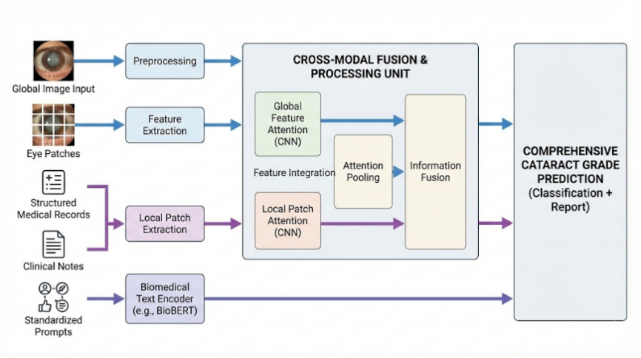
Fig. 1. Overview of the proposed CLIP-CAT framework illustrating the synergy between the global CLIP encoder and the local adaptive patching branch, fused via the attention mechanism.
The proposed CLIP-CAT framework integrates global semantics with fine-grained local details through a dual-stream visual encoder, as illustrated in Fig. 1.
Global Branch.This branch is designed to capture the overall anatomical structure, illumination conditions, and gross pathological changes. We utilize the pre-trained CLIP image encoder (ViT-L/14) as the backbone. The global feature extraction is mathematically formulated as:
$$v_{global}=ℰ_{imℊ_ℊlℴbal}\left(X_{resized}\right)∈R^{d} ( SEQ "equation" \backslash n \backslash ∗ MERGEFORMAT 1)$$
Let $X_{resized}$ denote the input resized to $224 ×224$. The encoder $E_{img_global}$ maps high-dimensional pixels to a latent vector $v_{global}$ ($d=768$), preserving semantic alignment. To balance generic visual filtering with domain specificity, we employ a partial fine-tuning strategy: freezing the initial 12 layers while optimizing the subsequent 12 transformer blocks.
Adaptive Patching Local Branch. Subtle lesions (e.g., peripheral cortical wedges) are often attenuated by the global pooling in standard ViTs. We address this via a three-stage Adaptive Patching mechanism:
- ROI Localization: Otsu thresholding and morphological closing are applied to segment the lens, isolating the ROI from background noise.
- Grid Sampling & Entropy Filtering: The ROI is partitioned into an $M ×M$ grid of patches $\{p_{j}\}$. To prioritize lesion-rich regions, we compute the Shannon Information Entropy $H\left(p_{j}\right)$ for each patch:
$H\left(p_{j}\right)=−\sum_{I}{P\left(I\right)}\log{P}\left(I\right)$ (2)
Here in equation 2, $P\left(I\right)$ represents the probability distribution of pixel intensity $I$ within the patch $p_{j}$. A higher entropy value $H\left(p_{j}\right)$ indicates a higher complexity of texture, which clinically correlates with lens opacity or cataractous changes, whereas clear lenses exhibit lower entropy. Based on this metric, we select the top-$K$ patches (experimentally set to $K=6$) that contain the most significant pathological features.
Feature Extraction: The selected patches are fed into a lightweight ResNet-50 encoder, denoted as $ℰ_{lℴc}$. We favor a CNN architecture here over a Transformer because CNNs possess translation invariance and inductive biases that excel at extracting fine-grained texture features (e.g., the roughness of opacity). The unified local feature representation is obtained via average pooling:
$$v_{local}=\frac{1}{K}\sum_{j=1}^{K}{ℰ_{lℴc}\left(p_{j}\right) }( SEQ "equation" \backslash n \backslash ∗ MERGEFORMAT 3)$$
This equation 3 aggregates the feature vectors from the top-$K$ patches. By averaging the embeddings $ℰ_{lℴc}\left(p_{j}\right)$, the resulting vector $v_{local}$ provides a noise-robust summary of the most severe lesions found in the eye.
To effectively combine the holistic view from the global branch and the microscopic details from the local branch, we employ a learnable attention mechanism. The fusion process is defined as:
$$α=σ\left(W_{att}⋅\left[v_{global};v_{local}\right]+b_{att}\right) (4)$$
$${ v}_{final}=α⋅v_{global}+\left(1−α\right)⋅v_{local} (5)$$
In equation 4 and 5:
$\left[v_{global};v_{local}\right]$ denotes the concatenation of the global and local feature vectors.
$W_{att}andb_{att}$ are the learnable weight matrix and bias vector of the attention layer, respectively.
$σ\left(⋅\right)$ is the Sigmoid activation function, which normalizes the output to a range of $\left(0,1\right)$.
$α$ acts as an adaptive gating coefficient. It dynamically weighs the importance of the global context versus local details for each specific image.
Finally, $v_{final}$ is the weighted sum, ensuring that the final representation balances structural information with lesion-specific textures based on the predicted attention score.
  - Medical Prompt Engineering Mechanism
Unlike traditional $N$-way classifiers that map visual features to semantically meaningless one-hot vectors, CLIP-CAT injects expert medical priors via natural language. This transforms the classification task into a vision-language alignment problem.
Prompt Construction. We design a set of grade-specific templates $T=\{t_{0},…,t_{C−1}\}$ based on the LOCS III clinical standards. Each template $t_{c}$ acts as a semantic anchor. As shown in Table 1:
Table 1. Grade-specific text descriptions
t0 | Fundus image showing clear lens with no nuclear cataract
t1 | Fundus image with NC2 nuclear cataract showing slight opacity
t2 | Fundus image with NC3 nuclear cataract and mild opacity
t3 | Fundus image with NC4 nuclear cataract and moderate opacity
t4 | Fundus image with NC5 nuclear cataract and severe opacity
t5 | Fundus image with NC6 nuclear cataract and dense opacity

Semantic Projection & Probability Calculation. These text descriptions are encoded by the pre-trained text encoder to produce semantic embeddings $w_{c}=ℰ_{tℯxt}\left(t_{c}\right)∈R^{d}$. The final classification probability $P\left(y=c | X\right)$ is computed via the temperature-scaled softmax of the cosine similarity between the fused visual feature $v_{final}$ and the text embeddings $w_{c}$:
$$P\left(y=c | X\right)=\frac{\exp\left(\left\langle v_{final},w_{c}\right\rangle /τ\right)}{\sum_{j=0}^{C−1}{}\exp\left(\left\langle v_{final},w_{j}\right\rangle /τ\right)} (6)$$
Detailed Explanation of the Formulation:
- $\left\langle v_{final},w_{c}\right\rangle$: This term measures the alignment between the image and the text description. If the visual features of the patient's eye align geometrically with the semantic vector for dense white opacification, the dot product value increases. This forces the model to understand the medical description rather than just memorizing a label ID.
- $τ$: $τ$ is a learnable scaling factor (initialized at 0.07).
- Function: It controls the sharpness of the probability distribution. A lower $τ$ exaggerates the differences between the correct class and incorrect classes, making the distribution peakier.
  - Bidirectional Rank-Aware Loss
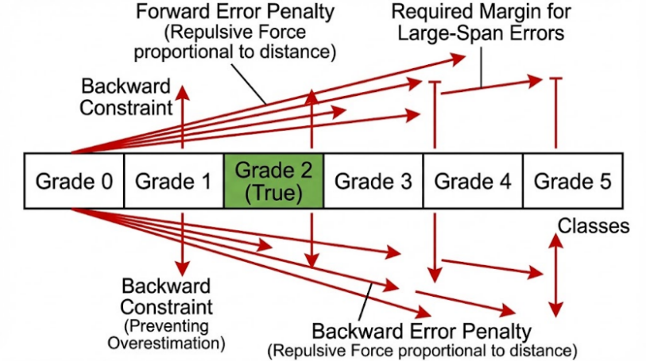
Fig. 2. Schematic representation of the distance penalty mechanism enforcing a unimodal probability distribution centered on the true label (Grade 2).
Figure 2 illustrates the physical simulation mechanism of the Bidirectional Rank Aware Loss ($ℒ_{rank}$). Unlike traditional Cross-Entropy, which treats classes as independent nominal variables, this mechanism introduces a grade distance penalty proportional to the prediction deviation. This repulsive force enforces bidirectional constraints preventing both overestimation and underestimation to shape the probability distribution into a unimodal form centered on the ground truth (Grade 2), effectively eliminating large-span errors.
$$ℒ_{tℴtal}=ℒ_{fℴcal}+λℒ_{rank} (7)$$
This scheme utilizes Focal Loss ($ℒ_{fℴcal}$) to mitigate class imbalance while leveraging the rank-aware term ($ℒ_{rank}$) for ordinal constraints. With $λ=1.0$, the system optimizes classification accuracy while ensuring consistency in grade distancing. This combined strategy ensures that even when misclassifications occur, predictions remain clustered within the neighborhood of the true grade, avoiding logically inconsistent long-range errors.
- Experiments
  - Dataset Description and Long-tail Analysis
To validate our framework, we curated a private clinical dataset of 2,000 slit-lamp images, with ground truth established by three senior ophthalmologists via consensus voting. The dataset exhibits a severe Long-tailed Distribution: head classes comprise approximately 70% of samples, while tail classes are scarce. Without intervention, this imbalance risks biasing the model toward the majority class (Grade 0) to minimize global loss, thereby failing to identify severe, sight-threatening cases.
  - Implementation Details
Experiments were conducted on an NVIDIA RTX 4050 using PyTorch 1.12. We used the AdamW optimizer and a Cosine Annealing learning rate schedule (initial $lr=1e−4$)[15]. Due to VRAM limits, the batch size was set to 8. To mitigate instability from small batches, we implemented momentum updates for global class centers. Focal Loss $\left(γ=2.0\right)$ was employed to suppress gradients from easy Grade 0 samples.
  - Results Analysis: CLIP-CAT vs. ResNet
We benchmarked our CLIP-CAT against standard CNN-based (ResNet50, DenseNet121) and Transformer-based (ViT-B/16) architectures. The quantitative results are summarized in Table 2[16-18].
Performance Superiority: CLIP-CAT outperforms the strongest baseline (ViT-B/16) by a significant margin of 4.21% in accuracy (86.76% vs. 82.55%). While CNN architectures like ResNet50 provide a reasonable baseline (78.45%), their relatively high Mean Squared Error (MSE = 1.24) suggests they struggle to capture the subtle, progressive nature of cataract severity.
MSE Reduction & Clinical Safety: A critical contribution of our method is the drastic reduction in MSE to 0.42. In the context of ordinal regression, MSE reflects the distance of the error. An MSE of 0.42 implies an average prediction deviation of $\sqrt{0.42}≈0.65$ grades. This indicates a Bounded Error property: even when CLIP-CAT misclassifies a sample, the prediction typically lands on the immediate neighboring grade, rather than making catastrophic errors. This property is vital for clinical safety, ensuring that the model's decision logic aligns with the continuous physiological progression of the disease. Furthermore, the high Kappa coefficient (0.88) confirms strong consistency with human expert grading[19].
Table 2. Performance comparison with baseline models.
Method | Backbone | Accuracy (Acc) | MSE | Kappa
ResNet50 | CNN | 78.45% | 1.24 | 0.72
DenseNet121 | CNN | 81.20% | 0.98 | 0.76
ViT-B/16 | Transformer | 82.55% | 0.85 | 0.79
CLIP-CAT (Ours) | CLIP ViT-L/14 | 86.76% | 0.42 | 0.88
  - Ablation Study
To verify the contribution of each component in our framework, we conducted a step-by-step ablation study. The results, detailed in Table 3, demonstrate the additive value of each module:
- Baseline (Row 1): The naive application of CLIP yields an accuracy of 80.15%. While promising, the domain gap between natural images and slit-lamp photography limits its precision.
- Impact of Local Patches (Row 2): Incorporating the Adaptive Patching Local Branch improves accuracy to 82.40%. This confirms that fine-grained local features are essential for capturing early-stage lesions that are often lost in global semantic tokens.
- Impact of Rank Loss (Row 3): The integration of Rank Loss provides the most significant improvement in error control, plummeting the MSE from 0.92 to 0.55. This validates that explicitly penalizing non-ordinal predictions forces the model to learn the topological order of severity, effectively eliminating large-span outliers.
- Impact of Imbalance Strategy (Row 4): Finally, combining the weighted sampling and Focal Loss strategies addresses the long-tail issue, further boosting the accuracy to 86.76% and achieving the lowest MSE of 0.42.
Table 3. Ablation study demonstrating the incremental improvements of each module.
No. | CLIP Base | Local Patches | Rank Loss | Imbalance Strategy | Accuracy | MSE
1 | √ | - | - | - | 80.15% | 1.00
2 | √ | √ | - | - | 82.40% | 0.92
3 | √ | √ | √ | - | 84.85% | 0.55
4 | √ | √ | √ | √ | 86.76% | 0.42
- Conclusion
In conclusion, this study presents CLIP-CAT, a novel vision-language framework designed to address the challenges of data scarcity, class imbalance, and ordinality in cataract grading. By synergizing adaptive patching for micro-lesion detection with a bidirectional rank-aware loss, our approach significantly outperforms traditional CNN baselines while offering interpretable, semantic reasoning essential for clinical trust. Although the current study is limited by a relatively small, single-center dataset and potential confounders from comorbidities, it establishes a solid foundation for explainable medical AI. Future work will prioritize validating the framework across diverse, multi-center cohorts and refining prompt engineering to enhance robustness against imaging artifacts and complex ocular conditions in real-world scenarios[20].

References
- World Health Organization: World report on vision. World Health Organization, Geneva (2019)
- Saunders J C ,Oporia F ,Lukaszyk C , et al.Leave no one behind: An African perspective on the first World Health Organization Global Status Report on Drowning Prevention[J].African Journal of Emergency Medicine,2026,16(1):100944-100944.DOI:10.1016/J.AFJEM.2026.100944.
- Courvoisier S D ,Garcia B D ,Buclin P C , et al. Beyond human gold standards: A multimodel framework for automated abstract classification and information extraction.[J].Research synthesis methods,2026,17(2):365-377.DOI:10.1017/RSM.2025.10054.
- Tao Y ,Xiao R ,Shi Y , et al. EnFuseNet: A Dual-Module approach combining tail-Class enhancement and dynamic fusion for long-Tail skin lesion diagnosis[J].Digital Signal Processing,2026,173105929-105929.DOI:10.1016/J.DSP.2026.105929.
- Jha T ,Tanveer N . Global standards, local realities: addressing disparities in the WHO classification of tumours ('Blue Books').[J].Journal of clinical pathology,2026,DOI:10.1136/JCP-2025-210608.
- Chen J ,Chen H ,Qin B , et al. Uniformity Preserving Transfer for Visual Prompt Tuning under Long-tailed Distribution[J].International Journal of Computer Vision,2026,134(3):100-100.DOI:10.1007/S11263-025-02712-Z.
- Panthier C ,Zeboulon P ,Rouger H , et al.CATALYZE: A DEEP LEARNING APPROCH FOR CATARACT ASSESSEMENT AND GRADING ON SS-OCT ANTERION IMAGES.[J].Journal of cataract and refractive surgery,2024,DOI:10.1097/J.JCRS.0000000000001598.
- Liu X ,Song W ,Zhang Y , et al. Complementary discriminative region feature fusion network with ordinal regression for fine-grained nuclear cataract grading in AS-OCT images[J].Biomedical Signal Processing and Control,2026,112(PA):108455-108455.DOI:10.1016/J.BSPC.2025.108455.
- Kim W H ,Lee E J ,Kim I , et al. Comparison of active sentry and ozil handpiece in cataract surgery according to the grade of nucleosclerosis and challenging conditions.[J].International ophthalmology,2025,45(1):427.DOI:10.1007/S10792-025-03814-W.
- Tang G ,Zhang J ,Du Y , et al. Artificial intelligence in cataract grading system: a LOCS III-based hybrid model achieving high-precision classification[J].Frontiers in Cell and Developmental Biology,2025,131669696-1669696.DOI:10.3389/FCELL.2025.1669696.
- Chen Y ,Zhang Q ,Shi X , et al. PromptMix: LLM-aided prompt learning for generalizing vision-language models[J].Information Fusion,2026,131104186-104186.DOI:10.1016/J.INFFUS.2026.104186.
- Chen Z ,Zhao Z ,Su F , et al. Data-efficient generalization for zero-shot composed image retrieval[J].Pattern Recognition,2026,176113187-113187.DOI:10.1016/J.PATCOG.2026.113187.
- Chylack, L.T., Wolfe, J.K., Singer, D.M., Leske, M.C., Bullimore, M.A., Bailey, I.L., Friend, J., McCarthy, D., Wu, S.Y.: The Lens Opacities Classification System III. Arch. Ophthalmol. 111(6), 831–836 (1993)
- Gao, P., Geng, S., Zhang, R., Ma, T., Fang, R., Zhang, Y., Li, H., Qiao, Y.: CLIP-Adapter: Better Vision-Language Models with Feature Adapters. Int. J. Comput. Vis. 132(2), 581–595 (2024)
- Loshchilov, I., Hutter, F.: Decoupled weight decay regularization. In: International Conference on Learning Representations (ICLR) (2019)
- He, K., Zhang, X., Ren, S., Sun, J.: Deep residual learning for image recognition. In: Proceedings of the IEEE Conference on Computer Vision and Pattern Recognition (CVPR), pp. 770–778 (2016)
- Huang, G., Liu, Z., Van Der Maaten, L., Weinberger, K.Q.: Densely connected convolutional networks. In: Proceedings of the IEEE Conference on Computer Vision and Pattern Recognition (CVPR), pp. 4700–4708 (2017)
- Dosovitskiy, A., et al.: An image is worth 16x16 words: Transformers for image recognition at scale. In: International Conference on Learning Representations (ICLR) (2021)
- de la Torre, J., Puig, D., Valls, A.: Weighted kappa loss function for multi-class classification of ordinal data in deep learning. Pattern Recognit. Lett. 105, 144–154 (2018)
- Zhang, H., Cisse, M., Dauphin, Y.N., Lopez-Paz, D.: Mixup: beyond empirical risk minimization. In: International Conference on Learning Representations (ICLR) (2018)

