# KP3S - some improvements.

After the printer is assembled, before printing, it is necessary to carry out an external inspection of mechanical components and electronics, to check the reliability of fastening screw connections, as well as freedom of movement on the axles and no play. Further recommendations to improve the nodes of 3D printer are purely recommendatory and are not mandatory to repeat. Remember that making changes to your design and software takes away your warranty!

1. Check the perpendicular axis of the printer. If necessary, adjust by loosening the screws fastening the rail guide axes X, Y. Tighten the screws after alignment.
2. Заглушка под слот карты Micro SD. [thingiverse.com](https://www.thingiverse.com/thing:4640058)

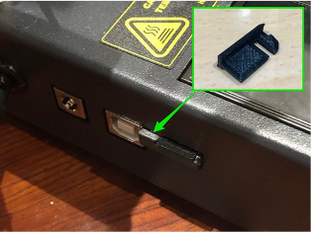

There is also a simpler way to eliminate this defect in the board mount design. Just need to replace under the board plastic washers with a thickness of 2 mm when it is mounted with screws on the rack. By the way, the board is mounted with 3 screws.

1. Table Finishing:

- replacement of attachment screws with a longer screw with a concealed head M3 35mm.

- replacement of table height adjustment springs by longer ones with sufficient elasticity, length 20 - 23 mm, inner diameter 4 - 5 mm. Small hint - the compression spring can be made from a tensile spring. )

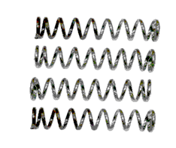

- thermal insulation, it is possible to use heat insulation material ALUFOM (PENOFOL) or similar, taking into account the maximum heating temperature of the table. Thickness 5-10mm size 175x175mm.

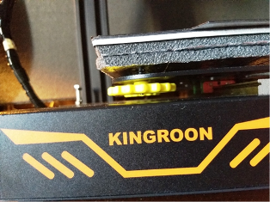 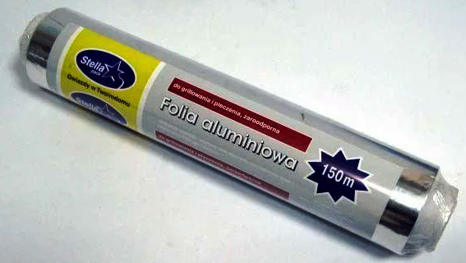

- so that the glass plate does not stick to the magnetic coating of the table, between the glass and the magnet put a sheet of aluminum foil (baking foil) according to the size of the table.

- we are finalizing the fastening of wires going to the table. To reduce bending and tension by mounting the wire through a 6-8 mm high gasket.

1. Fix the locking nut M4 bolt limit the working height of the end switch of the Z axis, after setting the zero Z.
2. Add a metal ball with a diameter of 8mm to the base of the Z-axis (between the rod of the engine and the screw guide).

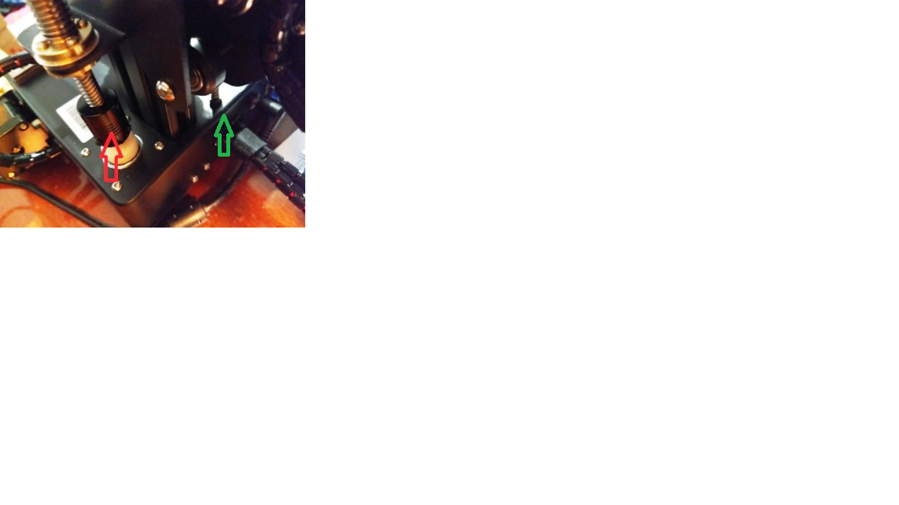

1. We install brass spring nut anti-luft 8mm thread pitch 8mm, on the Z axis (THSL drive shaft free nut). The new nut is attached to the existing nut on the shaft by screws M3x10 mm. Control the smoothness and ease of movement along the entire length of the Z-axis. If there is a displacement problem during the installation, it is necessary to install a washer made of improvised materials between the iron corner and the anti-luff nut. In my case, it’s 0.4 to 0.5 mm thick aluminum.

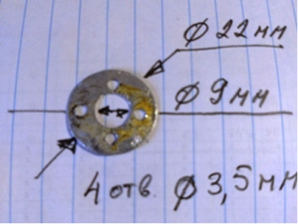 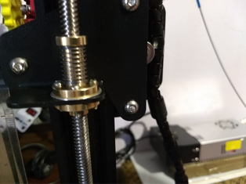

1. Fix the top end of the Z axis with the 608ZZ bearing, which is mounted in the holder of the plug of the aluminum profile.

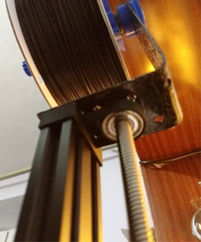 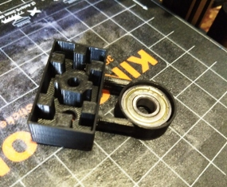 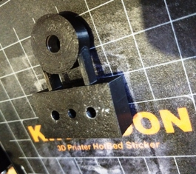

1. Top mounting of the coil with the help of the holder (corner-curved plate 40x300x2mm), mounted on the top of the aluminum profile. Fastening with two screws M5 30mm. In the profile it is necessary to cut the thread M5. The holder here 3dtoday.ru - Holder of the filament coil on bearings with brake.

# Новый рисунок (2)

1. E3D v5 extruder reboot for:

- higher nozzle fixation (twist to stop).

- winding with fume tape (3-5 turns) of the thread of the thermal barrier to the height of screwing into the heating unit.

- adding the CPT-19 thermopaste to the mounting holes of the heater and the temperature sensor.

- inserts the heater and temperature sensor at the rear of the heating unit of the extruder, which will reduce the visible length of the wires from the fans and the extruder engine to the main wiring harness (this depends on the height of the thread during assembly).

- adding a silicone case for the heating unit of the extruder.

- installation of two-way blowing model. The model file is located here. (fan connection is described below - para.).

- replacement of iron grid fans - plastic.

# Change NEMA 17HS4401 40 mm long, 280g weight on 17HS3410 34 mm long and 220g weight on X and Y axis, on extruder - NEMA 17HS2408 28mm long, 150g weight. This will make it possible to reduce the size and weight! The current on the drivers is reduced and the reference voltage of the modules of the drivers of new X and Y motors in 1V is set for the extruder 0.7-0.8 V.

# Add a visual pen to the engine shaft of the extruder.

# 

# We install cap-plug on screws fastening end switches X Z. 3dtoday.ru - plug end switches X, Z of KP3S printer.

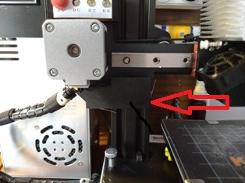

# The ZL-360-24 power supply (24V 15A) is modified to include:

# - installation of the radiator on the diode bridge.

# IMG_20201124_201855 C:\Users\USER\AppData\Local\Microsoft\Windows\INetCache\Content.Word\IMG_20210108_212236.jpg

# - strengthening of the power circuits if necessary (additional fading of the PCB).

# - replacement of thermopaste of transistors and diode assembly of BP.

# - addition at the input 220V of the varistor TVR10621 to the designated place ZNR1 on the printed circuit board BP.

# - addition of the varistor 472 to the CY3 footprint on the board.

# - addition of 0.01 - 0.1 µF capacitor at DC output to C16 footprint.

- installation of the bridge, inductance and capacitor 47 mF 35V for the operation of the connector of the second fan.

- replacement of the front panel of BP, modification of the power switch, socket of the network cable and addition of indication of the output voltage and current - ampervoltmeter of digital 100 V 10 A DC.

# We do not throw away the iron left after the completion, but we use it as a stand-holder. To do this, you need to drill 3 new mounting holes with a drill 4mm.

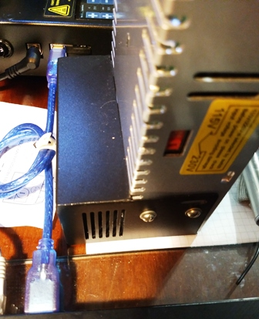 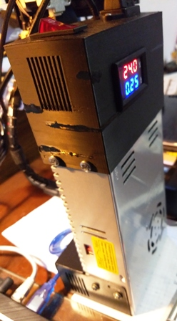

Note: The appearance of the ZL-360-24 board and the designation of the elements may vary depending on the manufacturer and date. Recommendations apply to other power supplies.

# Reducing blower noise. Fans are powered by 24V. In total we have three fans:

# - 24V 30x30mm Extruder Radiator Discharge (Main Noise Source, Directly From 24V Power Supply);

# - blowing models 24V 30x30mm (the speed of rotation is controlled programmatically - FAN socket on the board);

# - blowing circuit boards and drivers of stepper engines 24V 40x40mm, located inside the body on the bottom cover.

# The solution to the problem lies in the use of voltage downwards converters to supply the low voltage 20V of the extruder radiator blower and the voltage 12V of the board cooling fan and the drivers. To achieve this, it is necessary to use two reducing voltage converters: DC-DC LM2596S to form the voltage 20V and MP2307 (MINI-360) to form the voltage 12V. The MP2307 converter (MINI-360) is mounted on the mock-up board together with the connectors. The converters are fastened inside the body with the aid of screws or mounting rack. The blowing fan of the board inside the housing is changed to 12 volt size 40x40mm, and the fan 24V 40x40mm we use for blowing the extruder. It is installed on the seat through the adapter of the mount of the fan 30x40.

# Attention! The connectors of the 12V and 24V fans are mirror symmetrical. (protection against incorrect connection).

# IMG_20201126_100522 IMG_20201126_103609 IMG_20201126_110040

# As a result, printer noise has been significantly reduced.

# The KP3S printer model is blown by a 24V fan installed on a metal duct. I propose to replace metal with plastic with the addition of another fan that creates a counter-flow blower. 3dtoday.ru - Two-way blowing of KP3S models. The new part is fixed instead of the metal duct by the same screws. There is also an additional mounting with two M3x5mm screws on the right side of the metal extruder holder. Mounting fans (preferably together with the grid) - 8 screws M2H17mm. For mounting screws M3 need to increase the diameter of the mounting holes. The blowing fans of the model are connected in parallel to the power supply and are connected to the FAN socket.

# IMG_20201201_134401 IMG_20201201_103952

# At the same time, (if you need to lay additional wires) add a table illumination on a bright LED (or a small segment of the LED strip - enough 2 LEDs). The LED is switched on via a resistor of the order of 2 kOhm (considering the nominal current of the LED), it is fixed to the left of the nozzle on the metal frame of the extruder fastening with nylon screed.

# Add an indication fee.

# C:\Users\USER\AppData\Local\Microsoft\Windows\INetCache\Content.Word\IMG_20210108_110909.jpg C:\Users\USER\AppData\Local\Microsoft\Windows\INetCache\Content.Word\Новый рисунок.png

# On the board there is a button for turning off the illumination, an indicator for the presence of +12V (after the converter), and indicators for turning on the table heating and the extruder.

# The board is mounted in the grooves of the holder mounted on a metal profile above the motor of the X-axis.

# Improve cooling and convection of air inside the housing. We install a radiator on mosfets using heat-conducting glue Stars-922 Heatsink Plaster (optional, cooling with a cooler is enough). The wiring harness is hidden under the charge.

# IMG_20201215_174225

# Separately about the installation of the power module MOSFET to power the heated table. This revision was planned to be implemented, but after conducting research on heating and visual inspection, as well as the fact that the current of mosfets HY1403D is 42A at voltage up to 30V, is considered inappropriate. It should also be noted that the printer at full load consumes about 320 W. The main power-intensive load is the heated table (11-12 A). The weak link in the power chain is the pin power connector - the working current for heating the table exceeds the rated current of the DC Power Jack connector. As a consequence, the DC Power Jack is in critical mode.

# IMG_20201215_192942

# The end (presence) sensor of the filament has large dimensions and unsuccessful attachment that causes inconvenience in operation. In addition, a board is arranged inside the body on which the indication elements and a capacitor are removed, which is redundant for this unit. I propose to reduce its size by using as a filament filament detector only the mini micro switch to the KW10-Z0P computer mouse with a button, 3 contacts without a bar. (Same as in the old sensor, but with smaller dimensions). We print for it the case with the lid, solder the wires and use. 3dtoday.ru - KP3S sensor end (presence) of filament.

# Датчик нити 1796981629_1796981629

# In the photo, a new and ordinary sensor for comparison.

The sensor can be combined with the Teflon tube holder. The logic of the sensor - there is a thread - there is no thread it +. If there is no sensor presence of the thread - turn it off in the menu.

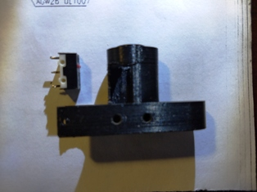

1. IMPORTANT!!! Recommendation to protect MKS TMC 2225 drivers (or similar in design) from short circuit. Look at your drivers! There are instances with curved glued radiator, which can close the contacts of the driver (the radiator is very close to them). The solution is to install a plastic strip 0.8-1.0 mm thick between the radiator and the contacts on both sides to avoid closure.

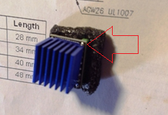 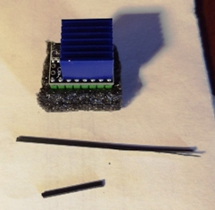

# Backlight inside the case is implemented in the latest firmware based on Marlin bugfix-2.0. x by connecting a unit of 3 LEDs to 12 V via a 1.5 kOhm damping resistance to the HE1 connector (second extruder). Brightness control is implemented by a separate menu item. The firmware activated item

#define CASE\_LIGHT\_ENABLE



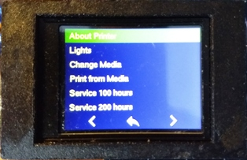 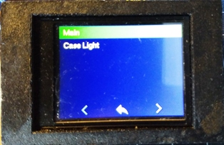 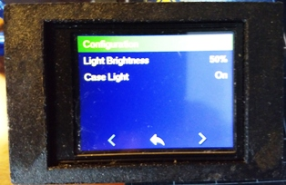

The firmware file can be downloaded here or here.

Firmware works without crashes and errors.

Note: firmware for non-inverted engines! (if the engine rotates the other way, the easiest way to fix it is to mirror the pins of the connector connecting the windings of the engine to the plume. Reshuffle contacts do when power is off! ). Next, a little more about engine inversion. As practice shows, the bulk of the firmware is made for non-inverted motors. Therefore, we take this as the default standard. Now about changing the direction of rotation (inversion). There are two ways:

- programming;

- hardware.

In the first case, change in the firmware Malin in strings (for example for the axis Z)

#define INVERT\_Z\_DIR false

On

#define INVERT\_Z\_DIR true

Compile, Flash, Activate EEPROM with new values!

The second way is more detailed to understand the process. The network is full of recommendations on the rearrangement of contacts for the hardware method, but often not disclosed the essence and meaning. So, we have 4 options to connect the motor.

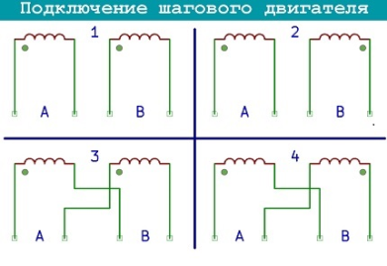Our option is first! The rest of the connections are wrong (for our special case). Change the beginning and end of the engine winding in the connector to the board (driver) or in the connector of the motor connection loop (as in the picture before and after)

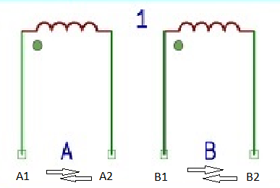 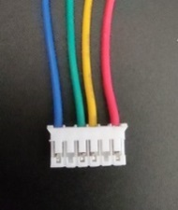 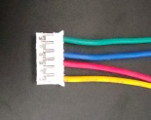

That is, not the entire connector with the contacts changes mirrored, but only the contacts of the windings of the engine! If there is a tester, before rearranging, ring the winding for confidence and check the correctness of action!

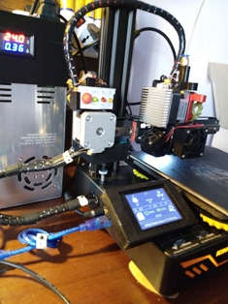

1. Print Extension. The easiest way is to replace the aluminum profile and shaft THSL of the Z axis. This requires the purchase of a trapezoidal shaft screw THSL-400-8D length 400mm with 8mm thread step and an aluminum profile 20x40 v-slot anodized black length 470mm. This will increase the printing height of the model to 230-240 mm. To further increase the height, existing cables need to be lengthened or new cables need to be laid.
2. Replacement of MKS TFT24 printer display with MKS TFT35.

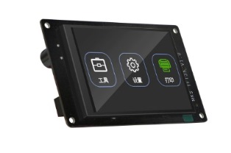

1. The MKS 3D Touch table level sensor can be installed, but is not relevant for these 180x180 printing sizes.

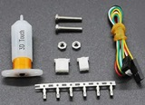

# All the above is applied by me after receiving information from various sources, as well as from personal experience of operation and not necessarily to repetition! Remember that all changes, design and software changes you make under your personal responsibility.

Quality printing for everyone!