INFINITY TECHNOLOGY INTERNATIONAL LTD.
SOFTWARE REQUIREMENT SPECIFICATION (SRS)


BANGLADESH NAVY ARMAMENT MANAGEMENT SYSTEM (BNAMS)

Contents
1. TECHNICAL REQUIREMENT 4
1.1 Introduction 4
1.2 Objective of this Document: 4
1.3 Limitation of this Document 4
1.4 SYSTEM DATABASE AND PLATFORM& HARDWARE SPECIFICATION 4
1.4.1 SYSTEM DATABASE AND PLATFORM 4
1.4.2 Hardware Specification 5
1.5 Requirement Analysis 6
1.5.1 Technical Requirement 6
2 Software Requirement /Functionality & Modules 7
2.1 Functionality of the BNAMS Software. 8
2 ORGANIZATION SETUP 9
2.1 Organization Flowchart of NHQ 9
2.1.1 Functionality of Directorate and Unit. 10
2.2 Admin Authority/ Directorate information 10
2.3 Ships/Depot Information: 10
3 INVENTORY AND PRODUCT INFORMATION 11
3.1 Warehouse Information under depot: 11
3.2 Bin Location Information 12
3.3 Gun Information 13
3.3.1 Gun Information Entry Screen 13
3.3.2 Web Equipment Information (Entry Screen) 14
3.3.3 Spare Parts Information 16
3.3.4 Gun Maintenance Information 17
3.3.5 Status of Gun after Maintenance 18
3.4 Ammunition Information 18
3.4.1 Ammunition Information (Entry Screen) 18
3.4.2 Ammunition Maintenance Information 19
3.5 Missile/Torpedo/Mine/RDC & LDC Information 20
3.5.1 Missile Information (Entry Screen) 20
3.5.2 Torpedo Information (Entry Screen) 21
3.5.3 Mine Information (Entry Screen) 23
3.5.4 RDC Information (Entry Screen) 24
3.5.5 LDC Information (Entry Screen) 25
3.6 Test/Inspection Item Ammunition, Missile, Torpedo & Mine for Bhatiary, ULKA. 27
3.7 Test/Inspection Item Gun for NASD. 27
3.8 Training Information 29
3.9 Trainee Person Bio Data 29
3.9.1 Store/Purchase Information 30
3.9.2 Item Category: 30
3.9.3 Item Status 30
3.9.4 Item Unit 31
3.9.5 Item Price Type 31
3.9.6 Item Category Information 31
3.9.7 Financial Year 31
3.9.8 Admin Authority (use by Ships/Depot Information) 32
3.9.9 Capability of weapons (use by Ships/Depot Information) 32
3.9.10 Gun Model / Mark/ Type (use by Gun/Ammunition entry screen) 32
3.9.11 Name of Gun (use by Gun/Ammunition entry screen) 32
3.9.12 Country (use by Gun/Ammunition entry screen) 33
3.9.13 Local Agent/ Supplier Information (use by Gun/Ammunition entry screen) 33
3.9.14 Procurement Category (use by Gun/Ammunition entry screen) 33
3.9.15 Quantity Category (use by Gun/Ammunition entry screen) 33
3.9.16 Status Information 33
3.9.17 Location / Shelf Information System 34
3.9.18 Flash Rules Setup 34
4 PROCUREMENT 34
4.1 Issue and Receive Item from Depot and Units: 35
4.2 Cancel/Change/Performed Indent from DNAI&S/Depot and Units’ 36
5 REPORT GENERATION 36
6 SECURITY AND USER MANAGEMENT 37
6.1 Data Encryption 37
6.2 User Roles/Functional Category. 37
6.3 Role/Functional Categories wise Menu and Submenu Right 38
6.4 Rules and Regulation of user Setup Parameter 38
6.5 Employee Information 38
6.6 Grant Role/Functional Category with Menu and Submenu to an Employee 38

TECHNICAL REQUIREMENT

Introduction
Naval Stores Sub Depot (NSSD) Dhaka of Bangladesh Navy has issued a work order No. 23.02.2608.212.07.364.18-19.0869.322 dated 24-02-2019 for Design and Development of NAVAL ARMAMENT MANAGEMENT SOFTWARE (NAMS) to Infinity Technology International Ltd. BDBL Bhaban, 12 Kawran Bazar (Level-6), Dhaka-1215. As per term and condition of work order and agreement the technical consultant of Infinity has study the present existing system and of NSSD with the co-ordination of NSSD representative. At the same time the up graduation requirement has been collected from the representative of NSSD. Therefore, the proposed software will be developed, install, implement and maintain in NSSD according to the following specification considering the requirement of work order, agreement and collected information.

Objective of this Document:

Following are the main objective of this document.

- Clearly identify the customer (NSSD) requirement.
- Easily point out the up gradation of the system
- Help the system designer to design the system.

Limitation of this Document

This document is not hundred percent limited of the requirement. If it is deemed necessary to introduce any features and function for the system for better operation than it will be included in the system with mutual consultations of NSSD and ITIL representative.

SYSTEM DATABASE AND PLATFORM& HARDWARE SPECIFICATION

SYSTEM DATABASE AND PLATFORM
The entire solution will be platform independent and database will be centralized and robust. Database will be designed by following multi-layer architecture and it can be migrated or customized in any time. The system will be able to run in both Microsoft and Oracle platform.
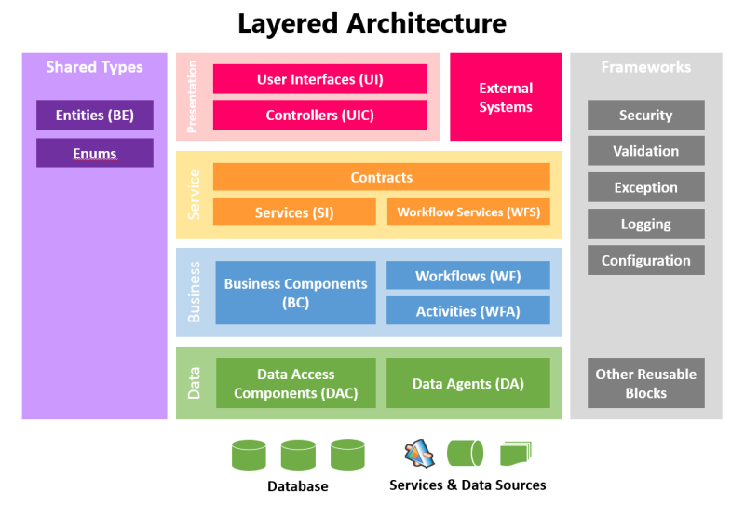
System/Platform | Recommended Software
Operating System | MS windows 2012 R2 /Latest Version/ Linux
Database Platform | MS SQL server 2014/ Latest Version
Development Platform | MS visual studio 2012 with .NET framework 4.5&MVC4 / Latest Version
Development Language | Angular JS, ASP.NET/C#.NET2012/JAVA Script/JQuery.
Report Platform | Crystal report or Report Builder /HTML report
Web Server | MS Internet Information service (IIS)

1.4.2 Hardware Specification

SL | Items | Product Model | Qty.
- Data Centre Server and Components:
01 | Server | Dell PowerEdge R740 Server | 04
02 | DB & Backup Server | Dell PowerEdge R740 Server | 04
03 | Networking Switch | Cisco 2960X24TSLL | 04
04 | Router | Cisco 2911SEC/K9 with Card | 04
05 | Firewall | Cisco ASA5516 | 04
06 | Server Rack | Data Rack J2M-6042 | 04
07 | UPS | NPS 3KVA On-Line (1hr) | 08

Requirement Analysis
The requirement analysis is defined by following two methods.
- Technical Requirement
- Software Requirement

1.5.1 Technical Requirement
The proposed BNAMS software must have the following technical features.
- The system must be Web Based, should be run in LAN and WAN environment
- Application Model: web-portal based three tier architecture.
- The software will be developed on SQL Server 2012 or any update version.
- The font end should be ASP .Net MVC/latest/better Compatible
- Existing Crystal report 10 will be updated by RDLC/latest/better compatible (license version)
- The system should run on in Windows 2012 or any update version as server and Windows XP/Windows Vista/Windows 7 or above as workstation.
- The system must support Internet Explorer (version 7 or latest), Opera (latest Version), Google Chrome (latest version) or Firefox (version3 or latest) as web browser.
- The system must have Sensitive Data Encryption though MD5, SSL. SSL must be enable for 3 years.
- The system should Comprehensive Security that complies Role Based Access Control (RBAC)
- The system will be able to provide an audit trail facility like user Audit Log and timing detail for every action and entry.
- System must be Services Oriented Architecture (SOA) compliant and support API based framework.
- The software should have capability to provide API or 2º d layer database connectivity for other software like BN-Software etc.
- Seamless integration with each module.
- To ensure cyber security. (Any security device purchase by Authority & system integrated by ITIL )
- To protect from cyber attract such as SQL Injection, DOS attach, cross site security etc.

Software Requirement /Functionality & Modules
The system must have the following modules to comply the existing system at DNAI&S, BNS ULKA, BNS BHATIARY and NASD.
Any activity of a user in the Application System for the above module will be executed through Menu/Sub-Menu under modules. The Main Menu which is introduced in the system with its Object Name only by System Administrator of Application Server.
The Application System should not allow any update delete option after final approval of the system. Administrator will allow update or delete after final customization of the system.

- Organization setup
- Policy Module
- Inventory/Store Module
- Issue/Receive Module
- Procurement Module
- Inspection Module
- Dynamic Report Generation Module
- User Management Module
- Provision to adding another module during development period required by user.

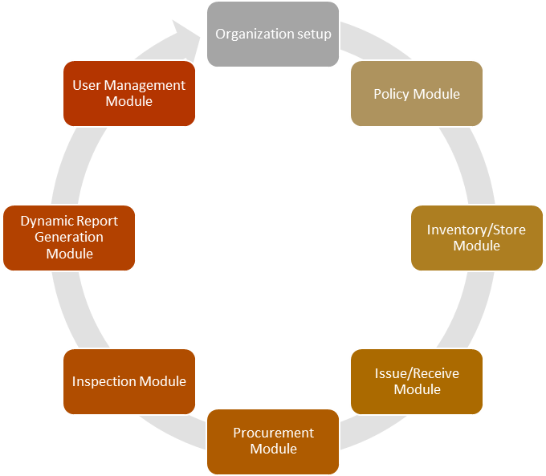
Functionality & Modules

Functionality of the BNAMS Software.
The BNAMS will maintain the following functions

- Organization Setup

- NHQ
- Directorate Info
- Unit Info ( Establishment unit/ Ship/ Organization )

- Policy Setup

- CFO (Ship, Mtg, Gun, Outfit Type, Practice Type, Annual Practice Allowance)
- Fiscal Year
- Item Category
- Item Status
- Item Unit
- Item Price Type
- Ship Capability Setup
- Ship/Gun Model
- Country
- Supplier Category
- Procurement Type
- Technical Data
- All Policy

- Inventory/Store Module

- Deport Stock (Individual Entry Screen. Like. ULKA, BHATERY, NASD )
- Ship Stock
- Store Information
- Repair/ Maintenance History

- Issue/Received Module

- Received Item ( Supplier/ Ship/ Establishment )
- Issue Item ( Ship/ Establishment )

- Procurement Module

- Supplier Information
- Procurement Category
- Procurement History
- Purchase Information

- Inspection Module

- Inspection History

- Dynamic Report Generation Module

- Searching
- Report

- User Management Module

- User Management Info
- Rule Setup
- User Create
- Password Change

ORGANIZATION SETUP
The “Organization Setup” will maintain the organization name, office address, financial year. It also maintains the Directorate and unites.
- Organization info. (NHQ, ACNS, COMKUL etc.)
- Directorate Info
- Unit info (Establishment unit, Sub unit, Ship, Sub marine)

Organization Flowchart of NHQ
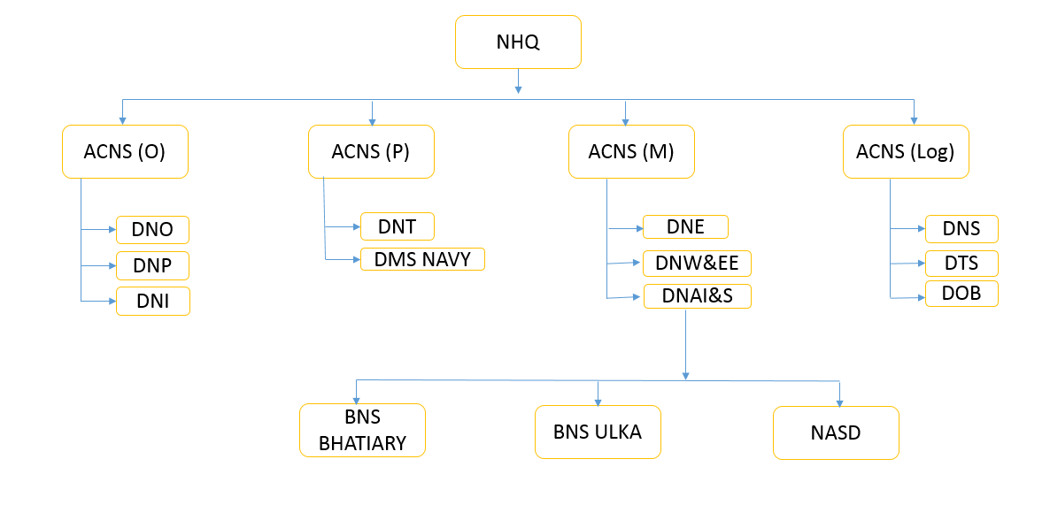

Functionality of Directorate and Unit.

Directorate and units have the following functional activities:

Sl. No. | Directorate and unit | Functionality
01.01 | Directorate of Naval Armament Inspection and Supply (DNAI&S) | Policy and Decision Making, All user under this Director.
01.01.01 | BNS ULKA | Receive store, maintenance, raising demand acceptance and Supply/Issue and other related module required by user.
01.01.02 | BNS BHATIARY | Receive Store, maintenance, raising demand acceptance and Supply/Issue and other related module required by user.
01.01.03 | Naval Armament Stores Depot (NASD) | Receive Store, maintenance, raising demand acceptance and other related module required by user.

Admin Authority/ Directorate information
The organization information must content the following information
Organization code  Admin Authority Name  Address  Telephone No.  Fax No  Web site Address  Organization Logo  Area | :------------------(Auto Generate)  :--------------------  :------------------  :--------------------  :------------------  :--------------------  :--------------------  :-----------(Drop Down)

Ships/Depot Information:
Each Ship (unit) will contain specific Item with its capacity and use. Considering on this the system will setup the items and item wise quantity and other criteria as follow

Ships/Depot code | :----------------- (Auto Generate)
Admin Authority  Category  Ships / Deport Name  Date Of Commission  W/T Call Sign  Capability of weapons  Type of The Ship  Telephone  Email  Fax No.  Web site Address | :----------------- ( Drop Down ) ( Comban, Conkhul)  :------------------ (Drop Down) (Office or Ship & Other)  :-----------------------  :-----------------------  :-----------------------  :------------------- (Drop Down) FS, Corvette, LPC, PC  :--------------------- (CO, EXO, GO)  :---------------------  :---------------------  :---------------------  :---------------------

INVENTORY AND PRODUCT INFORMATION

Warehouse Information under depot:

BNS BHATIARYWAREHOUSE

Program Name Process Date:99-99-999
Warehouse Type :---- (For example S=Store/W=Warehouse/R=Repair, P=Purchased, US= Unserviceable, PES = Primary Explosive Store, PS= Pyrotechnic store--------------etc)
Warehouse Code :---(auto Generate N= N+1)
Warehouse Name :- Sugandh (input)
Address1-:-----------xxxxxxx
Address2:-----------------yyyyyyy
Warehouse Belong to :-------(Under Unit )
Save Cancel Delete Edit

BNS ULKA WAREHOUSE

Program Name Process Date:99-99-999
Warehouse Type :---- (Saylow-1, 2 --------- etc )
Warehouse Code :---(auto Generate N= N+1)
Warehouse Name :- Sugandh (input)
Address1-:-----------xxxxxxx
Address2:-----------------yyyyyyy
Warehouse Belong to :-------(Under Unit )
Save Cancel Delete Edit

NASD WARHOUSE

Program Name Process Date:99-99-999
Warehouse Type :---- (Gun 4.5” UK, Gun 4” (UK), Gun 76.2mm (CHN)------------------- etc. )
Warehouse Code :---(auto Generate N= N+1)
Warehouse Name :- Sugandha (input)
Address1-:-----------xxxxxxx
Address2:-----------------yyyyyyy
Warehouse Belong to :-------(Under Unit )
Save Cancel Delete Edit

Bin Location Information

Bin location is mandatory for each warehouse to quick search and find out the item. Bin Location is composed of Zone, Self, Row and Column Id.

Program Name Process Date:99-99-999
Warehouse Code :--- (Warehouse info)
Name:---- (Auto Display)
Self-ID:------------
Row ID:-----------
Product Category: --- (Arm. Gun, Mine etc).

Save Cancel Delete Edit

Gun Information

Gun Information Entry Screen

System will maintain the each Gun/Armaments information under main group; sub-group with the following information:

Program ID Date:99/99/9999
Name of Gun  Gun Model / Mark/ Type  Gun Registration No  Year of Manufacture  Country of Manufacture  Country Of Origin  Purpose (AA/ASu/AA Short range)  Year of Procurement  Warranty Period  Price Type  Unit Price  Total Price  Local Agent  Principal Agent  Manufacture Agent  Quantity Category  Image  Depot Name  Procurement Category  Self-Name  Row Name  Technical Specification  Weight (Gun / Mounting)  Dimension ( Height/Breath / length)  Maximum Range  Effective Range  Muzzle Velocity  Barrel Life  Operating Temperature in ºC  Storing Temperature in ºC  Preservation Temperature in ºC  Status  Date of Received after acceptance  Contract / work order Number  Other Remarks | :--------------(Drop Down)  :---------------(Drop Down) (Small, Big, Large )  :---------------- ( Unique )  :---------------  :--------------- (Drop Down) (India, Belgium)  :--------------- (Drop Down) (India, Belgium)  :---------------  :--------------- (Drop Down) (Fiscal year)  :---------------  :--------------- (Drop Down) (BD, Dollar)  :---------------  :---------------  :--------------- ( Drop Down)  :--------------- ( Drop Down)  :--------------- ( Drop Down)  : --------------- (Drop Down) (KG,Unit.)  :--------------- (Scan and save with Image ID)  :--------------- (Drop Down) ( ULKA, NASD)  :--------------- ( Drop Down)(Tender/Certification/Paper Transaction)  :---------------(Drop Down)  :--------------( Drop Down)  :--------------  :---------------  :----------------  :-----------------  :----------------  :--------------  :--------------  :--------------  :--------------  :--------------  :--------------(Drop Down) (Serviceable , Un Serviceable or Defect, Other)  :--------------  :--------------  :--------------

Web Equipment Information (Entry Screen)

Program ID Date:99/99/9999
Name of Web Equipment  Date Of Received  Fiscal year  Brand/Model/Type  Year of Manufacture  Country of Manufacture  Country of Origin  Purpose  Year of Procurement  Warranty Period  Price Type  Unit Price  Total Price  Procurement Category  Local Agent  Principal Agent  Manufacture Agent  Quantity Category  Image  Depot Name  Self-Name  Row Name  Technical Specification  Weight  Status  Other Option | :--------------(Drop Down) ( Helmet, Whistleetc )  :---------------  :--------------- (Drop Down)  :---------------  :---------------  :--------------- ( Drop Down) (India, Belgium)  :--------------- ( Drop Down) (India, Belgium)  :---------------  :--------------- ( Drop Down) (Fiscal year)  :---------------  :--------------- (Drop Down) (BD, Dollar)  :---------------  :---------------  :--------------- ( Drop Down)(Tender/Certification/Paper transaction)  :--------------- ( Drop Down)  :--------------- ( Drop Down)  :--------------- ( Drop Down)  :--------------- (Drop Down) (Unit)  :--------------- (Scan and save with Image ID)  :--------------- (Drop Down) ( ULKA, NASD)  :---------------(Drop Down)  :--------------( Drop Down)  :--------------  :---------------  :--------------(Drop Down) (Serviceable , Un Serviceable, Repair )  :--------------(Input)

Spare Parts Information

Program ID Date:99/99/9999
Name of Spare Parts  Type  Brand  Model  Weight  Year of Manufacture  Country of Manufacture  Country of Origin  Purpose  Technical Specification  Year of Procurement  Warranty Period  Price Type  Unit Price  Total Price  Local Agent  Principal Agent  Manufacture Agent  Quantity Category  Serial Number  Image  Depot Name  Procurement Category  Self-Name  Row Name  Operating Temperature in Cº  Storing Temperature in Cº  Preservation Temperature in Cº  Date Of Received  Status  Other Option | :--------------(Drop Down) (---------------)  :---------------(Drop Down) (Gun/Ammunition/Missile)  :---------------  :---------------  :----------------  :---------------  :--------------- ( Drop Down) (India, Belgium)  :--------------- ( Drop Down) (India, Belgium)  :---------------  :---------------  :--------------- ( Drop Down) (Fiscal year)  :----------------  :--------------- (Drop Down) (BD, Dollar)  :---------------  :---------------  :--------------- ( Drop Down)  :--------------- ( Drop Down)  :--------------- ( Drop Down)  :--------------- (Drop Down) (KG,Unit.pic)  :---------------  :--------------- (Scan and save with Image ID)  :--------------- (Drop Down) ( ULKA, NASD)  :--------------- ( Drop Down)(Tender/Certification/Paper transaction)  :---------------(Drop Down)  :--------------( Drop Down)  :--------------(Input)  :--------------(Input)  :--------------(Input)  :--------------  :--------------(Drop Down) ( Serviceable , Un Serviceable)  :--------------(Input)

Gun Maintenance Information

Maintenance Code | :--------------- Auto Generated
Registration Number  Name  Present Location  Last Maintenance Date  Maintenance Year  Maintenance Detail  Last Maintenance Date  Present Location  Maintenance Year  Maintenance Location  Defect Information  Maintenance Detail  Maintenance Type  Next Maintenance due | :-------------- (Searching)  :---------------- (Auto Display)  :------------------- (Auto Display)  :----------------- (Auto Display)  :------------------ (Auto Display)  :------------------ (Auto Display)  :--------------------  :--------------------(Drop Down) (NASD , Bhatiary)  :-----------------------  :----------------------  :----------------------  :----------------------  :-----------(Drop down)( Monthly, Quarterly, Half yearly & yearly)  :-----------------

Status of Gun after Maintenance

Maintenance Code | :--------------- Auto Generated
Registration Number  Maintenance Result  Maintenance Status  Remarks  Next Maintenance Date | :-------------- (Searching)  :-----------------------  :--------------(Drop Down) ( serviceable, un serviceable, Damage)  :----------------  :---------------

Ammunition Information

Ammunition Information (Entry Screen)
(All Ammunition item lot wishes entry not individual item wish entry)
Ammunition Code | :--------------- Auto Generated
Caliber  Ammunition Type  Quantity  Lot Number  Year of Manufacture  Country of Manufacture  Country of Origin  Year of Procurement  Local Agent  Principal Agent  Manufacturer Agent  Currency  Unit Price  Total Price  Purpose  Technical Specification  Shelf life  Proof Firing  Proof Firing Date  Storing Temperature in ºC  Operating Temperature in ºC  Humidity  Remarks  Depot name  Shelf Name  Row name  Warranty  Image  Status | :--------------- ( Drop Down) ( 100mm, 25mm)  :----------------------- ( Drop Down) ( HE/HEI/HEIT/DPT)  :-----------------------  :-------------- (Searching) ( Lot number + Menuf: Year+ Country)  :-------------- (Drop Down) (Country)  :---------------- (Drop Down) (Country)  :--------------- (Drop Down) (Country)  :--------------- (Drop Down) (Country)  :--------------- (Drop Down) ( Supplier Name)  :--------------- (Drop Down) ( Supplier Name)  :--------------- ( Drop Down)  :--------------- (Drop Down) ( All Currency)  :---------------  :---------------  :---------------  :---------------  :---------------  :---------------  :---------------  :---------------  :---------------  :---------------  :---------------  :--------------- (Drop Down) ( NASD/ Bhatiry)  :--------------- (Drop Down)  :--------------- (Drop Down)  :---------------  :---------------  :------------(Drop Down)( serviceable, un serviceable, Damage)

Ammunition Maintenance Information

Maintenance Code | :--------------- Auto Generated
Registration Number  Name  Present Location  Last Maintenance Date  Present Stock  Maintenance Year  Maintenance Detail  Last Maintenance Date  Present Location  Maintenance Year  Maintenance Location  Defect Information  Maintenance Detail  Maintenance Type  Next Maintenance due | :-------------- (Searching) ( Lot Number )  :---------------- (Auto Display)  :------------------- (Auto Display)  :----------------- (Auto Display)  :----------------- (Auto Display)  :------------------ (Auto Display)  :------------------ (Auto Display)  :--------------------  :--------------------(Drop Down) (NASD , Bhatiary)  :-----------------------  :----------------------  :----------------------  :----------------------  :-----------(Drop down)( Monthly, Quarterly, Half yearly & yearly)  :-----------------

Missile/Torpedo/Mine/RDC & LDC Information

Missile Information (Entry Screen)
Missile Code | :--------------- Auto Generated
Name of Missile  Missile Type  Quantity  Serial Number  Year of Manufacture  Country of Manufacture  Country of Origin  Year of Procurement  Local Agent  Principal Agent  Manufacturer Agent  Currency  Unit Price  Total Price  Purpose  Technical Specification  Shelf life of Missile  Shelf life of Launcher  Missile Preparation Time  Combat Duration  Test Firing  Test Firing Date  Storing Temperature in ºC  Operating Temperature in ºC  Humidity  Remarks  Depot name  Date Of Received  Shelf Name  Row name  Warranty  Status | :------------------- (Drop Down) (C80/C804)  :----------------------- ( Drop Down) ( SAM/SSM)  :-----------------------  :----------------  :----------------  :----------------  :----------------  :----------------  :--------------- ( Drop Down)  :--------------- ( Drop Down)  :--------------- ( Drop Down)  :----------------  :----------------  :----------------  :----------------  :----------------  :----------------  :----------------  :---------------- ( Peace/War )  :----------------  :----------------  :----------------  :----------------  :----------------  :----------------  :----------------  :----------------  :----------------  :----------------  :----------------  :----------------  :------------(Drop Down)( serviceable, un serviceable, Damage)

Torpedo Information (Entry Screen)

Torpedo Code | :--------------- Auto Generated
Name of Torpedo  Torpedo Type  Quantity  Serial Number  Year of Manufacture  Country of Manufacture  Country of Origin  Year of Procurement  Local Agent  Principal Agent  Manufacturer Agent  Currency  Unit Price  Total Price  Purpose  Technical Specification  Shelf life  Shelf life  Preparation Time  Combat Duration  Test Firing  Test Firing Date  Storing Temperature in ºC  Operating Temperature in ºC  Humidity  Remarks  Depot name  Date of Received  Shelf Name  Row name  Warranty  Status | :------------------- (Drop Down) (C80/C804)  :----------------------- ( Drop Down) ( SAM/SSM)  :-----------------------  :----------------  :----------------  :----------------  :----------------  :----------------  :--------------- ( Drop Down)  :--------------- ( Drop Down)  :--------------- ( Drop Down)  :----------------  :----------------  :----------------  :----------------  :----------------  :----------------  :----------------  :---------------- ( Peace/War )  :----------------  :----------------  :----------------  :----------------  :----------------  :----------------  :----------------  :----------------  :----------------  :----------------  :----------------  :----------------  :------------(Drop Down)( serviceable, un serviceable, Damage)

Mine Information (Entry Screen)
Missile Code | :--------------- Auto Generated
Name of Mine  Mine Type  Quantity  Serial Number  Year of Manufacture  Country of Manufacture  Country of Origin  Year of Procurement  Local Agent  Principal Agent  Manufacturer Agent  Currency  Unit Price  Total Price  Purpose  Technical Specification  Shelf life  Shelf life of Launcher  Preparation Time  Test Firing  Test Firing Date  Storing Temperature in ºC  Operating Temperature in ºC  Humidity  Remarks  Depot name  Date of Received  Shelf Name  Row name  Warranty  Status | :------------------- (Drop Down) (C80/C804)  :----------------------- ( Drop Down) ( SAM/SSM)  :-----------------------  :----------------  :----------------  :----------------  :----------------  :----------------  :--------------- ( Drop Down)  :--------------- ( Drop Down)  :--------------- ( Drop Down)  :----------------  :----------------  :----------------  :----------------  :----------------  :----------------  :----------------  :---------------- ( Peace/War )  :----------------  :----------------  :----------------  :----------------  :----------------  :----------------  :----------------  :----------------  :----------------  :----------------  :----------------  :------------(Drop Down)( serviceable, un serviceable, Damage)

RDC Information (Entry Screen)
RDC Code | :--------------- Auto Generated
Name of RDC  RCD Type  Quantity  Serial Number  Year of Manufacture  Country of Manufacture  Country of Origin  Year of Procurement  Local Agent  Principal Agent  Manufacturer Agent  Currency  Unit Price  Total Price  Purpose  Technical Specification  Shelf life  Preparation Time  Test Firing  Test Firing Date  Storing Temperature in ºC  Operating Temperature in ºC  Humidity  Remarks  Depot name  Date of Received  Shelf Name  Row name  Warranty  Status | :------------------- (Drop Down)  :----------------------- ( Drop Down)  :-----------------------  :----------------  :----------------  :----------------  :----------------  :----------------  :--------------- ( Drop Down)  :--------------- ( Drop Down)  :--------------- ( Drop Down)  :----------------  :----------------  :----------------  :----------------  :----------------  :----------------  :---------------- ( Peace/War )  :----------------  :----------------  :----------------  :----------------  :----------------  :----------------  :----------------  :----------------  :----------------  :----------------  :----------------  :------------(Drop Down)( serviceable, un serviceable, Damage)

LDC Information (Entry Screen)
LDC Code | :--------------- Auto Generated
Name of LDC  LDC Type  Quantity  Serial Number  Year of Manufacture  Country of Manufacture  Country of Origin  Year of Procurement  Local Agent  Principal Agent  Manufacturer Agent  Currency  Unit Price  Total Price  Purpose  Technical Specification  Shelf life  Preparation Time  Combat Duration  Test Firing  Test Firing Date  Storing Temperature in ºC  Operating Temperature in ºC  Humidity  Remarks  Depot name  Date Of Received  Shelf Name  Row name  Warranty  Status | :------------------- (Drop Down)  :----------------------- ( Drop Down)  :-----------------------  :----------------  :----------------  :----------------  :----------------  :----------------  :--------------- ( Drop Down)  :--------------- ( Drop Down)  :--------------- ( Drop Down)  :----------------  :----------------  :----------------  :----------------  :----------------  :----------------  :---------------- ( Peace/War )  :----------------  :----------------  :----------------  :----------------  :----------------  :----------------  :----------------  :----------------  :----------------  :----------------  :----------------  :----------------  :------------(Drop Down)( serviceable, un serviceable, Damage)

Test/Inspection Item Ammunition, Missile, Torpedo & Mine for Bhatiary, ULKA.

Program ID Date:99-99-9999
Directorate/ Depot :---------- (Drop Down) ( Bhatiary, ULKA )
Item Category :------ Drop Down (Ammunition , Missile, Torpedo, Mine)
Lot / Registration No :------ Searching
Item Name :------ (Auto Display )
Warranty Date :-----------(input)
Last Maintenance date :-----Supplier ID and Name/Directorate
Supplier Information :------------ ( Auto Display )
Next Inspection Date :---------(input)
Install Date :--------------------------
Install By :---------------------------
Install At :------------------------------- Inspection Date:-------------------(input)
Inspection Method :---------------(By operate/By observation)
Inspection By :-------------------(input)
Commence :

Test/Inspection Item Gun for NASD.

Program ID Date:99-99-9999
Directorate/ Depot :---------- (Drop Down) (NASD )
Item Category :------ Drop Down (Gun)
Caliber :------ Searching
Item Name :------ (Auto Display )
Warranty Date :-----------(input)
Last Maintenance date :-----
Supplier Information :------------ ( Auto Display )
Next Inspection Date :---------(input)
Install Date :--------------------------
Install By :---------------------------
Install At :------------------------------- Inspection Date:-------------------(input)
Inspection Method :---------------(By operate/By observation)
Inspection By :-------------------(input)
Commence :

Training Information

The system will maintain the following Training Information for operating equipment.
Training Code | :--------------- Auto Generated
Name of Equipment  Course Name  Course Ref No  P.NO/ O.NO  Start Date  End Date  Name of Country  Organization  Local/Abroad | :-----------------------(Drop Down) (Gun/ Ammunition/ Missile)  :-----------------------  :-----------------------  :----------------------- (Searching Name & P.NO)  :-----------------------  :-----------------------  :-----------------------(Drop Down) (Local/ Foreign)  :-----------------------(Drop Down) ( ARMY/ Navy/ Air Force )  :-----------------------

Trainee Person Bio Data

BIO Data Code | :--------------- Auto Generated
P.NO/O.NO  Rank  Name | :-----------------------  :-----------------------(Drop down)  :-----------------------

Store/Purchase Information
Perpetual inventory system updated inventory accounts after each Received or Issue. Inventory subsidiary ledger is updated after each any transaction. The register / ledger account is updated at the end, periodic or calculation period of each accounting or transaction. This system automatic generated the all reports (Daily, Weekly, Monthly, Quarterly, Help Yearly, and Yearly)

- Inventory quantities are updated continuously.
- Inventory quantities updated by Entry Basis.
- Inventory quantities are updated calculation basis on a periodic.
- Pipeline (Contracted but not yet received).

The Store Information System follows the following three methods.

- Tender Method System
- Certification Method System
- Paper Transaction Method System

Certification Method System means: Any Gun/ Ammunition & Missile get from the outsourcing. If this item registered in our ledger, then this item is Certification item. (Without Purchase or Tender.) For example Ex-Bhatiary items.
Paper Transaction Method System: Any Gun/ Ammunition & Missile get from the purchase new Ship. If this item registered in our ledger, then this item is Certification item. (Without Purchase or Tender.)

Item Category:
The BNAMS will maintain the Item category as follow:

- Gun
- Ammunitions
- Web Equipment
- Missile
- Torpedo
- Mine
- Spare Parts
- RDC, Pyrotechnic, Demolition Item
- Non Explosive Items
- Other Items (If any)

Item Status
Each Items must be defined with following status according to the condition of the Item

- Serviceable
- Un Serviceable
- Repairable
- Lost Item
- Used Item
- Overaged
- Other Option

Item Unit
Each Item must be defined with following units according to item quality:

- Pieces
- Dozen
- KG
- Pound
- Quintile
- Kilometer
- Nos
- Set
- Rds
- Gm
- Mtr
- Cm
- Bar
- Pa
- Other Option

Item Price Type

Each Items must following price type according to particular quantity and Value

- Unit Price – in foreign currency & Local currency- Procurement Year
- Total Price

Item Category Information
Goods/Item is the main focal point of Inventory in BNAMS. The Goods and Item will be first categories according to functionality and use of goods and Item. Under category there may be Main Group and Sub Group of Goods and Items. Therefore the Goods and Items may be classified as

- Category ( as like Explosive Item/Non-Explosive Item )
- Main Group (as like Arms/Gun/Web Equipment/Missile/Torpedo/Mine/RDC/LDC etc. )
- Sub Group ( as like caliber )

The system must be kept N-level of Goods and Item Code in each category in such a way that the software user may add new Group in the system as when required.

Financial Year

The Financial Year for Bangladesh Navy Armament Management Software (BNAMS) will be Maintain July to June for each year.

The Fiscal Year Information must content the following information under the use this system.
Fiscal year Code | :--------------- Auto Generated
Fiscal Year Name  Short Name  Start Date  End Date | :-----------------------  :-----------------------  :-----------------------  :-----------------------

Admin Authority (use by Ships/Depot Information)

Admin Authority code | :----------------- (Auto Generate)
Admin Authority Name  Area  Contract  Email | :----------------- ( Drop Down )  :------------------ (Drop Down) (Dhaka/CTG/Khulna)  :------------------  :-----------------------

Capability of weapons (use by Ships/Depot Information)

Capability code | :----------------- (Auto Generate)
Capability Name  Telephone  Email | :-------------------  :------------------ (CO, EXO, GO)  :------------------

Gun Model / Mark/ Type (use by Gun/Ammunition entry screen)
Gun Model code | :----------------- (Auto Generate)
Gun Type Name  Short Name  Create Date | :------------------- (Small, Big, Large )  :------------------  :------------------

Name of Gun (use by Gun/Ammunition entry screen)
Name of Gun code | :----------------- (Auto Generate)
Name of Gun  Short Name  Create Date | :------------------- ( Gun, Ammunition, Missile, Torpedo )  :------------------  :------------------

Country (use by Gun/Ammunition entry screen)
Country code | :----------------- (Auto Generate)
Country Name  Short Name  Dollar Type  Create Date | :-------------------  :------------------  :------------------  :------------------

Local Agent/ Supplier Information (use by Gun/Ammunition entry screen)
Local Agent code | :----------------- (Auto Generate)
Supplier Name  Address  Enlistment Type  Email  Contract Number  Country | :-------------------  :------------------  :------------------ (Yes/No)  :------------------  :------------------  :------------------

Procurement Category (use by Gun/Ammunition entry screen)
Procurement code | :----------------- (Auto Generate)
Procurement Name  Create Date | :------------------- (Tender/Certification/Paper Transaction)  :-----------------

Quantity Category (use by Gun/Ammunition entry screen)
Quantity code | :----------------- (Auto Generate)
Quantity Name  Create Date | :------------------- (KG/Killo/GR)  :-----------------

Status Information
Status code | :----------------- (Auto Generate)
Status Name  Short Name  Create Date | :------------------- (Serviceable, Unserviceable, Repairable)  :----------------- (S,UNS,R)  :-----------------

Location / Shelf Information System
Through the use this method, the current position of the any Gun / Ammunition & Missile can be known.
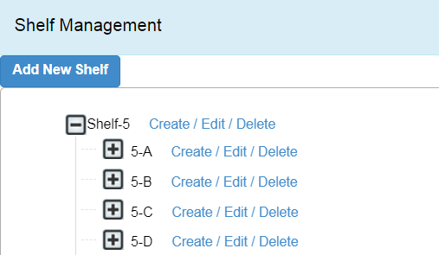

Flash Rules Setup

The system must have the provision to notification/alert to the designated authorized official of respective office regarding specific shortage of item ship (unit) for fulfillment of desired requirement. DNAI&S will also to the respective depot or get notification/alert.

Program Name Process Date:99-99-999
Depot/Unit :-------(Select )
Item Code :----- ---(Select )
Notification Less Than Balance :------------------ (input)
Notification to Office :-----------(input)
Notification to Officer :------------(input)
Notification Method :--------------(Letter/E-mail/Flashing)
Save Cancel Delete Edit

PROCUREMENT

Procurement will be done on the basis of indent. After getting indent from depot and unit, DNAI&S will take action to purchase after approval of respective authority.

For Purchasing following cycle and information is mandatory
Purchasing Cycle:
- Issue and Receive Indent from Depot and unit.
- After approval and Tender process Issue Purchase Order. By DGDP/NSSD/NSD.
- Item Received.
- Installation
- Test/Trial
- Acceptance
- Ledger entry

Issue and Receive Item from Depot and Units:

Program ID Date:99-99-9999
Date  Indent No.  Indent from/To  Issue Person  Item Code  Item Name  Composite Code  Composite Name  Product Supplier Name  Indent Quantity  Indent Validity  Indent Type  Other Options | :---------- (Auto Display from System)  : -------- (Auto Generate with Sequence No.)  :--------- (Select from) (Issue/ Received)  :---------- (Drop Down) ( All Ship & Depot )  :----------(Searching )  :----------(Auto Display)  :-------- (Select)  :-------(Auto Display)  :-----(Supplier ID and Name)  :--------- Unit  :-----------30 days  :--------------(Issue/Receive)  :------------

Cancel/Change/Performed Indent from DNAI&S/Depot and Units’

Program ID Date:99-99-9999
Date  Indent No.  Indent No  Indent Type  Indent Status  Status Date  Issue/ Received Date  Remarks  Others Option | :---------- (Auto Display from System)  : -------- (Auto Generate with Sequence No.)  :------------ (Searching )  :--------------(Issue/Receive)  :------------(Cancel/Change/Performed)  :---------------------(date)  :--------------------(input)  :--------------------(input)  :--------------------

REPORT GENERATION

The system has the provision to print out the different type of report as required by the user.
The following report is mandatory for the system

- Quarterly Return (Quarterly, Half Yearly & Yearly Inventory) Report
- Monthly Return (Monthly Inventory) Report
- Report on any ammunition giving it detail information.
- Report on stock position of armaments and ammunition of different ship and establishments.
- Report on totals stock position at any time
- Report on procurement showing earlier procurement related data.
- Report on ship’s state of armaments and ammunitions
- Report on shortage of any ammunition at any moment
- Provision to showing any other report required for concerned establishment.
- Report on overaged ammunition state.
- Report on expenditure of ammunition as caliberwise
- Report of ledger entry
- Report of trainee person of any gun & arms in abroad or home.
- Provision to showing any other reports as required by user.
- Report of any spec of arms, gun & ammunition
- Report of defective arms , gun & ammunition

The Report format and layout with contains will be designed with the consultation of DNAI&S.

SECURITY AND USER MANAGEMENT
The System will be developed for Central Database System which will be hosted in NHQ and managed by Directorate of Naval Armament Inspection and Supply (DNAI&S) as per requirement of Bangladesh Navy. The Directorate BNS ULKA, BNS BHATIARY and NASD and each Ship (Unit) will be connected with the Central Database. The system will operate on three tire architecture. The database, Network and Application security will controlled by its environment and integrated to each other. The Application BANGLADESH NAVY ARMAMENT MANAGEMENT SYSTEM (BNAMS) Security will be control by User, User Role, User Password, and User Access Right of Menu and Sub-menu.

Data Encryption
All Transaction and updated of Data by different authorized User must be encrypted. special stock balance and quantity of each Item must store in database with encrypted format.

User Roles/Functional Category.

The system will maintain multiple level of user role (functional category) which will be defined by the DNAI&S according to their level of office like Head office Division, Directorate and Ship (Unit) Offices. This functional category of user will setup at the initial stage of the system implementation with the consultation of DNAI&S. The system will keep provision to add new Functional Category of user of the system as per requirement of the DNAI&S.
DNAI&S, BNS ULKA, BNS BHATIARY and NASD and each Ship (Unit) have different entity so each have separate administrator, control and supervisor level as defined by DNAI&S. Therefor no one could access beyond their authorization limit.
It will be maintained only by System Admin of Application Server/Administrator of DataCenter for Application Server. The system should not allow any update delete option after final customization of the system. Administrator will allow update or delete after final customization of the system.
Example of User Roles/Functional Category may as Follow
- DNAI&S

- Admin Officer.
- Control Officer
- Supervisor or Data Operator

- BNS Ulka, BNS Bhatiary, NASD
- Admin. Officer
- Control Officer
- Data Operator

- Ship (Unit) Office
- Unit Admin.
- Unit Control Officer
- Unit Data Operator

Role/Functional Categories wise Menu and Submenu Right

The system has the provision to define Menu and Sub-Menu right on Role/Functional Categories of the system on the basis of Office Category (HO/Directorate/Ship (unit) Office etc.). It is the work group of predefine menu and sub-menu against the role of the system Head Office Admin, Head Office Control Officer, Head Office Data Operator etc. Similarly for Directorate Office, Ship (Unit) Office and other Control Offices etc.. It will be maintained only by System Administrator of Application Server.

Rules and Regulation of user Setup Parameter

The system has the provision to define the user parameter setup option as per Navy ICT security policy to maintain user access control of the system. The access control may be Bio-metric identification or Digital identification. The system firstly maintain the identification type. On the basis of identification type the system must maintain the other related field.
In case of Bio-metric identification it should maintain Image Category, image size, storing path, control no., authentication by, authentication date etc.
In case of Digital Identification it should maintain the Maxi. Password length, Min. Password length, Minimum number of numeric, alphanumeric digit etc. Maximum number of unsuccessful log-in attempt etc.

Employee Information
The System will maintain the physical information of Employee of the user of the system. The Employee information must be maintained from employee personal information. For system user employee information is mandatory. The mandatory fields of the employee information are EMP_ID, USER_NAME and ACTIVE_STATUS.

Grant Role/Functional Category with Menu and Submenu to an Employee
The Grant Role of a user (Employee) is the most important features of the system. It define the functional Category of the User with corresponding assign right of MENU and SUB_MENU of the system. If an Employee’s Role is assigned as Administrator of the Ship (Unit)/Directorate/Head Office Division than it is assigned by its upper control offices administrator or data center. Other than Administrator the user Role /Functional category is assigned against the employee by administrator of the respective offices.
SYSTEM PROCESS FLOW
