**Data Warehouses – Lab. 08**

Wroclaw University of Science and Technology, Date: 11 May 2022

|  |  |  |
| --- | --- | --- |
| Student: | ---------------------------------------------------------- | Grade |
| Identifier | 245784 |  |
| First name | Rahul |
| Last name | Vijayvargiya |

This laboratory assignment consists of 1 task. If you cannot solve the task, try to give at least a partial solution or justification for the reason for the lack of a solution.

# Task 1

Data source: AdventureWorksDW2019 (2017)

Develop sample analytical models (dimensional models) intended for traditional sales analyzes (Reseller sales), using the data source:

* 1. Present analytical models in the form of UML class diagrams, justifying the choice of measures and dimensions (what the proposed contexts of fact analysis are to serve)

**Solution:**

• Dim product:

We nee this because, to identify producy, which product sells the most, price and amount of product

• DimReseller: We need to analyze which reseller is selling the most, and from where the most reseller are opreating, which country has the highest no. Of exporters

And to find the which product sold the most, and which product to popular

• DimSalesTeritory: this dimension basically tells us group and country name.

• DimCurrency: this table has only one attribute called currency name and its used for analyzing which currency has more demand and maybe company should focus on buying respective currency.

• DimDate: another vital analysis dimension it has attribute year quarter month name and week. • FactResellerSales: the main table of analysis with measure discount amount, sales amount and orderquantity. The main motive for this measures where knowing sales amount in each region,order quantity in each day of week and discount amount for knowing if it effect orderquantity

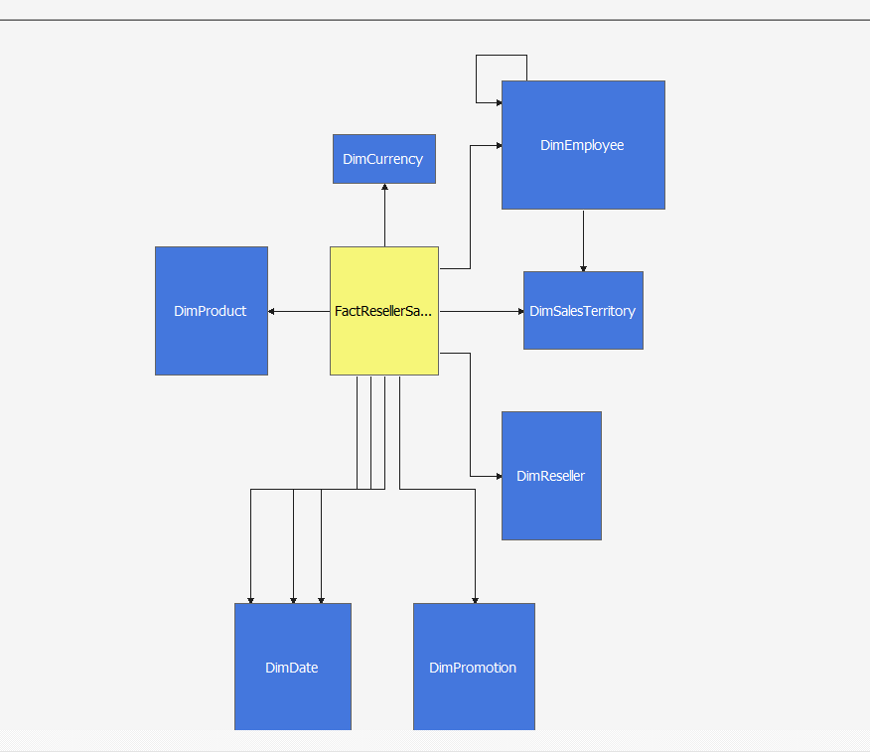

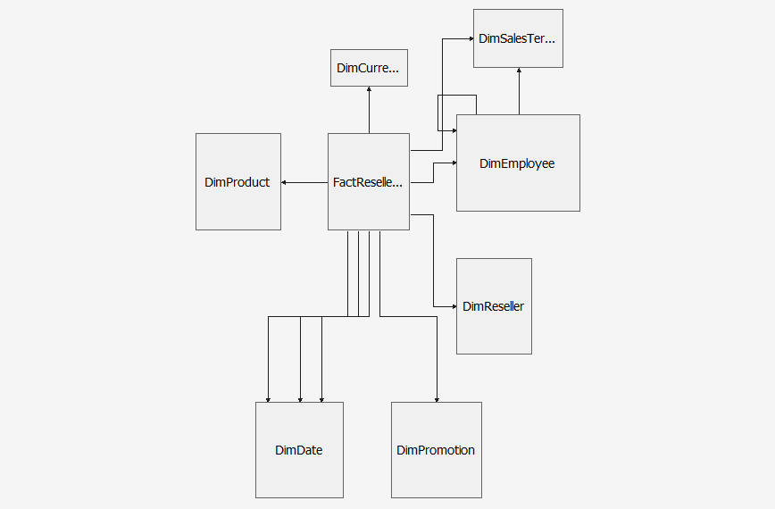

We Use Adventure Works 2019 in the data sources and

We select fact reseller and measures next

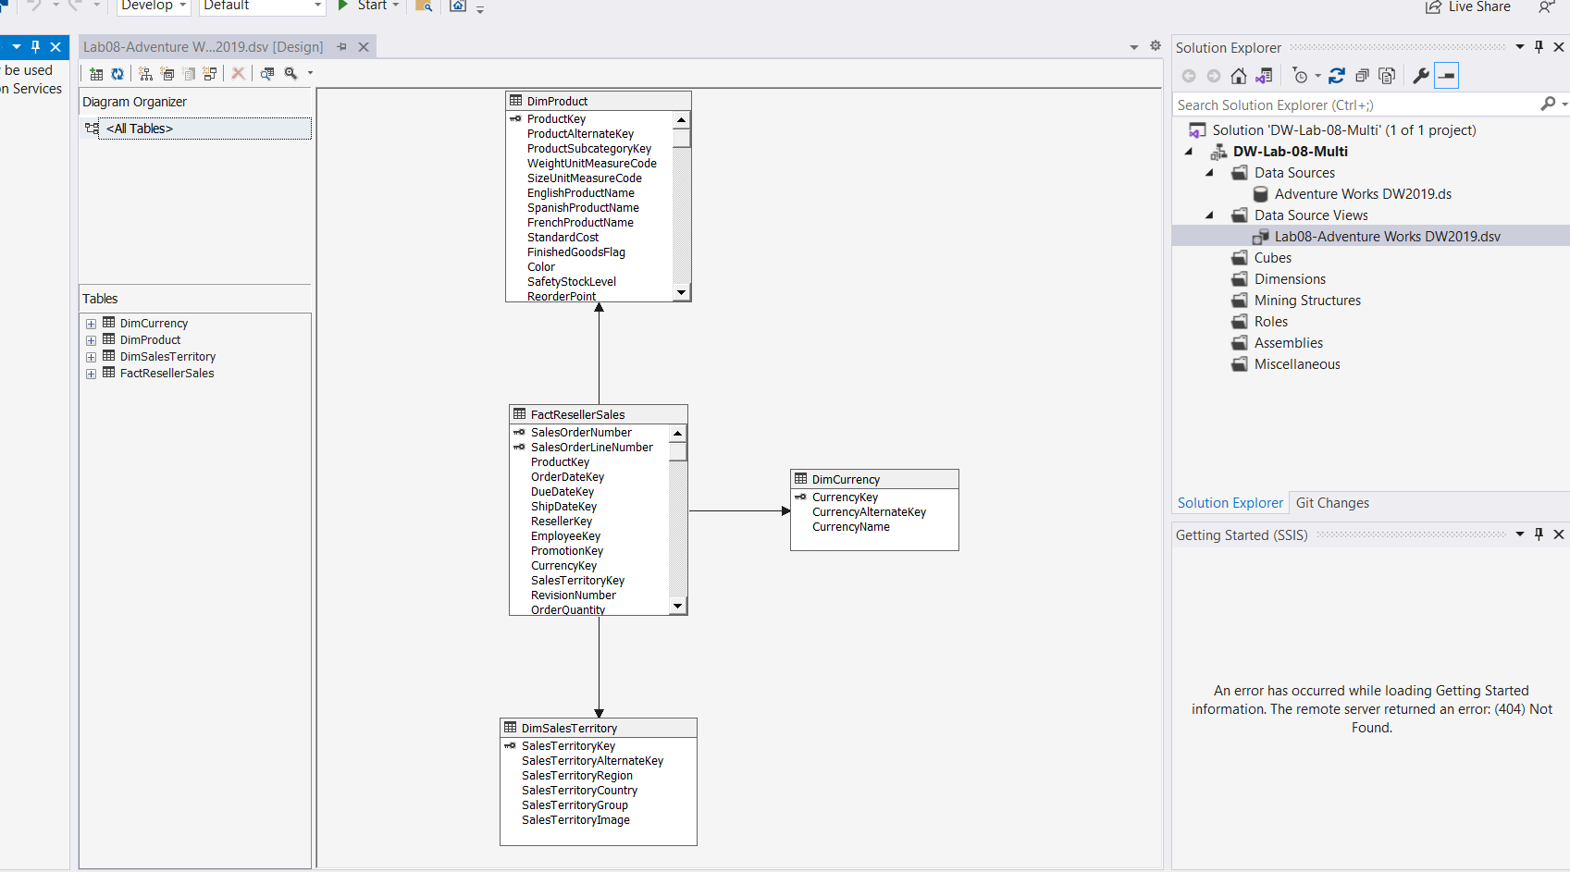

We successfully created a cube and dimensions as you can see below

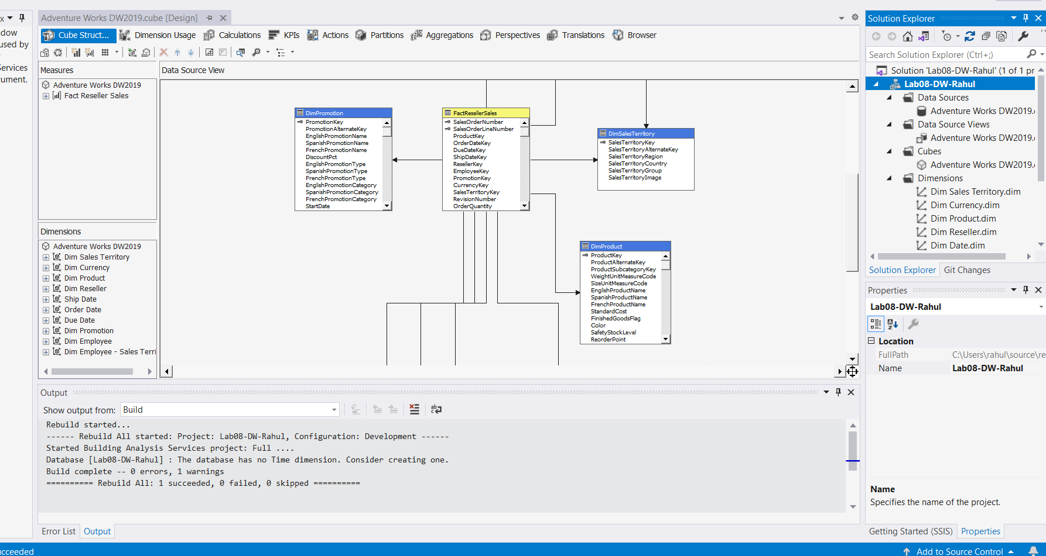

Deployment successfully our project

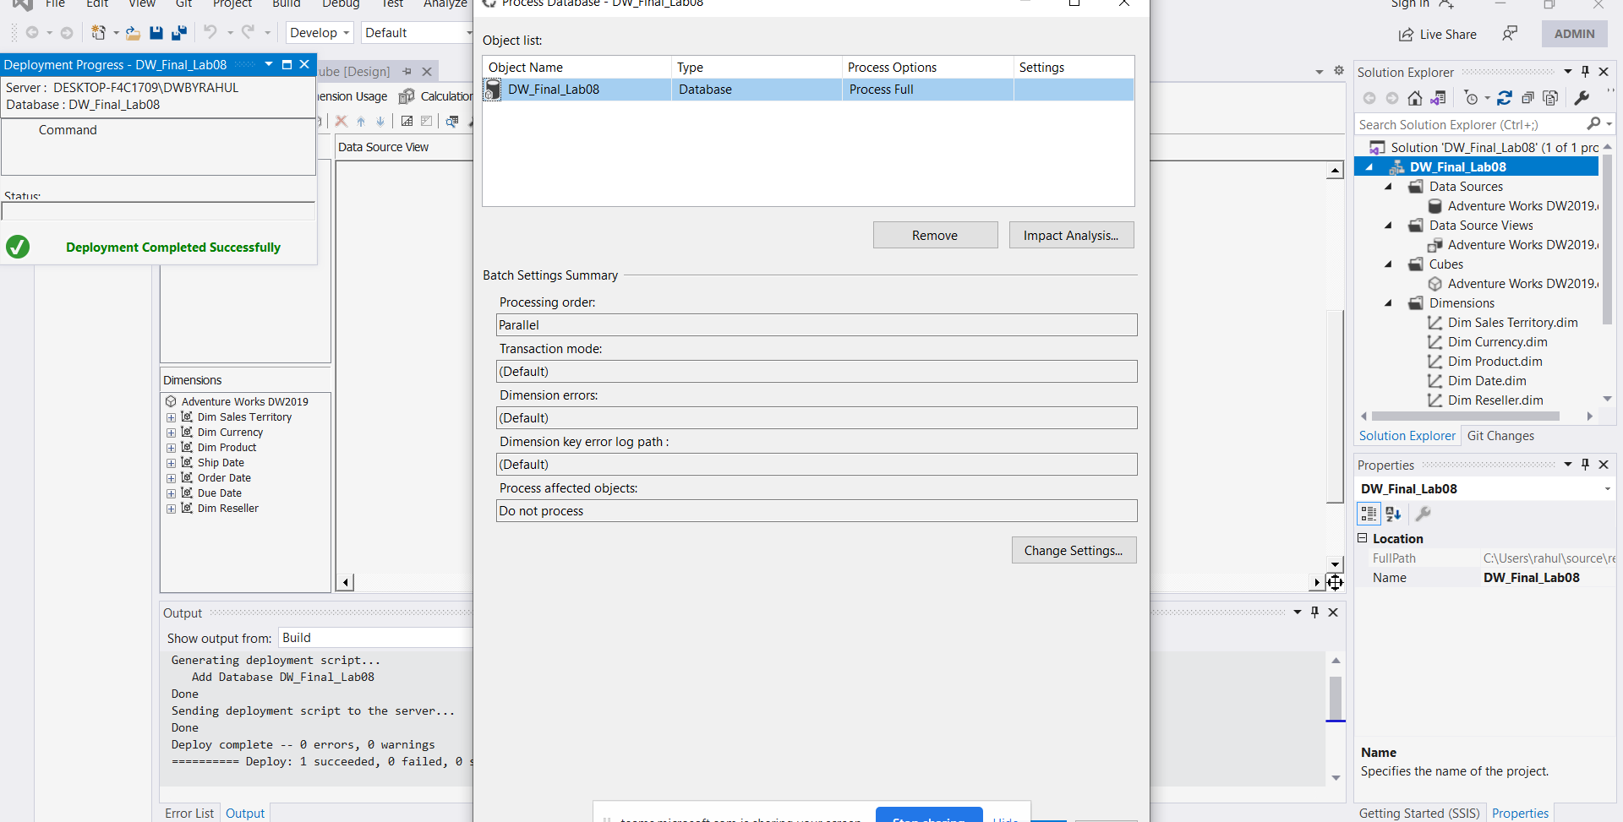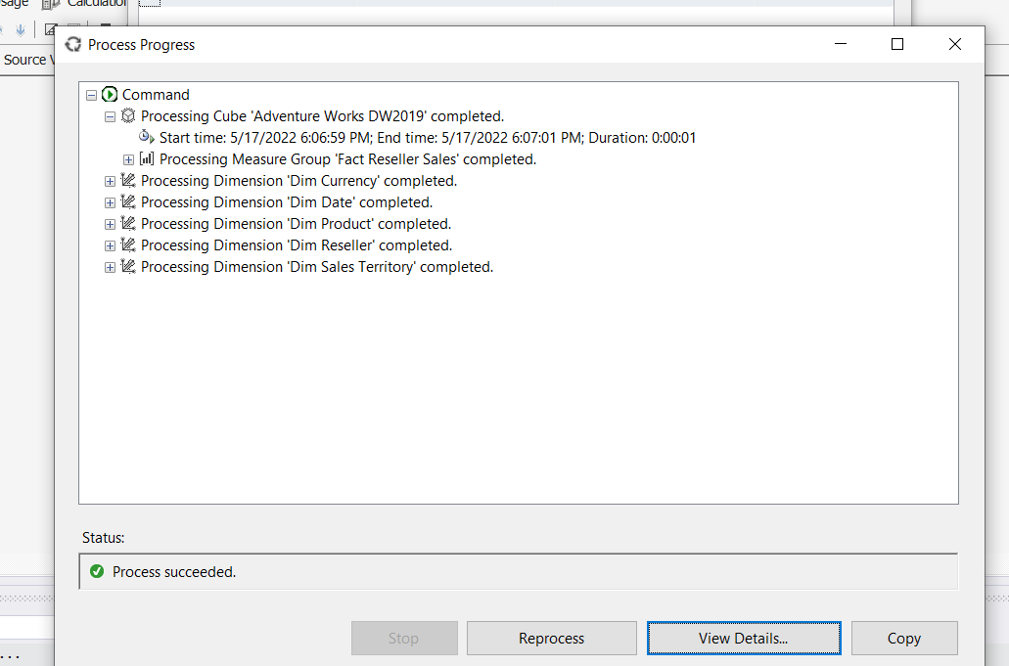

* 1. Propose exemplary data analyzes (examples of report analyzes in graphic form using Excel or Tableau) and conclusions resulting from the data analysis.

**Solution:**

**Following Analysis of Currency types v/s Sales amount in Excel**

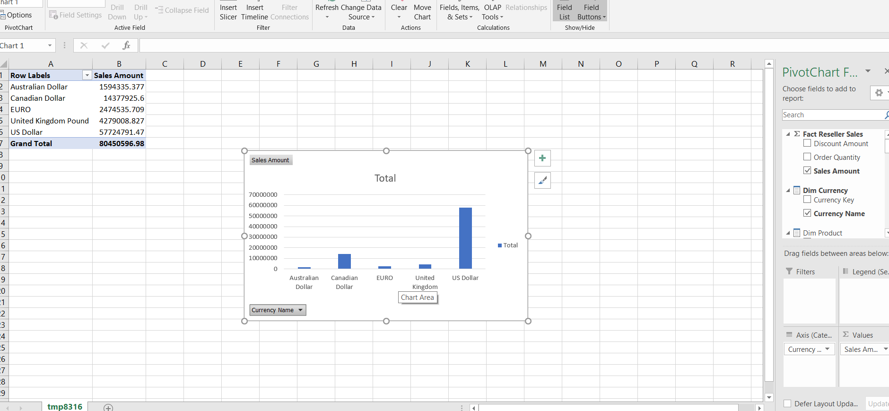

**Following Analysis is Sales as per country over the years as per sales territory group in Tableau**

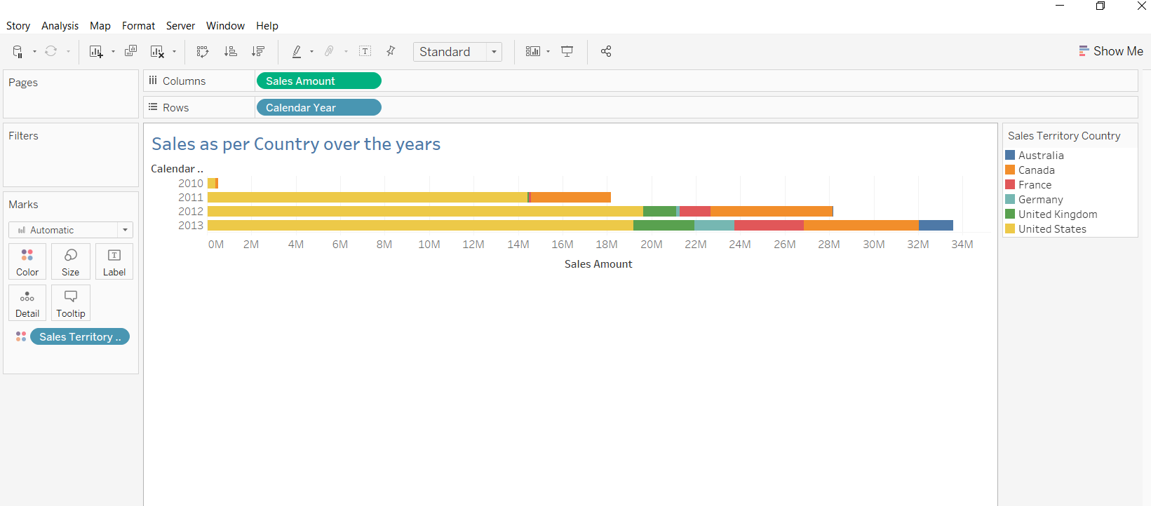

**Order Quantity V/S English Product name, to find which product sales the most**

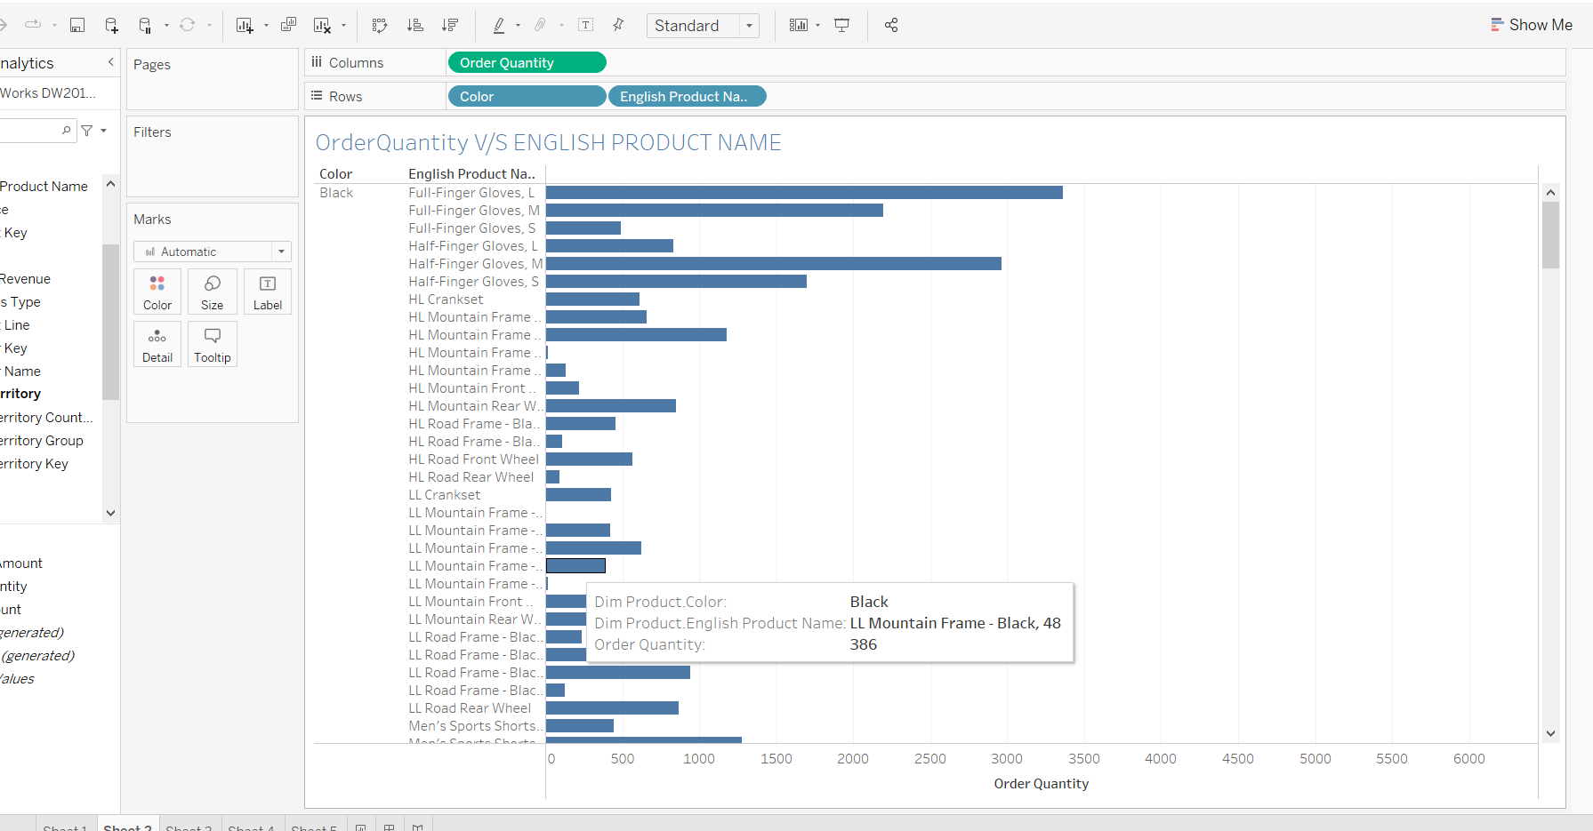

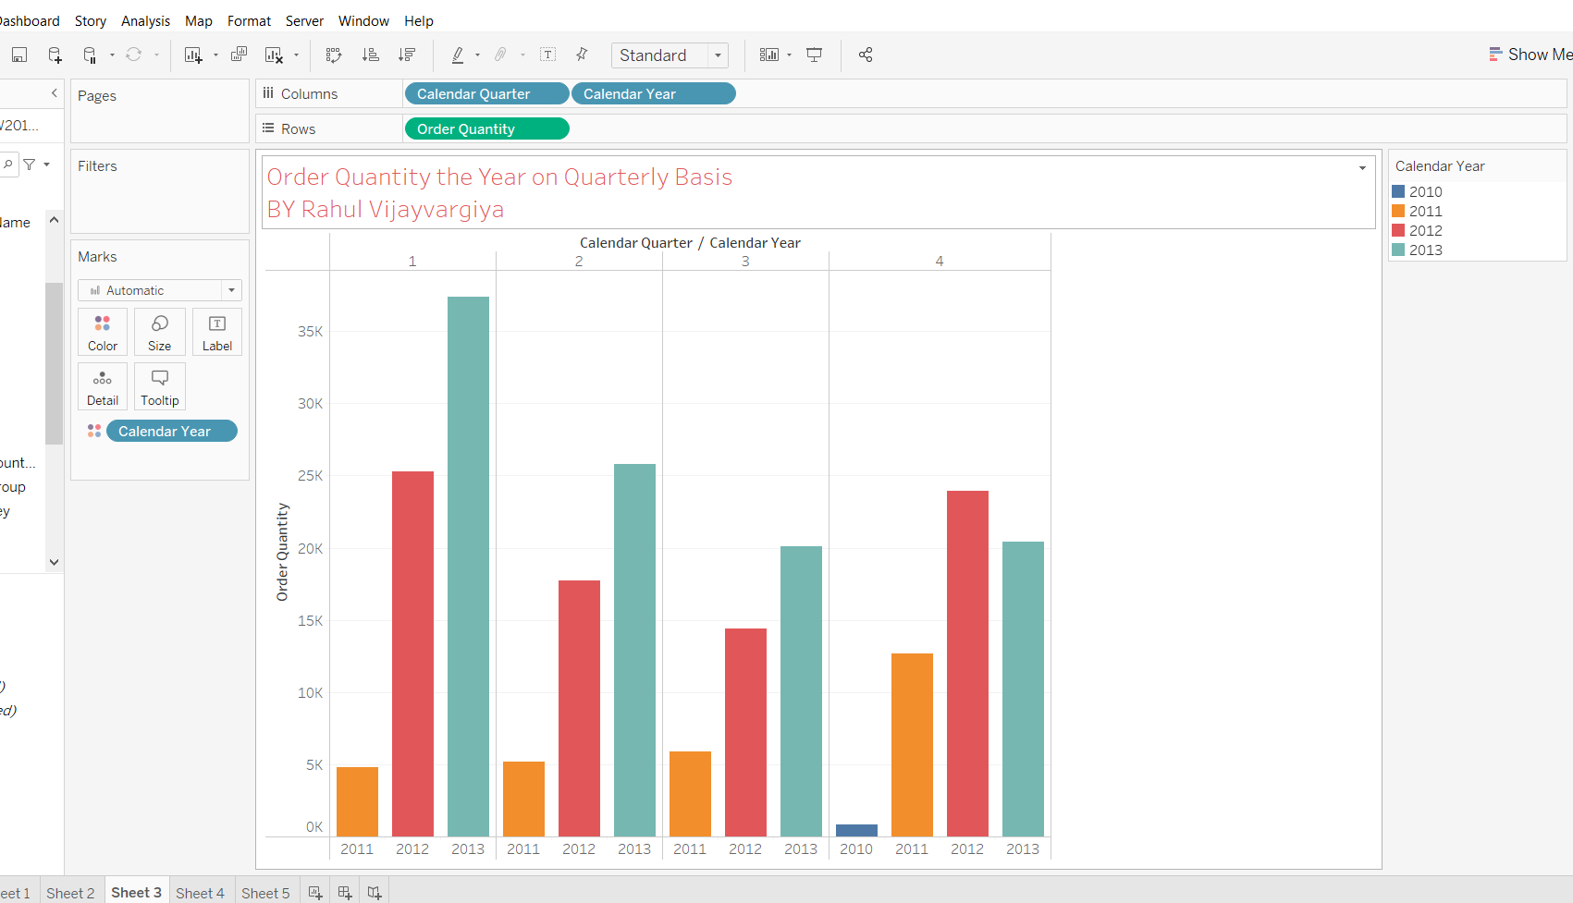

**Comparisons of order quantity and sales amount over the years and quarterly analysis**

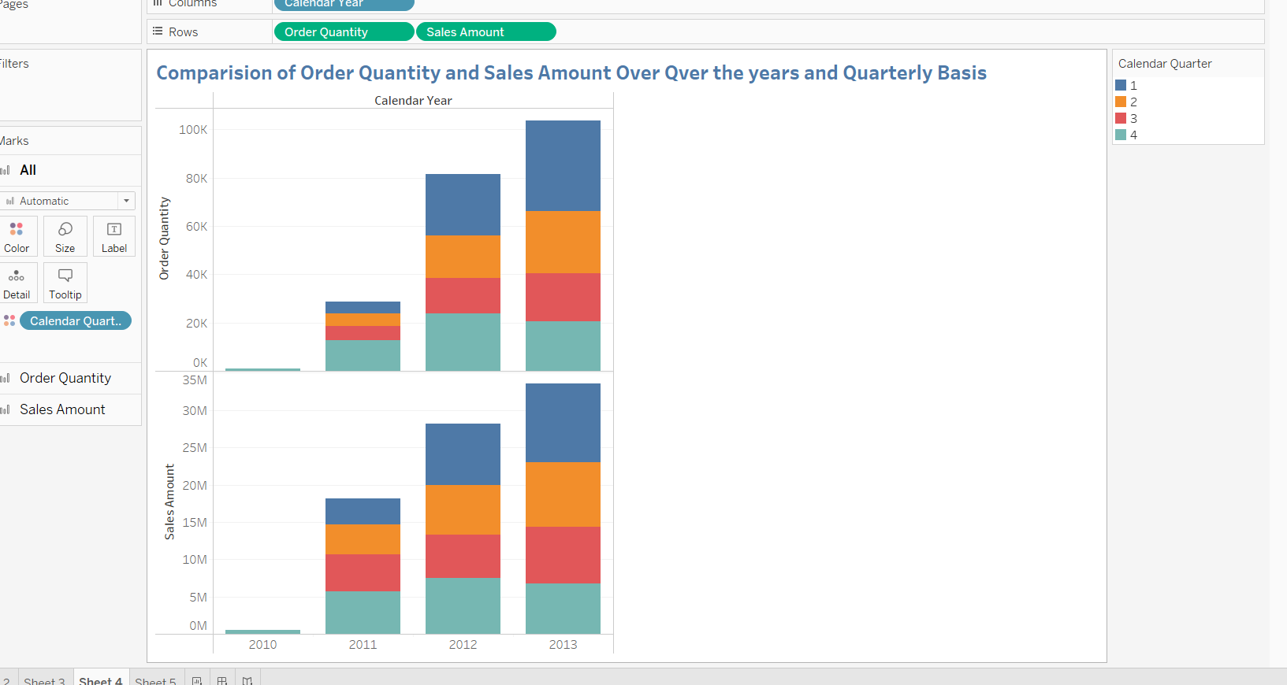

**Following tableau sheet contain annual revenue and reseller name**

**According to country**

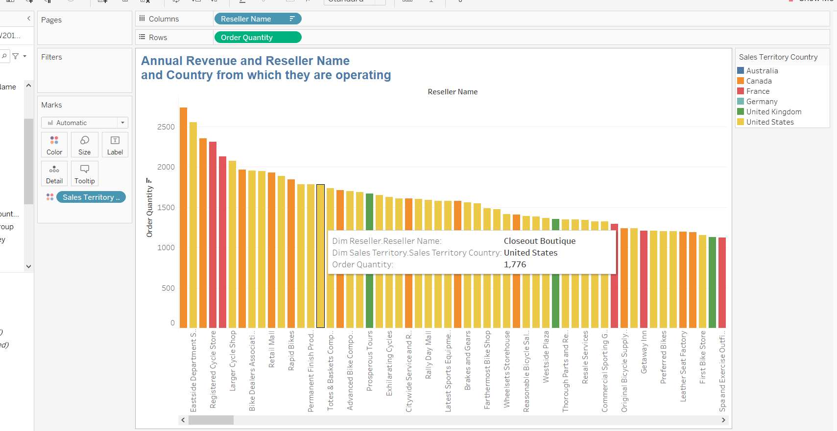

**Following sheet contain all the measures as per year and quarter**

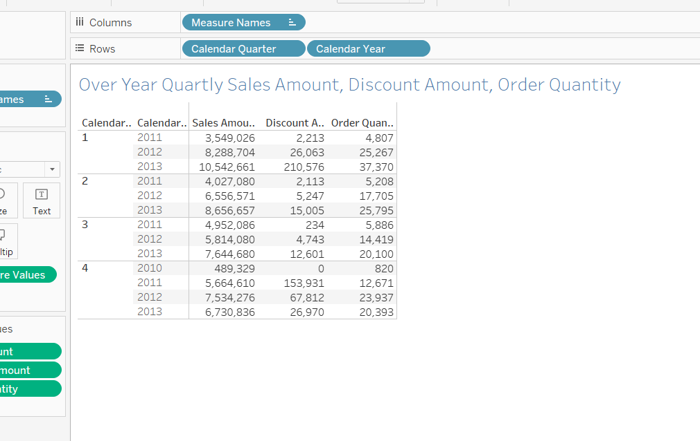

**An Interactive Dashboard, using filter to change the view**

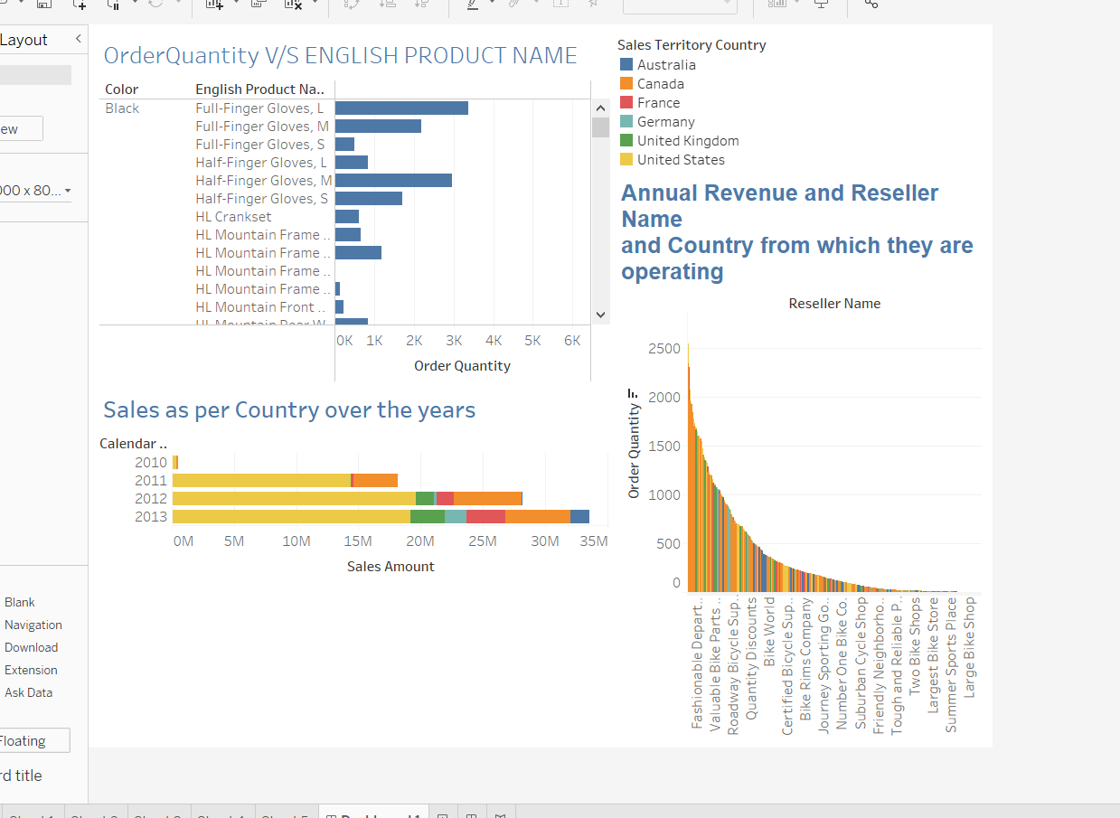

* 1. Propose a strategy for selling goods, taking into account the profitability of sales and the effectiveness of promotional and advertising activities

**Solution:**

• what I have observed we should focus on building more analytical database, it’s easy to analyze data, we can get in depth idea about data .

• From observation made on currency we found the US Doller has the most sales orders and it’s popular currency

• From observation made on currency we found over the years product sales has increased

• From observation made we found most reseller are from USA

• From observation made eastside department has the most annual revenu

• We should focus more on Europe as over Australia because of the fact that Europe is better market than Australia as uk,France and Germany comes together which makes sales amount significantly higher than Australia.

• Also we should consider the fact that black colored products are more popular on compared to silver/black and white we can increase promotion on white colored product to boost the sales

**General Conclusions**:

*Use this section to provide your general conclusions:*

*I have found the my SSMS in Analysis Service it was default set to Tabular mode, I had to change it to multidimensional*

*To deploy the cube had face a lot problem but it made life easy, I can get my hands-on data easily,*

*data cubes and dimension so that we can analyze in excel or tableau i used tableau and excel both,*

*I created an interactive dashboard with filters, when we click on something it changes the view for whole dashboard,*

Remarks

* A report without final conclusions will not be checked and results in a negative score!
* The report file should be named **Lab08DW-StudentID-Last name-2022**, please use the PDF format.
* You should use MS SQL SERVER 2019 (or 2017), Visual Studio, Excel, and Tableau Desktop (available at <https://www.tableau.com/academic/students>)