

WAME SETOMBEKO
20001099
LAB 5

AUTOMATION SUITE SOURCE CODE
Page object(login page and inventory page.js)
5 data driven UI tests(saucedemo.spec.js)
Test data(test-data.json)
Playwright config(playwright.config.js)
The documents are uploaded on the github repo

BEFORE REPORT
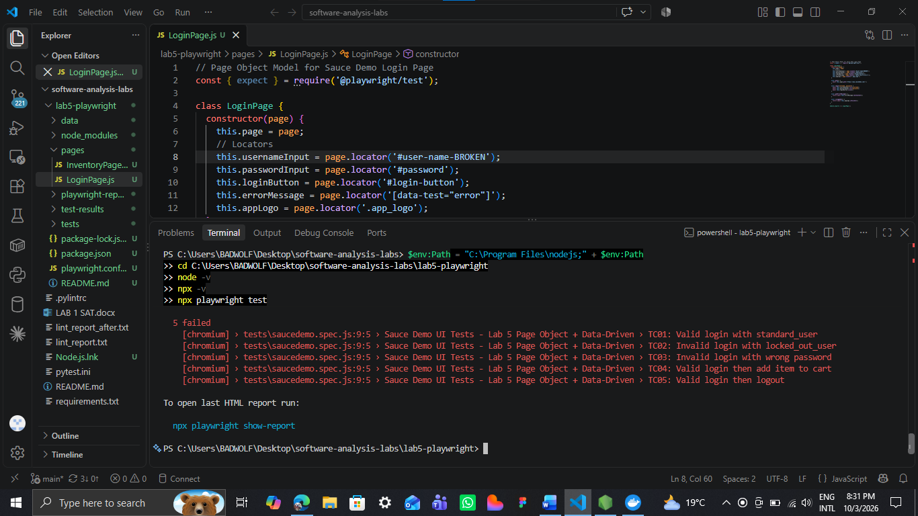

AFTER CHANGE
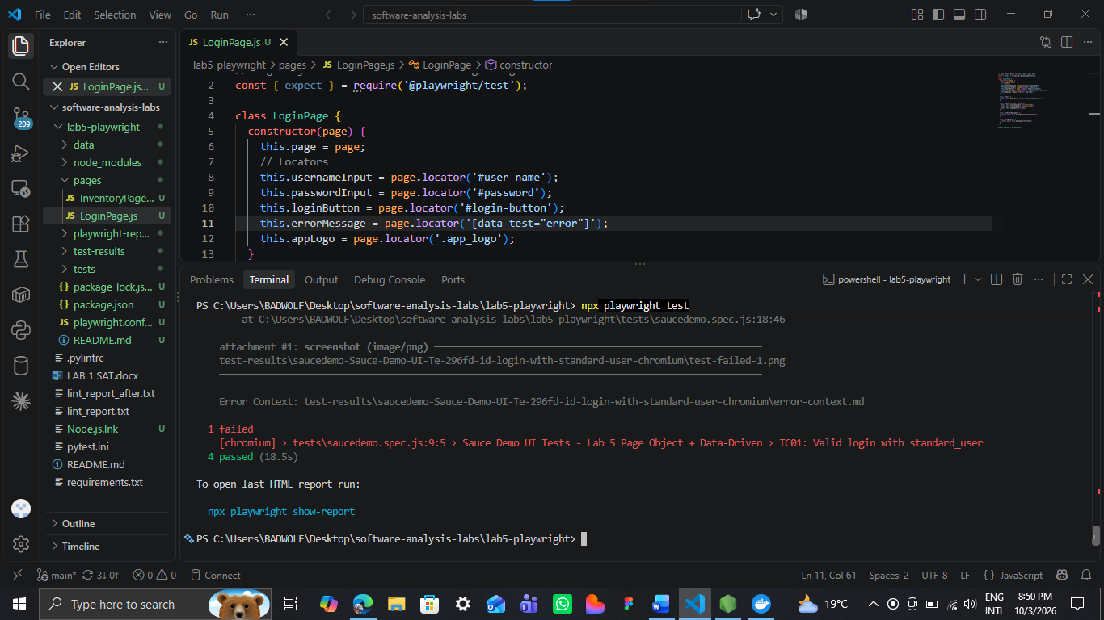
Only 4 tests passed

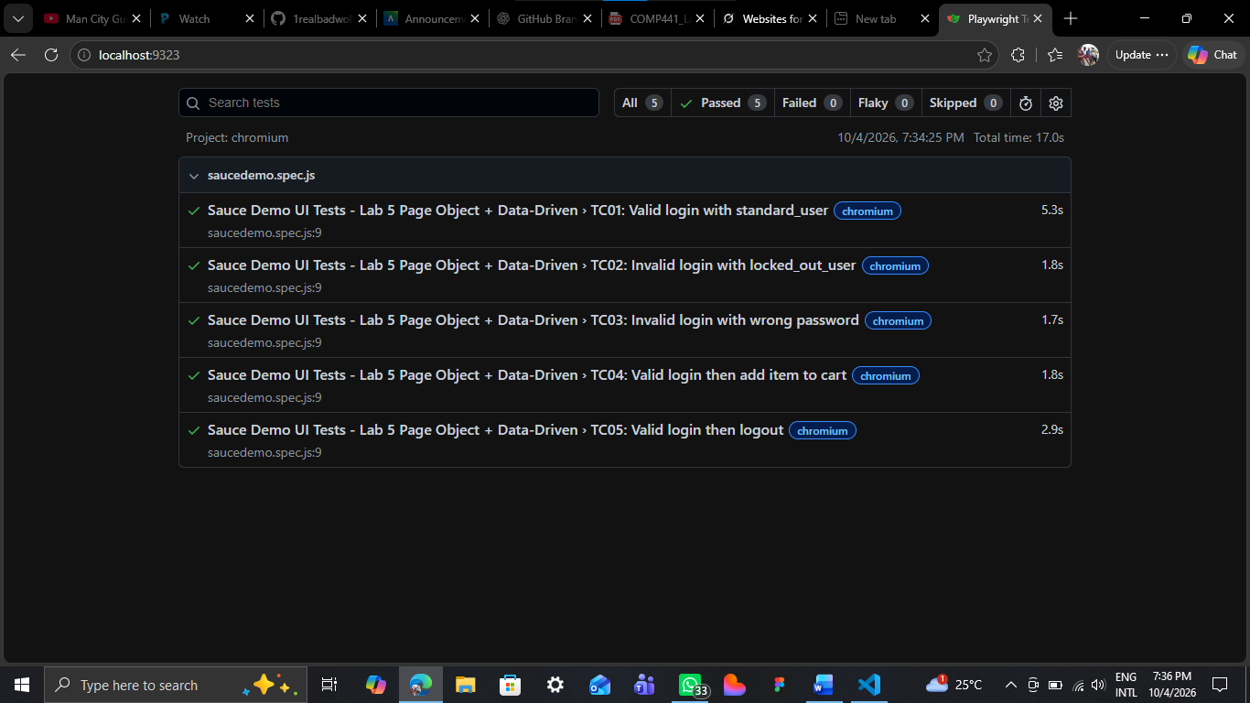
Npx report showing all the passed test and what was tested
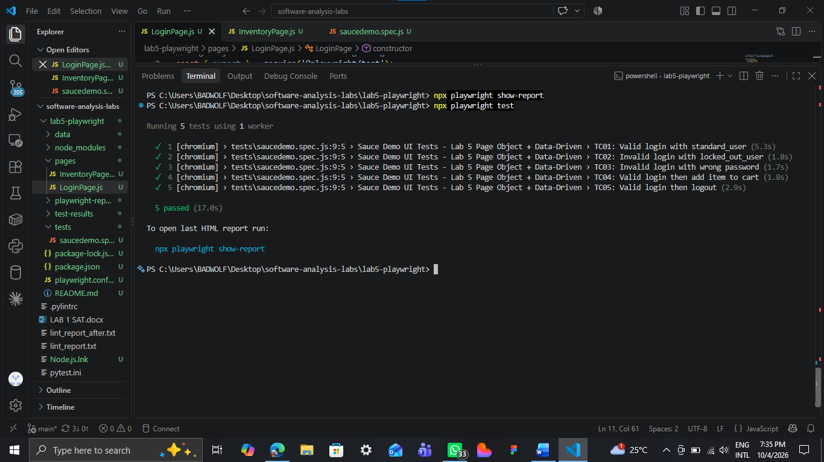
After changes all 5 tests passed

