R-Tist
Robotics Club NIT Jalandhar
Numbery Route
Description :-
In Numbery route the team of participants has to Build a autonomous line follower robot which should also be able to count the no. of boxes placed parallel along the route and also to count the number of boxes of same height.
Boxes of three different Heights will be placed Randomly along the route ,the bot has to count the no. of boxes of each type while following the line .
The bot should be autonomous i.e. it should it controlled via wired or wireless medium .
All this data along with the time of journey should be displayed on the LCD screen embedded into the bot.
Numbery Route will contain only one round .
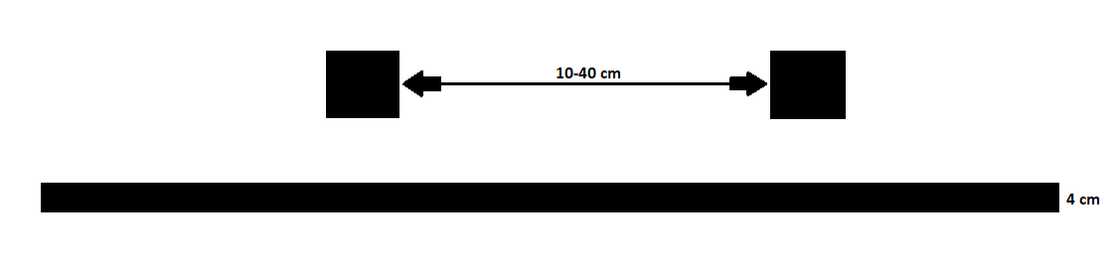
General Rules :-
- Bot will be given only three chances to be replaced if it misses the track
- It should display the number of blocks of each height .
- It should the display the travel time .
- Bot would have to follow a black line on a white Background
Specification’s:-
- Bot Specification : 30cm x 25 cm (maximum)
- Track Specifications : 3m x 4cm
- Width of black line to be followed : 4 cm
- Distance between boxes : 10 cm – 40 cm
- Height of Boxes :
  - 30 cm
  - 25 cm
  - 10 cm

Judgement Criteria :-
- Bot must follow the line.
- The number of blocks of each type must be counted.
- Priority will be given to the bot who will count the details correctly time correctly.
- If the bots in competition completes all above criteria then time of completion will be taken in consideration.
- In Situations of any Dispute/Tie the final decision of the organizers will be valid .

