Name: Rasha Mansour

ID:1210773

**3.6 Post Lab**

1. Implement 8x1 Multiplexer using lower order Multiplexers Show how to solve it.

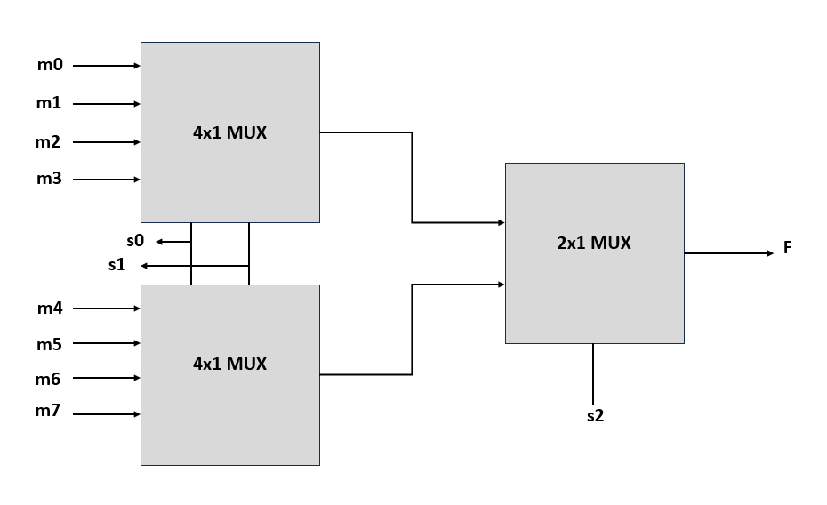

1. Design a Majority Circuit; a circuit that takes 4 inputs A, B, C, D and 1 output Y. Its output equals 1 when 3 or 4 of the inputs are 1. You can only use two 4×1 multiplexers.

