Name: Rasha Mansour

ID:1210773

**2.3 Pre Lab**

1) Prepare all sections and work out all the required designs.

2) Build half adder using basic gates.

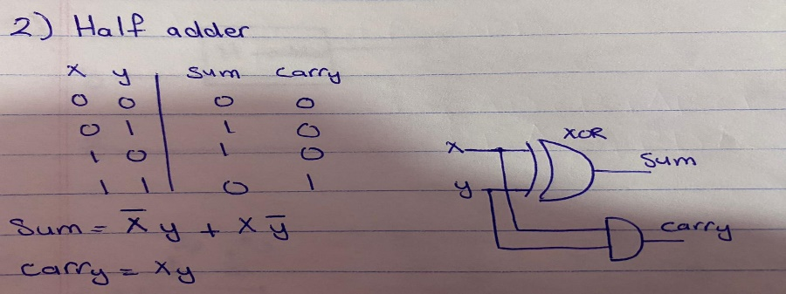

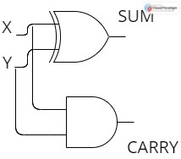

3) Build the above circuit using universal gates.

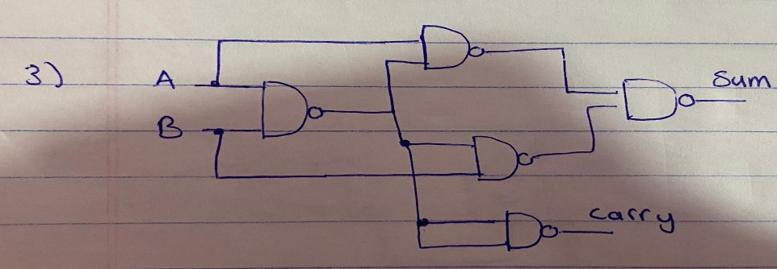

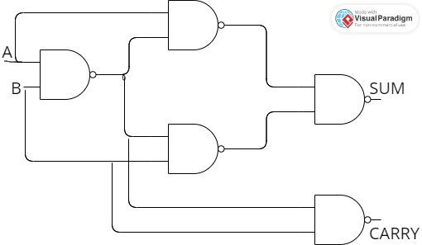

4) Build a full adder using basic gates.

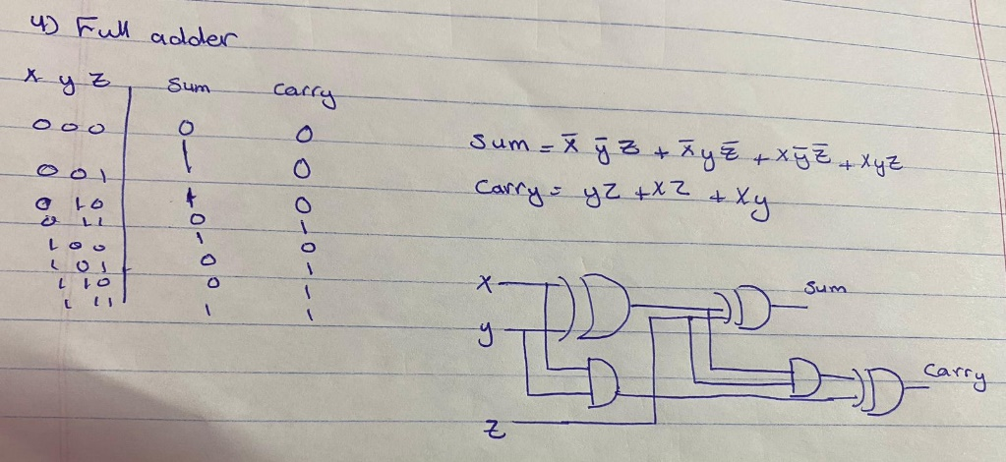

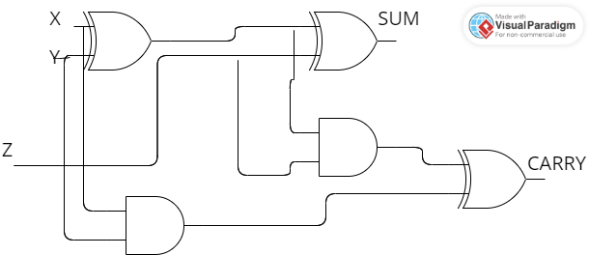

5) Build a full adder using half adder and another gate.

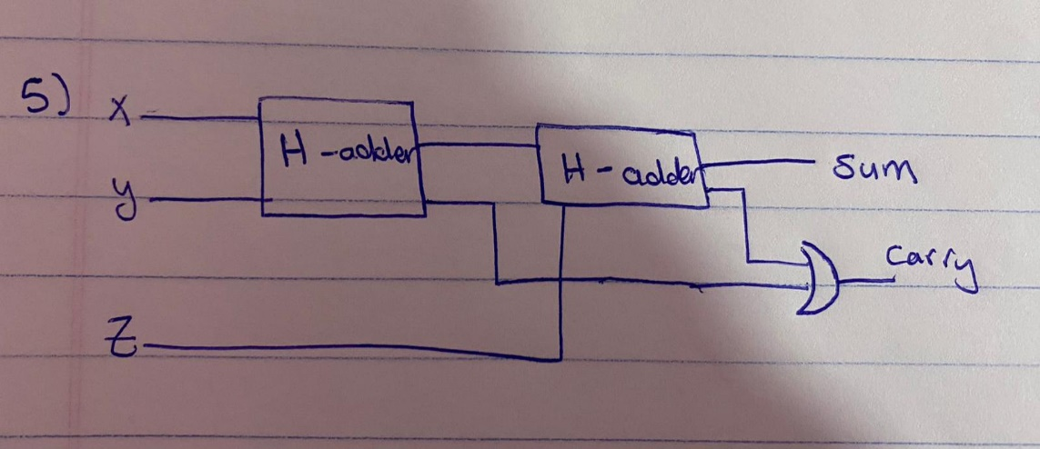

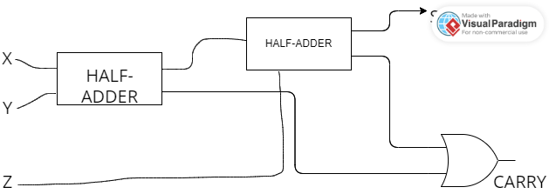

6) Build a 4-bit adder using a full adder.

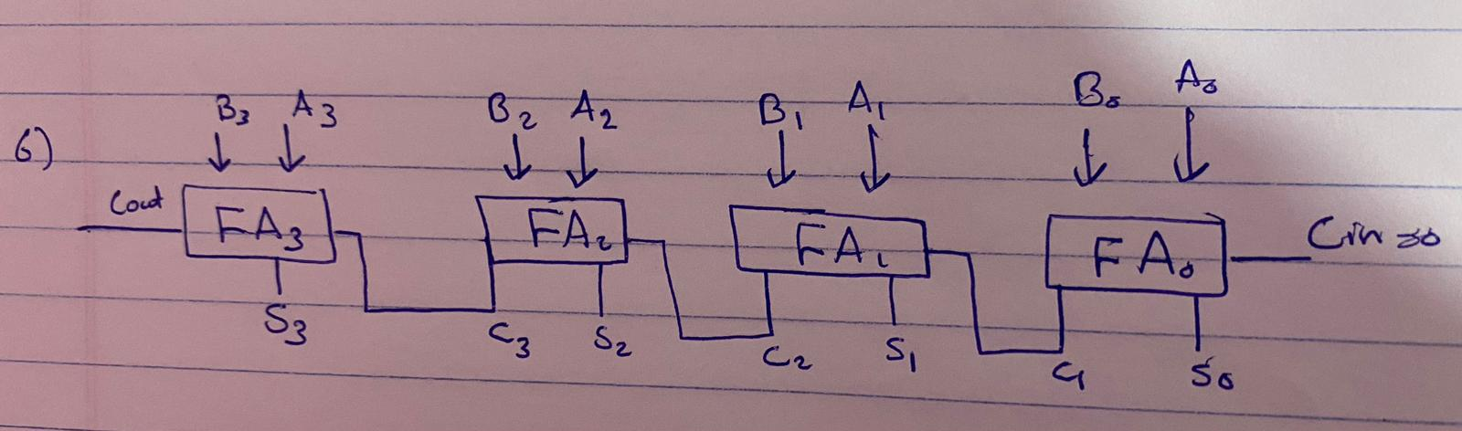

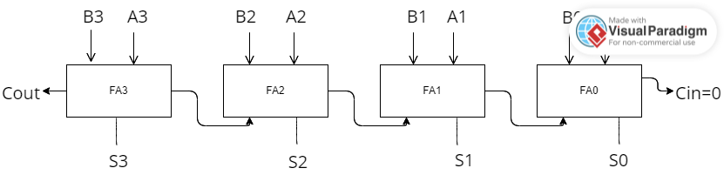

7) Build a 4-bit subtractor using basic gates.

