Name: Rasha Mansour

ID:1210773

**3.3 Pre Lab**

1) Design a circuit which uses an SN74151 to implement a sum-of-products expression, as

follows:

a) Convert the following expression into summation form (i.e., F (A, B, C) =∑ (…)):

𝑌 = 𝑓(𝐴,𝐵, 𝐶) = 𝐴𝐵 + 𝐵𝐶

F(A,B,C) = AB'(C+C') + (A+A')B'C

= AB'C + AB'C'+ AB'C+ A'B'C

= ∑(1,4,5)

|  |  |  |  |
| --- | --- | --- | --- |
| A | B | C | F |
| 0 | 0 | 0 | 0 |
| 0 | 0 | 1 | 1 |
| 0 | 1 | 0 | 0 |
| 0 | 1 | 1 | 0 |
| 1 | 0 | 0 | 1 |
| 1 | 0 | 1 | 1 |
| 1 | 1 | 0 | 0 |
| 1 | 1 | 1 | 0 |

b) Sketch on Figure 3.1 the input connections necessary to implement the function in part (a).

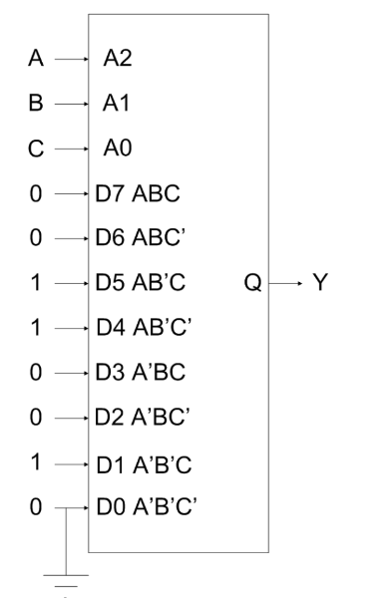

2) Design a circuit which uses an SN74138 Demultiplexer to implement a sum- of-products

expression, as follows:

a) Convert the following expression into summation (Sum of Products –SOP-) form (i.e.

F(A,B,C)=∑(…)):

𝑌 = 𝑓(𝐴,𝐵, 𝐶) = 𝐴̅𝐵𝐶 + 𝐵𝐶`

Y = A'BC +BC'

Y = A'BC +BC' = A'BC + (A+A') BC'

Y = A'BC + ABC' + A'BC'

Y = ∑ (2, 3, 6)

