Name: Rasha Mansour

ID:1210773

**4.3 Pre Lab**

3)Design and implement the following circuit using the gates on the chips as shown in Figure 4.1(.

Your final circuit must include the IC’s, their pin numbers, and the connections between the

pins.).

a) Build Full Adder using basic gates.

**full adder:**

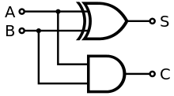

**F2**

**F1**

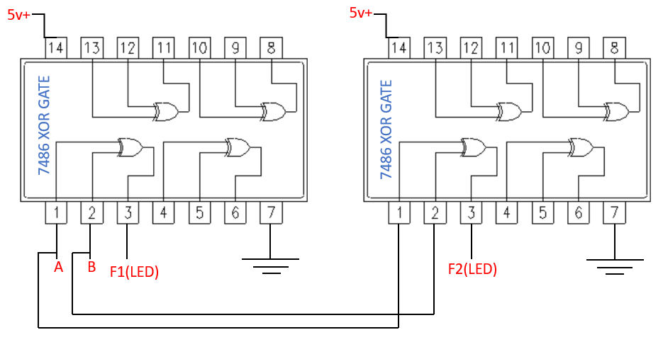

b) Build the bellow circuit using universal gates.

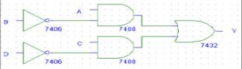

**The universal gates:**

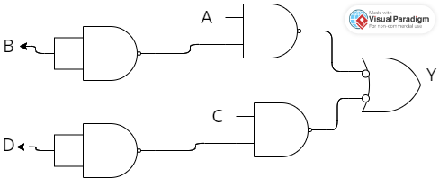

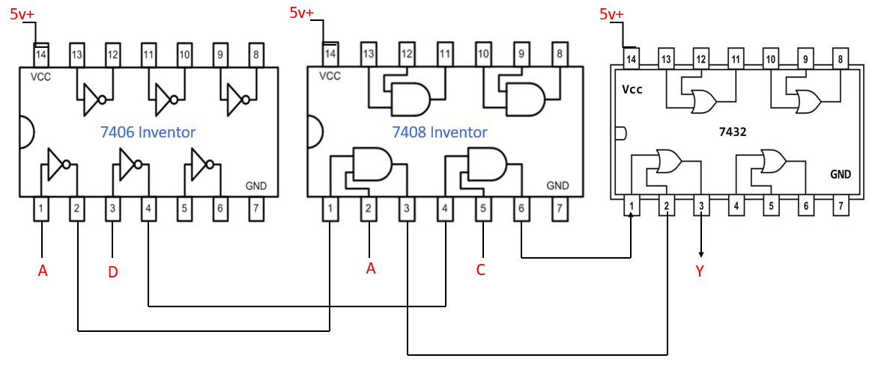

c) Build a 3x8 Decoder (active low) using basic gates.

|  |  |  |  |  |  |
| --- | --- | --- | --- | --- | --- |
|  | **00** | **01** | **11** | **10** |  |
| **0** | 0 | 1 | 1 | 0 |  |
| **1** | 0 | 1 | 0 | 1 |  |

**F=(Y+Z).(X+Z).(X`+Y`+Z`)**

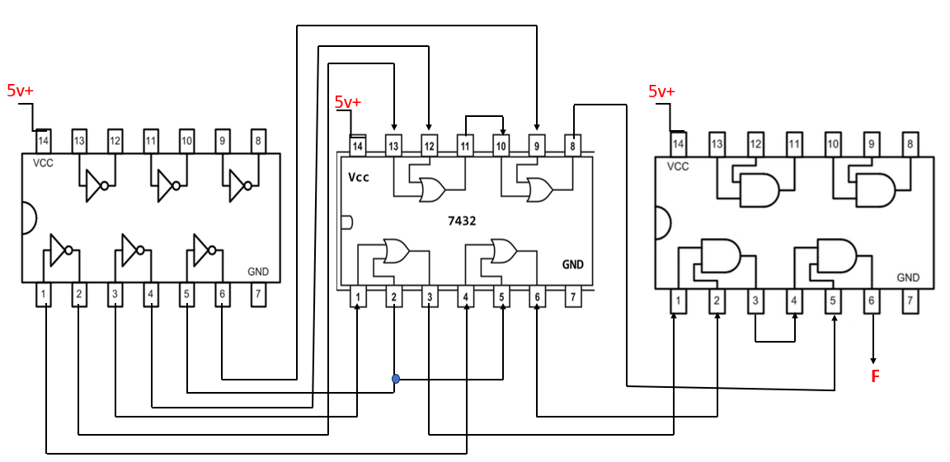

d) Build an 8x1 Multiplexer using basic gates.

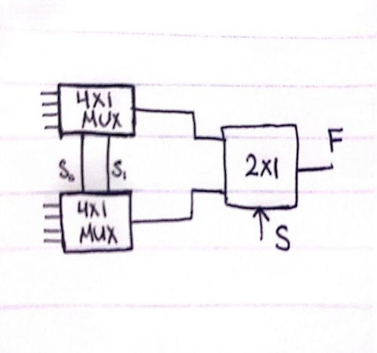 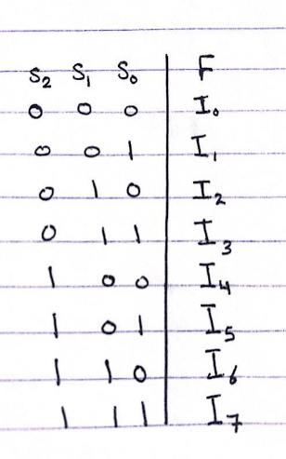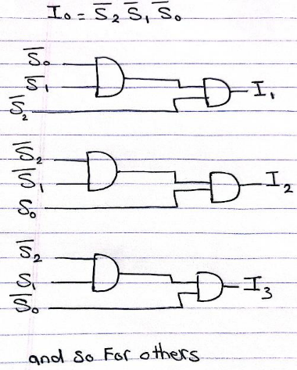

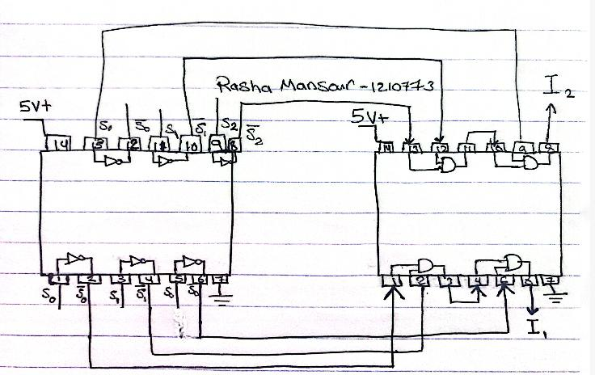

e) Use the just constructed 4x1 multiplexer to design a three inputs network that gives

1 if the majority of its inputs are 1 and outputs a zero otherwise.

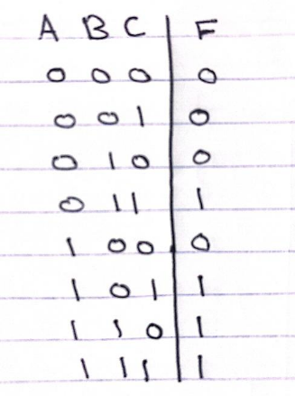 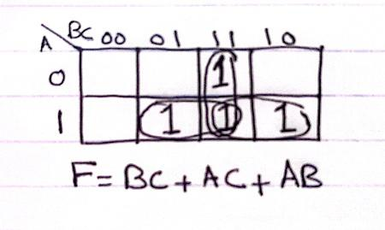 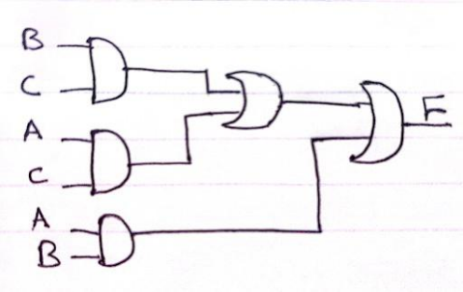

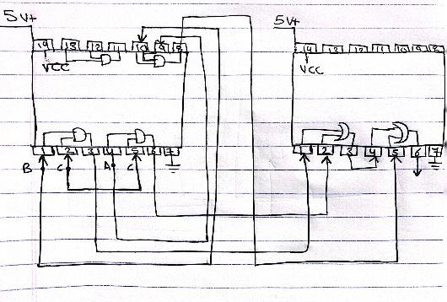

f) Use the 2x4 decoder to implement a 2 inputs function that acts like an equivalence

gate (XNOR): gives 1 on the output if both inputs are equal.

