Management Snapshot
Source: test6.pdf

Role-Specific Summary
Design of steel structures shall be done as per IRS Steel Bridge Code . Steel tubes shall be used for structural purpose . The detailed design of the viaduct will be carried out using various levels of temperature, pressure, pressure and other factors . The entire design process must be completed using a standard computer or standard software . The model was approved by the Delhi Transport Authority for the New Delhi Metro Railways .
The loading envelope chosen shall be as per the Rolling Stock planned to be used on the Metro system . For seismic forces, only 50% of gross tractive effort/braking force will be considered in transverse/longitudinal seismic condition . The value of braking and traction forces will be taken as per rolling stock used, to be decided by Metro . For more than 2 tracks, Clause 2.4 of IRS Bridge Rules shall be considered .

Figures & Diagrams

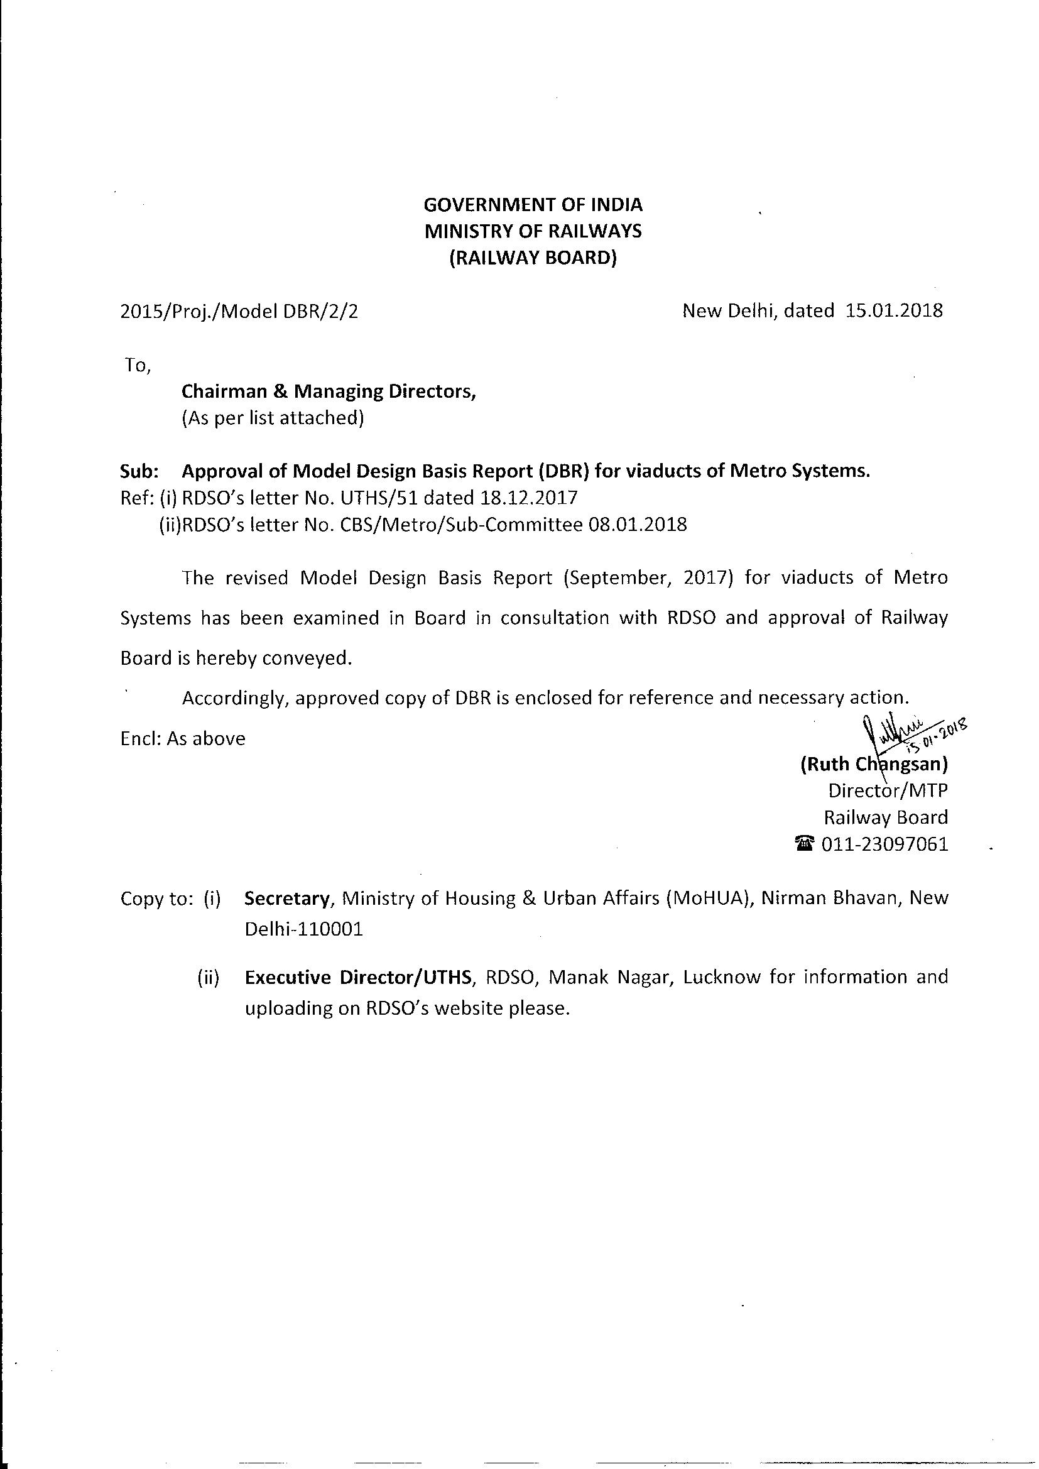
GOVERNMENT OF INDIA
MINISTRY OF RAILWAYS
(RAILWAY BOARD)
2015/Proj./Model DBR/2/2 New Delhi, dated 15.01.2018
To,
Chairman & Managing Directors,
(As per list attached)
Sub: Approval of Model Design Basis Report (DBR) for viaducts of Metro Systems.
Ref: (i) RDSO’s letter No. UTHS/51 dated 18.12.2017
(iiJRDSO’s letter No. CBS/Metro/Sub-Committee 08.01.2018
The revised Model Design Basis Report (September, 2017) for viaducts of Metro
Systems has been examined in Board in consultation with RDSO and approval of Railway
Board is hereby conveyed.
Accordingly, approved copy of DBR is enclosed for reference and necessary action.
Encl: As above ie cant
(Ruth Chiangsan)
Director/MTP
Railway Board
@ 011-23097061
Copy to: (i) Secretary, Ministry of Housing & Urban Affairs (MoHUA), Nirman Bhavan, New
Delhi-110001
(ii) Executive Director/UTHS, RDSO, Manak Nagar, Lucknow for information and
uploading on RDSO’s website please.

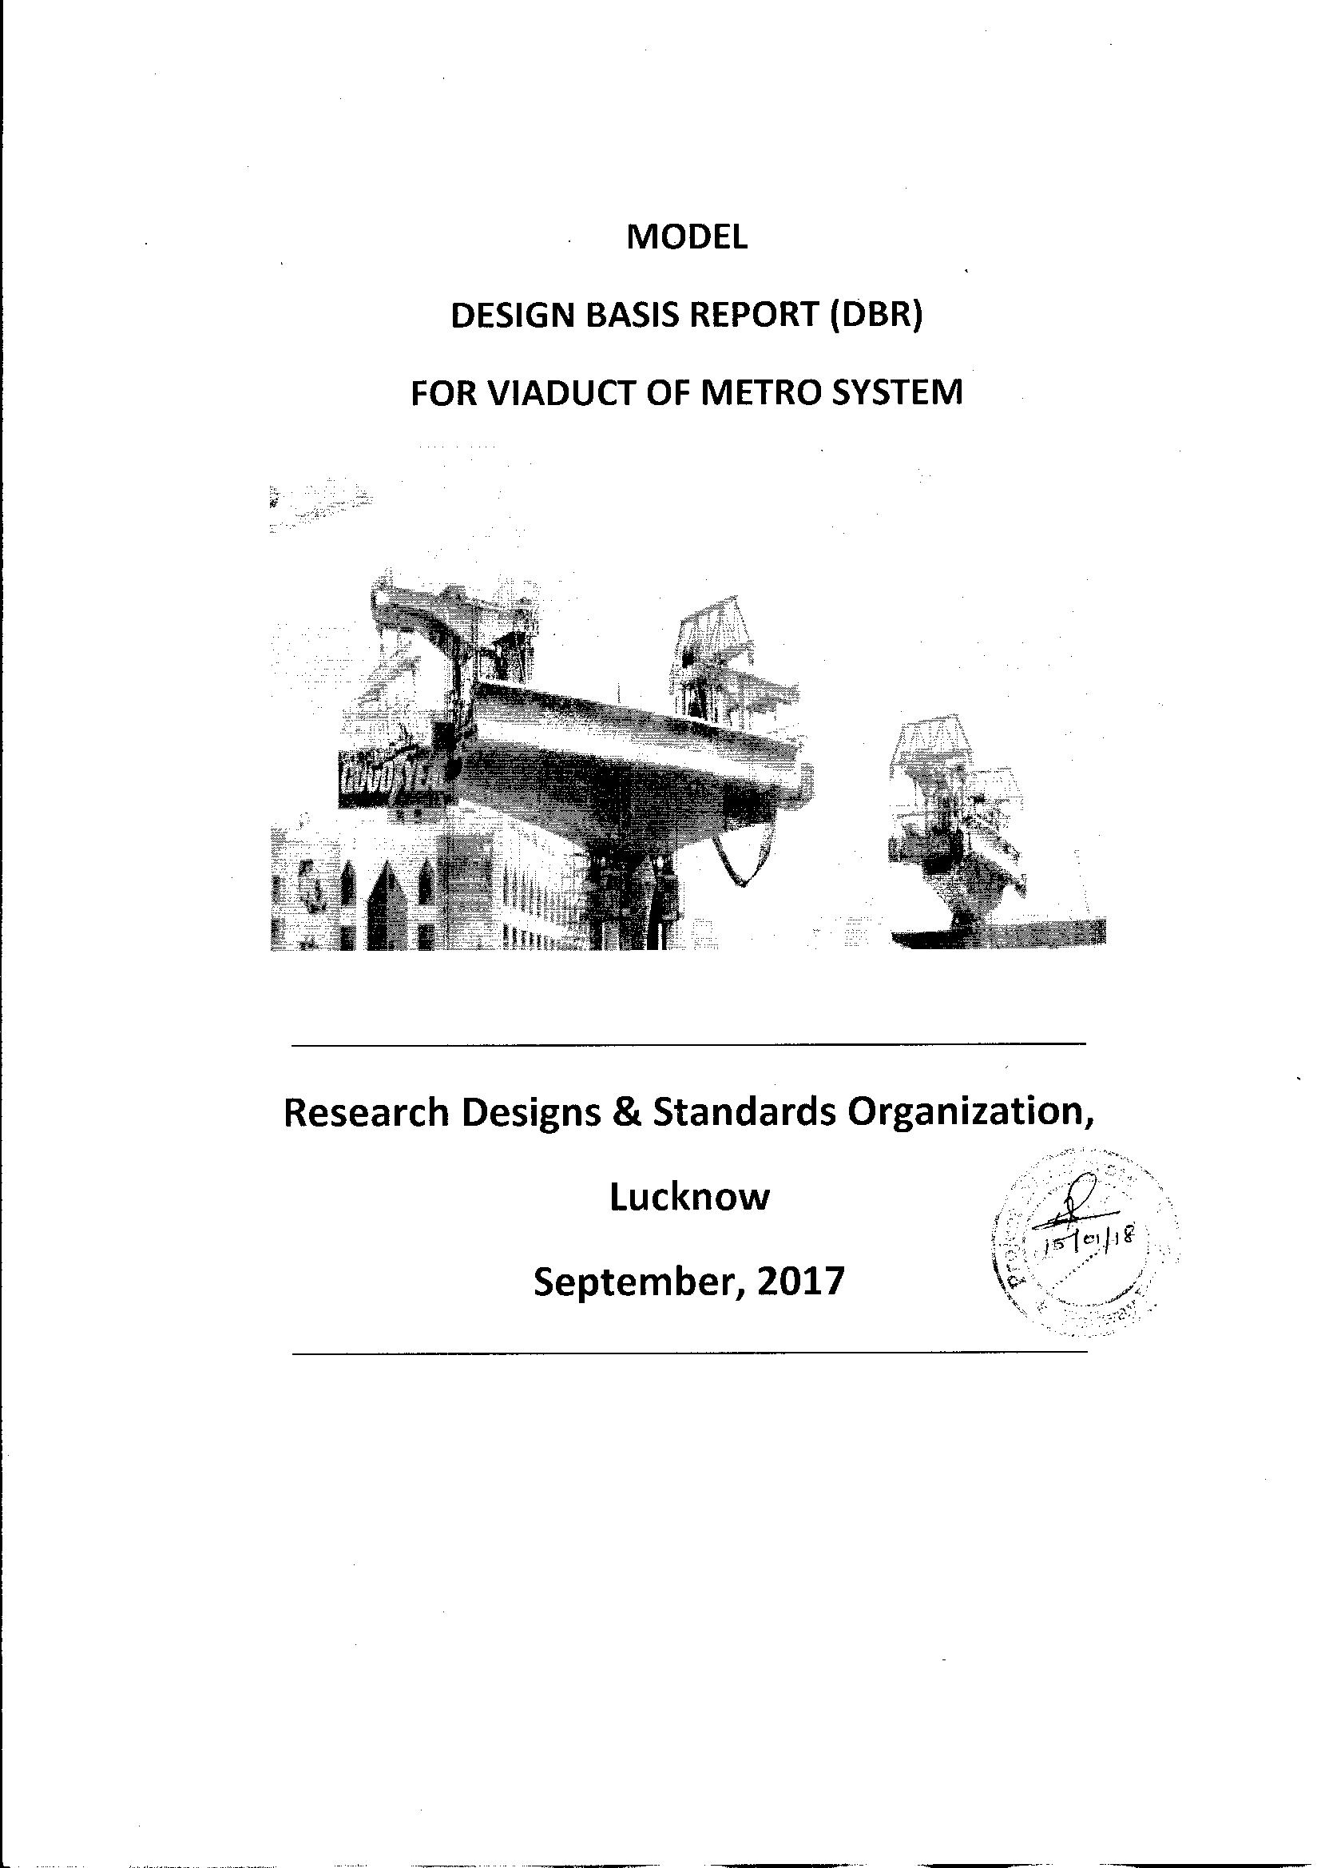
MODEL
DESIGN BASIS REPORT (DBR)
FOR VIADUCT OF METRO SYSTEM
Research Designs & Standards Organization,
Lucknow a
September, 2017

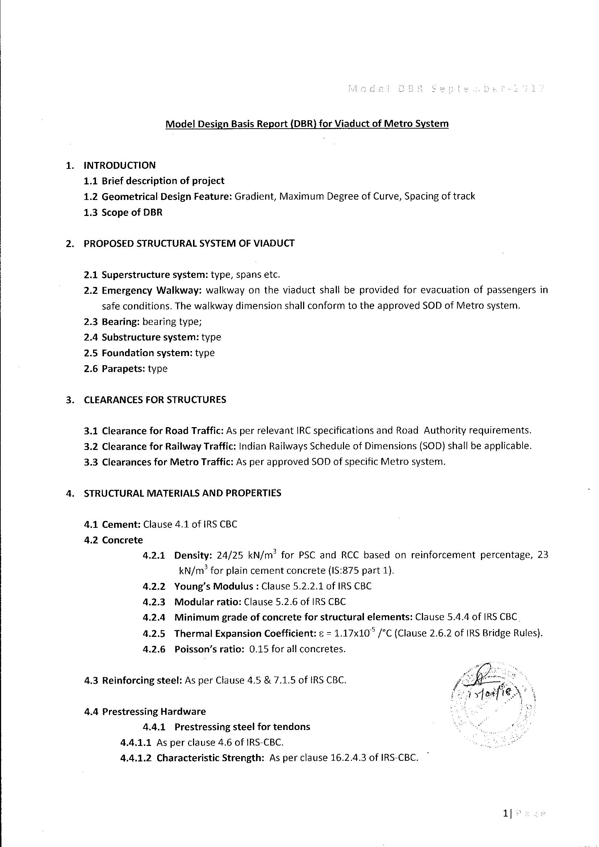
1.
Model Design Basis Report (DBR) for Viaduct of Metro System
INTRODUCTION
1.1 Brief description of project
1.2 Geometrical Design Feature: Gradient, Maximum Degree of Curve, Spacing of track
1.3 Scope of DBR
PROPOSED STRUCTURAL SYSTEM OF VIADUCT
2.1 Superstructure system: type, spans etc.
2.2 Emergency Walkway: walkway on the viaduct shall be provided for evacuation of passengers in
safe conditions. The walkway dimension shall conform to the approved SOD of Metro system.
2.3 Bearing: bearing type;
2.4 Substructure system: type
2.5 Foundation system: type
2.6 Parapets: type
CLEARANCES FOR STRUCTURES
3.1 Clearance for Road Traffic: As per relevant IRC specifications and Road Authority requirements.
3.2 Clearance for Railway Traffic: Indian Railways Schedule of Dimensions (SOD) shall be applicable.
3.3 Clearances for Metro Traffic: As per approved SOD of specific Metro system.
STRUCTURAL MATERIALS AND PROPERTIES
4.1 Cement: Clause 4.1 of IRS CBC
4.2 Concrete
4.2.1 Density: 24/25 kN/m? for PSC and RCC based on reinforcement percentage, 23
kN/m? for plain cement concrete (IS:875 part 1).
4.2.2 Young’s Modulus : Clause 5.2.2.1 of IRS CBC
4.2.3 Modular ratio: Clause 5.2.6 of IRS CBC
4.2.4 Minimum grade of concrete for structural elements: Clause 5.4.4 of [RS CBC_
4.2.5 Thermal Expansion Coefficient: ¢ = 1.17x10° /°C (Clause 2.6.2 of IRS Bridge Rules).
4.2.6 Poisson’s ratio: 0.15 for all concretes.
4.3 Reinforcing steel: As per Clause 4.5 & 7.1.5 of IRS CBC.
4.4 Prestressing Hardware
4.4.1 Prestressing steel for tendons
4.4.1.1 As per clause 4.6 of IRS-CBC.
4.4.1.2 Characteristic Strength: As per clause 16.2.4.3 of IRS-CBC.
12

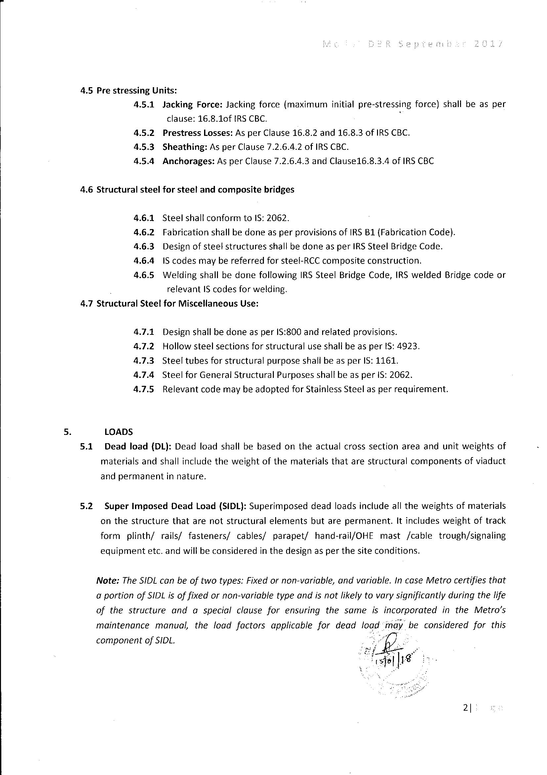
4.5
4.6
47
5.1
5.2
Pre stressing Units:
4.5.1 Jacking Force: Jacking force (maximum initial pre-stressing force) shall be as per
clause: 16.8.1of IRS CBC. ,
4.5.2 Prestress Losses: As per Clause 16.8.2 and 16.8.3 of IRS CBC.
4.5.3 Sheathing: As per Clause 7.2.6.4.2 of IRS CBC.
4.5.4 Anchorages: As per Clause 7.2.6.4.3 and Clause16.8.3.4 of IRS CBC
Structural steel for steel and composite bridges
4.6.1 Steel shall conform to IS: 2062.
4.6.2 Fabrication shall be done as per provisions of IRS B1 (Fabrication Code).
4.6.3. Design of steel structures shall be done as per IRS Steel Bridge Code.
4.6.4 IS codes may be referred for steel-RCC composite construction.
4.6.5 Welding shall be done following IRS Steel Bridge Code, IRS welded Bridge code or
. relevant IS codes for welding.
Structural Steel for Miscellaneous Use:
4.7.1 Design shall be done as per IS:800 and related provisions.
4.7.2 Hollow steel sections for structural use shall be as per tS: 4923.
4.7.3 Steel tubes for structural purpose shall be as per IS: 1161.
4.7.4 Steel for General Structural Purposes shall be as per (S: 2062.
4.7.5 Relevant code may be adopted for Stainless Steel as per requirement.
LOADS
Dead load (DL): Dead load shall be based on the actual cross section area and unit weights of
materials and shall include the weight of the materials that are structural components of viaduct
and permanent in nature.
Super Imposed Dead Load (SIDL): Superimposed dead loads include all the weights of materials
on the structure that are not structural elements but are permanent. It includes weight of track
form plinth/ rails/ fasteners/ cables/ parapet/ hand-rail/OHE mast /cable trough/signaling
equipment etc. and will be considered in the design as per the site conditions.
Note: The SIDL can be of two types: Fixed or non-variable, and variable. in case Metro certifies that
a portion of SIDL is of fixed or non-variable type and is not likely to vary significantly during the life
of the structure and a special clause for ensuring the same is incorporated in the Metro’s
maintenance manual, the load factors applicable for dead load imay be considered for this
component of SIDL. :
2|

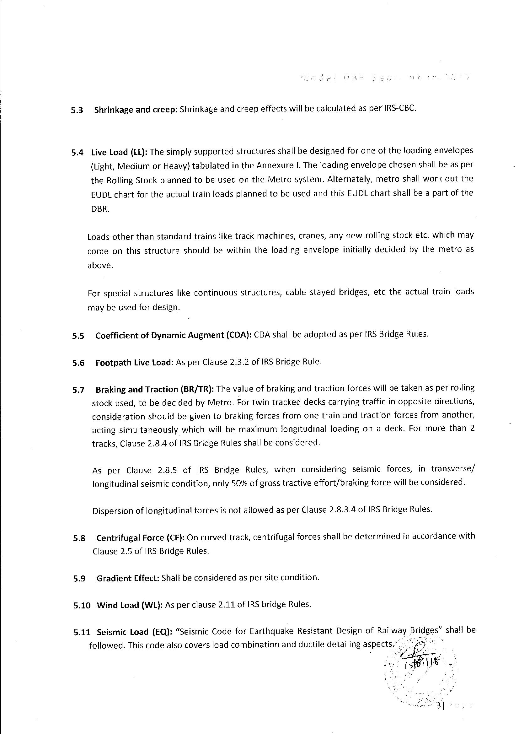
5.3
Shrinkage and creep: Shrinkage and creep effects will be calculated as per IRS-CBC.
5.4 Live Load (LL): The simply supported structures shall be designed for one of the loading envelopes
5.5
5.6
5.7
5.8
5.9
(Light, Medium or Heavy) tabulated in the Annexure I. The loading envelope chosen shall be as per
the Rolling Stock planned to be used on the Metro system. Alternately, metro shall work out the
EUDL chart for the actual train loads planned to be used and this EUDL chart shall be a part of the
DBR.
Loads other than standard trains like track machines, cranes, any new rolling stock etc. which may
come on this structure should be within the loading envelope initially decided by the metro as
above.
For special structures like continuous structures, cable stayed bridges, etc the actual train loads
may be used for design.
Coefficient of Dynamic Augment (CDA): CDA shall be adopted as per IRS Bridge Rutes.
Footpath Live Load: As per Clause 2.3.2 of IRS Bridge Rule.
Braking and Traction (BR/TR): The value of braking and traction forces will be taken as per rolling
stock used, to be decided by Metro. For twin tracked decks carrying traffic in opposite directions,
consideration should be given to braking forces from one train and traction forces from another,
acting simultaneously which will be maximum longitudinal loading on a deck. For more than 2
tracks, Clause 2.8.4 of IRS Bridge Rules shall be considered.
As per Clause 2.8.5 of IRS Bridge Rules, when considering seismic forces, in transverse/
longitudinal seismic condition, only 50% of gross tractive effort/braking force will be considered.
Dispersion of longitudinal forces is not allowed as per Clause 2.8.3.4 of IRS Bridge Rules.
Centrifugal Force (CF): On curved track, centrifugal forces shall be determined in accordance with
Clause 2.5 of IRS Bridge Rules.
Gradient Effect: Shall be considered as per site condition.
5.10 Wind Load (WL): As per clause 2.11 of IRS bridge Rules.
5.11 Seismic Load (EQ): “Seismic Code for Earthquake Resistant Design of Railway Bridges” shall be
followed. This code also covers load combination and ductile detailing aspects.”

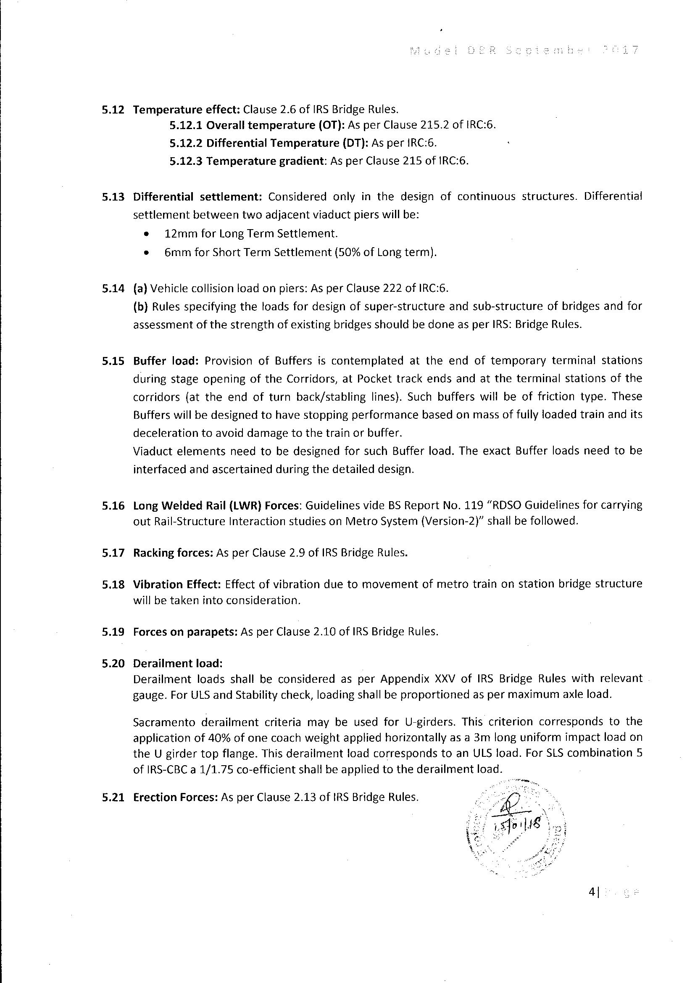
5.12
5.13
5.14
5.15
5.16
5.17
5.18
5.19
5.20
5.21
Temperature effect: Clause 2.6 of IRS Bridge Rules.
5.12.1 Overall temperature (OT): As per Clause 215.2 of IRC:6.
5.12.2 Differential Temperature (DT): As per IRC:6.
5.12.3 Temperature gradient: As per Clause 215 of IRC:6.
Differential settlement: Considered only in the design of continuous structures. Differential
settlement between two adjacent viaduct piers will be:
¢ 12mm for Long Term Settlement.
* 6mm for Short Term Settlement (50% of Long term).
(a) Vehicle collision load on piers: As per Clause 222 of IRC:6.
(b) Rules specifying the toads for design of super-structure and sub-structure of bridges and for
assessment of the strength of existing bridges should be done as per IRS: Bridge Rules.
Buffer load: Provision of Buffers is contemplated at the end of temporary terminal stations
during stage opening of the Corridors, at Pocket track ends and at the terminal stations of the
corridors (at the end of turn back/stabling lines}. Such buffers will be of friction type. These
Buffers will be designed to have stopping performance based on mass of fully loaded train and its
deceleration to avoid damage to the train or buffer.
Viaduct elements need to be designed for such Buffer load. The exact Buffer loads need to be
interfaced and ascertained during the detailed design.
Long Welded Rail (LWR) Forces: Guidelines vide BS Report No. 119 “RDSO Guidelines for carrying
out Rail-Structure Interaction studies on Metro System (Version-2)” shail be followed.
Racking forces: As per Clause 2.9 of IRS Bridge Rules.
Vibration Effect: Effect of vibration due to movement of metro train on station bridge structure
will be taken into consideration.
Forces on parapets: As per Clause 2.10 of IRS Bridge Rules.
Derailment load:
Derailment loads shall be considered as per Appendix XXV of IRS Bridge Rules with relevant
gauge. For ULS and Stability check, loading shall be proportioned as per maximum axle load.
Sacramento derailment criteria may be used for U-girders. This criterion corresponds to the
application of 40% of one coach weight applied horizontally as a 3m long uniform impact load on
the U girder top flange. This derailment load corresponds to an ULS load. For SLS combination 5
of IRS-CBC a 1/1.75 co-efficient shall be applied to the derailment load.
Erection Forces: As per Clause 2.13 of IRS Bridge Rules.
4|

Traceability: test6.pdf

