CS413 ACE Group 7

Scott Henderson, Candy Mortimer, Alexis McBride, Raniel Mark Lafferty and Paul Junior ‘PJ’ McGurk

Contents

Introduction

Assessment of Capabilities

**Introduction**

The project is to create a product using either an Arduino and/or Raspberry Pi that will be a part of the Internet of things. The Internet of things is about taking everyday objects and embedding them with software, electronics and networking capabilities so that they can sense the environment around them and then send and receive data. The idea, after much thought and discussion will be to create a smart fridge. This idea will not only have a physical benefit to its application but also an environmental one, as from the start the design is centred on trying to reduce food waste and energy consumption.

**Assessment of Capabilities**

Requirements

The device must be able to support a touchscreen, have a thermometer connected, webcam to act as barcode scanner, wireless capabilities and be able to run a web server.

Arduino

Raspberry Pi

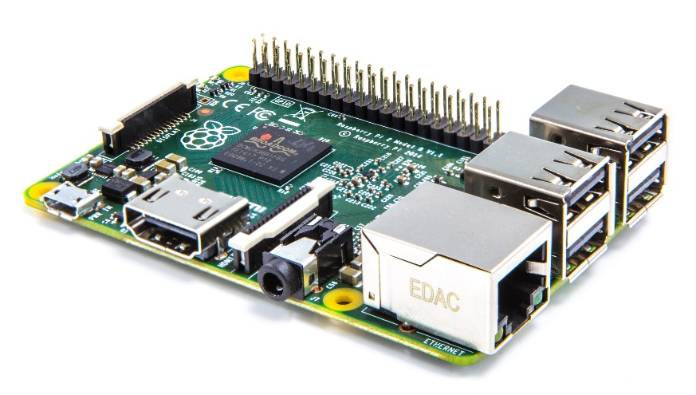

**Current Progress**

We have already made some progress on Phase 1 of our project. We have created a prototype to sense temperature and change the colour of an LED using a Raspberry Pi. We have also created the basis of the web interface to allow a user to view/change temperature, display current contents of the fridge, including expiration dates, and also to show the latest image from the PI camera.