**Hardcore**

This task is based on Hurt Me Plenty task:

1. Create a user and give him permission to read-only mode for Jenkins jobs without the access to edit or change settings

**Done**

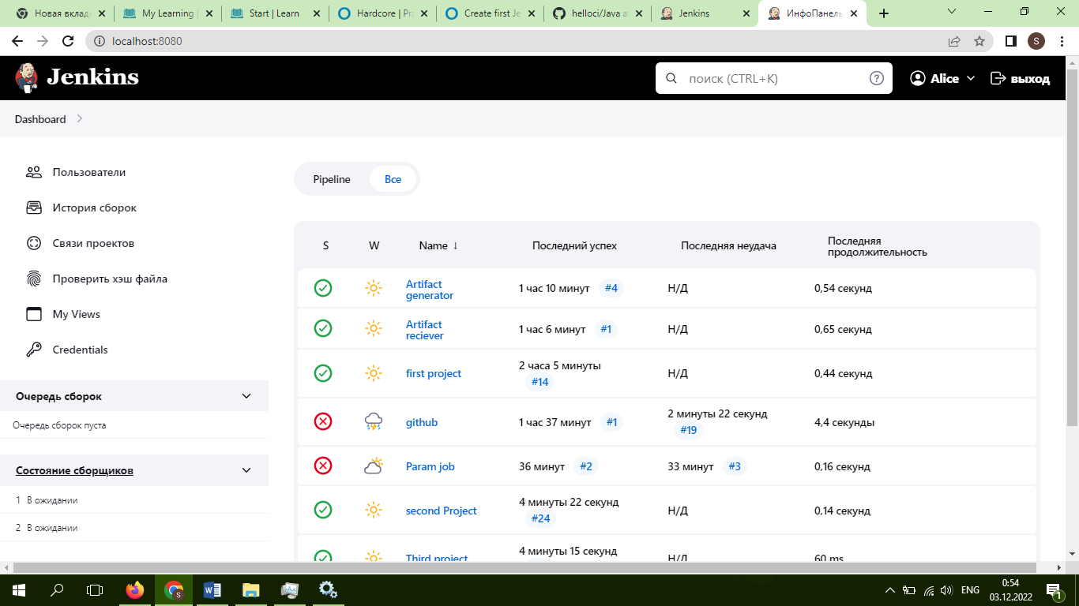

1. Create a parametrized job HelloUser which will ask for a user name as a parameter and output "Hello, username!" in the console

**I don’t find information how to do it**

3. Measure unit tests code coverage with the help of the goal mvn cobertura:cobertura and publish it on the job page as a graphic