**I Can Win**

1. Install Jenkins

**Done**

2. Create a task which will perform the following:

Clone the project

Launch tests from the project in Java directory with the help of mvn test goal

**Done**

**Bring IT ON**

3. Set up build triggers so that the task is performed every 5 minutes

* Launch tests not later than 5 minutes after committing in git
* Every workday at midnight

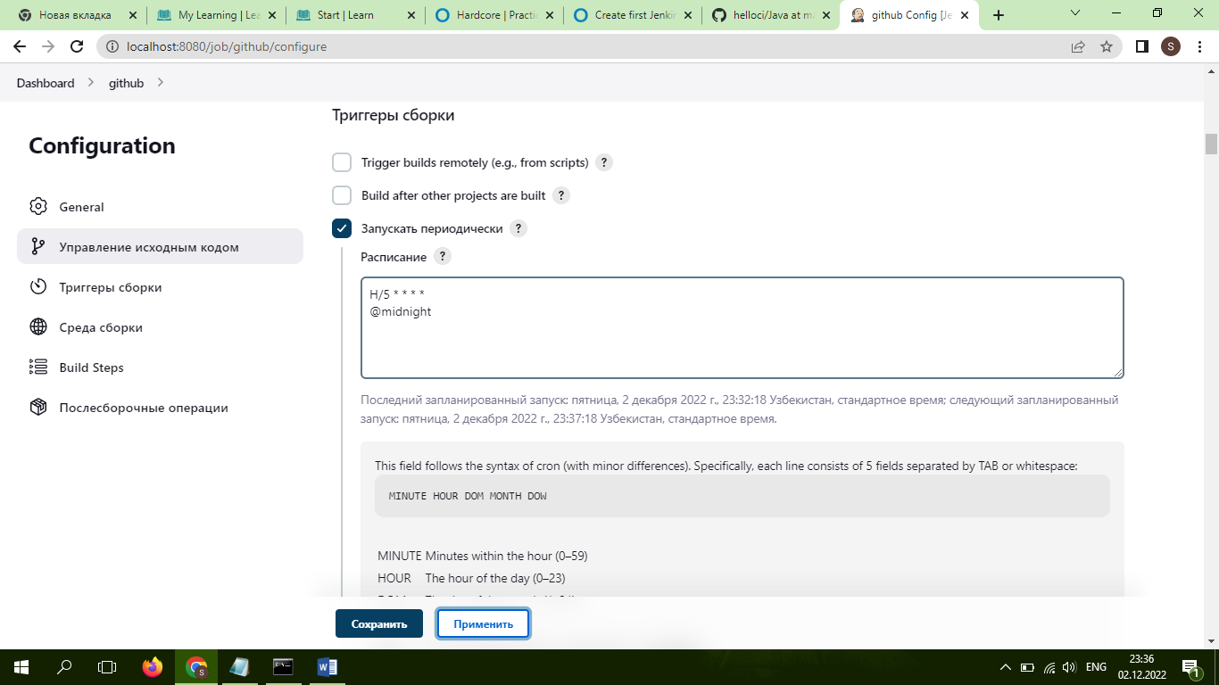**Done**

**Hurt me plenty**

4. Publish “Java\target\surefire-reports\com.github.vitalliuss.helloci.AppTest.txt” file as an artifact

This task is based on Bring It On task.

1. Change the server port for 8081

**Done**

1. Create a node and set up a server so that the job is performed on a slave-node only

I launch agent, the problem is

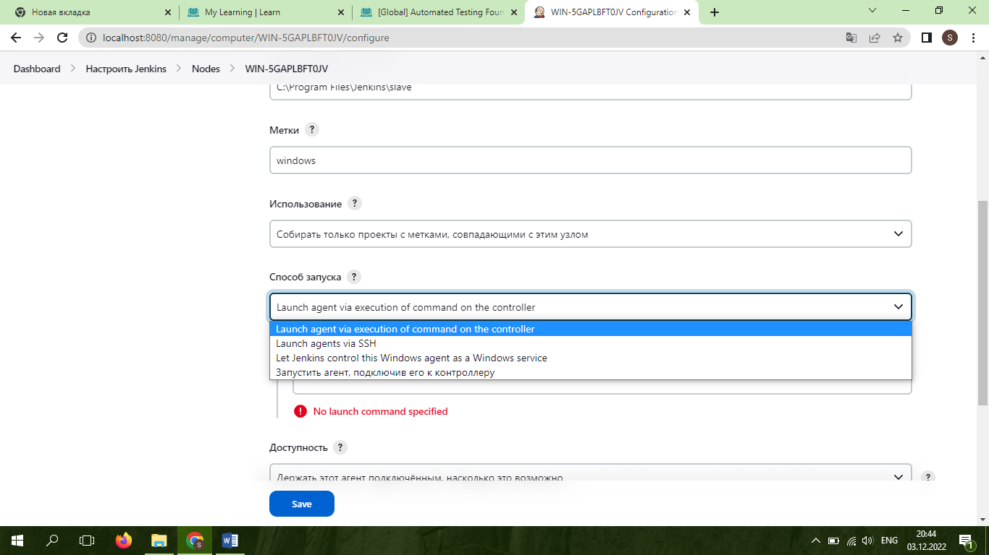

**Hardcore**

This task is based on Hurt Me Plenty task:

1. Create a user and give him permission to read-only mode for Jenkins jobs without the access to edit or change settings

**Done**

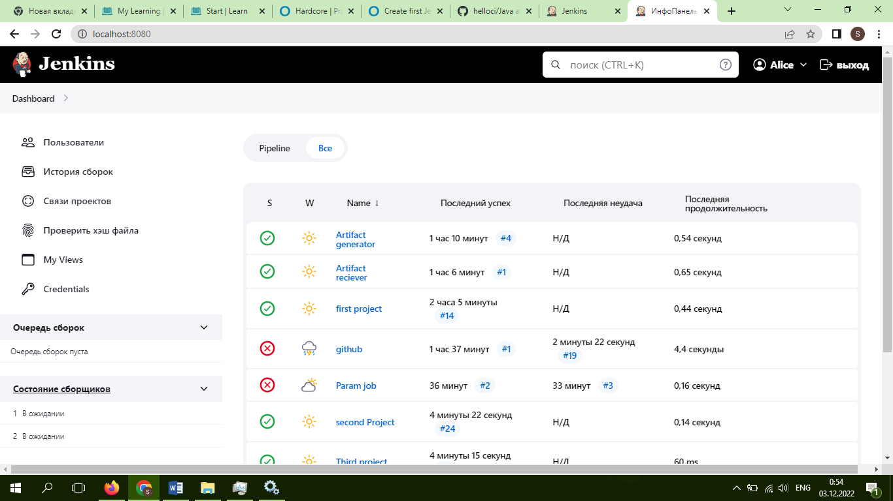

1. Create a parametrized job HelloUser which will ask for a user name as a parameter and output "Hello, username!" in the console

3. Mesure unit tests code coverage with the help of the goal mvn cobertura:cobertura and publish it on the job page as a graphic