吉林大学

DB2实验报告

班级：552410
姓名： 柳湛博
学号：55241019

姓名 | 柳湛博 | 学号 | 55241019
实验项目 | 2. Creating databases and data placement
实验性质 | □演示性实验 □验证性实验  操作性实验 □综合性实验
实验地点 | A108 | 机器编号 | 10
指导教师 | 刘雪洁 | 实验时间 | 2026年 9月 21日 10时 1 分
一、实验综述
1. 实验目的及要求
During this lab, you will create your database and your table spaces. Also in this lab, you will select information on table spaces from the system catalog (SYSCAT) views.
At the end of the lab, students should be able to:
• Create a database
• Create a table space
• Execute a script file to create multiple table spaces
• Access the SYSCAT views containing table space information
• List table space information
• List container information
2. 实验设备、软件
PC, windows XP Professional, DB2 9 Express-c
二、实验过程（实验步骤、记录、数据、分析）
Section 1 - Creating the Database
1. Creating a database can be done with the DB2 command create database. Use the online help facility to display the DB2 command syntax for create database.
Show your work below by printing screen.
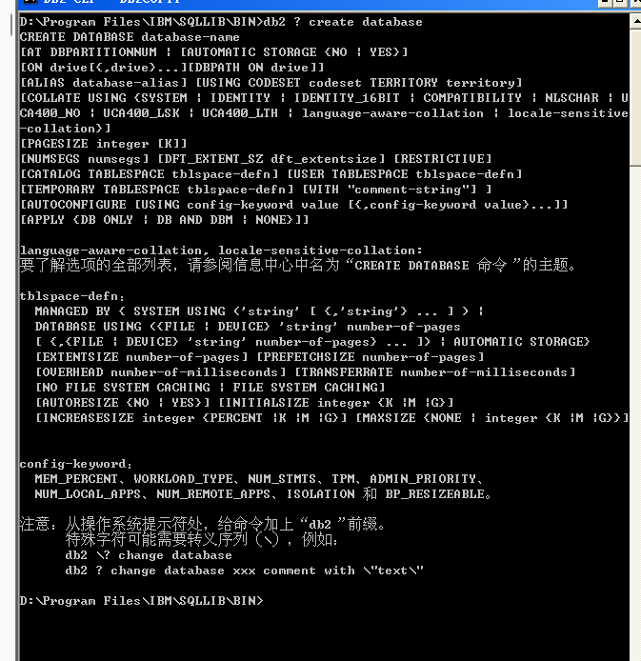

- What information can you specify on the create database command?
（1）数据库名称与别名（Database Name & Alias Name）。
（2）物理存放路径/驱动器（`ON path/drive` 或 `DBPATH ON`）。
（3）自动存储选项与路径（`AUTOMATIC STORAGE YES/NO` 以及 Storage Paths）。
（4）默认表空间定义（`CATALOG TABLESPACE`, `USER TABLESPACE`, `TEMPORARY TABLESPACE` 的容器、页面大小与区段定义）。
（5）字符集与区域属性（`TERRITORY`, `CODESET`, `COLLATE USING`）。
（6）页面大小与区段默认值（`PAGESIZE`, `DFT_EXTENT_SZ`, `NUMSEGS`）。
（7）安全与限制模式（`RESTRICTIVE`，是否开启限制性数据库权限）。
注释说明（`WITH "comment-string"`）。

3. Based on what you learned in lecture, what table spaces are created when a database is created?

DB2 默认自动创建以下 3 个表空间：

1. SYSCATSPACE（系统目录表空间）：存放系统目录表、视图及数据库所有元数据（Metadata）。
2. TEMPSPACE1（系统临时表空间）：供 DB2 数据库引擎执行内部排序、哈希连接、表重组（REORG）等临时操作。
3. USERSPACE1（默认用户表空间）：存放用户创建的业务数据表、索引及用户对象。

4. What type of table space, SMS or DMS, will your database use by default for these default table spaces?
在 DB2 9 Express-C 中（默认启用 Automatic Storage 自动存储）：

SYSCATSPACE：默认为 DMS（自动存储管理的 DMS 表空间）。
USERSPACE1：默认为 DMS（自动存储管理的 DMS 表空间）。
TEMPSPACE1：默认为 SMS（系统管理表空间）。

5. Before we create our MUSICDB database, remember what you learned in lecture about what some of the defaults will be.
•What is the default path that the database will be created on?
由数据库管理器配置（DBM CFG）参数 `DFTDBPATH` 决定，Windows 下默认为 DB2 安装驱动器根目录。
•What will be the default table space type (SMS or DMS) for the table spaces that will be created to house User Tables, Catalog Tables, and Temporary Tables?
Catalog 表空间（`SYSCATSPACE`）为 DMS；User 表空间（`USERSPACE1`）为 DMS；Temporary 表空间（`TEMPSPACE1`）为 SMS。
•What are the default Extent and Prefetch sizes?
默认 `EXTENTSIZE`（区段大小）为 32 页；默认 `PREFETCHSIZE`（预取大小）为 AUTOMATIC。
•What are the default Territory, Code Set and Collating Sequence values?
默认从操作系统的语言区域（Locale）派生。英文系统下为 Territory: `US`，Code Set: `UTF-8`（或 `1252`），Collating Sequence: `IDENTITY`；中文 Windows 系统下为 Territory: `CN`，Code Set: `GBK`（或 `UTF-8`）。

6. Create your database with a Database name of MUSICDB using the default settings. It will take a few minutes to create the database.
Show your work below by printing screen for the last step.
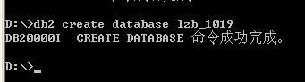

7. You should now have your MUSICDB database created. The System Database Directory contains an entry for all databases known by this instance. Check the System Database Directory for an entry for the MUSICDB database by issuing the list db directory command.
Show your work below by printing screen.
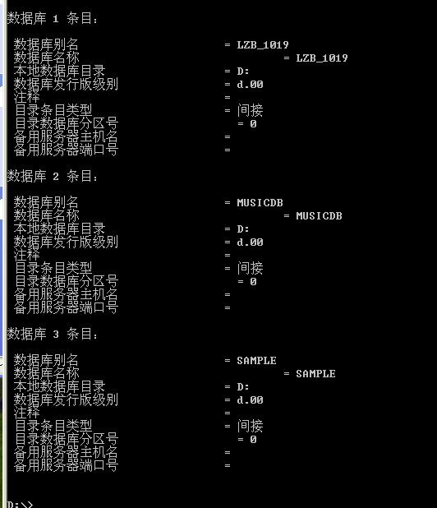

8. What is the Database alias name and where did it come from?
数据库别名是 LZB_1019。它来源于我们在第 6 步执行的 `create database lzb_1019` 命令

9. What does a Directory entry type of Indirect mean?
Indirect表示该数据库是本地数据库，物理存放在当前 DB2 实例所在的主机上。它指向系统数据库目录与本地数据库目录，应用程序在本地即可直接访问。

10. What does a Directory entry type of Remote mean?
Remote表示该数据库物理存放在网络中的另一台远程服务器或另一个 DB2 实例上。本地仅保存用于网络通信寻址的编目节点条目，客户端需跨网络进行连接。

- It's time to connect to your MUSICDB database. Check your current connection state with the get connection state command.
12. What is the connection state?
Show your work below by printing screen.
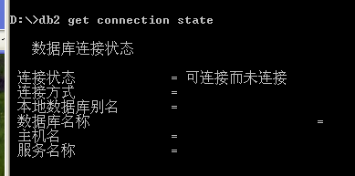
可连接而未连接（Connectable and unconnected）。

13. Connect to your MUSICDB database.
14. Did you get connected to your MUSICDB database?
Show your work below by printing screen.
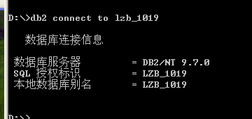
是的

15. Check your connection state again. What does it show?
Show your work below by printing screen.
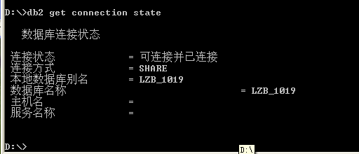

16. Every database has its own Database Configuration file that contains information about the database and tuning parameters. Look at the Database Configuration file for your MUSICDB database.
Show your work below by printing screen.
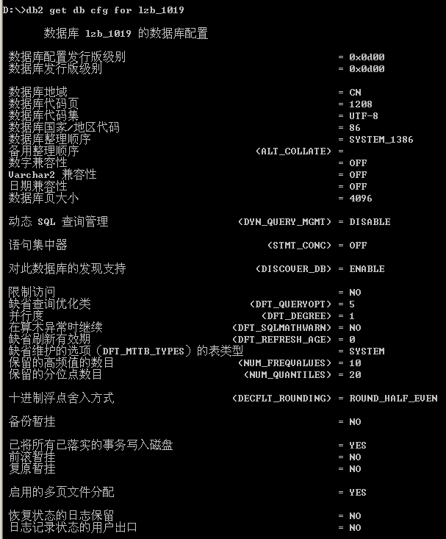

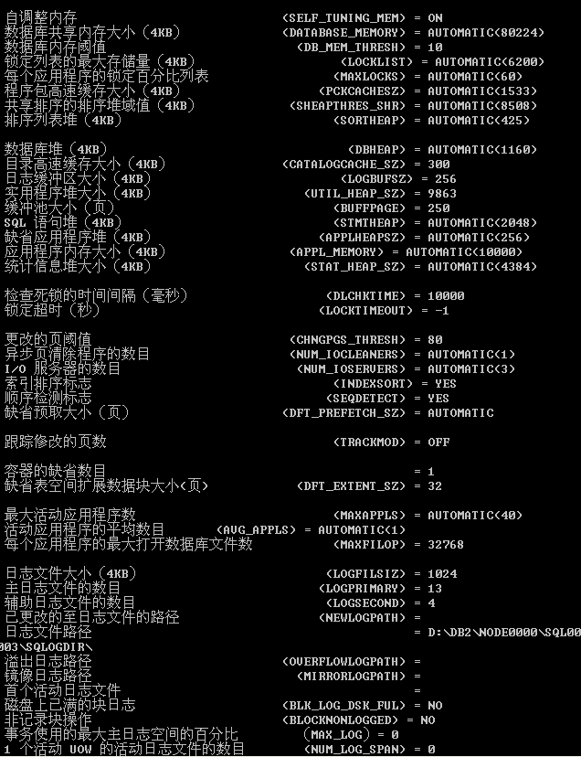
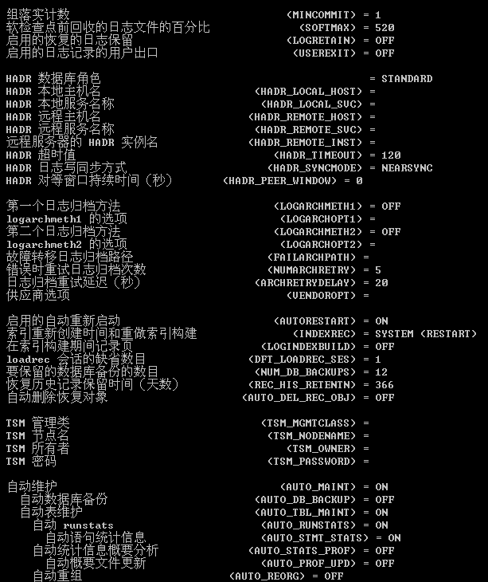

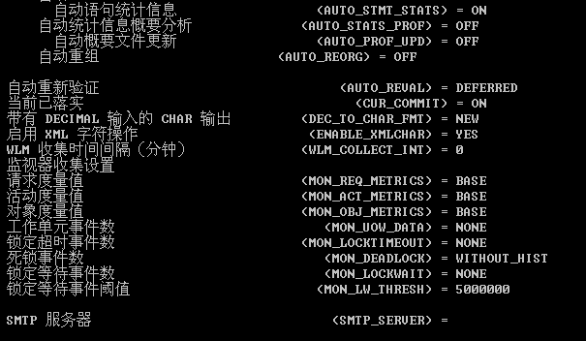

17. Find the default values for two specific configuration parameters for your database, LOCKLIST and MAXLOCKS. Since there are a large number of configuration parameters, we can use grep to find the specific ones we want when using a local connection (the equivalent for DB2 on Windows is: ... | find /i “lock”) — the option “i” means case insensitive.
Show your work below by printing screen.
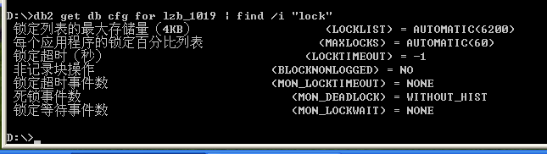

18.Values of some of the parameters can be changed. Update the following parameters and specify the values shown.
• Change maxlocks to 20
• Change num_freqvalues to 12
Show your work below by printing screen.
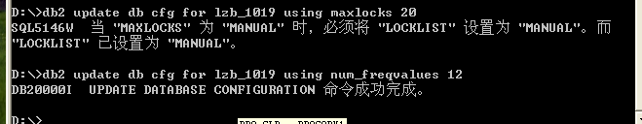

19. When do these database configuration file changes take effect?
MAXLOCKS：支持动态在线生效（Online configurable），修改后立即对新的事务/连接生效。
NUM_FREQVALUES：属于非动态/延迟生效参数，修改后写入配置文件，但必须在所有应用程序断开连接、数据库重新激活（重启或重新连接）后生效，并在下一次针对表执行 RUNSTATS 时起作用。

20. Check to see if the Current and Delayed Values are the same for maxlocks and num_freqvalues.
Show your work below by printing screen.
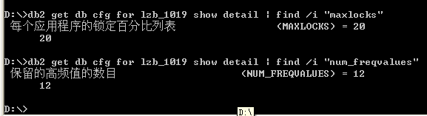

21. Repeat Step #17 above, and record here the new values of LOCKLIST and MAXLOCKS.
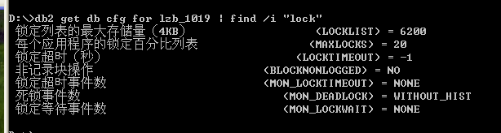

22. Some default table spaces were created during creation of the database. List the table space information.
Show your work below by printing screen.

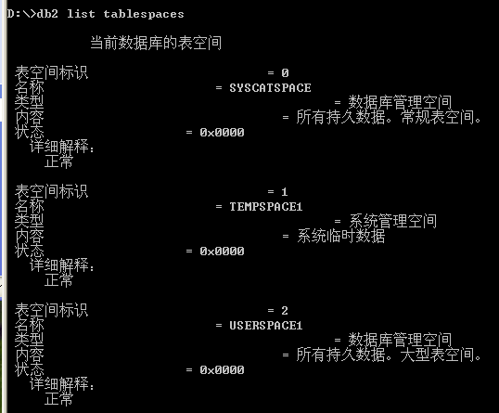

23. What are the table space names and what ID number is associated with the table space?
表空间标识 (ID) | 表空间名称 (Name) | 管理类型 (Type) | 内容与职能说明 (Content & Role)
0 | SYSCATSPACE | 数据库管理空间 (DMS) | 所有持久数据，常规表空间（系统目录表空间，存放元数据）
1 | TEMPSPACE1 | 系统管理空间 (SMS) | 系统临时数据（供数据库内部排序、连接、重组等操作使用）
2 | USERSPACE1 | 数据库管理空间 (DMS) | 所有持久数据，大型表空间（默认用户数据表空间）
24. Table space container information can be displayed with the list tablespace containers command. Use the Help facility to show the DB2 command syntax.
Show your work below by printing screen.
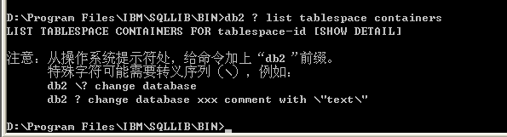

25. Show the container information for table space ID 0. What type of container is this and where is it located?
Show your work below by printing screen.
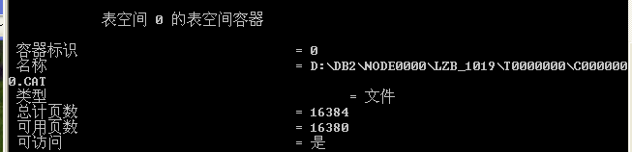

26. List the names of the system catalog tables. What are these tables?
Show your work below by printing screen.

表/视图 模式 类型 创建时间
------------------------------- --------------- ----- --------------------------
ATTRIBUTES SYSCAT V 2026-10-10-14.29.16.099052
AUDITPOLICIES SYSCAT V 2026-10-10-14.29.16.240008
AUDITUSE SYSCAT V 2026-10-10-14.29.16.240017
BUFFERPOOLDBPARTITIONS SYSCAT V 2026-10-10-14.29.16.240026
BUFFERPOOLNODES SYSCAT V 2026-10-10-14.29.16.255003
BUFFERPOOLS SYSCAT V 2026-10-10-14.29.16.255012
CASTFUNCTIONS SYSCAT V 2026-10-10-14.29.16.255021
CHECKS SYSCAT V 2026-10-10-14.29.16.255030
COLAUTH SYSCAT V 2026-10-10-14.29.16.255039
COLCHECKS SYSCAT V 2026-10-10-14.29.16.255048
COLDIST SYSCAT V 2026-10-10-14.29.16.255057
COLGROUPCOLS SYSCAT V 2026-10-10-14.29.16.271002
COLGROUPDIST SYSCAT V 2026-10-10-14.29.16.271011
COLGROUPDISTCOUNTS SYSCAT V 2026-10-10-14.29.16.271020
COLGROUPS SYSCAT V 2026-10-10-14.29.16.271029
COLIDENTATTRIBUTES SYSCAT V 2026-10-10-14.29.16.271038
COLLATIONS SYSCAT V 2026-10-10-14.29.16.287008
COLOPTIONS SYSCAT V 2026-10-10-14.29.16.287017
COLUMNS SYSCAT V 2026-10-10-14.29.16.287026
COLUSE SYSCAT V 2026-10-10-14.29.16.287035
CONDITIONS SYSCAT V 2026-10-10-14.29.16.302008
CONSTDEP SYSCAT V 2026-10-10-14.29.16.302017
CONTEXTATTRIBUTES SYSCAT V 2026-10-10-14.29.16.302026
CONTEXTS SYSCAT V 2026-10-10-14.29.16.302035
DATAPARTITIONEXPRESSION SYSCAT V 2026-10-10-14.29.16.302044
DATAPARTITIONS SYSCAT V 2026-10-10-14.29.16.302053
DATATYPEDEP SYSCAT V 2026-10-10-14.29.16.318008
DATATYPES SYSCAT V 2026-10-10-14.29.16.318017
DBAUTH SYSCAT V 2026-10-10-14.29.16.318026
DBPARTITIONGROUPDEF SYSCAT V 2026-10-10-14.29.16.318035
DBPARTITIONGROUPS SYSCAT V 2026-10-10-14.29.16.318044
EVENTMONITORS SYSCAT V 2026-10-10-14.29.16.318053
EVENTS SYSCAT V 2026-10-10-14.29.16.333007
EVENTTABLES SYSCAT V 2026-10-10-14.29.16.333016
FULLHIERARCHIES SYSCAT V 2026-10-10-14.29.16.333025
FUNCDEP SYSCAT V 2026-10-10-14.29.16.333034
FUNCMAPOPTIONS SYSCAT V 2026-10-10-14.29.16.333043
FUNCMAPPARMOPTIONS SYSCAT V 2026-10-10-14.29.16.333052
FUNCMAPPINGS SYSCAT V 2026-10-10-14.29.16.333061
FUNCPARMS SYSCAT V 2026-10-10-14.29.16.349008
FUNCTIONS SYSCAT V 2026-10-10-14.29.16.349017
HIERARCHIES SYSCAT V 2026-10-10-14.29.16.349026
HISTOGRAMTEMPLATEBINS SYSCAT V 2026-10-10-14.29.16.349035
HISTOGRAMTEMPLATES SYSCAT V 2026-10-10-14.29.16.349044
HISTOGRAMTEMPLATEUSE SYSCAT V 2026-10-10-14.29.16.349053
INDEXAUTH SYSCAT V 2026-10-10-14.29.16.349062
INDEXCOLUSE SYSCAT V 2026-10-10-14.29.16.365008
INDEXDEP SYSCAT V 2026-10-10-14.29.16.365017
INDEXES SYSCAT V 2026-10-10-14.29.16.365026
INDEXEXPLOITRULES SYSCAT V 2026-10-10-14.29.16.365035
INDEXEXTENSIONDEP SYSCAT V 2026-10-10-14.29.16.365044
INDEXEXTENSIONMETHODS SYSCAT V 2026-10-10-14.29.16.380007
INDEXEXTENSIONPARMS SYSCAT V 2026-10-10-14.29.16.380016
INDEXEXTENSIONS SYSCAT V 2026-10-10-14.29.16.380025
INDEXOPTIONS SYSCAT V 2026-10-10-14.29.16.380034
INDEXPARTITIONS SYSCAT V 2026-10-10-14.29.16.380043
INDEXXMLPATTERNS SYSCAT V 2026-10-10-14.29.16.396008
INVALIDOBJECTS SYSCAT V 2026-10-10-14.29.16.396017
KEYCOLUSE SYSCAT V 2026-10-10-14.29.16.396026
LIBRARIES SYSCAT V 2026-10-10-14.29.16.396035
LIBRARYAUTH SYSCAT V 2026-10-10-14.29.16.412008
LIBRARYBINDFILES SYSCAT V 2026-10-10-14.29.16.412017
LIBRARYVERSIONS SYSCAT V 2026-10-10-14.29.16.412026
MODULEAUTH SYSCAT V 2026-10-10-14.29.16.412035
MODULEOBJECTS SYSCAT V 2026-10-10-14.29.16.412044
MODULES SYSCAT V 2026-10-10-14.29.16.412053
NAMEMAPPINGS SYSCAT V 2026-10-10-14.29.16.427007
NICKNAMES SYSCAT V 2026-10-10-14.29.16.427016
NODEGROUPDEF SYSCAT V 2026-10-10-14.29.16.427025
NODEGROUPS SYSCAT V 2026-10-10-14.29.16.427034
PACKAGEAUTH SYSCAT V 2026-10-10-14.29.16.427043
PACKAGEDEP SYSCAT V 2026-10-10-14.29.16.427052
PACKAGES SYSCAT V 2026-10-10-14.29.16.427061
PARTITIONMAPS SYSCAT V 2026-10-10-14.29.16.490008
PASSTHRUAUTH SYSCAT V 2026-10-10-14.29.16.490017
PREDICATESPECS SYSCAT V 2026-10-10-14.29.16.490026
PROCEDURES SYSCAT V 2026-10-10-14.29.16.490035
PROCPARMS SYSCAT V 2026-10-10-14.29.16.490044
REFERENCES SYSCAT V 2026-10-10-14.29.16.505007
ROLEAUTH SYSCAT V 2026-10-10-14.29.16.505016
ROLES SYSCAT V 2026-10-10-14.29.16.505025
ROUTINEAUTH SYSCAT V 2026-10-10-14.29.16.505034
ROUTINEDEP SYSCAT V 2026-10-10-14.29.16.505043
ROUTINEOPTIONS SYSCAT V 2026-10-10-14.29.16.505052
ROUTINEPARMOPTIONS SYSCAT V 2026-10-10-14.29.16.521007
ROUTINEPARMS SYSCAT V 2026-10-10-14.29.16.521016
ROUTINES SYSCAT V 2026-10-10-14.29.16.521025
ROUTINESFEDERATED SYSCAT V 2026-10-10-14.29.16.521034
ROWFIELDS SYSCAT V 2026-10-10-14.29.16.537007
SCHEMAAUTH SYSCAT V 2026-10-10-14.29.16.537016
SCHEMATA SYSCAT V 2026-10-10-14.29.16.537025
SECURITYLABELACCESS SYSCAT V 2026-10-10-14.29.16.537034
SECURITYLABELCOMPONENTELEMENTS SYSCAT V 2026-10-10-14.29.16.537043
SECURITYLABELCOMPONENTS SYSCAT V 2026-10-10-14.29.16.537052
SECURITYLABELS SYSCAT V 2026-10-10-14.29.16.552008
SECURITYPOLICIES SYSCAT V 2026-10-10-14.29.16.552017
SECURITYPOLICYCOMPONENTRULES SYSCAT V 2026-10-10-14.29.16.552026
SECURITYPOLICYEXEMPTIONS SYSCAT V 2026-10-10-14.29.16.552035
SEQUENCEAUTH SYSCAT V 2026-10-10-14.29.16.568007
SEQUENCES SYSCAT V 2026-10-10-14.29.16.568016
SERVEROPTIONS SYSCAT V 2026-10-10-14.29.16.568025
SERVERS SYSCAT V 2026-10-10-14.29.16.568034
SERVICECLASSES SYSCAT V 2026-10-10-14.29.16.568043
STATEMENTS SYSCAT V 2026-10-10-14.29.16.568052
SURROGATEAUTHIDS SYSCAT V 2026-10-10-14.29.16.677007
TABAUTH SYSCAT V 2026-10-10-14.29.16.677016
TABCONST SYSCAT V 2026-10-10-14.29.16.677025
TABDEP SYSCAT V 2026-10-10-14.29.16.677034
TABDETACHEDDEP SYSCAT V 2026-10-10-14.29.16.677043
TABLES SYSCAT V 2026-10-10-14.29.16.677052
TABLESPACES SYSCAT V 2026-10-10-14.29.16.693007
TABOPTIONS SYSCAT V 2026-10-10-14.29.16.693016
TBSPACEAUTH SYSCAT V 2026-10-10-14.29.16.693025
THRESHOLDS SYSCAT V 2026-10-10-14.29.16.693034
TRANSFORMS SYSCAT V 2026-10-10-14.29.16.693043
TRIGDEP SYSCAT V 2026-10-10-14.29.16.693052
TRIGGERS SYSCAT V 2026-10-10-14.29.16.708003
TYPEMAPPINGS SYSCAT V 2026-10-10-14.29.16.708012
USEROPTIONS SYSCAT V 2026-10-10-14.29.16.708021
VARIABLEAUTH SYSCAT V 2026-10-10-14.29.16.708030
VARIABLEDEP SYSCAT V 2026-10-10-14.29.16.708039
VARIABLES SYSCAT V 2026-10-10-14.29.16.708048
VIEWDEP SYSCAT V 2026-10-10-14.29.16.724007
VIEWS SYSCAT V 2026-10-10-14.29.16.724016
WORKACTIONS SYSCAT V 2026-10-10-14.29.16.724025
WORKACTIONSETS SYSCAT V 2026-10-10-14.29.16.724034
WORKCLASSES SYSCAT V 2026-10-10-14.29.16.724043
WORKCLASSSETS SYSCAT V 2026-10-10-14.29.16.724052
WORKLOADAUTH SYSCAT V 2026-10-10-14.29.16.740007
WORKLOADCONNATTR SYSCAT V 2026-10-10-14.29.16.802007
WORKLOADS SYSCAT V 2026-10-10-14.29.16.802016
WRAPOPTIONS SYSCAT V 2026-10-10-14.29.16.802025
WRAPPERS SYSCAT V 2026-10-10-14.29.16.865007
XDBMAPGRAPHS SYSCAT V 2026-10-10-14.29.16.865016
XDBMAPSHREDTREES SYSCAT V 2026-10-10-14.29.16.880008
XMLSTRINGS SYSCAT V 2026-10-10-14.29.16.880017
XSROBJECTAUTH SYSCAT V 2026-10-10-14.29.16.880026
XSROBJECTCOMPONENTS SYSCAT V 2026-10-10-14.29.16.880035
XSROBJECTDEP SYSCAT V 2026-10-10-14.29.16.896003
XSROBJECTDETAILS SYSCAT V 2026-10-10-14.29.16.927007
XSROBJECTHIERARCHIES SYSCAT V 2026-10-10-14.29.16.927016
XSROBJECTS SYSCAT V 2026-10-10-14.29.16.927025
CHECK_CONSTRAINTS SYSIBM V 2026-10-10-14.29.15.990015
COLUMNS SYSIBM V 2026-10-10-14.29.16.021003
COLUMNS_S SYSIBM V 2026-10-10-14.29.16.037022
DUAL SYSIBM V 2026-10-10-14.29.16.037008
PARAMETERS SYSIBM V 2026-10-10-14.29.16.068012
PARAMETERS_S SYSIBM V 2026-10-10-14.29.16.068021
REFERENTIAL_CONSTRAINTS SYSIBM V 2026-10-10-14.29.16.037031
REF_CONSTRAINTS SYSIBM V 2026-10-10-14.29.16.052003
ROUTINES SYSIBM V 2026-10-10-14.29.16.068030
ROUTINES_S SYSIBM V 2026-10-10-14.29.16.083008
SQLCOLPRIVILEGES SYSIBM V 2026-10-10-14.29.20.427014
SQLCOLUMNS SYSIBM V 2026-10-10-14.29.20.443002
SQLFOREIGNKEYS SYSIBM V 2026-10-10-14.29.20.458004
SQLPRIMARYKEYS SYSIBM V 2026-10-10-14.29.20.458009
SQLPROCEDURECOLS SYSIBM V 2026-10-10-14.29.20.458014
SQLPROCEDURES SYSIBM V 2026-10-10-14.29.20.474004
SQLSCHEMAS SYSIBM V 2026-10-10-14.29.20.490009
SQLSPECIALCOLUMNS SYSIBM V 2026-10-10-14.29.20.474009
SQLSTATISTICS SYSIBM V 2026-10-10-14.29.20.474014
SQLTABLEPRIVILEGES SYSIBM V 2026-10-10-14.29.20.474019
SQLTABLES SYSIBM V 2026-10-10-14.29.20.490014
SQLTABLETYPES SYSIBM V 2026-10-10-14.29.20.490004
SQLTYPEINFO SYSIBM V 2026-10-10-14.29.20.490024
SQLUDTS SYSIBM V 2026-10-10-14.29.20.490019
SYSATTRIBUTES SYSIBM T 2026-10-10-14.29.11.443000
SYSAUDITPOLICIES SYSIBM T 2026-10-10-14.29.11.443000
SYSAUDITUSE SYSIBM T 2026-10-10-14.29.11.443000
SYSBUFFERPOOLNODES SYSIBM T 2026-10-10-14.29.11.443000
SYSBUFFERPOOLS SYSIBM T 2026-10-10-14.29.11.443000
SYSCHECKS SYSIBM T 2026-10-10-14.29.11.443000
SYSCODEPROPERTIES SYSIBM T 2026-10-10-14.29.11.443000
SYSCOLAUTH SYSIBM T 2026-10-10-14.29.11.443000
SYSCOLCHECKS SYSIBM T 2026-10-10-14.29.11.443000
SYSCOLDIST SYSIBM T 2026-10-10-14.29.11.443000
SYSCOLGROUPDIST SYSIBM T 2026-10-10-14.29.11.443000
SYSCOLGROUPDISTCOUNTS SYSIBM T 2026-10-10-14.29.11.443000
SYSCOLGROUPS SYSIBM T 2026-10-10-14.29.11.443000
SYSCOLGROUPSCOLS SYSIBM T 2026-10-10-14.29.11.443000
SYSCOLLATIONS SYSIBM T 2026-10-10-14.29.11.443000
SYSCOLOPTIONS SYSIBM T 2026-10-10-14.29.11.443000
SYSCOLPROPERTIES SYSIBM T 2026-10-10-14.29.11.443000
SYSCOLUMNS SYSIBM T 2026-10-10-14.29.11.443000
SYSCOLUSE SYSIBM T 2026-10-10-14.29.11.443000
SYSCOMMENTS SYSIBM T 2026-10-10-14.29.11.443000
SYSCONSTDEP SYSIBM T 2026-10-10-14.29.11.443000
SYSCONTEXTATTRIBUTES SYSIBM T 2026-10-10-14.29.11.443000
SYSCONTEXTS SYSIBM T 2026-10-10-14.29.11.443000
SYSDATAPARTITIONEXPRESSION SYSIBM T 2026-10-10-14.29.11.443000
SYSDATAPARTITIONS SYSIBM T 2026-10-10-14.29.11.443000
SYSDATATYPES SYSIBM T 2026-10-10-14.29.11.443000
SYSDBAUTH SYSIBM T 2026-10-10-14.29.11.443000
SYSDEPENDENCIES SYSIBM T 2026-10-10-14.29.11.443000
SYSDUMMY1 SYSIBM V 2026-10-10-14.29.16.099034
SYSEVENTMONITORS SYSIBM T 2026-10-10-14.29.11.443000
SYSEVENTS SYSIBM T 2026-10-10-14.29.11.443000
SYSEVENTTABLES SYSIBM T 2026-10-10-14.29.11.443000
SYSFUNCMAPOPTIONS SYSIBM T 2026-10-10-14.29.11.443000
SYSFUNCMAPPARMOPTIONS SYSIBM T 2026-10-10-14.29.11.443000
SYSFUNCMAPPINGS SYSIBM T 2026-10-10-14.29.11.443000
SYSFUNCPARMS SYSIBM V 2026-10-10-14.29.16.099007
SYSFUNCTIONS SYSIBM V 2026-10-10-14.29.16.083017
SYSHIERARCHIES SYSIBM T 2026-10-10-14.29.11.443000
SYSHISTOGRAMTEMPLATEBINS SYSIBM T 2026-10-10-14.29.11.443000
SYSHISTOGRAMTEMPLATES SYSIBM T 2026-10-10-14.29.11.443000
SYSHISTOGRAMTEMPLATEUSE SYSIBM T 2026-10-10-14.29.11.443000
SYSINDEXAUTH SYSIBM T 2026-10-10-14.29.11.443000
SYSINDEXCOLUSE SYSIBM T 2026-10-10-14.29.11.443000
SYSINDEXES SYSIBM T 2026-10-10-14.29.11.443000
SYSINDEXEXPLOITRULES SYSIBM T 2026-10-10-14.29.11.443000
SYSINDEXEXTENSIONMETHODS SYSIBM T 2026-10-10-14.29.11.443000
SYSINDEXEXTENSIONPARMS SYSIBM T 2026-10-10-14.29.11.443000
SYSINDEXEXTENSIONS SYSIBM T 2026-10-10-14.29.11.443000
SYSINDEXOPTIONS SYSIBM T 2026-10-10-14.29.11.443000
SYSINDEXPARTITIONS SYSIBM T 2026-10-10-14.29.11.443000
SYSINDEXXMLPATTERNS SYSIBM T 2026-10-10-14.29.11.443000
SYSINVALIDOBJECTS SYSIBM T 2026-10-10-14.29.11.443000
SYSJARCONTENTS SYSIBM T 2026-10-10-14.29.11.443000
SYSJAROBJECTS SYSIBM T 2026-10-10-14.29.11.443000
SYSJOBS SYSIBM T 2026-10-10-14.29.11.443000
SYSKEYCOLUSE SYSIBM T 2026-10-10-14.29.11.443000
SYSLIBRARIES SYSIBM T 2026-10-10-14.29.11.443000
SYSLIBRARYAUTH SYSIBM T 2026-10-10-14.29.11.443000
SYSLIBRARYBINDFILES SYSIBM T 2026-10-10-14.29.11.443000
SYSLIBRARYVERSIONS SYSIBM T 2026-10-10-14.29.11.443000
SYSMODULEAUTH SYSIBM T 2026-10-10-14.29.11.443000
SYSMODULES SYSIBM T 2026-10-10-14.29.11.443000
SYSNAMEMAPPINGS SYSIBM T 2026-10-10-14.29.11.443000
SYSNODEGROUPDEF SYSIBM T 2026-10-10-14.29.11.443000
SYSNODEGROUPS SYSIBM T 2026-10-10-14.29.11.443000
SYSPARTITIONMAPS SYSIBM T 2026-10-10-14.29.11.443000
SYSPASSTHRUAUTH SYSIBM T 2026-10-10-14.29.11.443000
SYSPLAN SYSIBM T 2026-10-10-14.29.11.443000
SYSPLANAUTH SYSIBM T 2026-10-10-14.29.11.443000
SYSPLANDEP SYSIBM T 2026-10-10-14.29.11.443000
SYSPREDICATESPECS SYSIBM T 2026-10-10-14.29.11.443000
SYSPROCEDURES SYSIBM V 2026-10-10-14.29.16.083026
SYSPROCPARMS SYSIBM V 2026-10-10-14.29.16.099016
SYSRELS SYSIBM T 2026-10-10-14.29.11.443000
SYSREVTYPEMAPPINGS SYSIBM V 2026-10-10-14.29.16.099025
SYSROLEAUTH SYSIBM T 2026-10-10-14.29.11.443000
SYSROLES SYSIBM T 2026-10-10-14.29.11.443000
SYSROUTINEAUTH SYSIBM T 2026-10-10-14.29.11.443000
SYSROUTINEOPTIONS SYSIBM T 2026-10-10-14.29.11.443000
SYSROUTINEPARMOPTIONS SYSIBM T 2026-10-10-14.29.11.443000
SYSROUTINEPARMS SYSIBM T 2026-10-10-14.29.11.443000
SYSROUTINEPROPERTIES SYSIBM T 2026-10-10-14.29.11.443000
SYSROUTINEPROPERTIESJAVA SYSIBM V 2026-10-10-14.29.16.099043
SYSROUTINES SYSIBM T 2026-10-10-14.29.11.443000
SYSSCHEMAAUTH SYSIBM T 2026-10-10-14.29.11.443000
SYSSCHEMATA SYSIBM T 2026-10-10-14.29.11.443000
SYSSECTION SYSIBM T 2026-10-10-14.29.11.443000
SYSSECURITYLABELACCESS SYSIBM T 2026-10-10-14.29.11.443000
SYSSECURITYLABELCOMPONENTELEME> SYSIBM T 2026-10-10-14.29.11.443000
SYSSECURITYLABELCOMPONENTS SYSIBM T 2026-10-10-14.29.11.443000
SYSSECURITYLABELS SYSIBM T 2026-10-10-14.29.11.443000
SYSSECURITYPOLICIES SYSIBM T 2026-10-10-14.29.11.443000
SYSSECURITYPOLICYCOMPONENTRULE> SYSIBM T 2026-10-10-14.29.11.443000
SYSSECURITYPOLICYEXEMPTIONS SYSIBM T 2026-10-10-14.29.11.443000
SYSSEQUENCEAUTH SYSIBM T 2026-10-10-14.29.11.443000
SYSSEQUENCES SYSIBM T 2026-10-10-14.29.11.443000
SYSSERVEROPTIONS SYSIBM T 2026-10-10-14.29.11.443000
SYSSERVERS SYSIBM T 2026-10-10-14.29.11.443000
SYSSERVICECLASSES SYSIBM T 2026-10-10-14.29.11.443000
SYSSTMT SYSIBM T 2026-10-10-14.29.11.443000
SYSSURROGATEAUTHIDS SYSIBM T 2026-10-10-14.29.11.443000
SYSTABAUTH SYSIBM T 2026-10-10-14.29.11.443000
SYSTABCONST SYSIBM T 2026-10-10-14.29.11.443000
SYSTABLES SYSIBM T 2026-10-10-14.29.11.443000
SYSTABLESPACES SYSIBM T 2026-10-10-14.29.11.443000
SYSTABOPTIONS SYSIBM T 2026-10-10-14.29.11.443000
SYSTASKS SYSIBM T 2026-10-10-14.29.11.443000
SYSTBSPACEAUTH SYSIBM T 2026-10-10-14.29.11.443000
SYSTHRESHOLDS SYSIBM T 2026-10-10-14.29.11.443000
SYSTRANSFORMS SYSIBM T 2026-10-10-14.29.11.443000
SYSTRIGGERS SYSIBM T 2026-10-10-14.29.11.443000
SYSTUNINGINFO SYSIBM T 2026-10-10-14.29.11.443000
SYSTYPEMAPPINGS SYSIBM T 2026-10-10-14.29.11.443000
SYSUSERAUTH SYSIBM T 2026-10-10-14.29.11.443000
SYSUSEROPTIONS SYSIBM T 2026-10-10-14.29.11.443000
SYSVARIABLEAUTH SYSIBM T 2026-10-10-14.29.11.443000
SYSVARIABLES SYSIBM T 2026-10-10-14.29.11.443000
SYSVERSIONS SYSIBM T 2026-10-10-14.29.11.443000
SYSVIEWDEP SYSIBM T 2026-10-10-14.29.11.443000
SYSVIEWS SYSIBM T 2026-10-10-14.29.11.443000
SYSWORKACTIONS SYSIBM T 2026-10-10-14.29.11.443000
SYSWORKACTIONSETS SYSIBM T 2026-10-10-14.29.11.443000
SYSWORKCLASSES SYSIBM T 2026-10-10-14.29.11.443000
SYSWORKCLASSSETS SYSIBM T 2026-10-10-14.29.11.443000
SYSWORKLOADAUTH SYSIBM T 2026-10-10-14.29.11.443000
SYSWORKLOADCONNATTR SYSIBM T 2026-10-10-14.29.11.443000
SYSWORKLOADS SYSIBM T 2026-10-10-14.29.11.443000
SYSWRAPOPTIONS SYSIBM T 2026-10-10-14.29.11.443000
SYSWRAPPERS SYSIBM T 2026-10-10-14.29.11.443000
SYSXDBMAPGRAPHS SYSIBM T 2026-10-10-14.29.11.443000
SYSXDBMAPSHREDTREES SYSIBM T 2026-10-10-14.29.11.443000
SYSXMLPATHS SYSIBM T 2026-10-10-14.29.11.443000
SYSXMLSTRINGS SYSIBM T 2026-10-10-14.29.11.443000
SYSXSROBJECTAUTH SYSIBM T 2026-10-10-14.29.11.443000
SYSXSROBJECTCOMPONENTS SYSIBM T 2026-10-10-14.29.11.443000
SYSXSROBJECTHIERARCHIES SYSIBM T 2026-10-10-14.29.11.443000
SYSXSROBJECTS SYSIBM T 2026-10-10-14.29.11.443000
TABLES SYSIBM V 2026-10-10-14.29.16.052021
TABLES_S SYSIBM V 2026-10-10-14.29.16.052030
TABLE_CONSTRAINTS SYSIBM V 2026-10-10-14.29.16.052012
UDT_S SYSIBM V 2026-10-10-14.29.16.052048
USER_DEFINED_TYPES SYSIBM V 2026-10-10-14.29.16.052039
VIEWS SYSIBM V 2026-10-10-14.29.16.068003
ADMINTABCOMPRESSINFO SYSIBMADM V 2026-10-10-14.29.20.677008
ADMINTABINFO SYSIBMADM V 2026-10-10-14.29.20.615025
ADMINTEMPCOLUMNS SYSIBMADM V 2026-10-10-14.29.20.724021
ADMINTEMPTABLES SYSIBMADM V 2026-10-10-14.29.20.724012
APPLICATIONS SYSIBMADM V 2026-10-10-14.29.20.693016
APPL_PERFORMANCE SYSIBMADM V 2026-10-10-14.29.20.693025
AUTHORIZATIONIDS SYSIBMADM V 2026-10-10-14.29.20.599052
BP_HITRATIO SYSIBMADM V 2026-10-10-14.29.20.693034
BP_READ_IO SYSIBMADM V 2026-10-10-14.29.20.693043
BP_WRITE_IO SYSIBMADM V 2026-10-10-14.29.20.693052
CONTACTGROUPS SYSIBMADM V 2026-10-10-14.29.20.677026
CONTACTS SYSIBMADM V 2026-10-10-14.29.20.677035
CONTAINER_UTILIZATION SYSIBMADM V 2026-10-10-14.29.20.693061
DBCFG SYSIBMADM V 2026-10-10-14.29.20.677044
DBMCFG SYSIBMADM V 2026-10-10-14.29.20.677053
DBPATHS SYSIBMADM V 2026-10-10-14.29.20.693007
DB_HISTORY SYSIBMADM V 2026-10-10-14.29.20.599034
ENV_FEATURE_INFO SYSIBMADM V 2026-10-10-14.29.20.599025
ENV_INST_INFO SYSIBMADM V 2026-10-10-14.29.20.599016
ENV_PROD_INFO SYSIBMADM V 2026-10-10-14.29.20.599007
ENV_SYS_INFO SYSIBMADM V 2026-10-10-14.29.20.583061
ENV_SYS_RESOURCES SYSIBMADM V 2026-10-10-14.29.20.724003
LOCKS_HELD SYSIBMADM V 2026-10-10-14.29.20.708003
LOCKWAITS SYSIBMADM V 2026-10-10-14.29.20.708012
LOG_UTILIZATION SYSIBMADM V 2026-10-10-14.29.20.708021
LONG_RUNNING_SQL SYSIBMADM V 2026-10-10-14.29.20.708030
NOTIFICATIONLIST SYSIBMADM V 2026-10-10-14.29.20.677017
OBJECTOWNERS SYSIBMADM V 2026-10-10-14.29.20.615016
PDLOGMSGS_LAST24HOURS SYSIBMADM V 2026-10-10-14.29.20.599043
PRIVILEGES SYSIBMADM V 2026-10-10-14.29.20.615007
QUERY_PREP_COST SYSIBMADM V 2026-10-10-14.29.20.708039
REG_VARIABLES SYSIBMADM V 2026-10-10-14.29.20.583052
SNAPAGENT SYSIBMADM V 2026-10-10-14.29.20.505055
SNAPAGENT_MEMORY_POOL SYSIBMADM V 2026-10-10-14.29.20.505064
SNAPAPPL SYSIBMADM V 2026-10-10-14.29.20.521002
SNAPAPPL_INFO SYSIBMADM V 2026-10-10-14.29.20.521011
SNAPBP SYSIBMADM V 2026-10-10-14.29.20.521020
SNAPBP_PART SYSIBMADM V 2026-10-10-14.29.20.521029
SNAPCONTAINER SYSIBMADM V 2026-10-10-14.29.20.521038
SNAPDB SYSIBMADM V 2026-10-10-14.29.20.537002
SNAPDBM SYSIBMADM V 2026-10-10-14.29.20.537020
SNAPDBM_MEMORY_POOL SYSIBMADM V 2026-10-10-14.29.20.537029
SNAPDB_MEMORY_POOL SYSIBMADM V 2026-10-10-14.29.20.537011
SNAPDETAILLOG SYSIBMADM V 2026-10-10-14.29.20.552007
SNAPDYN_SQL SYSIBMADM V 2026-10-10-14.29.20.552016
SNAPFCM SYSIBMADM V 2026-10-10-14.29.20.552025
SNAPFCM_PART SYSIBMADM V 2026-10-10-14.29.20.552034
SNAPHADR SYSIBMADM V 2026-10-10-14.29.20.552043
SNAPLOCK SYSIBMADM V 2026-10-10-14.29.20.552052
SNAPLOCKWAIT SYSIBMADM V 2026-10-10-14.29.20.552061
SNAPSTMT SYSIBMADM V 2026-10-10-14.29.20.568002
SNAPSTORAGE_PATHS SYSIBMADM V 2026-10-10-14.29.20.568011
SNAPSUBSECTION SYSIBMADM V 2026-10-10-14.29.20.568020
SNAPSWITCHES SYSIBMADM V 2026-10-10-14.29.20.568029
SNAPTAB SYSIBMADM V 2026-10-10-14.29.20.568047
SNAPTAB_REORG SYSIBMADM V 2026-10-10-14.29.20.568038
SNAPTBSP SYSIBMADM V 2026-10-10-14.29.20.568056
SNAPTBSP_PART SYSIBMADM V 2026-10-10-14.29.20.583007
SNAPTBSP_QUIESCER SYSIBMADM V 2026-10-10-14.29.20.583016
SNAPTBSP_RANGE SYSIBMADM V 2026-10-10-14.29.20.583025
SNAPUTIL SYSIBMADM V 2026-10-10-14.29.20.583034
SNAPUTIL_PROGRESS SYSIBMADM V 2026-10-10-14.29.20.583043
TBSP_UTILIZATION SYSIBMADM V 2026-10-10-14.29.20.708048
TOP_DYNAMIC_SQL SYSIBMADM V 2026-10-10-14.29.20.708057
DUAL SYSPUBLIC A 2026-10-10-14.29.16.037014
COLDIST SYSSTAT V 2026-10-10-14.29.16.927034
COLGROUPDIST SYSSTAT V 2026-10-10-14.29.17.052007
COLGROUPDISTCOUNTS SYSSTAT V 2026-10-10-14.29.17.052016
COLGROUPS SYSSTAT V 2026-10-10-14.29.17.052025
COLUMNS SYSSTAT V 2026-10-10-14.29.17.052034
FUNCTIONS SYSSTAT V 2026-10-10-14.29.17.052043
INDEXES SYSSTAT V 2026-10-10-14.29.17.052052
ROUTINES SYSSTAT V 2026-10-10-14.29.17.052061
TABLES SYSSTAT V 2026-10-10-14.29.17.068003

383 条记录已选择。

27. Get more detailed information for the table spaces and indicate which table spaces are set to automatic size increase.
Show your work below by printing screen.
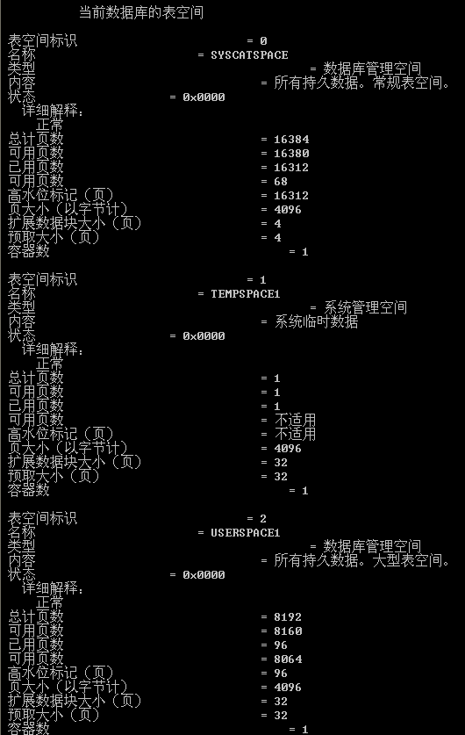

28. Verify which default path containers are associated with the temporary table space and the default user table space.
Show your work below by printing screen.
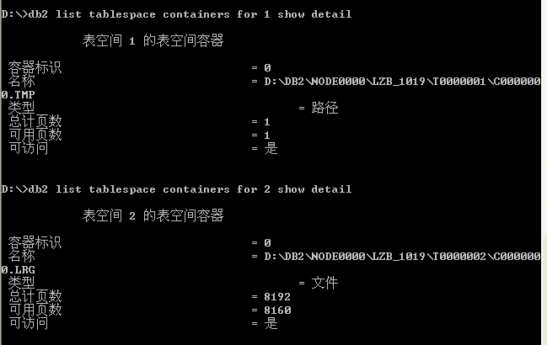

29. Retrieve detailed container information from the Catalog tables. What is the container types for each container?
Show your work below by printing screen.
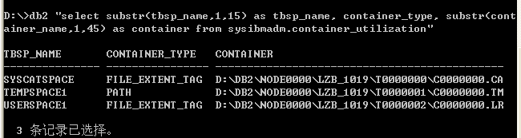

Section 2 - Creating Table Spaces
1. Create your first table space. It should have the following characteristics:
•Table space name is DMS01
•Table Space Type is Regular
•Buffer Pool should be IBMDEFAULTBP (which is also the default)
•Table Space management is DMS (also called high performance)
•Container size should be 1006 pages with 4 KB pages
•Container should be a File
•Container path and filename should be C:\dms\dms01 (Windows)
•Table space extent size and prefetch size should be 4
Show your work below by printing screen for the last step.
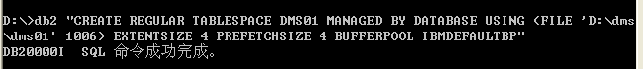

2. Verify your new table space (DMS01) by listing table spaces.
Show your work below by printing screen.
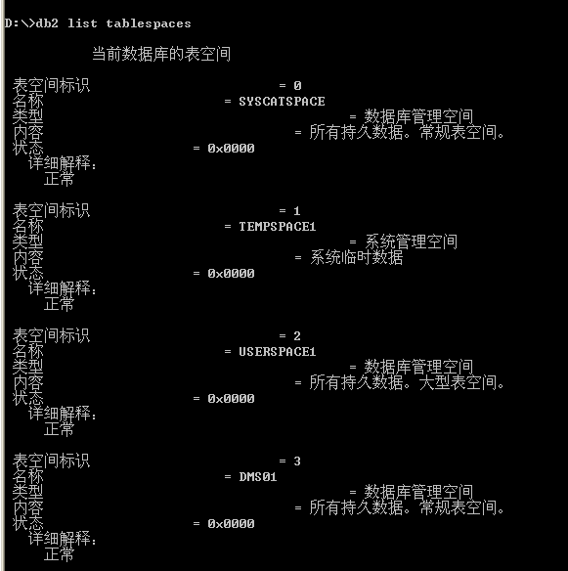

3. On your Windows Database Server, a script file named crtblsp contains SQL statements to create your additional table spaces.
4. Execute the script file to create your remaining table spaces.
Make sure you have the following options set before executing the script:
• Auto commit should be enabled.
• Execution should be stopped if there is an error.
• Commands and statements should be echoed back to the screen.
• A semicolon should be used as the termination character.
Show your work below by printing screen.

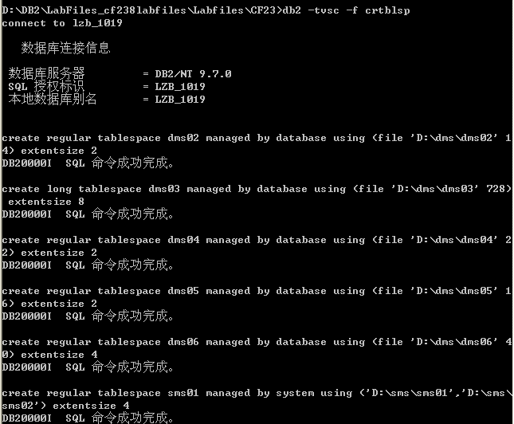

5. Confirm that the additional six table spaces are present. Are your new table space names listed?
Show your work below by printing screen.
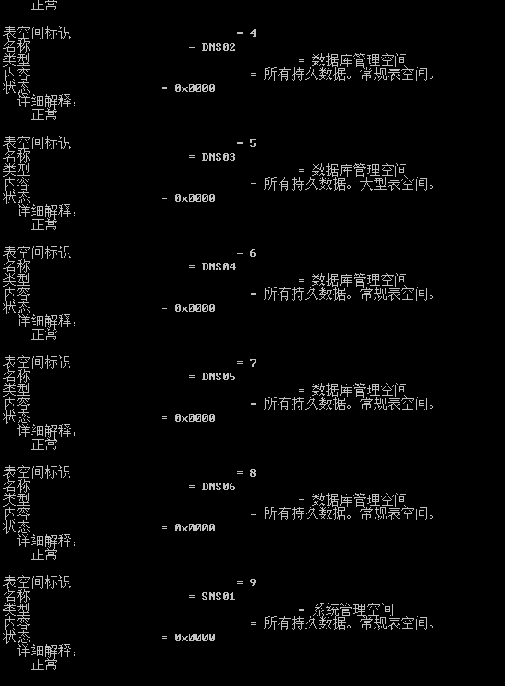

6. From your command window, change directories to C:\dms and do a list of the files.
7. What are these files?
Show your work below by printing screen.
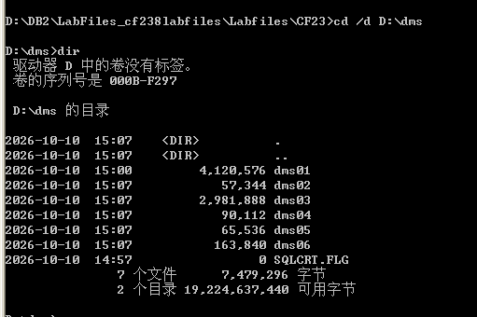

这些文件是 DB2 为 DMS 表空间预先分配的物理容器文件（Container Files）。在创建 DMS 表空间时，DB2 会绕过操作系统的动态按需分配机制，立即在物理磁盘上分配并占满指定页面大小的连续磁盘文件。这些文件直接交由 DB2 存储引擎进行底层块 I/O 管理。

8. Display detailed information about the table spaces. You must be connected to the database first.
Show your work below by printing screen.
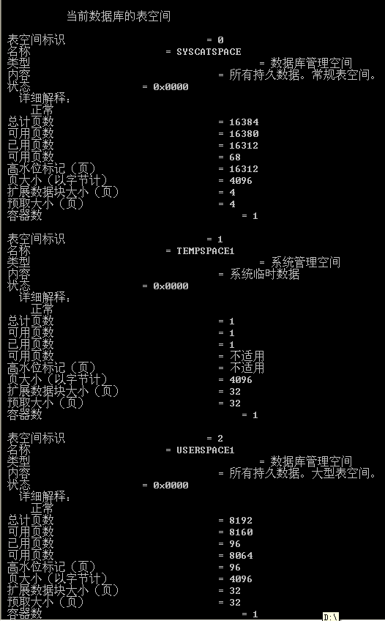
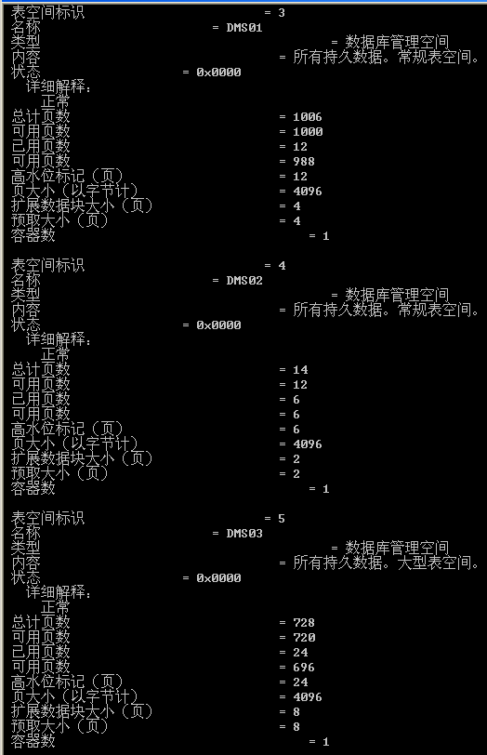
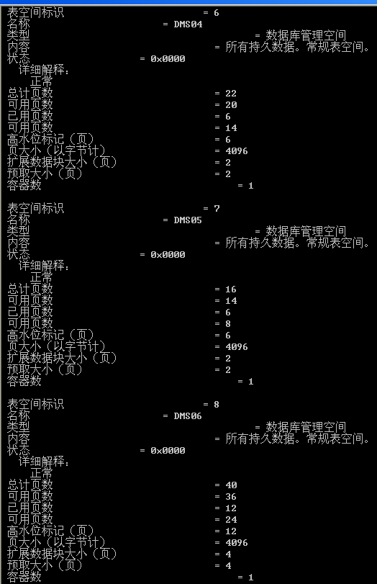
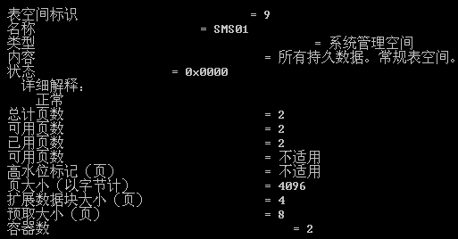

9. What ID numbers are associated with each of the table spaces? How many usable pages are there in the DMS table spaces? List a few differences between SMS and DMS table spaces.
1. 各表空间与 ID 标识的对应关系：
根据实测输出，当前数据库共有 10 个表空间（ID 0 ~ 9），对应关系如下：

ID 0：SYSCATSPACE（数据库管理空间 DMS，系统目录表空间）
ID 1：TEMPSPACE1（系统管理空间 SMS，系统临时表空间）
ID 2：USERSPACE1（数据库管理空间 DMS，默认用户表空间）
ID 3：DMS01（数据库管理空间 DMS，手动创建的常规表空间）
ID 4：DMS02（数据库管理空间 DMS，脚本创建的常规表空间）
ID 5：DMS03（数据库管理空间 DMS，脚本创建的长数据表空间）
ID 6：DMS04（数据库管理空间 DMS，脚本创建的常规表空间）
ID 7：DMS05（数据库管理空间 DMS，脚本创建的常规表空间）
ID 8：DMS06（数据库管理空间 DMS，脚本创建的常规表空间）
ID 9：SMS01（系统管理空间 SMS，脚本创建的系统管理表空间）
2. 各 DMS 表空间的可用页数（Usable Pages）及原因分析：
实测中各 DMS 表空间的可用页数具体如下：

SYSCATSPACE（ID 0）：总计 16384 页，可用页数 = 16380 页（保留 4 页）
USERSPACE1（ID 2）：总计 8192 页，可用页数 = 8160 页（保留 32 页）
DMS01（ID 3）：总计 1006 页，可用页数 = 1000 页（保留 6 页）
DMS02（ID 4）：总计 14 页，可用页数 = 12 页（保留 2 页）
DMS03（ID 5）：总计 728 页，可用页数 = 720 页（保留 8 页）
DMS04（ID 6）：总计 22 页，可用页数 = 20 页（保留 2 页）
DMS05（ID 7）：总计 16 页，可用页数 = 14 页（保留 2 页）
DMS06（ID 8）：总计 40 页，可用页数 = 36 页（保留 4 页）
原因解析：
DMS 表空间的可用页数总是少于总计页数。这是因为 DB2 必须预留部分页面（通常为 1 个 Extent 区段大小加上容器头空间）用于存储容器标记（Container Tag）、区段映射页（Extent Map Page, EMP）以及表空间控制信息等元数据开销。

3. SMS 与 DMS 表空间的核心区别对比：
对比维度 | SMS（系统管理表空间） | DMS（数据库管理表空间）
空间分配机制 | 按需动态分配：写入数据时由操作系统文件系统动态追加文件大小 | 预先分配：创建表空间时即在磁盘上占满固定大小的文件或裸设备
底层管理主体 | 由操作系统底层文件系统负责管理存储与调度 | 由 DB2 数据库引擎直接接管底层存储与块 I/O 调度
容器存储形态 | 容器必须是操作系统目录路径（Path） | 容器可以是磁盘文件（File）或裸设备（Device）
数据分离支持 | 表数据、索引、大对象（LOB）必须存放在同一表空间 | 支持分离存储：表数据、索引、长对象可分别存放于不同表空间
I/O 访问性能 | 受操作系统文件系统缓存与碎片影响，性能相对较低 | 绕过文件系统额外开销，支持直接 I/O，并发性能极高
容量扩充方式 | 依赖宿主磁盘剩余空间，无法手工添加容器 | 支持通过 ALTER TABLESPACE 在线扩展容器或追加新容器

10. Show the container information for table space ID 4. What type of container is this and where it is located?
Show your work below by printing screen.
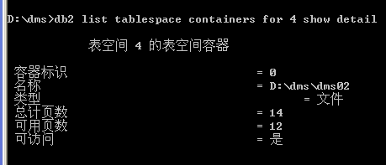
11. Show the container information for your SMS table space ID 10. What type of containers are being used and where are they?
Show your work below by printing screen.
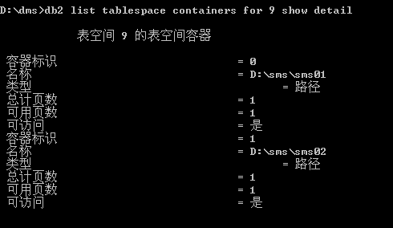

12. From your command window, change directories to SQLT0000.0 and list the directory.

13. Table data is stored in .DAT files, indexes in .INX files, and LOB info in .LB and .LBA files. And there is an SQLTAG.NAM file that holds overhead information about this container, and the tables that are found there.
Show your work below by printing screen.
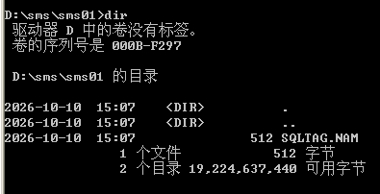

在 SMS 容器目录中，SQLTAG.NAM 是由 DB2 自动生成的容器标记控制文件。它的作用是标定当前目录已被某个特定的 DB2 数据库及表空间独占使用，防止其他表空间或外部进程误用该路径，保障多容器环境下的数据安全性与完整性。

14. From your ssh/telnet session to the database server, create a table and an index on that table in this table space. And then list the contents of the directory again. What do you see now? Are the new files named after the table name?

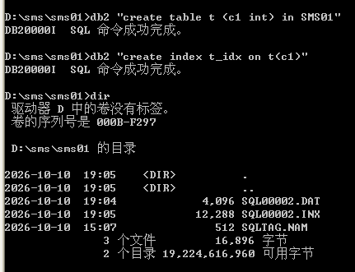

目录中新生成了两个物理文件：`SQL00002.DAT`（表数据文件）和 `SQL00002.INX`（表索引文件）。

No。DB2 不会使用 SQL 语句中的表名（`t`）作为磁盘文件名，而是使用系统内部赋予的对象标识符命名（格式为 `SQL0000x.DAT` 和 `SQL0000x.INX`，其中数字对应内部表对象 ID）。

15. Drop table t as it is no longer needed.
Show your work below by printing screen.
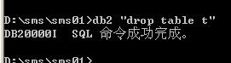

16. Table space information is accessible through a view with the name SYSCAT.TABLESPACES. The fields that contain table space information are:
• TBSPACE — Name of primary table space for this table
• DEFINER — Authid of table space creator
• TBSPACEID — Internal table space identifier
• TBSPACETYPE — Type of table space. D for DMS or S for SMS.
• DATATYPE — Type of data that can be stored in the table space.
L for long data only, A for all types of permanent data, or T for temporary tables only. Issue a select from SYSCAT.TABLESPACES to answer the following questions.
select substr(tbspace,1,18) as tbspace, substr(definer,1,10) as definer, tbspaceid, tbspacetype, datatype from syscat.tablespaces
Show your work below by printing screen.
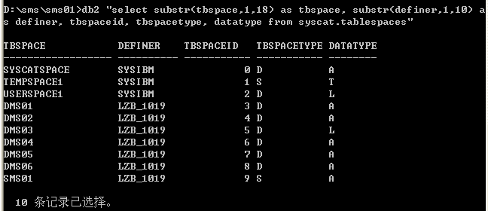
17. What is the authorization ID of table space definer for the default table spaces?
默认表空间（SYSCATSPACE, TEMPSPACE1, USERSPACE1）的 DEFINER 授权 ID 是 SYSIBM。

18. Which of the various table spaces allows long data types?
专门用于长数据的表空间为 DATATYPE = 'L' 的表空间（即 DMS03）。
同时，所有标记为 DATATYPE = 'A'（All types）的 Regular 表空间也允许存放长数据类型。

19. Which table space only allows temporary table data?
DATATYPE 标记为 `T` 的表空间仅允许临时表数据，即 `TEMPSPACE1`（以及用户临时表空间 `USERTEMP1`）。

20. Table space information for individual tables can be accessed through the SYSCAT.TABLES view. The fields that contain table space information are:
•TBSPACEID — Table space ID of primary table space for this table
•TBSPACE — Name of primary table space for this table
•INDEX_TBSPACE — Table space containing the indexes for this table
•LONG_TBSPACE — Table space containing LONG or LOB data for this table
List the table space information for the table SYSIBM.SYSTABLES.
Show your work below by printing screen.
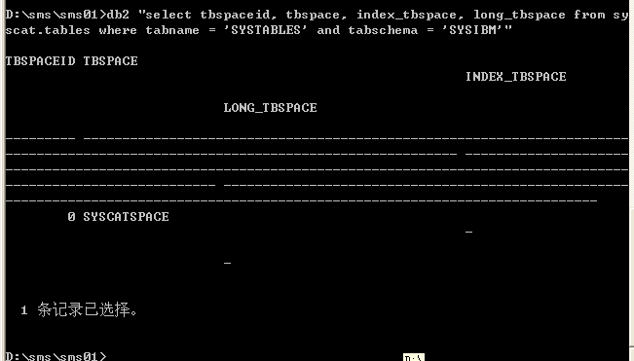
21. Is the SYSIBM.SYSTABLES table divided between different table spaces?
No

22. Enter connect reset to break your database connection.
Show your work below by printing screen.
