WatchTower Android User Guide

# Installation

Before downloading, make sure you have Google Play Services installed and updated. WatchTower relies on Google Play Services and will not run if it is not installed.

To download WatchTower, use a QR scanner and scan the QR code below. The ZXing Barcode scanner is free and available for download in the Google Play Store if you do not have a scanner:

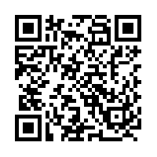

Open the link in a browser and download the Watchtower.apk file. Using the File Manager on your phone, navigate to the Downloads folder and click on the Watchtower.apk file and install. Depending on your device and OS version, you may see warnings about security risks. Allowing apps from unknown sources (Settings->Security->Unknown Sources/”Allow installation of apps from unknown sources”) will help speed up the installation process.

# Configuration

Before you begin sharing your location, you will need to configure WatchTower to send messages with your information. Click on the upper right corner (the three vertical dots) to display the Settings tab to configure the following settings:

* UserID: This value will be your identifier that appears when other WatchTower users tap on your icon, and can be any value such as a name or unit identifier. If left empty, this value will default to your phone’s device name.
* Agency: Fill in this value with the agency/department you represent. If left empty, this will be filled in with a generic agency.
* Resource Type: Select the resource type that is most applicable to you.

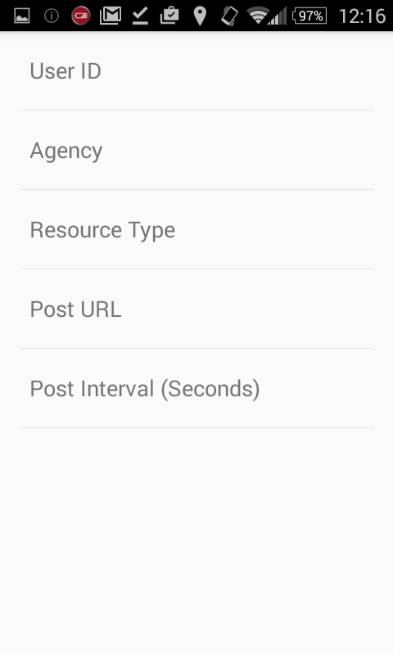

# Location Sharing

To share your location, you can tap the location button in the bottom right corner on the Maps tab or toggle the Location Sharing button on the Location tab. WatchTower will continue to share your location until it is closed or until location sharing is turned off by tapping the location button again or switching the Location Sharing button on the location tab to “Off”.

