1. Download the app by scanning the following QR code:



1. After installing the app, you may need to explicitly trust the app. The warning message below will display if you attempt to launch the app when it hasn’t been trusted.  
     
   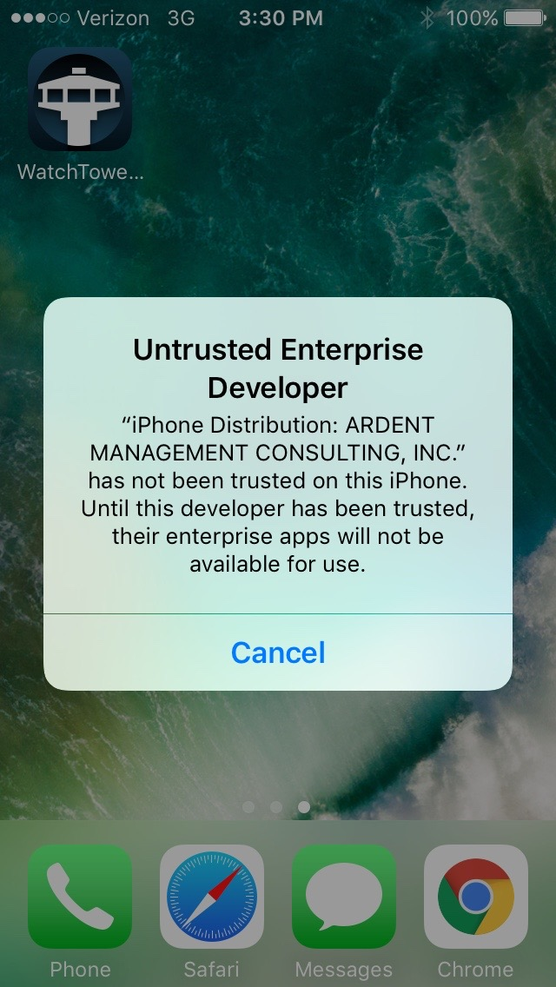
2. To trust the app, go to iPhone Settings -> General -> DeviceManagement, and select the ARDENT MANAGEMENT CONSULTING enterprise app:  
     
   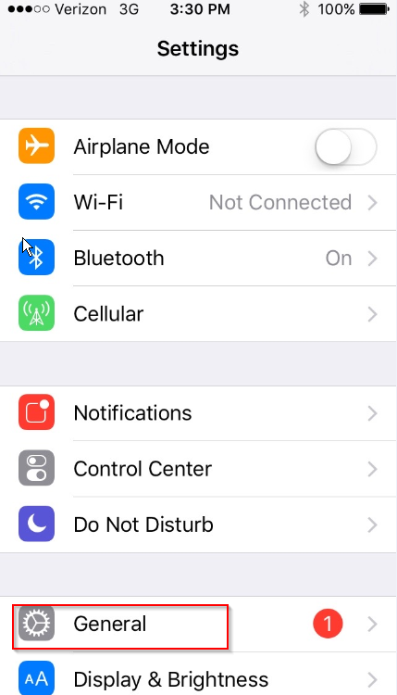  
     
   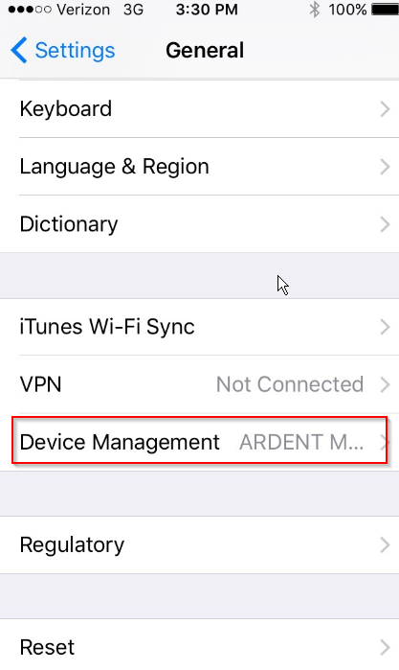  
     
   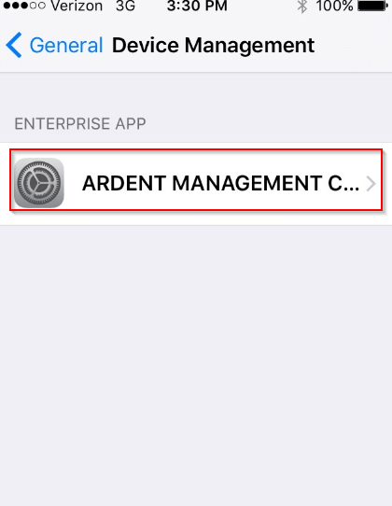
3. Next, click “Trust “ARDENT MANAGEMENT CONSULTING, INC.”, then click “Trust” in the second popup window. The application can now run on the phone.  
     
   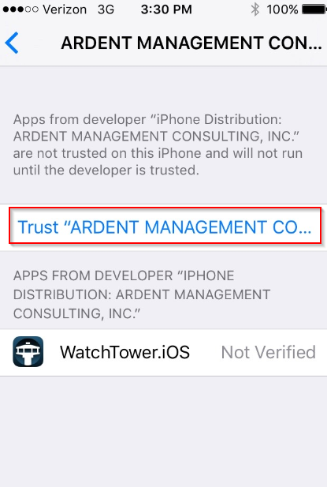  
     
   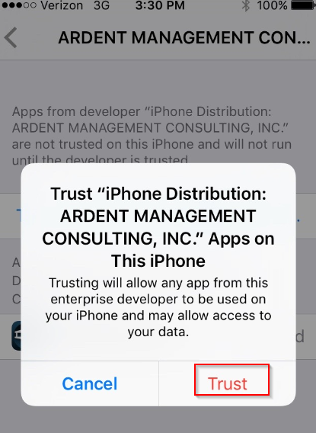  
     
   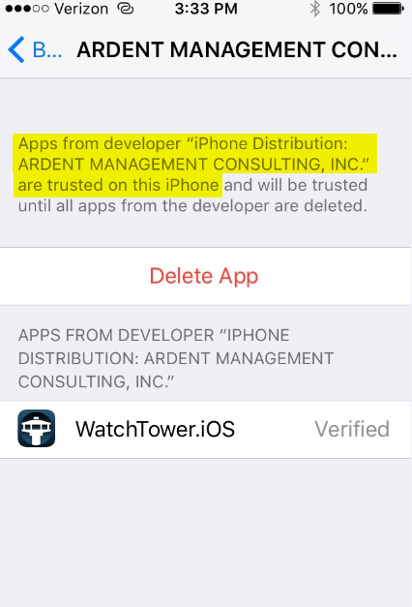
4. Return to top-level settings menu in iPhone, then scroll down until you see the “WatchTower.iOS” app. Select the app:  
     
   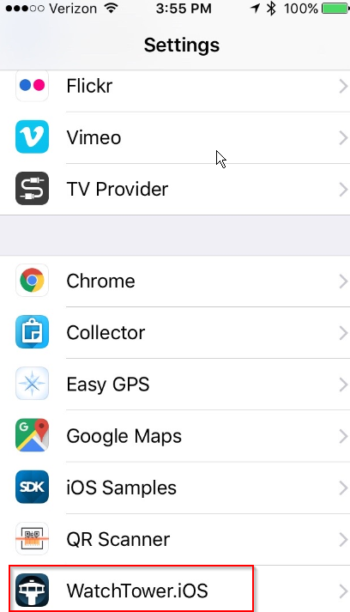
5. In the settings for WatchTower, you can set the various configuration values:  
   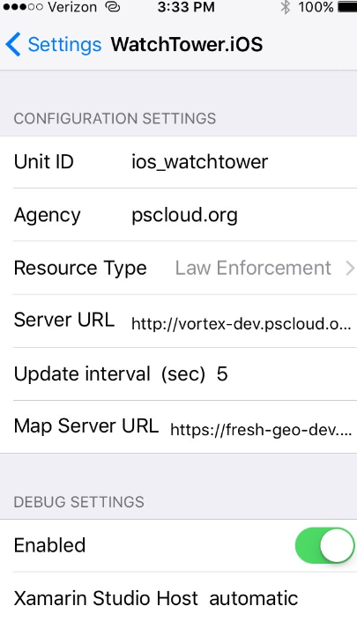
6. Navigate to the WatchTower app on the iPhone and launch it. When it first opens up, click “Allow” to enable WatchTower to track your position:  
     
   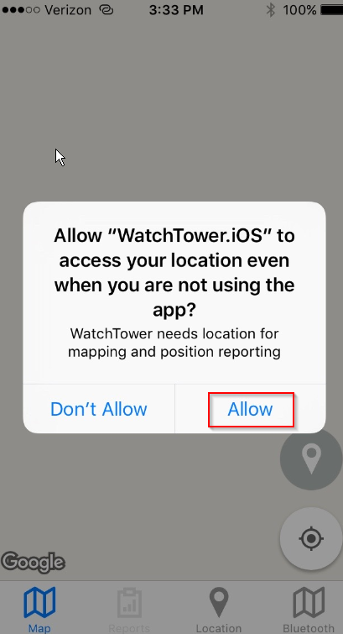
7. On the “Map” tab, click the location button to turn on (green) or off (gray) location reporting:  
     
   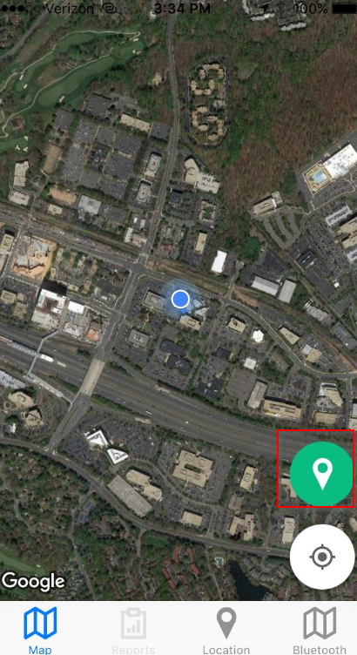
8. You can also toggle location reporting using the Location tab:  
     
   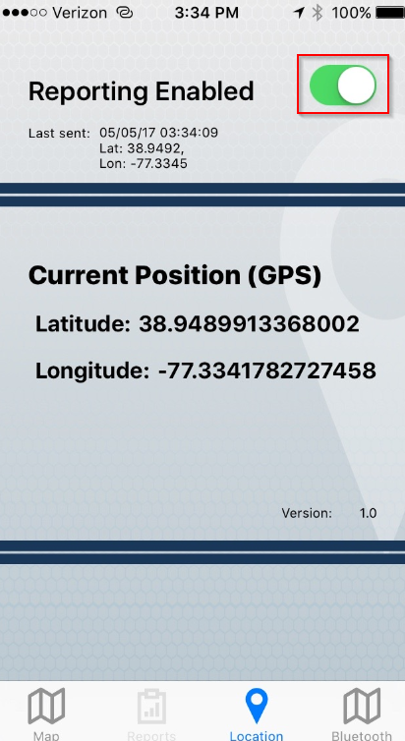
9. On the Bluetooth tab, press “Add Device” to go to the next screen where you will scan for Bluetooth devices:  
     
   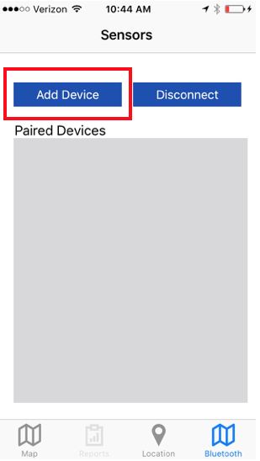
10. On the Sensor Pairing screen, press “Scan” to scan for Bluetooth Low Energy (BLE) devices:  
    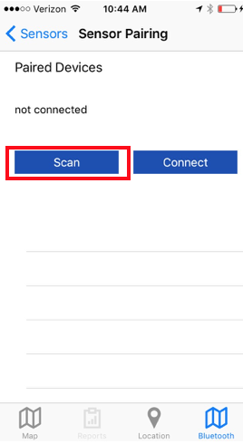
11. When the device that you want to connect to is found, select it and press “Connect”:  
      
    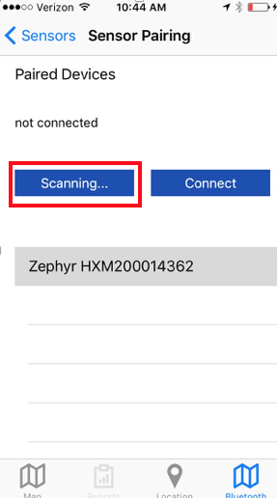

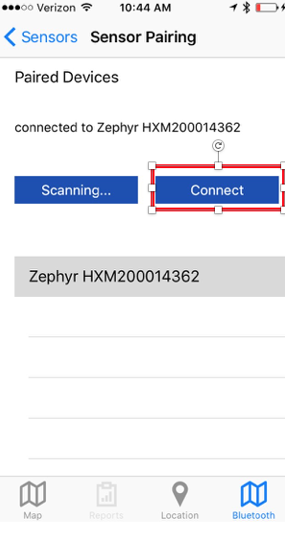

1. You can go back to the Sensors screen to view all connected devices, along with some of the data being received from the devices:  
     
   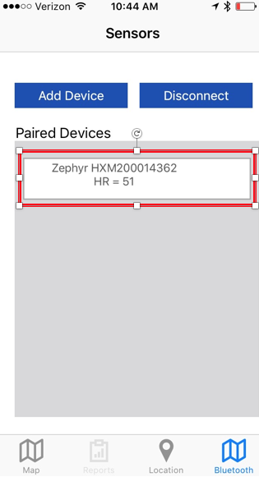
2. To disconnect from a device, select the device and press “Disconnect”:

