NICS

Windows Installation Guide

Version 7

Submitted By:

[](https://sp.ardentmc.com/Company%20Logos/ArdentMC2_White.png)

Ardent Management Consulting, Inc.

1840 Michael Faraday Drive, Suite 120

Reston, VA 20190

# Before You Begin:

## Notes Regarding Installation:

* When installing programs for NICS, be sure to use the exact versions specified by this guide. Installing a newer version of the program or 64bit vs 32bit can lead to unforeseen conflicts. It is recommended you use the executables included with NICS to avoid any issues.
* Make sure that each install is ran in administrative mode. Many of these programs will fail to install if the executables are ran normally.
* Throughout this guide, you will be asked to make a number of changes to the Window’s environmental variables. Make sure to periodically check and save these changes since they can be overwritten during the install process.
* In this guide, we will use: <FQDN> to stand for the fully qualified domain name (FQDN) of the server that NICS is running on.
* NICS 7 requires an Identity Provider (IDP) that supports WS-Federation (WS-Fed) to be run successfully.
  + In this guide we use Identity Server 3 as the IDP for NICS.
    - For information on Identity Server 3 visit: <https://identityserver.github.io/Documentation/>
  + It is also possible to use OpenAM in place of an IDP but it will cause a drop in performance
    - For information on OpenAM visit:

[https://backstage.forgerock.com/#!/docs/openam/12.0.0/getting-started](https://backstage.forgerock.com/%23!/docs/openam/12.0.0/getting-started)

## Default Log File Locations:

**TomCat**: C:\Program Files\Apache Software Foundation\Tomcat 8.0\logs

**PostGreSQL**: C:\Program Files\PostgreSQL\<VERSION>\data\pg_log

**RabbitMQ**: C:\Users\<PC_NAME>\AppData\Roaming\RabbitMQ\log

## Default Credentials:

**RabbitMQ**: guest guest

**GeoServer**: admin geoserver

## Prerequisites

* The following ports must not be in use:
  + 8080
  + 8081
  + 80
  + 443
* OpenSSL
* 7-Zip (Or another comparable file extractor)
* (Optional) If you wish to use Identity Server 3 for your IDP then you must have Visual Studio

# Installation

## Modify Host File

1. Open the hosts file for windows in a text editor of your choice.
   1. This file is located at: C:\windows\system32\drivers\etrc\hosts
2. Add the following lines to the end of the file

::1 localhost

127.0.0.1 localhost <FQDN>

## PostgreSQL

### Install PostgreSQL

1. Run postgresql-9.4.4-3-windows-x64.exe
   1. PostgreSQL 9.5 will also work
2. Accept the default installation location

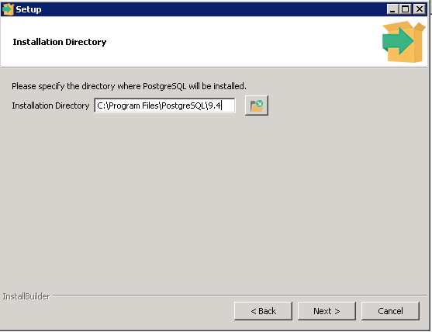

1. Accept the default data directory.

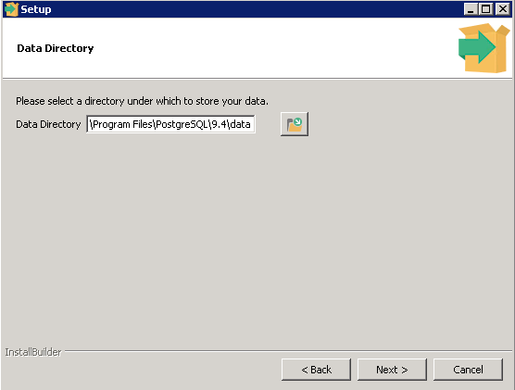

1. Provide and record a postgres superuser password.

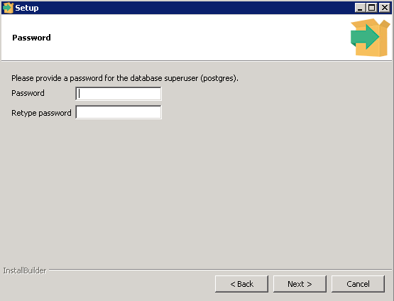

1. Accept the default database port

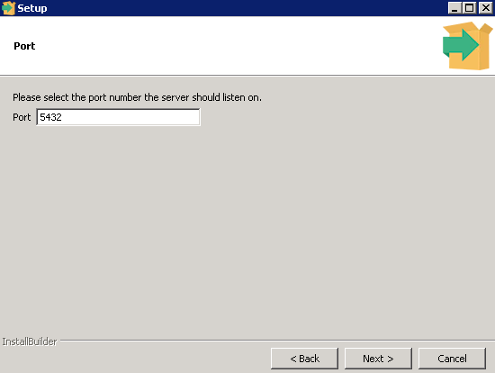

1. Accept the default locale.

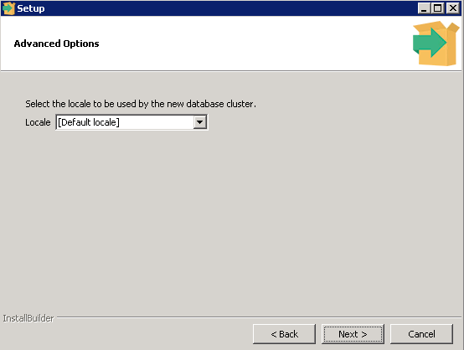

1. Proceed by clicking **Next**.

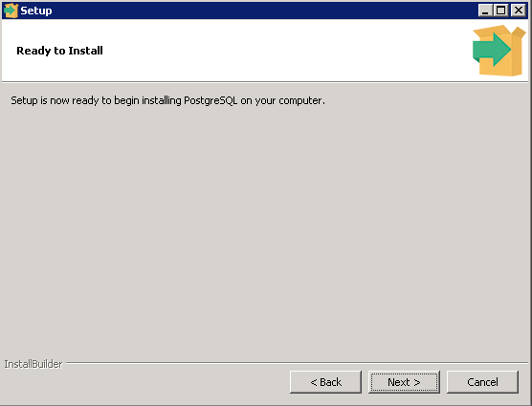

1. Ensure that the Stack Builder checkbox is checked, and click **Finish**.

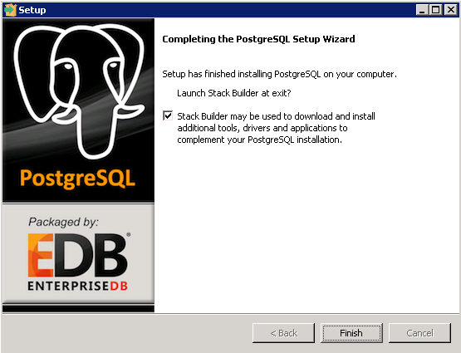

1. Select PostgreSQL 9.4 (x64) on port 5432

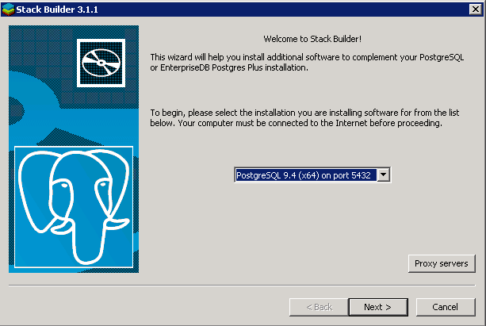

1. Select the Java JDBC driver and the 64-bit PostGIS Spatial extension

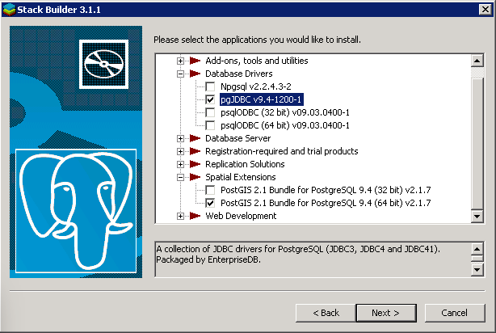

1. Specify a download folder

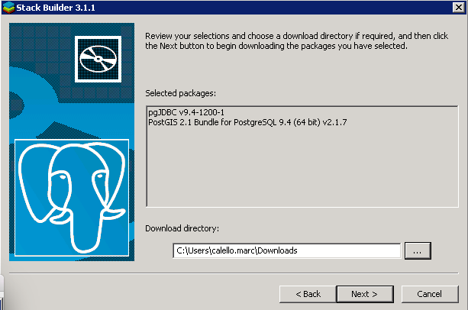

1. Once the selections have been downloaded, proceed to install them

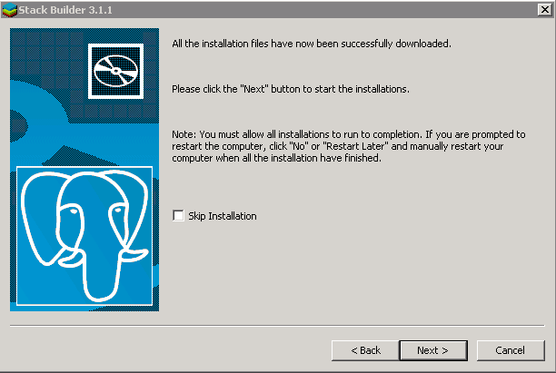

1. Install the JDBC driver

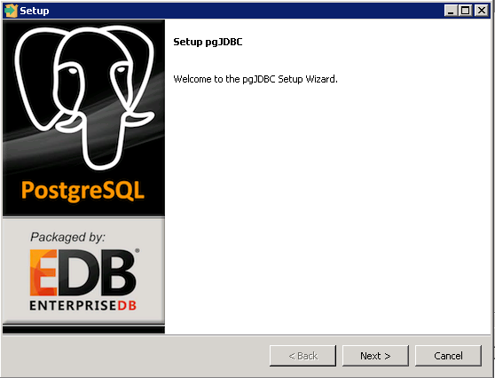

1. Accept the default installation directory

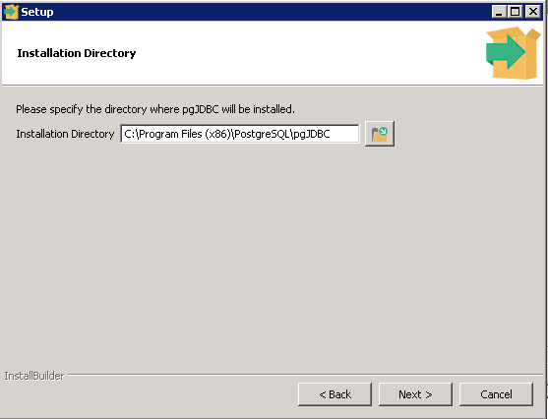

1. Click **Next** to install.

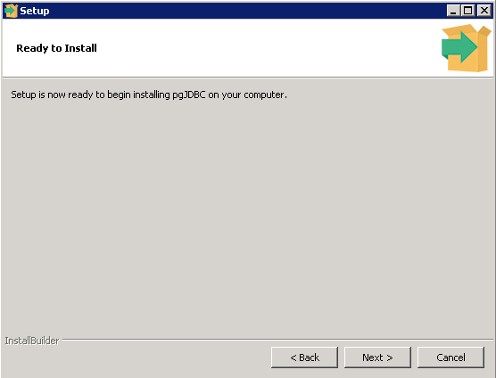

1. When complete, click **Finish**.

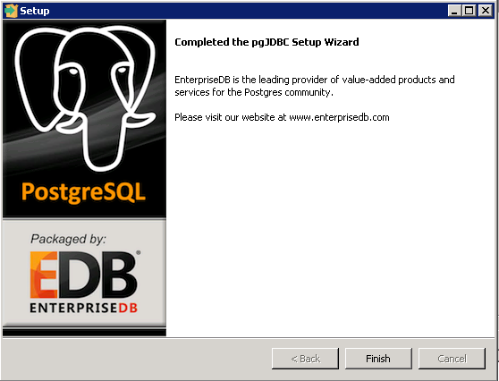

### Install PostGIS

1. Accept the license agreement  
   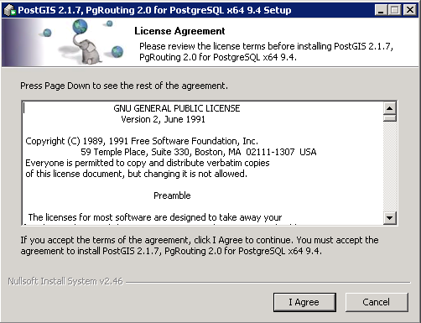
2. Accept the default components (Do not select create spatial database)  
   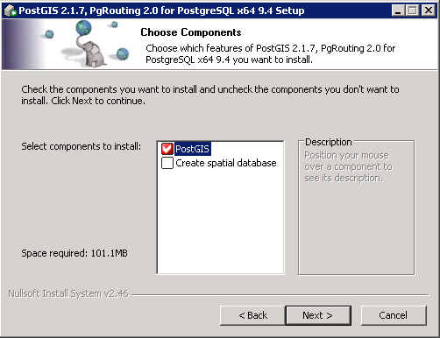
3. Accept the default installation directory  
   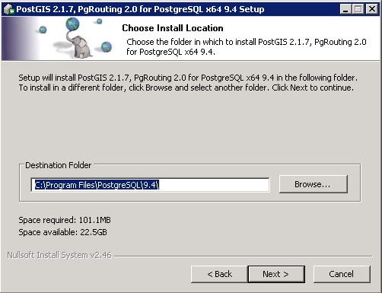
4. When prompted to update the GDAL environment variable, click **Yes**.  
   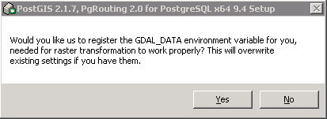
5. Click **Yes** to set POSTGIS_ENABLED_DRIVERS.  
   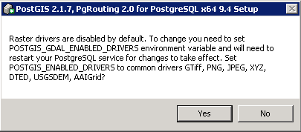
6. Click **Yes** to enable the db rasters.  
   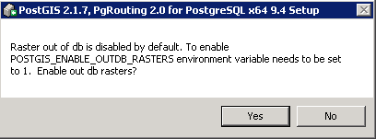
7. When complete, click **Close**.  
   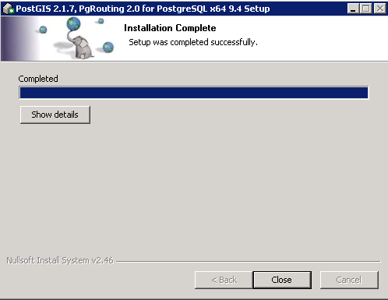
8. Finally, click **Finish**.  
   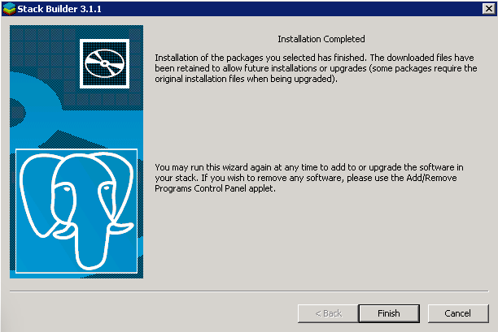

### Configure PostgreSQL

1. Create a new system environment variable called: POSTGRESQL_BIN and point it to: C:\Program Files\PostgreSQL\9.4\bin

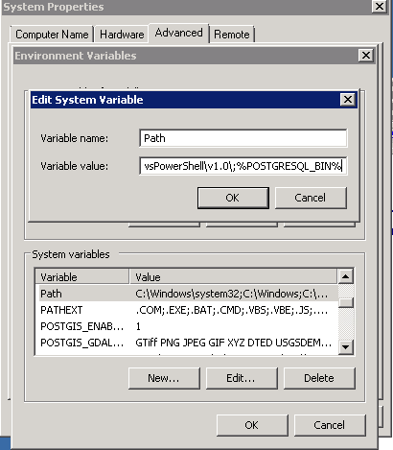

1. Add the POSTGRESQL_BIN variable to the System Path:
2. (Distributed Only) For multi-tier systems, PostGreSQL needs to be configured to allow non-local connections.
   1. Navigate to: C:\Program Files\PostgreSQL\9.4\data\pg_hba.conf
   2. Add the following line to the end of the pg_hba.conf file:

host all all <NON-LOCAL_IP_ADDRESS> md5

## Java

Two versions of Java are needed to run NICS properly.

### Install

1. Install the 64bit Java 7 JDK by running jdk-7u80-windows-x64.exe
   1. This is required for TomCat and the NICS Web Apps.
2. Install the 32bit Java 7 JRE by running jre-7u79-windows-i586.exe
   1. This is required for GeoServer.

### Configuration:

1. Create a new System Environment Variable called JRE_HOME and give it the path to the 32 bit JRE 7. Then add this variable to the system path.
2. Modify the JAVA_HOME environment variable so that it points to the 64 bit JDK 7.

## X509 Certificate

You will need an identity certificate for setting up SSL and for the IDP.

### Create a Self-signed Certificate

If you do not have an identity certificate, you can use OpenSSL to create one.

1. Run the following commands via the command line. The CN should be <FQDN>.

openssl pkcs12 -export -in public.pem -inkey private.pem mycert.pfx

openssl genrsa 2048 > private.pem

openssl req -x509 -days 1000 -new -key private.pem -out public.pem

### Import

It is not enough to just double click the certificate. It must be manually loaded in.

1. Open MMC (type mmc into the command line)
2. Click **File** then **Add/Remove Snap-ins**
3. Select **Certificates** from right and press **Add**
4. Select **Computer account**, **local computer**.
5. Press **Okay**
6. Click the **+** next to Certificates (Local Computer)
7. Right click **Trusted Root Certification Authorities**, navigate to **all tasks**, then click **import**
8. Select your newly created certificate and click **Next**
9. Select **Place all certificates in the following store**
10. Then **Finish**
11. You do not need to save the settings when closing MMC

## Apache Web Server

There are two versions of Apache in the Installs directory: httpd-2.4.25-win64-VC14.zip and httpd-2.4.25-win32-VC14.zip. If you plan on using the OpenAm with an OpenAM WebAgent then you must use the Win32 version.

### Install

1. Move the desired version of Apache into the C:\ drive and unzip the directory. You should now have a C:\Apache24 directory.
   1. This location is mandatory to make Apache work since it is where Apache assumes its root folder will be.
2. To install Apache, you will need to open the Administrator Command Line and navigate to C:\Apache24\bin.
3. Run the following command:

httpd.exe -k install

1. Apache should install successfully.

### Initial Test

Test that apache installed successfully by starting the service.

1. To start the service, you will need to open the Administrator Command Line and navigate to C:\Apache24\bin.
2. Run the following command:

Net start Apache2.4

1. Now, open the browser, navigate to: http://<FQDN>:80
2. You should see the following page:



If anything else appears or if you run into an error that indicates there’s an issue with your setup. To confirm that port 80 is not in use, run the following command:

netstat -aon | findstr :80

### Install mod_jk & isapi redirect Module

There will be two zips folders found in the install directory: mod_jk-1.2.42-win64-VC14.zip and mod_jk-1.2.42-win32-VC14.zip. Use the zip file that corresponds to the Apache Version that was installed above.

1. Unzip the mod_jk zip file in a location of your choice. This will reveal a folder with 5 new files. The only one we are concerned with is mod_jk.so.
2. Move the mod_jk.so file into C:\Apache24\modules.
3. Then navigate to C:\Apache24\conf and create a file called workers.properties
4. Open workers.properties in a text editor of your choice and paste the following into the file:
   1. Make sure that the file saves as a properties file and not a text file!

# Define 1 real worker using ajp13

worker.list=worker1

# Set properties for worker1 (ajp13)

worker.worker1.type=ajp13

worker.worker1.host=<FQDN>

worker.worker1.port=8009

worker.worker1.lbfactor=50

worker.worker1.socket_keepalive=1

worker.worker1.socket_timeout=300

1. Save and Close the file.

### Configure

#### httpd.conf

1. Navigate to C:\Apache24\conf and open httpd.conf in a text editor of your choice.
2. Make the following changes to the file:
3. Uncomment the following modules by removing the # before:
   * mod_headers.so
   * mod_proxy.so
   * mod_proxy_ajp.so
   * mod_proxy_html.so
   * mod_proxy_http.so
   * mod_proxy_http.so
   * mod_proxy_wstunnel.so
   * mod_socache_shmcb.so
   * mod_ssl.so
   * mod_xml2enc.so
4. Uncomment the following lines by removing the # before:
   * Include conf/extra/httpd-ssl.conf
   * ServerName www.example.com:80
5. Add the following line:

LoadModule jk_module modules/mod_jk.so

1. Replace the line:

Options Indexes FollowSymLinks

1. With:

Options -Indexes -FollowSymLinks

1. Set ServerAdmin to be your email
2. Set ServerName to <FQDN>:80
3. Add the following code to the end of the file:

JkWorkersFile conf/workers.properties

JkLogFile logs/mod_jk.log

JkLogLevel info

<VirtualHost _default_:80>

Redirect / <FQDN>/

</VirtualHost>

1. Save and close

#### Move Certificate

Apache will require an identity certificate to use SSL

1. Copy both the certificate and the key into C:\Apache24\conf

#### httpd-ssl.conf

1. Navigate to C:\Apache24\conf\extra and open httpd-ssl.conf in a text editor of your choice.
2. Set the ServerName to <FQDN>:443
3. Set the ServerAdmin to be your email
4. Specify the SSLCertificateFile and the SSLCertificateKeyFile for your setup (the files we just moved in the step before)
5. Add the following to the end of the file (but before </VirtualHost>)

ProxyPass /geoserver http://<FQDN>:8081/geoserver

ProxyPassReverse /geoserver http://<FQDN>:8081/geoserver

ProxyPass /nics/mediator ws://<FQDN>:8080/nics/mediator

ProxyPassReverse /nics/mediator ws://<FQDN>:8080/nics/mediator

ProxyPass /nics/mediator ws://<FQDN>:8080/nics/mediator

ProxyPassReverse /nics/mediator ws://<FQDN>:8080/nics/mediator

RedirectMatch 301 ^/nics/spring_logout$ https://<FQDN>/nics/login?loggedOut=true

JkMount /nics/* worker1

JkMount /nics worker1

JkUnMount /geoserver/* worker1

JkUnMount /spring_logout worker1

JkMount /em-api/* worker1

JkMount /em-api worker1

JkMount /upload/* worker1

JkMount /upload worker1

* 1. NOTE: Spring Security will redirect users to /spring_logout when their session is invalid.

1. (Optional) If using Identity Server 3 as your IDP, add the following to the end of the file (but before </VirtualHost>)

ProxyPass /core http://< IDP_URL>:<IDP_PORT>/core

ProxyPassReverse /core http://<IDP_URL>:< IDP_PORT >/core

1. Save and close

### Stop and Reinstall the service:

1. Stop and uninstall Apache with the following commands:

Net stop Apache2.4

httpd.exe -k uninstall

1. Install and start Apache with the following commands:

httpd.exe -k install

httpd.exe -k install

## NICS Database Scripts

### Notes Regarding Database Scripts:

If a script fails or you make a mistake you can use the following commands to start from scratch:

psql -U postgres --command="drop database nics"

psql -U postgres --command="drop user nics"

psql -U postgres --command="drop database \"nics.datalayers_postgis\" "

psql -U postgres --command="drop database \"nics.shapefiles\" "

psql -U postgres --command="drop database \"nics.datafeeds\" "

### Run the scripts

1. Run the command prompt as Administrator and navigate to the nics-db directory.
2. Run the following commands:

createNICSDatabase.bat nics

1. Go into the nics-db/scripts directory
   1. Create the NICS system with the following command:

create_system.bat <FQDN> <SYSTEM_DESCRIPTION> 1 Incident 1

* 1. Create the default user with the following command:

create_default_user.bat nicsadmin 1 1

* 1. Add an organization with the following command:

create_org.bat "<ORG_NAME>" <ORG_COUNTY> <OrgState> <OrgPrefix> <OrgTypeId>

1. Go into nics-db/datalayers
   1. Run the following command:

addDataLayer.bat

1. Go into nics-db/Change
   1. Run the following command:

add_Changes.bat

## GeoServer

### Install

1. Run geoserver-2.7.1.1.exe
2. Click **Next** to begin installing GeoServer.  
   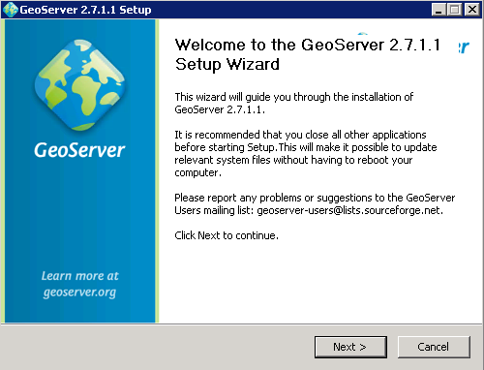
3. Accept the terms and conditions  
   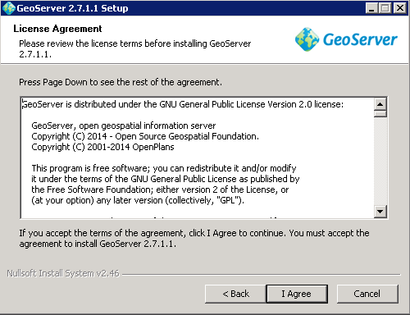
4. Accept the default destination folder  
   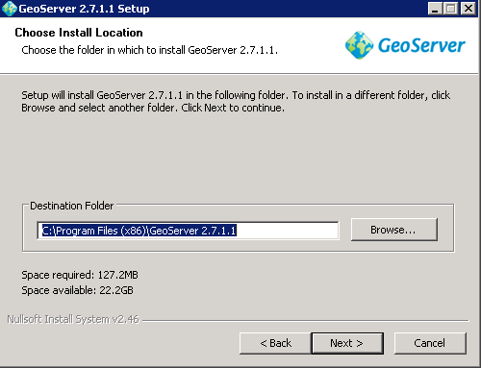
5. Accept the defaults for the Start Menu  
   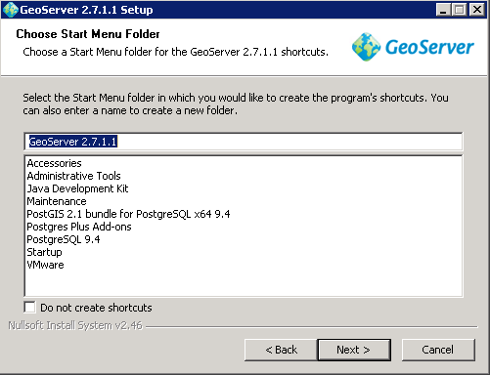
6. Make sure to set the JRE to the one specified in JRE_HOME (The 32bit Java 7 JRE).  
   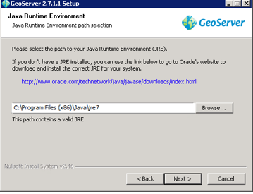
7. Accept the default data directory,  
   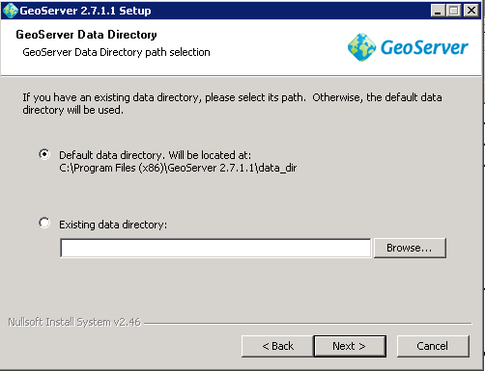
8. Provide a username and password for the GeoServer administrator.  
   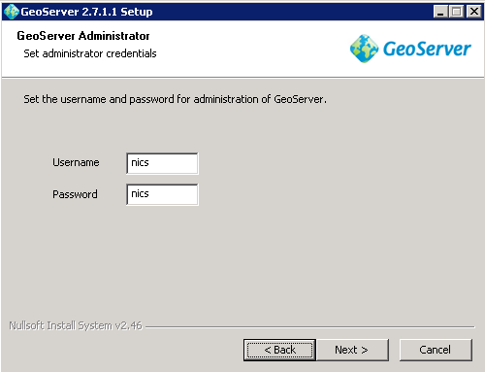
9. Change the default port (since Tomcat will use 8080 later) to 8081  
   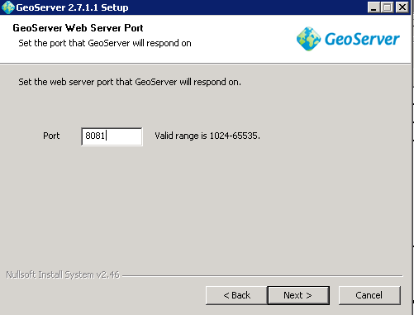
10. Select **Install as a service**  
    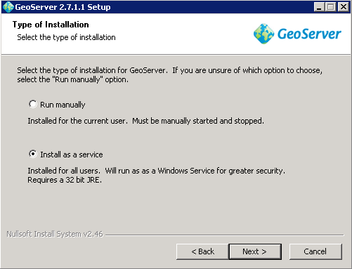
11. Review your configuration, and click **Install**.  
    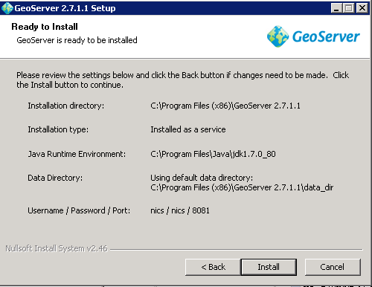
12. When GeoServer has successfully completed, click **Finish**.  
    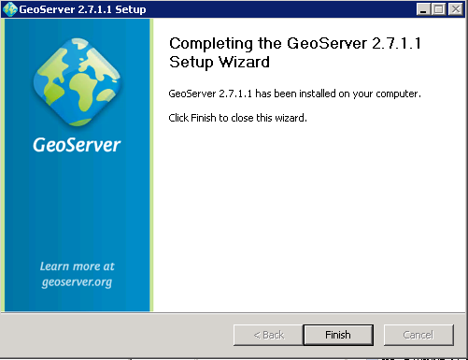

### Configure GeoServer

We will be making three different workspaces and three different stores for NICS.

#### Configure Install

1. Navigate to: C:\Program Files (x86)\GeoServer 2.7.1.1\wrapper
2. Open wrapper.conf with a text editor
3. Modify the first uncommented line so that it points to JRE_HOME and not JAVA_HOME

wrapper.java.command=%JRE_HOME%/bin/java

1. Open you windows environment variables and confirm that both JAVA_HOME and JRE_HOME are pointing to the correct values (GeoServer’s install tends to overwrite these).
2. Restart GeoServer
3. You can confirm GeoServer is working by navigating to:

http://<FQDN>:8081/geoserver/web

1. You should see the GeoServer Web Interface

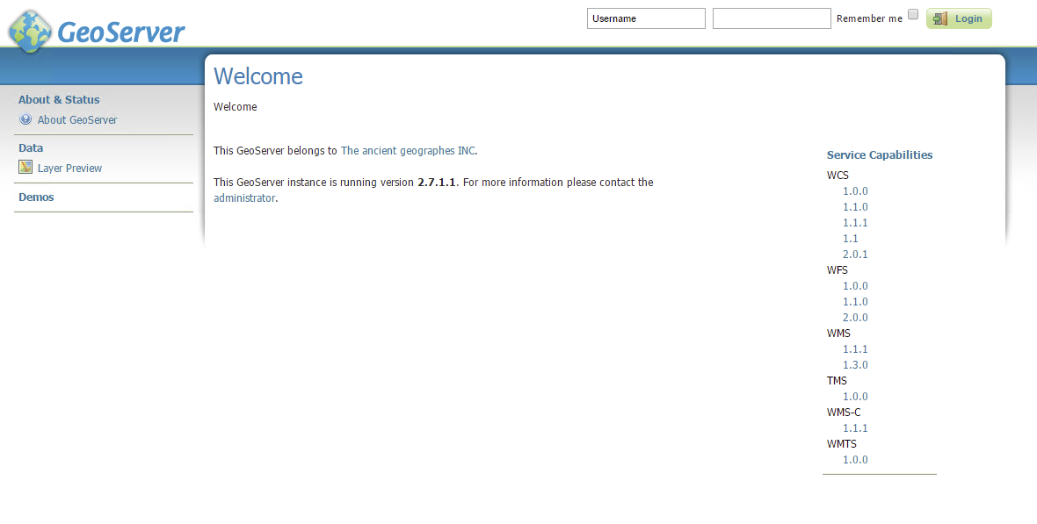

#### Add Workspaces

1. From the GeoServer Web Interface, select Workspaces from the side panel

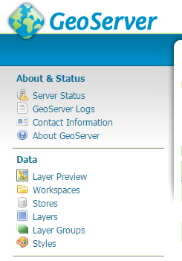

1. Click **Add a new workspace**

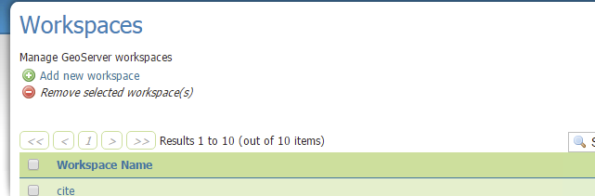

1. For the first workspace, use the following values:

**Name:** nics.collaborationfeed

**Namespace URI:** http://<FQDN>:8080/ nics.collaborationfeed

(You do not need to make the workspace the default one.)

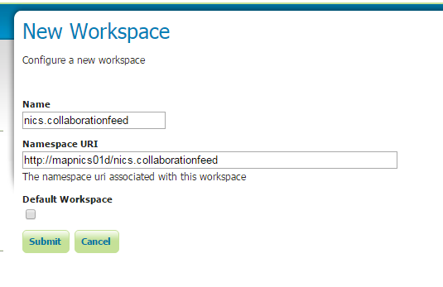

1. Click **Submit**

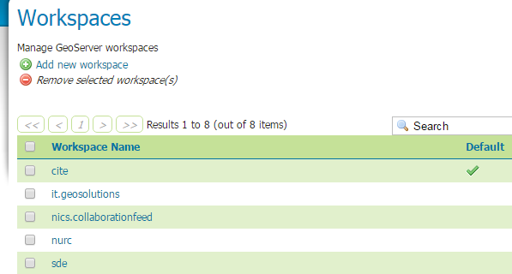

1. Now click the newly created workspace

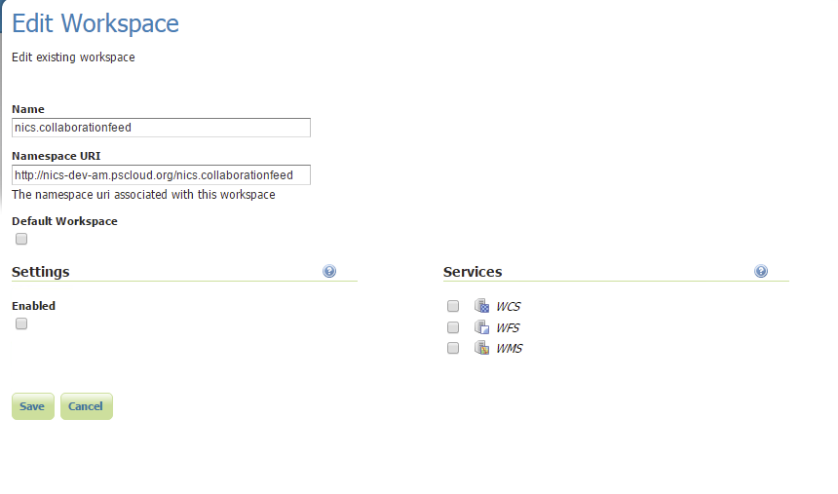

1. Select all the options under Services

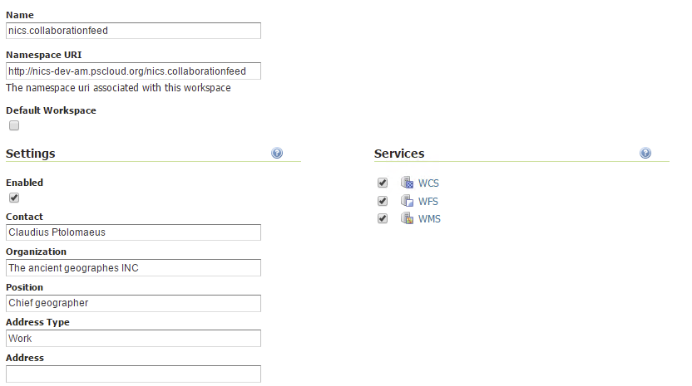

1. Enable the workspace by selecting **Enabled**
   1. You can leave the default information for the workspace.



1. Click **Save**
2. Repeat steps 2 -8 for the following workspaces
   1. Shape Files Workspace

nics.shapefiles

http://<FQDN>/nics.shapefiles

* 1. Images Workspace  
     nics.images

http://<FQDN>/nics.images

#### Add Stores

1. From the GeoServer Web Interface, select Stores from the side panel



1. Click **Add new Store**  
   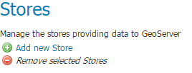
2. Select **PostGIS**   
   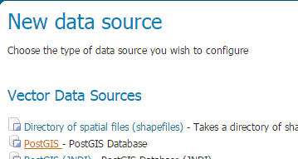
3. Fill out the new Store field with the following details:

**Name:** nics

**Database:** nics

**Workspace**: nics.collaborationfeed

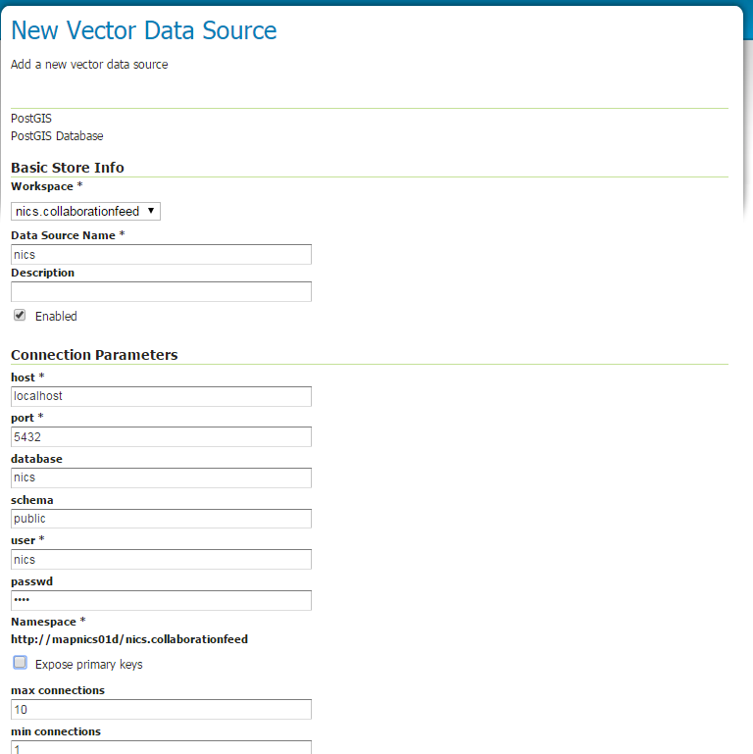

1. Provide the Connection parameters to the NICS database within Postgres.
2. Accept the defaults and click **Save**.
3. Repeat steps 1 – 6 for the following Data Stores:
   1. Nics Shapefiles

**Name:** nics.shapefiles

**Database:** nics.shapefiles

**Workspace**: nics.shapefiles

* 1. Nics Images

**Name:** nics.images

**Database:** nics

**Workspace**: nics.images

#### Style Sheet

1. Click **Styles** from The Navigation bar on the left  
   
2. Click **Add a new style**

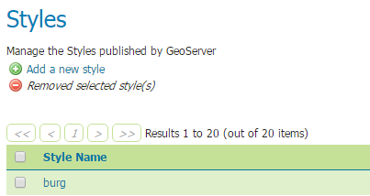

1. Provide the following parameters:

**Name:** collabRoomStyle

**Format:** SLD

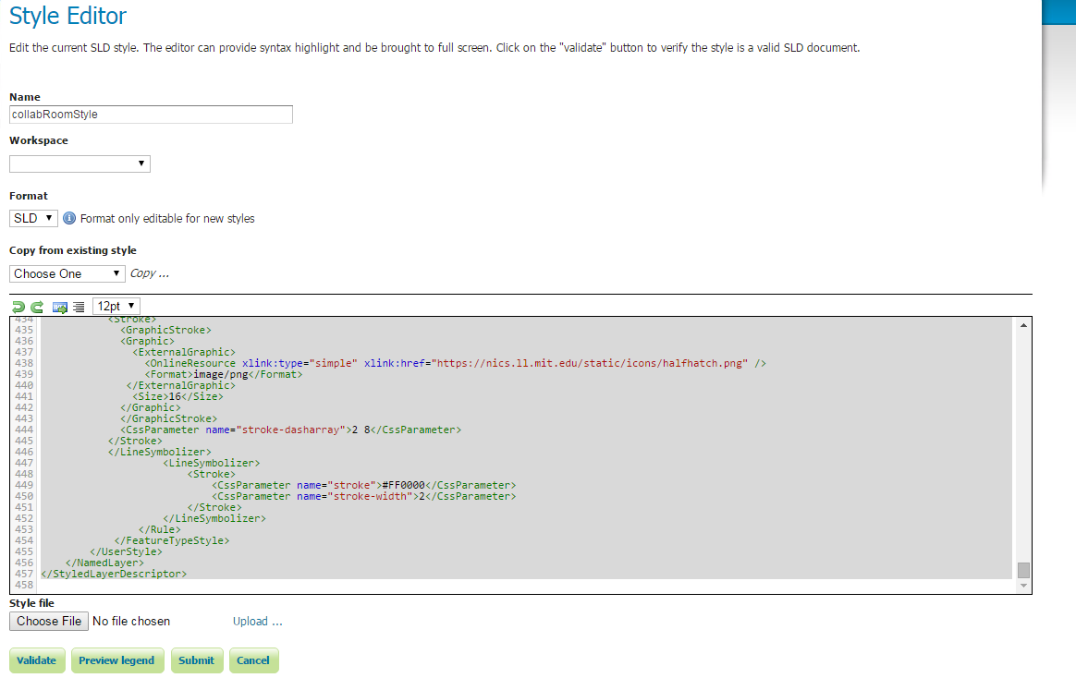

1. The style sheet you need is stores in the Config folder for NICS. The file is called collabRoomStyle.txt
2. Open this file in a text editor of your choice.
3. Copy and paste its contents into GeoServer



1. Click **Validate**, and then once successful, click **Submit**.

## RabbitMQ

The version for this program is hard coded into many of the configuration files (and possibly the code) for NICS. Be sure to use the included installer.

### Install Erlang

RabbitMQ will not let you install it without Erlang.

1. Run esl-erlang_18.0-1-windows_amd64.exe
2. Make sure to check all the boxes shown below, and click **Next**.  
   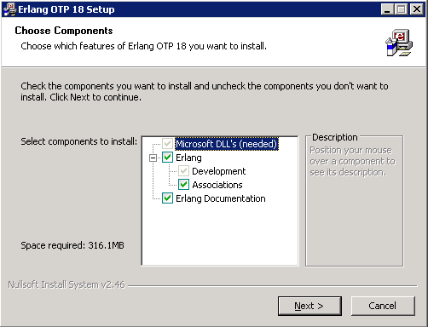
3. Accept the default installation location  
   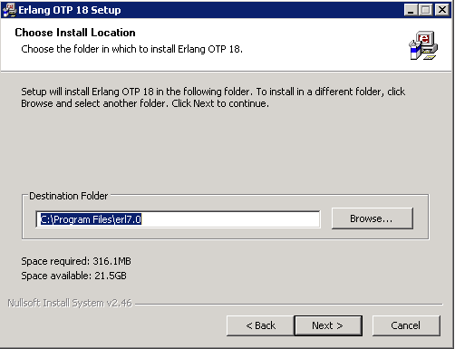
4. Accept the default Start Menu location  
   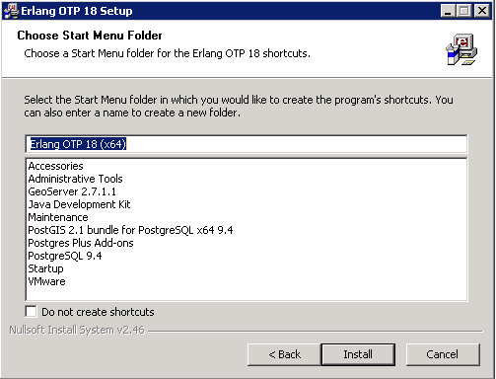
5. If the installer determined that it needed to install the VC++ dlls, it will prompt you to accept the license and terms. This is required to run Erlang.  
   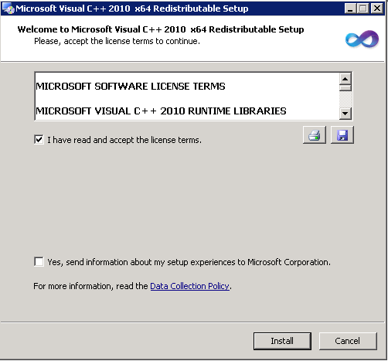
6. When the VC++ libraries are installed, click **Finish** and the Erlang installer will resume.  
   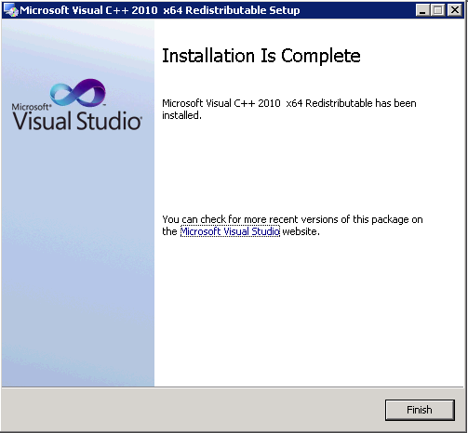
7. Once it completes successfully, click **Close**.  
   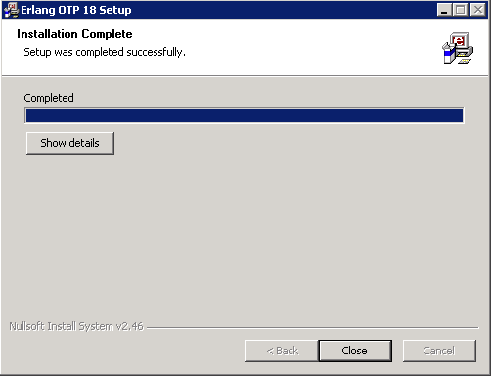

### Install RabbitMQ

1. Run rabbitmq-server-3.2.1.exe
2. Check the following component selections, and click **Next**.  
   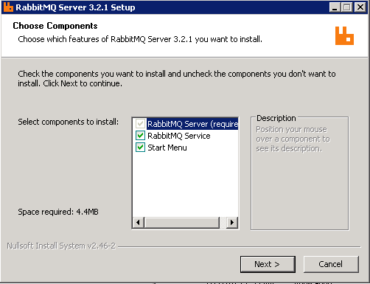
3. Accept the default installation location  
   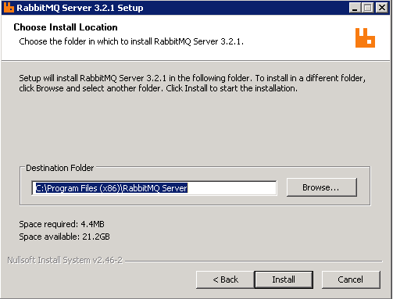
4. When the RabbitMQ installer has completed successfully, click **Finish**.  
   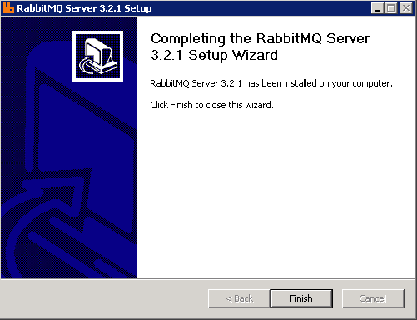

### Verify Installation

You can confirm RabbitMQ is working by checking the management panel.

#### Enable the Management Panel

1. Open the RabbitMQ command line terminal as Administrator
2. Run the following command:

rabbitmq-plugins enable rabbitmq_management

1. Restart RabbitMQ (this can be done via the Services Window).

#### View the Management Panel

1. In your browser, navigate to: http://<FQDN>:15672
2. If the install was successful you should see a login page.
   1. The default login is:

**Username:** guest

**Password:** guest

## TomCat

Be sure to check that your system variables are set correctly before you install.

### Install

1. Run apache-tomcat-8.0.24.exe
2. Click **Next** to begin the installation.  
   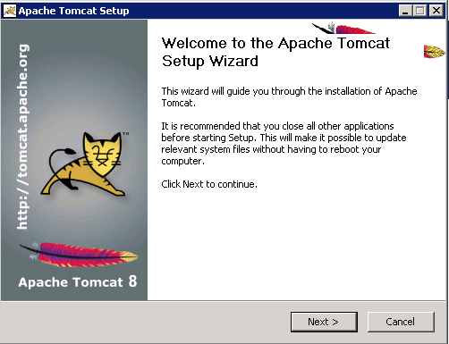
3. Accept the terms and conditions  
   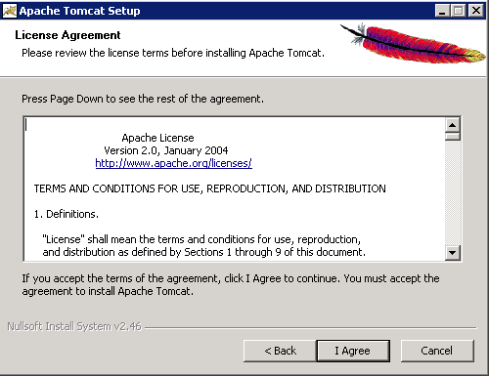
4. Select the following components  
   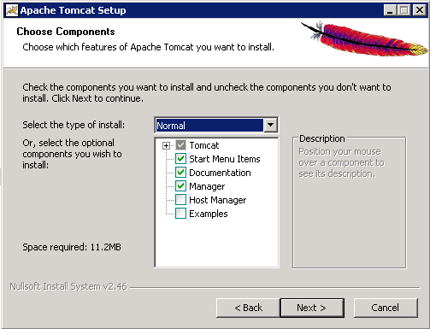
5. Keep the default ports, but check **Create a shortcut for all users** and provide a Tomcat Administrator User Name and Password  
   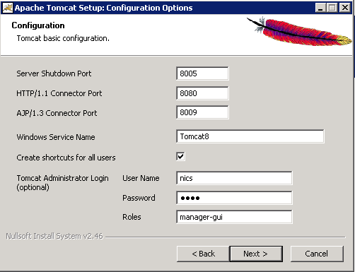
6. Provide the default JAVA_HOME (the 64bit JDK),  
   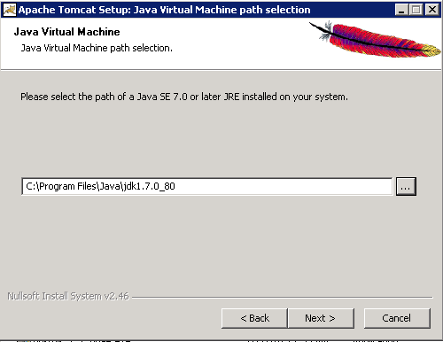
7. Accept the default installation location  
   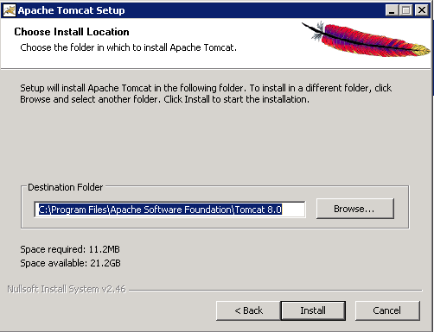
8. After successful installation click **Finish**.  
   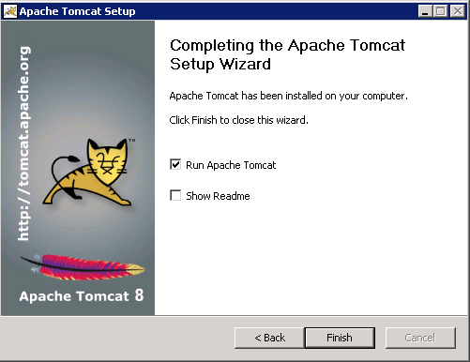

### Configure

Be sure that your JAVA_HOME is pointing the 64bit JDK

#### Context.xml

1. Navigate to your TomCat conf folder in file explorer: C:\Program Files\Apache Software Foundation\Tomcat 8.0\conf
2. Open context.xml and uncomment the following line:

<Manager pathname="" />

1. Save and close

#### Start Script

1. Navigate to your TomCat bin folder: C:\Program Files\Apache Software Foundation\Tomcat 8.0\bin
2. Create a new file called setenv.bat and add the following lines:

set JAVA_OPTS=-Dfile.encoding=UTF-8 -Xms512m -Xmx1024m -XX:PermSize=64m -XX:MaxPermSize=256m

set "JRE_HOME=C:\Program Files\Java\jdk1.7.0_79"

* 1. This script provides TomCat with the correct Java JRE and ensures that it has enough memory.

#### Web.xml

1. Navigate to TomCat’s webapp manager: C:\Program Files\Apache Software Foundation\Tomcat 8.0\webapps\manager
2. Open web.xml.
3. Modify max-file-size and max-request-size so both are equal to 152428800

<max-file-size>152428800</max-file-size>

<max-request-size>152428800</max-request-size>

1. Save and close

#### Server.xml

1. Navigate to TomCat’s conf : C:\Program Files\Apache Software Foundation\Tomcat 8.0\conf
2. Open server.xml
3. Add the following line under /Server/Service/Engine/Host/

<Context docBase="C:/opt/data/nics/upload" path="/upload" />

1. Save and close

#### Restart Tomcat

1. This can be done via the command line or through the Services window.

#### Verify

1. To confirm Tomcat8 is running properly, open a web browser to: http://<FQDN>:8080 and you should see the following:  
   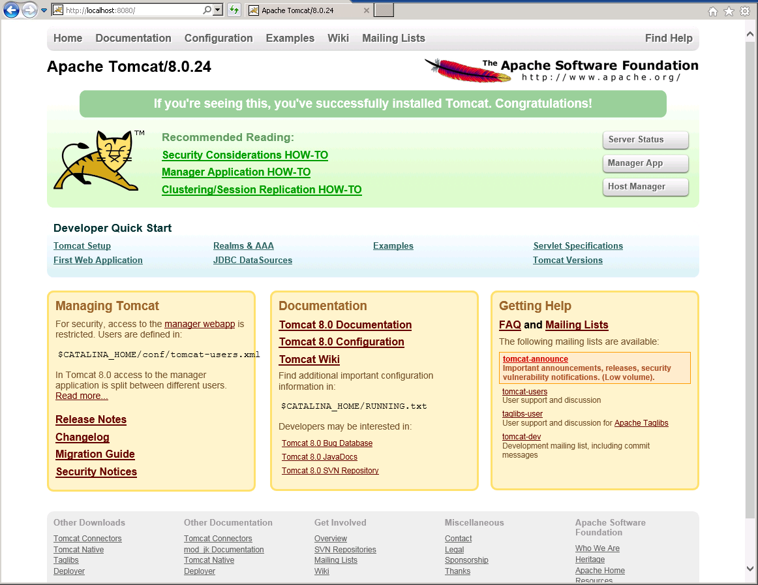
2. Next, confirm you can login Tomcat manager application by navigating to http://<FQDN>:8080/manager/
3. You will be prompted with an HTTP Basic AUTH dialog popup. Give the credentials you supplied during the install.  
   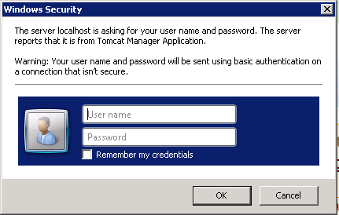
4. If your credentials are provided correctly, you should then see the Tomcat Manager application.  
   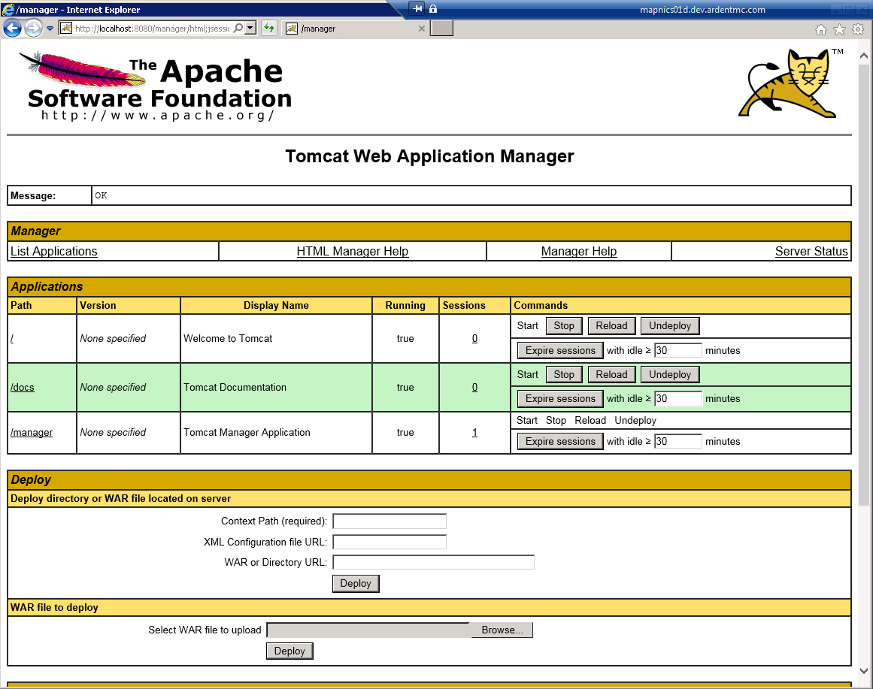

## IDP

This guide assumes that you already have the IDP and just need to configure it to work with NICS.

### About NICS Identity

* NICS uses a standard SAML 2.0 token for user identification.
* The token must include both a name and an email claim. NICS will look at the email claim to identify the user so this should be their login username for NICS. The name claim is not actually used for identification but is required due to spring security.
* Users must be registered with both the IDP and NICS in order to use the web application.

### Add Certificate to TomCat

You will need to add the certificate for your IDP to TomCat. These steps assume you are using Identity Server and that it’s already configured and running.

1. Navigate to the following URL via the browser: <IDP_URL>/core/wsfed/metadata
2. Copy the raw text under: /EntityDescriptor/Signature/KeyInfo/X509Data/X509Certificate/
3. Create a certificate file with this text and call it <HOST_NAME>-idp.cer.
4. PEM format this text and save
5. Import the newly created cert into a Java Key store using the following command:

keytool -import -trustcacerts -keystore <ENV>-idp.jks -storepass <PASSWORD> -alias <ENV>-file <ENV>-idp.cer –noprompt

1. Copy the newly created .jks file the Tomcat common class loader at: C:\Program Files\Apache Software Foundation\Tomcat 8.0\lib\

### Configure Relying Parties

The two following Relying Parties need to be made for the NICS IDP:

1. NICS-Web Relying Party:

**Name:** NICS_RP

**Realm:** https://<FQDN>/nics/

**Reply URL:** https://<FQDN>/nics/j_spring_fediz_security_check

**TokenType:** SAML2

1. em-api Relying Party

**Name:**  API_RP

**Realm:** https://<FQDN>/em-api/

**Reply URL:** https://<FQDN>/em-api/j_spring_fediz_security_check

**TokenType:** SAML2

## War Files

### Deploy

1. Copy the 2 WAR files (em-api.war, nics.war) into your TomCat webapps directory at: C:\Program Files\Apache Software Foundation\Tomcat 8.0\webapps
2. Open the em-api.war file with 7-Zip and navigate to the META-INF directory.
3. Open content.xml and update each Resource so that they hold the username and password of your Postgres database.
   1. NOTE: You may also need to modify the URL or port if your PostGreSQL is not running locally or if you choose a different port.

# NICS Configuration

## Create Directories

#### Config

You will need to create a directory to hold the NICS configuration files. This directory does not need a particular name or to be put in a particular place.

1. Create the directory in a location of your choice
2. Create a new system environment variable called NICS_CONFIG. It’s value should be the path of your NICS Config directory

#### Upload

NICS expects a certain file structure for importing files.

1. Create a directory called upload and place it in C:/opt/data/nics (If this structure does not already exist then create it).
2. Within the upload directory you will need to create the following 10 directories:
   * + arcgisrest
     + collabfeedkmltest
     + features
     + geojson
     + gpx
     + images
     + kml
     + kmx
     + reports
     + shapefiles
3. Then within the reports directory add the following:

* damage
* general
* uxo

## Configuration Files

1. Move the following 8 files into the newly create NICS Config directory:

* AMConfig.properties
* core.properties
* em-api.properties
* fediz_config-em-api.xml
* fediz_config-nics .xml
* openam-tools.properties
* sso-tools.properties
* kmlTemplate.kml

1. Then open each of these files in a text editor of your choice and fill them out using your own parameters.

## Jasypt

### Some Notes:

The NICS codes uses a Jasypt password and algorithm to encrypt/decrypt usernames and passwords

The NICS code will first look to see if a Djasypt.password system variable exists. If this exists and has a value then the Jasypt password becomes that.

Otherwise it will look in the configuration files (openam-tools.properties and sso-tools.properties) for the password. Be sure these values are the same!

If the password is in neither the system property nor the configuration file then it defaults back to secretpassword.

The algorithm is also specified in the configuration files (sso-tools.properties and openam-tools.properties). Be sure these are the same!

# Run NICS

All of the programs should now be running.

1. Navigate to http://<FQDN>/nics/
2. You should be redirected to the login page (if you are using an IDP this will be the IDP’s own login page)
3. Log in as nicsadmin
4. You should see the following error:

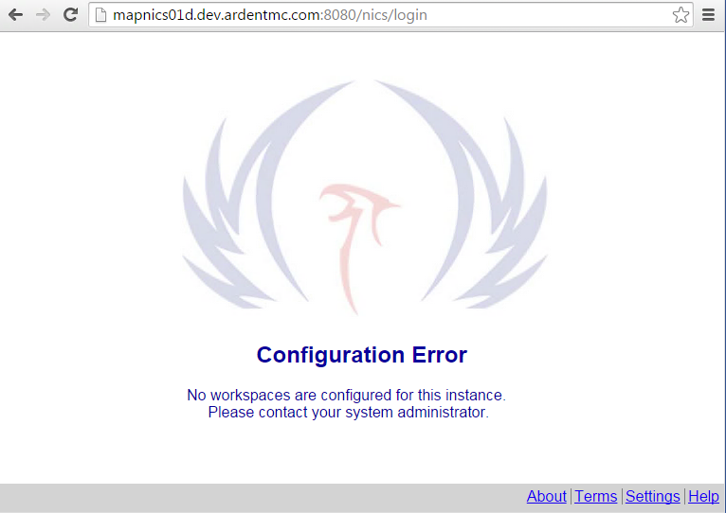

1. To resolve this error, you will need to update the nics user’s password in PostGreSQL.

## Change NICS user sql password

1. Run SQL Shell (psql)
2. Login as the postgres user
3. Run the following command:

alter user nics with encrypted password 'nics'

## Verify

1. Reload the page and once again log in as nicsadmin
2. The NICS web GUI should load
   1. NOTE: This can sometimes take a while to load.

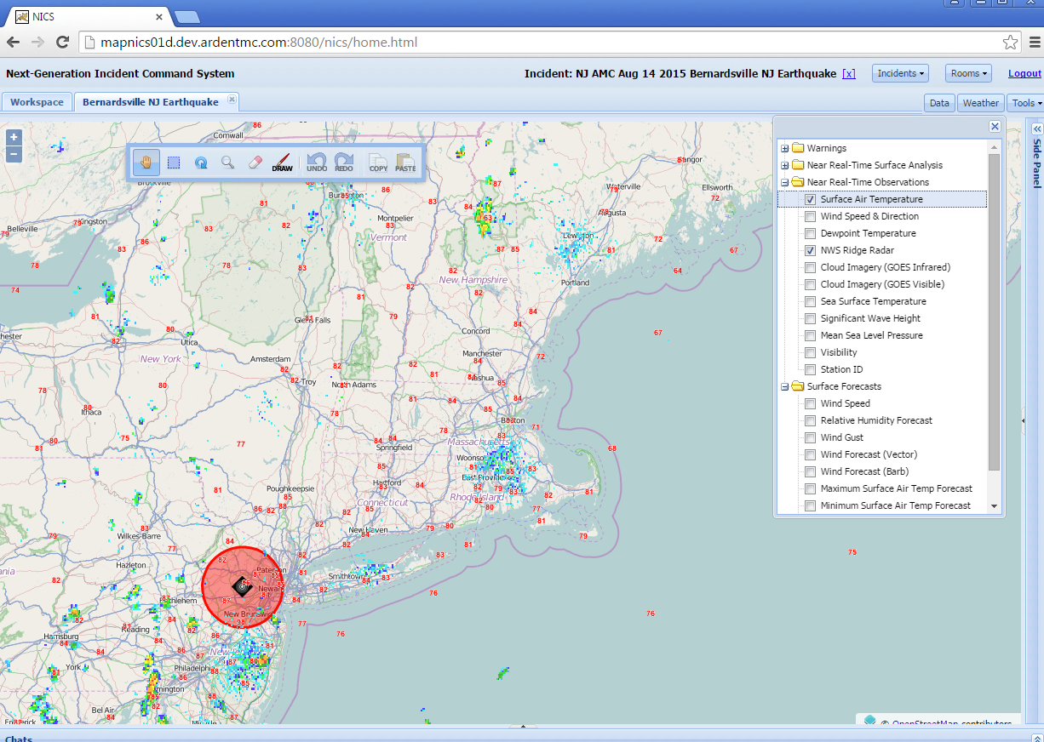

## Important Notes

### General

1. Sometimes the NICS UI will not load fully. To resolve this, simply refresh the page.

### For I.E Users

1. Users must have a PDF viewer installed and associated with IE in order for the census tool to work properly
2. The pop-up blocker must either be disabled, or an exception has to be made for NICS in order for file exports and imports to work correctly

# Background Batch Processes

## Collab-Feed-Manager Background Process

Schedule the collab-feed-manager background process to run and keep running.

### Setup

1. Copy and extract the collab-feed-manager-6.x.x-deployable.zip to C:\NICS\dist (create the directory if it does not already exist).
   1. Ensure that LOCAL_SERVICE has full control of the C:\NICS\dist\collab-feed-manager-6.1.1 folder.
2. Go into collab-feed-manager-6.x.x-deployable/config and fill out collab-feed-manager.properties file in a text editor of your choice and fill it out using the following values (Everything else can be the default value):

**geoserver.url:** http://<FQDN>:8081/geoserver/rest/

**kmlFilepath:** path to where your upload/kml directory is

**kmlUrl:** https://<FQDN> /upload/kml/

### Create the Task

1. Open the Windows Task Scheduler
2. Within the Task Scheduler, click **Create Task…**  
   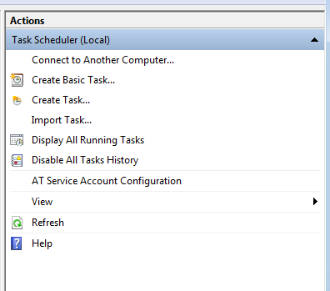
3. Name the scheduled task, collab-room-manager, then click **Change User or Group…**  
   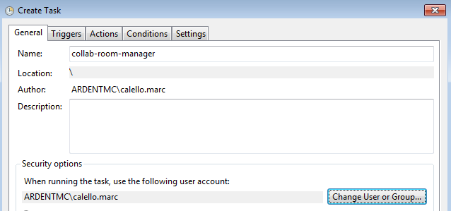
4. In the **Enter the object name to select textbox**, type Local and click the **Check Names** button to add LOCAL_SERVICE as the owning/running account.   
   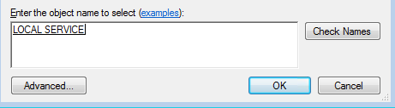
5. Click **Ok**

#### Set up Triggers

1. Click on the **Triggers** tab
2. Click **New…**
3. Set up the Trigger with the following values:

**Begin the task**: At task creation/modification

**Repeat task every**: 5 minutes

**For a duration of**: Indefinitely

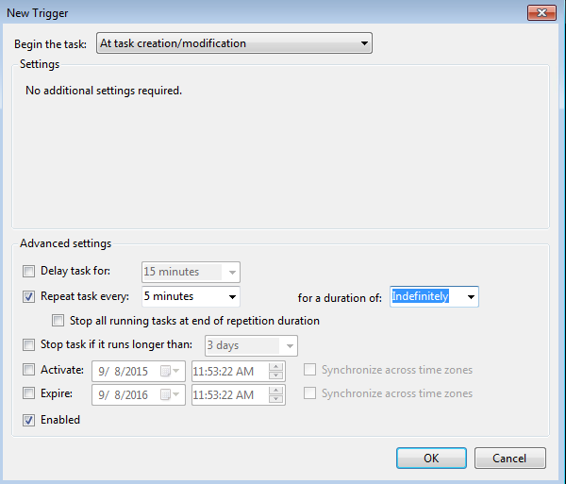

1. Click **Ok**

#### Set up Actions

1. Click on the **Actions** tab
2. Click **New…**
3. Create the new action with the following values:

**Action:** Start a program

**Program/script**: Link to the start.bat script within the C:\NICS\dist\collab-feed-manager-6.1.1 directory.

**Start in**: Same directory as above

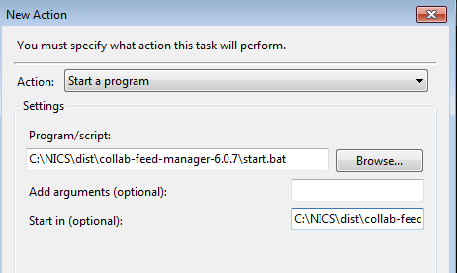

1. Click **Ok**.

#### Settings

1. Click on the **Settings** tab
2. Configure the task with the following values:

Uncheck **Stop the task if it runs longer than**

**If the task is already running, then the following rule applies:** Do not start a new instance.  
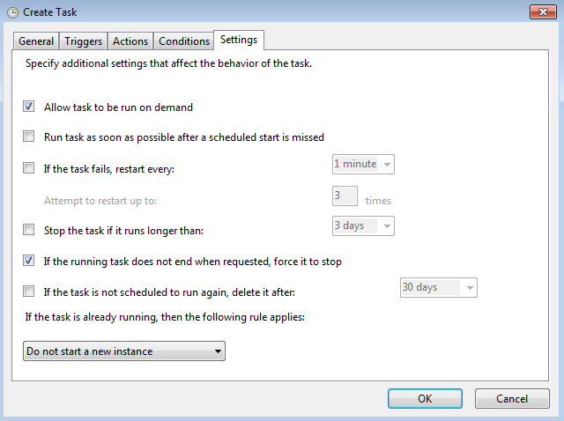

## Email-Consumer Background Process

Schedule the email-consumer background process to run and keep running.

### Setup

1. Copy and extract the email-consumer-6.x.x-deployable.zip to C:\NICS\dist.
   1. Ensure that LOCAL_SERVICE has full control of the C:\NICS\dist\email-consumer-6.1.1 folder (create the directory if it does not already exist).
2. Copy the email-consumer.properties file from C:\NICS\dist\email-consumer-6.1.1\config\ into the NICS configuration directory.
3. Open the email-consumer.properties file in a text editor of your choice and fill it out using the following values:

**mail.smtp.port**: <SMTP Server Port>

**mail.smtp.host**: <SMTP Server FQDN>

**mail.username:** <SMTP Server User or left blank>

**mail.password:** <SMTP Server Password or left blank>

### Create the Task

1. Repeat the steps from above. The task should be named email-consumer
   1. Make sure to specify the Program/script to be C:\NICS\dist\email-consumer-6.1.1 directory