Pinpoint

GPS location reporting application that sends EDXLDE/NIEM EMLC messages.

# Required Equipment

* Laptop
* GPS Receiver

# Installation

1. Install any drivers necessary for the GPS receiver and connect the receiver to the laptop.
2. Install/Build the Pinpoint project.
3. Run the Pinpoint application.

# User Guide

## Configuration

To configure Pinpoint, click ‘Options’ and then ‘Settings.’

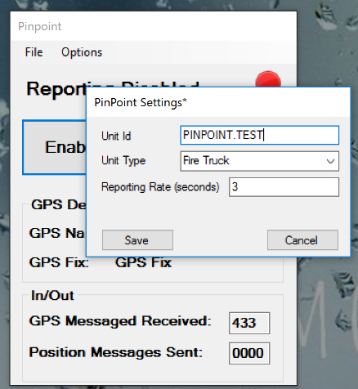Settings Options:

* Unit Id corresponds to the distributionId in the DE message
* Unit Type determines the EventTypeCode in the NIEM EMLC Event message
* Reporting Rate determines the time interval between sending location updates.

## Reporting

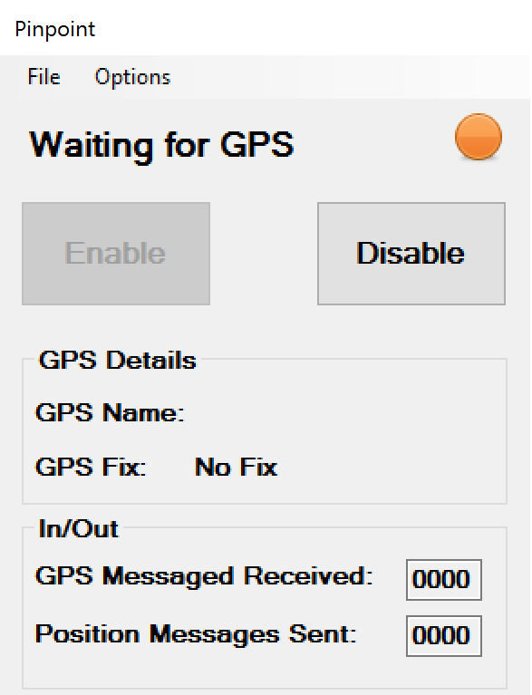Reporting is initially disabled. To enable reporting, click ‘Enable.’

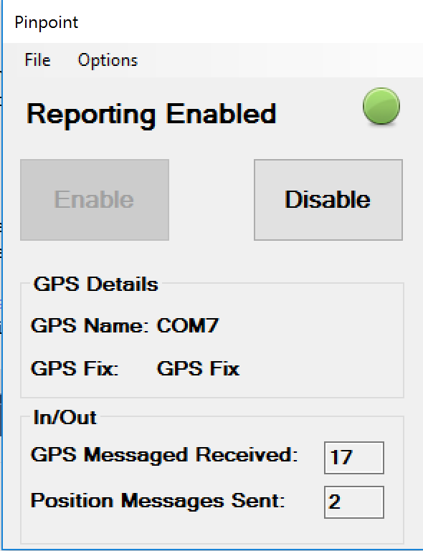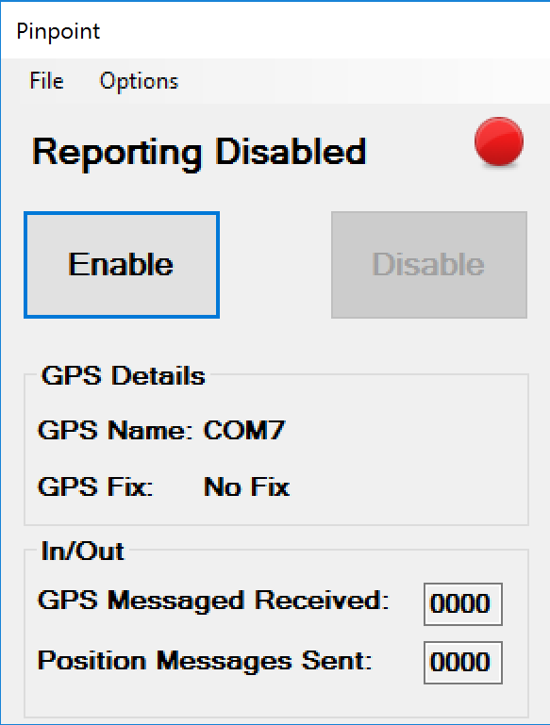

Acquiring GPS Fix

Sending location reports

Reporting disabled