**Support Vector Machine (SVM)**

A Support Vector Machine (SVM) is a supervised machine learning algorithm used for both classification and regression tasks. While it can be applied to regression problems, SVM is best suited for classification tasks. The primary objective of the SVM algorithm is to identify the optimal hyperplane in an N-dimensional space that can effectively separate data points into different classes in the feature space. The algorithm ensures that the margin between the closest points of different classes, known as support vectors, is maximized.

The dimension of the hyperplane depends on the number of features. For instance, if there are two input features, the hyperplane is simply a line, and if there are three input features, the hyperplane becomes a 2-D plane. As the number of features increases beyond three, the complexity of visualizing the hyperplane also increases.

Consider two independent variables, x1 and x2, and one dependent variable represented as either a blue circle or a red circle.

* In this scenario, the hyperplane is a line because we are working with two features (x1 and x2).
* There are multiple lines (or hyperplanes) that can separate the data points.
* The challenge is to determine the best hyperplane that maximizes the separation margin between the red and blue circles.

**How does Support Vector Machine Algorithm Work?**

One reasonable choice for the **best hyperplane** in a **Support Vector Machine (SVM)** is the one that maximizes the **separation margin** between the two classes. The **maximum-margin hyperplane**, also referred to as the **hard margin**, is selected based on maximizing the distance between the hyperplane and the nearest data point on each side.

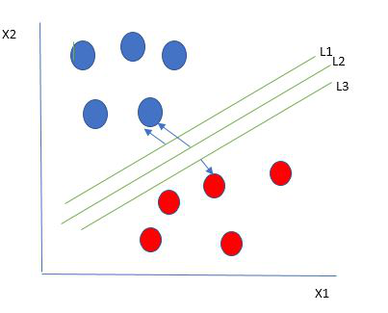

Multiple hyperplanes separate the data from two classes

So we choose the hyperplane whose distance from it to the nearest data point on each side is maximized. If such a hyperplane exists it is known as the **maximum-margin hyperplane/hard margin**. So from the above figure, we choose L2. Let’s consider a scenario like shown below

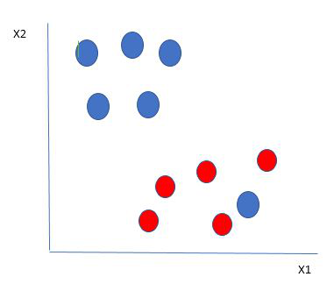

Selecting hyperplane for data with outlier

Here we have one blue ball in the boundary of the red ball. So how does SVM classify the data? It’s simple! The blue ball in the boundary of red ones is an outlier of blue balls. The SVM algorithm has the characteristics to ignore the outlier and finds the best hyperplane that maximizes the margin. SVM is robust to outliers.

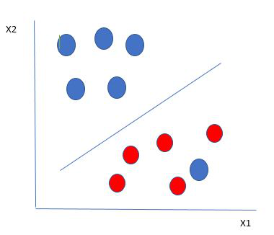

Hyperplane which is the most optimized one

So in this type of data point what SVM does is, finds the maximum margin as done with previous data sets along with that it adds a penalty each time a point crosses the margin. So the margins in these types of cases are called **soft margins**. When there is a soft margin to the data set, the SVM tries to minimize (1/margin+∧(∑penalty)). Hinge loss is a commonly used penalty. If no violations no hinge loss.If violations hinge loss proportional to the distance of violation.

Till now, we were talking about linearly separable data(the group of blue balls and red balls are separable by a straight line/linear line). What to do if data are not linearly separable?

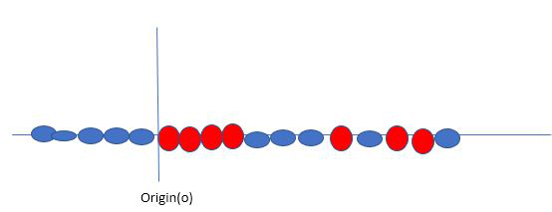

Original 1D dataset for classification

Say, our data is shown in the figure above. SVM solves this by creating a new variable using a **kernel**. We call a point xi on the line and we create a new variable yi as a function of distance from origin o.so if we plot this we get something like as shown below

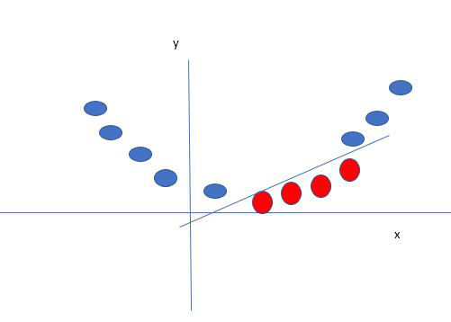

Mapping 1D data to 2D to become able to separate the two classes

In this case, the new variable y is created as a function of distance from the origin. A non-linear function that creates a new variable is referred to as a kernel.

**Support Vector Machine Terminology**

* **Hyperplane**: The **hyperplane** is the decision boundary used to separate data points of different classes in a feature space. For **linear classification**, this is a linear equation represented as wx+b=0.
* **Support Vectors**: **Support vectors** are the closest data points to the hyperplane. These points are critical in determining the hyperplane and the margin in **Support Vector Machine (SVM)**.
* **Margin**: The **margin** refers to the distance between the **support vector** and the hyperplane. The primary goal of the SVM algorithm is to maximize this margin, as a wider margin typically results in better classification performance.
* **Kernel**: The **kernel** is a mathematical function used in SVM to map input data into a higher-dimensional feature space. This allows the SVM to find a hyperplane in cases where data points are not linearly separable in the original space. Common **kernel functions** include linear, polynomial, radial basis function (RBF), and sigmoid.
* **Hard Margin**: A **hard margin** refers to the maximum-margin hyperplane that perfectly separates the data points of different classes without any misclassifications.
* **Soft Margin**: When data contains **outliers** or is not perfectly separable, SVM uses the **soft margin** technique. This method introduces a **slack variable** for each data point to allow some misclassifications while balancing between maximizing the margin and minimizing violations.
* **Hinge Loss**: The **hinge loss** is a common loss function in SVMs. It penalizes misclassified points or margin violations and is often combined with a regularization term in the objective function.

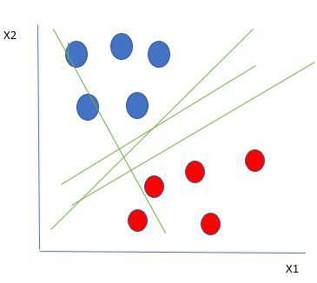

**1. Mathematical Formulation**

**a. Objective Function:**

For a binary classification problem, the SVM aims to solve the following optimization problem:

minimize (1/2) ||w||²

Subject to:

yi (w · xi + b) ≥ 1, ∀ i

Where:

w: Weight vector (normal to the hyperplane)  
b: Bias term  
xi: Feature vector for the i-th data point  
yi: Class label (+1 or -1) for the i-th data point

**b. Soft Margin (For Non-linearly Separable Data):**

To handle misclassifications, a slack variable ξi is introduced:

minimize (1/2) ||w||² + C Σ ξi

Subject to:

yi (w · xi + b) ≥ 1 - ξi, ξi ≥ 0

Here, C is a regularization parameter that balances maximizing the margin and minimizing classification errors.

**2. Regression (SVR)**

For regression tasks, SVM minimizes the ε-intensive loss:

minimize (1/2) ||w||² + C Σ (ξi + ξi*)

Subject to:

yi - (w · xi + b) ≤ ε + ξi

(w · xi + b) - yi ≤ ε + ξi*, ξi, ξi* ≥ 0

SVM computations involve solving a quadratic programming problem, making it computationally intensive for large datasets. However, the method is robust and works effectively with high-dimensional data.

**Types of Support Vector Machine**

Based on the nature of the decision boundary, Support Vector Machines (SVM) can be divided into two main parts:

* **Linear SVM:**Linear SVMs use a linear decision boundary to separate the data points of different classes. When the data can be precisely linearly separated, linear SVMs are very suitable. This means that a single straight line (in 2D) or a hyperplane (in higher dimensions) can entirely divide the data points into their respective classes. A hyperplane that maximizes the margin between the classes is the decision boundary.
* **Non-Linear SVM:** Non-Linear SVM can be used to classify data when it cannot be separated into two classes by a straight line (in the case of 2D). By using kernel functions, nonlinear SVMs can handle nonlinearly separable data. The original input data is transformed by these kernel functions into a higher-dimensional feature space, where the data points can be linearly separated. A linear SVM is used to locate a nonlinear decision boundary in this modified space

**Advantages of Support Vector Machine (SVM)**

1. **High-Dimensional Performance**: SVM excels in high-dimensional spaces, making it suitable for **image classification** and **gene expression analysis**.
2. **Nonlinear Capability**: Utilizing **kernel functions** like **RBF** and **polynomial**, SVM effectively handles **nonlinear relationships**.
3. **Outlier Resilience**: The **soft margin** feature allows SVM to ignore outliers, enhancing robustness in **spam detection** and **anomaly detection**.
4. **Binary and Multiclass Support**: SVM is effective for both **binary classification** and **multiclass classification**, suitable for applications in **text classification**.
5. **Memory Efficiency**: SVM focuses on **support vectors**, making it memory efficient compared to other algorithms.

**Disadvantages of Support Vector Machine (SVM)**

1. **Slow Training**: SVM can be slow for large datasets, affecting performance in **SVM in data mining** tasks.
2. **Parameter Tuning Difficulty**: Selecting the right **kernel** and adjusting parameters like **C** requires careful tuning, impacting **SVM algorithms**.
3. **Noise Sensitivity**: SVM struggles with noisy datasets and overlapping classes, limiting effectiveness in real-world scenarios.
4. **Limited Interpretability**: The complexity of the **hyperplane** in higher dimensions makes SVM less interpretable than other models.
5. **Feature Scaling Sensitivity**: Proper **feature scaling** is essential; otherwise, SVM models may perform poorly.