**RMIT International University Vietnam**

**Assignment Cover Page**

|  |  |
| --- | --- |
| **Subject Code:** | **EEET2482** |
| **Subject Name:** | **Software Engineering Design** |
| **Location & Campus (SGS or HN) where you study:** | **SGS** |
| **Title of Assignment:** | **Group Assignment 1** |
| **Student name:** | **Tran Tien An (s3699000)**  **Nguyen Minh Duong (3741280)**  **Pham Nguyen Vu (s3701522)**  **Tran Viet Anh (s3795683)** |
| **Teachers Name:** | **Minh Ngoc Dinh** |
| **Group Number:** | **18** |
| **Assignment due date:** | **29/11/2021** |
| **Date of Submission:** | **29/11/2021** |
| **Number of pages including this one:** | **9** |
| **Word Count:** | **672** |

**Contents**

**I. Introduction & Body: 3**

**1. Team 3**

**2. Body 3**

**II. Flowcharts 6**

**III. Conclusion 9**

**Assignment 1 – Group Report**

# Introduction & Body:

## **Team**

Our team has 4 members:

* **Tran Viet Anh - s3795683**
* **Pham Nguyen Vu - s3701522**
* **Nguyen Minh Duong - s3741280**
* **Tran Tien An – s3699000**

We, a group of four students in the field of information technology, formed Group 18 for the EEET2482 - Software Engineering Design course in order to succeed in the course's assignments and assessments while also gaining significant experience and knowledge from collaborating with other students.

The following table shows our role and contribution to the team.

|  |  |
| --- | --- |
| **Member name** | **Contribution** |
| Tran Viet Anh | Doing the first three statistical value (mode, median and variance and standard deviation). Writing report. |
| Pham Nguyen Vu | Calculate Mean Absolute Deviation and third quartile. Writing report. |
| Nguyen Minh Duong | Calculate Skewness and Kurtosis. Bug fixing. Writing report. |
| Tran Tien An | Doing the Inferential Statistics. Writing report. |

## **Body**

1. **Completion**

We are glad to say that we completed all of the essential activities inside the assignment's declarations for the code component within a short amount of time. The final source code has approximately 300 lines of code, with around 90% of the code devoted to statistical computations.

1. **Testing**

* **Methodology**

Given the program's tiny size, we chose to proceed with testing each function individually as we wrote the code; although this is not perfect, it is adequate for this kind of software. To clarify, routines were tested by inserting "cout" statements at appropriate locations inside the functions to output variables to the console, allowing us to determine whether or not the value calculated was right. We tested program arguments using both Command Arguments in Microsoft Visual Studio Code 2017's project properties Debugging and the Visual Studio Code, however the latter was preferable due to its efficiency.

* **Program Outputs**

The following photos demonstrate the application being executed in a number of settings using Visual Studio Code:

1. Executing the program using the parameter "data1.csv" (data1.csv is the file name)

included in the evaluation used to evaluate the program's effectiveness):

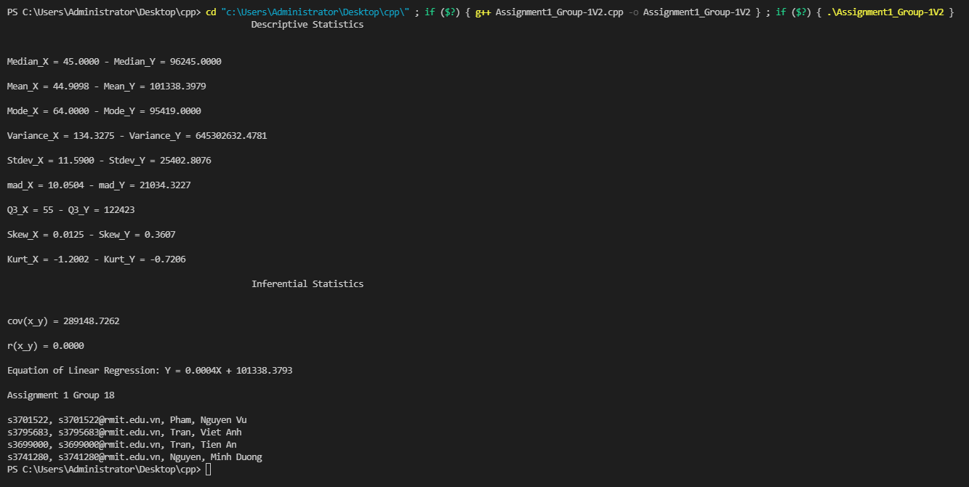

1. Running the program without any parameters

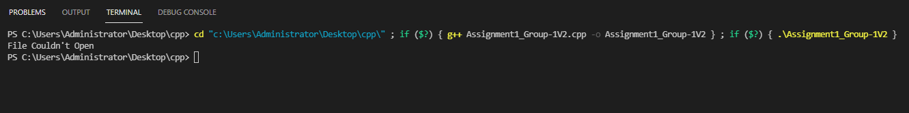

1. Running the program but with wrong arguments (in this case, data3.csv is not existed)

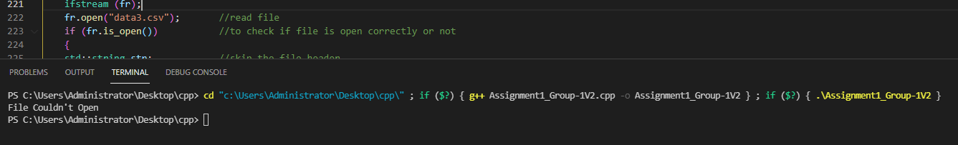

# Flowcharts

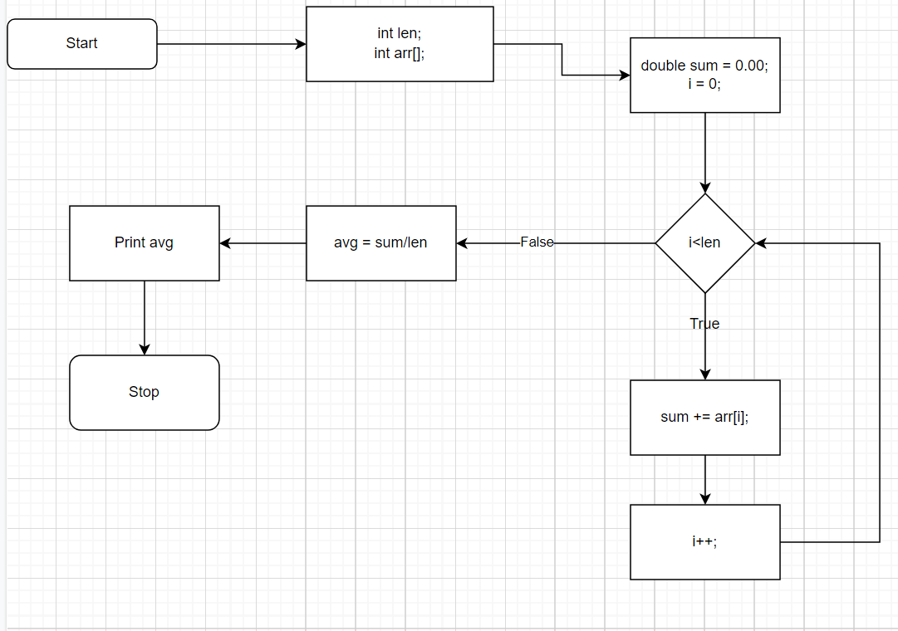

**Figure 1:** Mean calculation function flowchart

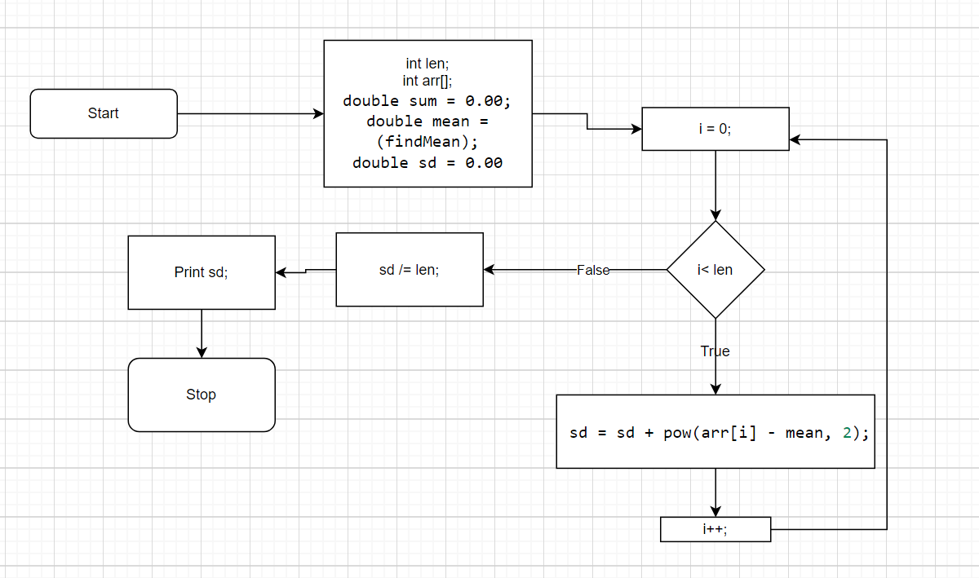

**Figure 2:** Variance and standard deviation calculation function flowchart

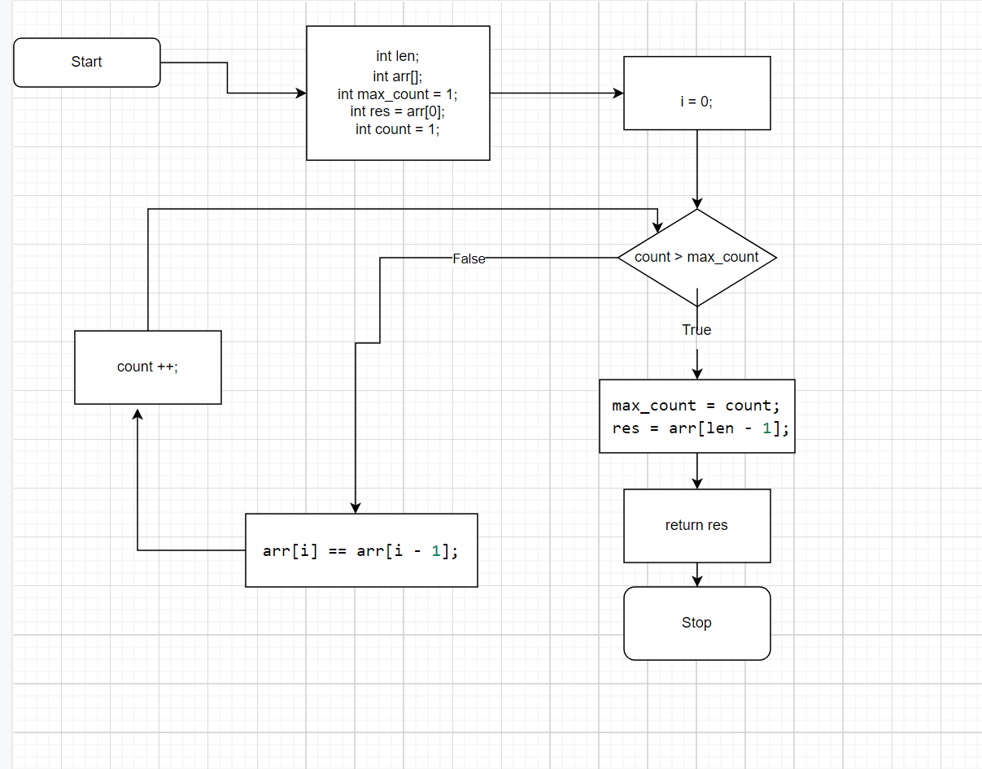

**Figure 3:** Mode calculation function flowchart

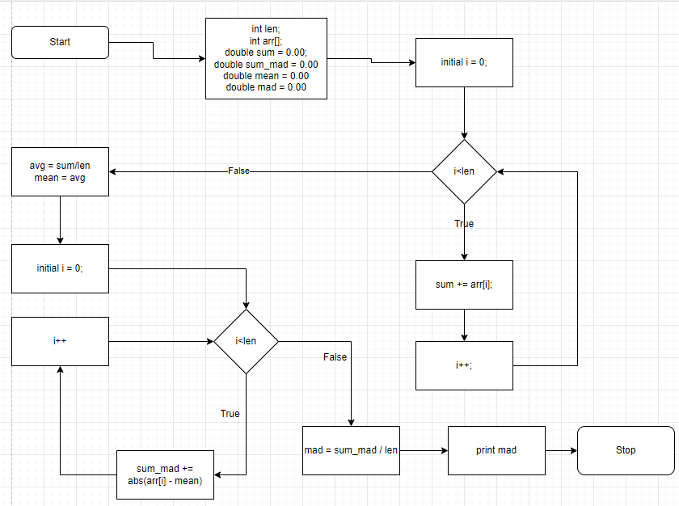

**Figure 4:** MAD calculation function flowchart

# Conclusion

In general, we did not run into as many difficult issues as we anticipated during the course of our project. However, because we are accustomed to utilizing numerous external libraries, we must spend some time figuring out how to create functions on our own. Another minor issue is that when testing, some Excel formulas differ from those specified in the assignment specification, which took us quite some time to figure out and properly sort for the report. The majority of our teammates completed their assigned tasks and even assisted the weaker members who encountered difficulties, assisting in the project's completion and ensuring accuracy across the board. We meet weekly via Teams to discuss, repair, and complete the group program as a group, and thus the majority of our problems have been resolved by other members making excellent suggestions. Not only do we gain and practice technical knowledge for the course through this group project, such as utilizing code with raw material, but we also learn to work more effectively as a team for the project's success. All of these experiences will undoubtedly benefit future work both in and out of class.