Who Can Govern? Hung-Council Probabilities for the Gauteng and Eastern Cape Metros in South Africa's 2026 Local Government Elections
Lunga Ngaka, University of Fort Hare
Forecast frozen on 3 November 2026, before polls opened on 4 November 2026. The figures in this paper will not be revised after the results are declared.

Abstract
South African metros are governed by councils whose seats follow a mixed electoral system, so small changes in votes can decide who is able to govern. This paper gives a timestamped probabilistic forecast for five metros in the 4 November 2026 Local Government Elections: Johannesburg, Tshwane and Ekurhuleni in Gauteng, and Nelson Mandela Bay and Buffalo City in the Eastern Cape. Vote shares are modelled as compositional data using a logistic-normal model that combines past results with published polls, and each of 200,000 simulated elections is passed through the exact seat allocation rule. That rule reproduces all ten official seat calculations for these metros in 2016 and 2021. An outright majority is very unlikely in all three Gauteng metros and in Nelson Mandela Bay. The DA is favoured to be the largest party in Johannesburg and Tshwane, while Ekurhuleni and Nelson Mandela Bay are close to even. In Gauteng, no two-party pairing other than ANC and DA is likely to reach a majority, so smaller parties decide what is possible. Buffalo City is the main uncertainty: the chance that the ANC loses its majority there is 27% under the base assumption and ranges from 18% to 47% across alternatives, because no poll figures are published for that metro. The forecast will be scored against the declared results using a plan fixed in advance.

1. Introduction
Since 2016, coalition government has become common in South Africa's largest cities. Whether a council is hung, and which parties can form a majority, matters more for how a city is run than a party's vote share alone. Forecasts of vote share do not answer this directly, for two reasons.
First, seats are not a smooth function of votes. In Nelson Mandela Bay in 2021 the DA won 210,007 combined votes and the ANC 207,443. Both finished on 48 seats, because the ANC took the last available seat on its remainder. Second, a single point forecast hides the uncertainty that matters. A party on 45% may or may not be near a majority, depending on how the remaining votes divide.
This paper therefore asks a probabilistic question. For each metro, what is the chance that no party wins an outright majority, which party is likely to finish largest, and which coalitions are arithmetically possible? It makes three contributions:
- An exact implementation of the seat rule, validated against every official seat report for these metros in 2016 and 2021.
- A transparent compositional model of vote shares, which combines fundamentals and polls in a closed form that can be checked by hand.
- A forecast published before the election, with a scoring plan fixed in advance, so that its performance can be judged fairly.

2. The seat rule
Metro councils are elected under Schedule 1 of the Local Government: Municipal Structures Act 117 of 1998. Half of the seats are ward seats, won by plurality, and the rest come from party lists so that the council is proportional overall. Each voter has one ward vote and one party vote.
Let A be the total valid votes for all parties on both ballots, B the council's seats, C the independent ward councillors elected, and D the ward seats won by parties with no list. The Electoral Commission (IEC) computes the quota
$$Q = \left\lfloor \frac{A}{B − C − D}\right\rfloor + 1.$$
A party with v combined votes first receives ⌊ v / Q ⌋ seats. Remaining seats go to the parties with the largest surpluses, and equal surpluses go to the party with more votes. Ward wins are then subtracted from each party's total, and the balance is filled from its list. A party that wins more wards than its total entitlement keeps them and receives no list seats.
Two consequences simplify the forecast. A party's total depends on its combined votes and not on which wards it wins, unless it exceeds its entitlement. In the ten councils examined no party did so, and no independent won a seat, so C = D = 0 in all of them. The forecast therefore needs each party's combined vote share and does not need a model of each ward.
The term D appears in the IEC's published reports but not in the 2009 text of the Act used here, which suggests a later amendment. The implementation follows the IEC's published calculation.
Validation. The rule was applied to the IEC's detailed results for 2016 and 2021 and compared with its Seat Calculation Detail reports. All ten councils matched on every party's votes, the quota, both allocation rounds and final seats. Matching required one detail that is easy to miss: the IEC's vote total counts only parties on the PR ballot, so parties that stood only in wards must be excluded.

3. Data
Results. Voting-district results for the 2016 and 2021 local elections and the 2019 and 2024 national elections come from the IEC. Local results use combined PR and ward votes. National results use the national ballot.
Council sizes. The IEC's 2026 ward lists show 135 wards in Johannesburg, 107 in Tshwane, 112 in Ekurhuleni, 60 in Nelson Mandela Bay and 50 in Buffalo City, unchanged from 2021. Councils therefore have 270, 214, 224, 120 and 100 seats.
Polls. Ten polls with fieldwork from August to October 2026 were used, being the latest from each pollster: four in Johannesburg, four in Tshwane, and one each in Ekurhuleni and Nelson Mandela Bay. Figures were checked against each pollster's report or press coverage of it. Ipsos withheld figures for Ekurhuleni, Nelson Mandela Bay and Buffalo City because of large margins of error, and no published poll figures were found for Buffalo City.
Parties are grouped as ANC, DA, EFF, MK, PA, ActionSA, FF+ and Others.

4. Model
Vote shares are positive and sum to one, so they are compositional data (Aitchison, 1986). Errors are modelled on the log scale, and each draw is returned to the simplex by dividing by its sum, which gives a logistic-normal model.
Fundamentals. With y_{j} the last local share and z_{j} the latest national share of party j,
$$f_{j} = w y_{j} + (1 − w) z_{j}.$$
A party absent from one of the two elections takes its share from the other, so that a new party such as MK is not halved. The shares are then rescaled to sum to one. The weight w = 0.45 was chosen by minimising error in the 2021 backtest.
Poll update. Let m_{j} = log f_{j} with prior variance a_{j}². Let p_{j} be the sample-weighted mean of log poll shares, with variance
$$b_{j}^{2} = \frac{s_{j}^{2}}{k_{j}} + c^{2},$$
where s_{j} is the pooled spread between pollsters, k_{j} is the effective number of polls, and c = 0.10 allows for an error common to all pollsters that their spread cannot reveal. The value of c is an assumption, and Section 7 varies it. The posterior for log share is normal with
$$precision = \frac{1}{a_{j}^{2}} + \frac{1}{b_{j}^{2}}, mean = \frac{m_{j} / a_{j}^{2} + p_{j} / b_{j}^{2}}{1 / a_{j}^{2} + 1 / b_{j}^{2}}.$$
For the ANC in Johannesburg the polls receive 81% of the weight. The prior spread a_{j} comes from the backtest: 0.25 for established parties, and 0.48 for new and smaller parties, the error of the group that contained the surprise new entrant in 2021.
Buffalo City. With no poll figures available, Buffalo City's prior is shifted by the difference between polls and fundamentals in Nelson Mandela Bay, the nearest comparable metro. This is the most consequential judgement in the forecast and Section 7 reports alternatives.
Simulation. For each metro, 200,000 sets of log shares are drawn from the posterior and closed. Others is split among smaller parties using their average 2021 and 2024 shares with Dirichlet noise, because small parties win seats on remainders. The exact seat rule is then applied to each draw. Probabilities are the proportion of draws in which an outcome occurs.

5. Backtest
The fundamentals were tested by predicting 2021 using only the 2016 local and 2019 national results.
Method | Mean absolute error (points)
Blend, weight chosen on all five metros | 3.48
Blend, leave-one-metro-out | 3.53
National result only | 4.09
Last local result only | 4.11

The blend beats both baselines, but modestly. Its largest errors are informative. The ANC was over-predicted by 9.6 points on average, as its 2021 fall was not captured by earlier results. ActionSA, a new party in 2021, was not predicted at all and won 16.2% in Johannesburg, which contributed to an error of 6.5 points there against 0.8 in Buffalo City. The Gauteng metros were harder to predict than the Eastern Cape metros, and the same may be true in 2026.
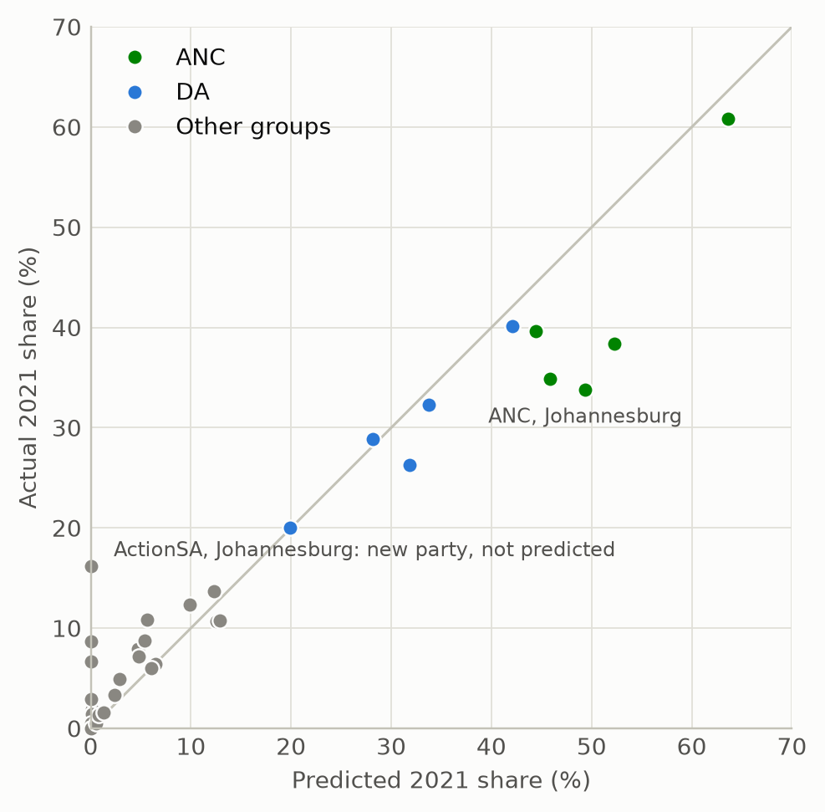
Figure 4. The 2021 backtest. Each dot is one party group in one metro, and points on the diagonal are perfect predictions.
Two limits apply. This is a single election, and the backtest cannot test the poll update, because this study has no 2021 metro polls.

6. Forecast
Table 1. Council outcomes
Metro | Seats | Needed | No majority | ANC largest | DA largest | Tied
Johannesburg | 270 | 136 | >99% | 4% | 95% | <1%
Tshwane | 214 | 108 | >99% | 9% | 89% | 2%
Ekurhuleni | 224 | 113 | >99% | 55% | 42% | 3%
Nelson Mandela Bay | 120 | 61 | >99% | 48% | 46% | 5%
Buffalo City | 100 | 51 | 27% | >99% | <1% | <1%

Table 2. Median seats with 90% ranges for the leading parties
Metro | ANC | DA | EFF | MK | ActionSA
Johannesburg | 67 (57-78) | 85 (74-97) | 29 (22-37) | 32 (22-44) | 24 (19-31)
Tshwane | 59 (50-68) | 71 (62-81) | 25 (20-33) | 10 (7-15) | 22 (18-28)
Ekurhuleni | 68 (56-81) | 66 (55-78) | 24 (17-33) | 28 (17-44) | 13 (9-17)
Nelson Mandela Bay | 45 (38-52) | 45 (38-52) | 10 (7-14) | 2 (1-4) | 3 (2-4)
Buffalo City | 55 (43-66) | 18 (12-26) | 13 (8-19) | 5 (2-10) | 4 (2-8)

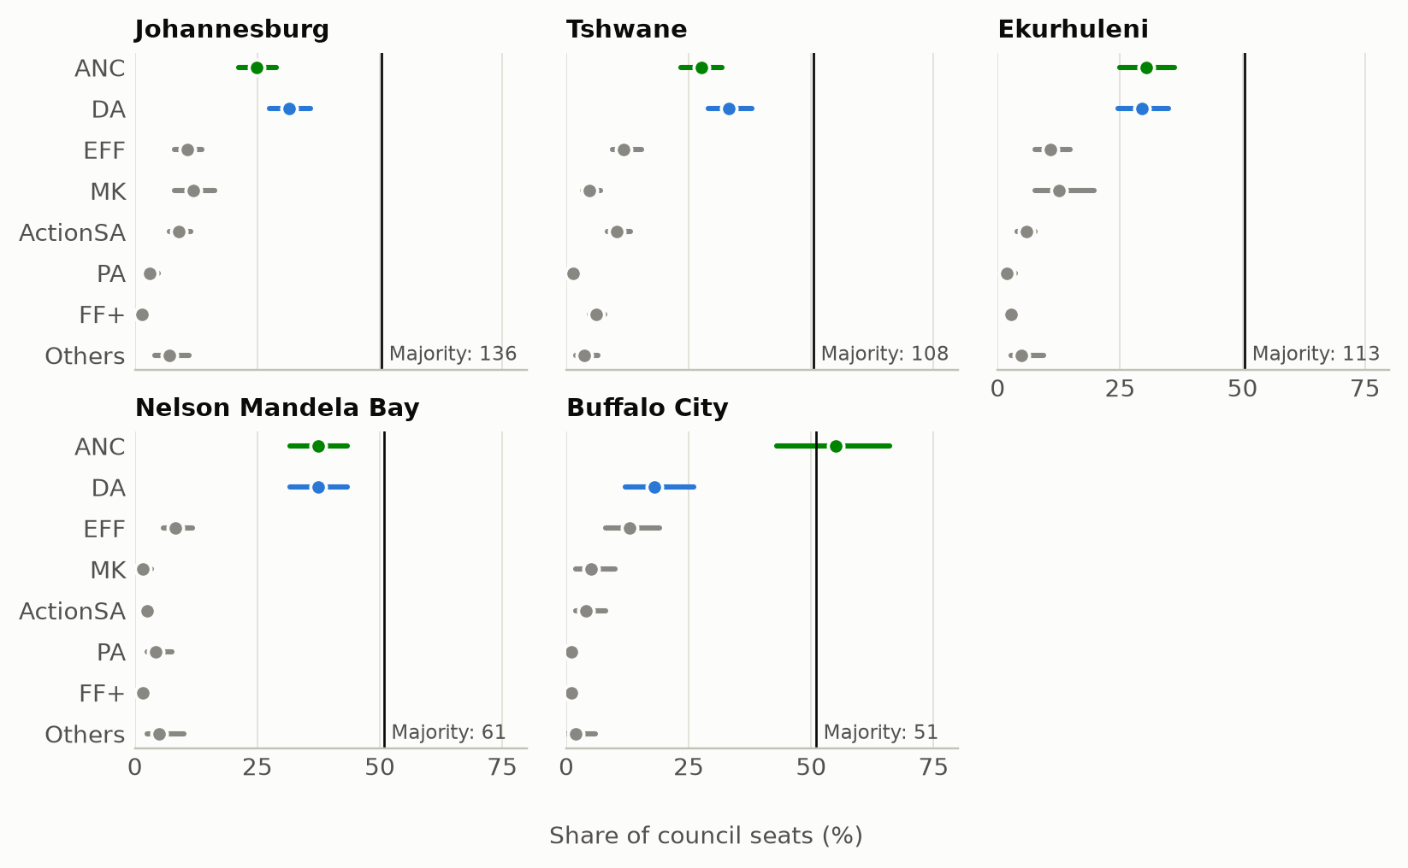
Figure 1. Median seats and 90% ranges as a share of each council. Only the ANC in Buffalo City reaches the majority line.
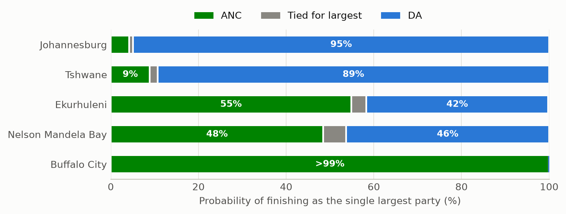
Figure 2. Chance of finishing as the single largest party, with exact ties shown separately.
The main result is that the hung-council question is effectively settled in four metros. In those four, the live questions are who finishes first and who can assemble a majority.
Table 3. Vote share in 2021 and forecast for 2026 (percent)
Metro | ANC 2021 | ANC 2026 | DA 2021 | DA 2026
Johannesburg | 33.8 | 24.6 | 26.3 | 31.5
Tshwane | 34.9 | 27.5 | 32.3 | 33.2
Ekurhuleni | 38.4 | 30.4 | 28.9 | 29.5
Nelson Mandela Bay | 39.6 | 37.3 | 40.1 | 37.2
Buffalo City | 60.8 | 54.8 | 20.0 | 17.6

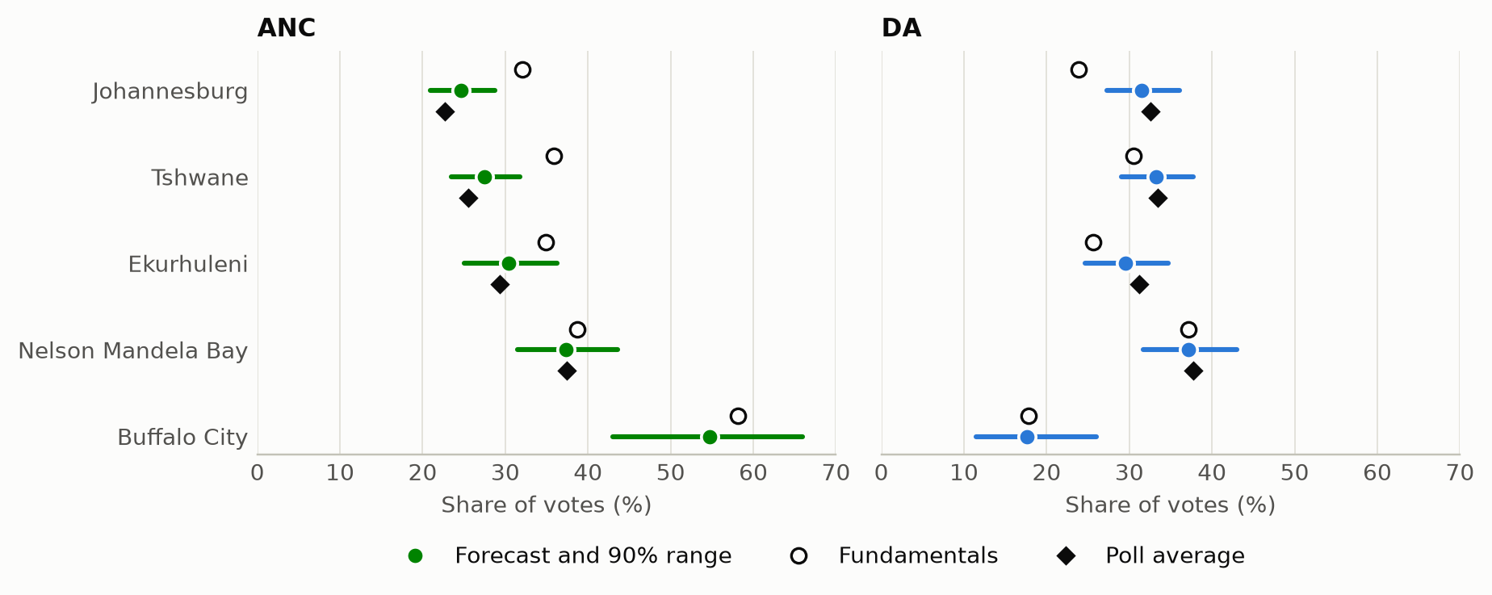
Figure 3. ANC and DA vote share from fundamentals, poll averages and the forecast. Buffalo City has no published poll, so its forecast borrows Nelson Mandela Bay's shift.

6.1 Gauteng
Gauteng is where the forecast departs most from past results. Fundamentals alone would place the ANC at 32% to 36% in the three metros. Polls put it much lower, and the forecast falls between them, closer to the polls: 24.6% in Johannesburg, 27.5% in Tshwane and 30.4% in Ekurhuleni, which is 7 to 9 points below 2021.
The three metros are not one story.
Johannesburg is the most fragmented. The DA is favoured to finish first (95%), but its median of 85 seats is 51 short of a majority. MK has no local election history but is forecast at 32 seats because of its 2024 result and the polls. EFF and ActionSA add 29 and 24. Even a DA and ActionSA pairing has a median of only 109 seats out of the 136 needed. Three-party routes with the DA include DA, EFF and MK (92% of simulations), DA, MK and ActionSA (80%) and DA, EFF and ActionSA (68%). A majority led by the ANC without the DA is much harder: ANC, EFF and MK reach one in 18%.
Tshwane gives the DA its largest share of seats in Gauteng, though Johannesburg has the higher chance of a DA first place, at 95% against 89%. The FF+ is strong here, with a median of 13 seats. ActionSA is the pivot. DA, EFF and ActionSA reach a majority in 98% of simulations, while ANC, EFF and ActionSA do so in 49%, and DA, FF+ and ActionSA in 47%.
Ekurhuleni is the closest Gauteng race, with the ANC at 55% and the DA at 42% to finish first. MK's vote share is highest here, at 12.3%, with a median of 28 seats and a wide range of 17 to 44, and it appears in both of the leading three-party routes: ANC, EFF and MK (86%) and DA, EFF and MK (80%).
Across all three, the only two-party pairing with a high chance of a majority is ANC and DA, above 97% in each. Every other route needs at least three parties.

6.2 Eastern Cape
The Eastern Cape metros raise different questions. Nelson Mandela Bay is a two-party contest and close to a coin flip, with the ANC at 48%, the DA at 46%, and a 5% chance of an exact tie for largest party, as occurred in 2021. Both parties are forecast 2 to 3 points below 2021, and the other parties are small: EFF has a median of 10 seats and PA 5. Two-party routes other than ANC and DA exist but are unlikely, with ANC and EFF at 13% and DA and EFF at 11%. ANC, EFF and PA reach a majority in 52%.
Buffalo City is the only metro where an outright majority remains likely. The ANC is forecast at 55 seats of the 51 needed, with a 90% range of 43 to 66. Section 7 shows how much this depends on one assumption.
These coalition figures are statements about arithmetic only and say nothing about who would agree to govern together.

7. Sensitivity
The chance of no majority in the three Gauteng metros and Nelson Mandela Bay stays above 92% in every variation, including fundamentals alone. Buffalo City is different.
Assumption for Buffalo City | Chance of no majority
No shift from fundamentals | 18%
Nelson Mandela Bay's shift (base) | 27%
Average shift of all four polled metros | 47%

Ipsos reports that the ANC in Buffalo City "may fall short of an outright majority", without publishing figures. This points towards the higher end of the range, and readers should treat 27% as the centre of a wide range and not as a precise estimate.
Ekurhuleni is also fragile. Only one poll with figures enters the model, and it has the DA narrowly ahead, while Ipsos describes the ANC as narrowly ahead.

8. Limitations
- The backtest rests on one election, and does not test the poll update.
- Pollsters report different groups. MarkData reports likely voters, and the others report registered voters.
- The latest Social Research Foundation metro samples are unpublished, so earlier sample sizes are used. Ipsos sample sizes are implied by its published margins of error.
- No adjustment is made for possible house effects.
- A party winning more wards than its seat entitlement is not modelled. This did not occur in any of the ten councils examined, but in 2021 the closest party in Johannesburg and in Ekurhuleni came within 2 seats of it. Fragmentation in 2026 makes this more plausible, as a party can win many wards on a low share, and it would change the seat totals in affected councils.
- Turnout is not modelled separately, and differential turnout is absorbed into vote-share uncertainty.
- Errors are treated as independent across metros, so this paper makes no joint statements across cities.
- Late campaign changes after the most recent fieldwork are not captured.

9. Scoring plan
After the IEC declares results, the forecast will be scored as published, using these measures:
- Brier score for the no-majority and largest-party probabilities, compared with always predicting the 2021 outcome.
- Mean absolute error in vote share and seats, against the two baselines in Section 5.
- Coverage of the 90% ranges, which should contain about 90% of outcomes for party vote shares and seats.
- Calibration, reported with the caveat that five councils is too few for firm conclusions.
Any change of method after the forecast is frozen will be reported as a departure from this plan.

Data and code
Code and processed data are available at https://github.com/1ungaka/za-metro-councils-2026, tag `v1.0-forecast`, which marks the frozen forecast. Raw IEC files are not redistributed and can be downloaded with the provided script.

Acknowledgements
[Yours to complete.]

References
Aitchison, J. (1986). The Statistical Analysis of Compositional Data. Chapman and Hall.
Electoral Commission of South Africa. Municipal and national election results, and Seat Calculation Detail reports. https://results.elections.org.za/home/
Ipsos South Africa (2026). Nationally, no party commands strong majority support as South Africa heads into coalition territory ahead of the November Local Government Elections. Press release, 30 October 2026.
Local Government: Municipal Structures Act 117 of 1998, Schedule 1.
Poll reports: eNCA/MarkData (October 2026), News24/SABI Strategy Group (October 2026), Social Research Foundation/The Common Sense (October 2026).

