Stallman 3D Printer
Assembly Manual

Copyright (C) 2015 1up3d.
Permission is granted to copy, distribute and/or modify this document under the terms of the GNU Free Documentation License, Version 1.3 or any later version published by the Free Software Foundation; with the Invariant Sections being Front-Cover Texts and Back-Cover Texts, with the Front-Cover Texts being Stallman 3D printer and with the Back-Cover Texts being Stallman 3D printer find it at RepRap.org thanks to Gnu.org and fsf.org . A copy of the license is included in the section entitled "GNU Free Documentation License".

Peel off the protective film from both sides.

Assemble the Z motor holders.

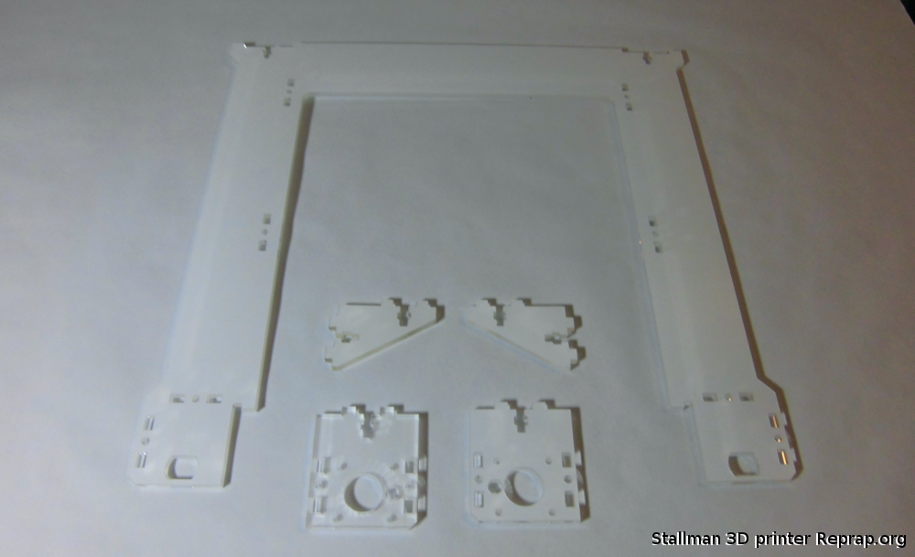

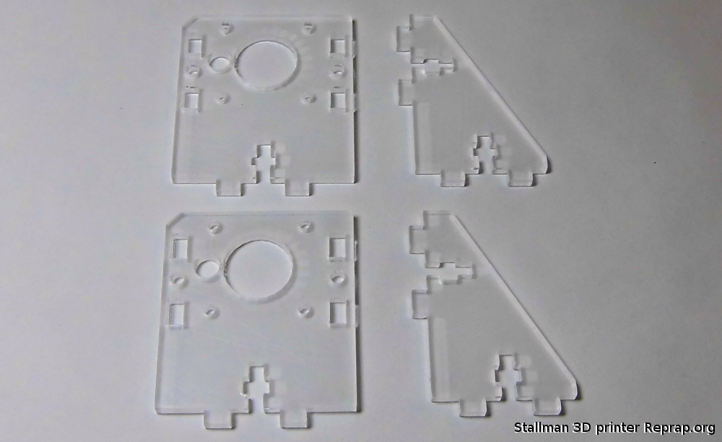
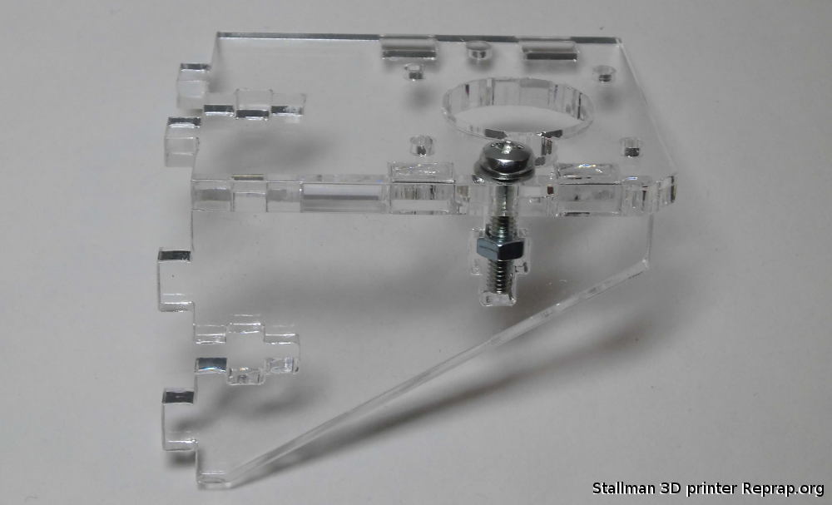

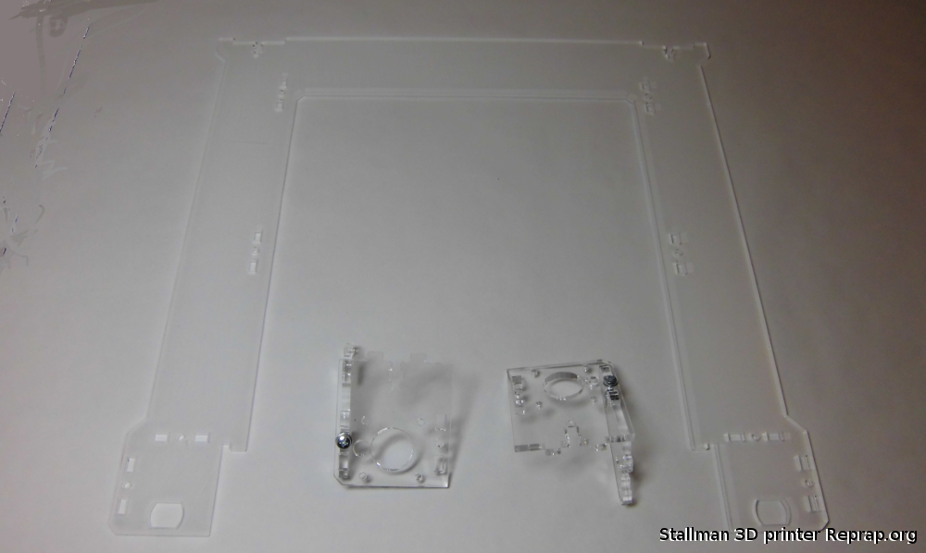
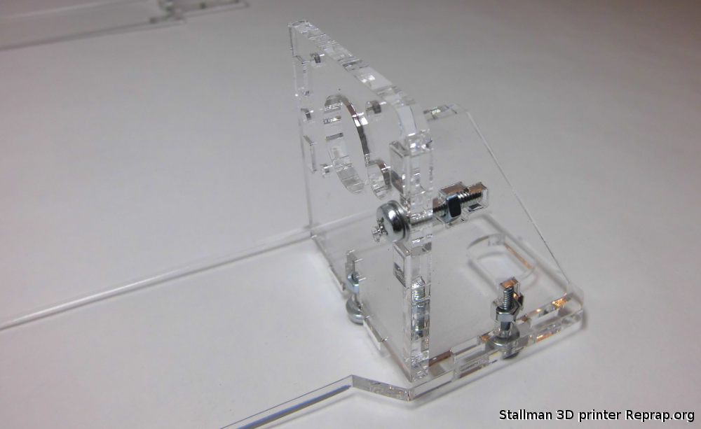

Put the frame sides in place.
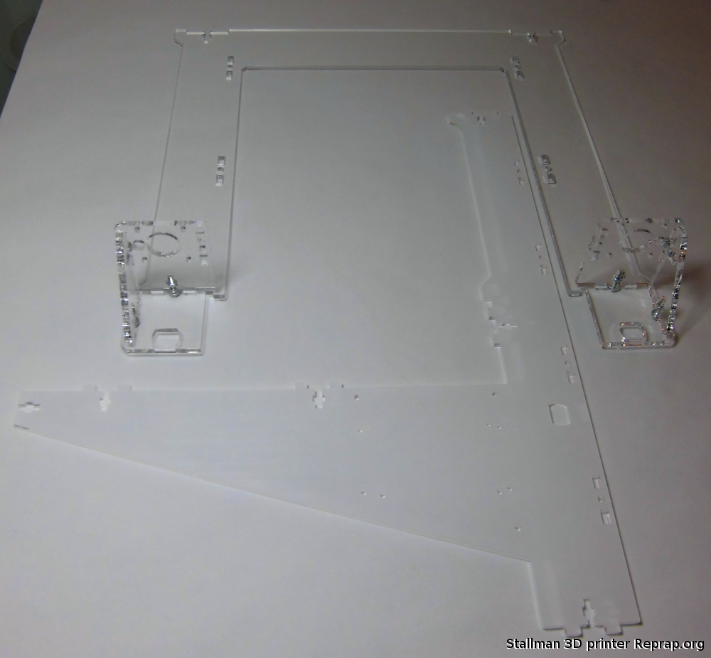

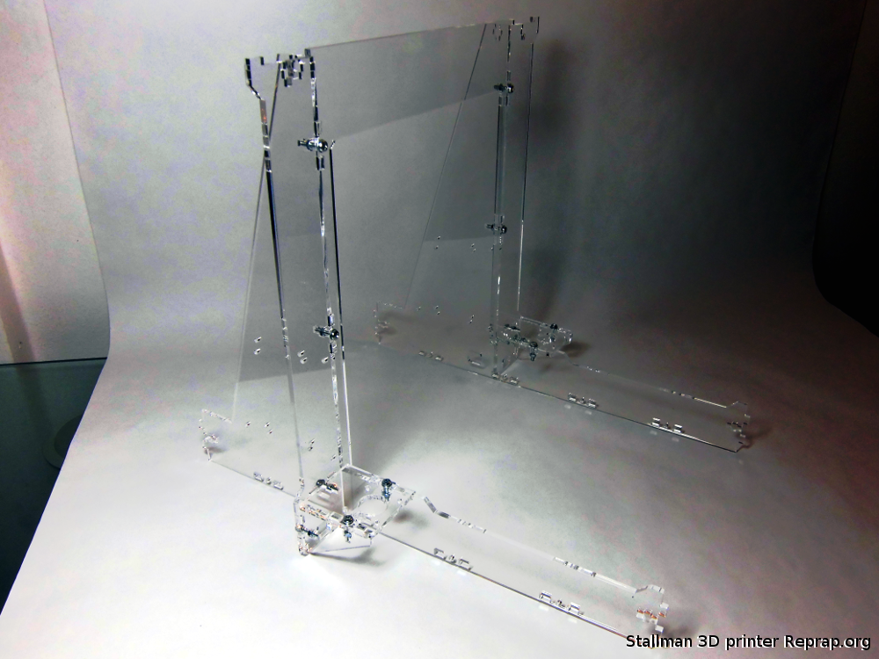

Now is time to put the bottom plate in place.

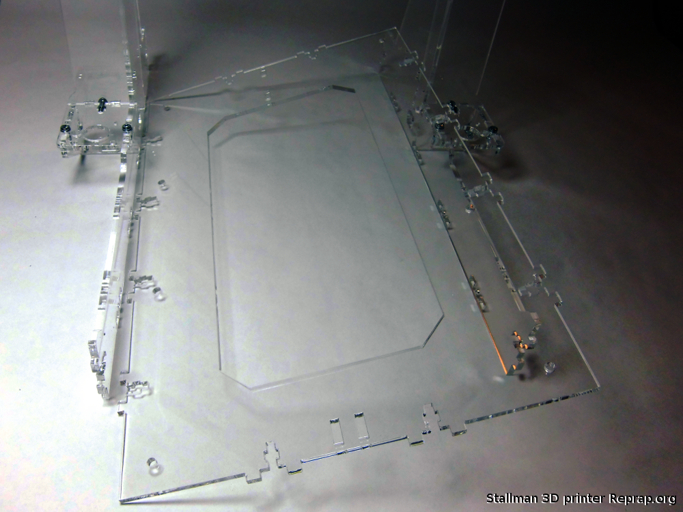
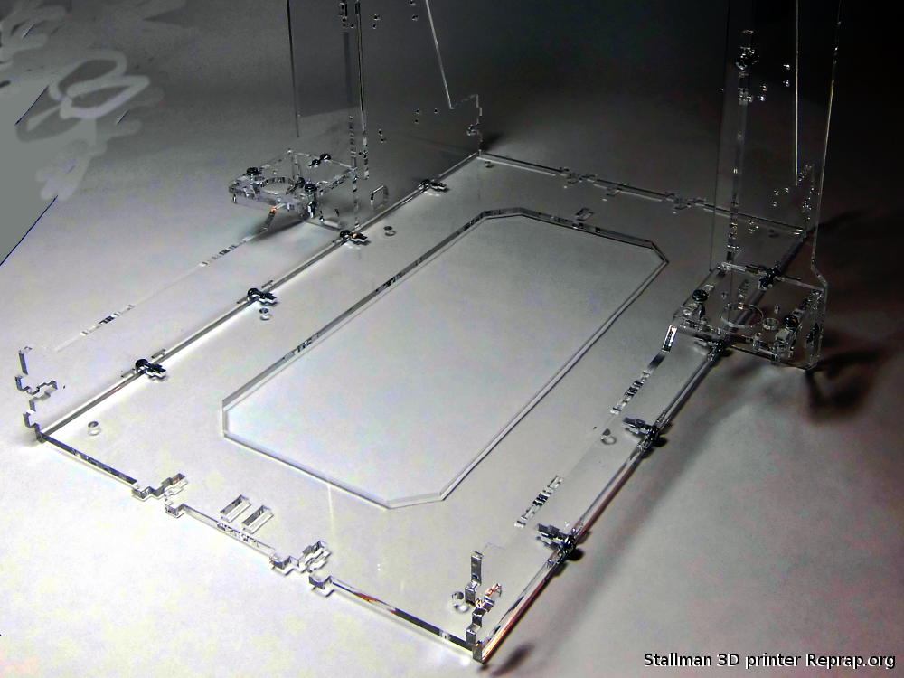

This part will hold the bearing for the belt.
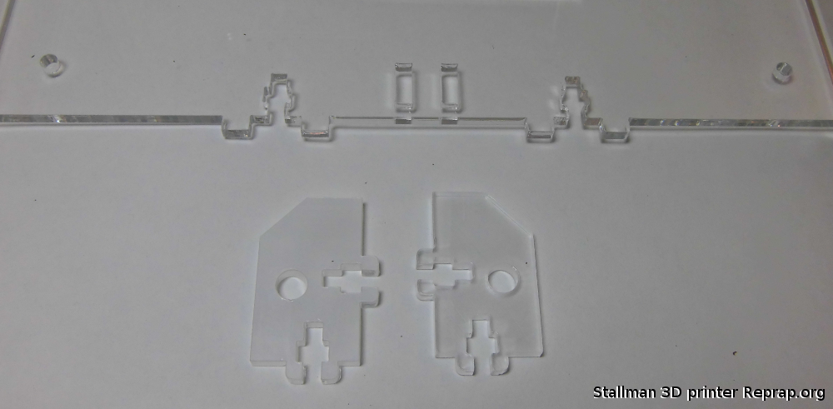
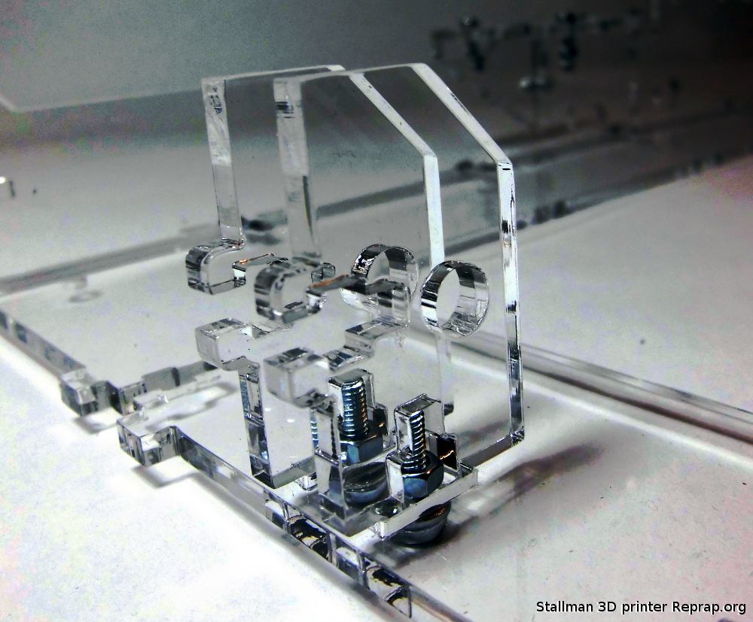

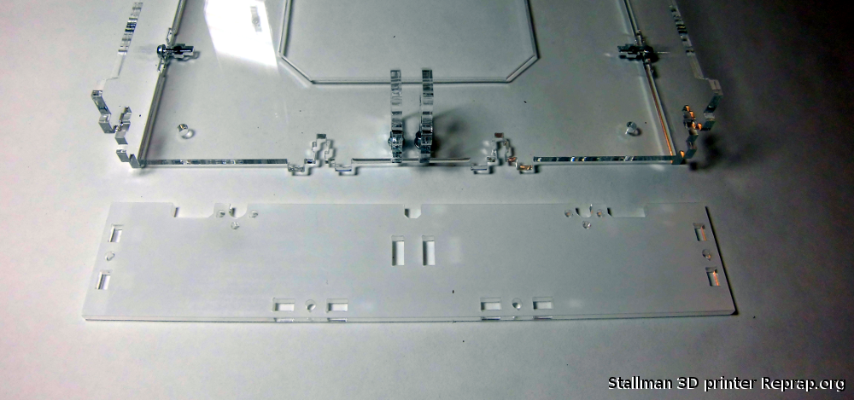

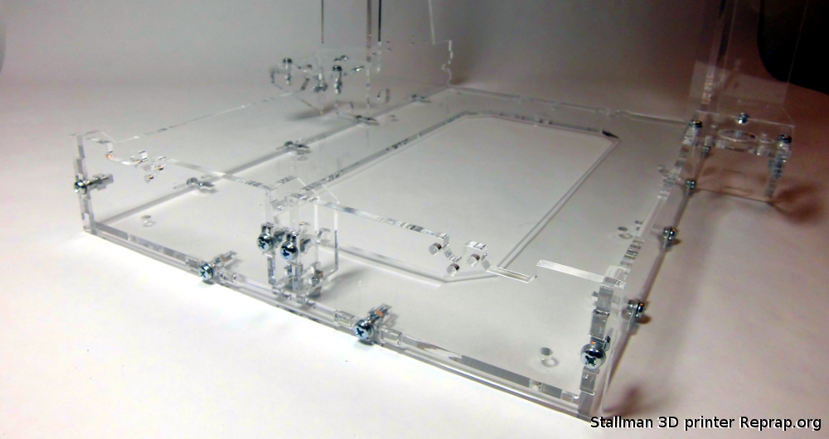
Y motor holder
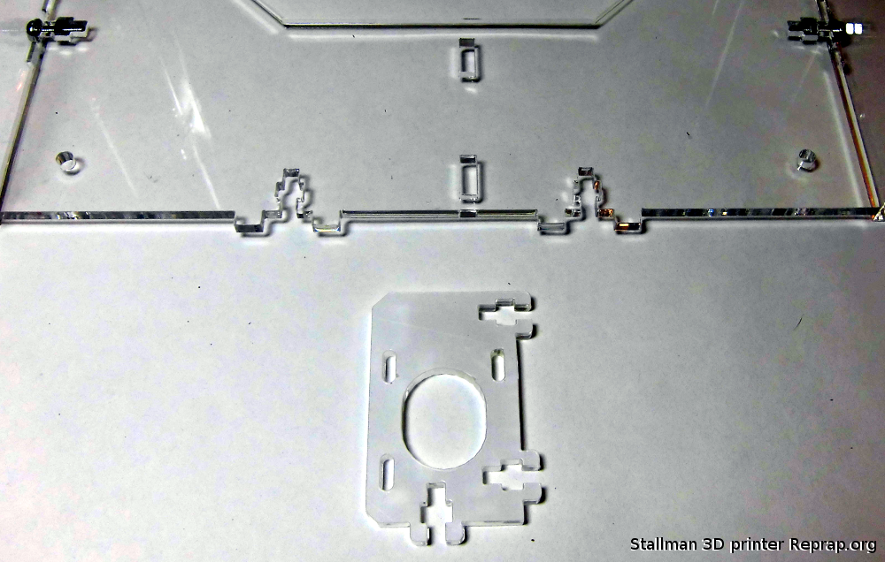

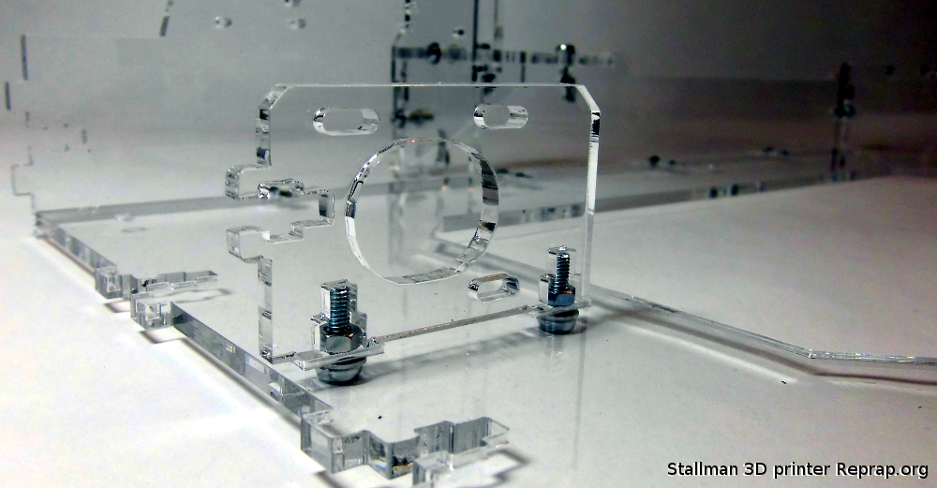
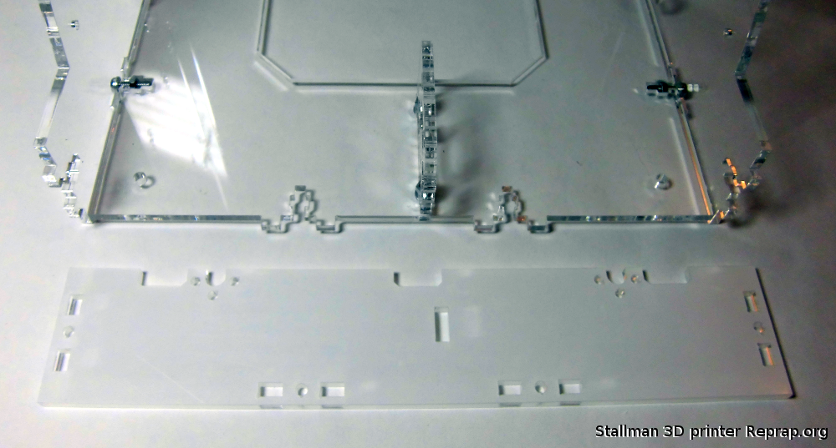

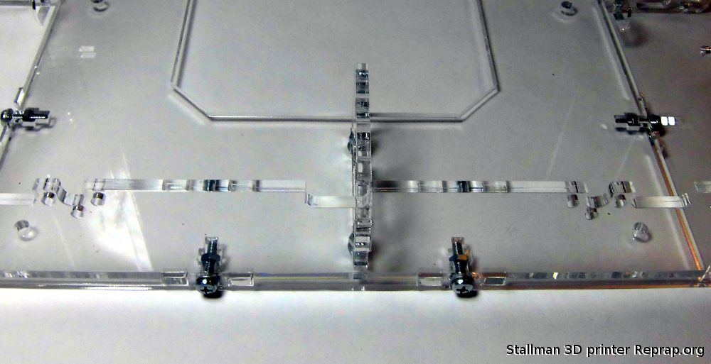
Z rods holder and stopper
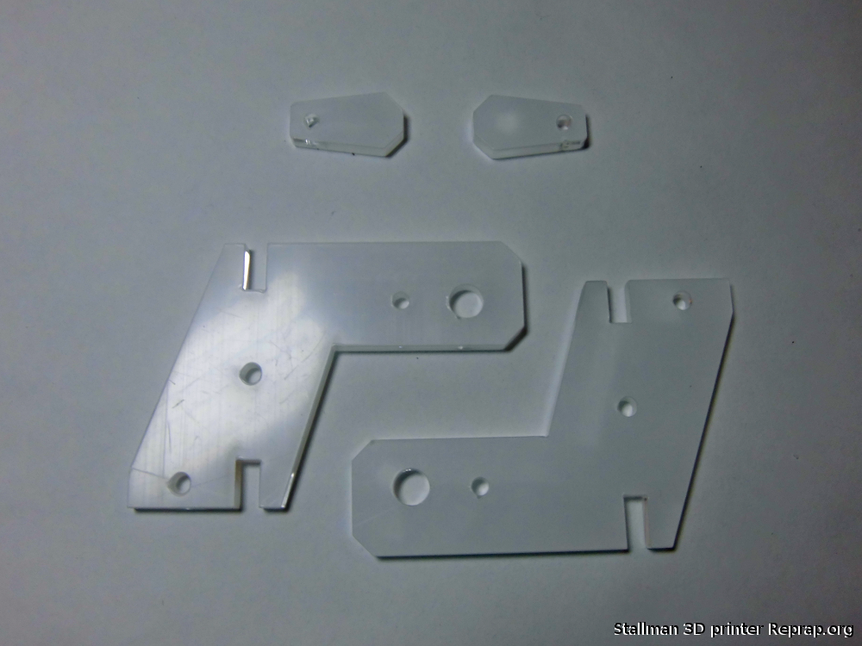

Do not tighten yet, wait until you place the Z rods.
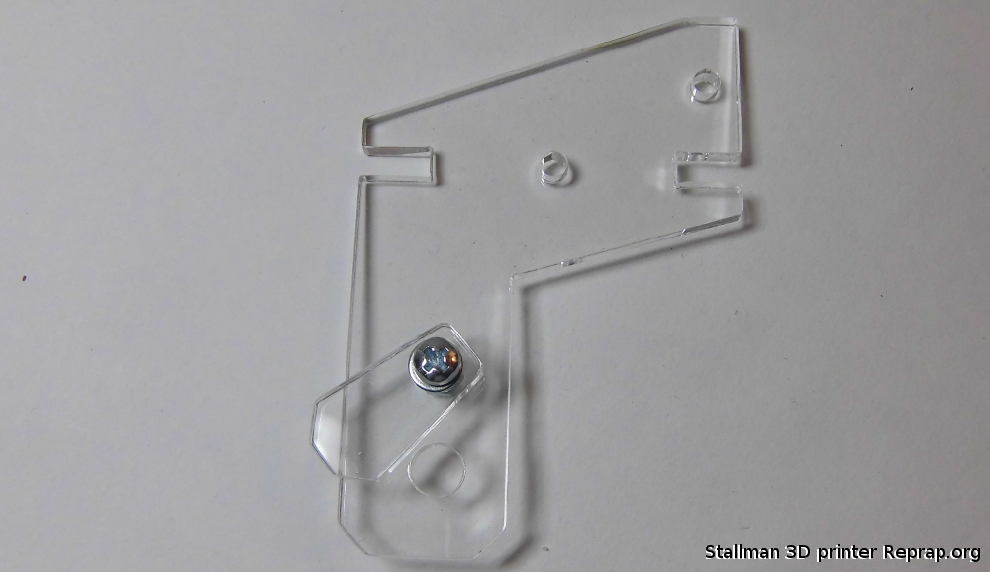
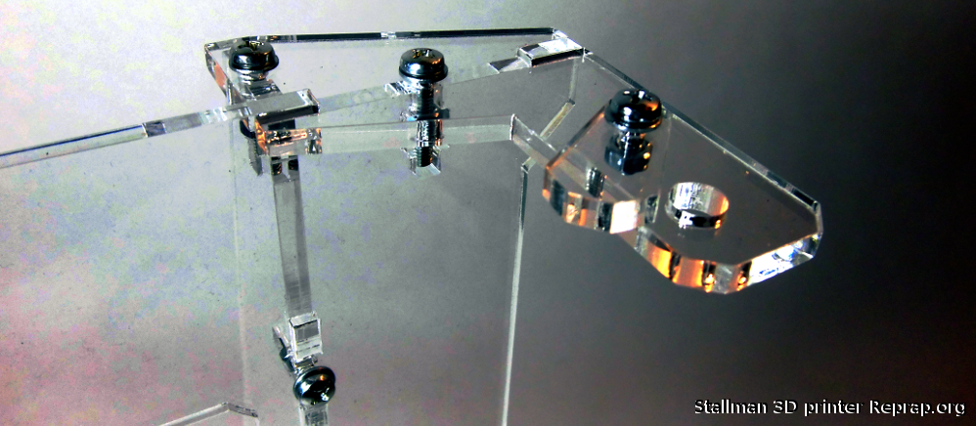
These pieces hold the Y rods in place
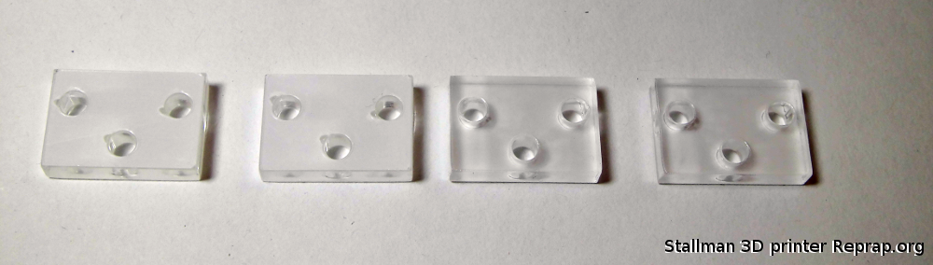

Do not tighten them yet, wait until you place the rods.
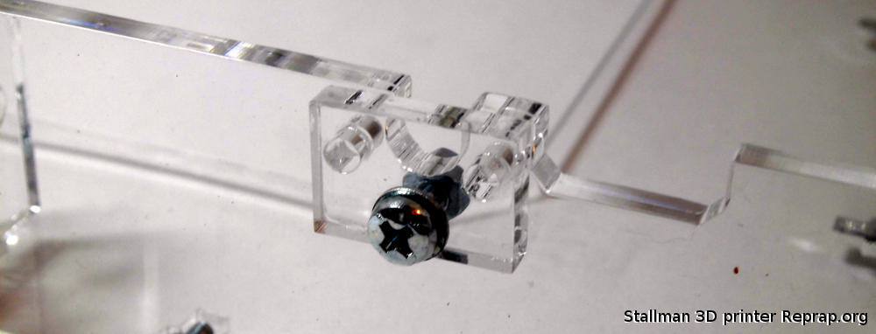
Assemble the Y Carriage

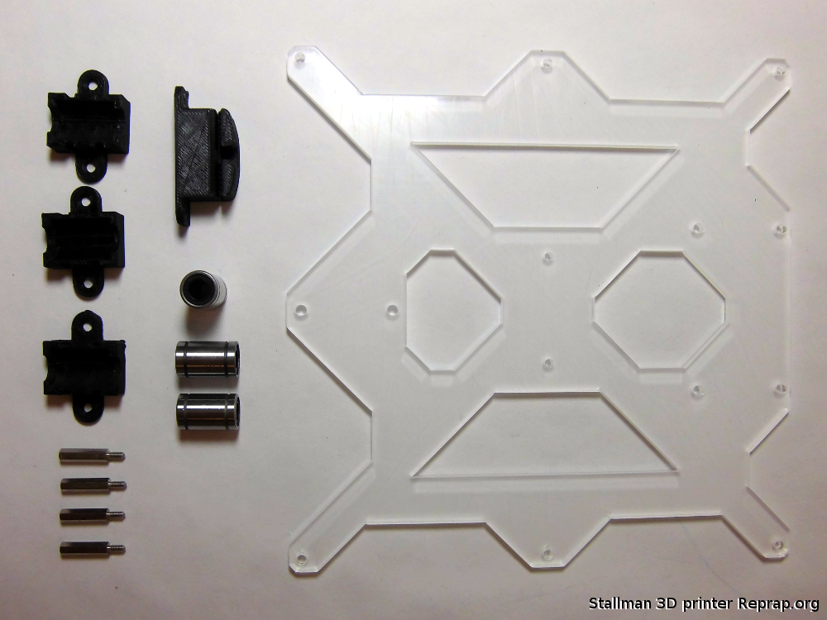

Insert the zip ties in the bearing holders
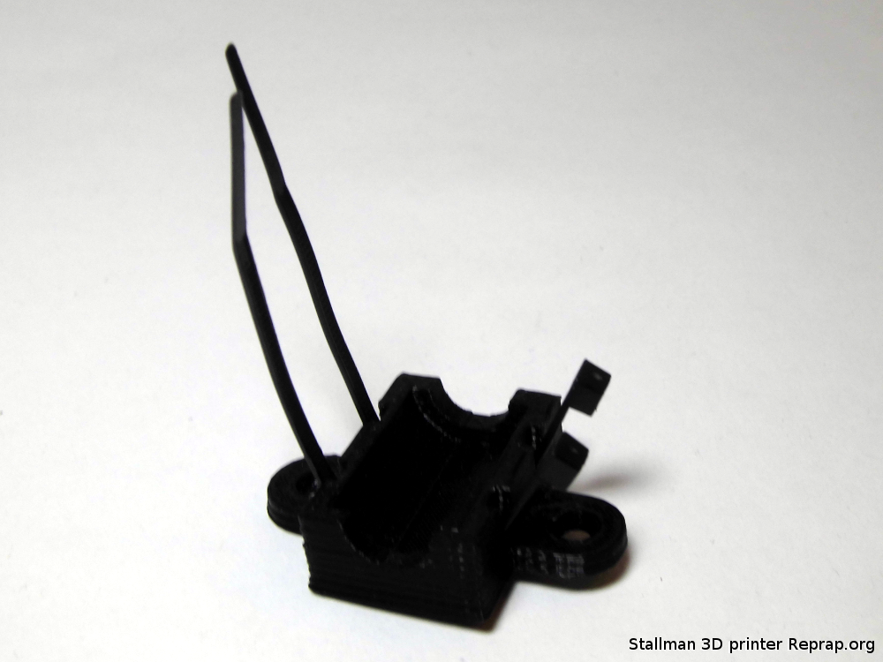

Place the bearing on the holder a little force may be necessary to snap it in place.

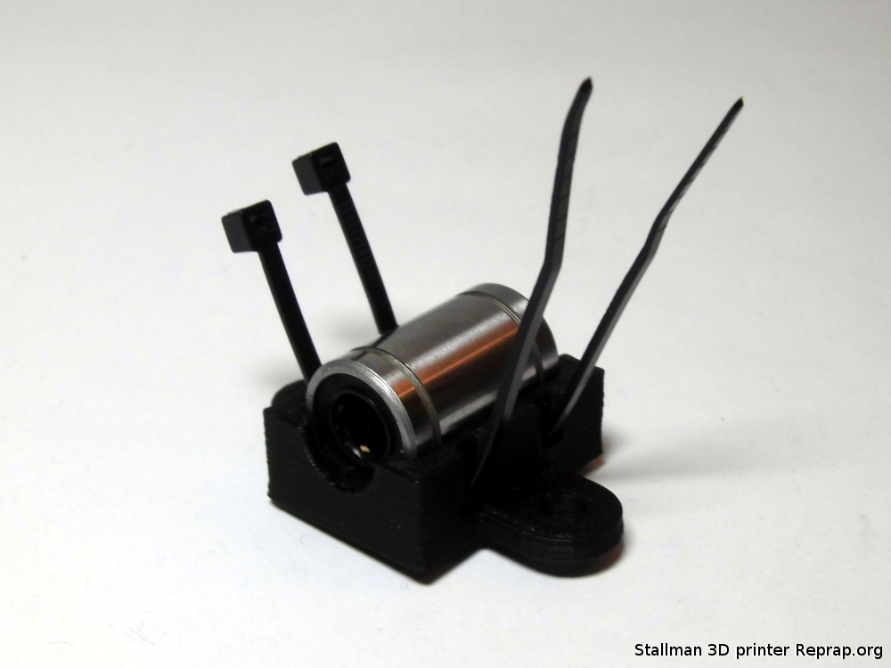

This is a top view of the Y carriage, the hotbed will be placed over here.

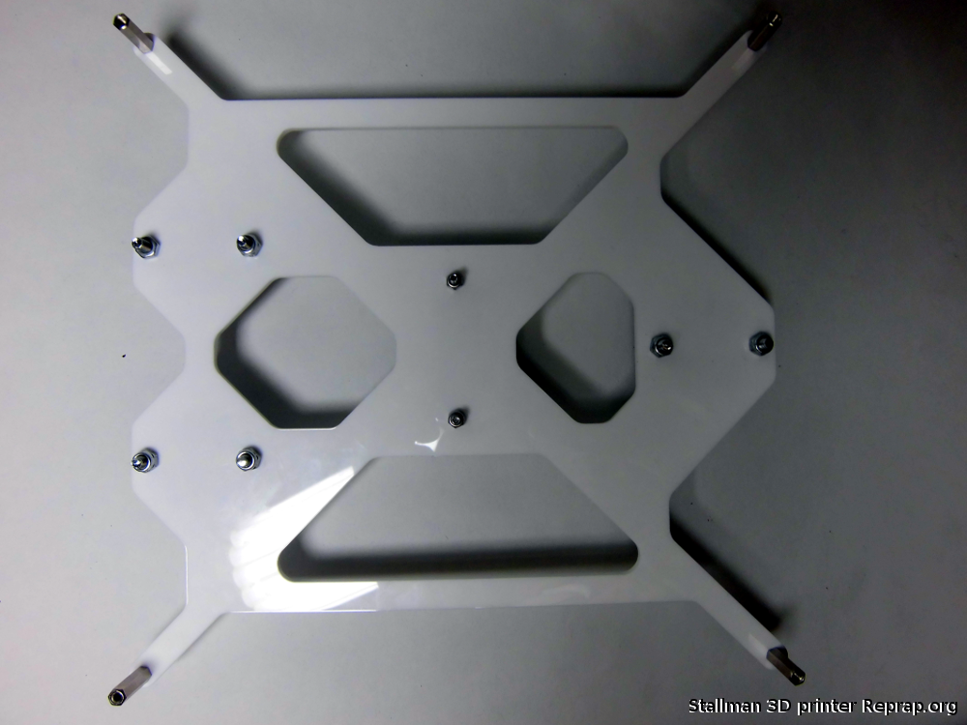

Bottom view of the Y carriage

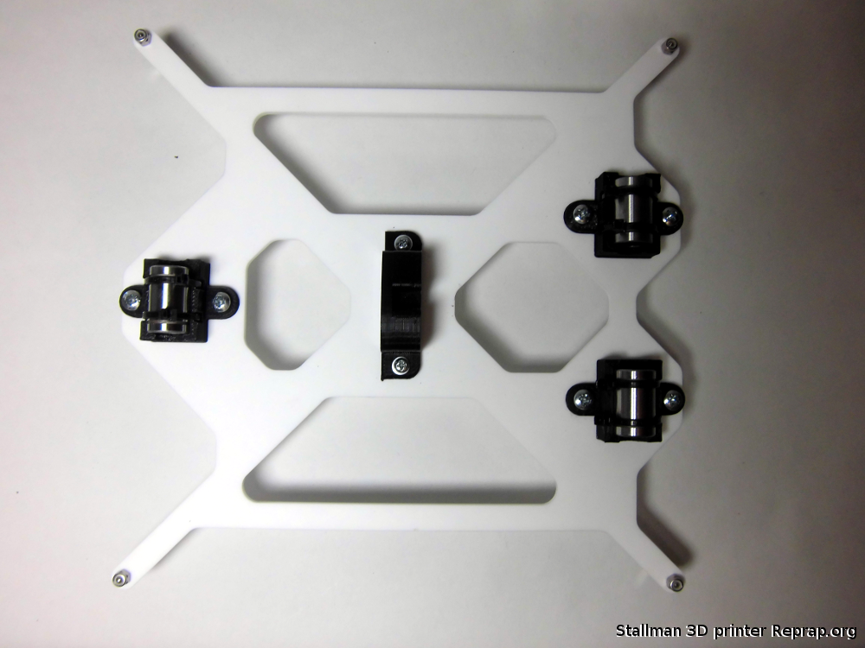

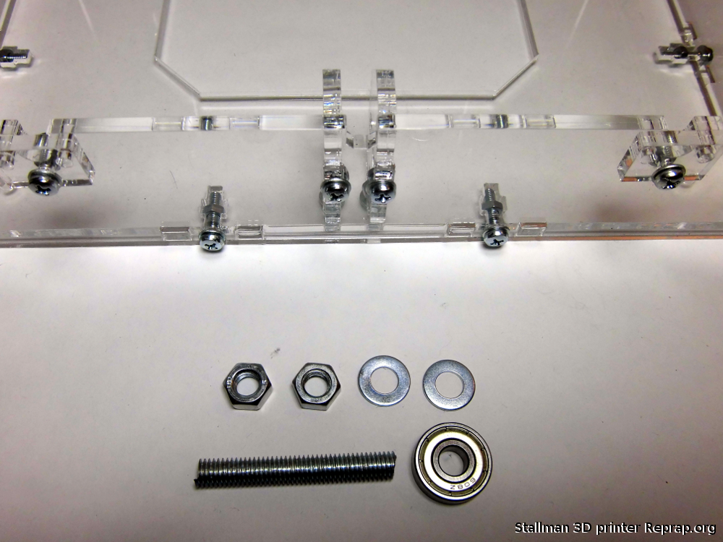

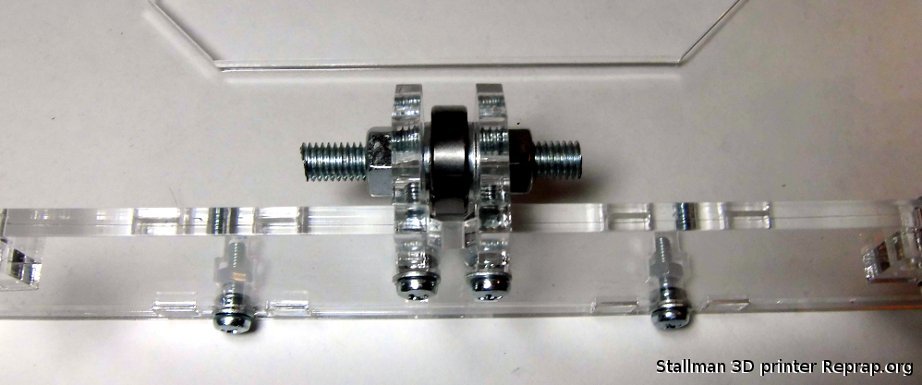

Y motor
Place the pulley on the motor shaft.
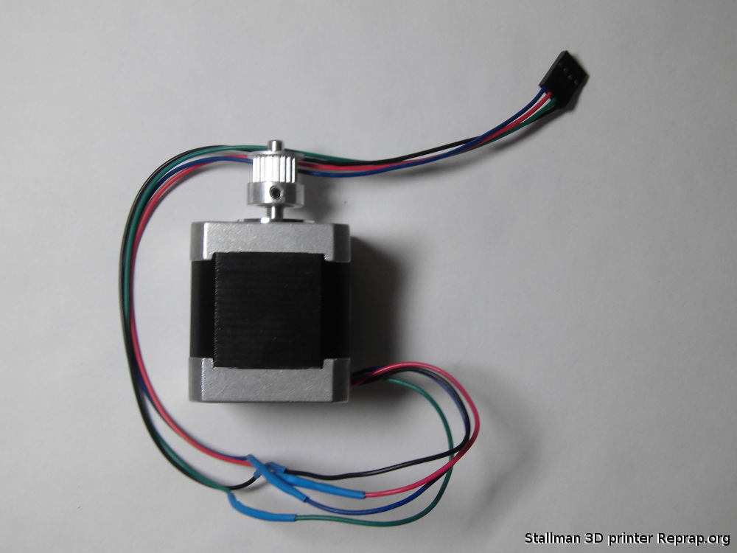

Notice the hole in the frame for the wire.

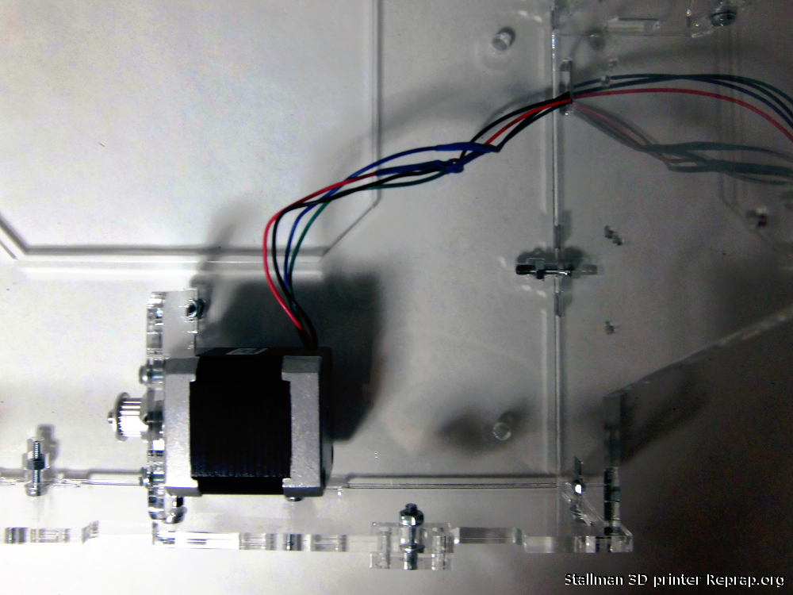


Y rods
Use the longest rods, slide the Y carriage in the rods before securing them with the fastener to the frame.
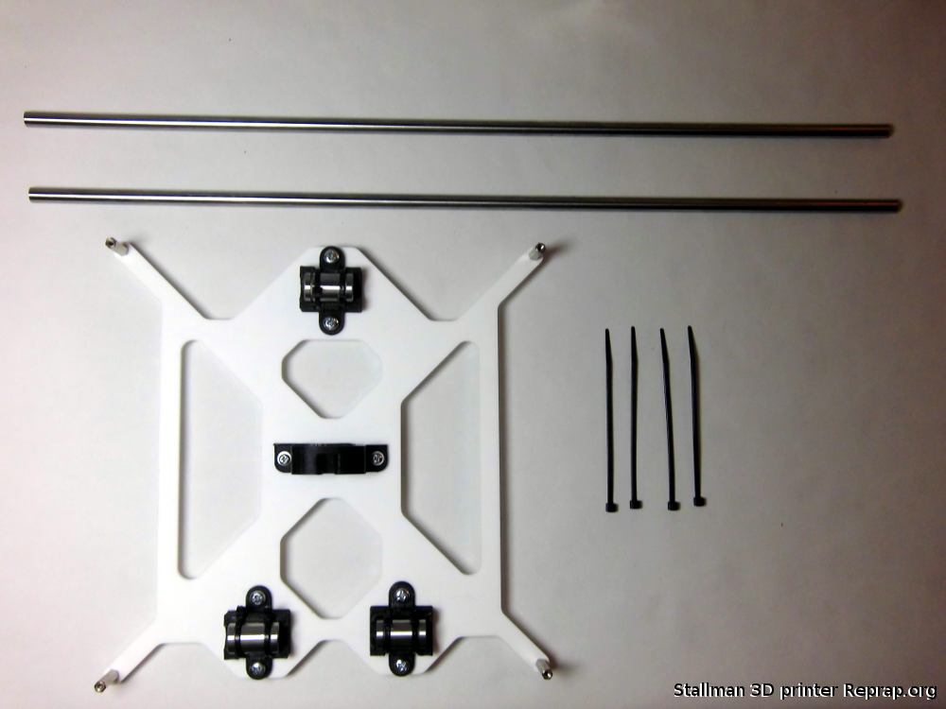

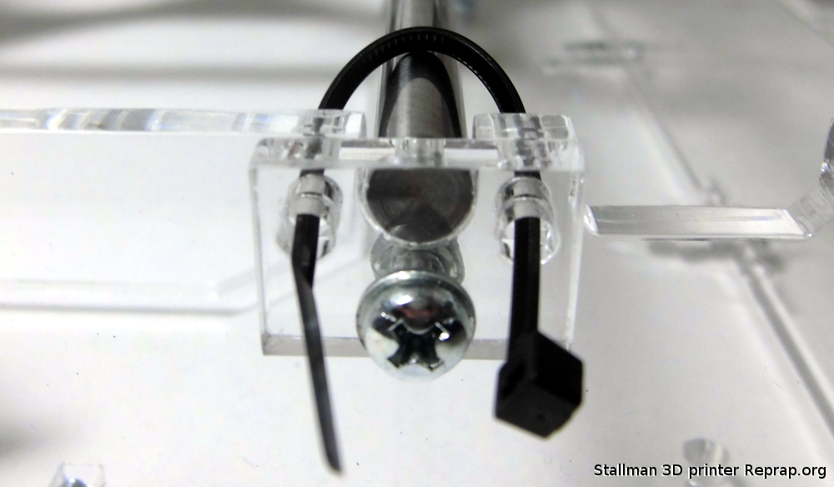
Take the longest belt

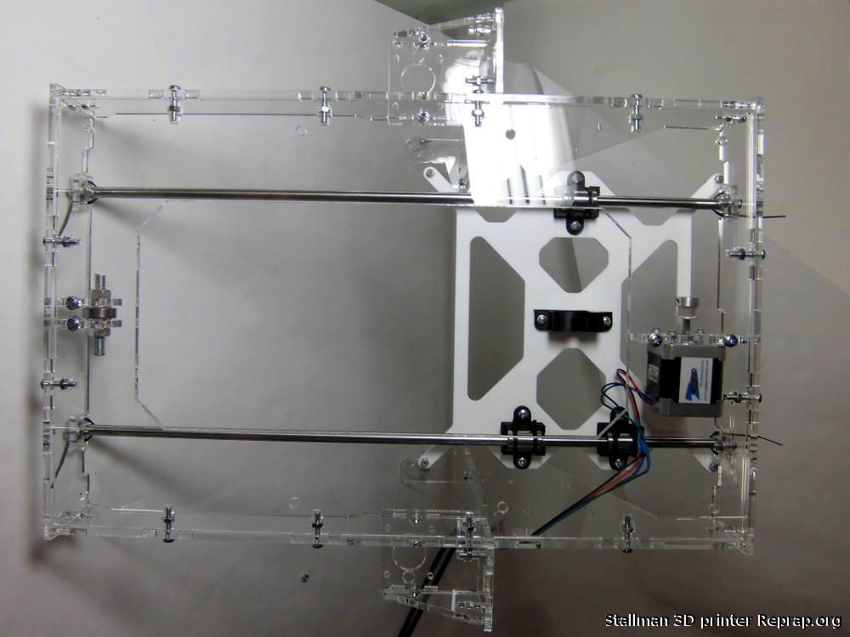

Be sure the the belt is tight if your printer prints an oval instead of a circle is usually because of under tightened belt.

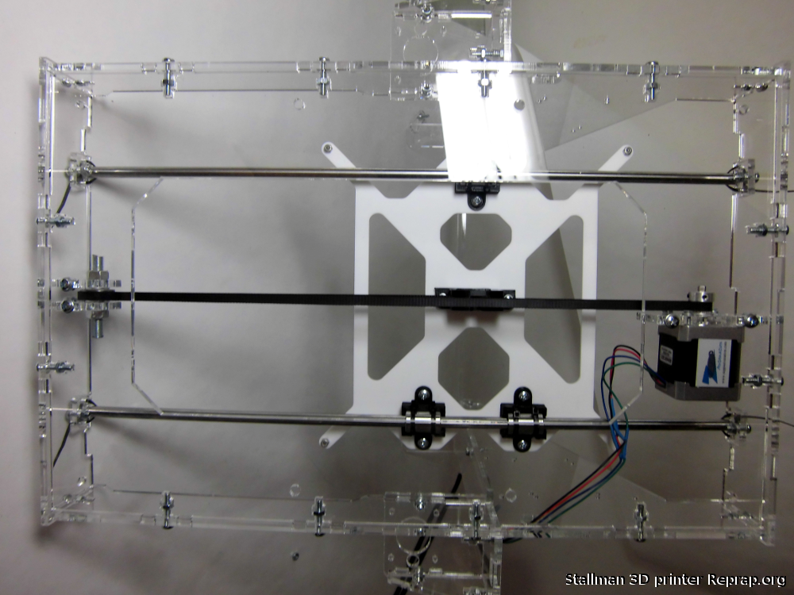

Z motors.
Depending on the electronics you have you might need to connect them together. With RAMPS 1.3 and above you don't.

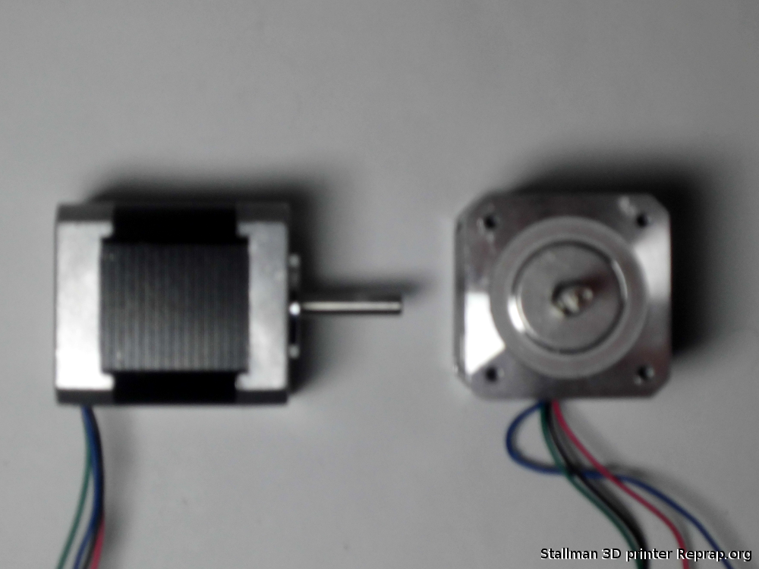

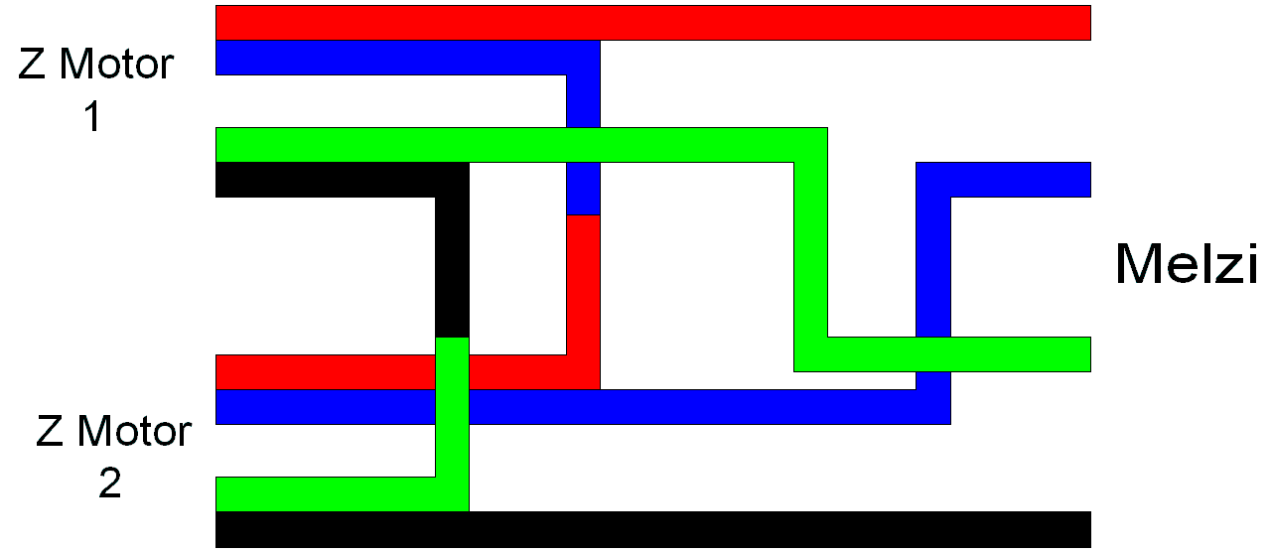
Thanks to Nophead for this pic of the motor wiring.

The two Z motors are installed on the side of the frames.
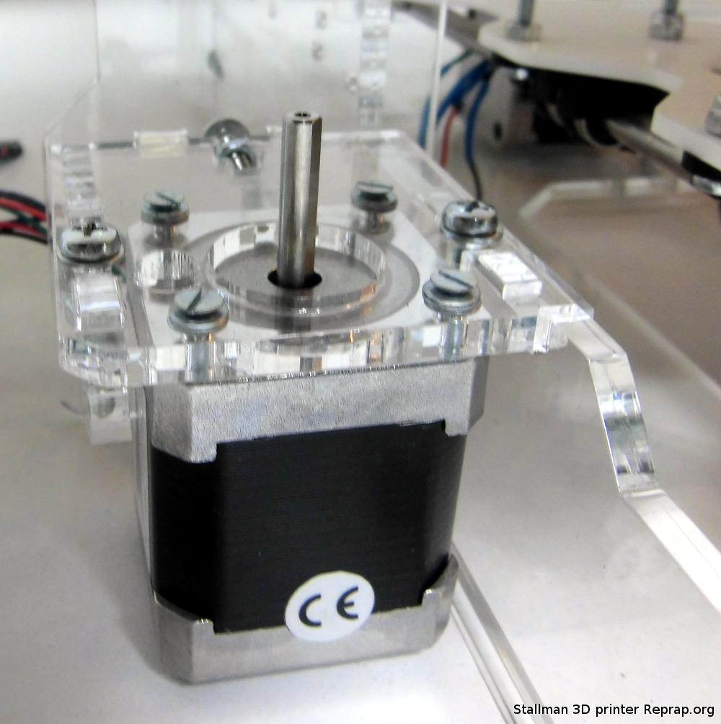

X motor
Place the pulley on the motor shaft.
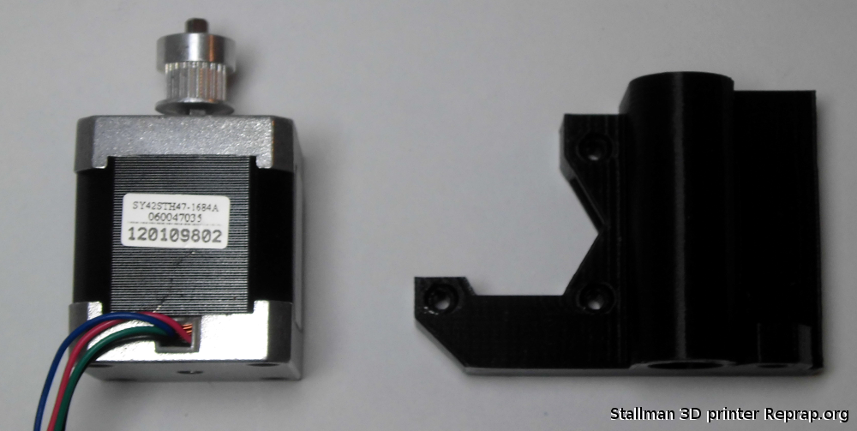

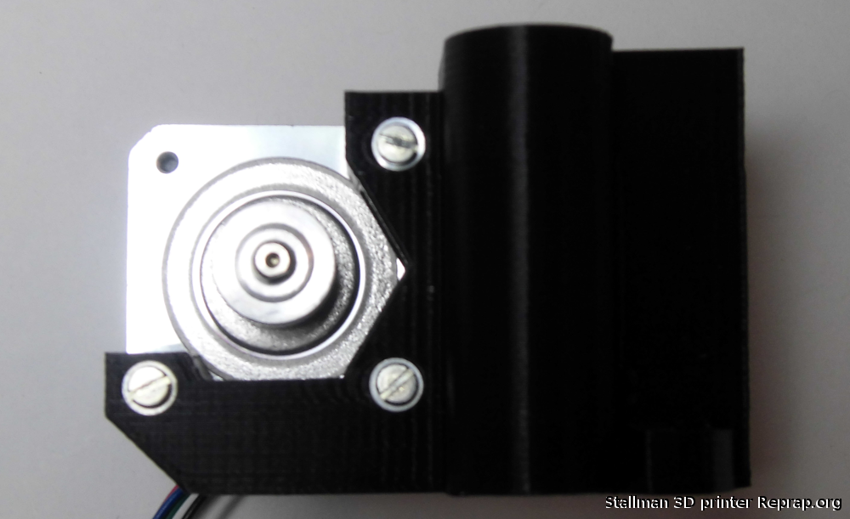

X idler
You can assembly with the x idler spacer or without, works both ways, here it is shown without.
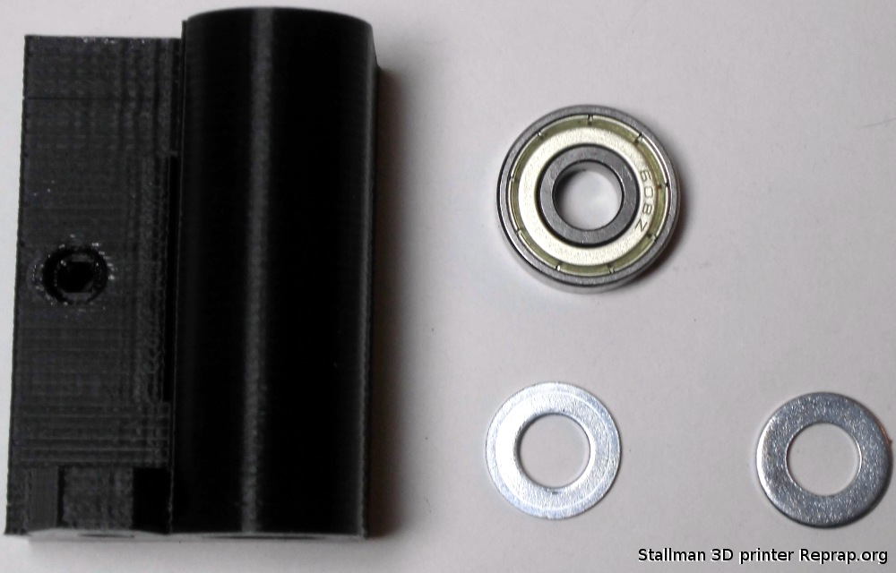

X idler
This is where the Y belt will slide.

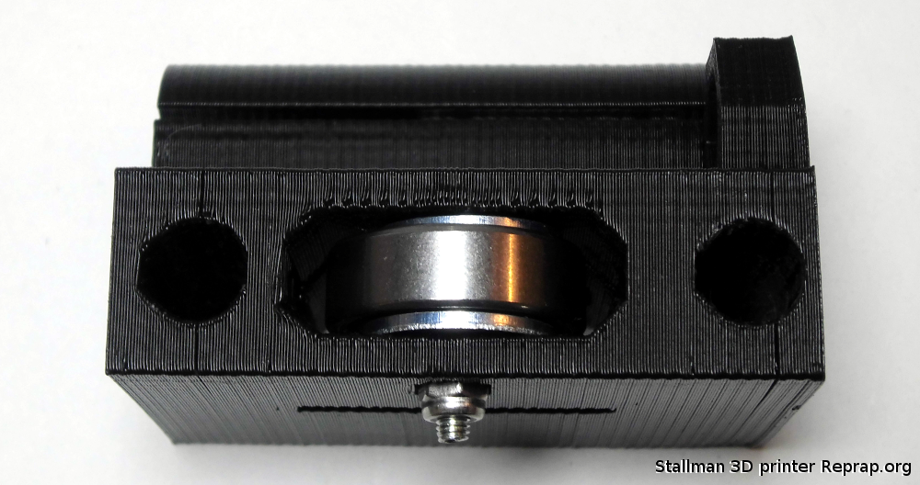

X carriage

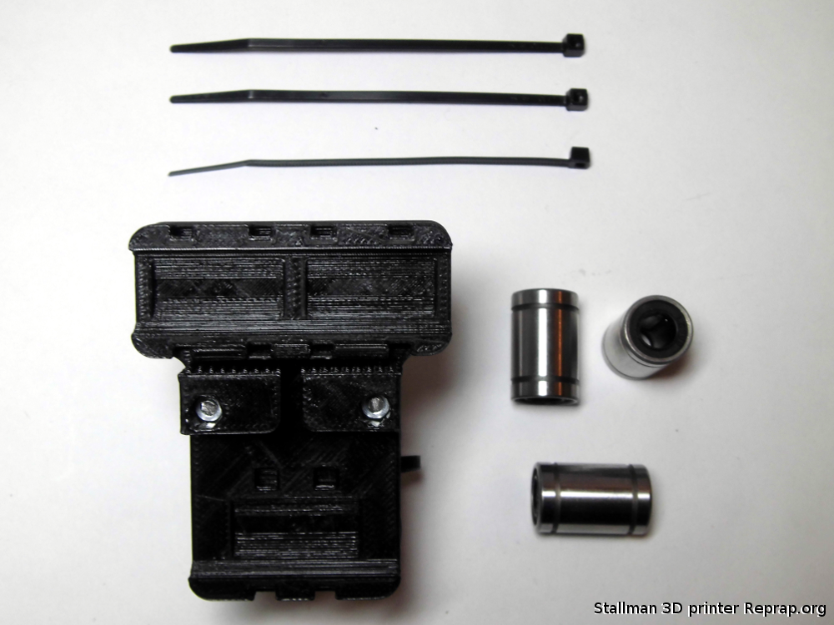

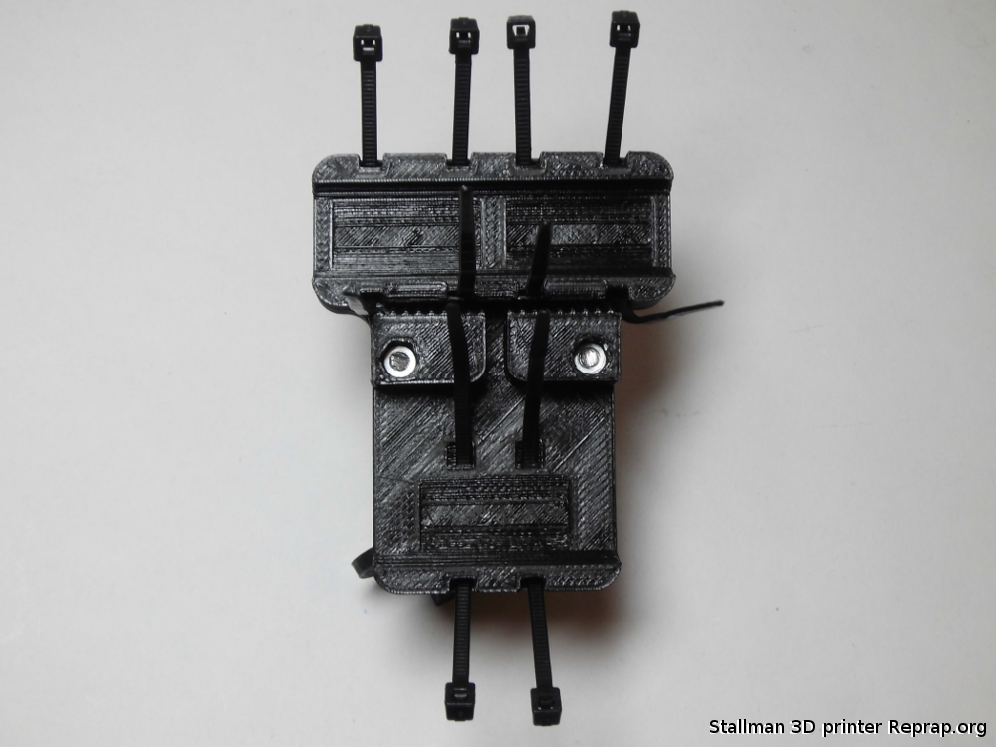
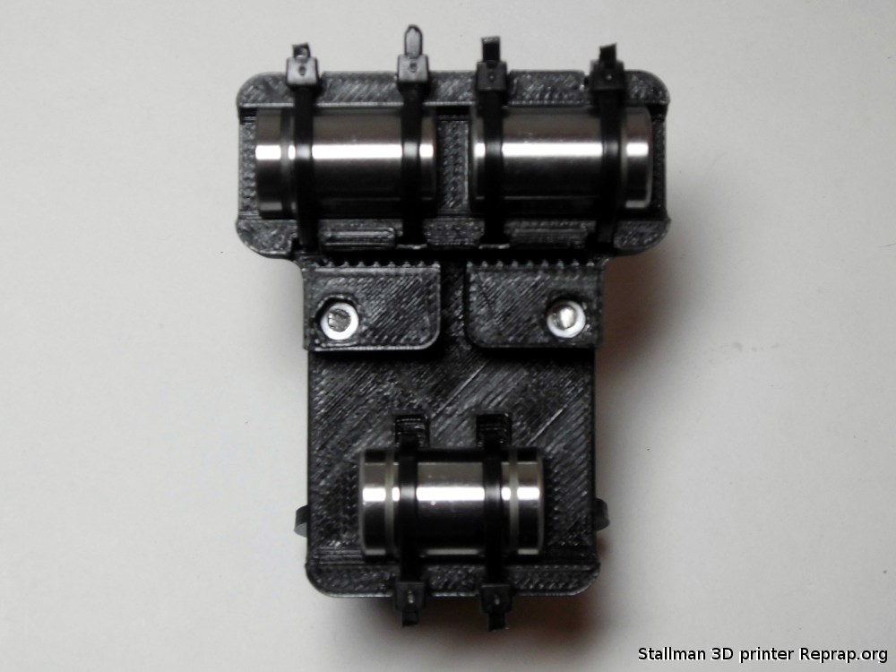

Assemble the X axe

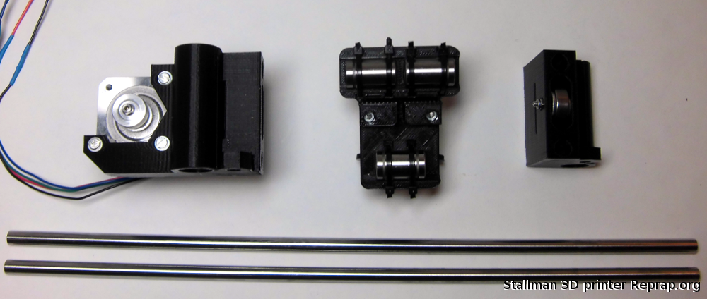

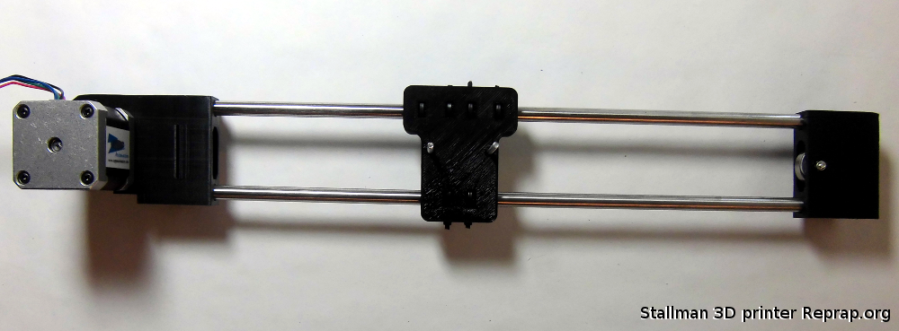

Take the two M5 threaded rods and the two Z rods and use them to put in place the X axe. Remember to connect the plastic tube to the threaded rods now. Place the M5 nuts in the middle of the threaded rods. You will insert the Z motor shafts in the free opening of the plastic tubes.
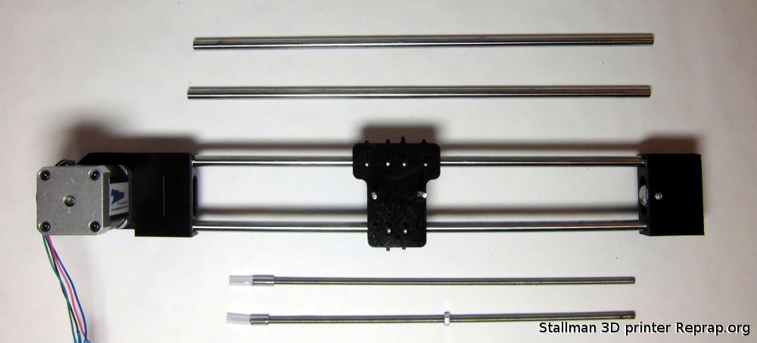

Personally I find it easier to slide the smooth rods first in the x axe and then connect the threaded rods to the motor shafts.

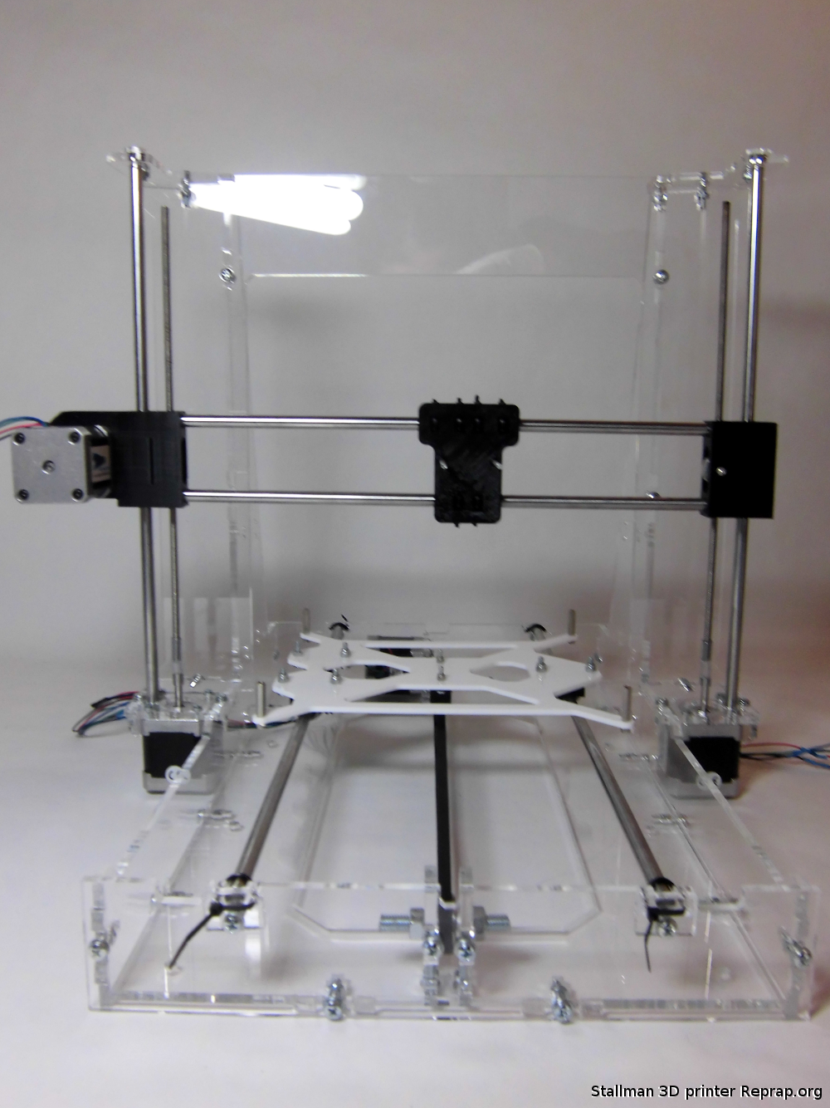
Extruder block

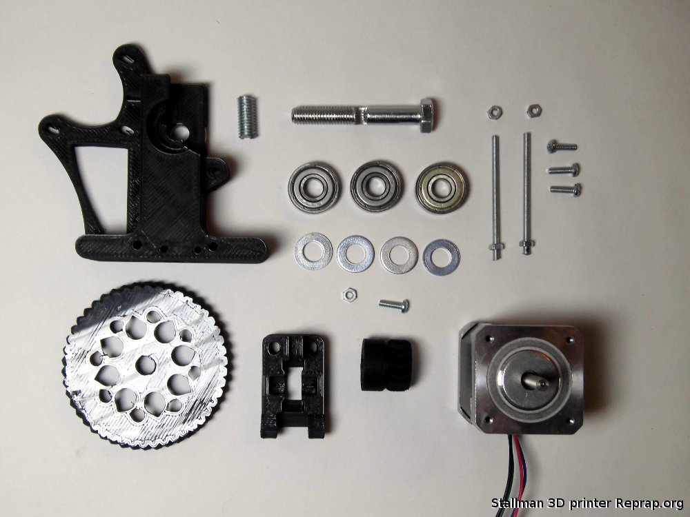
First step
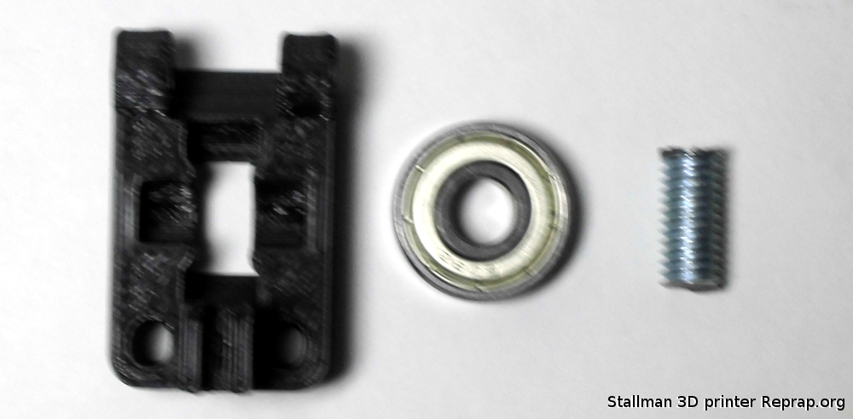

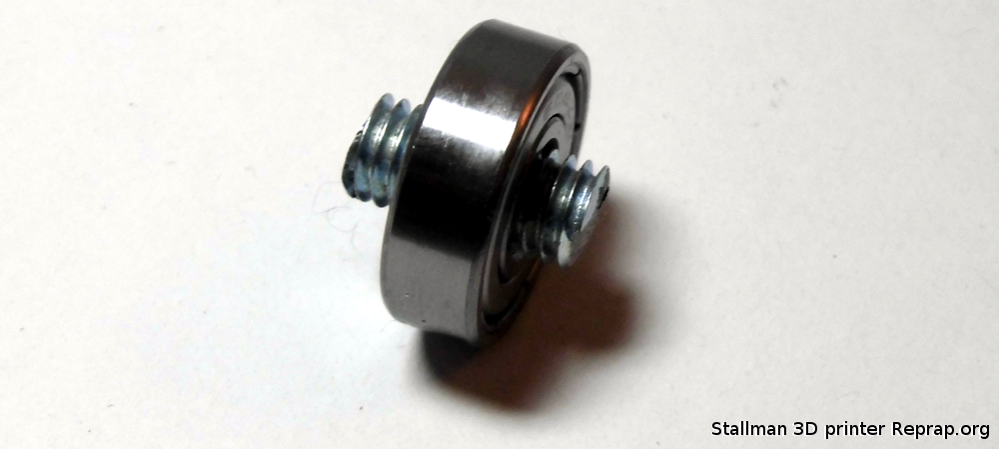

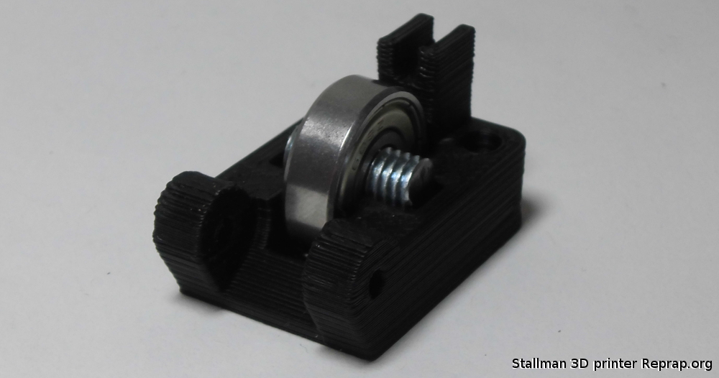

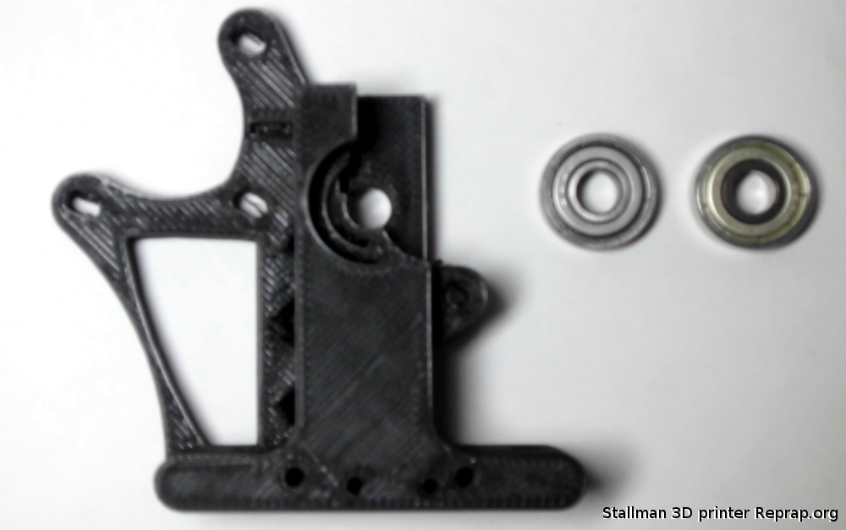

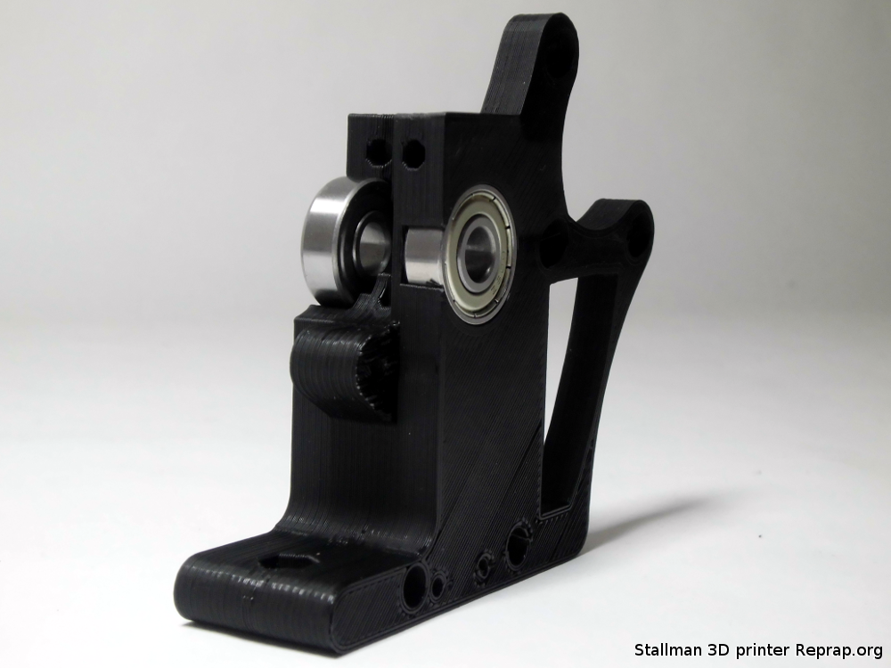

Place the motor on the extruder block, but do no tighten the screws yet. You need to move the motor a little bit to fit the big gear after you placed the small gear on the motor.

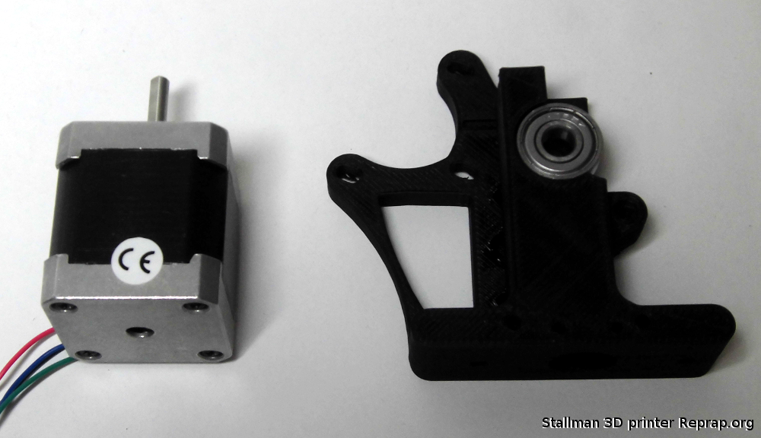
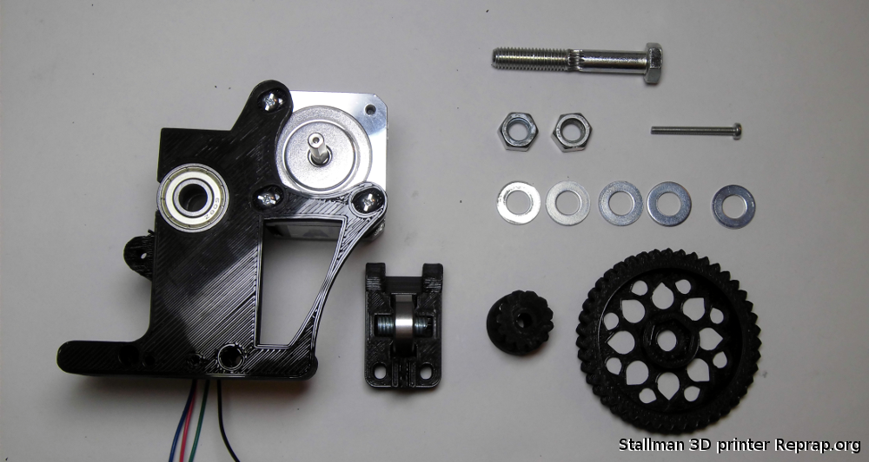

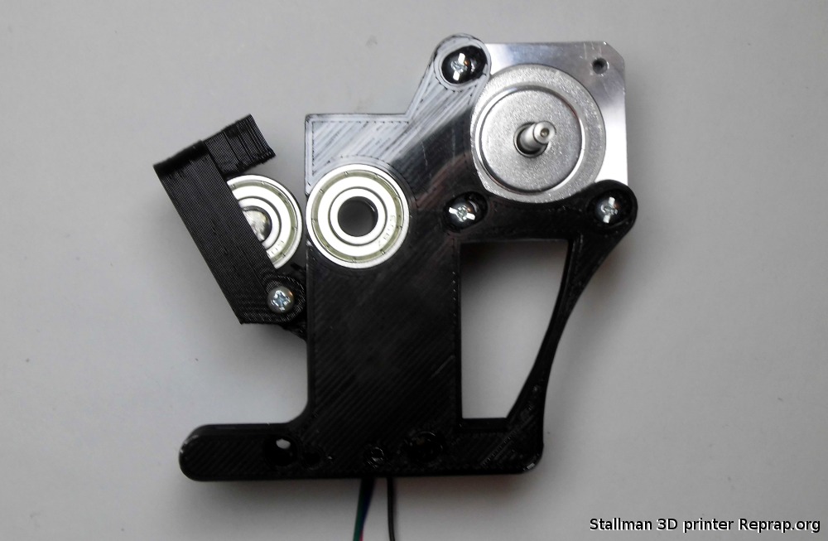
Put the small gear on the motor shaft
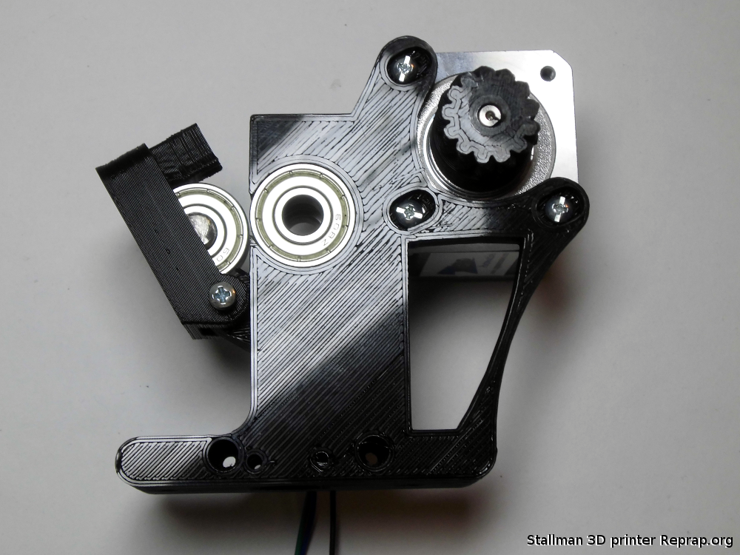
Depending on the groove on your hobbed bolt you will need one or more washers, the filament needs to stay in the center of the groove. 1UP3D kits use 4 washers.
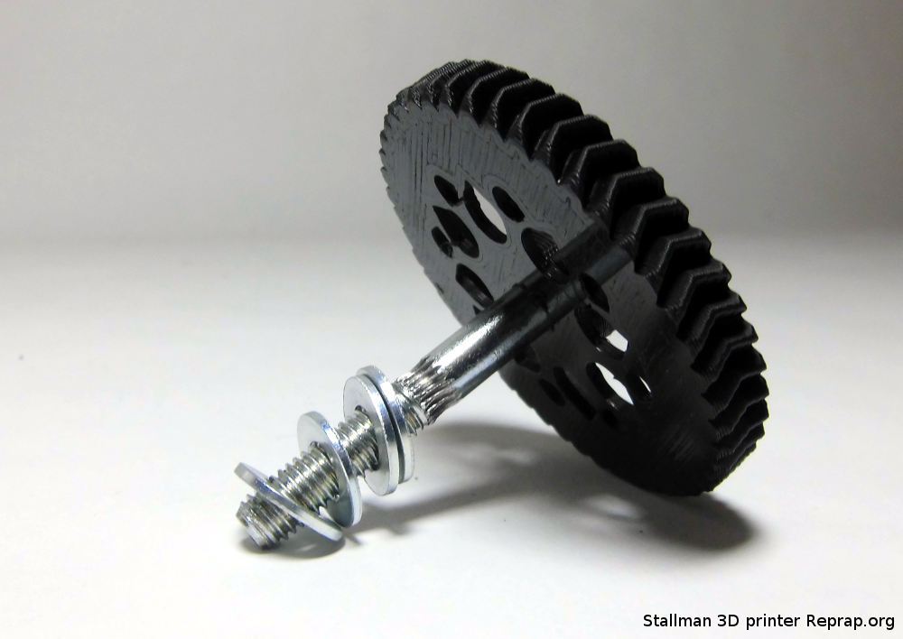
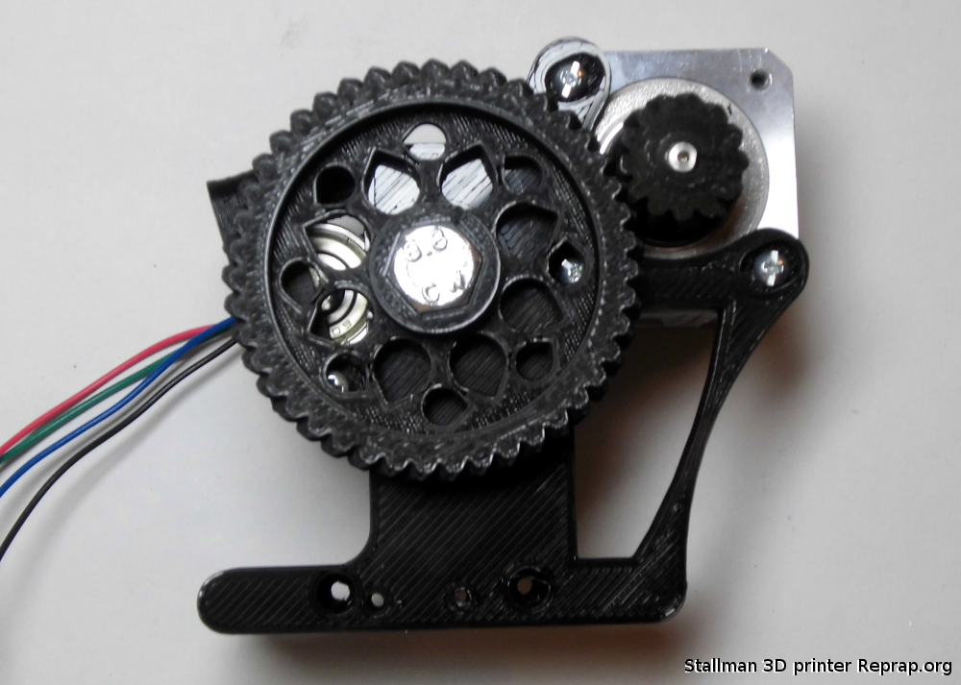

Adjust the motor position so the small and the big gear so that they touch and work together and then tighten the motor screws.
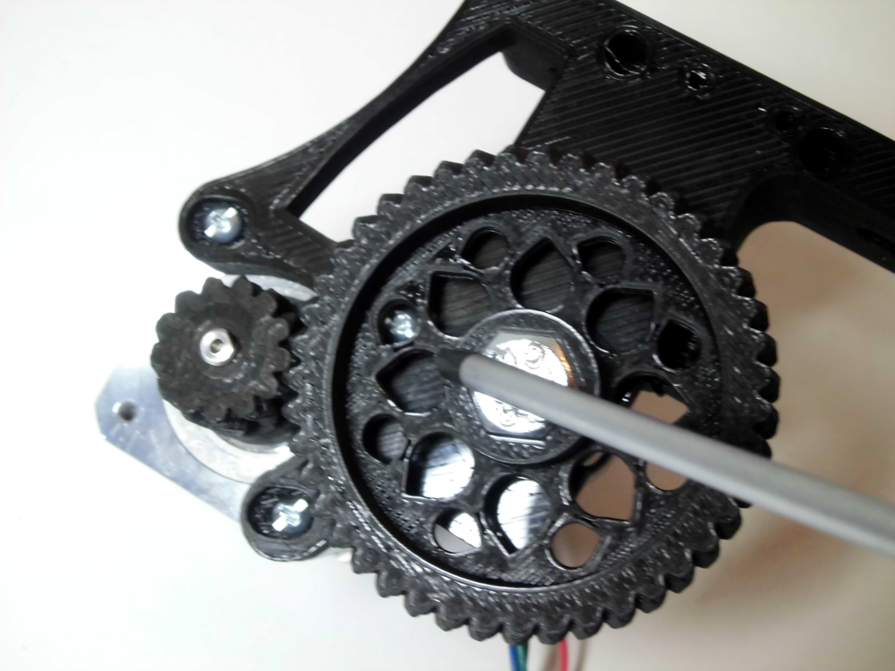
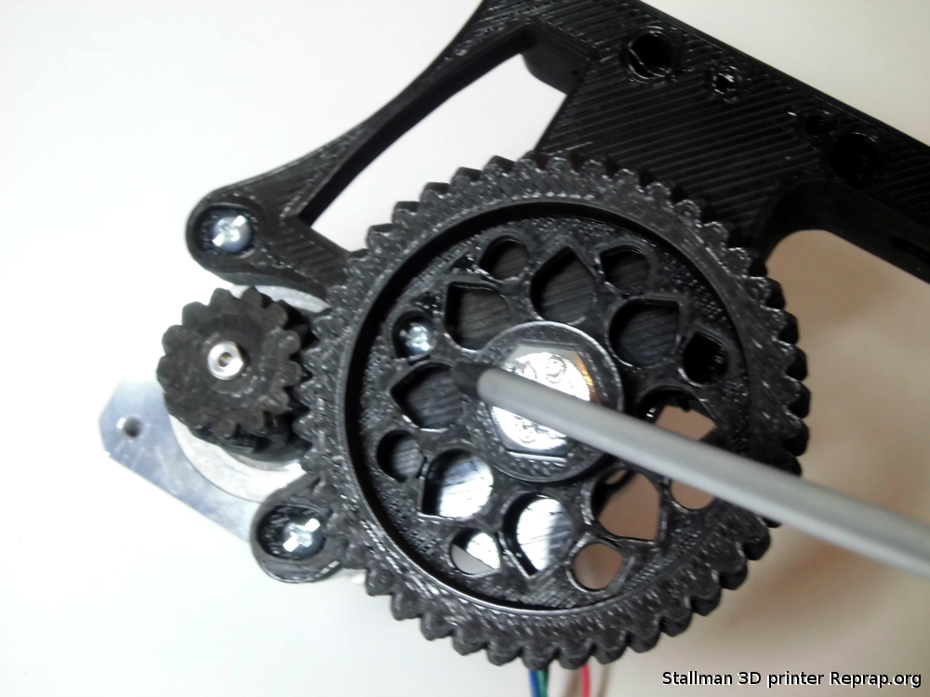

Take the two small M4 threaded rods and place them in the extruder body. The wing-nuts and the springs go on these.
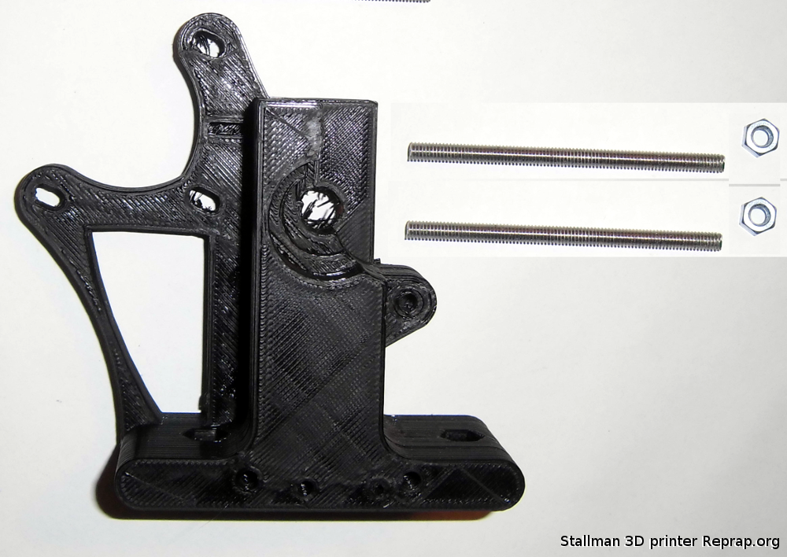

Take the hotend, insert it in the bottom hole of the extruder and secure it in place using the two wood screws. In this picture the extruder is partially assembled not like the one you have now, do not disassemble yours.

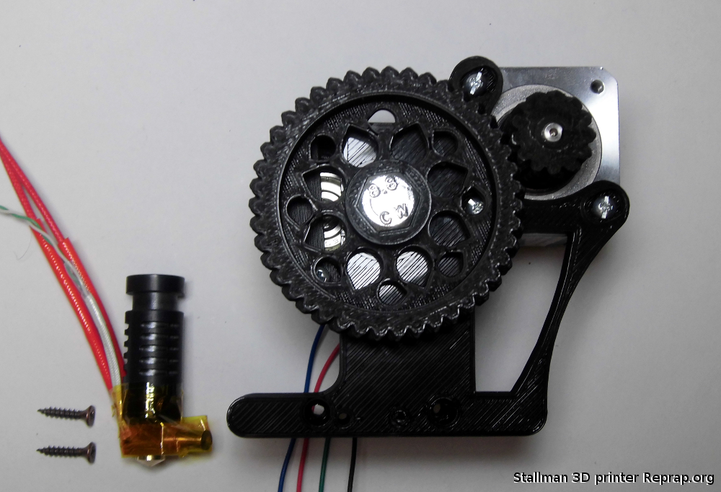

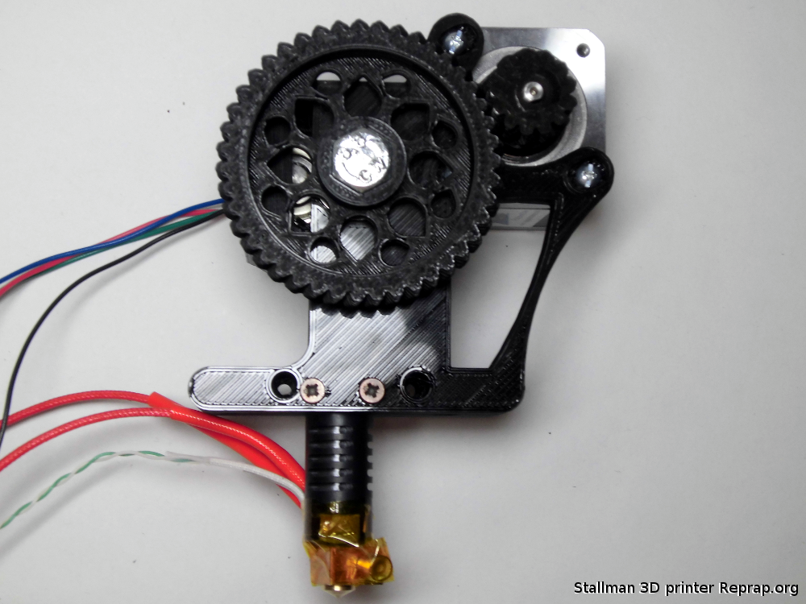

Heated Bed
The heated bed has two purposes: reduce warping and make the first layer stick. In general molten plastics don't stick well to cold smooth surfaces but they will stick to some hot surfaces.
As each layer is laid down it cools and shrinks a little due to thermal contraction. The second layer welds on to the first layer and then tries to contract, putting stress on it. The next layer does the same and eventually the cumulative stress becomes enough to overcome the adhesion of the first layer to the bed and the corners start to lift and curl up. By keeping the object warm the amount of contraction is reduced until the bed is switched off at the end and then all the layers cool to room temperature together.
The ideal temperature for the surface of the bed is just below the glass transition temperature of the plastic (Tg). This is the temperature at which the plastic transitions from a rubbery state to a rigid or glass like state. As the plastic cools from the molten state all the way down to Tg it isn't solid enough to stress the layer below. Stopping it cooling just below Tg means it doesn't contract much at all past the point where it is solid enough to stress the layer below and it is rigid enough to support the layer above.
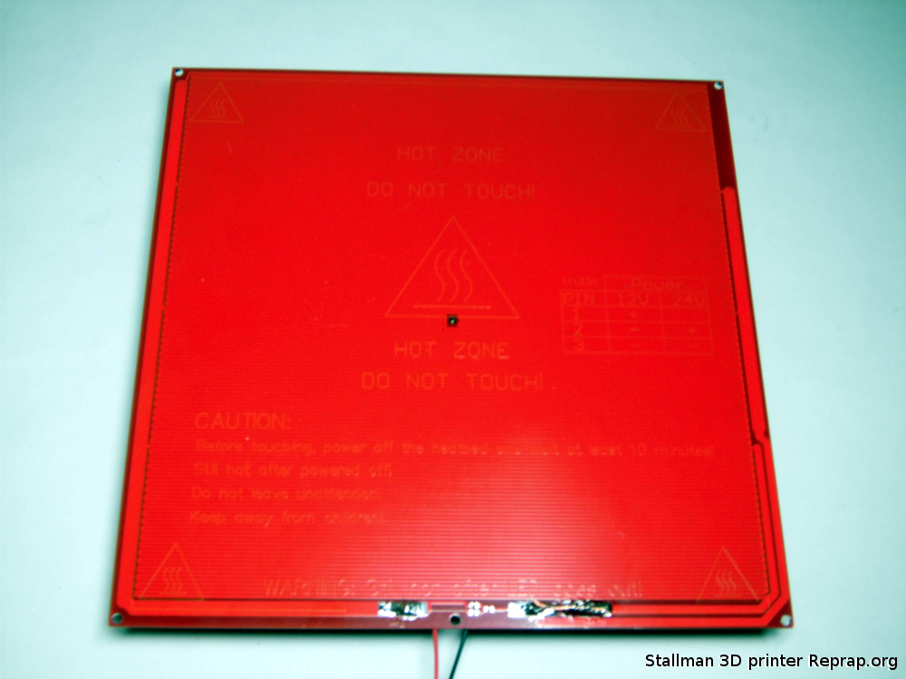

The temperature of the bed is measured underneath, so the temperature at the surface of the glass is around 10˚C lower. PLA has a glass transition around 55˚C, so 65˚C is a good temperature to set the bed to.
It can be set to a higher temperature for the first layer to increase adhesion, but after that it must be lowered again.
At the end of the build PLA objects will come lose when the temperature drops below about 35˚C due to the different contraction rate of the plastic and the glass.
ABS is more difficult because it has a higher glass transition and higher thermal expansion coefficient In addition it doesn't stick well to bare glass. A bed set temperature of 120˚C-130˚C is needed and the bed struggles to reach that temperature without insulation under it. Covering the top surface with a sheet of corrugated cardboard makes it warm up much faster.
To make ABS stick to the glass it will need some form of coating. A thin layer of a dilute solution and ABS in acetone works. PET or Kapton tape gives more adhesion but the disadvantage is the objects don't come loose when the bed cools and need to be prised off.
Always remember that ABS fumes are toxic while PLA is perfectly safe.

The four clamps will hold the glass on the heated bed place them close to the four corners. You need four because air bubbles between the glass/mirror and the heated bed is no good.

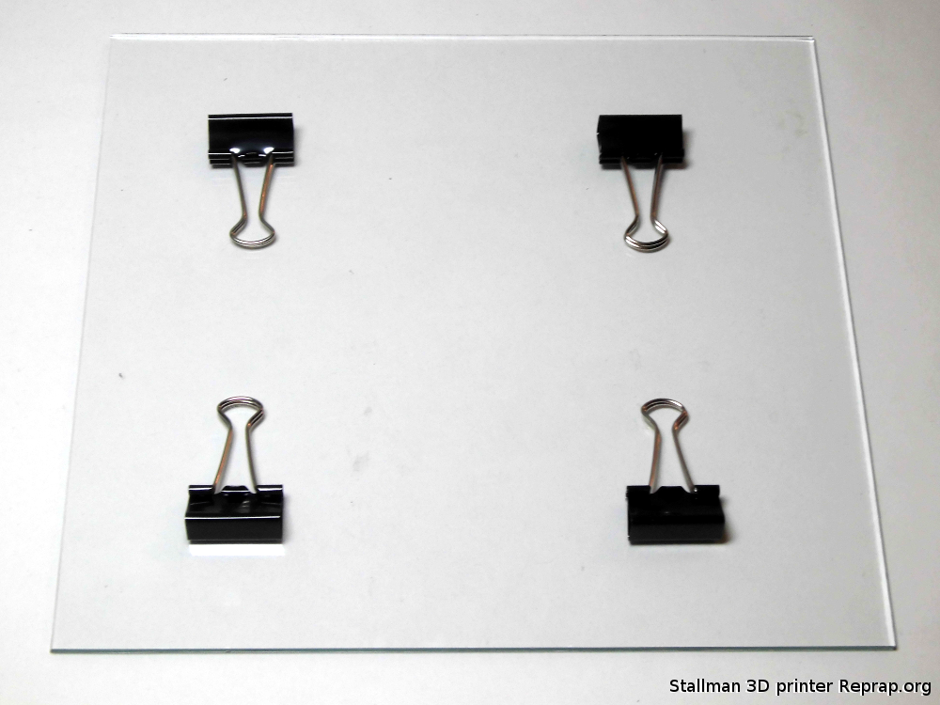

Endstops

You can use a 3D printer without endstops, but is not convenient. In case you find yourself with broken or missing endstops you can set absolute zero point for all your your axes at once with this command: G92
http://reprap.org/wiki/Gcode#G92:_Set_Position
In case of broken or missing endstops do not use auto homing in your slicer.

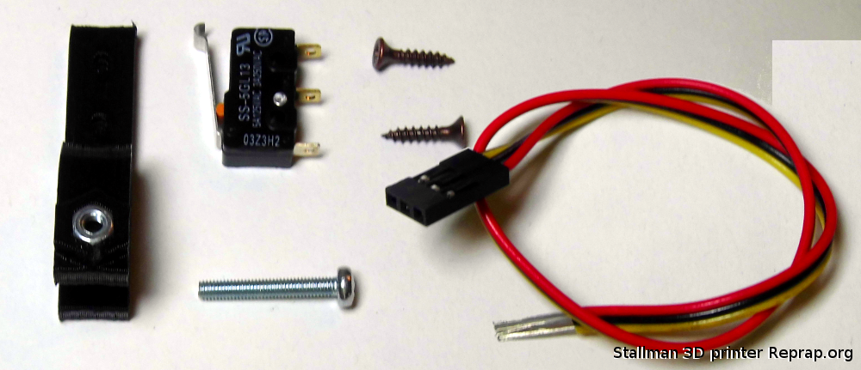
Mechanical endstops only use 2 wires for connecting the switch
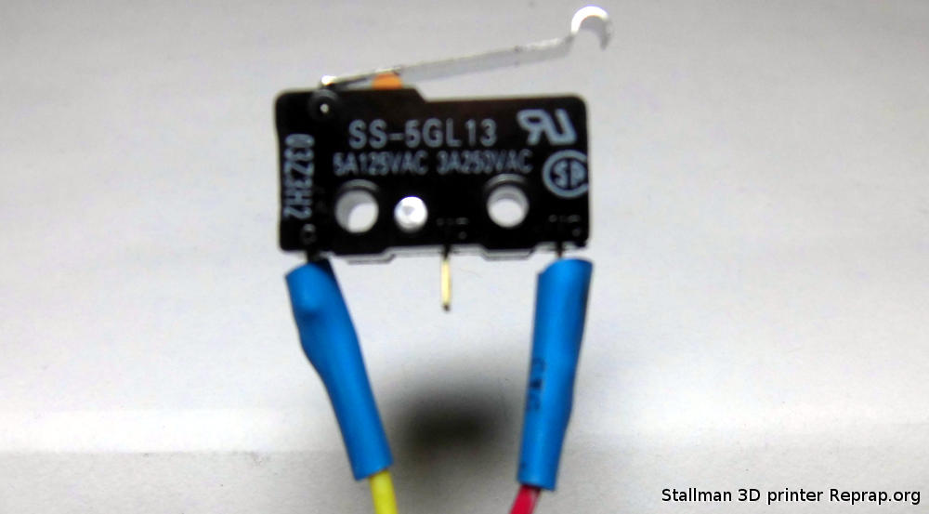

Changing filament
Do not to let the extruder run out of filament. If it does it will lose grip as soon as it gets past the hobbed bolt, making it difficult to remove as you cannot simply rewind it. You would have to remove the idler screws and grab the end with snipe nose pliers and pull it out while hot.

Removal
To change to a new reel of filament heat the extruder to normal operating temperature then rewind 100mm of filament. When the bit that has been molten gets to the hobbed bolt there will come a point where it is too thin or soft to be gripped. At this point pull it with enough hand tension to stop it from slipping and keep up the tension until it is all the way out. Do not stop rewinding it when it is part way out. This can cause soft filament to expand into the entrance of the J-Head (which is bigger than the filament path) and jam there as it cools down.
If you are switching between a strong colour and a weaker one it can take a long time to flush through all the pigment. To minimise this you can remove PLA at 76˚C (which is above its glass transition temperature but below its melting point). As it is therefore not a liquid but a rubbery solid, it will pull out in one piece leaving very little behind. It does stretch a lot though, so you need to rewind about 150mm to get it all out. The same trick can by done with ABS at 146˚C.
Do not leave the extruder hot without filament as the plastic residue inside will oxidise and become baked on to the inside of the melt chamber. Switch off the heater if you are not going to reload it immediately.

Insertion
To insert the new filament press the “Motors off” button, push the filament into the extruder while turning the big gear by hand. It is important to apply enough force to get the filament to open the idler without it slipping against the hobbed bolt. If the bolt slips against the plastic its teeth can get clogged.

Different types of filament
Please note different filaments require different temperatures. Not only does the type of plastic, but even the colour, makes a big difference. The good type of PLA are happy at around 185˚C but depends on the manufactures, avoid cheap deals. The pigments change how viscosity varies with temperature. ABS is likely to need about 235C.
Failure to use an appropriate temperature may cause the extruder to become blocked. When trying a new filament for the first time turn the extruder motor off and try feeding it by hand turning the big gear. If the temperature is too low it will be very stiff to turn. If it is too high it will drip out the nozzle like syrup rather than forming a solid filament. Other signs of it being too hot are discolouration or smoke. Don't select a temperature higher than 250˚C as it will damage the hot end.
Cleaning the hobbed bolt
In normal use the hobbed bolt does not need cleaning. If the filament starts slipping for any reason, such as not enough spring tension, or the nozzle is blocked then its teeth can become clogged with plastic. It will then not give consistent grip until it is cleaned.
- Remove the filament by the method described above.
- Lower the Z axis so the extruder is below the gantry.
- Undo the M8 nuts and remove the big gear and the hobbed bolt.
- Clean the bolt with a wire brush.
- Reassemble and reload the filament.

How to calibrate your printer
In this chapter you will learn how to change your STEPS PER UNIT in the firmware. Do this if the object you are printing has not the correct size.

Start the Arduino ide and open the printer firmware.
Press ctrl+F to open the search dialog.
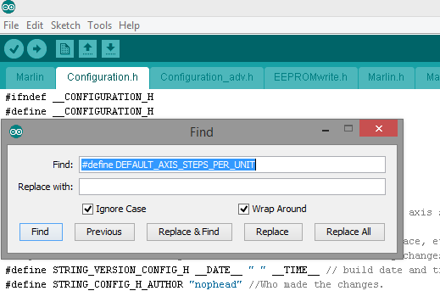

Search for #define DEFAULT_AXIS_STEPS_PER_UNIT
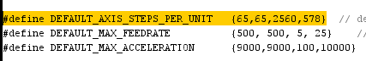
Values are separated by commas, X, Y, Z , E
If you move axis in sw for 10mm (demanded length) and actual machine moves for only 8mm, you need to do this calibration. To calculate new steps per mm value for the axis we calibrate use this calculator.

RepRap Calculator

Follow the instructions on the page to calibrate your machine, if you have a 1UP3D.com kit you have a 0.9 degrees motor step angle you need this value for the Z.

Once you have calculate the new STEPS PER UNIT you can paste that value in the firmware.

Now is time to upload the new firmware into the Arduino Mega.

After you pasted the new values save the configuration.
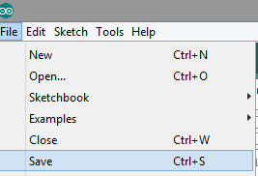

There are two way to save in the Arduino ide, you can select from menu File then Save or use the save icon.
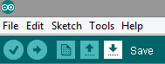

Check that the right board is selected
tools --> boards --> Arduino Mega
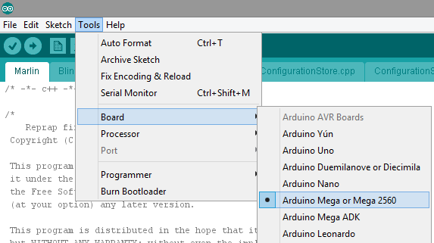

Now verify your firmware presssing the “verify” icon
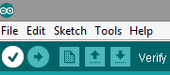

The firmware will compile, it might take a while.
After verification is complete is time to upload the firmware to the board. Press the upload icon.
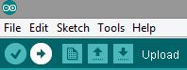

GNU Free Documentation License
Version 1.3, 3 November 2008
Copyright © 2000, 2001, 2002, 2007, 2008 Free Software Foundation, Inc. <http://fsf.org/>
Everyone is permitted to copy and distribute verbatim copies of this license document, but changing it is not allowed.

0. PREAMBLE
The purpose of this License is to make a manual, textbook, or other functional and useful document "free" in the sense of freedom: to assure everyone the effective freedom to copy and redistribute it, with or without modifying it, either commercially or noncommercially. Secondarily, this License preserves for the author and publisher a way to get credit for their work, while not being considered responsible for modifications made by others.
This License is a kind of "copyleft", which means that derivative works of the document must themselves be free in the same sense. It complements the GNU General Public License, which is a copyleft license designed for free software.
We have designed this License in order to use it for manuals for free software, because free software needs free documentation: a free program should come with manuals providing the same freedoms that the software does. But this License is not limited to software manuals; it can be used for any textual work, regardless of subject matter or whether it is published as a printed book. We recommend this License principally for works whose purpose is instruction or reference.

1. APPLICABILITY AND DEFINITIONS
This License applies to any manual or other work, in any medium, that contains a notice placed by the copyright holder saying it can be distributed under the terms of this License. Such a notice grants a world-wide, royalty-free license, unlimited in duration, to use that work under the conditions stated herein. The "Document", below, refers to any such manual or work. Any member of the public is a licensee, and is addressed as "you". You accept the license if you copy, modify or distribute the work in a way requiring permission under copyright law.
A "Modified Version" of the Document means any work containing the Document or a portion of it, either copied verbatim, or with modifications and/or translated into another language.
A "Secondary Section" is a named appendix or a front-matter section of the Document that deals exclusively with the relationship of the publishers or authors of the Document to the Document's overall subject (or to related matters) and contains nothing that could fall directly within that overall subject. (Thus, if the Document is in part a textbook of mathematics, a Secondary Section may not explain any mathematics.) The relationship could be a matter of historical connection with the subject or with related matters, or of legal, commercial, philosophical, ethical or political position regarding them.
The "Invariant Sections" are certain Secondary Sections whose titles are designated, as being those of Invariant Sections, in the notice that says that the Document is released under this License. If a section does not fit the above definition of Secondary then it is not allowed to be designated as Invariant. The Document may contain zero Invariant Sections. If the Document does not identify any Invariant Sections then there are none.
The "Cover Texts" are certain short passages of text that are listed, as Front-Cover Texts or Back-Cover Texts, in the notice that says that the Document is released under this License. A Front-Cover Text may be at most 5 words, and a Back-Cover Text may be at most 25 words.
A "Transparent" copy of the Document means a machine-readable copy, represented in a format whose specification is available to the general public, that is suitable for revising the document straightforwardly with generic text editors or (for images composed of pixels) generic paint programs or (for drawings) some widely available drawing editor, and that is suitable for input to text formatters or for automatic translation to a variety of formats suitable for input to text formatters. A copy made in an otherwise Transparent file format whose markup, or absence of markup, has been arranged to thwart or discourage subsequent modification by readers is not Transparent. An image format is not Transparent if used for any substantial amount of text. A copy that is not "Transparent" is called "Opaque".
Examples of suitable formats for Transparent copies include plain ASCII without markup, Texinfo input format, LaTeX input format, SGML or XML using a publicly available DTD, and standard-conforming simple HTML, PostScript or PDF designed for human modification. Examples of transparent image formats include PNG, XCF and JPG. Opaque formats include proprietary formats that can be read and edited only by proprietary word processors, SGML or XML for which the DTD and/or processing tools are not generally available, and the machine-generated HTML, PostScript or PDF produced by some word processors for output purposes only.
The "Title Page" means, for a printed book, the title page itself, plus such following pages as are needed to hold, legibly, the material this License requires to appear in the title page. For works in formats which do not have any title page as such, "Title Page" means the text near the most prominent appearance of the work's title, preceding the beginning of the body of the text.
The "publisher" means any person or entity that distributes copies of the Document to the public.
A section "Entitled XYZ" means a named subunit of the Document whose title either is precisely XYZ or contains XYZ in parentheses following text that translates XYZ in another language. (Here XYZ stands for a specific section name mentioned below, such as "Acknowledgements", "Dedications", "Endorsements", or "History".) To "Preserve the Title" of such a section when you modify the Document means that it remains a section "Entitled XYZ" according to this definition.
The Document may include Warranty Disclaimers next to the notice which states that this License applies to the Document. These Warranty Disclaimers are considered to be included by reference in this License, but only as regards disclaiming warranties: any other implication that these Warranty Disclaimers may have is void and has no effect on the meaning of this License.

2. VERBATIM COPYING
You may copy and distribute the Document in any medium, either commercially or noncommercially, provided that this License, the copyright notices, and the license notice saying this License applies to the Document are reproduced in all copies, and that you add no other conditions whatsoever to those of this License. You may not use technical measures to obstruct or control the reading or further copying of the copies you make or distribute. However, you may accept compensation in exchange for copies. If you distribute a large enough number of copies you must also follow the conditions in section 3.
You may also lend copies, under the same conditions stated above, and you may publicly display copies.

3. COPYING IN QUANTITY
If you publish printed copies (or copies in media that commonly have printed covers) of the Document, numbering more than 100, and the Document's license notice requires Cover Texts, you must enclose the copies in covers that carry, clearly and legibly, all these Cover Texts: Front-Cover Texts on the front cover, and Back-Cover Texts on the back cover. Both covers must also clearly and legibly identify you as the publisher of these copies. The front cover must present the full title with all words of the title equally prominent and visible. You may add other material on the covers in addition. Copying with changes limited to the covers, as long as they preserve the title of the Document and satisfy these conditions, can be treated as verbatim copying in other respects.
If the required texts for either cover are too voluminous to fit legibly, you should put the first ones listed (as many as fit reasonably) on the actual cover, and continue the rest onto adjacent pages.
If you publish or distribute Opaque copies of the Document numbering more than 100, you must either include a machine-readable Transparent copy along with each Opaque copy, or state in or with each Opaque copy a computer-network location from which the general network-using public has access to download using public-standard network protocols a complete Transparent copy of the Document, free of added material. If you use the latter option, you must take reasonably prudent steps, when you begin distribution of Opaque copies in quantity, to ensure that this Transparent copy will remain thus accessible at the stated location until at least one year after the last time you distribute an Opaque copy (directly or through your agents or retailers) of that edition to the public.
It is requested, but not required, that you contact the authors of the Document well before redistributing any large number of copies, to give them a chance to provide you with an updated version of the Document.

4. MODIFICATIONS
You may copy and distribute a Modified Version of the Document under the conditions of sections 2 and 3 above, provided that you release the Modified Version under precisely this License, with the Modified Version filling the role of the Document, thus licensing distribution and modification of the Modified Version to whoever possesses a copy of it. In addition, you must do these things in the Modified Version:
- A. Use in the Title Page (and on the covers, if any) a title distinct from that of the Document, and from those of previous versions (which should, if there were any, be listed in the History section of the Document). You may use the same title as a previous version if the original publisher of that version gives permission.
- B. List on the Title Page, as authors, one or more persons or entities responsible for authorship of the modifications in the Modified Version, together with at least five of the principal authors of the Document (all of its principal authors, if it has fewer than five), unless they release you from this requirement.
- C. State on the Title page the name of the publisher of the Modified Version, as the publisher.
- D. Preserve all the copyright notices of the Document.
- E. Add an appropriate copyright notice for your modifications adjacent to the other copyright notices.
- F. Include, immediately after the copyright notices, a license notice giving the public permission to use the Modified Version under the terms of this License, in the form shown in the Addendum below.
- G. Preserve in that license notice the full lists of Invariant Sections and required Cover Texts given in the Document's license notice.
- H. Include an unaltered copy of this License.
- I. Preserve the section Entitled "History", Preserve its Title, and add to it an item stating at least the title, year, new authors, and publisher of the Modified Version as given on the Title Page. If there is no section Entitled "History" in the Document, create one stating the title, year, authors, and publisher of the Document as given on its Title Page, then add an item describing the Modified Version as stated in the previous sentence.
- J. Preserve the network location, if any, given in the Document for public access to a Transparent copy of the Document, and likewise the network locations given in the Document for previous versions it was based on. These may be placed in the "History" section. You may omit a network location for a work that was published at least four years before the Document itself, or if the original publisher of the version it refers to gives permission.
- K. For any section Entitled "Acknowledgements" or "Dedications", Preserve the Title of the section, and preserve in the section all the substance and tone of each of the contributor acknowledgements and/or dedications given therein.
- L. Preserve all the Invariant Sections of the Document, unaltered in their text and in their titles. Section numbers or the equivalent are not considered part of the section titles.
- M. Delete any section Entitled "Endorsements". Such a section may not be included in the Modified Version.
- N. Do not retitle any existing section to be Entitled "Endorsements" or to conflict in title with any Invariant Section.
- O. Preserve any Warranty Disclaimers.
If the Modified Version includes new front-matter sections or appendices that qualify as Secondary Sections and contain no material copied from the Document, you may at your option designate some or all of these sections as invariant. To do this, add their titles to the list of Invariant Sections in the Modified Version's license notice. These titles must be distinct from any other section titles.
You may add a section Entitled "Endorsements", provided it contains nothing but endorsements of your Modified Version by various parties—for example, statements of peer review or that the text has been approved by an organization as the authoritative definition of a standard.
You may add a passage of up to five words as a Front-Cover Text, and a passage of up to 25 words as a Back-Cover Text, to the end of the list of Cover Texts in the Modified Version. Only one passage of Front-Cover Text and one of Back-Cover Text may be added by (or through arrangements made by) any one entity. If the Document already includes a cover text for the same cover, previously added by you or by arrangement made by the same entity you are acting on behalf of, you may not add another; but you may replace the old one, on explicit permission from the previous publisher that added the old one.
The author(s) and publisher(s) of the Document do not by this License give permission to use their names for publicity for or to assert or imply endorsement of any Modified Version.

5. COMBINING DOCUMENTS
You may combine the Document with other documents released under this License, under the terms defined in section 4 above for modified versions, provided that you include in the combination all of the Invariant Sections of all of the original documents, unmodified, and list them all as Invariant Sections of your combined work in its license notice, and that you preserve all their Warranty Disclaimers.
The combined work need only contain one copy of this License, and multiple identical Invariant Sections may be replaced with a single copy. If there are multiple Invariant Sections with the same name but different contents, make the title of each such section unique by adding at the end of it, in parentheses, the name of the original author or publisher of that section if known, or else a unique number. Make the same adjustment to the section titles in the list of Invariant Sections in the license notice of the combined work.
In the combination, you must combine any sections Entitled "History" in the various original documents, forming one section Entitled "History"; likewise combine any sections Entitled "Acknowledgements", and any sections Entitled "Dedications". You must delete all sections Entitled "Endorsements".

6. COLLECTIONS OF DOCUMENTS
You may make a collection consisting of the Document and other documents released under this License, and replace the individual copies of this License in the various documents with a single copy that is included in the collection, provided that you follow the rules of this License for verbatim copying of each of the documents in all other respects.
You may extract a single document from such a collection, and distribute it individually under this License, provided you insert a copy of this License into the extracted document, and follow this License in all other respects regarding verbatim copying of that document.

7. AGGREGATION WITH INDEPENDENT WORKS
A compilation of the Document or its derivatives with other separate and independent documents or works, in or on a volume of a storage or distribution medium, is called an "aggregate" if the copyright resulting from the compilation is not used to limit the legal rights of the compilation's users beyond what the individual works permit. When the Document is included in an aggregate, this License does not apply to the other works in the aggregate which are not themselves derivative works of the Document.
If the Cover Text requirement of section 3 is applicable to these copies of the Document, then if the Document is less than one half of the entire aggregate, the Document's Cover Texts may be placed on covers that bracket the Document within the aggregate, or the electronic equivalent of covers if the Document is in electronic form. Otherwise they must appear on printed covers that bracket the whole aggregate.

8. TRANSLATION
Translation is considered a kind of modification, so you may distribute translations of the Document under the terms of section 4. Replacing Invariant Sections with translations requires special permission from their copyright holders, but you may include translations of some or all Invariant Sections in addition to the original versions of these Invariant Sections. You may include a translation of this License, and all the license notices in the Document, and any Warranty Disclaimers, provided that you also include the original English version of this License and the original versions of those notices and disclaimers. In case of a disagreement between the translation and the original version of this License or a notice or disclaimer, the original version will prevail.
If a section in the Document is Entitled "Acknowledgements", "Dedications", or "History", the requirement (section 4) to Preserve its Title (section 1) will typically require changing the actual title.

9. TERMINATION
You may not copy, modify, sublicense, or distribute the Document except as expressly provided under this License. Any attempt otherwise to copy, modify, sublicense, or distribute it is void, and will automatically terminate your rights under this License.
However, if you cease all violation of this License, then your license from a particular copyright holder is reinstated (a) provisionally, unless and until the copyright holder explicitly and finally terminates your license, and (b) permanently, if the copyright holder fails to notify you of the violation by some reasonable means prior to 60 days after the cessation.
Moreover, your license from a particular copyright holder is reinstated permanently if the copyright holder notifies you of the violation by some reasonable means, this is the first time you have received notice of violation of this License (for any work) from that copyright holder, and you cure the violation prior to 30 days after your receipt of the notice.
Termination of your rights under this section does not terminate the licenses of parties who have received copies or rights from you under this License. If your rights have been terminated and not permanently reinstated, receipt of a copy of some or all of the same material does not give you any rights to use it.

10. FUTURE REVISIONS OF THIS LICENSE
The Free Software Foundation may publish new, revised versions of the GNU Free Documentation License from time to time. Such new versions will be similar in spirit to the present version, but may differ in detail to address new problems or concerns. See http://www.gnu.org/copyleft/.
Each version of the License is given a distinguishing version number. If the Document specifies that a particular numbered version of this License "or any later version" applies to it, you have the option of following the terms and conditions either of that specified version or of any later version that has been published (not as a draft) by the Free Software Foundation. If the Document does not specify a version number of this License, you may choose any version ever published (not as a draft) by the Free Software Foundation. If the Document specifies that a proxy can decide which future versions of this License can be used, that proxy's public statement of acceptance of a version permanently authorizes you to choose that version for the Document.

11. RELICENSING
"Massive Multiauthor Collaboration Site" (or "MMC Site") means any World Wide Web server that publishes copyrightable works and also provides prominent facilities for anybody to edit those works. A public wiki that anybody can edit is an example of such a server. A "Massive Multiauthor Collaboration" (or "MMC") contained in the site means any set of copyrightable works thus published on the MMC site.
"CC-BY-SA" means the Creative Commons Attribution-Share Alike 3.0 license published by Creative Commons Corporation, a not-for-profit corporation with a principal place of business in San Francisco, California, as well as future copyleft versions of that license published by that same organization.
"Incorporate" means to publish or republish a Document, in whole or in part, as part of another Document.
An MMC is "eligible for relicensing" if it is licensed under this License, and if all works that were first published under this License somewhere other than this MMC, and subsequently incorporated in whole or in part into the MMC, (1) had no cover texts or invariant sections, and (2) were thus incorporated prior to November 1, 2008.
The operator of an MMC Site may republish an MMC contained in the site under CC-BY-SA on the same site at any time before August 1, 2009, provided the MMC is eligible for relicensing.

Stallman 3D printer
find it on
RepRap.org
thanks to Gnu.org and fsf.org

