COL867 – Programming Assignment 1

Simulation of P2P cryptocurrency network

[Yash Gupta – 2013CS10302]

# Conclusion

1. **Block creation time**: Branching factor **decreases** as average time taken by the network to generate a block **increases**.
   1. When inter-block-creation time is comparable to end-to-end network latency, trees get wider, with high branching factor.

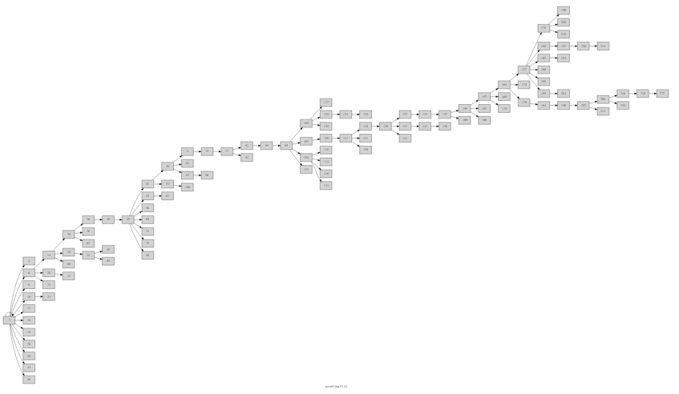

* 1. When inter-block-creation time is much more than network latency, the trees are more or less linear with low number of short-lived branches.



1. **Network links density:** More density results in low branching factor and short lived branches.
   1. When the peers are sparsely connected, several parallel side-chains exist due to increased time taken for blocks to propagate throughout the network.

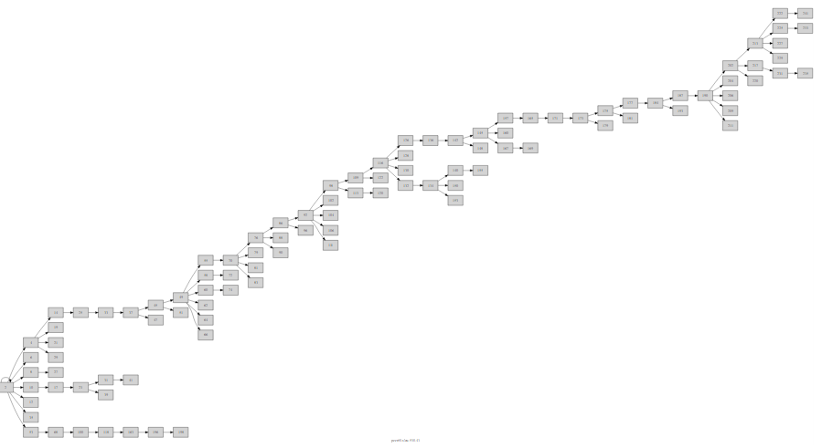

* 1. When peers are densely connected, this propagation delay decreases and side-chain length as well as count decreases.

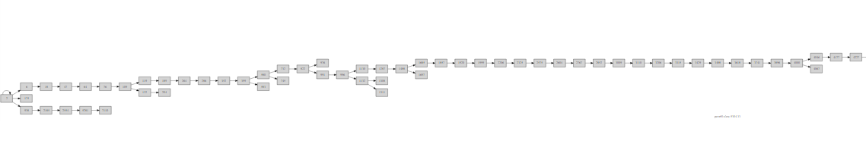

1. **Mean transaction inter-arrival time:** Transaction inter-arrival time does not have any effect on tree structure in our simulation, as we do not simulate network congestion or high verification time that might be caused due to very high number of transactions.
2. **Number of nodes:**
   1. Low number of peers result in lower branching factor and very small side chain length.



* 1. High number of peers results in higher branching factor, but around same side chain length

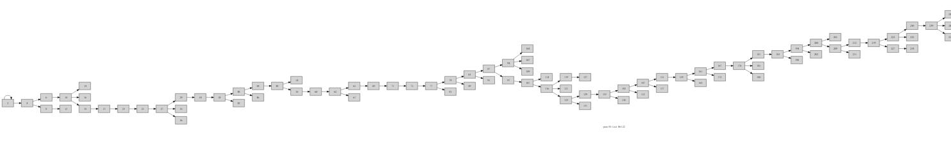

1. **Variation among nodes:**
   1. **CPU power:** Blue nodes below signify blocks created by the peer itself. Low CPU peer own significantly lesser number of blocks as compared to high-CPU peer.
      1. **Low CPU power** (mean inter-block time = 261s, blocks owned = 2)

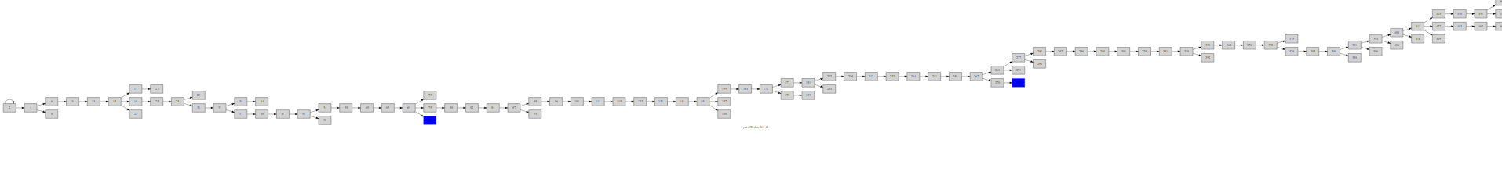

* + 1. **High CPU power** (mean inter-block time = 35s, blocks owned = 19)

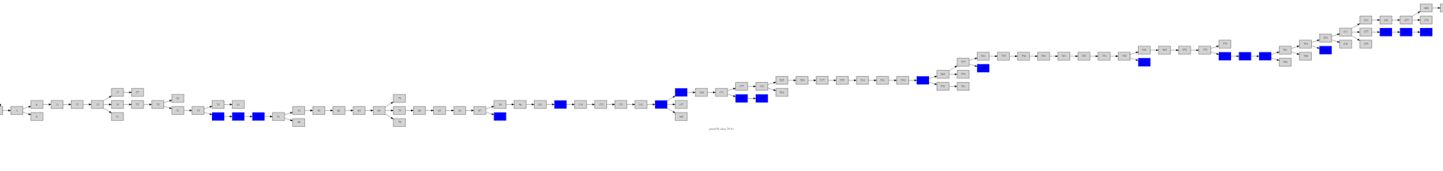

* 1. **Network speed:** The only difference seen is towards the end of the blockchain. High speed peers typically has last block faster than slow peers.

1. **Fraction of slow nodes:**
   1. High fraction of slow nodes results in wide trees with longer side chains, sue to multiple bottlenecks in the network.

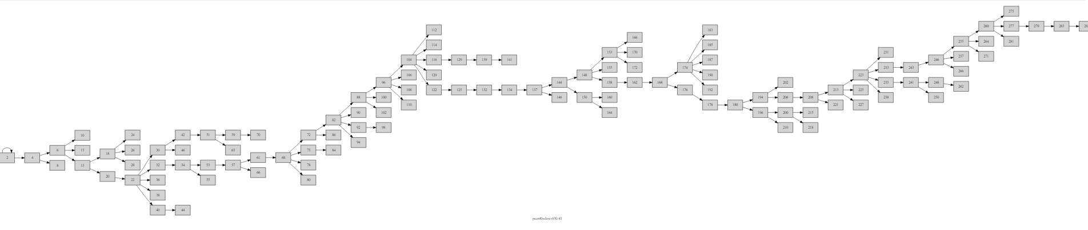

* 1. Low fraction of slow nodes results in more linear trees.

