1. Create three variables in a single line and assign values to them in such a manner that each one of

them belongs to a different data type.

E.g. :

a = 1,

b = 2.01,

c = 'string'

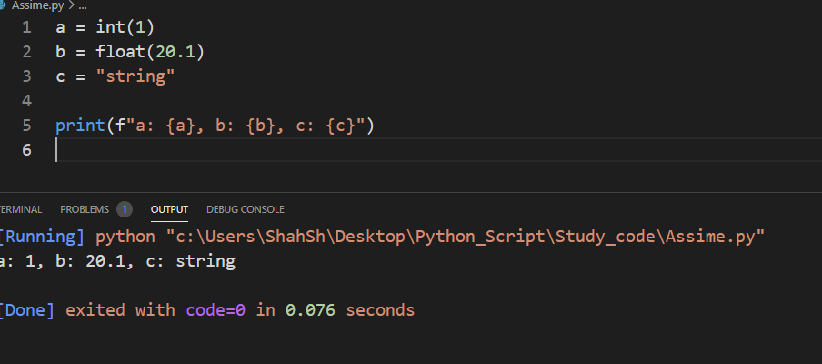

2. Create a variable of type complex and swap it with another variable of type integer.

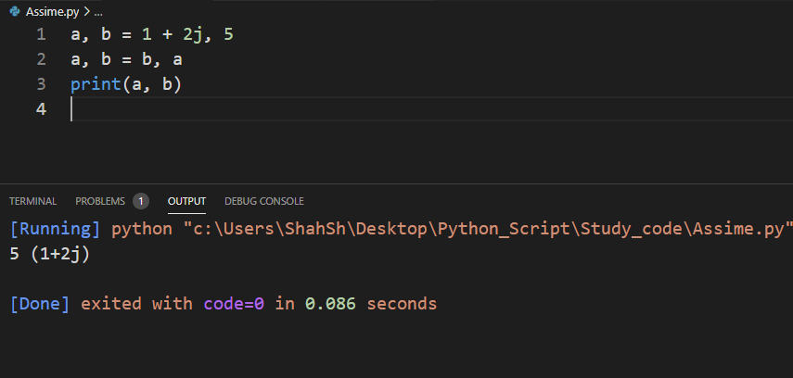

3. Swap two numbers using a third variable and do the same task without using any third variable.

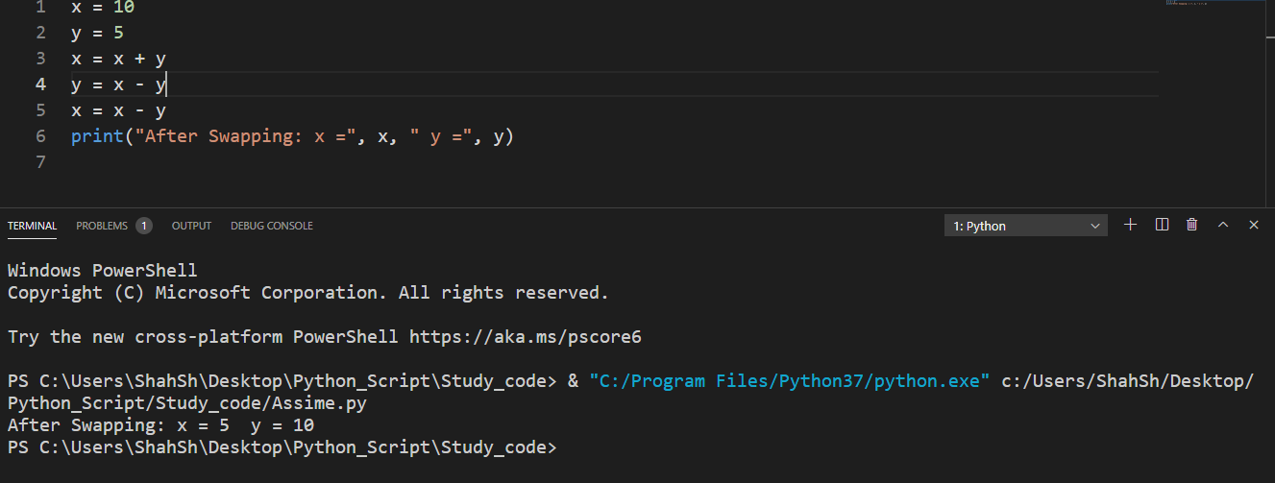

4. Write a program that takes input from the user and prints it using both Python 2.x and Python 3.x

Version.

x = input("x:")

y = int(x) + 1

print(f"x: {x}, y: {y}")

5. Write a program to complete the task given below:

Ask users to enter any 2 numbers in between 1-10 , add the two numbers and keep the sum in

another variable called z. Add 30 to z and store the output in variable result and print result as the

final output.

x = input("x:")

y = input("y:")

z = int(x) + int(y)

output = int(z) + 30

print(output)

6. Write a program to check the data type of the entered values.

message = "Apple"

n = 05

x = 3.14159

print(type(message))

print(type(n))

print(type(x))

7. Create Variables using formats such as Upper CamelCase, Lower CamelCase, SnakeCase and

UPPERCASE.

(Refer: <https://capitalizemytitle.com/camel-case/>)

name = "I am an apple"

print(name.upper())

8. If one data type value is assigned to ‘a’ variable and then a different data type value is assigned to ‘a’

again. Will it change the value? If Yes then Why?

Yes, variables in Python can be changed to a new value that is a different data type from its current value.

Task 2:

1.

num = 5

if num % 3 == 0 and num % 5 == 0:

    print("“Consultadd - Python Training”")

elif num % 3 == 0:

    print("Consultadd")

elif num % 5 == 0:

    print("Python_Training")

else:

    pass

2.

num1 = int(input("Enter First Number: "))

num2 = int(input("Enter Second Number: "))

print("Enter which operation would you like to perform?")

formu = input(

    "Enter any of these char for specific operation Enter1,Enter2,Enter3,Enter4,Enter5 : "

)

result = 0

if formu == "Enter1":

    result = num1 + num2

elif formu == "Enter2":

    result = num1 - num2

elif formu == "Enter3":

    result = num1 / num2

elif formu == "Enter4":

    result = num1 * num2

elif formu == "Enter5":

    result = (num1 + num2) / 2

else:

    print("Input character is not recognized!")

print(num1, formu, num2, ":", result)

3.

a, b, c = 10, 20, 30

ave = (a + b + c) / 3

print("ave =", ave)

if ave > a and ave > b and ave > c:

    print("Ave is higher than a,b,c")

elif ave > a and ave > b:

    print("ave is higher than a,b,c")

elif ave > a and ave > c:

    print("ave is higher than a and c")

elif ave > b and ave > c:

    print("ave is higher than b and c")

elif ave > a:

    print("ave is higher than a")

elif ave > b:

    print("ave is higher than b")

elif ave > c:

    print("ave is higher than c ")

else:

    print("ave is just higher than c")

4.

while True:

    Num = int(input("Enter your number:"))

    if Num >= 0:

        print("Good Going")

        continue

    else:

        print("its over ")

        break

5.

for x in range(2000, 3200):

    if x % 7 == 0 and x % 5 != 0:

        print(x)

6.

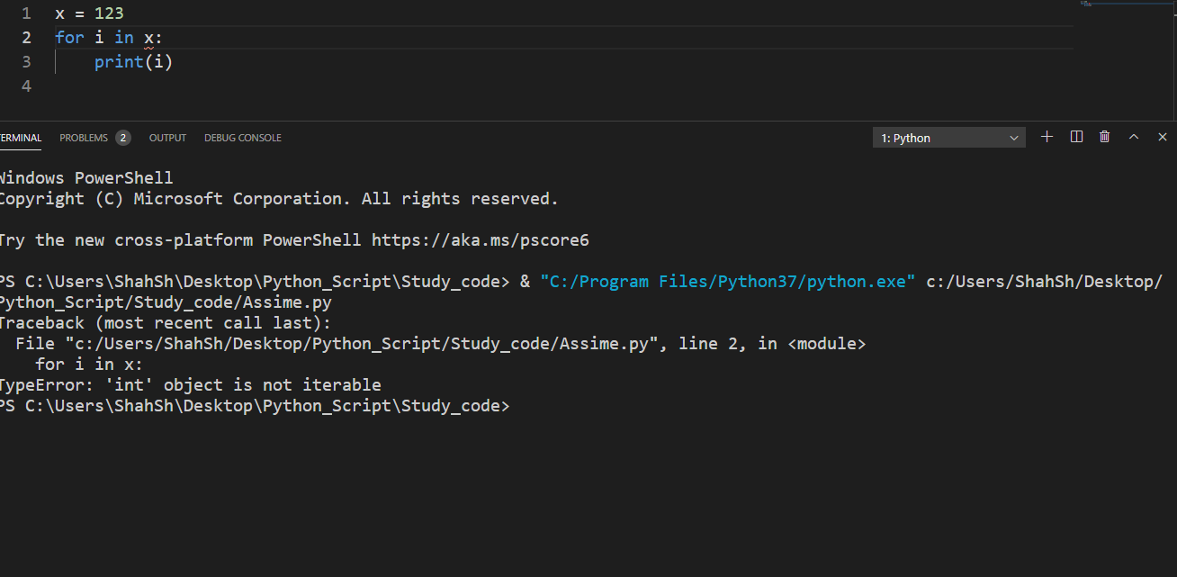

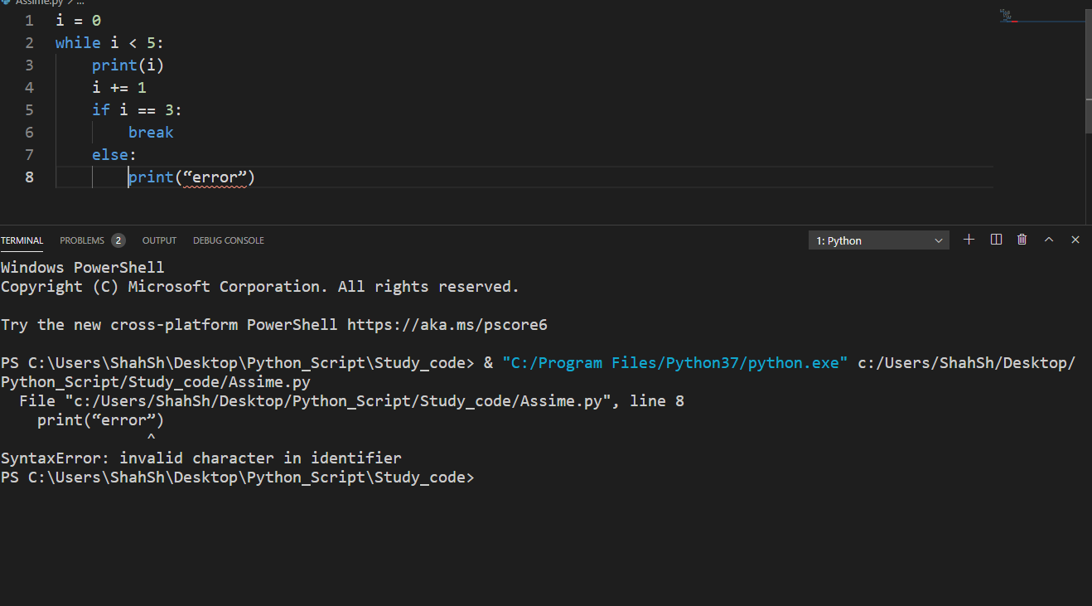

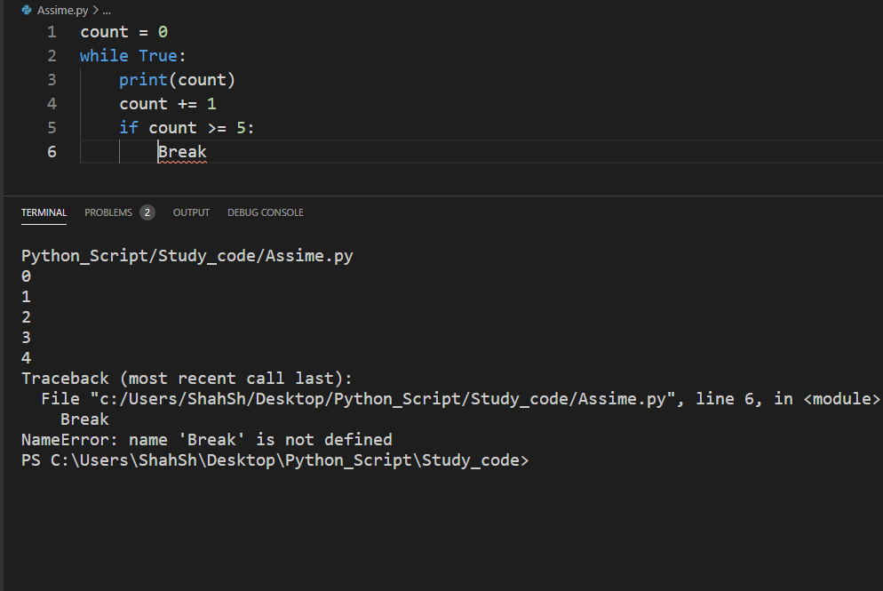

7.

for i in range(7):

    if i == 3 or i == 6:

        continue

    print(i)

8.