* Write a program in Python to allow the error of syntax to be handled using exception handling.

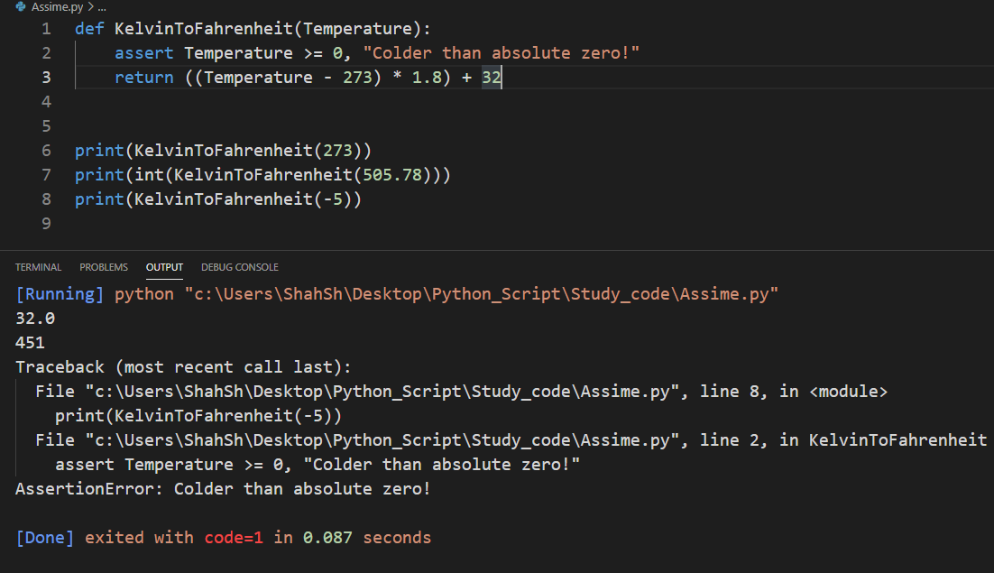

* Write a program in Python to allow the user to open a file by using the argv module. If the entered name is incorrect throw an exception and ask them to enter the name again. Make sure to use read only mode
* import sys
* file_name = sys.argv[1]
* text = []
* try:
* fh = open(file_name, "r")
* text = fh.readlines()
* fh.close()
* except IOError:
* print("cannot open", file_name)
* if text:
* print(text[100])
* Write a program to handle an error if the user entered a number more than four digits it should return “The length is too short/long !!! Please provide only four digits,
* while True:
* try:
* n = input("Please enter four digit number: ")
* n = len(n) != 5
* break
* except ValueError:
* print("Please try again ...")
* print("Great, you successfully entered four digit number!")
* Create a login page backend to ask users to enter the username and password. Make sure to ask for a Re-Type Password and if the password is incorrect give chance to enter it again but it should not be more than 3 times.
* print("Enter username and password")
* count = 0
* while count < 3:
* username = input("Enter username: ")
* password = input("Enter password: ")
* if password == "Apple_Aplle_2312" and username == "SHAHSH":
* print("Access granted")
* break
* else:
* print("Access denied. Try again.")
* count += 1
* Go through the link provided below to understand finally and raise con  
  <https://www.programiz.com/python-programming/exception-handling>
* Read doc.txt file using Python File handling concept and return only the even length string from the file. Consider the content of doc.txt as given below:

Hello I am a file  
Where you need to return the data string  
Which is of even length  
Make sure you return the content in The same link as it is present.

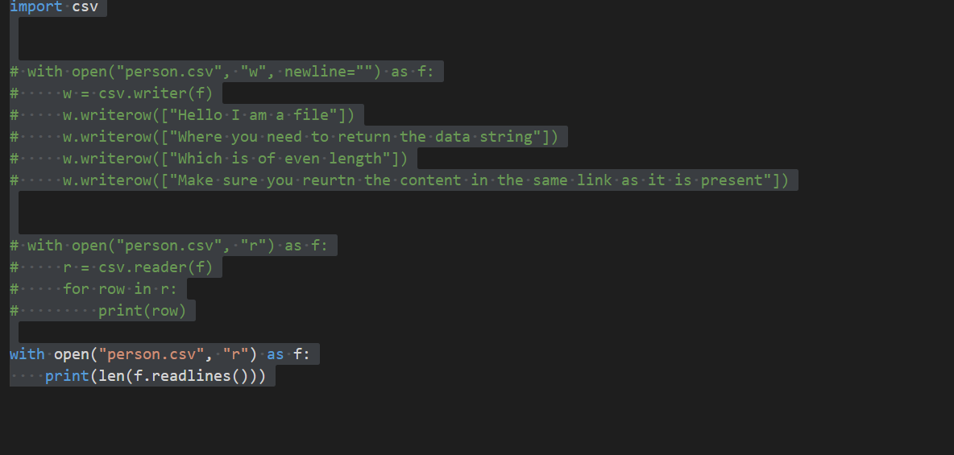

* Write a program in Python to find out the character in a string which is uppercase using list comprehension

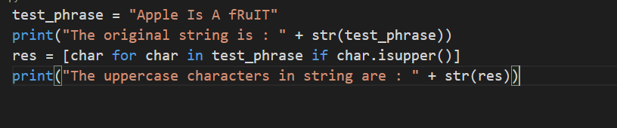

* Write a program to construct a dictionary from the two lists containing the names of students and their corresponding subjects. The dictionary should map the students with their respective subjects. Let’s see how to do this using for loops and dictionary comprehension.

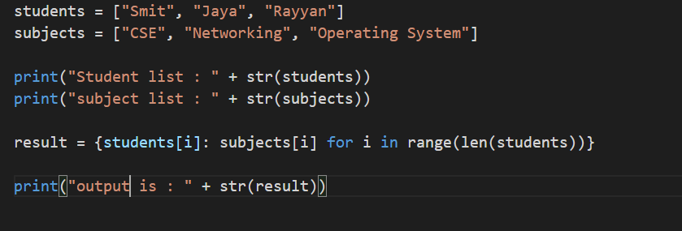

* Write a program in Python using generators to reverse the string.