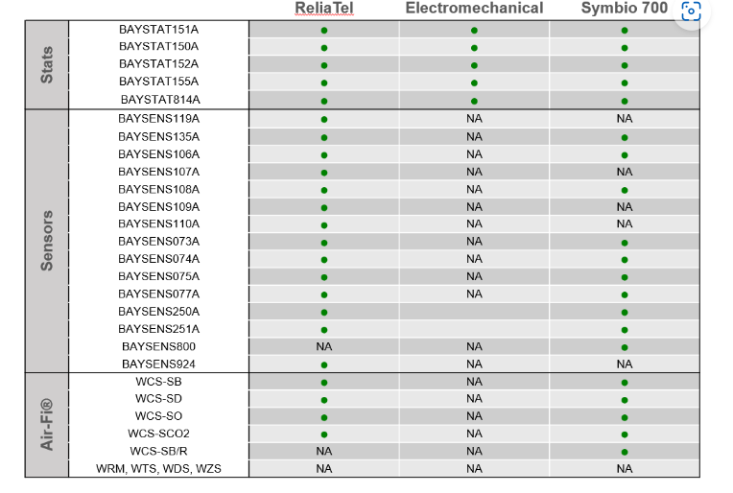

Zone Sensors
Zone Temperature Only  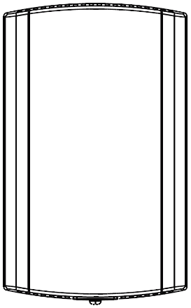 | Manual Changeover  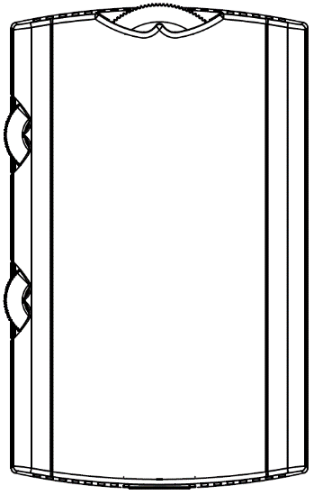 | Manual / Automatic Changeover  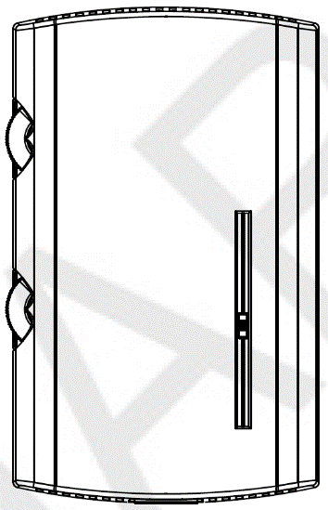
BAYSENS077  Provides temperature input only. Can be used as a secondary remote temperature input for thermostats. | BAYSENS106 / BAYSENS107  Heat, Cool or Off System Switch. Fan Auto or Off Switch. Single temperature setpoint thumbwheel. | BAYSENS108 / BAYSENS109 / BAYSENS110  Auto, Heat, Cool or Off System Switch. Fan Auto or Off Switch. Dual temperature setpoint sliders
Integrated Comfort™ System  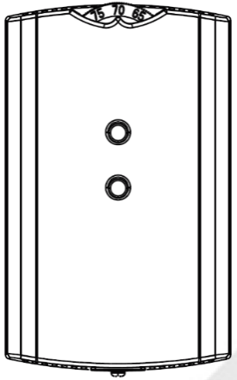 | Wired Display Sensor  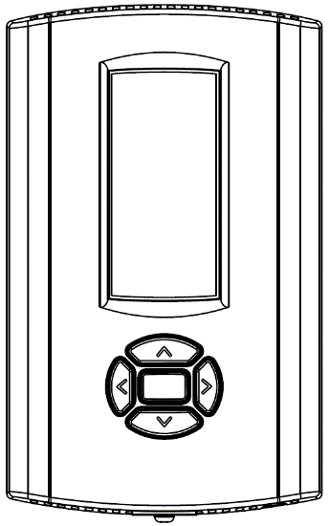 | Touchscreen Digital Display Communicating Sensor  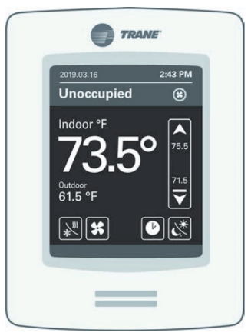
BAYSENS073 / BAYSENS074 / BAYSENS075  Sensor (s) available with optional temperature adjustment and override buttons to provide central control through a Trane Integrated Comfort system. | BAYSENS135  LCD display that provides heat, cool, auto, or off. Includes two temperature setpoints and a lockable setting with ○F or ○C indicators. | BAYSENS800  Uses BACnet MS/TP link to communicate zone temperature and setpoints. Auto, Heat, Cool or Off System Switch. Fan Auto or On Switch. 7-day programmable thermostat with night setback.  Not compatible with VAV units. Requires BACnet communications.

Air-Fi Wireless Communicating Zone Sensors
Wireless Zone Temperature Only | Wireless Display Sensor  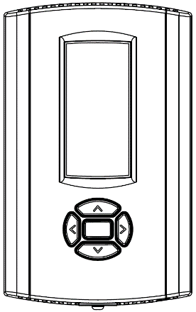 | Wireless Zone Temperature, CO2, and Occupancy  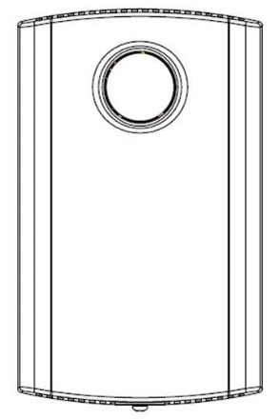
WCS-SB  Measures temperature and optional humidity (with WCS-SH) for use in public spaces where no local user interface is preferred.  Requires BACnet communications. | WCS-SD  Easy-to-use interface for clear and simple monitoring and control. Can be configured for any Trane system or to meet the customer’s preference.  Requires BACnet communications. | WCS-SO / WCS-SCO2  Measures temperature, optional humidity (with optional WCS-SH), CO2 levels in parts per million, and occupancy. All sensing values are displayed in an internal facing LCD display, which prevents public viewing. This sensor is typically used on demand - control ventilation applications.  Requires BACnet communications.
Wired CO2 Sensor | Wired Zone Temperature and Humidity Sensor
X13790422010  The maintenance-free carbon dioxide (CO2) sensor is primarily used for demand control ventilation applications. | BAYSENS036  Measures temperature and relative humidity. Relative humidity input is used to control activation of dehumidification.
Thermostats
Digital Display Programmable Thermostat (3H/2C)  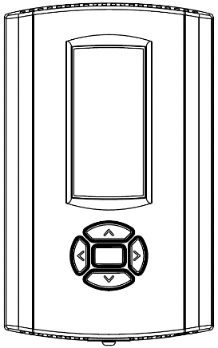 | Digital Display Programmable Thermostat (1H/1C) | Digital Display Thermostat (3H/2C)
BAYSTAT150  Three Heat / Two Cool Auto changeover digital display thermostat. 7-day programmable thermostat with night setback.  Not compatible with VAV units. | BAYSTAT151  One Heat / One Cool Auto changeover digital display thermostat.  Not compatible with VAV units. | BAYSTAT155  Three Heat / Two Cool Auto changeover display thermostat.  Not compatible with VAV units
Pivot® Web Enabled Smart Thermostat (3H/2C)  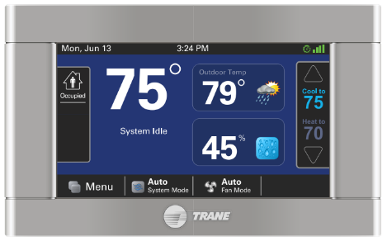 | Touchscreen Programmable Thermostat with Relative Humidity Sensor (3H/2C)  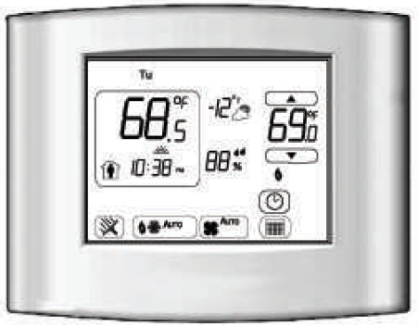
BAYSTAT814  Our Pivot Smart Thermostat system is great for commercial buildings. With its intuitive touchscreen and customizable display, it is easy for occupants to use. The Trane Pivot mobile app enables users to control multiple buildings remotely, making changes in seconds to all systems.  Not compatible with VAV units. | BAYSTAT152  Three Heat, Two Cool digital display thermostat with built-in humidity control. This thermostat combines both humidity and temperature into one.  Not compatible with VAV units.

