|  |
| --- |
| **SOUTHERN CROSS UNIVERSITY** |

**ASSIGNMENT COVER SHEET**

For use with online submission of assignments

Please complete all of the following details and then make this sheet the **first page of each file of your assignment – do not send it as a separate document.**

Your assignments must be submitted as either **Word documents, text documents with .rtf extension or as .pdf documents**. If you wish tosubmit in any other file format please discuss this with your lecturer well before theassignment submission date.

|  |  |
| --- | --- |
| Student Name: | ______Wang Nan____________ |
| Student ID No.: | ____________________________ |
| Unit Name: | **Designing the User Experience** |
| Unit Code: | **PROG2006** |
| Tutor’s name: | ____________________________ |
| Assessment No.: | ____________________________ |
| Assessment Title: | ____________________________ |
| Due date: | ____________________________ |
| Date submitted: | ____________________________ |

Declaration:

*I have read and understand the Rules Relating to Awards ([Rule 3 Section 18 – Academic Misconduct Including Plagiarism](http://policies.scu.edu.au/view.current.php?id=00140" \l "s18)) as contained in the SCU Policy Library. I understand the penalties that apply for plagiarism and agree to be bound by these rules. The work I am submitting electronically is entirely my own work.*

|  |  |
| --- | --- |
| Signed:  (please type your name) | ____________________________ |
| Date: | ____________________________ |

**"Little Panda Qiqi's Bedtime Routine" — An Interactive Storybook App for Children's Habit Formation**

**Design Documentation**

By Wang Nan

Table of Contents

1 Concept Paper 1

*1.1* Introduction 1

1.2 Updated sketches and details 2

1.3 Evaluation Form and Feedback 3

1.4 Link to GitHub and itch.io 3

*1.5* Module Journals 3

1.6 Link to Reflective video 5

2 Updated Functional Specifications 5

2.1 Updated User Interface 5

2.2 Updated Storyboards 9

2.3 Final Media List 2

References 2

Appendix A 2

Appendix B – GenAI use 2

Acknowledgement Statement: 2

GenAI generation conversation: 2

# Concept Paper

## Introduction

**Background**:

This project aims to develop an interactive storybook app titled *Little Panda Qiqi's Bedtime Routine*. Targeted at toddlers aged 2 to 4 and their parents, the app effectively addresses the common issues of children's resistance and procrastination by transforming daily bedtime preparations into an immersive adventure story.

**Market Demand**:

The project is inspired by a common phenomenon in parenting: establishing a regular bedtime routine is crucial for children's development, yet practical implementation often poses challenges and stress for parents. While there are already numerous storybook apps on the market, there remains significant potential to develop products that deeply integrate the cultivation of specific life skills with coherent storytelling.

The app’s core design concept is "cultivating good habits through interaction." Users will take on the role of a caring companion to Qiqi, the baby panda. Across four key scenarios, users will help Qiqi complete tasks such as "tidying up toys," "taking a bubble bath," "putting on pajamas," and "listening to a bedtime story" through simple touch interactions like tapping and dragging. Each successful interaction advances the plot, and through positive visual and auditory feedback, children are motivated by a sense of accomplishment to naturally imitate and learn proper bedtime behaviors.

This project will adhere to a user-centered design philosophy. Starting with clarifying the target users and their needs, it will comprehensively present the app’s user experience and interface design through storyboards, wireframes, and paper prototypes—laying a solid foundation for developing a truly educational and entertaining children’s product that eases parental anxiety.

**Rationale:**

The idea stems from the common pain point of parents feeling frustrated after spending an hour getting their children to sleep: preaching is ineffective, as toddlers resist instructions but are highly engaged by stories and games. I wanted to package activities like brushing teeth, tidying up, and bathing into the interactive story of Little Panda Qiqi's Bedtime Routine, allowing children to help Qiqi complete bedtime adventures. This replaces power struggles with a sense of accomplishment, helps children develop a regular schedule in 21 days, and provides families with a scientific and effective bedtime solution.

## Updated sketches and details

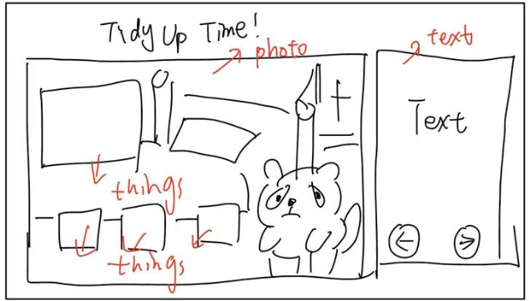

I adjusted the text to the right and then added interactive sections.

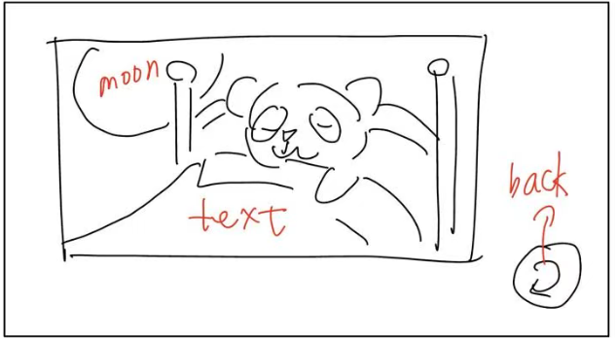

Created a back button showing that the little panda is sleeping, with a text description indicating he is asleep.

## Evaluation Form and Feedback

**Questionnaire Example 1 – Usability for website/app:**

|  |  |  |  |  |  |  |  |  |
| --- | --- | --- | --- | --- | --- | --- | --- | --- |
| Thinking about the website/app, indicate whether you agree or disagree with the following statements: | Strongly Disagree | Disagree | Slightly Disagree | Neutral | Slightly Agree | Agree | Strongly Agree | Not Applicable |
| I thought the website/app was easy to use | **🞎** | **🞎** | **🞎** | **🞎** | **🞎** | **🗹** | **🞎** | **🞎** |
| I would use the website/app frequently | **🞎** | **🞎** | **🞎** | **🞎** | **🗹** | **🞎** | **🞎** | **🞎** |
| I found it difficult to keep track of where I was in the website/app | **🞎** | **🞎** | **🞎** | **🞎** | **🞎** | **🗹** | **🞎** | **🞎** |
| I think most people would learn to use the website/app quickly | **🞎** | **🞎** | **🞎** | **🗹** | **🞎** | **🞎** | **🞎** | **🞎** |
| I can get information quickly | **🞎** | **🞎** | **🞎** | **🞎** | **🞎** | **🗹** | **🞎** | **🞎** |
| The home page’s content makes me want to explore the website/app | **🞎** | **🞎** | **🞎** | **🞎** | **🗹** | **🞎** | **🞎** | **🞎** |
| The website/app’s content would keep me coming back | **🞎** | **🞎** | **🞎** | **🞎** | **🗹** | **🞎** | **🞎** | **🞎** |
| The website/app is well-organised | **🞎** | **🞎** | **🞎** | **🞎** | **🞎** | **🗹** | **🞎** | **🞎** |

**Questionnaire Example 2 – System Usability Scale (SUS):**

|  |  |  |  |  |  |  |  |  |
| --- | --- | --- | --- | --- | --- | --- | --- | --- |
| Thinking about the website/app, indicate whether you agree or disagree with the following statements: | Strongly Disagree | Disagree | Slightly Disagree | Neutral | Slightly Agree | Agree | Strongly Agree | Not Applicable |
| I think that I would like to use this website/app frequently. | **🞎** | **🞎** | **🞎** | **🞎** | **🞎** | **🗹** | **🞎** | **🞎** |
| I found the website/app unnecessarily complex. | **🞎** | **🞎** | **🞎** | **🞎** | **🗹** | **🞎** | **🞎** | **🞎** |
| I thought the website/app was easy to use. | **🞎** | **🞎** | **🞎** | **🗹** | **🞎** | **🞎** | **🞎** | **🞎** |
| I think I would need the support of a technical person to be able to use this website/app. | **🞎** | **🞎** | **🞎** | **🞎** | **🗹** | **🞎** | **🞎** | **🞎** |
| I found the various functions in this website/app were well-integrated. | **🞎** | **🞎** | **🞎** | **🞎** | **🗹** | **🞎** | **🞎** | **🞎** |
| I thought there was too much inconsistency in this website/app. | **🞎** | **🞎** | **🞎** | **🞎** | **🗹** | **🞎** | **🞎** | **🞎** |
| I would imagine that most people would learn to use this website/app very quickly. | **🞎** | **🞎** | **🞎** | **🗹** | **🞎** | **🞎** | **🞎** | **🞎** |
| I found the website/app very cumbersome to use. | **🞎** | **🞎** | **🞎** | **🞎** | **🗹** | **🞎** | **🞎** | **🞎** |
| I felt very confident using the website/app. | **🞎** | **🞎** | **🞎** | **🞎** | **🞎** | **🗹** | **🞎** | **🞎** |
| I needed to learn a lot of things before I could get going with this website/app. | **🞎** | **🞎** | **🞎** | **🞎** | **🗹** | **🞎** | **🞎** | **🞎** |

**Questionnaire Example 3 – Technology Acceptance Model (TAM):**

|  |  |  |  |  |  |  |  |  |
| --- | --- | --- | --- | --- | --- | --- | --- | --- |
| Thinking about the website/app, indicate whether you agree or disagree with the following statements: | Strongly Disagree | Disagree | Slightly Disagree | Neutral | Slightly Agree | Agree | Strongly Agree | Not Applicable |
| Using this website/app in my job would enable me to accomplish tasks more quickly. | **🞎** | **🞎** | **🞎** | **🞎** | **🞎** | **🗹** | **🞎** | **🞎** |
| Using this website/app would improve my job performance. | **🞎** | **🞎** | **🞎** | **🞎** | **🗹** | **🞎** | **🞎** | **🞎** |
| Using this website/app in my job would increase my productivity. | **🞎** | **🞎** | **🞎** | **🞎** | **🞎** | **🗹** | **🞎** | **🞎** |
| Using this website/app would enhance my effectiveness on the job. | **🞎** | **🞎** | **🞎** | **🞎** | **🗹** | **🞎** | **🞎** | **🞎** |
| Using this website/app would make it easier to do my job. | **🞎** | **🞎** | **🞎** | **🗹** | **🞎** | **🞎** | **🞎** | **🞎** |
| I would find this website/app useful in my job. | **🞎** | **🞎** | **🞎** | **🞎** | **🞎** | **🗹** | **🞎** | **🞎** |
| Note: these are focussed on work productivity. |  |  |  |  |  |  |  |  |

1. **Other ideas for Questions**

**Evaluation** (use Likert scales – Strongly Disagree to Strongly agree)

I enjoyed the way the website/app interacted with it when I clicked the screen

Agree

The theme was implemented in a consistent way

Agree

The theme was very clever

Agree

I enjoyed this website/app because of the theme

Slightly Agree

This website/app made me laugh

Agree

The website/app responded as I expected it to

Agree

I kept wanting to use this website/app over and over

Agree

I enjoyed the animations in this website/app

Agree

There were times that this website/app surprised me

Slightly Agree

I thought the graphics looked great.

Slightly Agree

It was easy to work out how to use this website/app.

Agree

**Testing** (use Likert scales – Strongly Disagree to Strongly agree)

There were no errors when I used this website/app

Agree

I found it easy to succeed at this website/app

Agree

I never found myself being frustrated at this website/app

Agree

The animations were very smooth

Agree

The animations added to my enjoyment playing the game

Agree

**Open-ended questions:**

What did you think were the **best aspects** of the website/app?

The app excels in intuitive gesture interactions (drag, swipe, tap) with instant positive feedback, creating achievement-driven learning. The soothing visual design uses soft nighttime colors and dreamlike elements, while the logical narrative progression mirrors real bedtime routines with exploratory moments that enhance replay value.

What did you think were the **worst aspects** of the website/app?

The linear flow may become repetitive without branching paths or customization. The design needs clearer parent involvement guidelines, accessibility considerations for children with motor or visual impairments, defined failure states, and more detailed storybook selection options. Additional features like volume controls and parental screen time settings would strengthen the experience.

Do you have any other comments about the design of the website/app?

The app creates a calm, nurturing atmosphere through its companionship framing ("helping a friend" vs. "following orders"), soft color palette, and gentle animations. Achievement-oriented feedback builds confidence while reducing bedtime resistance, making children feel cozy and comforted—the ideal emotional tone for establishing positive sleep routines.

How did the website/app make you feel?

An interactive storybook app helping toddlers (ages 2-4) build positive bedtime habits through engaging touch-based interactions.

## Link to GitHub and itch.io

*Place your GitHub (or OneDrive or Dropbox for example) and/or itch.io links in here if you decide to prototype your designs beyond the documentation. Make sure your GitHub project is public as often the links will not work if the project is set to private.*

GitHub: https://github.com/1wangnan1/Panda-Qiqi

Itch.io: https://1wangnan1.itch.io/panda-qiqi

## Module Journals

**Module Log 1**

**Module Description:** Adjust text position

**Date:** 2025-10-13

**Version/Build Number:** v1.1

**Change Type:** UI Minor Adjustment

**Change Content:**

Uniformly adjusted the text content on the app’s homepage and all internal pages to the right area of the interface. Selected dark blue as the background tone for the text display area to ensure consistency and professionalism in visual presentation.

**Reason for Change:**

Results from the first round of usability testing showed that in the original interface layout, the text display area was frequently obscured by the user’s right thumb during operation. This forced parents to repeatedly adjust their grip to read the content in full. After the position optimization, the text’s line of sight focus points and the finger operation area were effectively separated, avoiding visual interference during interaction. Parents who participated in the testing generally reported a significant improvement in text reading fluency and information acquisition efficiency.

**Module Log 2**

**Module Description:** Add Music

**Date:** 2025-10-16

**Version Number:** v2.1

**Change Type:** Content Expansion

**Change Content:**

To enhance user experience and scenario adaptability, the following optimization adjustments were made to the audio system:

Added looping background music to 6 key nodes in total, including the homepage, four core scenarios, and the end screen. The music selection focuses on soft and soothing tones such as piano and string music to ensure the audio output meets the scenario’s atmosphere requirements.

The music design uses a layered progressive approach that advances with the process: only pure melody lines are retained in the tidying scenario to create a simple and focused auditory environment; when entering the bathing scenario, soft percussion rhythm elements are added to the original melody. This enriches the music layers to achieve a natural transition between scenario changes.

**Reason for Change:**

The original ambient sound was relatively thin and monotonous, lacking layering and continuity. It could not effectively create a stable soothing atmosphere, leading to frequent fluctuations in children’s emotions. After adding the slow, progressive background music, the overall atmosphere becomes more immersive and comfortable through soft melody changes and gentle rhythm transitions, which better helps children maintain a calm state.

## Link to Reflective video

[This should include a self-evaluation of your project and the processes you went through to complete the assessment. We would expect you to discuss UX principles in your video.

You should use a PowerPoint presentation to show screenshots of your project so that you can demonstrate that you understand the processes and UX principles you have applied to the project.

You can either upload your video to YouTube and make your video unlisted or share it using OneDrive, Dropbox, or another file-sharing tool. You MUST show your ID at the start of the video. Please be aware to put tape over any personal details such as your address. This can be flagged by YouTube and removed if this is not done.]

Ppt链接

# Updated Functional Specifications

## Updated User Interface

*[Please update any changes you made here. ]*

This interface is designed for joint use by children aged 2–4 and their parents, aiming to resolve bedtime power struggles from a perspective of "helping" rather than "being ordered." It adopts an overall soft nighttime visual language, including low-saturation blue-purple gradients, rounded cloud-shaped buttons, and reduced visual and operational load for young children.

Colors are designed as a narrative metronome, flowing dynamically with the four bedtime tasks:

Tidy up → Gentle reminders to stimulate interest in helping;

Brush teeth → Bright clarity, implying shiny teeth;

Bathing → Lightness and safety, allowing the sound of water and colors to relax together;

Reading → Brightness dimming frame by frame, guiding children to close their eyes in sync.

**Home:***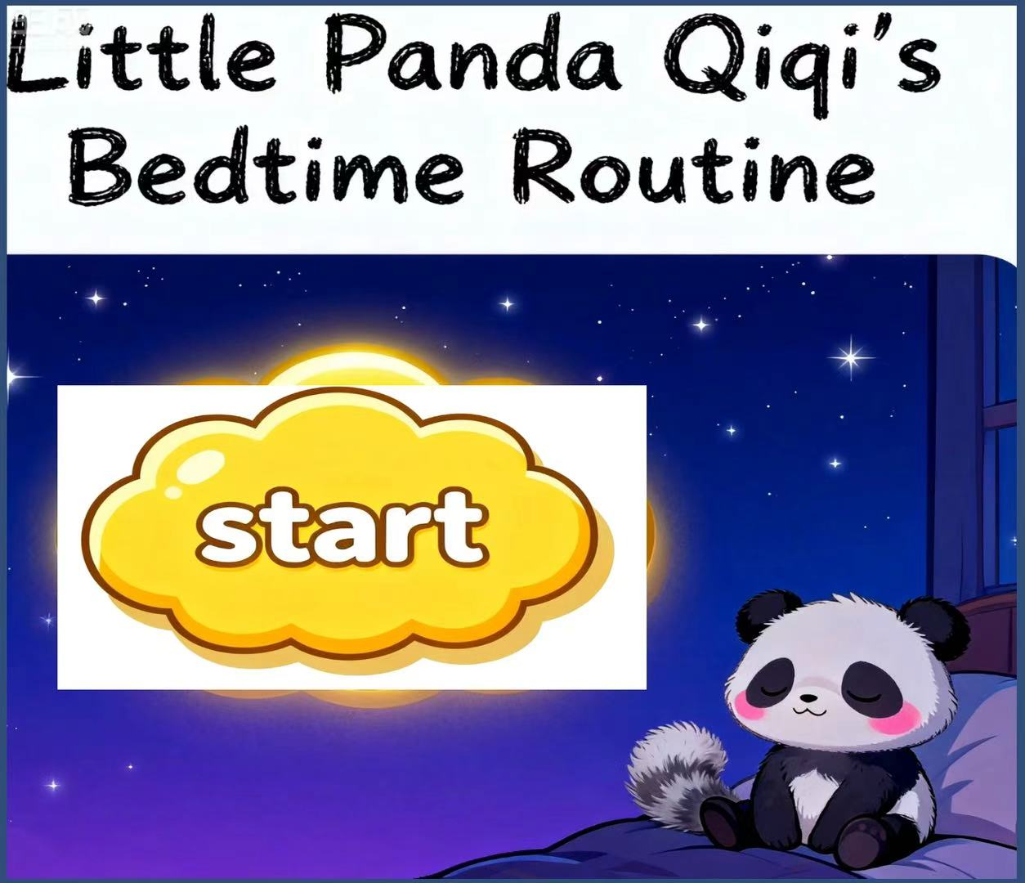*

**Tidy up:**

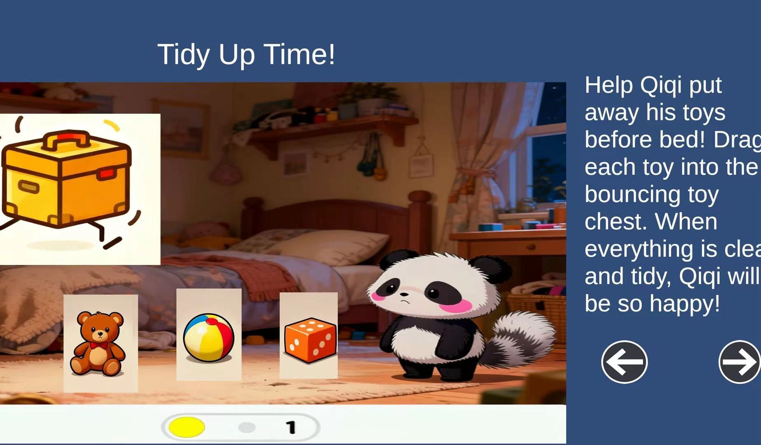

**Brush teeth:**

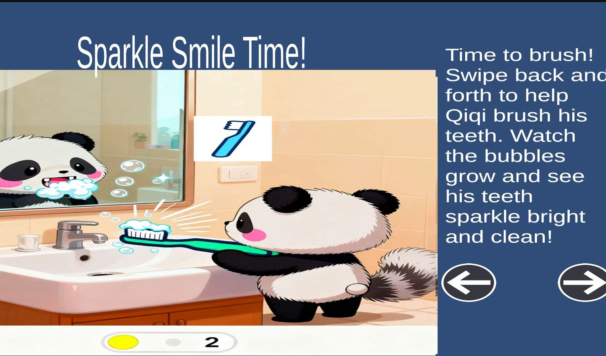

**Bath:**

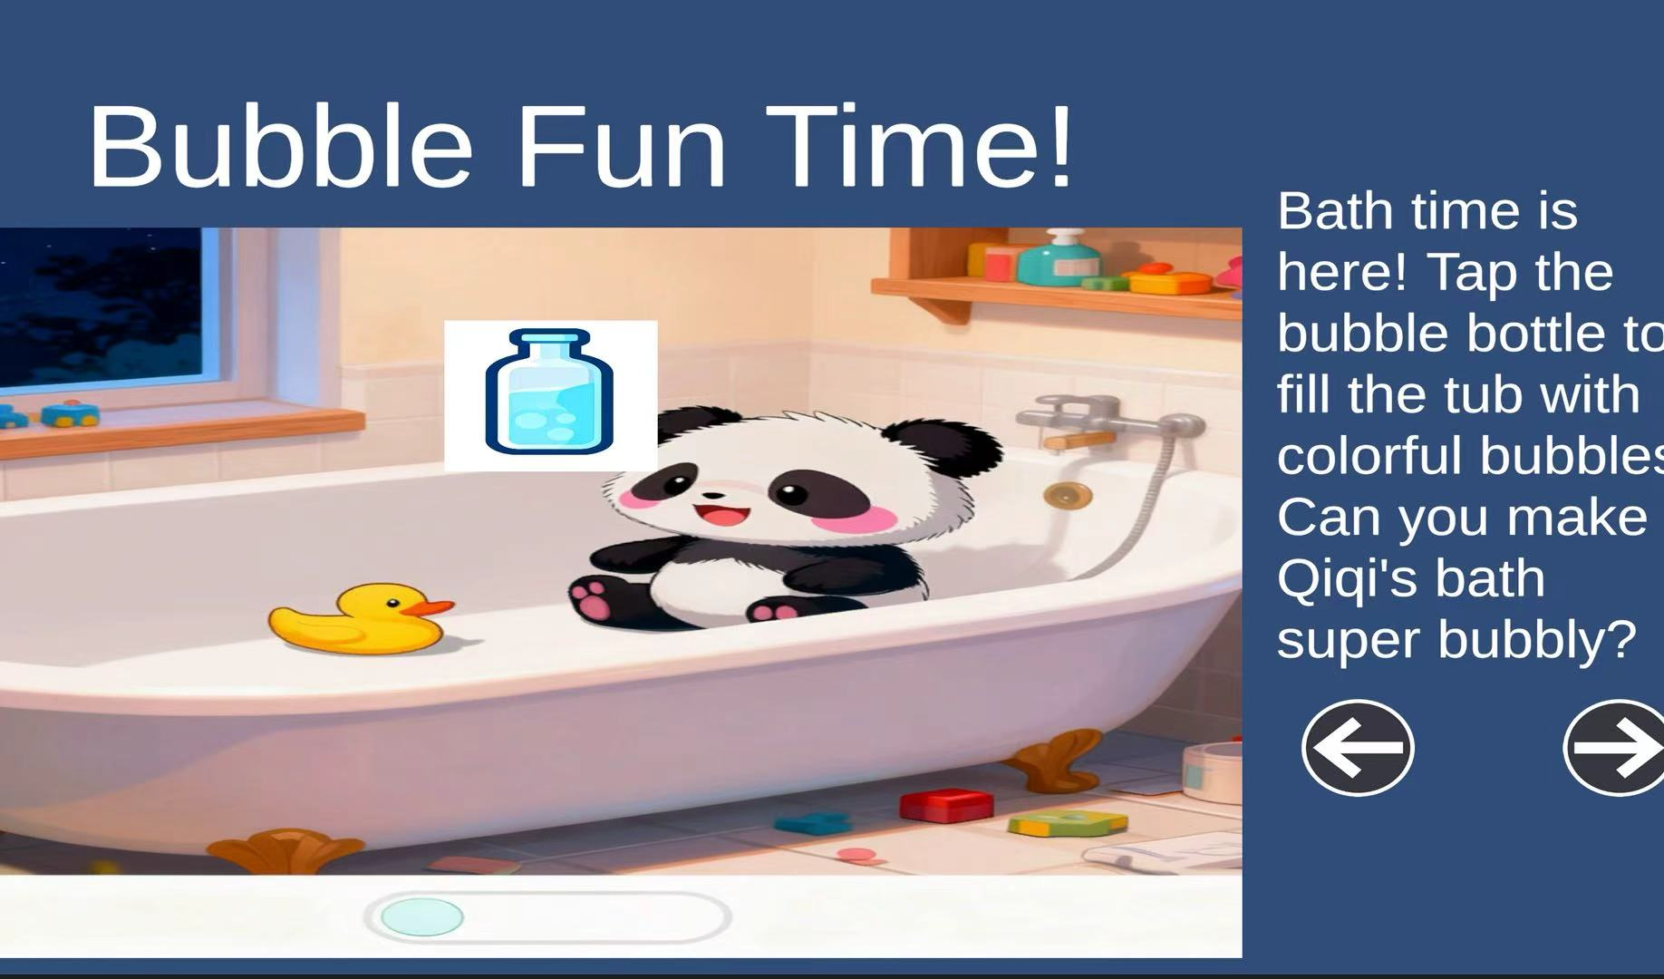

**Read:**

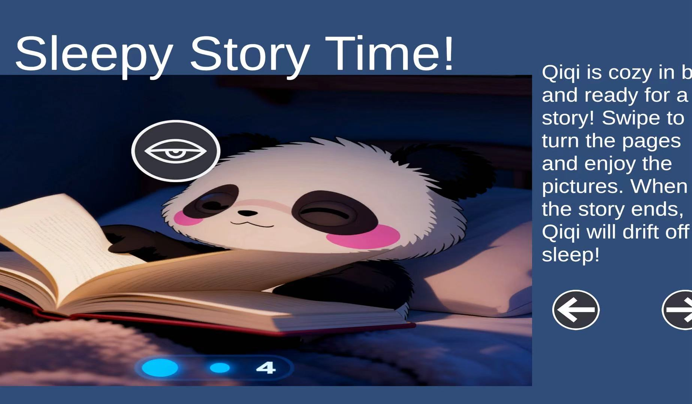

**Sleepy:**

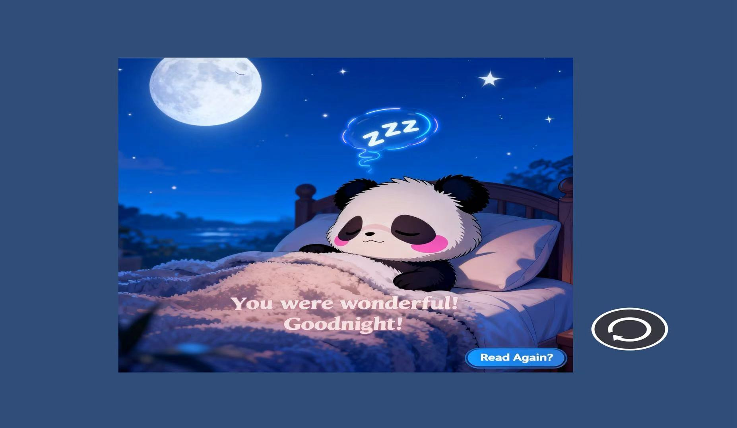

## Updated Storyboards

**Title**: Home Page **Frame ID**: *Home*

**Dimensions:**

**16:9 (e.g., 1920x1080px)**

**Media Used:**

**Digital Illustration, Gentle Background Music**

**Buttons:**

A large, glowing "Start " button in the center, using the Primary Button style.

**Background**:

A quiet night sky unfolds like a vast velvet curtain, its color gradually transitioning from deep sapphire blue to soft lavender purple. Countless stars, like tiny diamond pieces, are dotted among it, twinkling with faint yet charming light. Little Panda Qiqi is curled up drowsily in a cozy corner of her room, and the soft plush carpet makes him feel as comfortable as lying on a cloud.

**Content:**

The game's title "Little Panda Qiqi's Bedtime Story" is displayed at the top in a warm, rounded hand-drawn font. A faint starlit outline effect is skillfully added to the edges of the font, blending perfectly with the atmosphere of the night sky background.

**Description (purpose / objectives):**

To create a warm and user-friendly initial experience for first-time users, the app is carefully designed to have an overall atmosphere that is calm, soothing and relaxing. It jointly builds an immersive scene through soft color matching, gentle light and shadow effects, and soft background sounds. A single core operation button – "Start the Story" – is clearly and prominently displayed in the center of the interface, ensuring users can quickly understand and perform key interaction steps without extra thinking.

**Animations:**

The "Start Adventure!" button will attract users' attention with a soft breathing effect. Its light glow slowly expands outward from the center and then gradually contracts, like the rhythmic rise and fall of breathing. Coordinating with the delicate flicker of the pale gold outline around the button's edge, it naturally draws users' eyes to this core interaction entry point.

**User Interactions Required:**

Click the "Start" button.

**User Feedback:**

When the user clicks the button, the interface immediately provides a skeuomorphic press feedback — the button completes shrinking and deforming with a smooth animation lasting 0.2 seconds, simulating the sinking feel of a real physical button. At the same time, it triggers the system to play a "click" sound, which conveys a pleasant interactive experience through its soft sound quality and positive tone.

**Navigation / Links:**

Proceeds to Frame ID: Scene1_TidyUp

**Title**: Tidy Up Toys **Frame ID**: *Scene1_TidyUp*

**Dimensions:**

**16:9 (e.g., 1920x1080px)**

**Media Used:**

**Digital Illustration, Sound Effects (drag, drop, success chime)**

**Buttons:**

The bouncing Toy Chest (acts as an Icon Button).

Three scattered toys (a ball, a teddy bear, a block) are also Interactive Objects.

**Background**:

Qiqi’s bedroom is filled with a warm and cozy atmosphere. A night light hangs on the wall, and a few stuffed toys are scattered on the soft carpet. However, the room looks a bit messy: picture books are left open and piled on the bedside table, building blocks are scattered at the foot of the bed, and a few small clothes are casually draped over a chair. She stands in the middle of the room, twisting the hem of her clothes unconsciously with her little hands. Her eyes slowly sweep over the messy items, her little brows furrow slightly, and a hint of helplessness shows on her face.

**Content:**

The page indicator at the bottom of the interface consists of circular icons. Among them, the first dot is in a prominent yellow filled state to indicate the current active page position, while the other dots remain in a light gray inactive state. The overall design adopts a translucent style that blends naturally with the background. It not only clearly indicates the user’s current page progress but also strengthens the visual guidance effect through color contrast.

The title font uses a rounded handwritten style. Its font structure is soft with no sharp corners, reducing visual aggressiveness and fitting the contexts of "bedtime" and "children". The starlight outline uses low-saturation warm white, with transparency controlled between 30% and 40% to avoid glare interference. At the same time, it simulates a "moonlight refraction" effect to enhance the dreamy feel of the night sky.

**Description (purpose / objectives):**

Through the design of an intuitive drag-and-drop interaction mechanism, users are guided to actively participate in the first core task of the bedtime process: tidying up scattered toys and items. During the hands-on organizing process, their sense of responsibility for personal space is imperceptibly cultivated. At the same time, the gamified operation method helps users naturally start the pre-sleep preparation process, establishing coherent behavioral expectations for subsequent steps such as tooth brushing and changing clothes.

**Animations:**

The toy box will bounce slightly up and down, and the edge of the box lid will glow with yellow light. Along with the trajectory of the user’s finger slide, the box moves smoothly, ensuring a light and precise operation feel.

**User Interactions Required:**

Long-press with a finger to select the toys scattered on the carpet, drag them smoothly to above the toy box in the corner of the room, align them with the box opening, and then release the finger to let the toys fall naturally into the box and complete the tidying action.

**User Feedback:**

When a toy is successfully placed into the box, it makes a soft "puff" sound, turns into colorful particles and disappears. At the same time, a faint glow effect like fireflies appears around the toy box. After the last toy is properly placed, the box lid closes slowly with a soft "click" sound. Seeing this, Qiqi immediately raises her hands high and claps happily in celebration, with a bright smile blooming on her face.

**Navigation / Links:**

After all toys are tidied, an automatic transition (or a "Next" button appearing) leads to Frame ID: Scene2_BrushTeeth.

**Title**: Brush Teeth **Frame ID**: *Scene2_BrushTeeth*

**Dimensions:**

**16:9 (e.g., 1920x1080px)**

**Media Used:**

**Digital Illustration, Sound Effects (squeeze, brushing, rinse)**

**Buttons:**

Toothbrush (Interactive Object).

**Background**:

A neat bathroom with warm tones. The walls are covered with beige tiles, and soft light filters through the frosted glass window. A mouthwash cup and toothbrush are placed on the sink. Qiqi stands in front of the sink, staring at her reflection in the mirror, her little paws gently resting on the cool countertop. The mirror not only clearly shows Qiqi’s round face and drooping ears, but also cleverly presents the user’s "first-person perspective" through perspective design—making it feel as if the user is standing in the bathroom with the little panda, ready to wash up.

**Content:**

The page indicator at the bottom shows that the second dot is in an active state with a prominent yellow fill, creating a sharp contrast with the other light gray inactive dots. This clearly indicates that the current step is the second part of the pre-sleep process.

The page indicator uses circles, a basic geometric shape. This is because circles have no sharp edges or directional sense, matching the softness and sense of security required for the bedtime scenario. The active yellow is not a high-saturation warning yellow, but a twilight warm yellow that shares the same origin as the main button. This not only maintains brand color consistency, but also acts like a night light in low-light environments.

**Description (purpose / objectives):**

Through the design of interactive gamified scenarios, users are guided to perform toothbrushing motions in a vivid, interesting and engaging way. With the help of animation demonstrations, this daily basic habit is standardized and normalized through a fun experience. This helps users develop scientific oral care awareness and independent toothbrushing skills.

**Animations:**

When the user uses their finger to simulate the toothbrushing motion on the screen, it mimics the friction and foaming of real toothpaste on teeth. This not only provides intuitive feedback on the toothbrushing effect, but also adds fun to the interaction.

**User Interactions Required:**

Perform left-and-right swipes on the virtual toothbrush on the screen to simulate the horizontal cleaning motion of real toothbrushing. Through the back-and-forth movement of the finger on the touch interface, the toothbrush model is driven to rub back and forth over the teeth area—fully replicating the physical operation trajectory of daily toothbrushing.

**User Feedback:**

Each swipe generates more animated bubbles. After 5-6 swipes, Qiqi’s teeth will shine with a dazzling glow, and she will show a big, bright smile. At this point, a clear "ding!" sound will play.

**Navigation / Links:**

Proceeds to Frame ID: Scene3_Bath.

**Title**: Bubble Bath **Frame ID**: *Scene3_Bath*

**Dimensions:**

**16:9 (e.g., 1920x1080px)**

**Media Used:**

**Digital Illustration, Sound Effects (pour, bubble)**

**Buttons:**

Bubble Bath Bottle (Icon Button).

**Background**:

The bathroom scene focuses on a bathtub filled with clear warm water. A yellow rubber duck floats on the water’s surface, while a bottle of body wash and a blue sponge sit on the edge of the tub. Qiqi is already comfortably settled in the bathtub, her little paws gently tickling the water surface and sending tiny ripples spreading outward. The corners of her mouth are slightly upturned, and her eyes sparkle with excitement—looking both joyful and eager for the upcoming bathing game.

**Content:**

The page indicator at the bottom shows that the third dot is in an active state with a bright yellow fill, creating a clear contrast with the other light gray inactive dots. This intuitively indicates that the user has now entered the third phase of the pre-sleep process: the bathing phase.

**Description (purpose / objectives):**

Through carefully designed multi-dimensional relaxing and sensory play experiences deeply integrated with the bathing scenario, the design combines water texture, gentle scent, and interactive games. It creates an immersive atmosphere using elements like foam shapes, colorful light effects, and soft water sounds—transforming the originally monotonous cleaning process into an exploratory and fun parent-child bonding time. This allows the activity to naturally blend into children’s daily routines, becoming a positive part of fostering good hygiene awareness and emotional regulation skills.

**Animations:**

When the cute-shaped body wash bottle receives light taps from a finger, countless streams of translucent colorful bubbles slowly escape from the bottle’s opening. Meanwhile, the yellow rubber duck floats gently in the water, moving with the rising bubbles and the ripples of the water.

**User Interactions Required:**

Tap gently on the bubble bath bottle decorated with pink flower patterns on the screen, allowing fine bubbles to slowly pour out from the bottle’s opening.

**User Feedback:**

As soon as the bottle is tapped, a gurgling sound plays, and colorful bubbles instantly fill the entire bathtub, hiding Qiqi inside. Shortly after, she pops up above the water with a happy smile.

**Navigation / Links:**

Proceeds to Frame ID: Scene4_Story

**Title**: Goodnight Story **Frame ID**: *Scene4_Story*

**Dimensions:**

**16:9 (e.g., 1920x1080px)**

**Media Used:**

**Digital Illustration**

**Buttons:**

Left click header, right click header

**Background**:

The bedroom of Qiqi is dimly lit; only the star-shaped nightlight by the bedside emits a soft, hazy warm yellow glow. She curls up snugly on the small bed covered with a soft plush pad, wrapped in a warm blanket. Her fluffy tail hangs down from the edge of the blanket, swaying gently with her breath. Her pink little nose twitches from time to time, and she lets out contented purrs. Every now and then, she opens her small mouth to yawn, and her long eyelashes cast faint shadows under her eyelids.

**Content:**

The page indicator at the bottom shows that the fourth dot is in an active state with a bright yellow fill, creating a clear contrast with the other light gray inactive dots. This intuitively indicates that the user has now entered the fourth phase of the pre-sleep process: the sleep preparation phase.

**Description (purpose / objectives):**

It provides a quiet, soothing interactive pre-sleep activity as a warm closing ritual for children’s daily routines. Through a soft lighting atmosphere, gentle background music, and imaginative storylines, it helps children naturally transition from an active state to a relaxed state, fully preparing them for falling asleep. During the story progression, multiple simple yet meaningful choice points are set up, allowing children to independently choose the next direction of the story. For example, they can decide what type of bedtime story to tell Little Panda Qiqi, which plush toy to choose to accompany Qiqi to sleep, or select a goodnight lullaby. This enhances children’s sense of participation and control, turning bedtime into a warm parent-child interaction moment filled with anticipation.

**Animations:**

The pages flip smoothly with a swipe.

When the story "ends," Qiqi’s eyes slowly close.

**User Interactions Required:**

Swipe left-to-right to turn the pages of the book.

**User Feedback:**

When the user lightly taps the eye-shaped button at the bottom right corner of the interface, Little Panda Qiqi’s eyes then slowly close, and her pink little mouth also makes a sleepy expression to match. When the user clicks the left arrow button on the left side of the screen, the page switches to the previous page with a smooth flip animation, accompanied by a soft rustling page-turn sound effect. Clicking the right arrow button on the right side triggers the same transition animation to move to the next page, making the entire reading process coherent and immersive.

**Navigation / Links:**

Proceeds to Frame ID: Credits.

**Title**: Credits Page **Frame ID**: *Credits*

**Dimensions:**

**16:9 (e.g., 1920x1080px)**

**Media Used:**

**Digital Illustration**

**Buttons:**

A "Read Again?" button (Primary Button style) in the corner.

**Background**:

Like the homepage, the quiet night sky is gently covered as if with velvety dark blue fabric. Perhaps a sleepy moon and stars accompany it—the moon hangs quietly in the sky, while the stars blink with drowsy eyes, casting faint silvery light between the clouds. Little Panda Qiqi curls up on her small bed, her fluffy tail resting softly by her side, sound asleep. She is covered with a warm quilt, her pink little nose twitching slightly with each steady breath, and a contented smile lingering on her lips.

**Content:**

The text "You’re amazing! Good night!" is presented in a soft handwritten font, as if carrying a warm smile between the lines. A faint golden glow lingers around the edge of each character, echoing the starlight in the night sky.

**Description (purpose / objectives):**

To help children develop healthy sleep habits and fall asleep peacefully, parents should use specific verbal praise and gentle physical contact to reinforce their positive behaviors during the bedtime routine—such as taking the initiative to tidy up toys or cooperating with washing up. They should also use soft reassuring words and loving encouragement to guide children in naturally transitioning to sleep. At the same time, the app’s built-in restart function allows parents to repeat the entire bedtime interaction process according to their child’s actual needs. This ensures a familiar and comfortable sleep environment for the child every night, gradually fostering a regular sleep routine.

**Animations:**

The stars twinkle gently. The "ZZZ" bubbles above Qiqi dance softly.

**User Interactions Required:**

Without exiting the app, users can directly tap the prominent "Read Again?" button at the bottom of the current interface to restart the bedtime story interaction with one tap, no need to go through complicated startup steps repeatedly.

**User Feedback:**

The user hears a gentle, soothing lullaby playing continuously like flowing water. The melody is light and gentle, like a mother's hand gently stroking a child’s cheek. Each note carries soothing power, wrapping the entire room in a serene and peaceful atmosphere.

**Navigation / Links:**

returns to Frame ID: Home

## Final Media List

*[You should list all media used here]*

|  |  |
| --- | --- |
| Image name or description | Resource address/URL |
| all media | https://github.com/1wangnan1/Panda-Qiqi/tree/main/Assets/Sprites |

# References

Text in this section is not included in maximum word count.

# Appendix A

Include screen shots – essential if evaluating an application and other information here

# Appendix B – GenAI use

## Acknowledgement Statement:

I acknowledge that I have used GenAI to complete this assessment. I used <GenAI tool(s)> to <specific purpose(s) of using GenAI> within the parameters outlined in the Assessment Brief and by the Unit Assessor. I have maintained accurate records of my GenAI use where applicable and acknowledge that I may be required to provide further evidence.

## GenAI generation conversation:

<paste your conversation with your GenAI tool here.>