实验9跨进程共享数据-ContentProvider
【实验目的】
了解ContentProvider类的使用；熟练掌握跨进程共享数据的实现，包括Android系统定义的内容提供者和自定义内容提供者。
【实验要求】
上机完成实验并撰写实验报告
【实验内容】
1、读取通信录中的联系人数据
2、自定义内容提供者实现数据库的增删改查
【实验步骤】

二、自定义ContentProvider
程序功能：使用ContentProvider实现数据库的增删改查操作。

1、创建工程或module
在android studio中新建工程或module，名称为“ContentProviderTwo
”。选择Java语言，并让Android studio给我们自动生成一个主活动MainActivity和对应的布局文件activity_main。

2、创建数据库表的操作类
在com.example.contentprovidertwo包中新建一个java类，名称为“MyDatabaseHelper”。代码如下：
import android.content.Context;
import android.database.sqlite.SQLiteDatabase;
import android.database.sqlite.SQLiteOpenHelper;
public class MyDatabaseHelper extends SQLiteOpenHelper {
public static final String CREATE_BOOK = "create table Book ("
+ "id integer primary key autoincrement, "
+ "author text, "
+ "price real, "
+ "pages integer, "
+ "name text)";
public static final String CREATE_CATEGORY = "create table Category ("
+ "id integer primary key autoincrement, "
+ "category_name text, "
+ "category_code integer)";

private Context mContext;
public MyDatabaseHelper(Context context, String name,
SQLiteDatabase.CursorFactory factory, int version) {
super(context, name, factory, version);
mContext = context;
}
@Override
public void onCreate(SQLiteDatabase db) {
db.execSQL(CREATE_BOOK);
db.execSQL(CREATE_CATEGORY);
// Toast.makeText(mContext, "Create succeeded", Toast.LENGTH_SHORT).show();
}

@Override
public void onUpgrade(SQLiteDatabase db, int oldVersion, int newVersion) {
db.execSQL("drop table if exists Book");
db.execSQL("drop table if exists Category");
onCreate(db);
}
}

3、创建ContentProvider
自定义一个内容提供者类，该类必须继承ContentProvider类。具体的操作如下：
鼠标右击com.example.contentprovidertwo包->New->Other->Content Provider，弹出一个对话框，并填写名称和URI,如下图所示：
Exported属性表示是否允许外部程序访问我们自定义的内容提供者。
Enabled属性表示是否启用这个内容提供者。
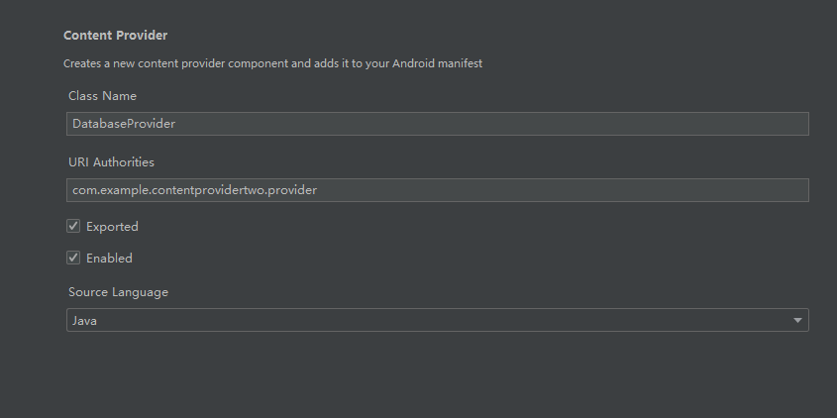
进程间共享数据的本质是：添加、删除、获取和修改（更新）数据。
因此ContentProvider的子类，必须要实现query()、insert()、update()、delete()等方法。
注册自定义ContentProvider。
打开Android Manifest.xml文件，系统已经自动注册了我们定义的ContentProvider。如下图所示：
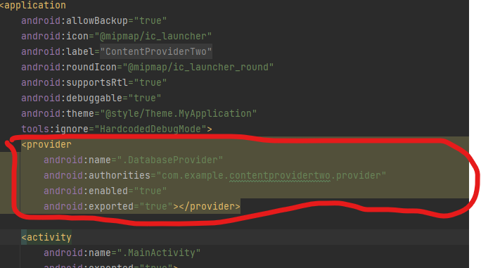
DatabaseProvider类的具体代码如下：
import android.content.ContentProvider;
import android.content.ContentValues;
import android.content.UriMatcher;
import android.database.Cursor;
import android.database.sqlite.SQLiteDatabase;
import android.net.Uri;
public class DatabaseProvider extends ContentProvider {
//定义4个常量
public static final int BOOK_DIR = 0;//访问book表中所有数据
public static final int BOOK_ITEM = 1;//访问book表中单条数据
public static final int CATEGORY_DIR = 2;//访问category表中所有数据
public static final int CATEGORY_ITEM = 3;//访问category表中单条数据
//访问权限
public static final String AUTHORITY = "com.example.contentprovidertwo.provider";
/*定义UriMatcher类对象
UriMatcher类是Android提供的一个实用类，用于在ContentProvider中匹配传入的URI，
从而帮助 ContentProvider 确定需要对哪些数据执行操作（如查询、插入、更新或删除）。*/
private static UriMatcher uriMatcher;
private MyDatabaseHelper dbHelper;
//静态块，初始化数据
static{
uriMatcher = new UriMatcher(UriMatcher.NO_MATCH);
//book中所有数据
uriMatcher.addURI(AUTHORITY, "book", BOOK_DIR);
//book中单条数据，#符号代表任意长度的数字
uriMatcher.addURI(AUTHORITY, "book/#", BOOK_ITEM);
//category表中所有数据
uriMatcher.addURI(AUTHORITY, "category", CATEGORY_DIR);
//category表中单条数据，#符号代表任意长度的数字
uriMatcher.addURI(AUTHORITY, "category/#", CATEGORY_ITEM);
}
public DatabaseProvider() {
}
@Override
/*
从内容提供者中删除数据，使用uri参数来确定删除哪张表中数据，selection和selectionArgs参数
用于约束删除哪些行。值返回：被删除的行数
*/
public int delete(Uri uri, String selection, String[] selectionArgs) {
// Implement this to handle requests to delete one or more rows.
// 删除数据
SQLiteDatabase db = dbHelper.getWritableDatabase();
int deletedRows = 0;
switch (uriMatcher.match(uri)) {
case BOOK_DIR:
deletedRows = db.delete("Book", selection, selectionArgs);
break;
case BOOK_ITEM:
String bookId = uri.getPathSegments().get(1);
deletedRows = db.delete("Book", "id = ?", new String[] { bookId });
break;
case CATEGORY_DIR:
deletedRows = db.delete("Category", selection, selectionArgs);
break;
case CATEGORY_ITEM:
String categoryId = uri.getPathSegments().get(1);
deletedRows = db.delete("Category", "id = ?", new String[] { categoryId });
break;
default:
break;
}
return deletedRows;
}
@Override
//根据传入的内容URI来返回相应的MIME类型
public String getType(Uri uri) {
// TODO: Implement this to handle requests for the MIME type of the data
// at the given URI.
switch (uriMatcher.match(uri)) {
case BOOK_DIR:
return "vnd.android.cursor.dir/vnd.com.example.databasetest. provider.book";
case BOOK_ITEM:
return "vnd.android.cursor.item/vnd.com.example.databasetest. provider.book";
case CATEGORY_DIR:
return "vnd.android.cursor.dir/vnd.com.example.databasetest. provider.category";
case CATEGORY_ITEM:
return "vnd.android.cursor.item/vnd.com.example.databasetest. provider.category";
}
return null;
}
//以下方法为添加数据，参数uri确定更新那张表中的数据，待添加的数据保存在values参数中。
@Override
public Uri insert(Uri uri, ContentValues values) {
// TODO: Implement this to handle requests to insert a new row.
// 添加数据
SQLiteDatabase db = dbHelper.getWritableDatabase();
Uri uriReturn = null;
switch (uriMatcher.match(uri)) {
case BOOK_DIR:
case BOOK_ITEM:
long newBookId = db.insert("Book", null, values);
uriReturn = Uri.parse("content://" + AUTHORITY + "/book/" + newBookId);
break;
case CATEGORY_DIR:
case CATEGORY_ITEM:
long newCategoryId = db.insert("Category", null, values);
uriReturn = Uri.parse("content://" + AUTHORITY + "/category/" + newCategoryId);
break;
default:
break;
}
return uriReturn;
}
@Override
//初始化内容提供者，完成数据库和表的创建和升级。返回false表示失败
public boolean onCreate() {
// TODO: Implement this to initialize your content provider on startup.
dbHelper = new MyDatabaseHelper(getContext(), "BookStore.db", null, 2);
return true;
}
//查询方法：参数uri确定查询新那张表中的数据，projection确定哪些列，
//selection和selectionArgs参数用于约束查询哪些行
//结果放入Cursor对象中
@Override
public Cursor query(Uri uri, String[] projection, String selection,
String[] selectionArgs, String sortOrder) {
// TODO: Implement this to handle query requests from clients.
// 查询数据
SQLiteDatabase db = dbHelper.getReadableDatabase();
Cursor cursor = null;
switch (uriMatcher.match(uri)) {
case BOOK_DIR:
cursor = db.query("Book", projection, selection, selectionArgs, null, null, sortOrder);
break;
case BOOK_ITEM:
String bookId = uri.getPathSegments().get(1);
cursor = db.query("Book", projection, "id = ?", new String[] { bookId }, null, null, sortOrder);
break;
case CATEGORY_DIR:
cursor = db.query("Category", projection, selection, selectionArgs, null, null, sortOrder);
break;
case CATEGORY_ITEM:
String categoryId = uri.getPathSegments().get(1);
cursor = db.query("Category", projection, "id = ?", new String[] { categoryId }, null, null, sortOrder);
break;
default:
break;
}
return cursor;
}
@Override
public int update(Uri uri, ContentValues values, String selection,
String[] selectionArgs) {
// TODO: Implement this to handle requests to update one or more rows.
// 更新数据
SQLiteDatabase db = dbHelper.getWritableDatabase();
int updatedRows = 0;
switch (uriMatcher.match(uri)) {
case BOOK_DIR:
updatedRows = db.update("Book", values, selection, selectionArgs);
break;
case BOOK_ITEM:
String bookId = uri.getPathSegments().get(1);
updatedRows = db.update("Book", values, "id = ?", new String[] { bookId });
break;
case CATEGORY_DIR:
updatedRows = db.update("Category", values, selection, selectionArgs);
break;
case CATEGORY_ITEM:
String categoryId = uri.getPathSegments().get(1);
updatedRows = db.update("Category", values, "id = ?", new String[] { categoryId });
break;
default:
break;
}
return updatedRows;
}
}

4、编写 ContentResolver类
其他应用或组件可以通过ContentResolver来访问ContentProvider中的数据。本例不额外定义ContentResolver，直接在MainActivity中实现对ContentProvider中数据的访问。MainActivity的代码如下：
import android.annotation.SuppressLint;
import android.content.ContentValues;
import android.database.Cursor;
import android.database.sqlite.SQLiteDatabase;
import android.os.Bundle;
import android.os.Debug;
import android.util.Log;
import android.view.View;
import android.widget.Button;
import androidx.appcompat.app.AppCompatActivity;
public class MainActivity extends AppCompatActivity {
private MyDatabaseHelper dbHelper;
@Override
protected void onCreate(Bundle savedInstanceState) {
super.onCreate(savedInstanceState);

setContentView(R.layout.activity_main);
dbHelper = new MyDatabaseHelper(this, "BookStore.db", null, 2);
Button createDatabase = (Button) findViewById(R.id.create_database);
createDatabase.setOnClickListener(new View.OnClickListener() {
@Override
public void onClick(View v) {
dbHelper.getWritableDatabase();
}
});
Button addData = (Button) findViewById(R.id.add_data);
addData.setOnClickListener(new View.OnClickListener() {
@Override
public void onClick(View v) {
SQLiteDatabase db = dbHelper.getWritableDatabase();
ContentValues values = new ContentValues();
// 开始组装第一条数据
values.put("name", "西游记");
values.put("author", "吴承恩");
values.put("pages", 454);
values.put("price", 16.96);
db.insert("Book", null, values); // 插入第一条数据
values.clear();
// 开始组装第二条数据
values.put("name", "红楼梦");
values.put("author", "曹雪芹");
values.put("pages", 410);
values.put("price", 19.95);
db.insert("Book", null, values);
values.clear();
// 开始组装第三条数据
values.put("name", "水浒传");
values.put("author", "施耐庵");
values.put("pages", 520);
values.put("price", 20.95);
db.insert("Book", null, values); // 插入第二条数据
}
});
Button updateData = (Button) findViewById(R.id.update_data);
updateData.setOnClickListener(new View.OnClickListener() {
@Override
public void onClick(View v) {
SQLiteDatabase db = dbHelper.getWritableDatabase();
ContentValues values = new ContentValues();
values.put("price", 10.99);
db.update("Book", values, "name = ?", new String[] { "水浒传" });
}
});
Button deleteButton = (Button) findViewById(R.id.delete_data);
deleteButton.setOnClickListener(new View.OnClickListener() {
@Override
public void onClick(View v) {
SQLiteDatabase db = dbHelper.getWritableDatabase();
db.delete("Book", "pages > ?", new String[] { "500" });
}
});
Button queryButton = (Button) findViewById(R.id.query_data);
queryButton.setOnClickListener(new View.OnClickListener() {
@Override
public void onClick(View v) {
SQLiteDatabase db = dbHelper.getWritableDatabase();
// 查询Book表中所有的数据
Cursor cursor = db.query("Book", null, null, null, null, null, null);
if (cursor.moveToFirst()) {
do {
// 遍历Cursor对象，取出数据并打印
@SuppressLint("Range") String name = cursor.getString(cursor.getColumnIndex("name"));
@SuppressLint("Range") String author = cursor.getString(cursor.getColumnIndex("author"));
@SuppressLint("Range")int pages = cursor.getInt(cursor.getColumnIndex("pages"));
@SuppressLint("Range")double price = cursor.getDouble(cursor.getColumnIndex("price"));
Log.d("MainActivity", "book name is " + name);
Log.d("MainActivity", "book author is " + author);
Log.d("MainActivity", "book pages is " + pages);
Log.d("MainActivity", "book price is " + price);
} while (cursor.moveToNext());
}
cursor.close();
}
});
}

}

5、布局文件
activity_main.xml的代码如下：
<?xml version="1.0" encoding="utf-8"?>
<LinearLayout xmlns:android="http://schemas.android.com/apk/res/android"
android:orientation="vertical"
android:layout_width="match_parent"
android:layout_height="match_parent"
>
<Button
android:id="@+id/create_database"
android:layout_width="match_parent"
android:layout_height="wrap_content"
android:text="Create database"
/>
<Button
android:id="@+id/add_data"
android:layout_width="match_parent"
android:layout_height="wrap_content"
android:text="Add data"
/>
<Button
android:id="@+id/update_data"
android:layout_width="match_parent"
android:layout_height="wrap_content"
android:text="Update data"
/>
<Button
android:id="@+id/delete_data"
android:layout_width="match_parent"
android:layout_height="wrap_content"
android:text="Delete data"
/>
<Button
android:id="@+id/query_data"
android:layout_width="match_parent"
android:layout_height="wrap_content"
android:text="Query data"
/>
</LinearLayout>

6、运行结果
