[第一頁]

(停一下)

Hello everyone! Have you ever heard of the "Kibo-RPC" competition?

(切畫面)

[第二頁]

(停一下)

(慢一點) Kibo-RPC is a global contest organized for students from around the world.

(停一下)

(切畫面)

[第三頁]

(停一下)

You can form a team consisting of at least three students and even collaborate with students from other countries. For detailed information, please visit the official website.

(停一下)

(切畫面)

[第四頁]

(停一下)

In this competition, participants are required to control the Astrobee robot to complete various missions such as laser targeting, capturing images, and scanning and interpreting QR codes. Players also need to pay attention to the robot's path. Both the simulation and the real International Space Station have Keep-Out Zones and Keep-In Zones.

(切畫面)

[第五頁]

(停一下)

Prior to the deadline, teams have the opportunity to adjust their Java code and modify their strategies. There are multiple scoring criteria, so strive to achieve the highest score possible!

(停一下)

(切畫面)

[第六頁]

(停一下)

Competitors will write Java code to control the Astrobee robot using the API provided by the organizers. The organizers have also prepared instructional videos for those who have no prior coding experience. Don't worry about your coding skills.

(停一下)

(切畫面)

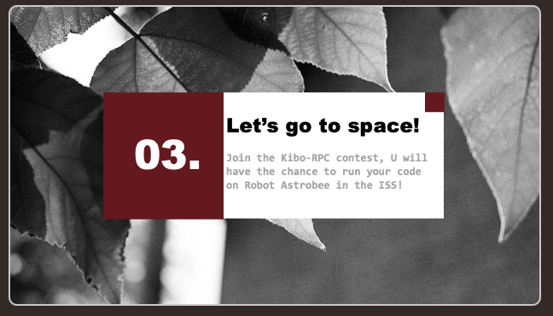

[第七頁]

(停一下)

If your team advances to the final round, you will have the chance to run your code on the actual Astrobee robot aboard the International Space Station. What an invaluable experience!

(停一下)

(切畫面)

[第八頁]

(停一下)

If you wish to participate in the competition, please follow the official website for the latest information on Kibo-RPC 2024. Thank you for your attention. We are Team WhyMyCodeWork?

(停一下)

Hello everyone! Have you ever heard the contest“Kibo-RPC”?

Kibo-RPC is a contest hold up for students around the world.

You can build up the team with at least three students. You can even teamwork with students from other country. Check out for details on the official website.

In this competitive, the competitors need to control the robot Astrobee to finish different missions such as hit the target with laser, take pictures or scan and interpret the QR code. The players also need to focus on the path of robot. There are Keep-Out Zone(KOZ) and Keep-In Zone(KIZ) in both simulation or real ISS.

Before the deadline, every team can adjust their JAVA code to change the strategy. There are many score item, try your best to get higher score as you can!

Competitors will write JAVA code to control the robot Astrobee with the API provided by 主辦方. 主辦方 also prepare some videos for who has no experience about coding. Don’t worry about the coding skills.

If your team passed the preliminary round, you’ll have the chance to run the code on the real Astrobee in International Space Station. What’s a precious experience!

If you want to join the competitive by yourself, please follow the official site for the newest information of Kibo-RPC 2024. Thanks for your listiening. We are team WhyMyCodeWork? .

Hello everyone! Have you ever heard of the "Kibo-RPC" competition?

Kibo-RPC is a global contest organized for students from around the world.

You can form a team consisting of at least three students and even collaborate with students from other countries. For detailed information, please visit the official website.

In this competition, participants are required to control the Astrobee robot to complete various missions such as laser targeting, capturing images, and scanning and interpreting QR codes. Players also need to pay attention to the robot's path. Both the simulation and the real International Space Station have Keep-Out Zones and Keep-In Zones.

Prior to the deadline, teams have the opportunity to adjust their Java code and modify their strategies. There are multiple scoring criteria, so strive to achieve the highest score possible!

Competitors will write Java code to control the Astrobee robot using the API provided by the organizers. The organizers have also prepared instructional videos for those who have no prior coding experience. Don't worry about your coding skills.

If your team advances to the final round, you will have the chance to run your code on the actual Astrobee robot aboard the International Space Station. What an invaluable experience!

If you wish to participate in the competition individually, please follow the official website for the latest information on Kibo-RPC 2024. Thank you for your attention. We are Team WhyMyCodeWork?