https://github.com/codefuse-ai/codefuse-ide
需要python环境,安装3.10.x
Electron环境, npm install electron --save-dev
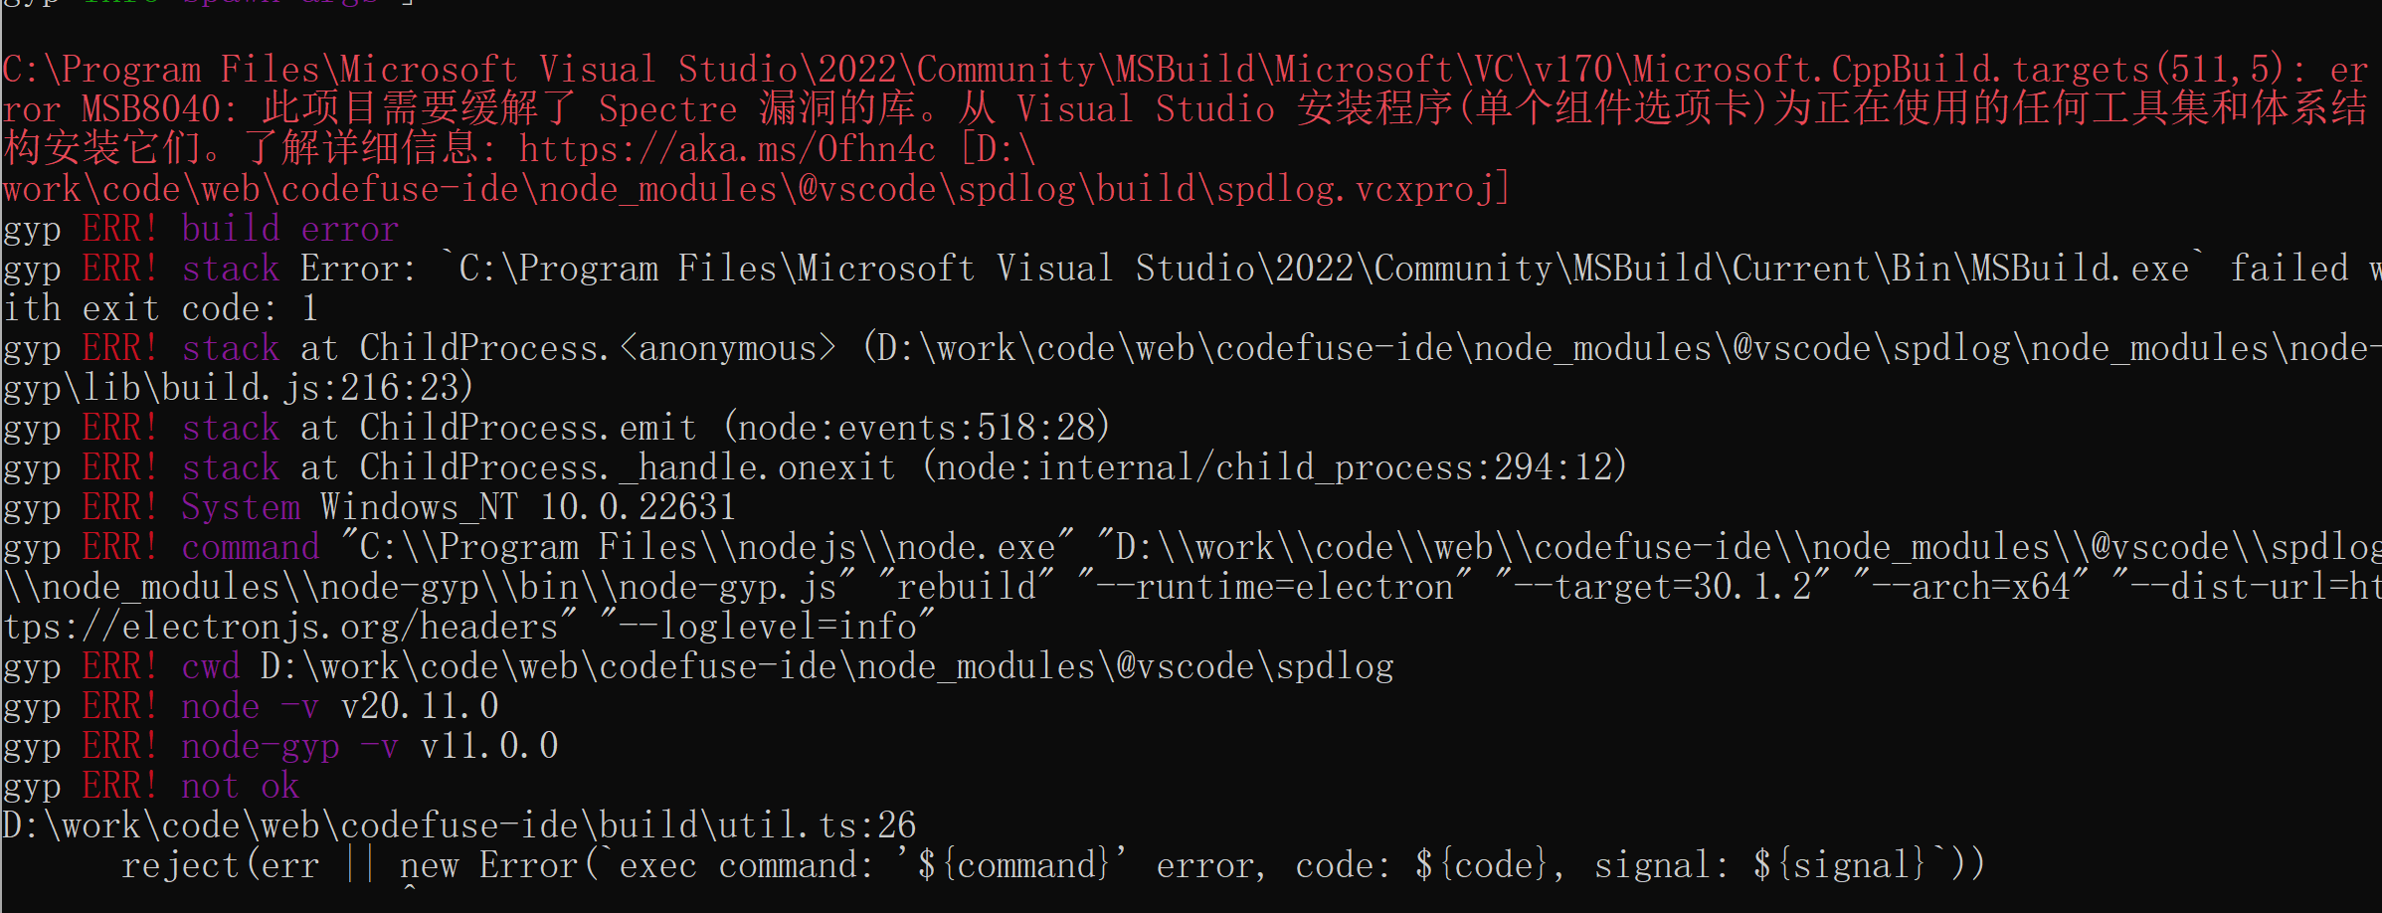
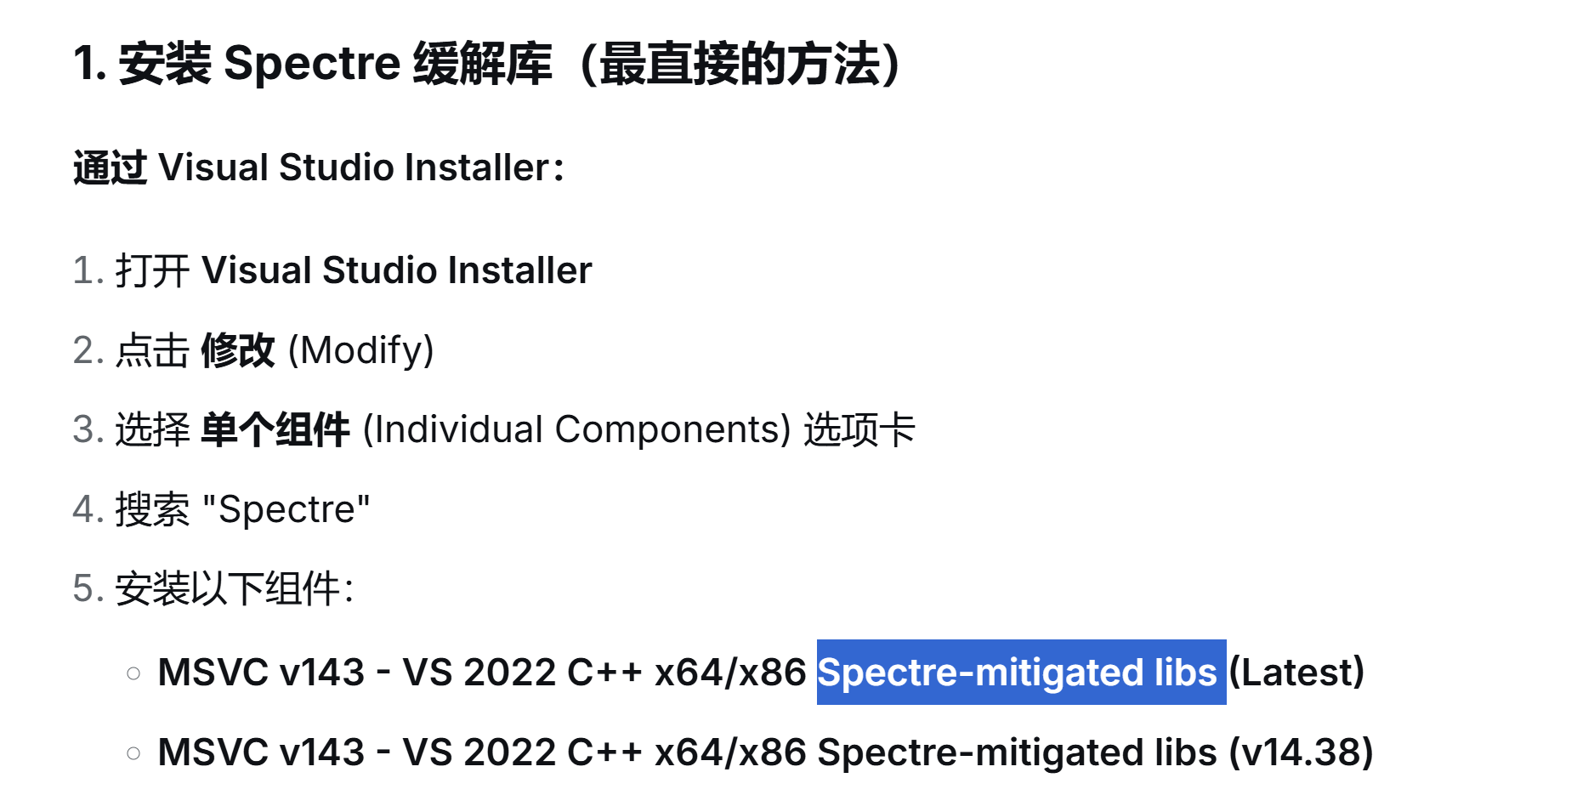
Start the web project (experimental)
# install dependencies
yarn
# rebuild native dependencies for web
yarn run web-rebuild
# build web
yarn run build-web
# start project, visit http://localhost:8080 or http://localhost:8080/?workspaceDir=workspace_dir
yarn run start-web
开启网页 http://localhost:8080/
调试异常-控制台npm run serve异常
重新build
# 1. 确保在项目根目录
cd /d/work/codelweb/codefuse-ide

# 2. 运行 electron-rebuild
npx electron-rebuild -v 30.1.2

# 3. 如果失败，强制重建
npx electron-rebuild -v 30.1.2 -f

# 4. 启动
yarn run start
不能调试改用https://gitee.com/mirrors/OpenSumi
源码编译参考上面,启动后支持终端npm 指令启动vue项目调试
Autocode地址: https://github.com/1yongjie/autocode
