Philip Warton

CS 162

January 12, 2020

Assignment 1 Design Document

**Understanding the Problem:**

*Summary.* We are being asked to write a program that will allow users to access and sort their financial budgets, each with multiple transactions. It must be secure in that users must remember their ID and password in order to be able to view their transactions. It must also be secure in that users can choose to see the data on the screen immediately or written to a separate file.

*User experience.* The user should run the program with the name of the necessary source files, and then be prompted to enter their ID and password. Upon successful login, the user should have four options: sort categorically, sort chronologically, sort monetarily, and exit the program. After choosing one of the three options they should either choose to print to the screen or write the transactions to file of their naming.

*Assumptions*:

* I am assuming that users know which filenames to enter to command line arguments
* I am assuming that these files are formatted correctly
* I am assuming that a given user does not want to run the program more than once

**Design:**

*(see next page)*

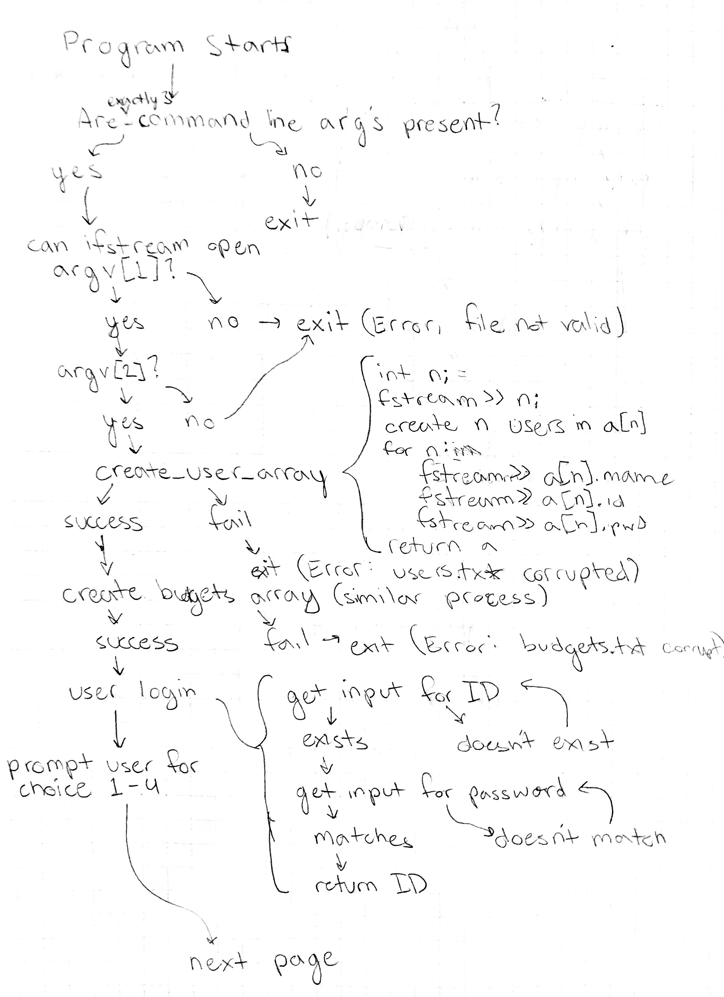

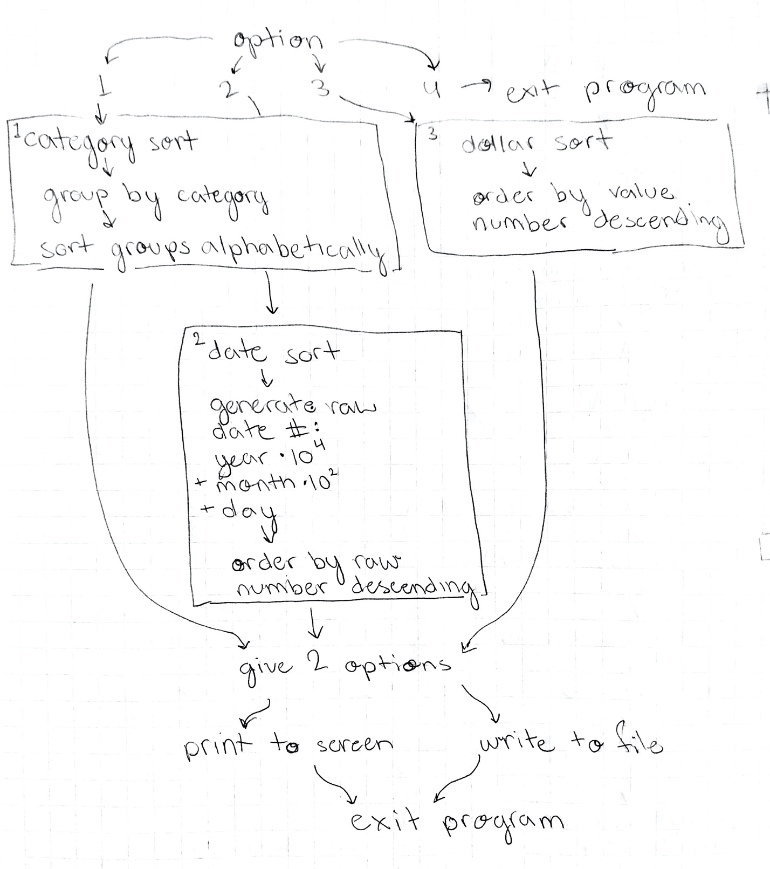

**Testing:**

|  |  |  |  |
| --- | --- | --- | --- |
| *Function* | *Case* | *Case Type* | *Outcome* |
| Choose_option | Input: 3 | Good | Sort by dollar amount |
| Choose_option | Input: 03.000 | Edge | Error: number must be an integer |
| Choose_option | Input: Option 100 | Bad | Error: number must be an integer |
| Check_cmd_args | Argv[1] = users.txt (and said file exists) | Good | Continues |
| Check_cmd_args | Argv[1] = users..txt | Edge | Error: file not found/file not valid |
| Check_cmd_args | Argv[1] = NULL | Bad | Error: incorrect number of arguments |
| Get_user_id | Input: 4069032 (not found in source file) | Bad | User ID not found: please try again (2 tries remaining) |
| Get_pwd | Input: 1234 (matches appropriate password) | Good | Password correct. Login successful. |
| Get_pwd | Input: “ ” | Bad | Error: password is not correct |
| Get_pwd | Input: “1234 ” (with a space) | Edge | Error: password is not correct |