Philip Warton

CS 162

January 25, 2020

Assignment 2 Design Document

**Understanding the Problem:**

*Summary.* We are being asked to write a program that allows two users to play the game Crazy Eights. This game works functionally like Uno where the eight can be used as a wild card. To win the game, a player must have an empty hand, or have the least number of cards in their hand when the deck runs out. We must use classes and object-oriented design in our program with classes for cards, decks, hands, players, and games. Users must have the option to place which ever card down they like, and be forced to draw a card if theirs is rejected. If a player plays an eight, they must be allowed to choose which suit they would like it to represent.

*Assumptions*:

* I am assuming players do not cheat in this game and look at the other players’ hand
* I am assuming the players do not intend to play the game with a deck that includes joker
* I am assuming that players input cards that are in their hand

**Design:**

*(see next page)*

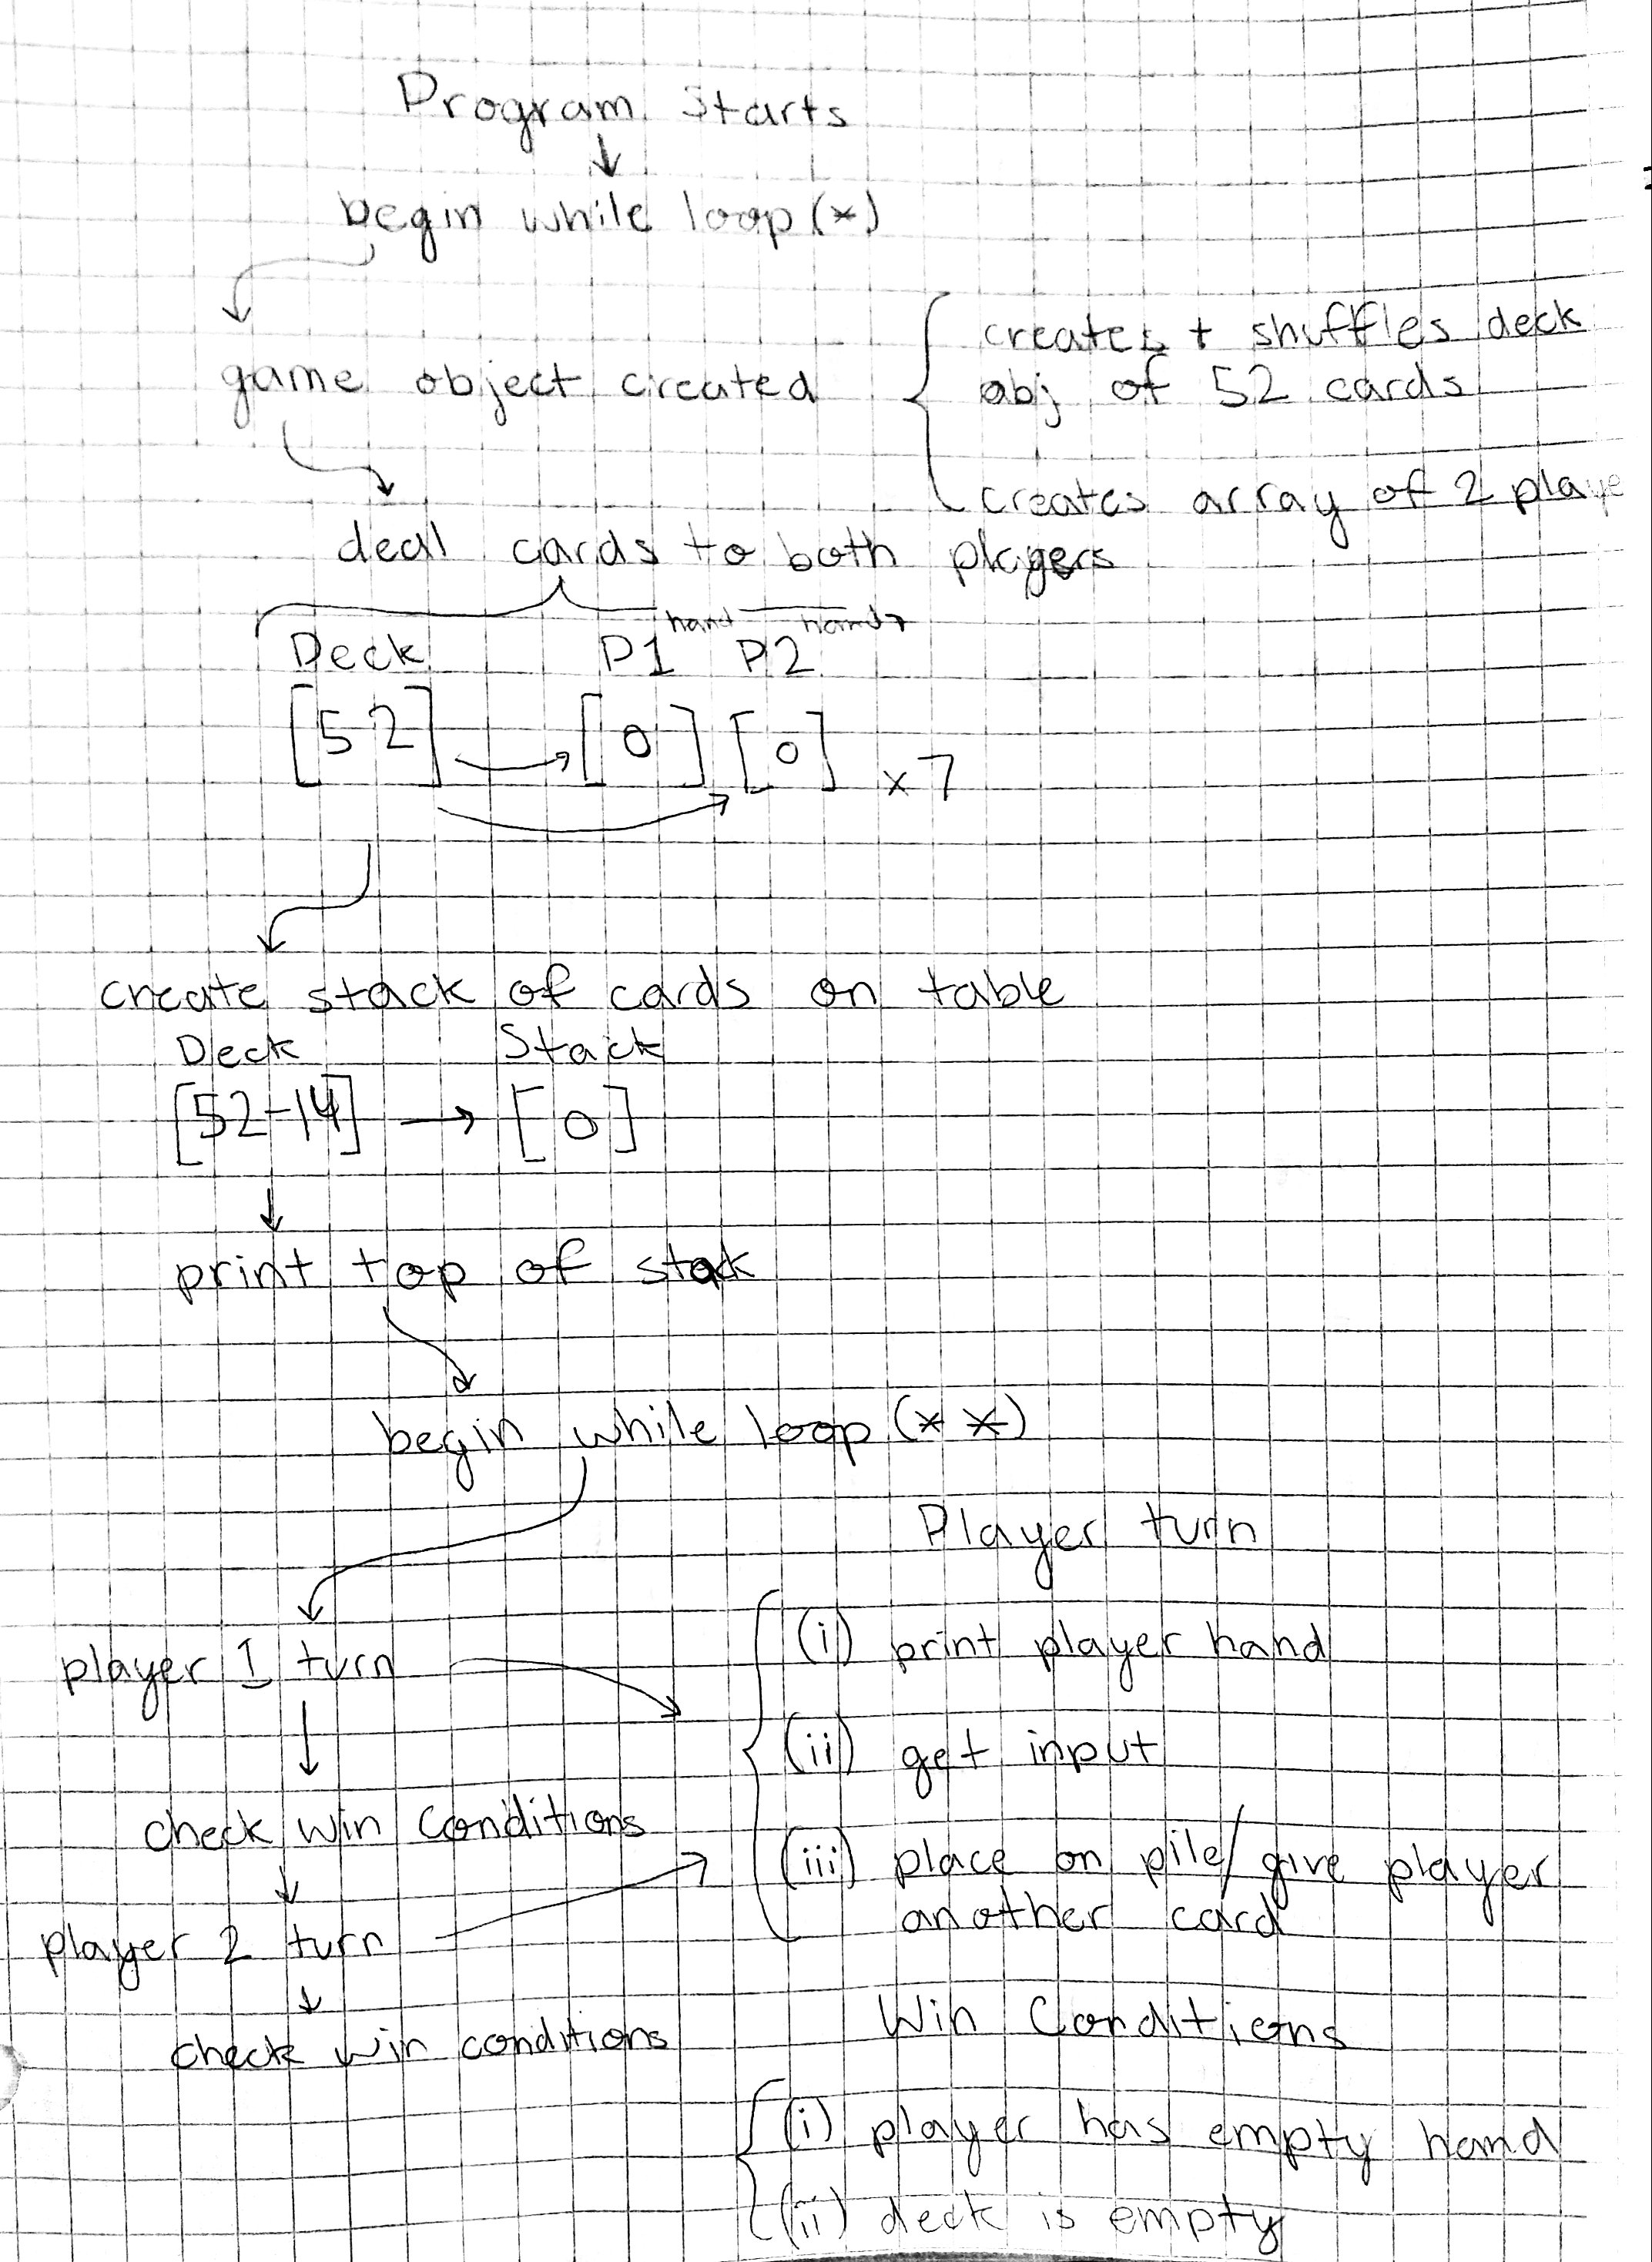

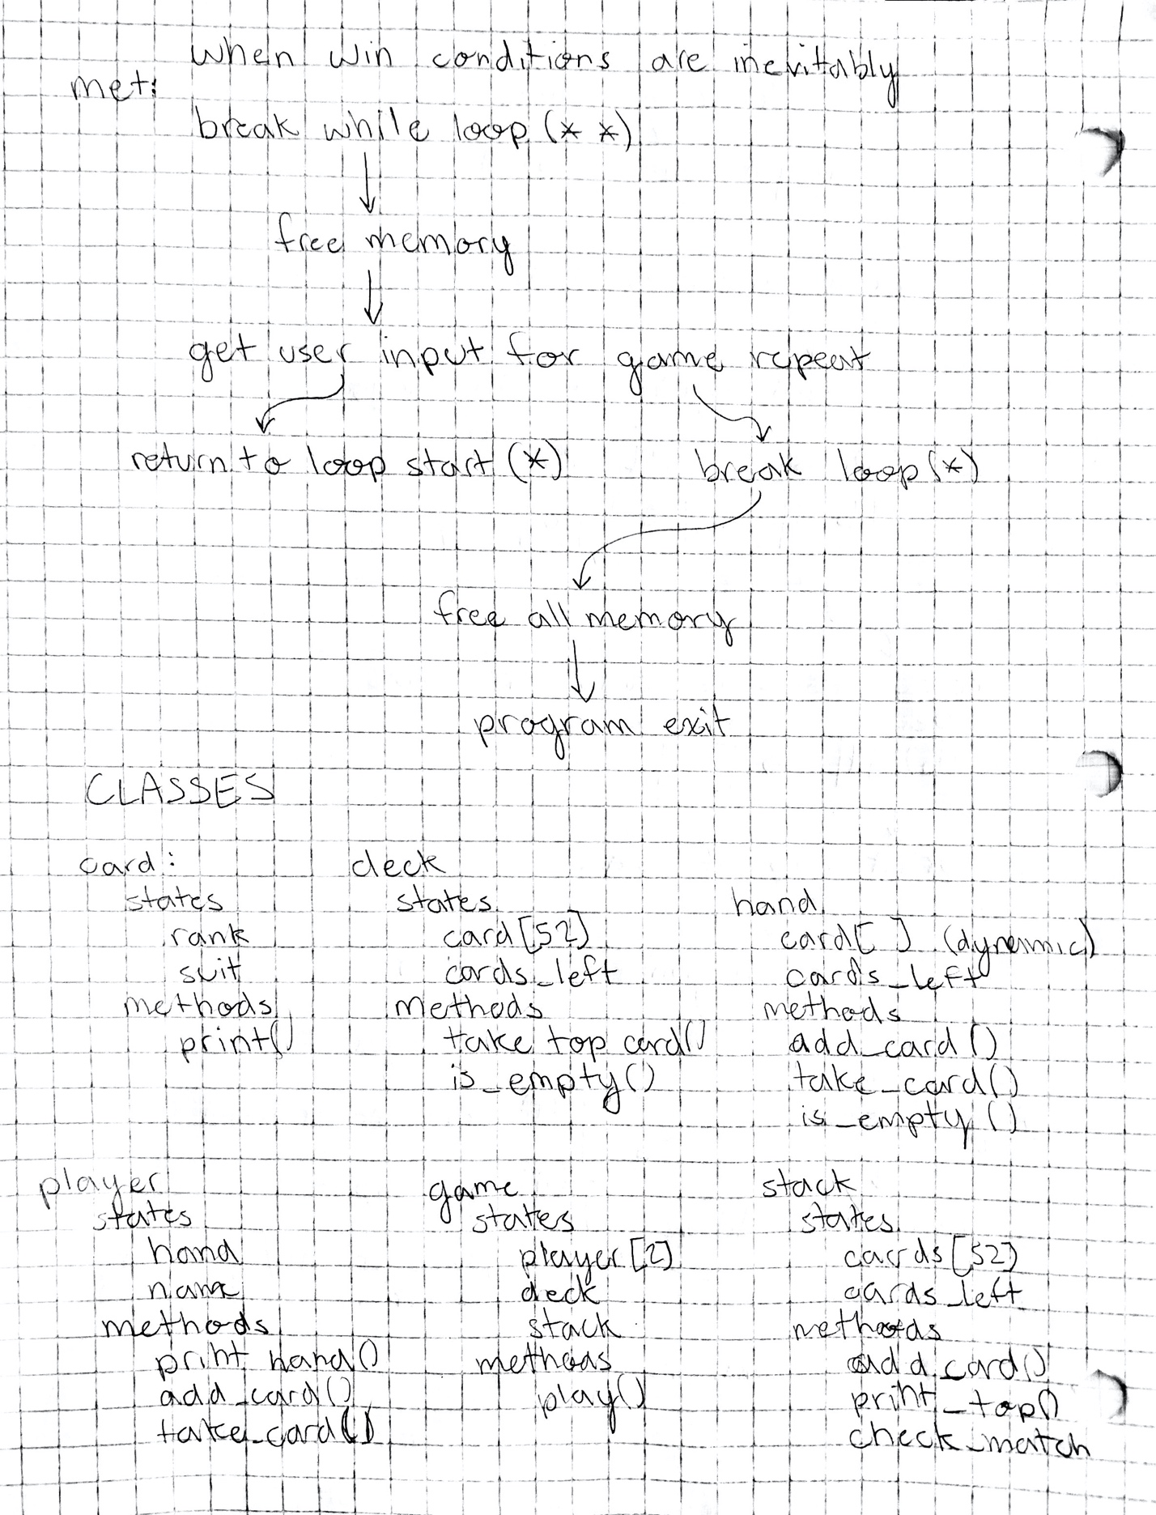

**Testing:**

|  |  |  |  |
| --- | --- | --- | --- |
| *Function* | *Case* | *Case Type* | *Outcome* |
| Check_match | In: Ace of Spades  Pile: Queen of hearts | Bad | Player draws a card from the deck |
| Check_match | In: 4 of hearts  Pile: Queen of hearts | Good | Player places card from hand on pile |
| Check_match | In: Queen of diamonds  Pile: Queen of hearts | Good | Player places card from hand on pile |
| Check_match | In: 0 of clubs  Pile: 2 of clubs | Edge | Throw error: card should not exists, exiting program |
| Get_card_from_hand  Print: please which card you would like to try to place | 1 | Good | Attempts to place first card in hand down |
| Get_card_from_hand | 0 | Edge | Error, input must be between 1 and n_cards |
| Get_card_from_hand | -1 | Bad | Error, input must be a positive integer |
| Get_repeat_input | Input: yes | Bad | Must enter 1 or 0 |
| Get_repeat_input | Input: “ ” | Edge | Error: must input 1 or 0 |
| Get_repeat_input | Input: 010 | Edge | Error: must input 1 or 0 |
| Get_repeat_input | Input: 1 | Good | Set repeat to true |