Philip Warton

CS 162

February 23, 2020

Assignment 4 Design Document

**Understanding the Problem:**

*Summary:* In this assignment we are asked to create a program that is a game. There is a grid of points that serves as the game board. There are two types of hazards, with two instances of each, placed somewhere on the board. There is also a gold prize, and the Wumpus monster. Players can move in four directions and fire up to three arrows in any given direction. If the player retrieves the gold and escape, then they win.

The goal of this assignment is to use polymorphism on the event class and its child classes.

*Assumptions*:

* I am assuming that the player does not press ‘ctrl-c’ to exit the game
* I am assuming that the player does not input the enter key when prompted for input
* I am assuming that the size of the board does not exceed 105 x 105
* I am assuming that the size of the board is positive

**Design:**

*(see next page)*

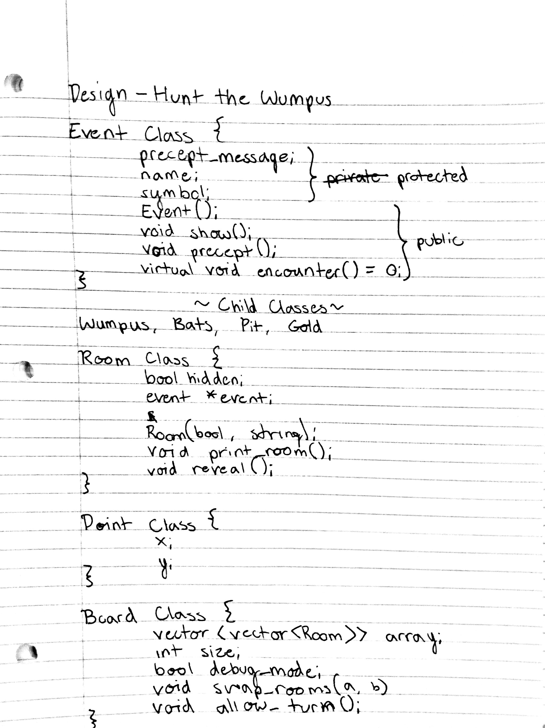

**Testing:**

|  |  |  |  |
| --- | --- | --- | --- |
| *Function* | *Case* | *Case Type* | *Outcome* |
| Board::allow_turn() | Input = “ “ | Bad | Error, must input direction or shoot an arrow |
| Board::allow_turn() | Input = “WA” | Edge | Error, must input one direction at a time |
| Board::allow_turn() | Input = “S” | Good | Move downwards if possible, otherwise nothing happens |
| Gold::encounter() | Player encounters gold | Good | Changes player has_gold member to true |
| Pit::encounter() | Player encounters bottomless pit | Bad | Game ends, message prints to console “You died.” |
| Wumpus::encounter(Arrow a) | Player misses Wumpus | Edge | Wumpus lives and moves to an empty random room |
| Wumpus::encounter(Arrow a) | Player hits Wumpus | Good | Wumpus is removed from game board |
| Wumpus::encounter(Player p) | Player runs into the Wumpus | Bad | Game Over. Player dies. |