Philip Warton

CS 162

March 8, 2020

Assignment 5 Design Document

**Understanding the Problem:**

*Summary:* In this assignment we are asked to implement a linked list. This is meant so that we get a taste of what is like to implement data structures in c++. The class is already build for the most part, but we have to fill in the blanks on the function definitions. We also must come up with an algorithm that can sort the linked list.

*Assumptions*:

* I am assuming that there is enough room in memory for the linked list
* I am assuming that the person who uses the linked list class doesn’t change the function members of the class
* I am assuming that we don’t need to access any index I > length

**Design:**

*(see next page)*

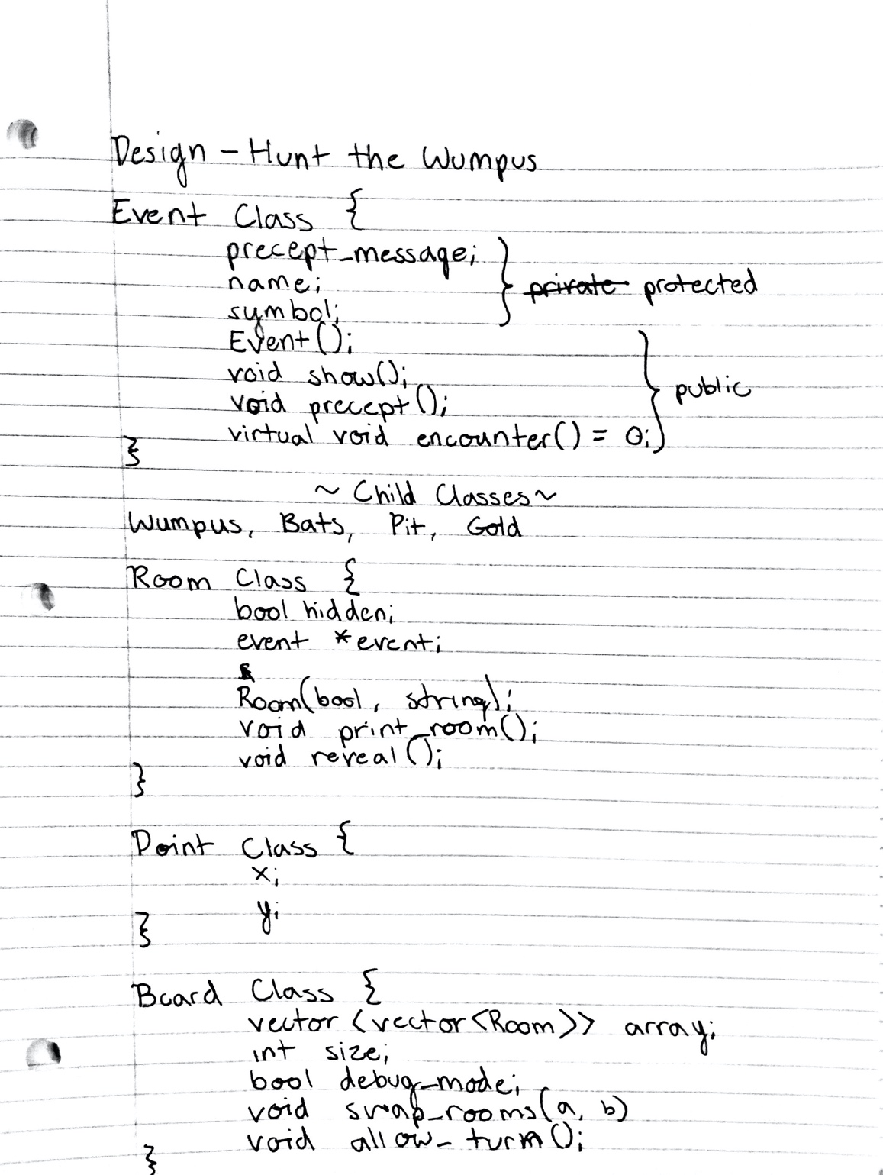

**Testing:**

|  |  |  |  |
| --- | --- | --- | --- |
| *Function* | *Case* | *Case Type* | *Outcome* |
| Push_front | Pass in i | I > length | ERRROR OUT OF RANGE |
| Push front | Pass in I < length, >= 0 | Good | Puts thing at head of LL |
| Push front | Pass in i negative | Edge | ERROR OUT OF RANGE |
| Push back | Runs pushback | Good | Puts thing at back |
| Push at(i) | Passes in I not in range | Bad | ERROR OUT OF RNAGE |
| Push at(i) | Passes in I in range | Good | Inserts the item at the ith index |
| Sort | Calls sort function | Good | Sords the linked list by value ascendending |