Table after add:

Table after update id=1:

Table after delete id=3:

Get email [Lamoor@gmail.com](mailto:Lamoor@gmail.com):

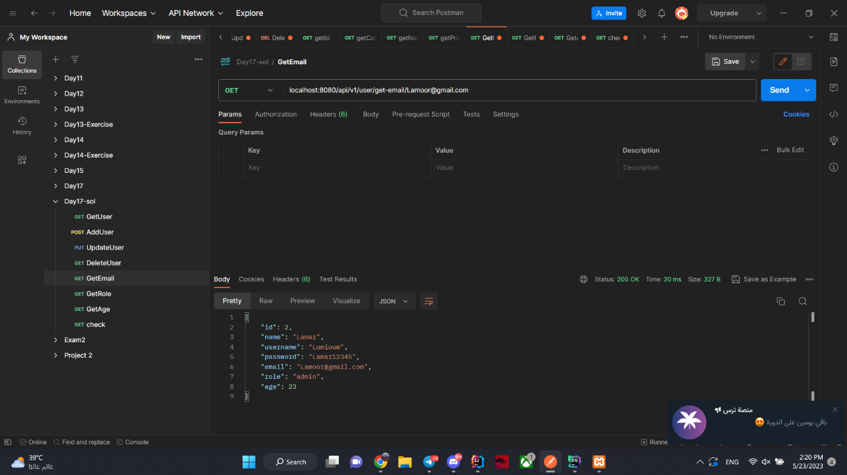

Get role admin:

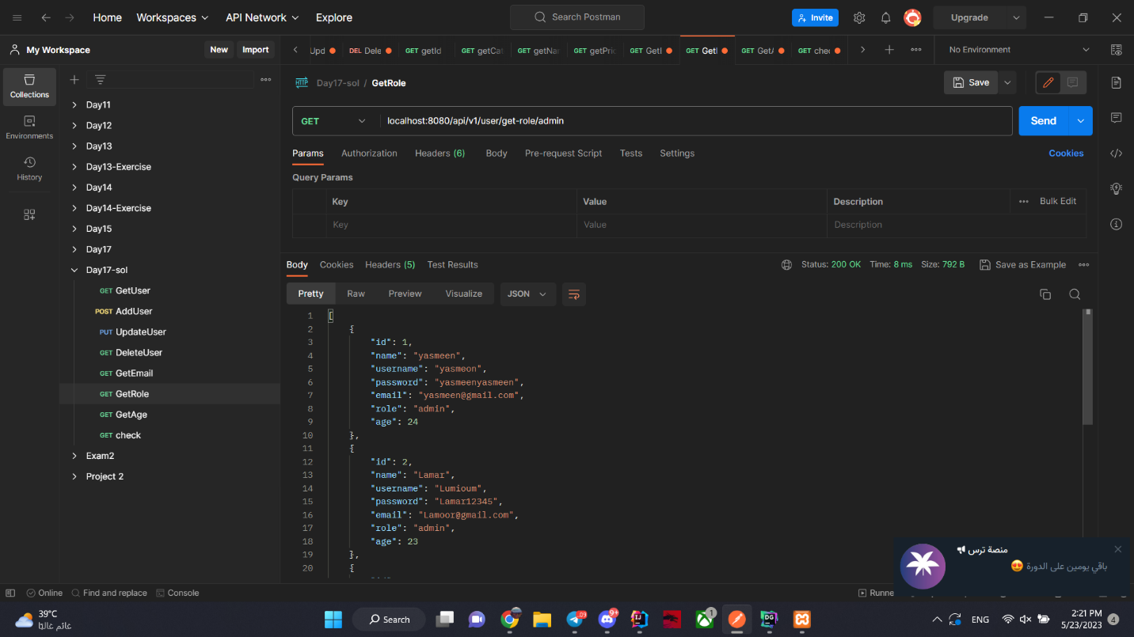

Get age 25 and above

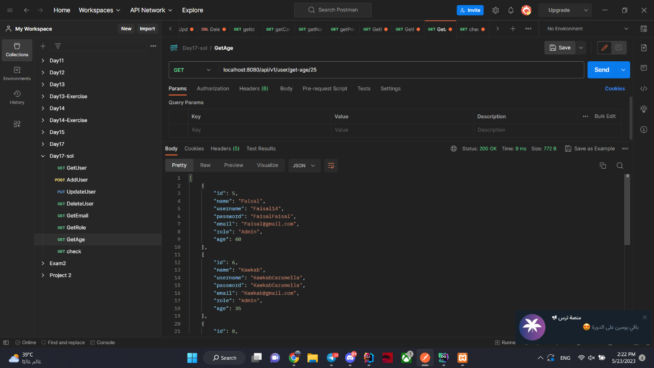

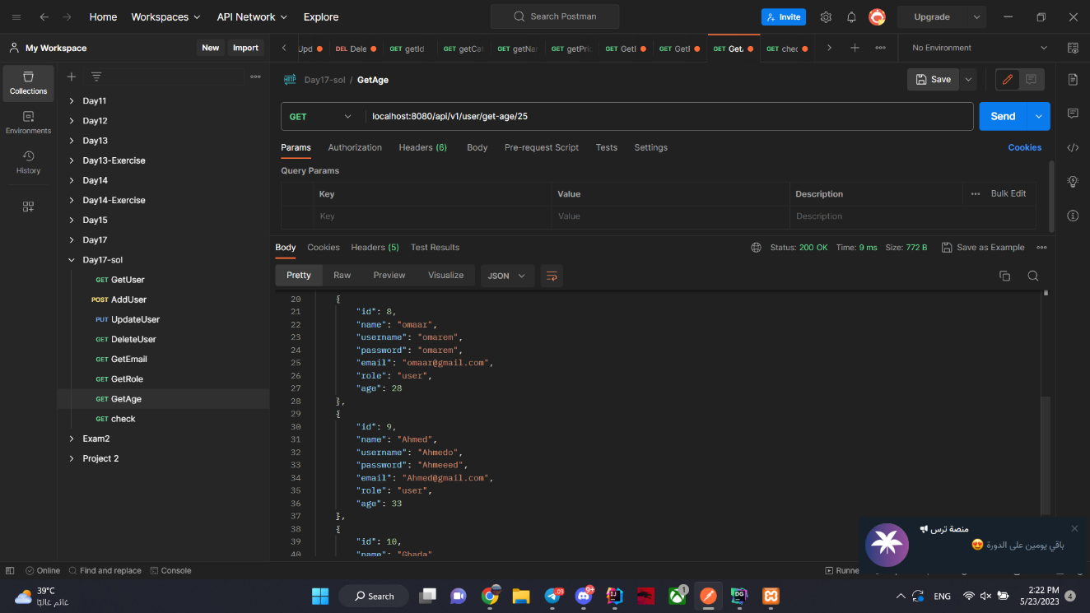

Check username: omarem

and password: omarem

