《程序设计基础课程设计》第五周实验报告

班级：21计算机类2班
姓名：周钰坤 申康
学号：21009200438 21009200580

所做题目：5_1

第5_1题

算法描述：
编写一个程序模拟图书管理系统。用户分为管理员和读者两类，分别显示不同文本格式菜单，通过菜单项对应数字进行选择。读者菜单包括借书、还书、查询等功能。管理员菜单包括图书和读者信息录入、修改和删除。图书信息至少应包括：编号、书名、数量，读者信息至少应包括：编号、姓名、所借图书。可根据图书名称或编号进行图书信息查询，可查询某本书现在被哪些读者借走。

源程序：
Libsim.c
#include<stdio.h>
#include<string.h>
#include<stdbool.h>
#define READER_FILE "E:\\c\\reader.txt"
#define BOOK_FILE "E:\\c\\book.txt"
#define ADMIN_FILE "E:\\c\\admin.txt"
typedef struct book{
int id;
char name[20];
int num;
}Book;
typedef struct reader{
int id;
char name[10];
int bro_num;
char bro_book[30][20];
}Reader;
typedef struct admin{
char name[10];
}Admin;

Book books[100];
Reader readers[30];
Admin admins[10];
//书，读者，管理员的数量
int book_num = 0;
int reader_num = 0;
int admin_num = 0;
void init(){
//打开文件，录入信息
FILE *b_f = fopen(BOOK_FILE, "r");
fscanf(b_f, "%d", &book_num);
for(int i = 0; i < book_num; i++){
fscanf(b_f,"%d %s %d", &books[i].id, books[i].name, &books[i].num);
}
FILE *r_f = fopen(READER_FILE, "r");
fscanf(r_f, "%d", &reader_num);
for(int i = 0; i < reader_num; i++){
fscanf(r_f, "%d %s %d", &readers[i].id, readers[i].name, &readers[i].bro_num);
for(int j = 0; j < readers[i].bro_num; j++){
fscanf(r_f,"%s ", readers[i].bro_book[j]);
}
}
FILE *a_f = fopen(ADMIN_FILE, "r");
fscanf(a_f, "%d", &admin_num);
for(int i = 0; i < admin_num; i++){
fscanf(a_f, "%s", admins[i].name);
}
fclose(b_f);
fclose(r_f);
fclose(a_f);
}
void save(){
FILE *b_f = fopen(BOOK_FILE, "w");
fprintf(b_f, "%d\n", book_num);
for(int i = 0; i < book_num; i++){
fprintf(b_f,"%d %s %d\n", books[i].id, books[i].name, books[i].num);
}
FILE *r_f = fopen(READER_FILE, "w");
fprintf(r_f, "%d\n", reader_num);
for(int i = 0; i < reader_num; i++){
fprintf(r_f, "%d %s %d\n", readers[i].id, readers[i].name, readers[i].bro_num);
for(int j = 0; j < readers[i].bro_num; j++){
fprintf(r_f,"%s", readers[i].bro_book[j]);
}
fprintf(r_f,"\n");
}
FILE *a_f = fopen(ADMIN_FILE, "w");
fprintf(a_f, "%d\n", admin_num);
for(int i = 0; i < admin_num; i++){
fprintf(a_f, "%s\n", admins[i].name);
}
fclose(b_f);
fclose(r_f);
fclose(a_f);
}
//管理员的操作
void add_reader(){
int temp = reader_num;
printf("请输入读者的编号：");
scanf("%d", &readers[temp].id);
printf("请输入读者的姓名：");
scanf("%s", readers[temp].name);
readers[temp].bro_num = 0;
reader_num++;
printf("录入成功！");
system("pause");
system("cls");
}
void delete_reader(){
int id, temp = -1;
printf("请输入要删除读者的编号：");
scanf("%d", &id);
for(int i = 0; i < reader_num; i++){
if(readers[i].id == id){
temp = i;
break;
}
}
if(temp == -1){
printf("不存在该读者，请再次确认！");
}else{
printf("你确定要删除该读者吗？\n");
printf("1.确认 2.取消");
int select;
scanf("%d", &select);
if(select == 1){
for(int i = temp; i < reader_num - 1; i++){
readers[i] = readers[i+1];
}
reader_num--;
}
}
system("pause");
system("cls");
}
void modify_reader(){
int id, temp = -1;
printf("请输入要修改读者的编号：");
scanf("%d", &id);
for(int i = 0; i < reader_num; i++){
if(readers[i].id == id){
temp = i;
break;
}
}
if(temp == -1){
printf("不存在该读者，请再次确认！");
}else{
printf("请输入修改后读者的编号：");
scanf("%d", &readers[temp].id);
printf("请输入修改后读者的姓名：");
scanf("%s", readers[temp].name);
printf("修改成功！");
}
system("pause");
system("cls");
}
void add_book(){
int temp = book_num;
printf("请输入图书的编号：");
scanf("%d", &books[temp].id);
printf("请输入图书的名字：");
scanf("%s", books[temp].name);
printf("请输入图书的本数：");
scanf("%d", &books[temp].num);
book_num++;
printf("添加成功！");
system("pause");
system("cls");
}

void delete_book(){
int id, temp = -1;
printf("请输入要删除图书的编号：");
scanf("%d", &id);
for(int i = 0; i < reader_num; i++){
if(books[i].id == id){
temp = i;
break;
}
}
if(temp == -1){
printf("不存在该图书，请再次确认！");
}else{
printf("你确定要删除该图书吗？\n");
printf("1.确认 2.取消");
int select;
scanf("%d", &select);
if(select == 1){
for(int i = temp; i < book_num - 1; i++){
books[i] = books[i+1];
}
book_num--;
}
}
system("pause");
system("cls");
}
void modify_book(){
int id, temp = -1;
printf("请输入要修改图书的编号：");
scanf("%d", &id);
for(int i = 0; i < reader_num; i++){
if(books[i].id == id){
temp = i;
break;
}
}
if(temp == -1){
printf("不存在该图书，请再次确认！");
}else{
printf("请输入修改后图书的编号：");
scanf("%d", &books[temp].id);
printf("请输入修改后图书的名字：");
scanf("%s", books[temp].name);
printf("请输入修改后图书的本数：");
scanf("%d", &books[temp].num);
printf("修改成功!");
}
system("pause");
system("cls");
}

void quit(){
printf("欢迎您的下次使用！");
system("pause");
save();
}
void show_A(){
int select = 1;
while(select != 0){
printf("---------\n");
printf("欢迎进入图书管理系统，以下是可选的操作：\n");
printf("1.读者信息录入 2.读者信息删除 3.读者信息修改\n");
printf("4.图书信息录入 5.图书信息删除 6.图书信息修改\n");
printf("0.退出\n");
scanf("%d", &select);
switch (select) {
case 1:
add_reader();
break;
case 2:
delete_reader();
break;
case 3:
modify_reader();
break;
case 4:
add_book();
break;
case 5:
delete_book();
break;
case 6:
modify_book();
break;
case 0:
quit();
break;
default:
printf("输入错误，请重试");
system("pause");
system("cls");
break;
}
}
}
void borrow_book(int flag){
int id, temp = -1;
printf("请输入要借的书的编号：");
scanf("%d", &id);
for(int i = 0; i < book_num; i++){
temp = i;
break;
}
if(temp == -1){
printf("不存在该图书，请再次确认！");
}else{
if(books[temp].num == 0) printf("该书已被借完，抱歉！");
else{
printf("你确定要借出该书吗？\n");
printf("1.确认 2.取消");
int select;
scanf("%d", &select);
if(select == 1){
int tem = readers[flag].bro_num;
strcpy(readers[flag].bro_book[tem], books[temp].name);
readers[flag].bro_num++;
books[temp].num--;
}
}
}
system("pause");
system("cls");
}

void return_book(int flag){
char *name, temp = -1;
printf("请输入你想还书的名字：");
scanf("%s", name);
for(int i = 0; i < readers[flag].bro_num; i++){
if(strcmp(readers[flag].bro_book[i], name) == 0){
temp = i;
break;
}
}
if(temp != -1){
//在书库中找到该书
for(int i = 0; i < book_num; i++){
if(strcmp(name, books[i].name) == 0){
books[i].num++;
break;
}
}
//从读者中拿走该书
for(int i = temp; i < readers[flag].bro_num - 1; i++){
strcpy(readers[flag].bro_book[i], readers[flag].bro_book[i+1]);
}
readers[flag].bro_num--;
}else printf("你并没有该书，请再次确认!");
system("pause");
system("cls");
}

void show_book_inf(int flag){
printf("该书的编号为：%d\n", books[flag].id);
printf("该书的名字为：%s\n", books[flag].name);
printf("该书还有：%d本\n", books[flag].num);
system("pause");
system("cls");
}
void query_book(){
int select, temp = -1;
printf("你想以书名还是书的编号查？\n");
printf("1.书名 2.编号\n");
scanf("%d", &select);
if(select == 1){
printf("请输入书名：");
char *name;
scanf("%s", name);
for(int i = 0; i < book_num; i++){
if(strcmp(name, books[i].name) == 0){
temp = i;
break;
}
}
}else{
int id;
scanf("%d", &id);
for(int i = 0; i < book_num; i++){
if(books[i].id == id){
temp = i;
break;
}
}
}
if(temp != -1){
show_book_inf(temp);
}else printf("图书室中没有该书，请重试");
system("pause");
system("cls");
}

void show_R(int flag){
int select = 1;
while(select != 0){
printf("---------\n");
printf("欢迎进入图书管理系统，以下是可选的操作：\n");
printf("1.借书 2.还书 3.查询\n");
printf("0.退出\n");
scanf("%d", &select);
switch (select) {
case 1:
borrow_book(flag);
break;
case 2:
return_book(flag);
break;
case 3:
query_book();
break;
case 0:
quit();
break;
default:
printf("输入错误，请重试");
system("pause");
system("cls");
break;
}
}
}

bool isInA(char* name){
for(int i = 0; i < admin_num; i++){
if(strcmp(name, admins[i].name) == 0) return true;
}
return false;
}

int isInR(char* name){
for(int i = 0; i < reader_num; i++){
if(strcmp(name, readers[i].name) == 0) return i;
}
return -1;
}
int main(int argc, char *argv[]){
//打开文件，做初始化操作
init();
//判断是管理员还是读者
if(strcmp(argv[1], "-a") == 0){
if(isInA(argv[2])){
//打开管理员菜单
show_A();
}else printf("没有该用户名，请重试");
}else if(strcmp(argv[1], "-u") == 0){
int flag;
if(flag = isInR(argv[2]) != -1){
//打开读者菜单
show_R(flag);
}else printf("没有该用户名，请重试");
}else printf("请输入“-a” 或 “-u” 表示你的身份");
return 0;
}

测试数据:
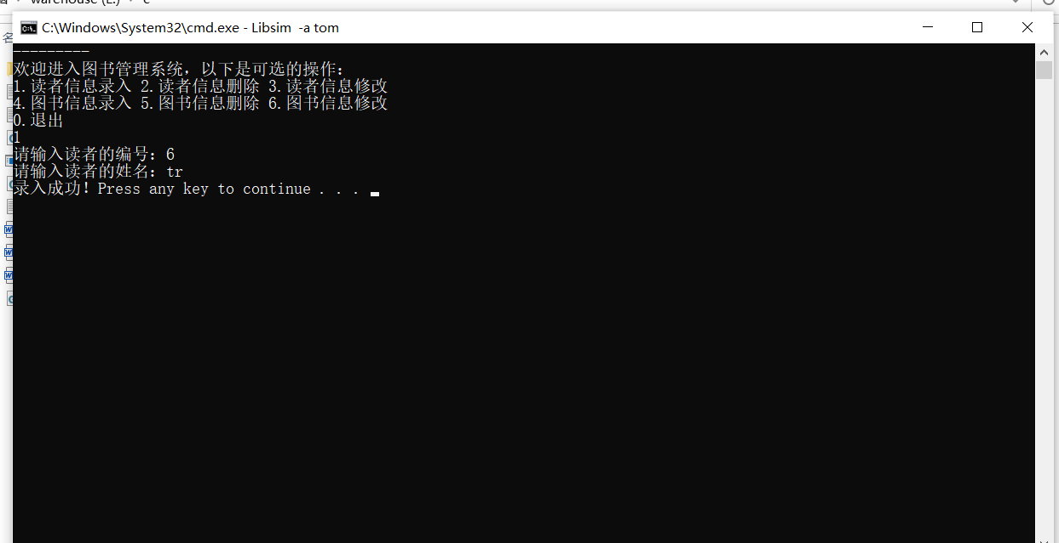
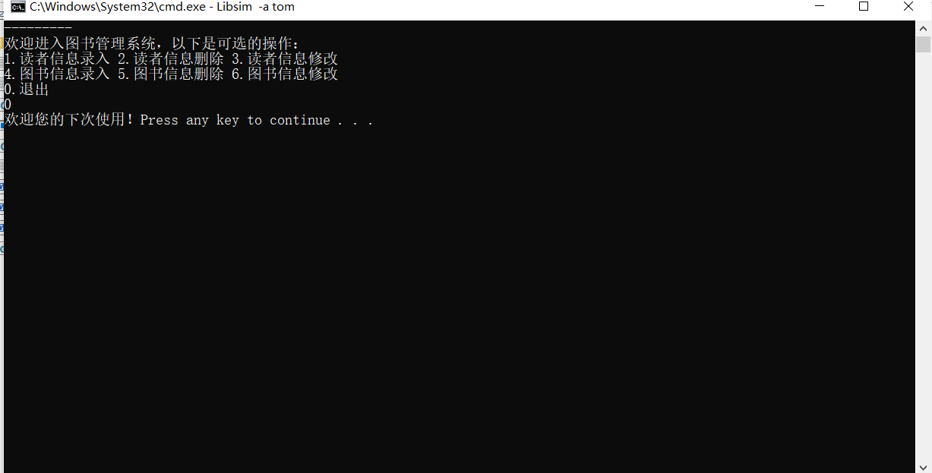
课程设计小结
懂得了如何输入输出数据到文件，并且知道了功能分类，一段代码做一段代码的事。

