CPU Scheduling Simulator — C5
Round Robin vs Shortest Job First (SJF)
Project Description :
This document presents the implementation and comparison of three CPU scheduling algorithms: Round Robin (RR), Shortest Job First (SJF), and Shortest Remaining Time First (SRTF). The project compares all three algorithms using the same workloads and evaluates their performance using scheduling metrics such as Waiting Time (WT), Turnaround Time (TAT), and Response Time (RT).
Team Information :
Name | Id
زياد محمد محمد الراوي سعيد | 20240389
خالد احمد حمدي | 20240321
زياد عمرو جمال | 20240382
شادي عبده محمد عبده | 20240471
علي محمد عبدالسلام عبدالصمد | 20240603
عمر محمد اسامه عبيد | 20240638

Project :
Round Robin (RR):
Round Robin distributes CPU time fairly between processes using a fixed time quantum. Each process receives a small portion of CPU time before the scheduler switches to the next process.
Shortest Job First (SJF):
SJF selects the process with the shortest burst time first. It improves efficiency and usually reduces average waiting time
Shortest Remaining Time First (SRTF):
SRTF is the preemptive version of SJF. It always selects the process with the shortest remaining burst time and can interrupt a running process if a shorter job arrives. This improves response time and reduces waiting time for short processes.
Metrics
- Waiting Time (WT) = Turnaround Time - Burst Time
- Turnaround Time (TAT) = Completion Time - Arrival Time
- Response Time (RT) = First Start Time - Arrival Time
Scenarios
Scenario A — Basic Mixed Workload :
Goal: A normal workload with different arrival times and burst times to establish baseline comparison between RR and SJF.
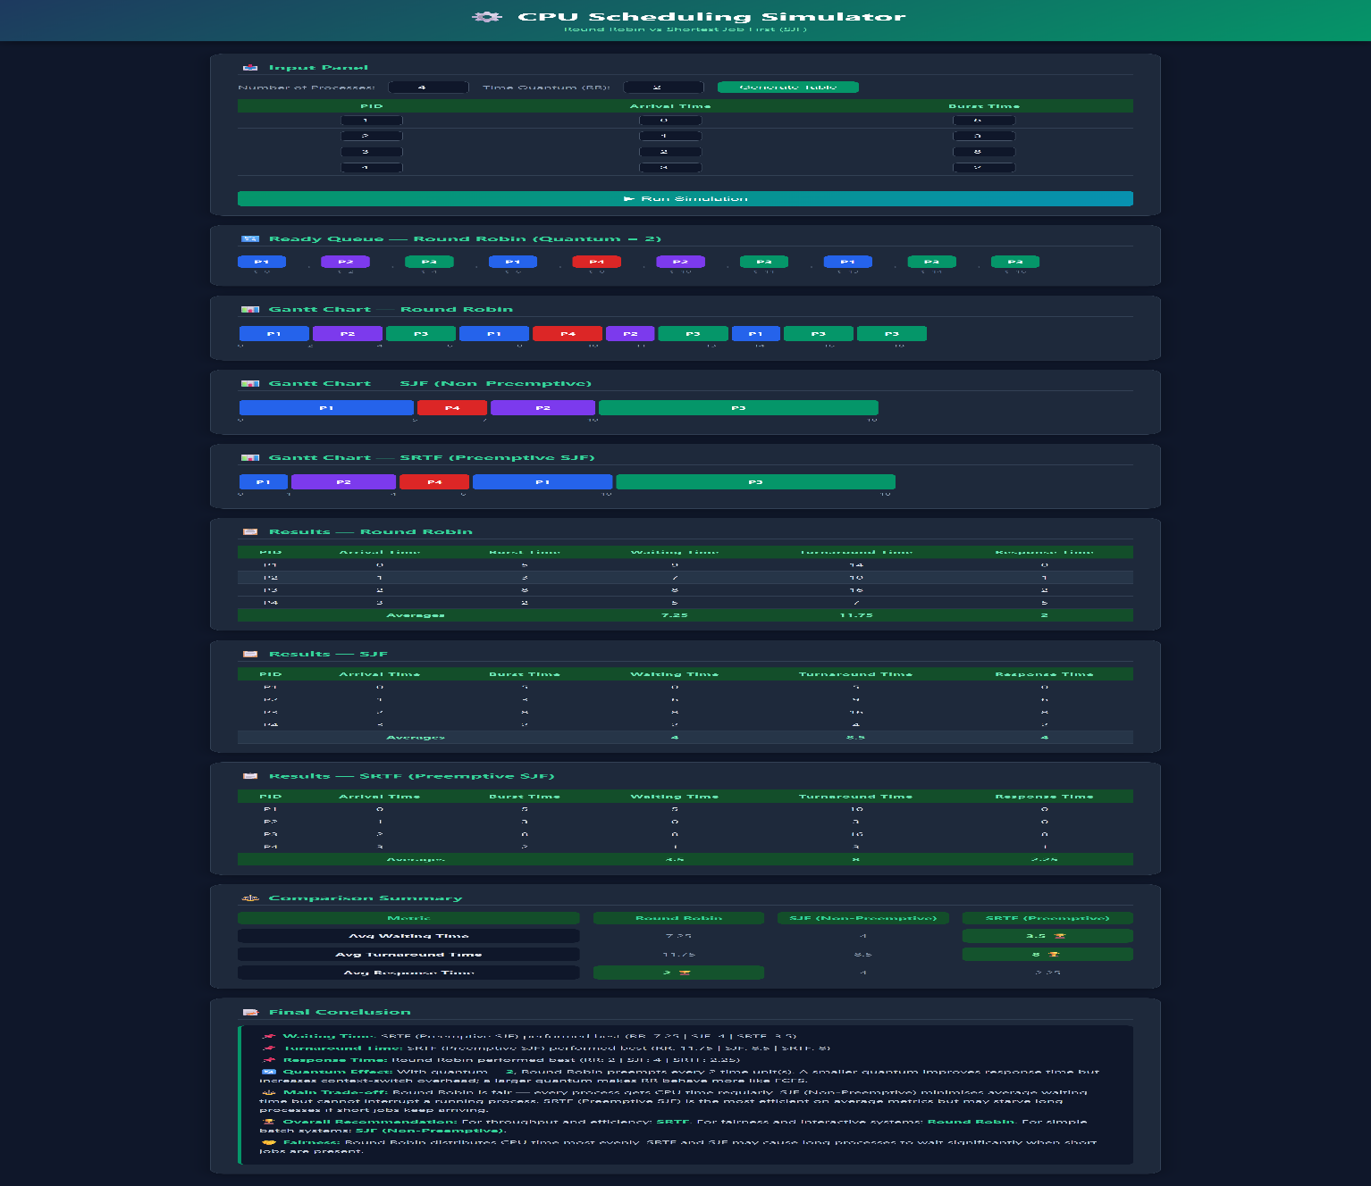
z
Scenario B — Short-Job-Heavy
Goal: Many short jobs so SJF behavior becomes very visible and clearly favors short burst times.
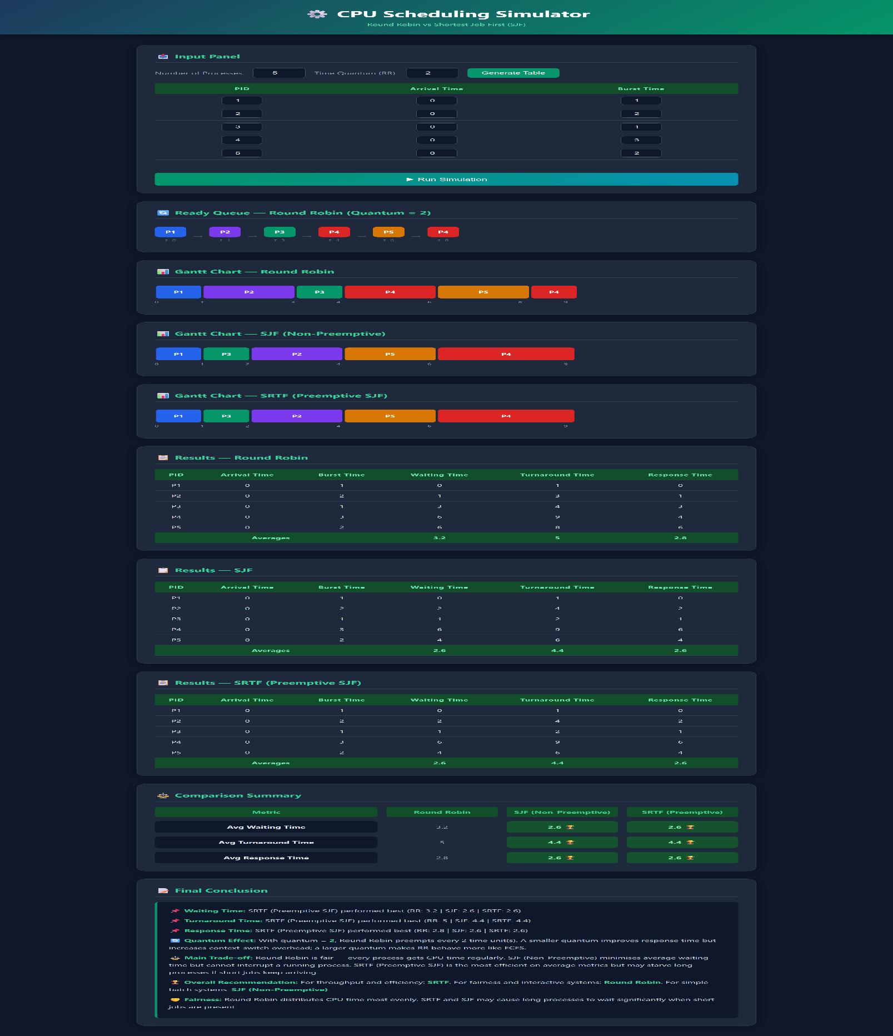
Scenario C — Fairness Case
Goal: Show how Round Robin distributes CPU time more fairly across all processes compared to SJF
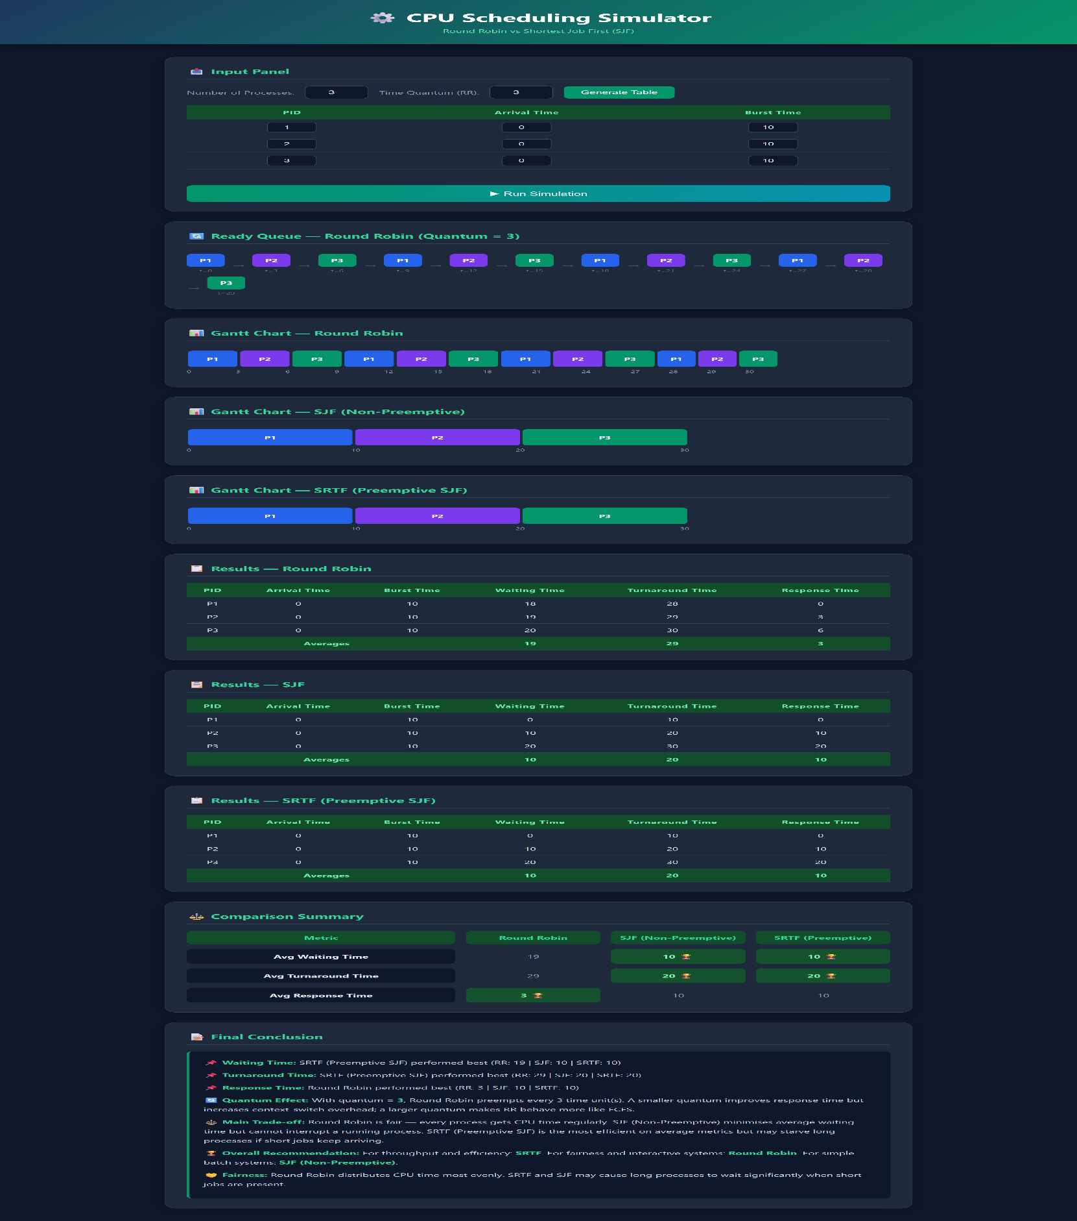
Scenario D — Long-Job Sensitivity
Goal: One long process competes with shorter ones. SJF (non-preemptive) cannot interrupt it, causing unfair delay for short jobs that arrive later.
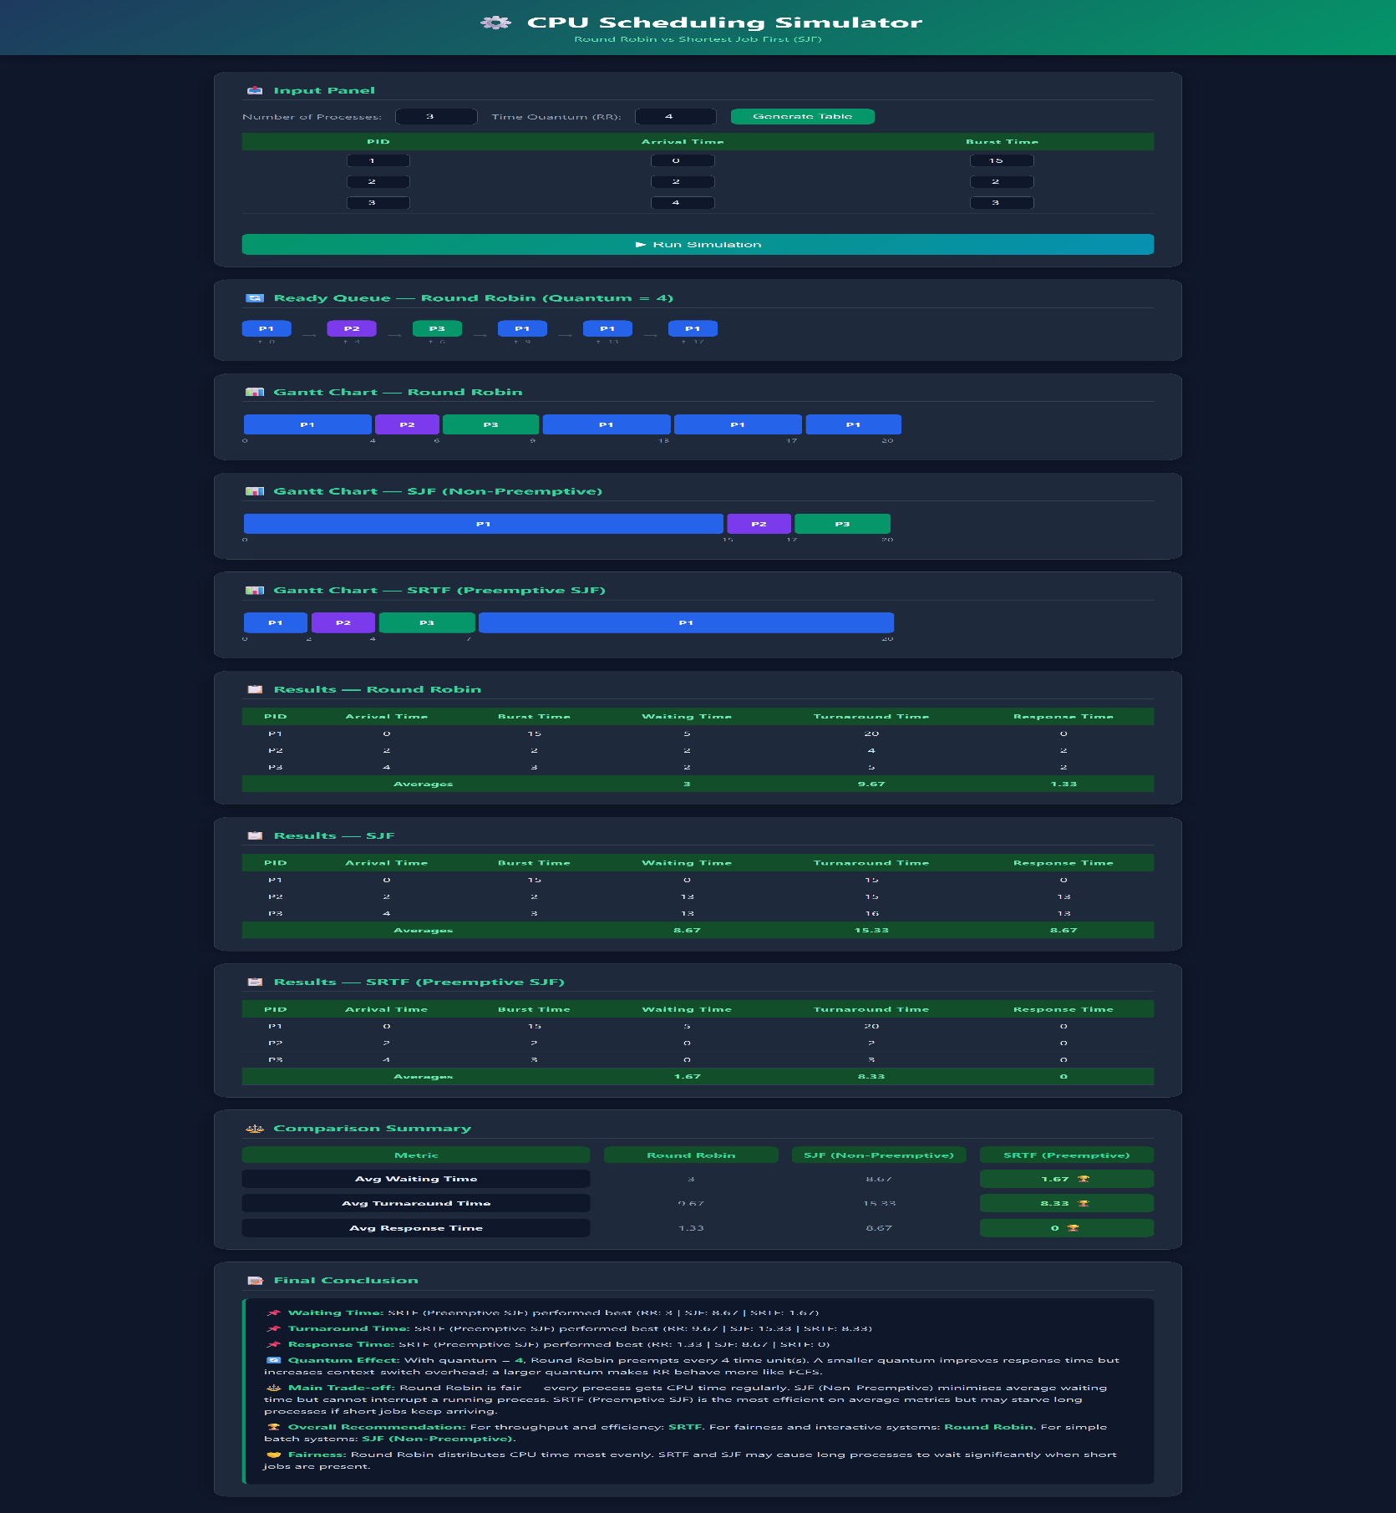
Scenario E — Validation Case
