Nanjing University of Information Science and Technology Laboratory (Internship) Report
Experiment (Internship) Name Software Development Tools Lab 7: Multi-Container Application with Docker Compose Date 2026-11-03 Score Instructor
College Waterford Major Grade Class Name Zhou Haoran Student ID 202583930032
Software Development Tools | Lab 7 | Zhou Haoran | 202583930032 | 2026-11-03
────────────────────────────────────────────────────────────
Nanjing University of Information Science and Technology Laboratory (Internship) Report
Experiment (Internship) Name Software Development Tools Lab 7: Multi-Container Application with Docker Compose Date 2026-11-03 Score Instructor
College Waterford Major Grade Class Name Zhou Haoran Student ID 202583930032
Software Development Tools | Lab 7 | Zhou Haoran | 202583930032 | 2026-11-03

1. Abstract
In this lab I split the containerized calculator of Lab 6 into a real multi-container application. The
single image became two independent services: backend, a Java HTTP API built from the Lab 3-6
calculator code and listening on port 8000, and web, an nginx server that serves the static frontend
and reverse-proxies API calls to the backend. Both services have their own Dockerfile, and a commented
docker-compose.yml declares the two services, their build contexts, the port mappings 8000:8000 and
8080:80, the depends_on relationship, a restart: on-failure policy and LOG_LEVEL / PORT environment
variables. The stack was verified end to end in the browser at http://127.0.0.1:8080, and the GitHub
Actions workflow from Lab 5/6 was extended with a new job that validates docker-compose.yml and runs
docker compose build as a CI gate. The hardest part of the lab was network related: an unstable local
proxy kept resetting TLS connections during image pulls and Maven downloads inside the container, so
the build was made resilient with a Docker Hub mirror image and a retry loop (section 6.3).

2. Introduction
A single container is a good start, but real applications are usually assembled from several small
services that each do one job. Docker Compose describes such an application in one YAML file: every
service has a name, a build context or image, ports, environment variables and relationships to other
services. On docker compose up Compose creates a dedicated bridge network, gives every service a
DNS entry named after the service, and starts the containers in dependency order.
The calculator project is a natural fit for this split. The calculation logic does not need to know
anything about HTML, and the web server does not need a JDK. Splitting them means the frontend can be
scaled or redeployed without rebuilding the Java image, the backend can be reached by other services
later on, and each container ships only what it needs - the backend keeps the multi-stage Maven/JRE
image from Lab 6, the web service is a 50 MB nginx image plus two files.
The key networking rule of this lab: inside the Compose network a service must address the other
service by its service name (backend), never by localhost - localhost inside a container is the
container itself. The browser, however, runs on the host machine, where the name "backend" does not
resolve at all, so the page only uses a relative path and lets nginx do the internal hop
(section 4.5).

3. Environment
Item | Version / Detail
Operating system | Microsoft Windows 11 Home (x64), WSL2 backend
Docker | Docker Desktop 4.96.1, Docker Engine 29.9.2
Docker Compose | Docker Compose v5.6.0 (docker compose plugin)
JDK (local) | OpenJDK 17.0.16, Temurin 17 inside the build image
Backend base images | maven:3.9-eclipse-temurin-17 (build), eclipse-temurin:17-jre-jammy (run)
Web base image | nginx:1.27-alpine (Server header: nginx/1.27.5)
CI runner | GitHub Actions, ubuntu-latest, Docker Buildx

4. Implementation

4.1 Task 1 - Project restructuring
The Lab 6 repository (single folder "calculator") was reorganized into two service directories while
keeping all existing code and tests:
backend/ - pom.xml, config/checkstyle.xml, the complete src/ tree of the calculator
(ApiServer.java added, Main.java extended), settings.xml, .dockerignore and the backend Dockerfile.
web/ - index.html (frontend page), nginx.conf (reverse proxy) and the web Dockerfile.
Repository root - docker-compose.yml, .github/workflows/ci-calculator.yml, BUGS.md, .gitignore.
Figure 1: Repository directory structure after Task 1 - backend/ and web/ directories
with their own Dockerfiles, docker-compose.yml at the repository root.

4.2 Task 2 - backend/Dockerfile (full source, commented)
# ============================================================
# Lab 7 - Dockerfile for the BACKEND service (calculator API)
# Two-stage build, same strategy as Lab 6:
# Stage 1 (build): Maven + JDK compiles the jar
# Stage 2 (run) : lightweight JRE image only runs the jar
# Build context: ./backend (see docker-compose.yml)
# ============================================================
# --- Stage 1: build -----------------------------------------
# FROM: full image with Maven 3.9 and JDK 17, so mvn can run directly.
FROM maven:3.9-eclipse-temurin-17 AS build
# WORKDIR: working directory for every following COPY / RUN.
WORKDIR /app
# COPY: pom.xml first, so the dependency layer stays cached
# as long as the pom does not change.
COPY pom.xml .
# COPY: Maven settings.xml that redirects "central" to the Aliyun mirror,
# because direct access to repo.maven.apache.org is blocked in this network.
COPY settings.xml /root/.m2/settings.xml
# RUN: download all Maven dependencies into this layer (reused cache layer).
# Retry loop: the Docker Desktop proxy in this network resets TLS connections
# intermittently ("Remote host terminated the handshake"), so the command is
# retried up to 40 times; every attempt keeps whatever was already downloaded
# in /root/.m2, so each retry makes progress instead of starting from zero.
RUN i=1; until mvn -B -U dependency:go-offline; do \
i=$((i+1)); \
if [ "$i" -gt 40 ]; then echo "dependency download failed 40 times"; exit 1; fi; \
echo "=== dependency:go-offline failed, retry $i/40 ==="; \
sleep 5; \
done
# COPY: the Java sources, including ApiServer.java (HTTP API) and Main.java.
COPY src ./src
# RUN: compile + package. -DskipTests because CI already runs the tests
# before the image build job starts.
# Same retry loop as above (intermittent TLS resets through the proxy).
RUN i=1; until mvn -B -U clean package -DskipTests; do \
i=$((i+1)); \
if [ "$i" -gt 40 ]; then echo "mvn package failed 40 times"; exit 1; fi; \
echo "=== mvn package failed, retry $i/40 ==="; \
sleep 5; \
done
# --- Stage 2: runtime ---------------------------------------
# FROM: small JRE-only image, no Maven and no sources shipped.
FROM eclipse-temurin:17-jre-jammy
# WORKDIR: working directory of the final image.
WORKDIR /app
# COPY --from=build: take ONLY the packaged jar out of stage 1.
COPY --from=build /app/target/calculator-1.0.0.jar calculator.jar
# EXPOSE: documents that the API listens on port 8000
# (compose maps host 8000 -> container 8000).
EXPOSE 8000
# PORT / LOG_LEVEL: environment variables read by ApiServer;
# values are injected in docker-compose.yml.
ENV PORT=8000 \
LOG_LEVEL=INFO
# ENTRYPOINT: fixed command of the container.
ENTRYPOINT ["java", "-jar", "calculator.jar"]
# CMD: default argument "server" starts the HTTP API instead of the CLI,
# so "docker compose up" brings up the API on port 8000.
CMD ["server"]
The Java side was extended minimally: ApiServer.java starts the JDK built-in
com.sun.net.httpserver on $PORT, exposes GET /health and GET /calc?a=..&op=..&b=.. returning JSON,
adds the CORS headers, and logs one line per request when LOG_LEVEL=DEBUG. Main.java gained a
"server" mode that calls ApiServer.start(port); the Lab 3-6 CLI behaviour and all unit tests are
unchanged.

4.3 Task 2 - web/Dockerfile (full source, commented)
# ============================================================
# Lab 7 - Dockerfile for the WEB service (static frontend)
# Single stage: the official nginx image already contains a web
# server, we only drop in our page and our proxy configuration.
# Build context: ./web (see docker-compose.yml)
# ============================================================
# FROM: official nginx image, runs the web server on port 80.
FROM nginx:1.27-alpine
# WORKDIR: not strictly required, kept for readability.
WORKDIR /usr/share/nginx/html
# COPY: our reverse-proxy config replaces the default nginx site.
# It forwards /api/ to the compose service name "backend" (port 8000).
COPY nginx.conf /etc/nginx/conf.d/default.conf
# COPY: the static calculator page served at http://127.0.0.1:8080.
COPY index.html /usr/share/nginx/html/index.html
# EXPOSE: documents container port 80; compose maps host 8080 -> 80.
EXPOSE 80
# CMD: inherited from the nginx base image (nginx -g 'daemon off;'),
# so no override is needed here.

4.4 Task 3 - docker-compose.yml (full source, commented)
# ============================================================
# Lab 7 - Docker Compose file for the multi-container calculator
# Services: backend (Java API, port 8000) + web (nginx, port 80)
# Run: docker compose up --build
# ============================================================
services:
# --- backend: Java calculator HTTP API --------------------
backend:
# build: compile the image from the local Dockerfile
# (no pull from a registry for our own code).
build:
context: ./backend # build context = backend/ directory
dockerfile: Dockerfile # explicit, the default would also work
image: calculator-backend:lab7 # local tag of the built image
container_name: calc-backend
ports:
- "8000:8000" # host 8000 -> container 8000 (API)
environment:
# Task 3.6 (optional): inject env vars into the container.
# ApiServer reads LOG_LEVEL and prints one line per request at DEBUG.
- LOG_LEVEL=DEBUG
- PORT=8000
restart: on-failure # restart only when the process exits with an error
# --- web: static frontend + reverse proxy ------------------
web:
build:
context: ./web # build context = web/ directory
dockerfile: Dockerfile
image: calculator-web:lab7
container_name: calc-web
ports:
- "8080:80" # host 8080 -> container 80 (nginx)
depends_on:
# web starts after backend has been started (ordering only,
# see Bug record: it does NOT wait for business readiness).
- backend
restart: on-failure
environment:
# Passed to the web container for debugging in docker compose logs.
- ENVIRONMENT=lab7

4.5 Task 2/3 - Cross-service addressing with the service name
The frontend must not write localhost for the backend. The problem is that there are two networks to
think about: the browser runs on the host, the containers run inside the Compose bridge network where
only the service name "backend" resolves. The solution used here has three parts:
/* index.html - browser side: a relative path, no host at all */
const resp = await fetch(`/api/calc?a=${a}&op=${op}&b=${b}`);
# nginx.conf - inside the "web" container: the service name "backend"
location /api/ {
proxy_pass http://backend:8000/; # /api/calc -> http://backend:8000/calc
}
The browser stays on http://127.0.0.1:8080 - no CORS, no DNS problem, no localhost for the API.
nginx resolves backend through Compose's embedded DNS - exactly the required service-name
communication, and it fails fast with "host not found in upstream" if the backend does not exist.
Backend port 8000 is still published for direct testing (Figure 4 / Table 1), while the page only
needs the published 8080.

4.6 Task 5 - Extended GitHub Actions workflow
The Lab 5/6 jobs (JDK 17/21 test matrix, then Docker image build + smoke test) were kept and only
adjusted for the new layout (mvn -f backend/pom.xml, context ./backend), because the Dockerfile moved
into the backend directory. A third job was added:
# ==========================================================
# Lab 7 - Validate the multi-container setup.
# "docker compose build" parses docker-compose.yml and builds
# BOTH images (backend + web). This catches broken YAML and
# broken Dockerfiles before they reach the main branch.
# No long-running "compose up" in CI - build validation only.
# ==========================================================
compose:
name: Docker Compose build
needs: build # run after the unit tests are green
runs-on: ubuntu-latest
steps:
# 1. Checkout gives the runner the complete repository
# (backend/, web/, docker-compose.yml, workflow files).
- name: Checkout source code
uses: actions/checkout@v4
# 2. Validate the compose file syntax first (fails fast on bad YAML)
- name: Validate docker-compose.yml
run: docker compose config --quiet
# 3. Build both service images: this proves the compose file,
# both Dockerfiles and the build contexts are correct.
- name: Build all services
run: docker compose build --pull
# 4. Show what was built (evidence in the CI log)
- name: List built images
run: docker images --format 'table {{.Repository}}\t{{.Tag}}\t{{.Size}}'
Key points: actions/checkout@v4 pulls the complete repository first; docker compose
config --quiet is a pure syntax check of the YAML; docker compose build --pull builds both
service images so a broken compose file or Dockerfile can never reach main; CI does not keep the
stack running, which avoids resource waste and port conflicts on the shared runner.

5. Experimental Results

5.1 Starting the stack
Command: docker compose up --build -d - both images were built locally (build field, no image
pull for our own code) and the default network lab7_project_default was created:
Figure 2: docker compose up --build -d - both images built, network created, calc-backend
and calc-web started.

5.2 docker compose ps
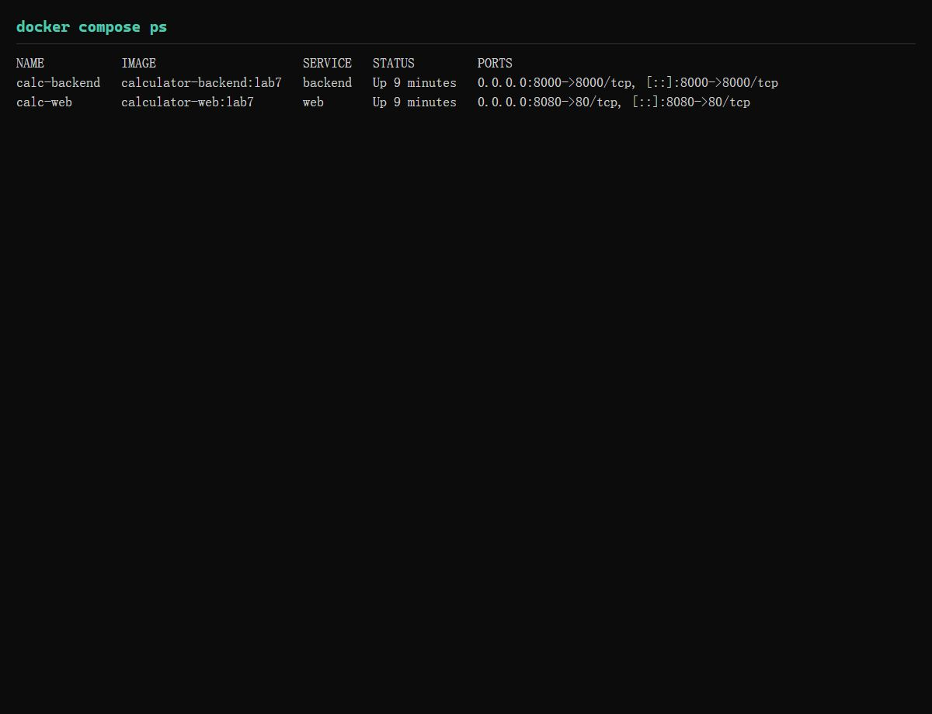

5.3 docker compose logs
The logs prove the environment injection works: the backend runs with LOG_LEVEL=DEBUG from
docker-compose.yml and prints one line per incoming request plus the computed result.
Figure 4: docker compose logs - nginx startup of the web service, backend listening on
8000, DEBUG request traces and results from the API tests.

5.4 API verification
Table 1: every endpoint was called twice - directly on the published backend port and through the
nginx proxy of the web service.
CommandOutputVerdict
GET :8000/health200 {"status":"up"}PASS
GET :8000/calc?a=6&op=*&b=7{"a":6.0,"op":"*","b":7.0,"result":42}PASS
GET :8080/api/calc?a=20&op=/&b=4{"result":5} (nginx -> backend:8000)PASS
GET :8080/api/calc?a=10&op=/&b=0400 {"error":"Division by zero"}PASS
GET :8080/ (frontend)200, index.html 4487 bytesPASS

5.5 End-to-end browser test
http://127.0.0.1:8080 opened the calculator page; two calculations were executed in the browser
(3 + 5 = 8 and 20 / 4 = 5). Both responses show "backend responded with HTTP 200", and the browser
console stayed free of errors, so the full chain browser -> nginx(web) -> backend:8000 works.
Figure 5: Calculator page in the browser performing 20 / 4 = 5, status line "backend
responded with HTTP 200" proves the frontend called the backend API successfully.

5.6 GitHub Actions pipeline
After pushing to main, every run now executes four jobs: "Build and test (JDK 17)", "Build and test
(JDK 21)", "Build Docker image" (unchanged Lab 6 job, now pointing to backend/Dockerfile) and the new
"Docker Compose build" job, which validates docker-compose.yml and builds both images.
Figure 6: Green GitHub Actions run showing all four jobs passed: JDK 17 test, JDK 21 test,
Docker image build, and Docker Compose build.

6. Discussion & Analysis

6.1 One container vs. two containers
Aspect | Lab 6: one container | Lab 7: two containers + Compose
Responsibility | CLI, API and web serving mixed in one image | backend = computation only, web = serving only
Image size | 93 MB JRE image for everything | backend 93 MB + web ~50 MB, but each ships only what it needs
Scaling | Scale everything together | Scale backend and web independently
Networking | Only a single published port | Internal DNS by service name, published ports 8000/8080
Redeployment | Rebuild one image for any change | Frontend changes never rebuild the Java image
Startup | docker run with ad-hoc flags | One declarative docker-compose.yml, repeatable everywhere

6.2 Compose concepts used in this lab
- services / build: both images are built from local contexts (./backend, ./web), so the whole
stack is reproducible from the repository alone.
- Service-name networking: Compose creates one bridge network and registers each service name
as a hostname. nginx uses http://backend:8000; the actual container IP is never hard-coded, so it can
change freely on recreation.
- depends_on: guarantees ordering only - web is created after backend is started, but it does
not wait for the API to be ready to accept connections. For a real deployment a healthcheck
(backend /health endpoint) plus condition: service_healthy would be the next step.
- restart: on-failure: a crashed process is restarted automatically, but healthy services are
not restarted in a loop - appropriate for a lab, unlike restart: always.
- environment: LOG_LEVEL=DEBUG is injected into the backend container and is directly visible
in docker compose logs (Figure 4), which demonstrates out-of-band configuration without rebuilding
the image.

6.3 Problems, debugging and fixes
Problem 1: docker compose build cannot pull the nginx base image.
Symptom: "failed to resolve source metadata for docker.io/library/nginx:1.27-alpine ... connecting via
app settings HTTPS proxy socks5://127.0.0.1:10808: connection refused".
Diagnosis: the error names the proxy, and port 10808 was not listening - v2rayN was not running. After
starting it the error changed to TLS timeouts; curl through the proxy answered baidu (200) but failed
on google/auth.docker.io/registry-1.docker.io, so the proxy node itself was unstable. A DNS check
returned 31.13.86.21 (a Facebook IP) for auth.docker.io, confirming DNS poisoning - a proxy-less pull
could not work either.
Fix: start the proxy and switch to a working node (verified with curl returning 204 for
google.com/generate_204); as a stable fallback the base image was pre-pulled from a Chinese mirror and
tagged as the official name: docker pull docker.1ms.run/library/nginx:1.27-alpine && docker tag
... nginx:1.27-alpine. CI on GitHub runners is unaffected.
Problem 2: Maven downloads inside the backend build fail with TLS resets.
Symptom: "Could not transfer artifact ... Remote host terminated the handshake"; the build died at
RUN mvn dependency:go-offline.
Diagnosis: repo.maven.apache.org is blocked here, so backend/settings.xml redirected "central" to the
Aliyun mirror. That was not enough - transfers still failed intermittently. An isolation test with the
same URL, five attempts each: host direct 5/5 OK, host through the proxy 2/5 OK, inside a container
2/5 OK. The container has no proxy environment variables, yet it fails exactly like a proxied
connection, so Docker Desktop applies its "app settings proxy" transparently to container traffic and
the unstable node resets TLS handshakes. Container DNS and the route table were verified as
correct.
Fix: (1) keep the Aliyun mirror (backend/settings.xml copied to /root/.m2/settings.xml), (2) wrap both
mvn commands in a retry loop of up to 40 attempts - every attempt keeps the artifacts already
downloaded in /root/.m2, so the log shows the number of missing artifacts shrinking each round
(30+ -> 1 -> success). The final docker compose up --build completed with exit code 0.
Problem 3: starting the API locally failed with "could not find main method".
Symptom: java -cp ... calculator.ApiServer returned "错误: 在类 calculator.ApiServer 中找不到 main
方法".
Diagnosis: ApiServer only exposes start(int port); the main method lives in Main, which got the new
"server" mode. The command used the wrong class.
Fix: start it with java -cp ... calculator.Main server; the backend Dockerfile does the same through
CMD ["server"] appended to the ENTRYPOINT.
Design note (the classic trap of this lab): the frontend never addresses the backend with
localhost. localhost in a container is the container itself, and the DNS name "backend" does not exist
on the host, so a browser fetch to http://backend:8000 would fail with ERR_NAME_NOT_RESOLVED. The page
therefore uses the relative path /api/calc and nginx (inside the compose network) performs the hop to
http://backend:8000 - the service name is used exactly where it resolves.

7. Conclusion
This lab turned the calculator from a single container into a small distributed system. I learned how
Compose declares services, build contexts, port mappings, dependency ordering, restart policies and
environment variables in one file; how a service name becomes a DNS entry inside the Compose network;
and why a frontend must never hard-code localhost for another service. The practical verification - up,
ps, logs, direct API calls and two calculations in the browser - shows the whole chain working: browser
-> 8080 -> nginx (web) -> backend:8000 -> JVM calculator.
The main limitation discovered was environmental: an unstable local proxy sat transparently in front
of container traffic and broke image pulls and Maven downloads. The fixes (mirror image, Aliyun Maven
mirror, retry loops) make the build resilient but also show what a production setup should do instead:
use a stable registry cache/mirror, an internal artifact repository, and a healthcheck-based
depends_on so that "started" really means "ready". The next steps would be adding a healthcheck to the
backend service, letting CI run docker compose up plus a curl smoke test, and pushing the images of both
services to a registry from CI.

8. Appendix
- GitHub repository: https://github.com/1zhouhaoran1/Lab7_Project
- Repository layout: /backend (Dockerfile, pom.xml, settings.xml, src/), /web (Dockerfile, index.html,
nginx.conf), /docker-compose.yml, /.github/workflows/ci-calculator.yml
- Bug record: /BUGS.md in the repository (same content as section 6.3)
- Evidence screenshots: /report_figures (Figure 1-5) and /screenshots (raw compose up/ps/logs output
and the browser capture)
- Local commands used: docker compose config --quiet, docker compose up --build -d, docker compose ps,
docker compose logs, docker compose down

