1. Birački spisak - Miki Maus

#include <iostream>

#include <iomanip>

#include <stdlib.h>

#include <string.h>

using namespace std;

void fjaPrva(char \*sp, char \*sn, char \*sg);

#include <iostream>

#include <iomanip>

#include <stdlib.h>

#include <string.h>

using namespace std;

void fjaPrva(char \*sp, char \*sn, char \*sg)

{

int p = strrchr(sp, ' ') - sp;

char s1[50], s2[50];

strcpy(s1, sp + p + 2);

strncpy(s2, sp, p);

s2[p] = '\0';

strcat(s1, " ");

strcat(s1, s2);

strcpy(sn, s1);

strncpy(sg, sn + 3, 3);

sg[3] = '\0';

strcpy(s2, "1");

strcat(s2, sg);

strcpy(sg, s2);

}

#include "Fja.h";

void main()

{

FILE \*fd = fopen("jmbg.txt", "r");

char s[50], sn[50], sg[5];

while (fgets(s, 50, fd))

{

fjaPrva(s, sn, sg);

cout << "\nIzlaz: " << sn << endl;

cout << "\nGodina: " << sg << endl;

}

fclose(fd);

system("pause");

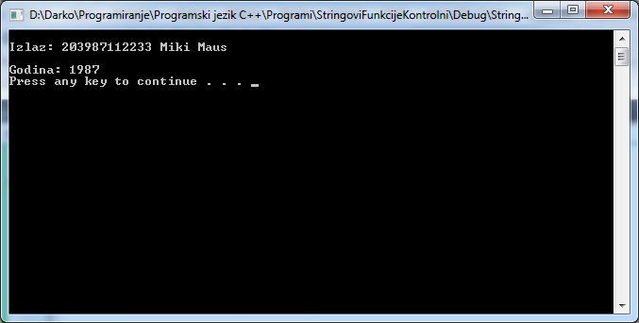}

2. Zdravstvena služba - Nada Macura

void noviDoktor(char \*dok, char \*noviDok)

{

char sif[100], ime[30];

int pp = strrchr(dok,' ')-dok;

strncpy(sif,dok+pp+1,4);

sif[4] = '\0';

strncpy(ime, dok, pp-3);

ime[pp-3] = '\0';

strcat(sif," ");

strcat(sif,ime);

strcpy(noviDok,sif);

}

void main ()

{

FILE \*fd = fopen("Doktor.txt","r");

char s[50], sn[50];

while (fgets(s,50,fd))

{

noviDoktor(s,sn);

cout<<"Izgled novog "<<sn<<endl;

}

fclose (fd);

cout<<"KRAJ!\n\n";

system("pause");

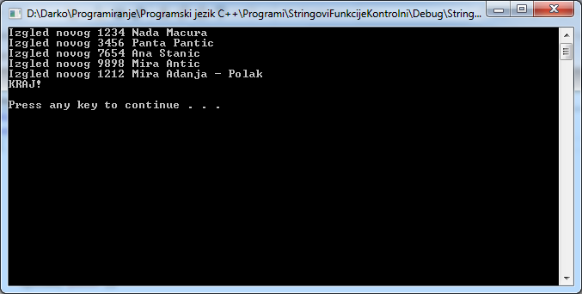}

3. Evidencija robe – IMLEK

void Artikal(char \*Naz, char \*NoviNaz)

{

char Ime[50], Cena[50];

int pp = strrchr(Naz, ' ') - Naz;

strcpy(Cena, Naz + pp);

strncpy(Ime, Naz, 5);

Ime[5] = '\0';

strcat(Ime, " ");

strcat(Ime, Cena);

strcpy(NoviNaz, Ime);

}

void main()

{

FILE \*fd = fopen("Roba.txt", "r");

char s[50], sn[50];

while (fgets(s, 50, fd))

{

Artikal(s, sn);

cout << "Izgled nove evidencije: " << sn << endl;

}

fclose(fd);

cout << "\nKRAJ!\n\n";

system("pause");

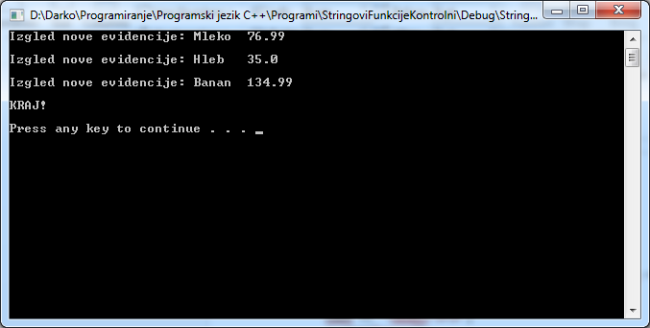}

4. Srednja imena - Tomić I. Aleksandar

void fjaPrva(char \*s, char \*pom)

{

char prezime[50], ime[50], srime[50];

int p = strchr(s, ' ') - s;

strncpy(prezime, s, p);

prezime[p] = '\0';

int p1 = strrchr(s, ' ') - s;

strncpy(ime, s + p1 + 1, p1);

ime[p1] = '\0';

int p2 = strchr(s, '(') - s;

strncpy(srime, s + p2 + 1, 1);

srime[1] = '\0';

strcat(prezime, " ");

strcat(prezime, srime);

strcat(prezime, ". ");

strcat(prezime, ime);

strcpy(pom, prezime);

}

void main()

{

FILE \*fd = fopen("srime.txt", "r");

char s[50], sn[50];

while (fgets(s, 50, fd))

{

fjaPrva(s, sn);

cout << "\nIzlaz: " << sn << endl;

}

fclose(fd);

system("pause");

}

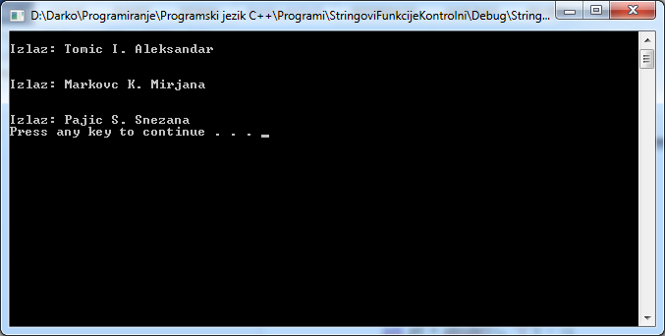

5. Vrtić - Sortiranje

void fjaPrva(char \*s, char \*pom)

{

char godina[50], ime[50];

int p = strrchr(s, ' ') - s;

strncpy(godina, s + p + 1, 4);

godina[4] = '\0';

int p1 = strrchr(s, ' ') - s;

strncpy(ime, s, p1);

ime[p1] = '\0';

strcat(godina, " ");

strcat(godina, ime);

strcpy(pom, godina);

}

void main()

{

FILE \*fd = fopen("vrtic.txt", "r");

char s[4][50], sn[50], pom[50];

int i = 0;

while (fgets(sn, 50, fd))

{

fjaPrva(sn, pom);

strcpy(s[i], pom);

i++;

}

for (i = 0; i<4; i++)

for (int j = 0; j<4; j++)

{

if (strcmp(s[i], s[j])>0)

{

strcpy(sn, s[i]);

strcpy(s[i], s[j]);

strcpy(s[j], sn);

}

}

for (i = 0; i<4; i++)

{

cout << "\nIzlaz: " << s[i] << endl;

}

fclose(fd);

system("pause");

}

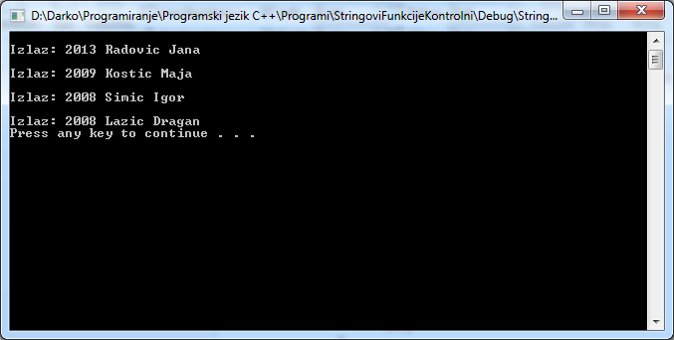

6. Elektrodistribucija - JAT

void fjaPrva(char \*s, char \*pom)

{

char broj[50], ime[50];

int p = strrchr(s, '\*') - s;

strncpy(broj, s + p + 1, 5);

broj[5] = '\0';

int p1 = strrchr(s, ' ') - s;

strncpy(ime, s, p1);

ime[p1] = '\0';

strcat(broj, " ");

strcat(broj, ime);

strcpy(pom, broj);

}

void main()

{

FILE \*fd = fopen("elektrodistribucija.txt", "r");

char s[50], sn[50];

while (fgets(s, 50, fd))

{

fjaPrva(s, sn);

cout << "\nIzlaz: " << sn << endl;

}

fclose(fd);

system("pause");

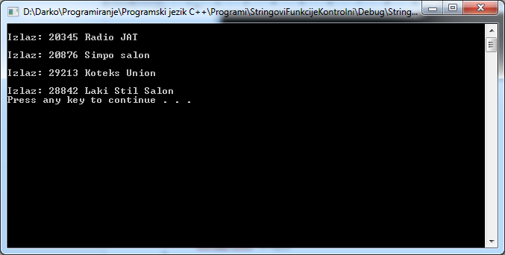}

7. Telefonija - zamena cifara

void fjaPrva (char \*s, char \*pom)

{

char broj[50],ime[50],broj2[50],prazan[40];

int p=strrchr(s,' ')-s;

strncpy(broj,s+p+1,6);

broj[6]='\0';

int p1=strchr(s,' ')-s;

strncpy(ime,s,p);

ime[p]='\0';

if(broj[0]=='3'||broj[0]=='4'||broj[0]=='5')

{

broj[0]='7';

strcat(ime," ");

strcat(ime,broj);

strcpy(pom,ime);

}

else if(broj[0]=='7')

{

strcat(ime," 33");

strcat(ime,broj+1);

strcpy(pom,ime);

}

else

{

strcat(ime," ");

strcat(ime,broj);

strcpy(pom,ime);

}

strcmp(broj,broj+1);

}

void main()

{

FILE \*fd = fopen("brojevi.txt", "r");

char s[50], sn[50];

while (fgets(s, 50, fd))

{

fjaPrva(s, sn);

cout << "\nIzgled novog: " << sn << endl;

}

fclose(fd);

system("pause");

}

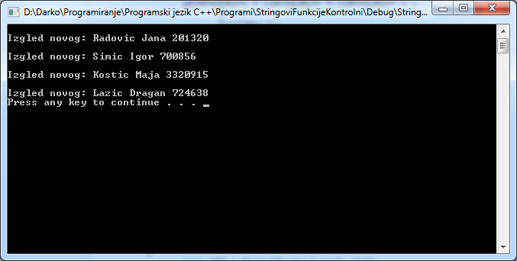

8. Fudbal Rad - Jagodina

int fjaPrva(char \*s,char \*pom)

{

char golDom[50],golGost[50];

int p1=strchr(s,'/')-s;

int p2=strrchr(s,':')-s;

strncpy(golDom,s+p1+1,p2-p1);

strncpy(golGost,s+p2+1,1);

if(golDom[0]>golGost[0])

{

return 1;

}

else if(golDom[0]<golGost[0])

{

return -1;

}

else

{

return 0;

}

}

void main()

{

FILE \*fd = fopen("utakmice.txt", "r");

char s[50], sn[50];

while (fgets(s, 50, fd))

{

if (fjaPrva(s, sn) == 1)

{

cout << "\nDomacin je pobedio!" << endl;

}

else if (fjaPrva(s, sn) == 0)

{

cout << "\nNereseno je!" << endl;

}

else

{

cout << "\nGost je pobedio!" << endl;

}

}

fclose(fd);

system("pause");

}

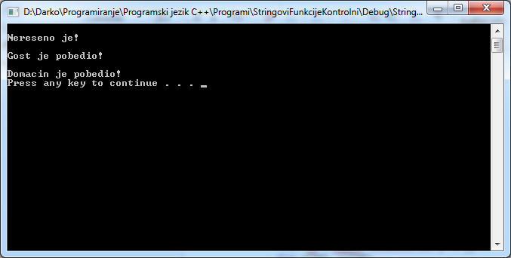

9. Pacijenti u zdravstvenoj službi

void Pacijenti(char \*sp, char \*sn)

{

char BZK[100], IiP[50], SIF[50];

int pp = strrchr(sp, ' ') - sp;

int p = strchr(sp, ' ') - sp;

strcpy(SIF, sp + pp + 2);

strncpy(BZK, sp, p);

BZK[p] = '\0';

strncpy(IiP, sp + p+1, pp - p);

IiP[pp - p] = '\0';

strcat(SIF, " ");

strcat(SIF, IiP);

strcat(SIF, " ");

strcat(SIF, BZK);

strcpy(sn, SIF);

}

void main()

{

FILE \*fd = fopen("Pacijenti.txt", "r");

char s[50], sn[50];

while (fgets(s, 50, fd))

{

Pacijenti(s, sn);

cout << "Izgled nove evidencije: " << sn << endl;

}

fclose(fd);

cout << "\nKRAJ!\n\n";

system("pause");

}

