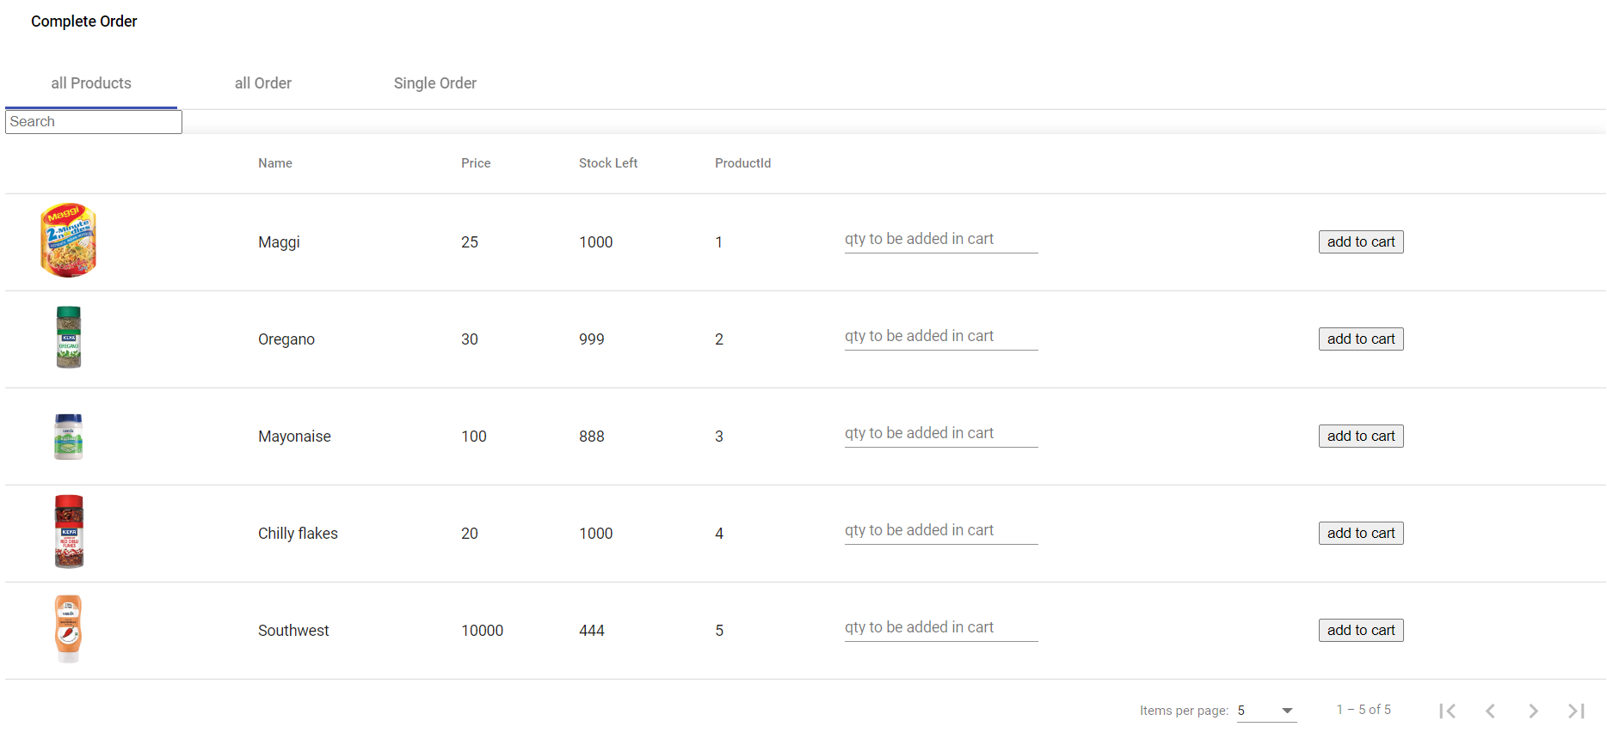

Initial page to add to a order- creates a order and keeps adding to same order till order complete is added

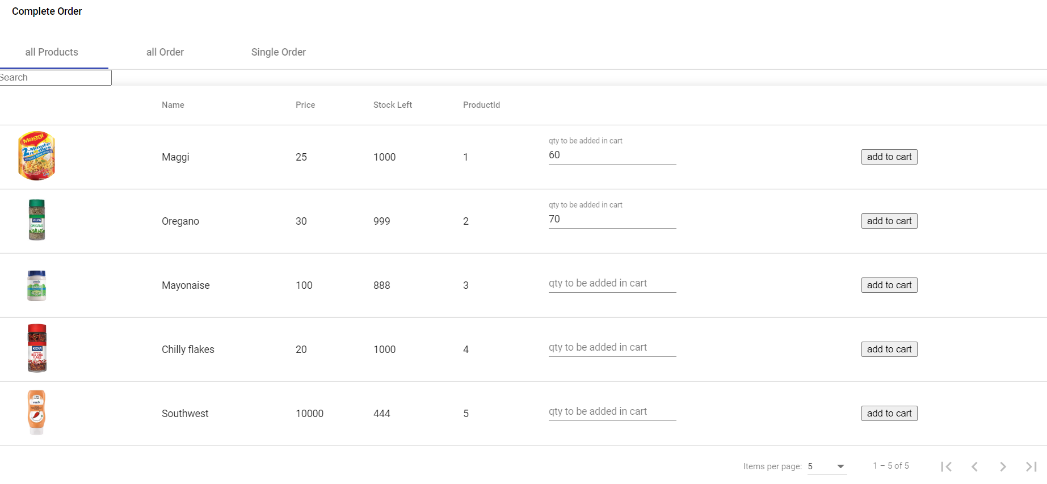

Can fill any value for a single product and it will be added

As of now user id is always send as 1 to backend but it can be configured later if wanted

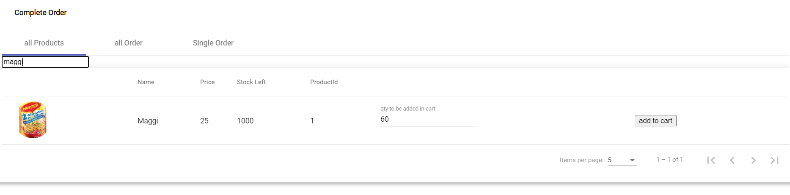

Search for the products work in table

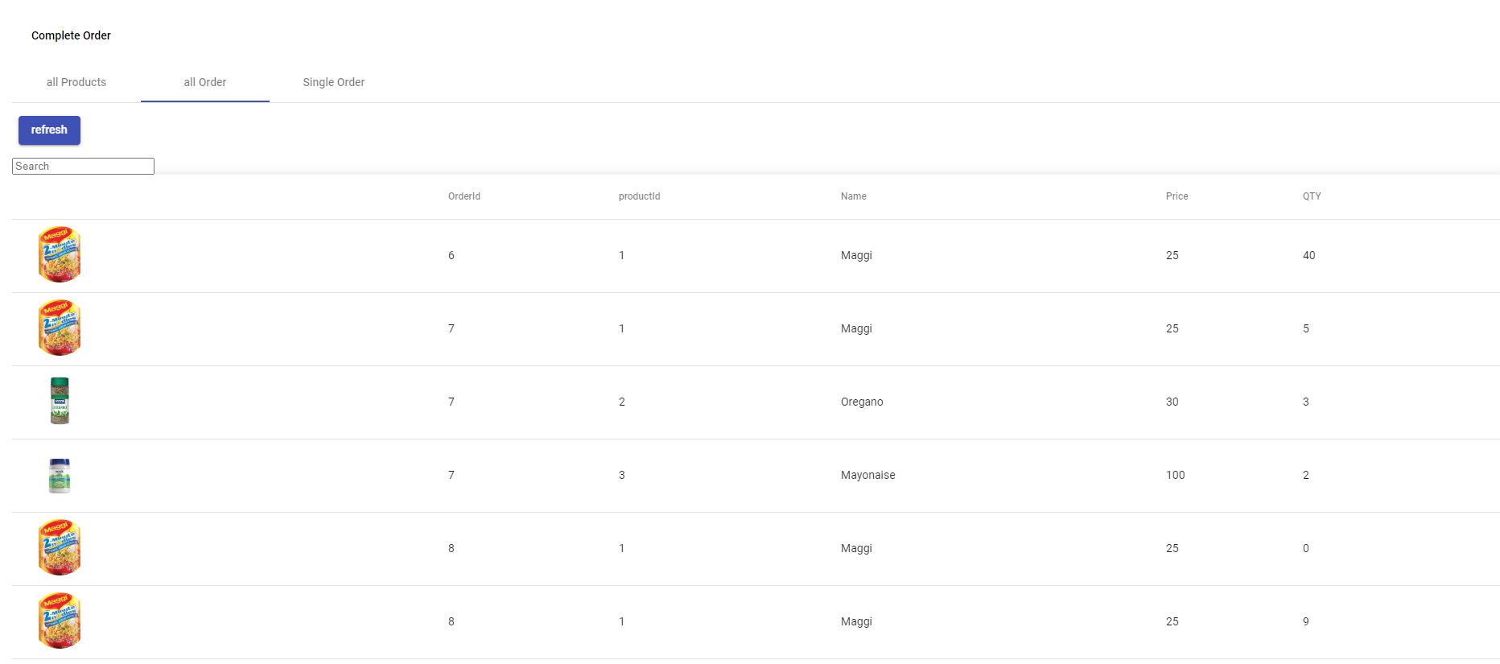

All the orders for user with id 1 can be seen at once in table

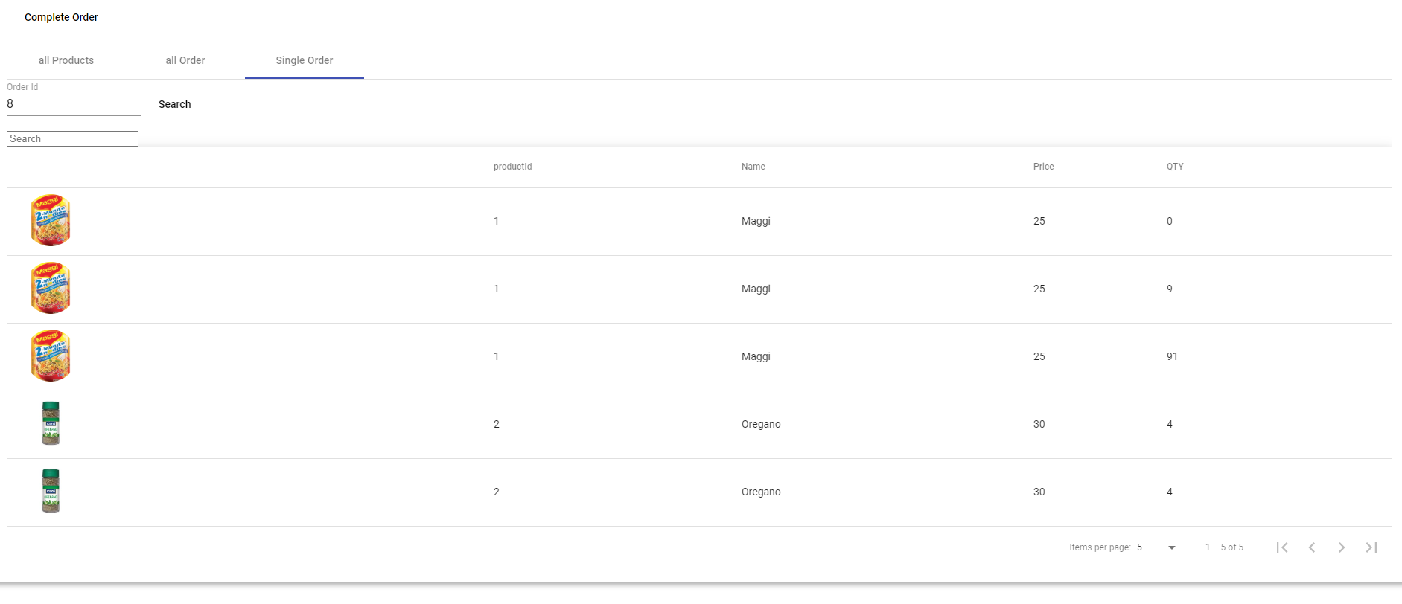

Can also search for orders with a particular id to get the products in that order.

Technology used

1)mySQL database

2) java Spring boot backend

3)angular typescript frontend