## Developer Manual Documentation of Encryption and Decryption of files Project

1. Firstly, u might have **a code editor(intellij or eclipse ide)** and **maria db database server software** and **php**.
2. U must create a databse in your database server.
3. And inside the EncDec folder, u must find application.properties file. Inside this file, u must edit your database setting. According to the following photo, change your database name at ..../EncDec and change your database username and password in the following spring.datasource.username and spring.datasource.password.

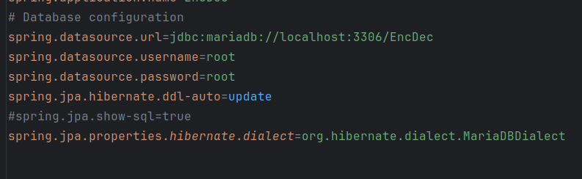

1. Now open your main project folder and go to EncDec folder in Intellij and find the pom.xml file and go and inside this, u must see the button or something at the bottom to ask to install dependencies. So install dependencies.
2. Now u can run the EncDec folder and go to the Frontend folder, open terminal or command prompt inside Frontend folder (Inside Frontend folder, not the main project folder) and run “ php –S localhost:5500 “ . Now u can visit the url “ localhost:5500”.
3. If there is something wrong, u can contact our team.