Student ID: 12876615
Name: KWOK Hiu Lam Queenie

Solution Description

Chosen focus area

MakeArtsFund is a crowdfunding web application designed to support creative arts projects in Australia. The platform connects local artists with supporters who wish to contribute to original artistic work. It is intended to assist artists in raising funds for projects in various categories such as Visual Arts, Handicrafts, 3D Printing, Photography, Music, and Film & Performance. Users can browse campaigns by category and location, helping them discover creative projects in their local communities.

Purpose of the application
Unlike general crowdfunding websites, MakeArtsFund emphasises local creativity and community engagement. The application is designed to assist early-stage artists in developing innovative ideas into viable creative projects. Each campaign displays its associated location and artistic category, allowing supporters to identify projects that are relevant to their interests or communities.

Besides, completed campaigns that achieved their funding goals are presented in a dedicated Success Stories section. This section demonstrates the creative ideas made possible through community support, providing potential supporters with evidence of the platform’s positive impact.

Target audience
The target users of MakeArtsFund are artists located in Australia, supporters of creative projects and platform administrators. Artists use the platform to create campaigns by describing their creative ideas, establishing funding targets and publishing project updates. Supporters use the public interface to browse featured projects, explore specific categories, review detailed project information and contribute to selected campaigns. Administrators operate the platform by approving newly submitted campaigns, managing user accounts, handling reported issues and selecting projects for the featured and Success Stories sections on the Home Page.

Core features of the solution
    - Home Page
The Home Page is the most visually engaging page to attract potential donors to browse and donate. It includes essential components of content they need to understand quickly, such as a navigation bar with a search function, artistic categories, a concise explanation of how the platform operates, featured projects, a Success Stories section, and a footer.

The “How It Works” section explains the platform through three simple steps: Discover, Support, and Create. For the Featured Project section, at least three active projects should be shown. Each project card includes an image, project title, artist name, artistic category, location, funding progress bar and campaign countdown. Visitors should be directed to the Fundraiser Details and Donation Page when selecting the project card.

Another outstanding feature is the Success Stories Session, which should be displayed separately from active projects. Campaigns that achieved their goals are labelled as “Completed”, allowing users to clearly distinguish them from projects that are currently seeking support.
    - Fundraiser Details and Donation Page
The Fundraiser Details and Donation Page shall contain the most comprehensive content of one selected project for donors to review. The page includes the project title, artist name, artistic category, location, project image, fundraising goal, current amount raised, funding progress and campaign countdown.

Additional sections describe the project, introduce the artist, supplement project updates and display supporter messages. Project updates, such as milestones reached and upcoming exhibitions, can demonstrate the creators' ongoing progress. This feature enhances transparency, reinforces trust and encourages continued engagement with the campaign.

A clear call-to-action button, “Fund This Art”, from the Funding Summary section directs users to the donation form. The donation form should request the pledge amount, supporter name, supporter email address and payment method. The payment will be confirmed after the supporter clicks on the “Pay” button in the donation form.

Supporters who wish to leave a message can do so when they complete checkout. It will then be shown in the Supporter Messages section.
    - Campaign Management Page
The campaign management page provides artists with a data-driven and structured dashboard to monitor and maintain their projects. It identifies the selected project and displays key information. The Campaign Overview section illustrates figures and analysis of the specific project, including the funding progress, number of supporters and campaign countdown. Each transaction record is shown in the Recent Donations section for reference. Informative descriptions shown in the Fundraiser Details and Donation Page can be revised by the creators on this page. The project description, self-introduction and project updates are editable. The dashboard provides a clear distinction between the public campaigns interface and private campaign management interface.
    - Administrator Dashboard
The Administrator Dashboard acts as a moderator for the MakeArtsFund admin team to oversee the platform by reviewing platform statistics, approving submitted projects, managing artist and supporter accounts, monitoring reported content, selecting active projects on the Home Page’s Featured Projects section, and showcasing completed campaigns in the Success Stories section.

The Administration Overview section provides cards to illustrate statistics such as the total number of campaigns, creators, supporters and reports for their investigation. The Pending Project Approvals section displays submitted campaigns requiring approval of projects. The Project Management section, showing project name and creator name, allows staff to suspend or delete active projects. The User Management section lists artist and supporter accounts, including their roles, account statuses and controls for editing, approving, suspending or deleting accounts. The Reported Content section identifies reported issues with the reason, reporter information, report submission date and the corresponding review status. Administrators can select active projects featuring on the Home Page in the Featured Projects section and manage completed campaigns displayed as Success Stories. It plays a crucial role in maintaining the quality, safety and visibility of published projects and created accounts in MakeArtsFund.
    - Overall Design and Layout
The visual design of this platform reflects creativity and professionalism by applying a consistent colour palette across all webpages. To stand out for brand recognition, a dark charcoal tone is used for primary text, contrasting with the warm light background. One strong primary colour, such as coral and one secondary colour, such as ash grey, are used for action buttons and highlighted labels. This colour match demonstrates an artistic visual identity while preserving disparity and readability.

Web layout should be consistent and clear across all four pages. The website uses a sans-serif typeface with clear headings to support readability across desktop, tablet and mobile screens. The same navigation bar, footer, button style and typography should be applied on each page. Bootstrap cards, grids and tables are used to structure the interface across diverse screen sizes.

User stories and acceptance criteria

User Story 1

As an administrator, I want to select outstanding art projects on the Home Page so that visitors can immediately spot the one that interests them.

Acceptance Criteria 1

At least three featured projects should be shown per row on large screens in the Featured Projects section on the Home Page.

Projects are displayed as cards on the Home Page.

Each card contains an image, a project name, a creator’s name, a category, a location, a progress bar and a funding countdown on the Home Page.

Direct visitors to the Fundraiser Details and Donation Page by clicking the box on the Home Page.

Add a “Discover More” button so visitors can explore more projects. Add a “Discover More” button for visitors to discover more projects on the Home Page.

Indicate projects that are currently featured in the Featured Projects section on the Administrator Dashboard.

Display project details such as a project name, a creator’s name, a category and a location in the Featured Projects section on the Administrator Dashboard.

Added projects in the Featured Projects section on the Administrator Dashboard are shown in the Featured Projects section on the Home Page.

Removing a featured project does not delete or suspend it.

User Story 2

As a supporter, I want to view successfully funded campaigns so that I can understand the positive impact of community support and feel more confident in funding projects.

Acceptance Criteria 2

Add a Success Stories section on the Home Page.

Display completed projects in the Success Stories section separately from active projects in the Featured Projects section.

Label projects in the Success Stories section as “Completed” to clearly distinguish achieved projects from featured projects.

At least two successfully completed projects should be shown per row on large screens on the Home Page.

Projects are displayed as a card.

Each card contains an image, a project name, a creator’s name, a category, a location and a one-liner description of the project.

User Story 3

As a supporter, I want to browse projects by categories so that I can explore creative artworks which match my interests.

Acceptance Criteria 3

Display categories on the Home Page, such as Visual Arts, Handicrafts, 3D Printing, Photography, Music, and Film & Performance.

Label each category with even spacing.

User Story 4

As a backer, I want to find projects based on the location so that I can support artists in my city.

Acceptance Criteria 4

Display the location in project cards from the Featured Projects section on the Home Page.

Keep showing the location from the Project Overview section on the Fundraiser Details and Donation Page.

Creators should identify the location when creating a new project from the Project Information section on the Campaign Management Page.

User Story 5
As a supporter, I want to review detailed project information, such as project description, fundraising target and project updates with images, so that I can make an informed decision before donating.

Acceptance Criteria 5

Display project information including the project image, project title, name of the creator, category and location on the Fundraiser Details and Donation Page.

Add a Funding Summary section, including the funding progress bar, funds raised, fundraising goal, number of supporters, and campaign countdown on the Fundraiser Details and Donation Page.

Include an “About This Project” section as a project description on the Fundraiser Details and Donation Page.

Include an “About the Artist” section to introduce the artist of the corresponding project on the Fundraiser Details and Donation Page.

Include a Project Updates section to list any upcoming events or milestones made by the creators on the Fundraiser Details and Donation Page.

User Story 6
As a supporter, I want to submit a donation form and leave a supporter message with my donation so that I can contribute to a project idea I appreciate.

Acceptance Criteria 6

Users need to fill in a donation form on the Fundraiser Details and Donation Page.

The donation form requires the donor’s pledge amount, name, email and payment method on the Fundraiser Details and Donation Page.

Insert an eye-catching button “Fund this Art”, directing supporters to the donation form on the Fundraiser Details and Donation Page.

Insert a clear button “Pay” to confirm the payment on the Fundraiser Details and Donation Page.

Allow supporters to leave a message to the creators when submitting the donation form on the Fundraiser Details and Donation Page.

Show messages from the supporters in the Supporter Message section on the Fundraiser Details and Donation Page.

User Story 7
As an artist, I want to update my project information, such as project description, self-introduction, and project updates with images, so that supporters can review the most updated campaign details.

Acceptance Criteria 7

Add an “Edit Project Information” section for creators to edit the project title, category, location, fundraising goal, project description and self-introduction on the Campaign Management Page.

Add a “Save Changes” button to the “Edit Project Information” section on the Campaign Management Page.

Add a “Publish Update” button for creators to publish new project updates on the Campaign Management Page.

Allow creators to review previous project updates on the Campaign Management Page.

Allow creators to upload pictures in the Project Updates section on the Campaign Management Page.

User Story 8
As a creator, I want to review the content of my projects, fundraising progress and supporter messages so that I can access the progress of the project towards the fundraising target.

Acceptance Criteria 8

Allow the creator to select their project with a drop-down menu on the Campaign Management Page.

Show the status of the creator’s selected project on the Campaign Management Page.

Display the total amount raised on the Campaign Management Page.

Display the fundraising goal on the Campaign Management Page.

Calculate and show the percentage of funding achieved in the progress bar on the Campaign Management Page.

Show the number of supporters of the corresponding project on the Campaign Management Page.

Show the campaign countdown on the Campaign Management Page.

Add a Recent Donations section to list recent donation activity, including the supporter’s name, donation date, pledge amount and transaction status on the Campaign Management Page.

Add a Supporter Messages section to show all messages received by the creators from the supporters.

User Story 9
As a MakeArtsFund admin team member, I want to review recently submitted campaigns so that only approved campaigns are published on the platform.

Acceptance Criteria 9

Display the number of active campaigns in the Administration Overview section on the Administrator Dashboard.

Display the number of campaigns pending for the admin team to approve in the Administration Overview section on the Administrator Dashboard.

Add a Pending Project Approvals section to display project information that is pending approval, including project name, creator name, project category, location and project submission date, on the Administrator Dashboard.

Add an “Approve” and a “Reject” button in the Pending Project Approvals section on the Administrator Dashboard.

Add a label showing the number of campaigns pending for the admin team to approve in the Pending Project Approvals section on the Administrator Dashboard.

Add an “Export as Excel” button for the admin team to do easier and further investigation from the database in the Pending Project Approvals section on the Administrator Dashboard.

User Story 10
As an administrator, I want to review reported content submitted by users and control the status of user accounts so that potentially inappropriate content can be banned and removed from the platform.

Acceptance Criteria 10

Display submitted reports in the Reported Content section on the Administrator Dashboard.

Show the reported content, report reason, reporter name, reporter role, report submission date and status in the Reported Content section on the Administrator Dashboard.

Add a “Review” and a “Resolve” button for the administrator to update the corresponding report status in the Reported Content section on the Administrator Dashboard.

Add a label showing the number of reports pending for the admin team to review in the Reported Content section on the Administrator Dashboard.

Add an “Export as Excel” button for the admin team to further investigate the database in the Pending Project Approvals section on the Administrator Dashboard.

Display user names, emails, roles and account statuses in the User Management section on the Administrator Dashboard.

Add “Approve”, “Suspend”, “Delete” and “Edit” buttons for the administrator to update the account status of each user in the User Management section on the Administrator Dashboard.

Conceptual model

Step 1: Identify the nouns
User Story | Nouns
1 | administrator, projects, Home Page, visitor
2 | supporter, campaigns, impact, community support, projects
3 | supporter, projects, categories, artwork, interests
4 | backer, projects, location, artist, city
5 | supporter, project information, project description, fundraising target, project updates, images, decision
6 | supporter, donation form, supporter message, donation, project idea
7 | artist, project information, project description, self-introduction, project updates, images, supporters, campaign details
8 | creator, content, projects, fundraising progress, supporter messages, progress, project, fundraising target
9 | admin team member, campaigns, platform
10 | administrator, reported content, users, user accounts, content, platform

Step 2: Filter the list
Noun | Can this noun exist independently? | Is this already covered by another noun? | Is this noun part of the application? | Decision
user | Yes | No: This is the general term to consolidate all account user roles, including the supporter, artist and administrator. | Yes | Keep
supporter | Yes | No: Only users can make donations | Yes: Supporters submit donations and messages. | Keep
backer | Yes | Yes: A backer is a supporter. | Yes | Eliminate
artist | Yes | No: Only artists can create and management project. | Yes: Artists create, provide and update project details. | Keep
creator | Yes | Yes: A creator is an artist. | Yes | Eliminate
administrator | Yes | No: Only administrators can approve projects and handle reported content. | Yes: Administrators approve campaigns and handle reports. | Keep
MakeArtsFund admin team member | Yes | Yes: A MakeArtsFund admin team member is an administrator. | Yes | Eliminate
project/ art project | Yes | No: Having projects is essential to be created for running a crowdfunding platform. | Yes: Projects are created, reviewed and funded. | Keep
campaign | Yes | Yes: A campaign is a project. | Yes | Eliminate
Home Page | Yes | No | Yes: Although it displays projects, it is an interface, not a class. | Eliminate
impact | No: It describes the outcome of funding a project. | No | No | Eliminate
community support | No: It describes the outcome of funding a project. | No | No | Eliminate
category | Yes | No | Yes: Supporters browse projects by category. | Keep
artwork | Yes | Yes: An artwork is a project. | Yes | Eliminate
interest | No: It describes the preference of a supporter. | No | No | Eliminate
location | No: It is supplementary information for a project. | No | Yes: Location helps supporters to find projects in their community. | Eliminate
city | No: It is supplementary information for a project. | Yes: A city is a location. | Yes: Location helps supporters to find projects in their community. | Eliminate
project information | No: It provides details of a project. | Yes: It can be listed as the attributes of a project. | Yes | Eliminate
project description | No: It provides details of a project. | Yes: A project description is project information. | Yes | Eliminate
fundraising target | No: It is a target for each project to reach. | Yes: It can be listed as the attributes of a project. | Yes | Eliminate
fundraising progress/ progress | No: It is a calculation for a project to achieve the fundraising goal. | Yes: It is derived from the fundraising target. | Yes | Eliminate
project update | Yes | No: It is distinct from the project description. Having a project description may not necessarily have project updates. | Yes | Keep
image | Yes | No: An image is distinct from the text form of a project update. | Yes | Keep
decision | No: It describes the judgement of a supporter. | No | No | Eliminate
donation form | Yes | No | Yes: Although it collects information for the donation, it is an interface, not a domain class. | Eliminate
donation | Yes | No | Yes: Supporters give donations to interested projects. | Keep
supporter message | Yes | No | Yes: Supporters leave messages which can be read by creators. | Keep
project idea | No: It describes the project. | Yes: A project idea is a project description. | Yes | Eliminate
self-introduction | No: It introduces the background of an artist. | Yes: It can be listed as the attributes of a project. | Yes: Artists need to provide their introductions. | Eliminate
campaign details | No: It describes the project. | Yes: Campaign details are project information. | Yes | Eliminate
user accounts | Yes | Yes: The user class indicates the user account and store its details | Yes | Eliminate
content | No: It is a general term for project information. | Yes: It refers to the details, updates, images and donors' messages of a project. | Yes | Eliminate
platform | Yes | No | No: A platform is the application. | Eliminate
reported content | Yes | No | Yes: Administrators review and resolve reported cases. | Keep

Step 3: Draw classes and attributes
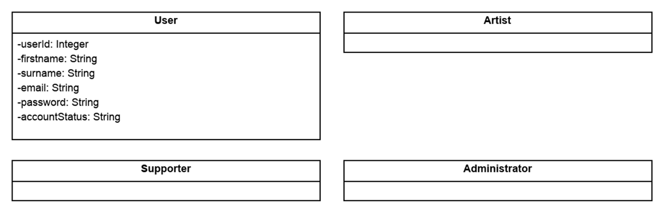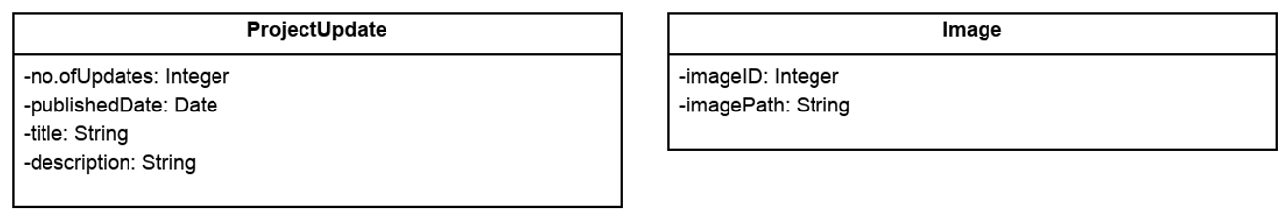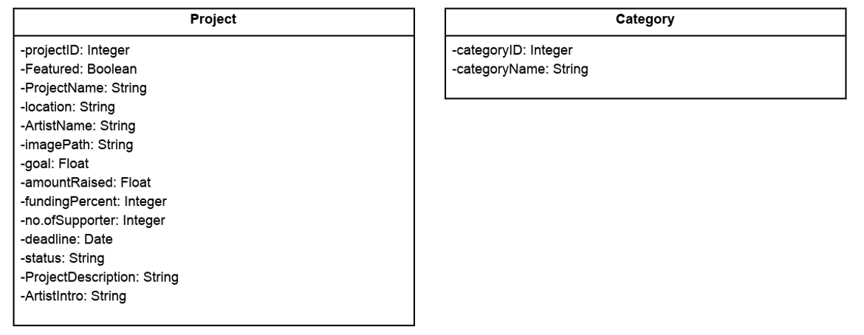
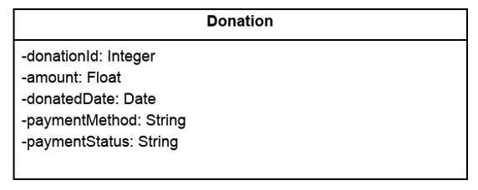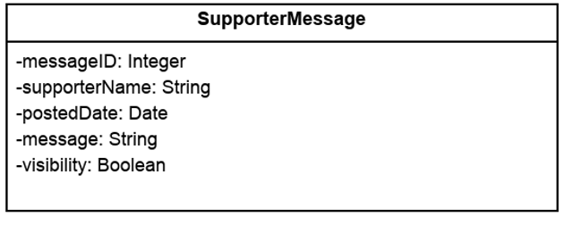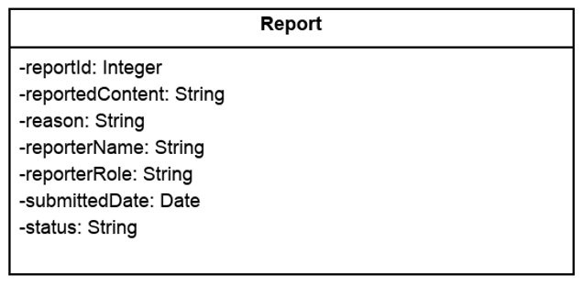

Step 4: Identify operations
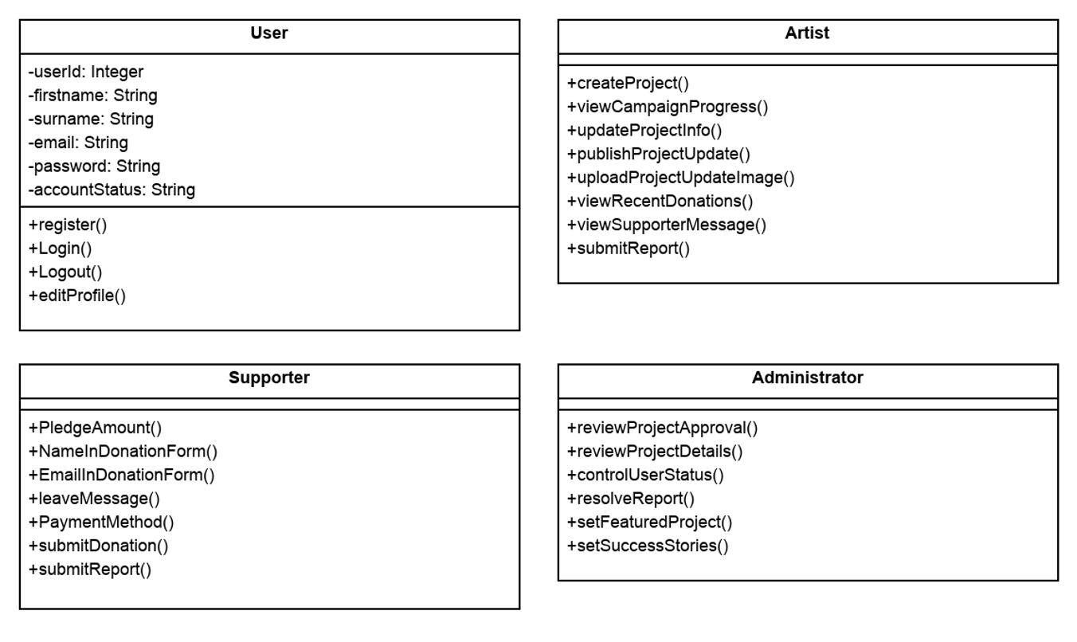
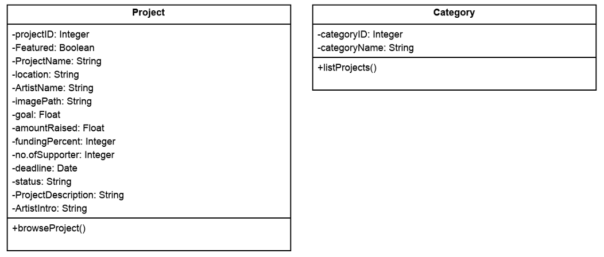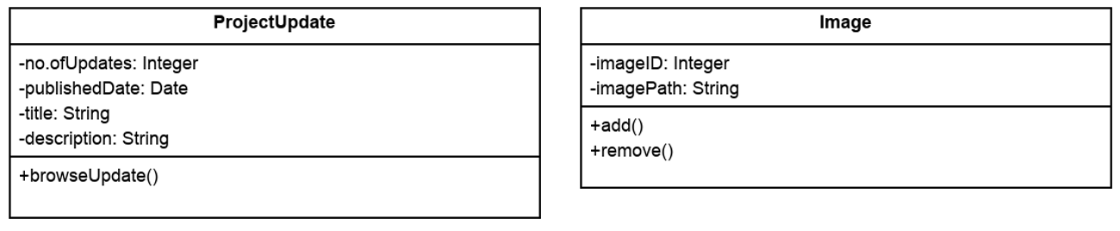
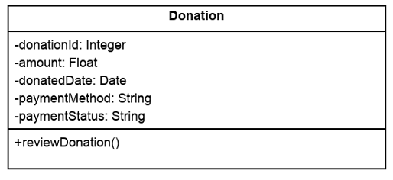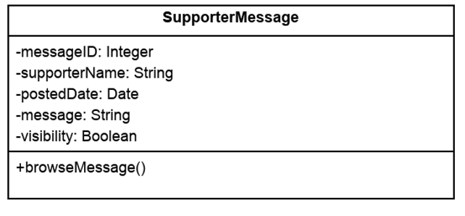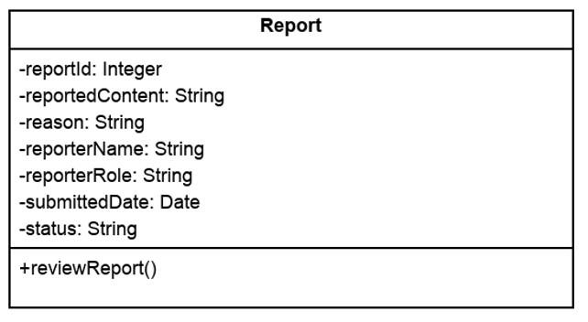

Step 5: Identify relationships
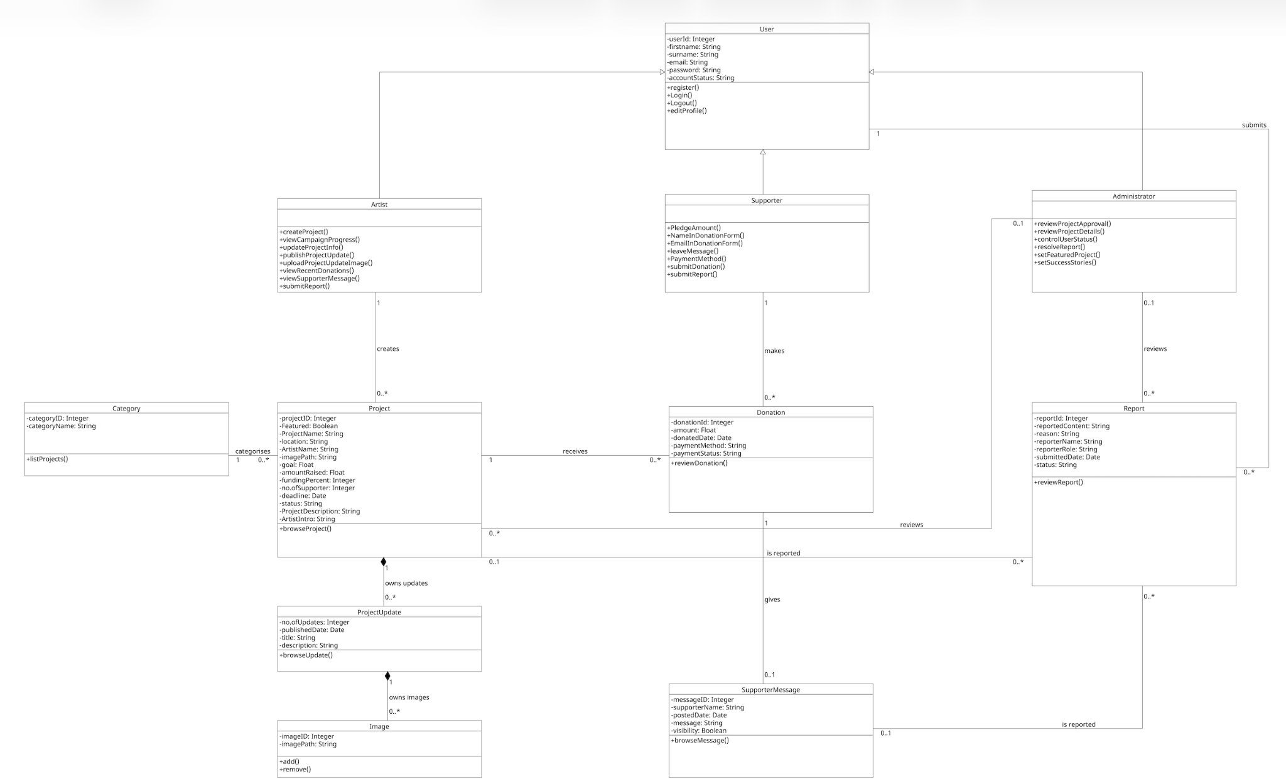

Data model

First normal form (1NF) tables

User
userId [PK] | firstname | surname | email | password | accountStatus
1 | Queenie | Kwok | queenie.work@gmail.com | password1 | Active
2 | Melanie | Brant | m.brant@gmail.com | password2 | Active
3 | M. | Cheung | marcokhc22@gmail.com | password3 | Active
4 | Lily | Cronin | n12345678@qut.edu.au | password4 | Suspended
5 | Kayshay | Smith | kayshay@gmail.com | password5 | Active
6 | Tim | Lee | leetim@gmail.com | password6 | Active
7 | Eloise | Bao | ebao@hotmail.com | password7 | Active
8 | Janet | White | fpwjanet@gmail.com | password8 | Active
9 | Samantha | Robinson | admin2@makeartsfund.com | Password2 | Active
10 | Casey | Bright | admin23@makeartsfund.com | Password23 | Active
11 | Johnathan | Jones | jjones@gmail.com | password9 | Active
12 | Hannah | Brown | hannahbrown@gmail.com | password10 | Active
13 | Maria | Watts | admin13@makeartsfund.com | Password13 | Active
14 | Jayden | Butler | admin14@makeartsfund.com | Password14 | Active
15 | Nina | Burcher | admin15@makeartsfund.com | Password15 | Active
16 | John | Thompson | thomjohn@gmail.com | password11 | Active
17 | Karen | Hack | khacker@gmail.com | password12 | Active

Artist
userId [PK, FK]
1
3
5
6
8

Supporter
userId [PK, FK]
2
4
7
11
12
16
17

Administrator
userId [PK, FK]
9
10
13
14
15

Project
projectID [PK] | creatorID [FK] | categoryID [FK] | ProjectName | location | imagePath | goal | deadline | status | ProjectDescription | ArtistIntro | Featured | SuccessStoryFeatured | reviewerID [FK] | artistName | categoryName
1 | 1 | 2 | janie._.bean | Brisbane | img/janie._.bead.png | 5000 | 23/9/2026 | Active | janie._.bean is a family-based handmade seed bead project run by Janet and Queenie. | For 12 years, I've been making seed beads with my mother, Janet, and now we've decided to take it a step further to janie._.bean. | TRUE | FALSE | 15 | Queenie Kwok | Handicrafts
2 | 3 | 3 | MORY Model Diary | Perth | img/MORY-Model-Diary.png | 6000 | 18/9/2026 | Active | Original 3D printed models. | Makes original printed models for 3 years. | TRUE | FALSE | 13 | M. Cheung | 3D Printing
3 | 5 | 2 | Croshay | Sydney | img/Croshay.png | 8000 | 11/9/2026 | Active | Handmade local crochet accessories. | Design crochet accessories for 8 years. | TRUE | FALSE | 14 | Kayshay Smith | Handicrafts
4 | 6 | 4 | Positioning in Melbourne | Melbourne | img/Positioning-in-Melbourne.png | 4500 | 2/8/2026 | Completed | A photo series retracing postcard images to identify and photograph their exact original locations in Melbourne. | Capture my hometown in Melbourne. | FALSE | TRUE | 10 | Tim Lee | Photography
5 | 8 | 2 | Get Thready | Brisbane | img/Get-Thready.png | 7000 | 12/8/2026 | Completed | Delicate handmade flower accessories crocheted from single strands of embroidery thread. | Makes embroidered flower accessories for 12 years. | FALSE | TRUE | 9 | Janet White | Handicrafts

Category
categoryID [PK] | categoryName
1 | Visual Arts
2 | Handicrafts
3 | 3D Printing
4 | Photography
5 | Music
6 | Film & Performance

ProjectUpdate
updateID [PK] | projectID [FK] | publishedDate | title | description | projectName
1 | 1 | 14/8/2026 | Pop-Up Store in September | We’re excited to announce that janie._.bean is preparing for a pop-up store at Wintergarden, Queen Street Mall, starting from 1 September 2026 for a month. | janie._.bean
2 | 1 | 2/8/2026 | See you at the West End Market this Saturday! | We’re excited to share that we will have a sales booth at the West End Market on 8 August, from 9:00 am to 2:00 pm. | janie._.bean
3 | 2 | 11/8/2026 | Our First Product is Out! | The first printed model is on sale now. | MORY Model Diary
4 | 3 | 7/9/2026 | Halloween crochet series | No tricks but just treats: up to 20% off for the Halloween Series | Croshay
5 | 4 | 20/7/2026 | Upcoming exhibit | The final photo album is ready to exhibit on 30 July | Positioning in Melbourne

Image
imageID [PK] | updateID [FK] | imagePath | title
1 | 1 | updates/store.jpg | Pop-Up Store in September
2 | 1 | updates/storecollection.jpg | Pop-Up Store in September
3 | 2 | updates/market.jpg | See you at the West End Market this Saturday!
4 | 3 | updates/model.jpg | Our First Product is Out!
5 | 4 | updates/crochet.jpg | Halloween crochet series
6 | 5 | updates/photos.jpg | Upcoming exhibit

Donation
donationId [PK] | projectID [FK] | supporterID [FK] | amount | donatedDate | paymentMethod | paymentStatus | projectName | supporterName
1 | 1 | 11 | 200 | 21/8/2026 | Card | Pending | janie._.bean | Johnathan Jones
2 | 1 | 7 | 300 | 14/8/2026 | PayPal | Received | janie._.bean | Eloise Bao
3 | 1 | 12 | 120 | 14/8/2026 | Card | Received | janie._.bean | Hannah Brown
4 | 1 | 16 | 100 | 2/8/2026 | BankTransfer | Received | janie._.bean | John Thompson
5 | 1 | 2 | 500 | 2/8/2026 | Card | Received | janie._.bean | Melanie Brant

SupporterMessage
messageID [PK] | donationId [FK] | postedDate | message | visibility | userId [FK] | supporterName
1 | 1 | 21/8/2026 | Good Work! | FALSE | 11 | Johnathan Jones
2 | 2 | 14/8/2026 | Looking forward to the new collection. | TRUE | 7 | Eloise Bao
3 | 3 | 14/8/2026 | Can't wait to be the first to receive the first model. | TRUE | 12 | Hannah Brown
4 | 4 | 2/8/2026 | FXXXXXX Happy Halloween! | FALSE | 16 | John Thompson
5 | 5 | 2/8/2026 | Such a lovely family-based project. I can’t wait to see your handmade earrings in the market! | TRUE | 2 | Melanie Brant

Report
reportId [PK] | reporterID [FK] | projectID [FK] | messageID [FK] | reportedContent | reason | reporterRole | submittedDate | status | reviewerID [FK] | reporterName
1 | 1 | 2 | NULL | Project image | Copyright of image posted | Artist | 19/8/2026 | Pending | NULL | Queenie Kwok
2 | 5 | NULL | 4 | Supporter messages | Inappropriate language. | Artist | 6/8/2026 | Resolved | 13 | Kayshay Smith
3 | 17 | 3 | NULL | Project description | Misleading information | Supporter | 5/8/2026 | Resolved | 14 | Karen Hack
4 | 12 | 4 | NULL | Content under Project Updates | Disclosure of sensitive personal info | Supporter | 20/7/2026 | Resolved | 10 | Hannah Brown
5 | 2 | 4 | NULL | Project image | Copyright of image posted | Supporter | 21/7/2026 | Resolved | 9 | Melanie Brant

First to second normal form
Having candidate keys with single attributes, all 1NF tables satisfy 2NF. Since there are no partial dependencies, the table structure and data remain unchanged for 2NF.

Second normal form (2NF) tables

User
userId [PK] | firstname | surname | email | password | accountStatus
1 | Queenie | Kwok | queenie.work@gmail.com | password1 | Active
2 | Melanie | Brant | m.brant@gmail.com | password2 | Active
3 | M. | Cheung | marcokhc22@gmail.com | password3 | Active
4 | Lily | Cronin | n12345678@qut.edu.au | password4 | Suspended
5 | Kayshay | Smith | kayshay@gmail.com | password5 | Active
6 | Tim | Lee | leetim@gmail.com | password6 | Active
7 | Eloise | Bao | ebao@hotmail.com | password7 | Active
8 | Janet | White | fpwjanet@gmail.com | password8 | Active
9 | Samantha | Robinson | admin2@makeartsfund.com | Password2 | Active
10 | Casey | Bright | admin23@makeartsfund.com | Password23 | Active
11 | Johnathan | Jones | jjones@gmail.com | password9 | Active
12 | Hannah | Brown | hannahbrown@gmail.com | password10 | Active
13 | Maria | Watts | admin13@makeartsfund.com | Password13 | Active
14 | Jayden | Butler | admin14@makeartsfund.com | Password14 | Active
15 | Nina | Burcher | admin15@makeartsfund.com | Password15 | Active
16 | John | Thompson | thomjohn@gmail.com | password11 | Active
17 | Karen | Hack | khacker@gmail.com | password12 | Active

Artist
userId [PK, FK]
1
3
5
6
8

Supporter
userId [PK, FK]
2
4
7
11
12
16
17

Administrator
userId [PK, FK]
9
10
13
14
15

Project
projectID [PK] | creatorID [FK] | categoryID [FK] | ProjectName | location | imagePath | goal | deadline | status | ProjectDescription | ArtistIntro | Featured | SuccessStoryFeatured | reviewerID [FK] | artistName | categoryName
1 | 1 | 2 | janie._.bean | Brisbane | img/janie._.bead.png | 5000 | 23/9/2026 | Active | janie._.bean is a family-based handmade seed bead project run by Janet and Queenie. | For 12 years, I've been making seed beads with my mother, Janet, and now we've decided to take it a step further to janie._.bean. | TRUE | FALSE | 15 | Queenie Kwok | Handicrafts
2 | 3 | 3 | MORY Model Diary | Perth | img/MORY-Model-Diary.png | 6000 | 18/9/2026 | Active | Original 3D printed models. | Makes original printed models for 3 years. | TRUE | FALSE | 13 | M. Cheung | 3D Printing
3 | 5 | 2 | Croshay | Sydney | img/Croshay.png | 8000 | 11/9/2026 | Active | Handmade local crochet accessories. | Design crochet accessories for 8 years. | TRUE | FALSE | 14 | Kayshay Smith | Handicrafts
4 | 6 | 4 | Positioning in Melbourne | Melbourne | img/Positioning-in-Melbourne.png | 4500 | 2/8/2026 | Completed | A photo series retracing postcard images to identify and photograph their exact original locations in Melbourne. | Capture my hometown in Melbourne. | FALSE | TRUE | 10 | Tim Lee | Photography
5 | 8 | 2 | Get Thready | Brisbane | img/Get-Thready.png | 7000 | 12/8/2026 | Completed | Delicate handmade flower accessories crocheted from single strands of embroidery thread. | Makes embroidered flower accessories for 12 years. | FALSE | TRUE | 9 | Janet White | Handicrafts

Category
categoryID [PK] | categoryName
1 | Visual Arts
2 | Handicrafts
3 | 3D Printing
4 | Photography
5 | Music
6 | Film & Performance

ProjectUpdate
updateID [PK] | projectID [FK] | publishedDate | title | description | projectName
1 | 1 | 14/8/2026 | Pop-Up Store in September | We’re excited to announce that janie._.bean is preparing for a pop-up store at Wintergarden, Queen Street Mall, starting from 1 September 2026 for a month. | janie._.bean
2 | 1 | 2/8/2026 | See you at the West End Market this Saturday! | We’re excited to share that we will have a sales booth at the West End Market on 8 August, from 9:00 am to 2:00 pm. | janie._.bean
3 | 2 | 11/8/2026 | Our First Product is Out! | The first printed model is on sale now. | MORY Model Diary
4 | 3 | 7/9/2026 | Halloween crochet series | No tricks but just treats: up to 20% off for the Halloween Series | Croshay
5 | 4 | 20/7/2026 | Upcoming exhibit | The final photo album is ready to exhibit on 30 July | Positioning in Melbourne

Image
imageID [PK] | updateID [FK] | imagePath | title
1 | 1 | updates/store.jpg | Pop-Up Store in September
2 | 1 | updates/storecollection.jpg | Pop-Up Store in September
3 | 2 | updates/market.jpg | See you at the West End Market this Saturday!
4 | 3 | updates/model.jpg | Our First Product is Out!
5 | 4 | updates/crochet.jpg | Halloween crochet series
6 | 5 | updates/photos.jpg | Upcoming exhibit

Donation
donationId [PK] | projectID [FK] | supporterID [FK] | amount | donatedDate | paymentMethod | paymentStatus | projectName | supporterName
1 | 1 | 11 | 200 | 21/8/2026 | Card | Pending | janie._.bean | Johnathan Jones
2 | 1 | 7 | 300 | 14/8/2026 | PayPal | Received | janie._.bean | Eloise Bao
3 | 1 | 12 | 120 | 14/8/2026 | Card | Received | janie._.bean | Hannah Brown
4 | 1 | 16 | 100 | 2/8/2026 | BankTransfer | Received | janie._.bean | John Thompson
5 | 1 | 2 | 500 | 2/8/2026 | Card | Received | janie._.bean | Melanie Brant

SupporterMessage
messageID [PK] | donationId [FK] | postedDate | message | visibility | userId [FK] | supporterName
1 | 1 | 21/8/2026 | Good Work! | FALSE | 11 | Johnathan Jones
2 | 2 | 14/8/2026 | Looking forward to the new collection. | TRUE | 7 | Eloise Bao
3 | 3 | 14/8/2026 | Can't wait to be the first to receive the first model. | TRUE | 12 | Hannah Brown
4 | 4 | 2/8/2026 | FXXXXXX Happy Halloween! | FALSE | 16 | John Thompson
5 | 5 | 2/8/2026 | Such a lovely family-based project. I can’t wait to see your handmade earrings in the market! | TRUE | 2 | Melanie Brant

Report
reportId [PK] | reporterID [FK] | projectID [FK] | messageID [FK] | reportedContent | reason | reporterRole | submittedDate | status | reviewerID [FK] | reporterName
1 | 1 | 2 | NULL | Project image | Copyright of image posted | Artist | 19/8/2026 | Pending | NULL | Queenie Kwok
2 | 5 | NULL | 4 | Supporter messages | Inappropriate language. | Artist | 6/8/2026 | Resolved | 13 | Kayshay Smith
3 | 17 | 3 | NULL | Project description | Misleading information | Supporter | 5/8/2026 | Resolved | 14 | Karen Hack
4 | 12 | 4 | NULL | Content under Project Updates | Disclosure of sensitive personal info | Supporter | 20/7/2026 | Resolved | 10 | Hannah Brown
5 | 2 | 4 | NULL | Project image | Copyright of image posted | Supporter | 21/7/2026 | Resolved | 9 | Melanie Brant

Second to third normal form
By removing transitive dependencies, the 2NF tables are refined to 3NF tables, as shown below. Each non-key attribute depends on the primary key or other non-key attributes. Repeated names and titles will be removed in 3NF. Foreign keys (FK) help retrieve the joint information in order to reduce duplication of data and prevent inconsistent updates.

Third normal form (3NF) tables

User
userId [PK] | firstname | surname | email | password | accountStatus
1 | Queenie | Kwok | queenie.work@gmail.com | password1 | Active
2 | Melanie | Brant | m.brant@gmail.com | password2 | Active
3 | M. | Cheung | marcokhc22@gmail.com | password3 | Active
4 | Lily | Cronin | n12345678@qut.edu.au | password4 | Suspended
5 | Kayshay | Smith | kayshay@gmail.com | password5 | Active
6 | Tim | Lee | leetim@gmail.com | password6 | Active
7 | Eloise | Bao | ebao@hotmail.com | password7 | Active
8 | Janet | White | fpwjanet@gmail.com | password8 | Active
9 | Samantha | Robinson | admin2@makeartsfund.com | Password2 | Active
10 | Casey | Bright | admin23@makeartsfund.com | Password23 | Active
11 | Johnathan | Jones | jjones@gmail.com | password9 | Active
12 | Hannah | Brown | hannahbrown@gmail.com | password10 | Active
13 | Maria | Watts | admin13@makeartsfund.com | Password13 | Active
14 | Jayden | Butler | admin14@makeartsfund.com | Password14 | Active
15 | Nina | Burcher | admin15@makeartsfund.com | Password15 | Active
16 | John | Thompson | thomjohn@gmail.com | password11 | Active
17 | Karen | Hack | khacker@gmail.com | password12 | Active

Artist
userId [PK, FK]
1
3
5
6
8

Supporter
userId [PK, FK]
2
4
7
11
12
16
17

Administrator
userId [PK, FK]
9
10
13
14
15

Project
projectID [PK] | creatorID [FK] | categoryID [FK] | ProjectName | location | imagePath | goal | deadline | status | ProjectDescription | ArtistIntro | Featured | SuccessStoryFeatured | reviewerID [FK]
1 | 1 | 2 | janie._.bean | Brisbane | img/janie._.bead.png | 5000 | 23/9/2026 | Active | janie._.bean is a family-based handmade seed bead project run by Janet and Queenie. | For 12 years, I've been making seed beads with my mother, Janet, and now we've decided to take it a step further to janie._.bean. | TRUE | FALSE | 15
2 | 3 | 3 | MORY Model Diary | Perth | img/MORY-Model-Diary.png | 6000 | 18/9/2026 | Active | Original 3D printed models. | Makes original printed models for 3 years. | TRUE | FALSE | 13
3 | 5 | 2 | Croshay | Sydney | img/Croshay.png | 8000 | 11/9/2026 | Active | Handmade local crochet accessories. | Design crochet accessories for 8 years. | TRUE | FALSE | 14
4 | 6 | 4 | Positioning in Melbourne | Melbourne | img/Positioning-in-Melbourne.png | 4500 | 2/8/2026 | Completed | A photo series retracing postcard images to identify and photograph their exact original locations in Melbourne. | Capture my hometown in Melbourne. | FALSE | TRUE | 10
5 | 8 | 2 | Get Thready | Brisbane | img/Get-Thready.png | 7000 | 12/8/2026 | Completed | Delicate handmade flower accessories crocheted from single strands of embroidery thread. | Makes embroidered flower accessories for 12 years. | FALSE | TRUE | 9

Category
categoryID [PK] | categoryName
1 | Visual Arts
2 | Handicrafts
3 | 3D Printing
4 | Photography
5 | Music
6 | Film & Performance

ProjectUpdate
updateID [PK] | projectID [FK] | publishedDate | title | description
1 | 1 | 14/8/2026 | Pop-Up Store in September | We’re excited to announce that janie._.bean is preparing for a pop-up store at Wintergarden, Queen Street Mall, starting from 1 September 2026 for a month.
2 | 1 | 2/8/2026 | See you at the West End Market this Saturday! | We’re excited to share that we will have a sales booth at the West End Market on 8 August, from 9:00 am to 2:00 pm.
3 | 2 | 11/8/2026 | Our First Product is Out! | The first printed model is on sale now.
4 | 3 | 7/9/2026 | Halloween crochet series | No tricks but just treats: up to 20% off for the Halloween Series
5 | 4 | 20/7/2026 | Upcoming exhibit | The final photo album is ready to exhibit on 30 July

Image
imageID [PK] | updateID | imagePath
1 | 1 | updates/store.jpg
2 | 1 | updates/storecollection.jpg
3 | 2 | updates/market.jpg
4 | 3 | updates/model.jpg
5 | 4 | updates/crochet.jpg
6 | 5 | updates/photos.jpg

Donation
donationId [PK] | projectID [FK] | supporterID [FK] | amount | donatedDate | paymentMethod | paymentStatus
1 | 1 | 11 | 200 | 21/8/2026 | Card | Pending
2 | 1 | 7 | 300 | 14/8/2026 | PayPal | Received
3 | 1 | 12 | 120 | 14/8/2026 | Card | Received
4 | 1 | 16 | 100 | 2/8/2026 | BankTransfer | Received
5 | 1 | 2 | 500 | 2/8/2026 | Card | Received

SupporterMessage
messageID [PK] | donationId [FK] | postedDate | message | visibility
1 | 1 | 21/8/2026 | Good Work! | FALSE
2 | 2 | 14/8/2026 | Looking forward to the new collection. | TRUE
3 | 3 | 14/8/2026 | Can't wait to be the first to receive the first model. | TRUE
4 | 4 | 2/8/2026 | FXXXXXX Happy Halloween! | FALSE
5 | 5 | 2/8/2026 | Such a lovely family-based project. I can’t wait to see your handmade earrings in the market! | TRUE

Report
reportId [PK] | reporterID [FK] | projectID [FK] | messageID [FK] | reportedContent | reason | reporterRole | submittedDate | status | reviewerID [FK]
1 | 1 | 2 | NULL | Project image | Copyright of image posted | Artist | 19/8/2026 | Pending | NULL
2 | 5 | NULL | 4 | Supporter messages | Inappropriate language. | Artist | 6/8/2026 | Resolved | 13
3 | 17 | 3 | NULL | Project description | Misleading information | Supporter | 5/8/2026 | Resolved | 14
4 | 12 | 4 | NULL | Content under Project Updates | Disclosure of sensitive personal info | Supporter | 20/7/2026 | Resolved | 10
5 | 2 | 4 | NULL | Project image | Copyright of image posted | Supporter | 21/7/2026 | Resolved | 9

Finalised data model in 3NF
