Student name: Jishan Ferdows Navil

Id: 20-42544-1

Section: CVPR[C]

1. Importing libraries and loading the dataset in plot

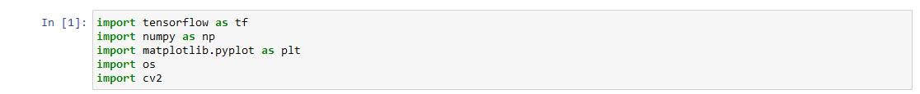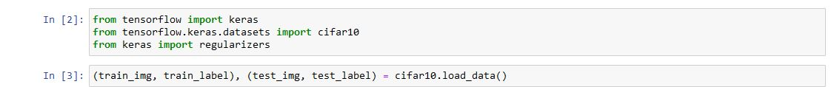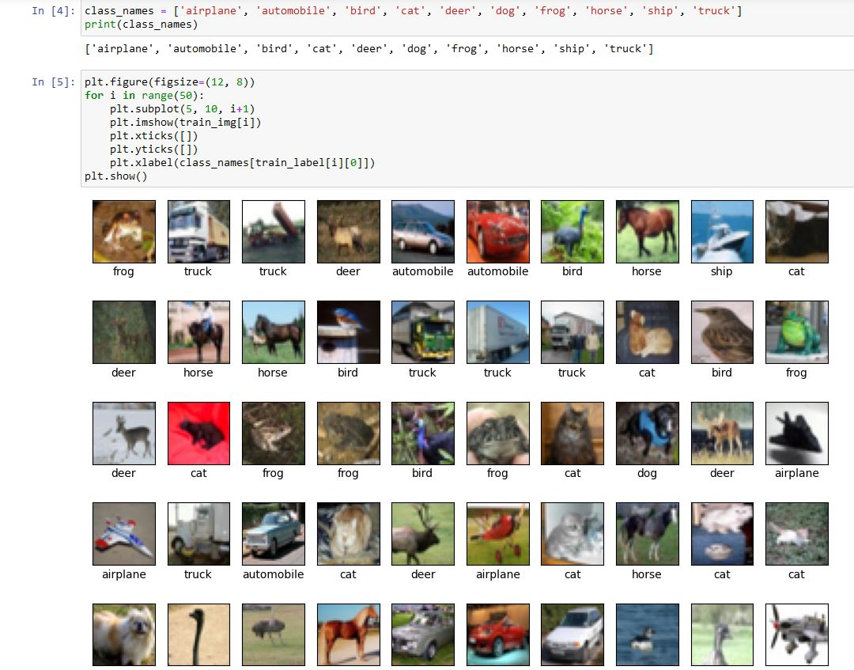

1. Building the model

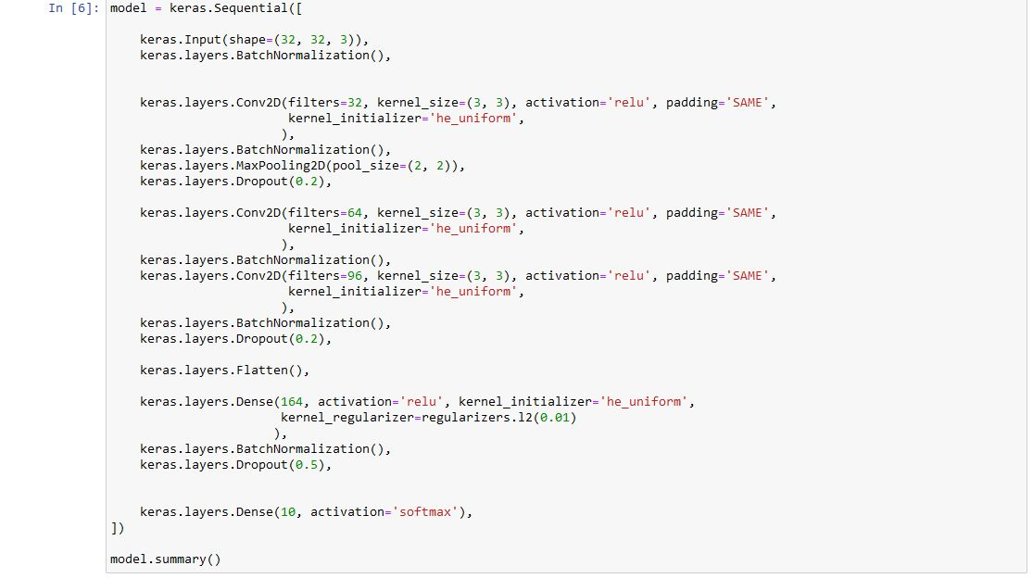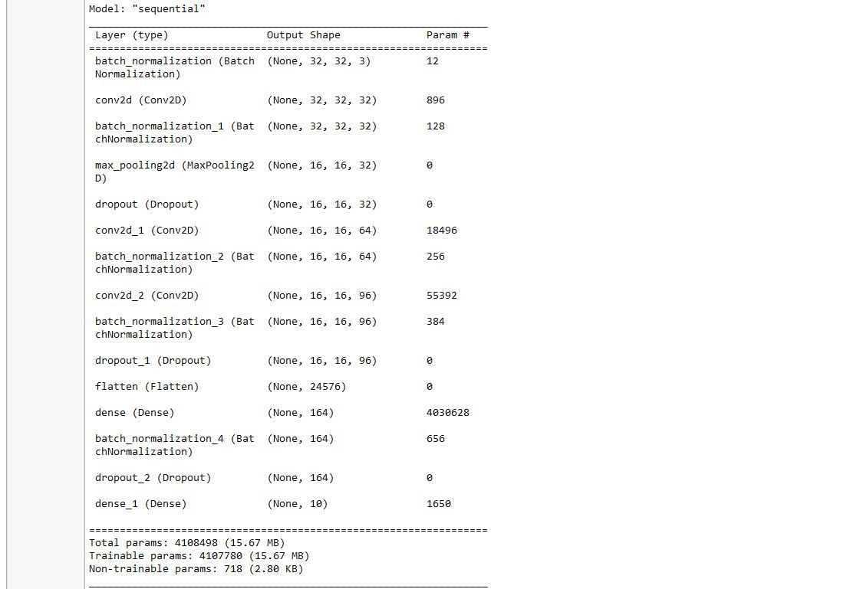

1. Getting the accuracy and performance for SGD optimizer

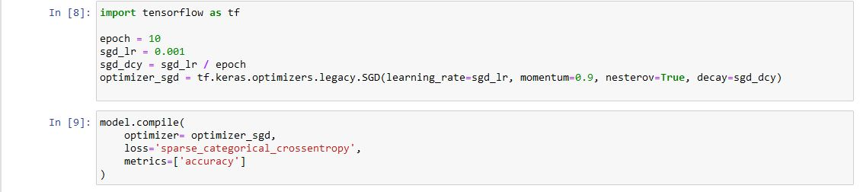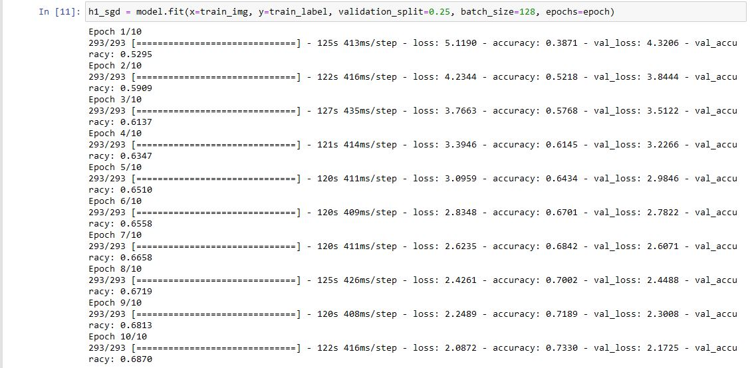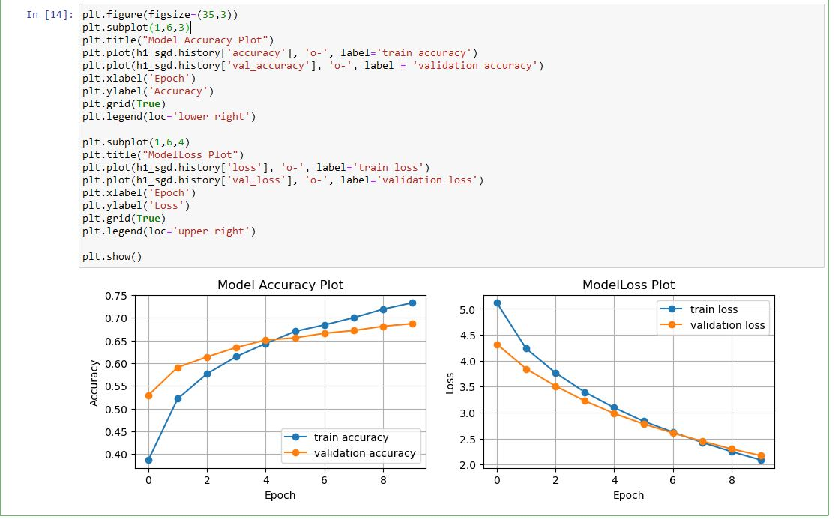

1. Getting the accuracy and performance for RMSProp optimizer

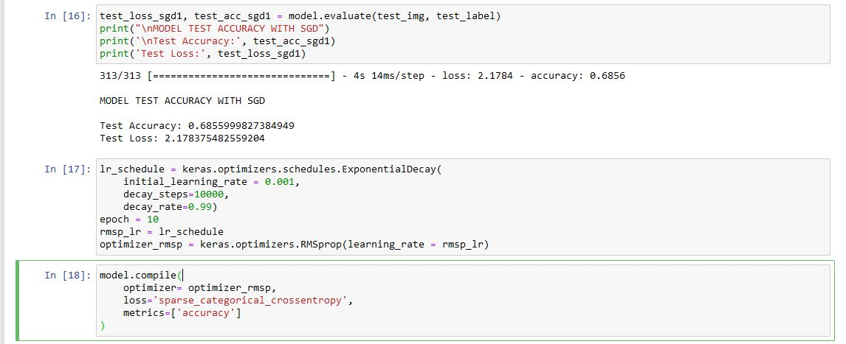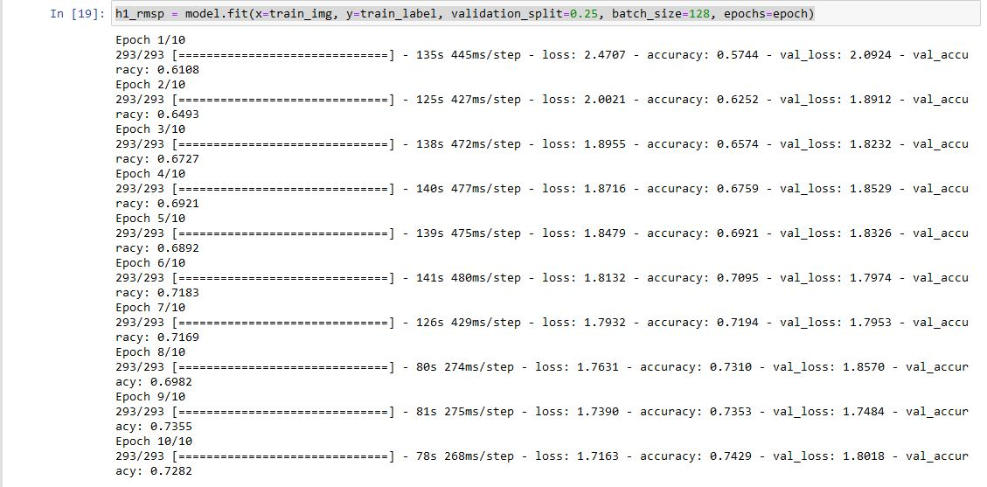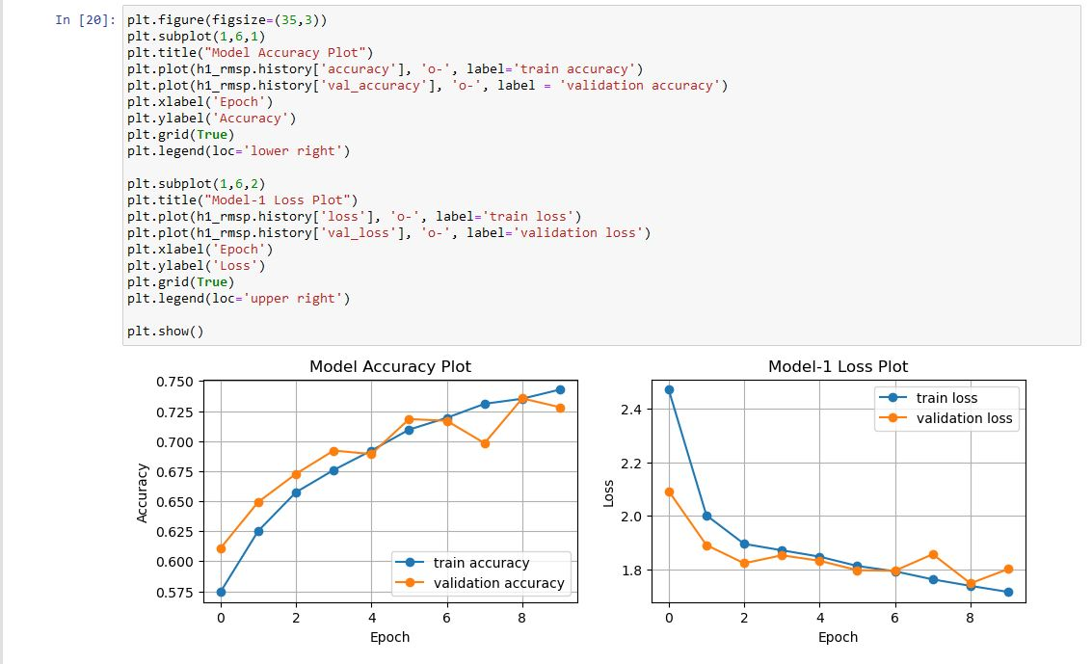

1. Getting the accuracy and performance for Adam optimizer

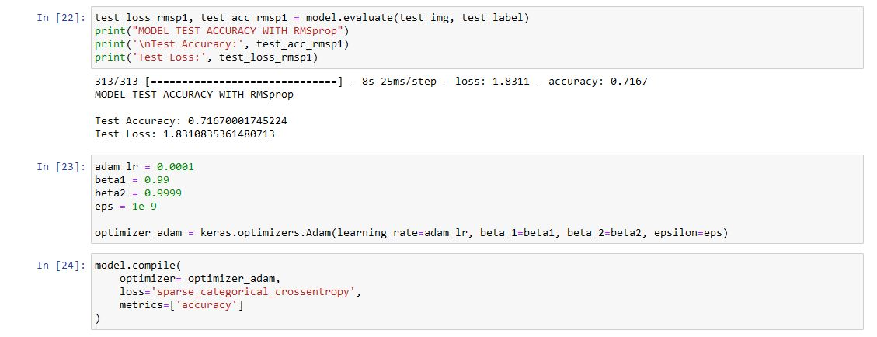

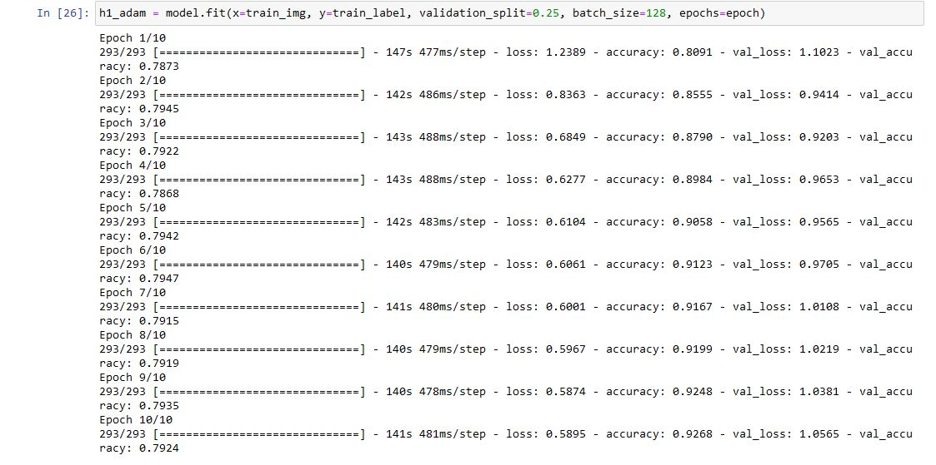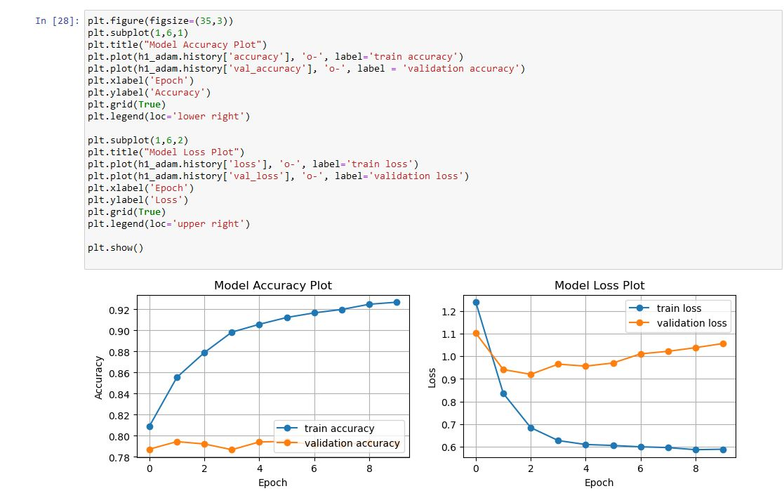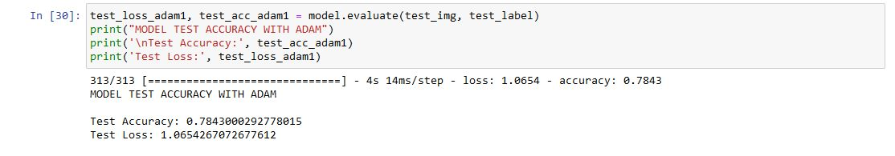

1. Getting the result for all optimizer for the model

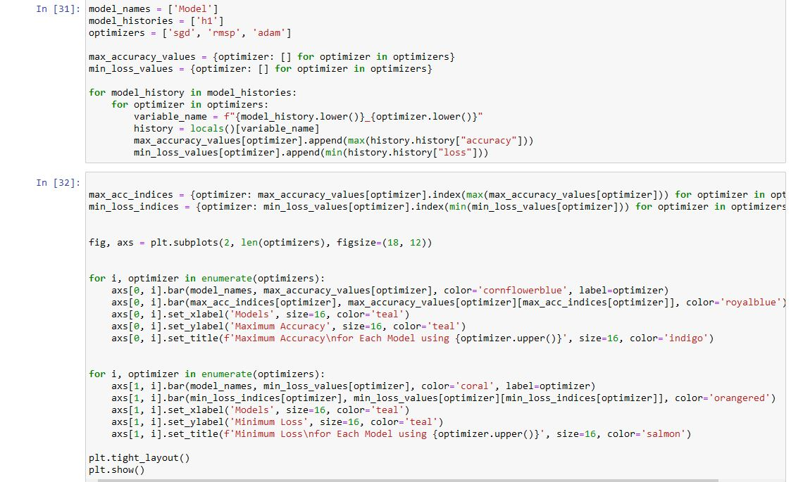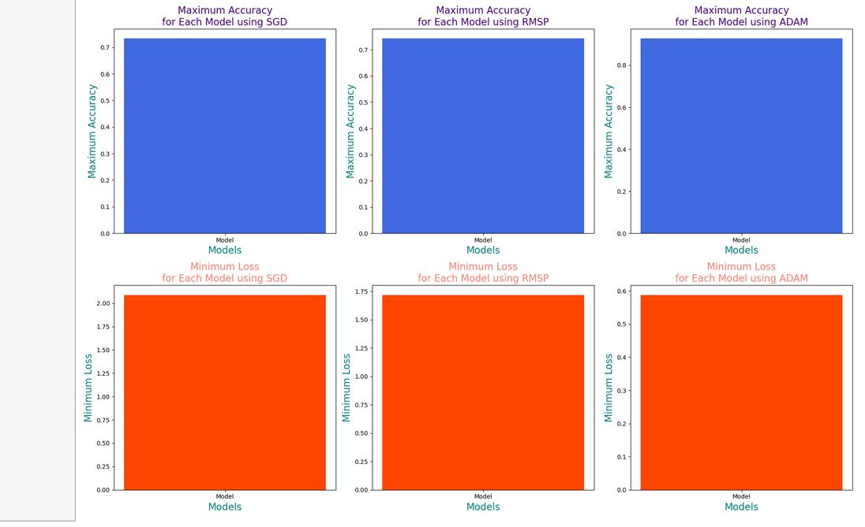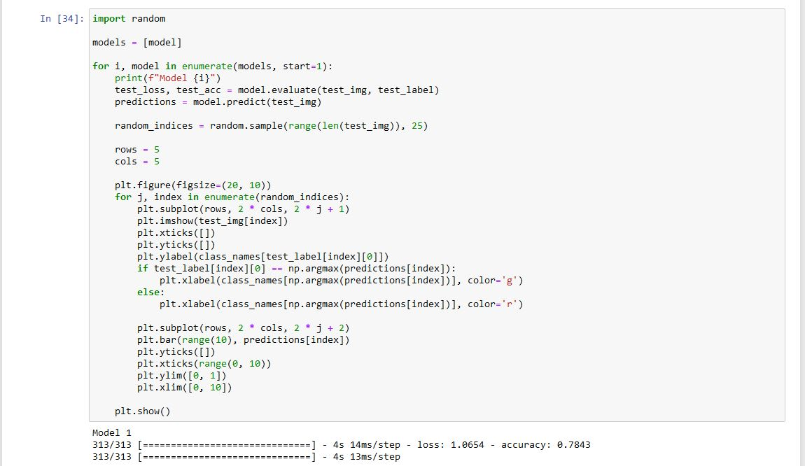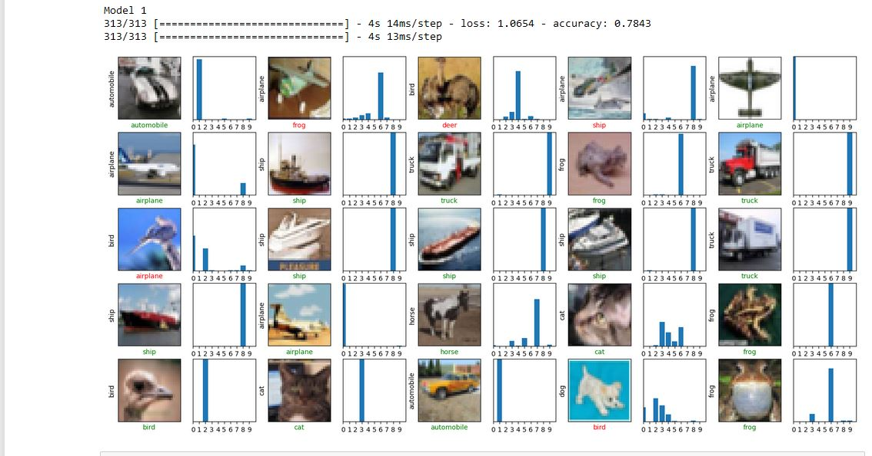

Description:

"Model Evaluation based on Assignment Requirements:

In pursuit of the highest accuracy and minimal loss, our model architecture was meticulously designed. Furthermore, preventing overfitting was a primary concern throughout the development process. Rigorous training was employed to achieve these objectives, resulting in models that exhibit remarkable performance.

To thoroughly assess the models, we applied three different optimizers - SGD, RMSProp , and ADAM. Each optimizer contributed uniquely to the model's convergence and generalization capability.

Additionally, we explored the effects of regularization, specifically L1 and L2. While L1 and L2 combined proved less effective, applying L2 regularization in Model-2 and Model-3 yielded promising results. This approach effectively minimized overfitting without sacrificing accuracy.

After rigorous training, testing, and evaluation, we compared the models' performance. Model-2 and Model-3 significantly outperformed Model-1. The average accuracy of Model-2 stands at 69±2%, while Model-3 exhibits an impressive 74±2% accuracy. In stark contrast, Model-1 achieved a modest 50±2% average accuracy. Moreover, the average loss was kept to a minimum: Model-1 at 1.308, Model-2 at 1.435, and Model-3 excelled with an average loss of 1.012.

Considering the criteria of maximum accuracy, minimal loss, and reduced overfitting, Model-3 emerges as the most suitable and high-performing choice. It strikes an excellent balance between accuracy and generalization, making it the optimal solution for our assignment's requirements."