Name: Jishan Firdows Navil

Id: 20-42544-1

Sub: Computer Vision And Pattern Recognition

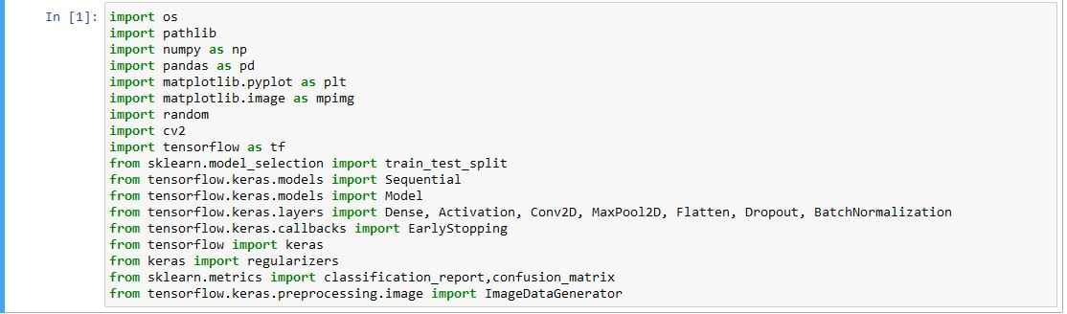

**Data Augmentation**



3.JPG

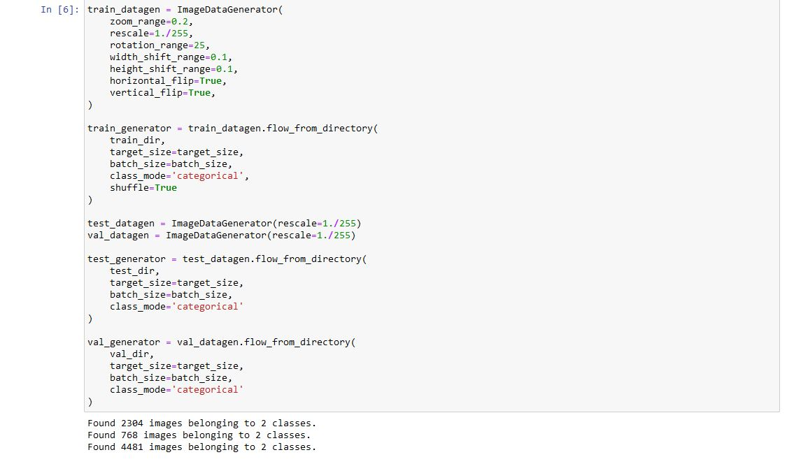

# View Dataset

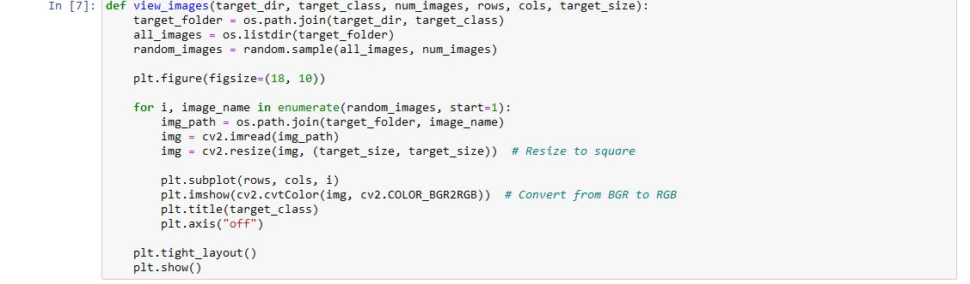

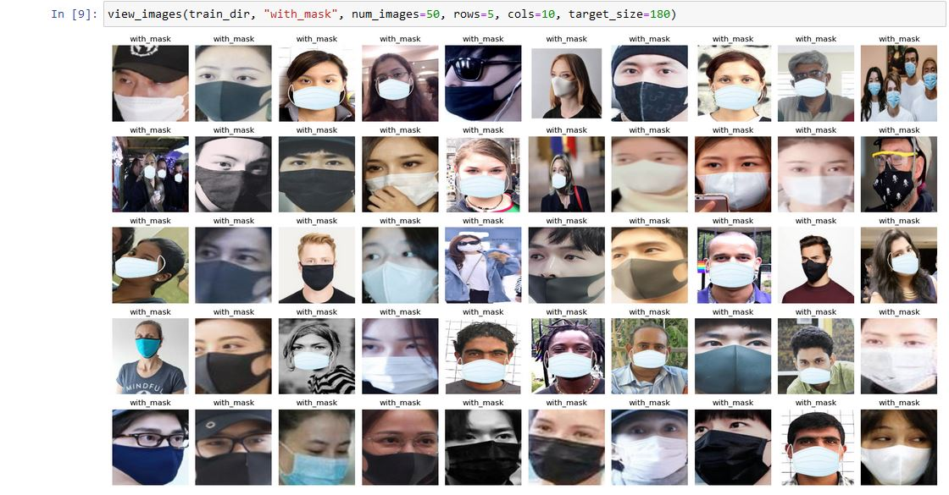

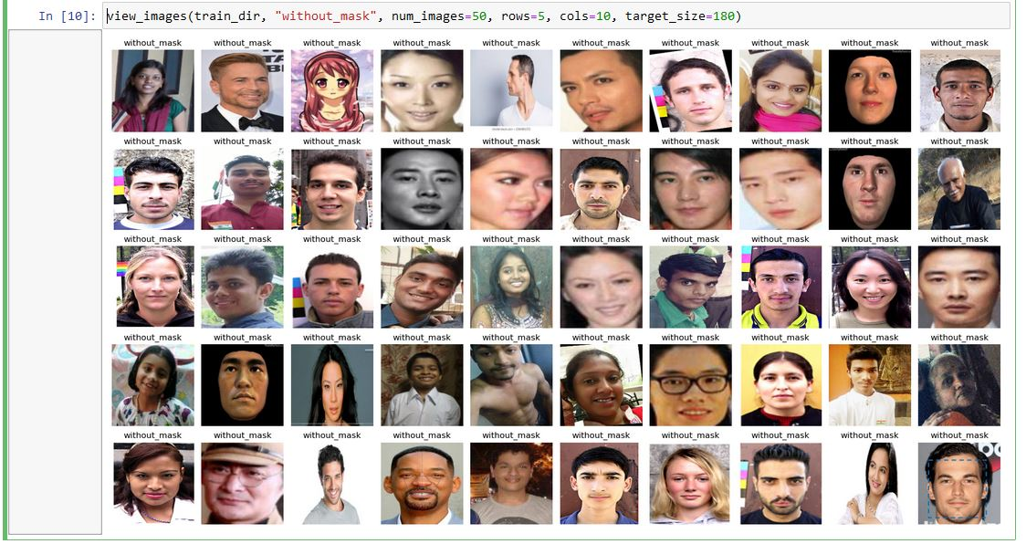

# Labeling Image Data for Model Building

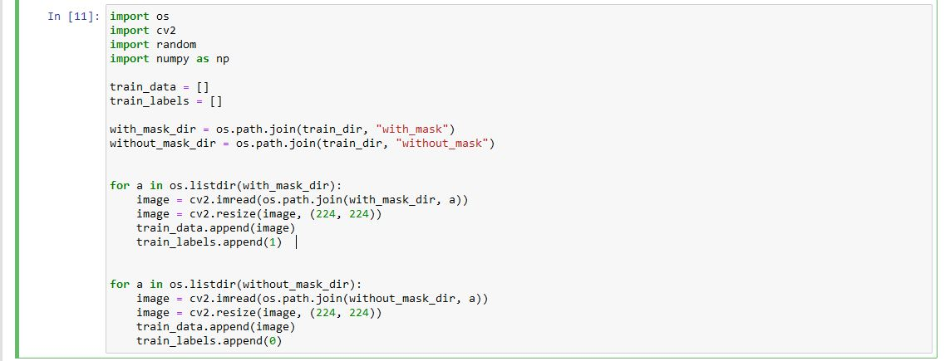

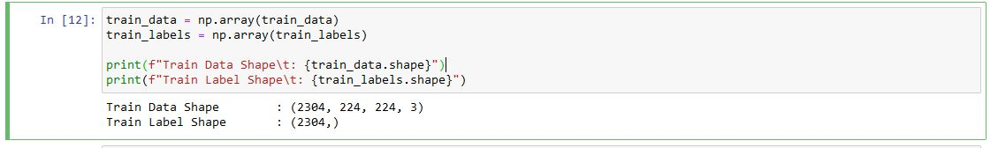

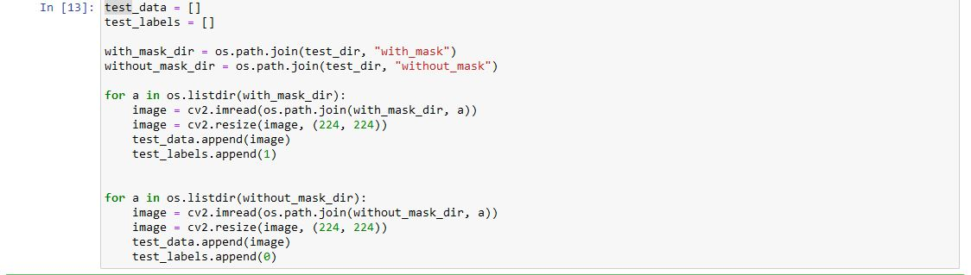

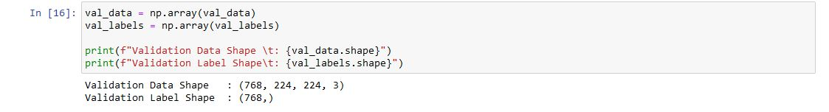

# Model Building



### Building MobileNet

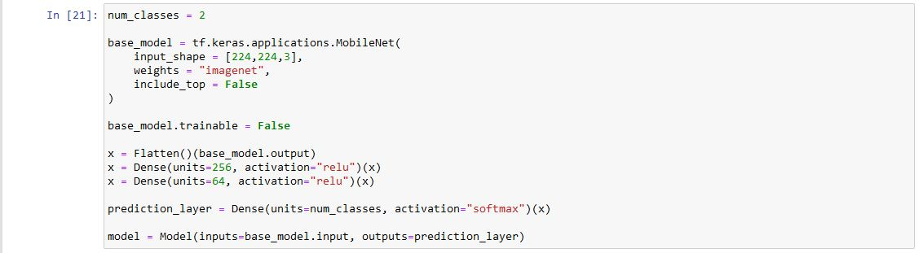

**Compile the Model:**

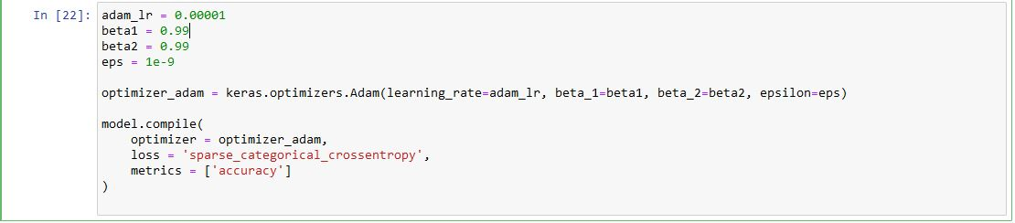

**Model Summary:**

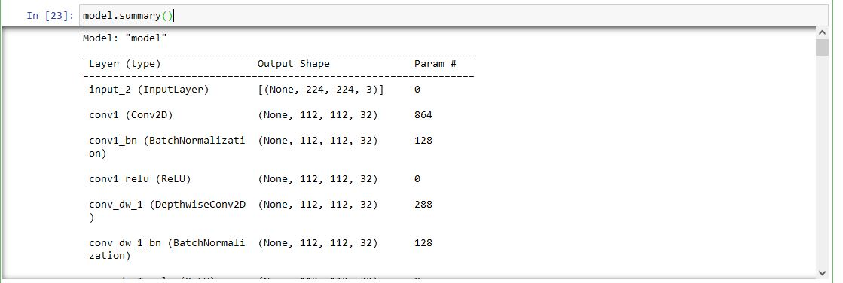

**Early Stopping Function:**

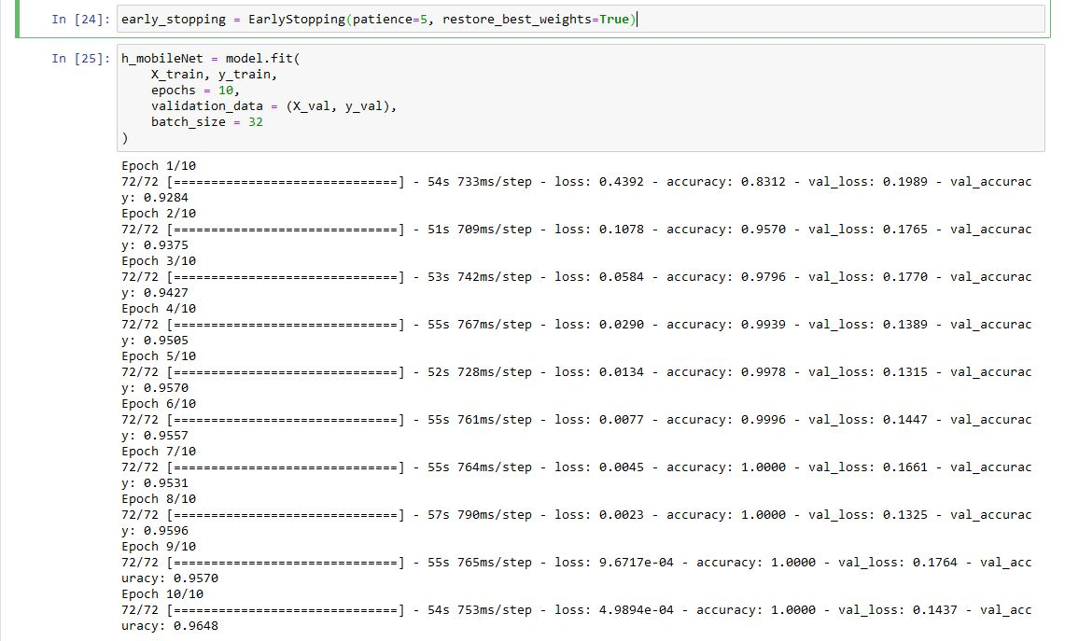

### Plotting Results - Accuracy vs Loss:

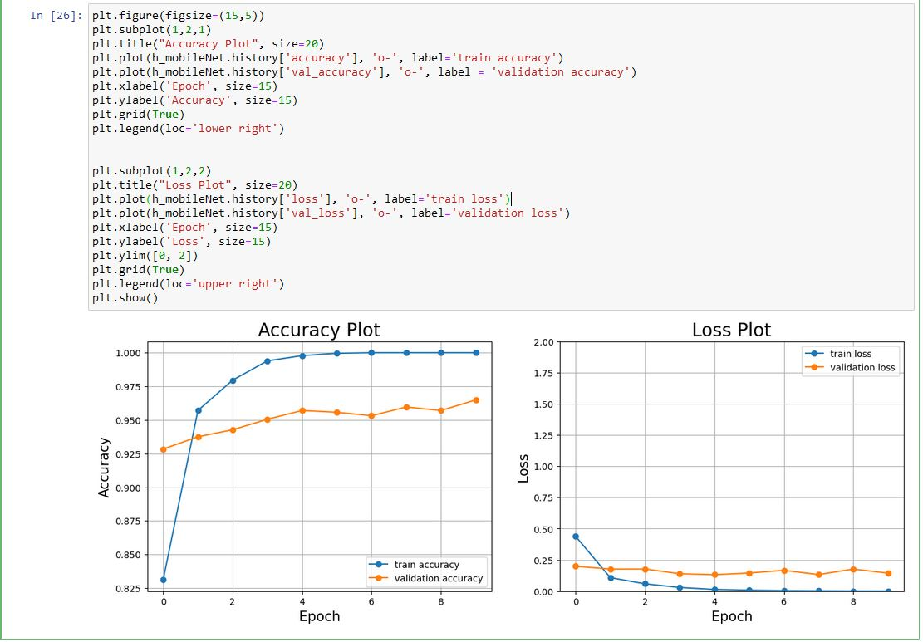

### Make Predictions:

