**AMERICAN INTERNATIONAL**

**UNIVERSITY-BANGLADESH**

Faculty of Science & Technology

**Mid Semester Assignment – Fall 2021-22**

ASSIGNMENT TITLE: **E-HOSPITAL MANAGEMENT SYSTEM**

COURSE TITLE : OBJECT ORIENTED ANALYSIS AND DESIGN

SECTION : E

SEMESTER : FALL 2021-22

GROUP NO : 17

COURSE TEACHER : S. A. M. MANZUR HOSSAIN KHAN

|  |  |  |  |
| --- | --- | --- | --- |
| **No** | **Name** | **ID** | **Program** |
| 1. | RAHAT, MD SAIMUN ISLAM | 20-43632-2 | BSc [CSE] |
| 2. | RABBY, RAHAD-UL-ISLAM | 20-43644-2 | BSc [CSE] |
| 3 | ADIKTA, RIDITA ZAMAN | 20-43679-2 | BSc [CSE] |

**E-Hospital Management System**

**Description:**

Assume that ‘X’ is a patient. He needs to take an appointment of a doctor. So, he/she enters the system by creating an account. He has to select a hospital nearby him, then the information of doctors will appear in front of him. He has to select the exact doctor then also need to select the way of communication. If he selects ‘via online’ then he needs to ask for the consulting hour of that doctor. Then both will communicate with each other via video call on their schedule. The payment of that doctor will be given by online banking.

If he selects ‘via offline’ then he needs to take appointment and confirm the serial number.

If the patient needs to get admitted at hospital, he/she can take cabin by using this system. Medicine list, medicine bill, canteen bill, hospital bill will be added inside the system periodically. Two methods will be given to the patient for clearing the payment. One is online banking, another is offline. The selection will be dependent on that patient.

All information like doctor, suggested medicine, test, test reports, bill, problem/s of patient etc. will be recorded inside the system so that, in future, doctor can know the history of that patient.

**Case Study of Use Case Diagram:**

In this system members need to create an account and log in. The patient will choose via online or via offline, then they can make appointments according to schedule availability with the help of a receptionist. Before visiting the doctor, patients must pay the visiting charge. If the patient chooses to visit the doctor online, then he/she must pay the bill by online banking. But offline patients must pay the bill to the staff (accountant). They can pay by card or cash. After visiting the doctor, patients can rent cabin, ward or ICU with the suggestion of the doctor through online and offline both. All the payments will be made with the help of staff (accountant). Through this whole system all the information about the patient will be recorded by the doctor.

**Use Case Diagram:**

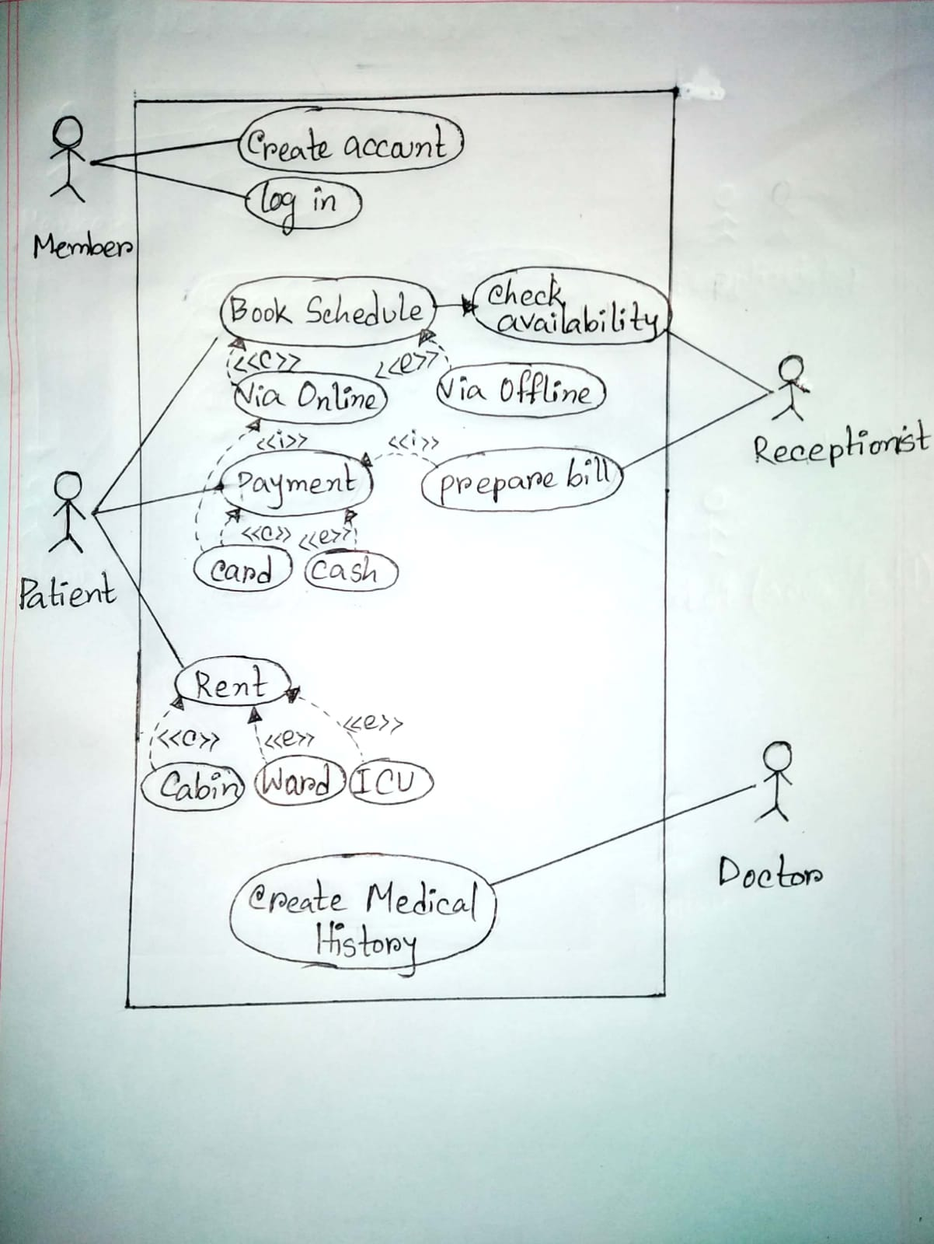

**Case Study of Class Diagram**:

In this system member need to create an account and log in. Then check the schedule via online and offline of doctors. Then according to the appointment patient will visit the doctor via online/offline. Patient must provide the visiting charges through online/offline. Patient can book cabin, ward or ICU with the suggestions of doctor. All the financial works will be done by staff accountant. This whole system will and the reports will be recorded by the doctor.

**Class Diagram:**

|  |
| --- |
| Doctor |
| +DoctorID:int  +dName:String  +dept:string  +dPhone:int  +dRoom:int |
| +prescription()  +CheckReport()  +UpdateHistory() |

|  |
| --- |
| Rooms |
| +RoomNo:int  +RoomType:string |
|  |

1…*

0…1

|  |
| --- |
| Patient |
| -PatientID:int  -pName:string  -pPhone:int  -pAddress:string  -pAge:int  -pSex:string |
| +getPatientID(): Int  +setpName(pName:String)  +getpPhone(): Int  +getpAddress(): String  +getpAge(): Int  +getpSex(): String  +Payment() |

1…*

|  |
| --- |
| Receptionist |
| +ReceptionistID:int  +rName:stirng |
| +DoctorAvaibility()  +PrepareBill() |

1…*

1…*

1…*

|  |
| --- |
| Bill |
| -BillNo:string  -pName:string  -Amount:float |
| +getpName(): String  +setpName(pName:String)  +setAmount(Amount:Float)  +getAmount(): Float  +AddMoney()  +SubstractMoney() |

1…*

1…**

0…1

1…**

**Detail Design:**

|  |
| --- |
| **Class Name:** Patient |
| **Attribute:**  -PatientID: Integer  -pName: String  -pPhone: Integer  -pAddress: String  -pAge: Integer  -pSex: String |
| **Operation:**  +getPatientID(): Integer  +setpName(pName:String)  +getpPhone(): Integer  +getpAddress(): String  +getpAge(): Integer  +getpSex(): String  +Payment() |

|  |
| --- |
| **Class Name:** Doctor |
| **Attribute:**  +DoctorID: Integer  +dName: String  +dept: String  +dPhone: Integer  +dRoom: Integer |
| **Operation:**  +prescription(): String  +CheckReport(): String  +UpdateHistory(): String |

|  |
| --- |
| **Class Name:** Receptionist |
| **Attribute:**  +ReceptionistID: Integer  +rName: Stirng |
| **Operation:**  +DoctorAvaibility(): String  +PrepareBill(): String |

|  |
| --- |
| **Class Name:** Rooms |
| **Attribute:**  +RoomNo: Integer  +RoomType: String |
|  |

|  |
| --- |
| **Class Name:** Bill |
| **Attribute:**  +BillNo: String  +pName: String  +Amount: Float |
| **Operation:**  +AddMoney(): Float  +SubstractMoney(): Float |

**CRC Card:**

**Class: Patient**

|  |
| --- |
| Class Name: Patient |
| Subclass Name: |
| Superclass Name: |
| |  |  | | --- | --- | |  |  | | **Responsibilities** | **Collaborators** | |  |  | | Book Schedule | Patient | | Payment | Receptionist | | Rent | Staff | |  | Doctor | |

**Class: Doctor**

|  |
| --- |
| Class Name: Doctor |
| Subclass Name: |
| Superclass Name: |
| |  |  | | --- | --- | |  |  | | **Responsibilities** | **Collaborators** | |  |  | | Prescription | Doctor | | Check Reports | Patient | | Update Medical History |  | |

**Class: Bill**

|  |
| --- |
| Class Name: Receptionist |
| Subclass Name: |
| Superclass Name: |
| |  |  | | --- | --- | |  |  | | **Responsibilities** | **Collaborators** | |  |  | | Check Doctor Availability | Patient | | Confirm Appointment | Receptionist | | Prepare Bill | Bill | |