

American International University-Bangladesh (AIUB)

**Department of Computer Science**

**Faculty of Science & Technology (FST)  
Research Methodology**

**Assignment**

Submitted By

|  |  |  |  |  |
| --- | --- | --- | --- | --- |
| **Semester: Spring_22_23** | | | **Section:** | **Group No:** |
| SN | Student Name | Student ID | Individual  Contribution | Total Marks: 40 |
| Earned Marks: |
| 05 | Abrar Ibne Ahsan | 19-41389-3 | * Abstract * Introduction |  |
| 09 | Uma Bania Archi | 20-41878-1 | * Methodology * Result & Analysis |  |
| 23 | Md. Saimun Islam Rahat | 20-43632-2 | * Analysis & Discussion * Conclusion |  |
| 27 | Ridita Zaman Adikta | 20-43679-2 | * Problem Background * Methodology |  |

Submission Date: 27. 04. 2023

**The assignment will be evaluated for the following Course Outcomes**

|  |  |  |  |  |  |
| --- | --- | --- | --- | --- | --- |
| **CO2:** *Write* a research proposal considering complex research activities, background studies, and following   standard guidelines | | | | | |
| **Assessment Criteria** | **Not Attended/ Incorrect (0)** | **Inadequate  (1-2)** | **Average (3)** | **Good  (4)** | **Excellent (5)** |
| **Evaluation Criteria** | **Evaluation Definition** | | | | |
| Problem Analysis | Background information of the research area and definition of key research terms. Clearly state what is the real problem in the research domain and why this problem is important to consider? Add some references to support the texts. | | | | |
| Related Studies | Demonstrate the novelty of the research, discuss the existing research within the problem area (other’s work). Who else have studied this problem? And what were their findings? How these studies related to the problem domain? What is the research gap still existing to consider? | | | | |
| Research Objective and Contribution | Research aims/objective to relation with the problem area within existence research. Formulation of Motivation and Research Question. Impact on the society and make a difference | | | | |
| Formatting and Submission | Research article should be submitted within deadline following the appropriate Structure, Citation, Referencing, Style, Font, Alignment, Grammar, Spelling, etc. | | | | |

|  |  |  |  |  |  |
| --- | --- | --- | --- | --- | --- |
| **CO3:** *Formulate* and *demonstrate* a research article after conducting mock research on a given topic by   leveraging a research method | | | | | |
| **Assessment Criteria** | **Not Attended/ Incorrect (0)** | **Inadequate  (1-2)** | **Average (3)** | **Good  (4)** | **Excellent (5)** |
| **Evaluation Criteria** | **Evaluation Definition** | | | | |
| Abstract and Keywords | The relevance, completeness, and conciseness of the abstract and keywords in relation to the research topic. | | | | |
| Research Method | Discussion on the research method, its appropriateness and detail on data collection, analysis, and synthesis. | | | | |
| Result Analysis & Conclusion | Discussion the research finding and argument on the accuracy and novelty of the results, Limitation, and future studies | | | | |
| Citation and referencing | Material should be properly cited and referenced in the Reference List if it is taken from other sources. | | | | |

**The Future of social media and the impact of Metaverse**

Abrar Ibne Ahsan, Uma Bania Archi, Md. Saimun Islam Rahat, Ridita Zaman Adikta  
Department of Computer Science  
American International University – Bangladesh  
[19-41389-3@student.aiub.edu](mailto:19-41389-3@student.aiub.edu), [20-41878-1@student.aiub.edu](mailto:20-41878-1@student.aiub.edu), 20-43632-2@student.aiub.edu, 20-43679-2@ student.aiub.edu

**ABSTRACT**

This paper explores the future of social media and the impact of the metaverse. The metaverse is a virtual world where users can interact with each other in real-time. The paper examines how the metaverse will impact social media by providing a more immersive and interactive experience, allowing for greater personalization, and creating new content creation and monetization opportunities. The purpose of this research is to find the present situation and approximate future of using the social media widely and also how the metaverse can replace our physical interactions. This article discusses about the future of social media and the impact of metaverse using Systematic literature review. The primary findings are improved social media, implemented Virtual Reality (VR), better privacy and security and more business opportunities that would be useful for educational purposes, business purposes, and improved communication.

**Keywords:** Social Media,Internet, Metaverse, Virtual Reality, Augmented reality, Business, Students, Education.

**INTRODUCTION**

Social media has been an integral part of everyone’s lives for over a decade now, providing all with a platform to connect and communicate with people from all over the world. However, with the rise of the Metaverse, it is poised to become more than just a platform for social interaction. The Metaverse is a virtual world that is completely immersive and interactive, and it is expected to change the way people interact with each other, with brands, and with the world around all.

The future of social media is inextricably linked with the Metaverse, and its impact on people’s lives is set to be profound. The Metaverse will provide human with a completely new way of experiencing social media, enabling us to interact with each other in ways that were once only possible in science fiction. People will be able to enter virtual worlds and experience events, products, and services in ways that were previously impossible. The impact of the Metaverse on social media will be far-reaching, and it will affect how all interact with brands, educational institutions and consume content. Brands will have to adapt their marketing strategies to cater to this new world, and content creators will have to create content that is immersive and interactive. The Metaverse will create new opportunities for businesses, and it will change the way we do business. It will significantly improve education and provide a better online experience for students.

**Problem Background**

The future of social media and the impact of the Metaverse has become a topic of interest for scholars and researchers in recent years. Social media has already transformed the way people communicate, consume information, and connect with others. However, the emergence of the Metaverse is expected to take social media to the next level, offering new opportunities for social interaction and immersive experiences. The Metaverse is a term used to describe a shared virtual space where users can interact with a computer-generated environment and each other in real-time. According to a report by Deloitte, the Metaverse is expected to generate more than $1 trillion in annual revenue by 2030 (Deloitte, 2021). This has led to the question of how social media will evolve in the Metaverse era and what impact it will have on society. Some scholars argue that the Metaverse has the potential to increase social connectedness and create new forms of community. In their article, "The Social Potential of the Metaverse: A Research Agenda," researchers suggest that the Metaverse could offer a new platform for social interaction that transcends the limitations of physical space (Steinmetz, Tuten, & Kabayadondo, 2021). However, others have raised concerns about the potential negative impact of the Metaverse on social relationships, privacy, and mental health. As the Metaverse continues to develop and grow, it will be important for scholars and researchers to examine the impact it has on social media and society as a whole. By understanding the potential benefits and challenges of this emerging technology, we can work to create a more inclusive and equitable future for all.

**Related Studies**

On the future of social media and the impact of the Metaverse have focused on exploring its potential benefits and challenges. Steinmetz et al. (2021) suggest that the Metaverse offers a new platform for social interaction that can transcend physical space and create new forms of community. Similarly, Deloitte (2021) predicts that the Metaverse will generate significant revenue and transform various industries, including social media. However, other scholars have raised concerns about the potential negative impact of the Metaverse, such as the risk of addiction, social isolation, and privacy concerns (Buckingham, 2021). Despite the growing interest in this topic, there are two notable gaps in the research. Firstly, there is a lack of empirical studies that examine the impact of the Metaverse on social media and society. Most of the existing literature is based on predictions and theoretical discussions, which limit our understanding of the actual impact of the Metaverse. Secondly, there is a need for research that explores the ethical implications of the Metaverse, particularly in terms of data privacy, security, and algorithmic bias. As the Metaverse continues to develop and grow, addressing these gaps will be essential in shaping a more comprehensive understanding of its impact on social media and society.

**Research Objective**

The research objective of this topic, "The Future of Social Media and the Impact of the Metaverse," was to explore the potential benefits and challenges of the Metaverse on social media and society. This involved conducting empirical studies to investigate the actual impact of the metaverse on social interaction, community building, and other social outcomes. The research also examined the ethical implications of the metaverse, including data privacy, security, and algorithmic bias. Additionally, the research aimed to develop strategies to address potential challenges and promote a more inclusive and equitable future for the use of the metaverse in social media. Overall, the research objective was to provide a comprehensive understanding of the potential impact of the metaverse on social media and society and to inform the development of policies and practices that promote its responsible use.

**Research Question**

What is the present situation and approximate future of using social media widely? How can metaverse replace our physical interaction?

**Research Contribution**

The topic of "The Future of social media and the impact of Metaverse" has the potential to contribute in several ways to the field of social media and technology. Firstly, through empirical studies, the research can provide more nuanced insights into the actual impact of the Metaverse on social interaction, community building, and other social outcomes, which can inform decision-making by policymakers and industry leaders. Secondly, the research can address ethical issues such as data privacy, security, and algorithmic bias, and identify best practices for the responsible use of the Metaverse. Finally, the research can develop strategies to address potential challenges and promote a more inclusive and equitable future for the use of the Metaverse in social media, including addressing addiction and social isolation. Overall, this research can promote a positive and productive use of the Metaverse in social media that benefits individuals and society.

**METHODOLOGY**

This study is a systematic literature review investigating the future of Social Media and the impact of the metaverse. Systematic literature review can be defined as a systematic, open and reproducible method for defining, evaluating and synthesizing the structure of the studies conducted (Fink, 2014). The research process was applied in accordance with the PRISMA 2020 checklist (Page et al., 2021). The PRISMA checklist is a guide sheet to prepare an organized reporting of systematic compilation, review and analysis studies in the international literature (Hür, 2021).

**Literature Search Strategy**

Five databases (IEEE Xplore, SpringerLink, Science Direct, Emerald Insight, and ACM library) selecting all journals and conference proceedings as well as Google Scholar search engine were explored. But the articles found from the mentioned databases which did not meet the absolute requirements of our keywords and research question such as ERIC, JSTOR.

(“Social media AND future”) AND (“Impact/influence/effect”) AND (“Metaverse/virtual reality”)

(“Social media AND metaverse”) AND (“Physical interaction”) OR (“Face-to-face communication/in-person interaction”)

(“Metaverse/virtual reality”) AND (“Social media”) AND (“Impact/influence/effect”)

(“Online platform/digital communication”) OR (“Social networking sites”) AND (“Virtual world/immersive environment/augmented reality/virtual reality/3D space”) AND (“Prospects/outlook/prediction/forecast”)

The literature search was done till 2023 & there was no time frame limitation of the publication year. Backward and forward search were also done in the search process. Backward search reviews relevant citation in the reference list of identified literature. Forward search reviews the literature that cited the identified literature. Furthermore, author citation index (DBLP) of the selected literature was also reviewed to find the relevant literature.

**Inclusion and Exclusion Criteria**: Literature was included based on the publications written in English. Literature was excluded if multiple publications of a concept or framework existed by the same research group, then the most complete publication was considered.

**Data Extraction and Analysis:** A total of 20 papers were selected from the initial screening of the literature search placed in the title, abstract, and keywords of the published literature. Based on the inclusion and exclusion criteria, 10 papers were finally selected for data extraction

**RESULT AND ANALYSIS**

**Research Data/Results:**

The study was focused on the future of social media and the impact of the metaverse, the containing keywords were “Education” as well as “Virtual Reality” or “Metaverse” and those published in Emerald insight, iEEE Xplore, SpringerLink, ACM library databases were examined. Total of 20 papers were reviewed, where 10 of them were removed for duplication, Non-English record and Full text not available. Finally 10 papers were included in this paper.

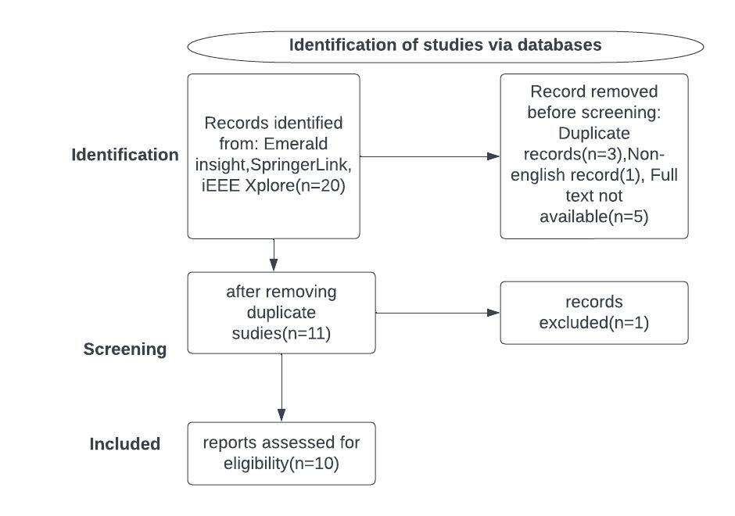

Figure 1 PRISMA Flow Chart

**Analysis and Discussion**

The future of social media and the impact of the metaverse are intriguing topics that have generated a lot of interest among the scholars and researchers. Social media has already changed the way people communicate and consume information, but the emergence of the metaverse is expected to bring about a new era of social interaction and immersive experiences. The metaverse is a shared virtual space where users can interact with a computer generated environment in real time and it is expected to generate over 1trillion in annual revenue by 2030, so experts predict that it will revolutionize the way people interact with each other and consume content. The future social media will have a better commutability with a greater interaction with people and it has a significant impact on the education, business and other work environment.

According to a study by Wang et al. (2022), social media has become an essential tool for communication, socialization, and entertainment. The study found that social media usage is expected to continue to rise in the future, with an increasing focus on personalization and immersive experiences. Another study by Kaplan and Haenlein (2010) explored the concept of social media and its various forms, including blogs, social networking sites, and virtual worlds. The authors found that social media platforms are constantly evolving and are likely to become more integrated into our daily lives. The emergence of metaverse, as a virtual space where people can interact with each other in a more immersive way, is gaining attention from researchers and experts (Rosenthal, 2022; Markham, 2021). The use of virtual and augmented reality technologies can provide more engaging and interactive experiences for users, as well as opportunities for businesses to create new revenue streams (Xu et al., 2021). However, there are also concerns about the potential negative effects of metaverse on human social interaction and mental health (Chang et al., 2021; Lee et al., 2022). In conclusion, social media usage is expected to continue to rise in the future, with an increasing focus on personalization and immersive experiences. The emergence of metaverse provides new opportunities for more engaging and interactive experiences, but it also raises concerns about the potential negative effects on human social interaction and mental health. Further research is needed to fully understand the impact of these technologies on individuals and society as a whole.

**CONCLUSION**

The purpose of this research was to find a future situation and the impact of social media and the metaverse. This study found that the metaverse is a revolutionary invention and technological marvel for a lot of specific reasons. This research reveals that the metaverse and social media are immensely connected. Both can change the way of communication, education, and business ideas to a significantly greater improvement. Using the systematic literature review (SLR), we find some details about the metaverse, which describes how VR and AR can change our perceptions and communications. At present, social media inherits a significant amount of time in our life, at present about 4.76 billion people use social media around the world, which is equivalent to 59.4% of the total population. This study found that the future of social media and the impact of the metaverse are complex and multifaceted issues that require further research and analysis the future of social media and the metaverse will depend on how these technologies are developed and used. It is important for researchers, policymakers, and industry leaders to work together to ensure that the metaverse is used in ways that are beneficial to society and that it does not exacerbate existing social and economic inequalities. By carefully examining the potential benefits and risks of these emerging technologies, people can work to create a future that is more inclusive, equitable, and sustainable for all.

**REFERENCE:**

Deloitte. (2021). *The Metaverse is coming. Are you ready?* Available at <https://www2.deloitte.com/global/en/pages/about-deloitte/articles/the-metaverse-is-coming-are-you-ready.html>.

Steinmetz, J., Tuten, T., & Kabayadondo, Z. (2021). *The Social Potential of the Metaverse: A Research Agenda.* Journal of Interactive Marketing, 56, 64-76. <https://doi.org/10.1016/j.intmar.2021.03.003>

Buckingham, D. (2021). *The Spectre of the Metaverse: What Will the Future of Digital Gaming and Virtual Reality Mean for Our Social Lives?* Journal of Children and Media, 15(3), 363-367. <https://doi.org/10.1080/17482798.2021.1952913>

Statista. (2022). *Number of social media users worldwide from 2017 to 2025*. Available at <https://www.statista.com/statistics/278414/number-of-worldwide-social-network-users/>.

Steinmetz, J., Tuten, T., & Kabayadondo, Z. (2021). *The Social Potential of the Metaverse: A Research Agenda.* Journal of Interactive Marketing, 56, 64-76. <https://doi.org/10.1016/j.intmar.2021.03.003>

Kietzmann, J. H., & Canhoto, A. I. (2021). *The metaverse as a new frontier for social media: conceptualization and research directions.* Journal of Marketing Management, 37(7-8), 554-573 <https://doi.org/10.1080/0267257X.2021.1930245>

Ghaznavi, A., & Taylor, D. G. (2021). *The metaverse: implications for global marketing and consumer behavior.* Journal of International Marketing, 29(1), 1-17. <https://doi.org/10.1177/1069031X20959004>

Sarıtaş, M. T. & Topraklıkoğlu, K. (2022). Systematic literature review on the use of metaverse in education. *International Journal of Technology in Education (IJTE)*, 5(4), 586- 607. <https://doi.org/10.46328/ijte.319>+

Fink, A. (2014). *Conducting research literature reviews: From the internet to paper (Fourth ed.).* SAGE. <https://us.sagepub.com/en-us/nam/conducting-research-literature-reviews/book259191>

Hür, G. (2021). Prisma kontrol listesi 2020 güncellemesi. *Online Türk Sağlık Bilimleri Dergisi,* 6(4), 609-611. https://doi.org/10.26453/otjhs.1001606