
Title:
Credit Card Behaviour Score Prediction Using Classification and
Risk-Based Techniques
Name: Visheshta
23113167
Date: 16 June, 2025

Project Overview
This project focuses on building a Behaviour Score — a predictive classification model designed to estimate whether a credit card customer is likely to default in the upcoming billing cycle. Leveraging anonymized data from Bank A, which includes credit limits, demographic attributes, repayment history, and bill/payment behaviour, we aim to develop a model that can effectively identify high-risk customers in advance.
The objective goes beyond just predictive accuracy; the model must also offer financial interpretability, empowering the bank to make informed, proactive decisions such as revising credit limits, triggering early-warning mechanisms, or providing customer support before a default occurs.
Key challenges addressed:
- Imbalanced classes, as default cases are relatively rare
- Sequential behavioural patterns embedded in repayment timelines
- The need for metrics that reflect financial and operational priorities, rather than just technical performance
Our approach includes:
- Conducting detailed exploratory and financial analysis
- Engineering meaningful features (e.g., credit utilization, delinquency streaks)
- Comparing multiple models including Logistic Regression, Random Forest, XGBoost, and LightGBM
- Evaluating model performance using F2-score, which emphasizes recall — critical for minimizing undetected defaulters
Final deliverables includes:
- A clean prediction CSV with default probabilities on the validation set
- A reproducible codebase (Jupyter Notebook)
- A comprehensive report summarizing data insights, modelling decisions, evaluation results, and business impact implications
1. Problem Statement
Credit cards offer customers flexible short-term borrowing options but also pose significant risks for issuing banks — particularly the risk of payment default. A default typically refers to a customer's failure to pay at least the minimum amount due in a billing cycle, resulting in financial losses and increased portfolio risk for the bank.
To address this, the project focuses on building a Behaviour Score — a predictive classification model that estimates whether a customer will default in the next billing cycle. This is framed as a binary classification problem, where:
- next_month_default = 1 → Customer defaults
- next_month_default = 0 → Customer pays on time(non default)
The dataset contains six months of behavioral and financial data for each customer, including:
- Demographic details: age, gender, education, marital status
- Credit profile: assigned credit limit, monthly bill and payment amounts
- Repayment behaviour: status of payments over time (on-time, delayed, or partial)
The goal is not only to make accurate predictions, but also to ensure the model is:
- Financially interpretable: so insights can be trusted by business teams
- Risk-sensitive: giving more importance to identifying defaulters, even at the expense of a few false alarms
By deploying such a model, Bank A can:
- Proactively flag high-risk accounts
- Adjust credit exposure before a default happens
- Initiate support or follow-up actions
- Strengthen its overall credit risk strategy

2. Project Objective
The main objective is to build a binary classification model that predicts whether a credit card customer will default in the upcoming billing cycle. The model should not only deliver strong performance, but also produce interpretable outputs that align with the bank’s credit risk priorities.
Specifically, the project aims to:
- Identify key behavioral patterns that drive credit risk
- Perform feature engineering to extract meaningful financial indicators
- Address class imbalance using techniques like SMOTE and class weighting
- Train and evaluate models such as:
  - Logistic Regression
  - Random Forest
  - XGBoost
  - LightGBM
- Optimize using metrics like F2 score and recall, as these better capture the business cost of missing actual defaulters
- Deploy a model that generalizes well to unseen data and aids data-driven decision making

3. Data Description
The project uses anonymized behavioral data from over 30,000 credit card customers provided by Bank A. The data is split into:
- Training Set (~25,000 records): Contains both features and the target variable (next_month_default)
- Validation Set (~5,000 records): Contains only the features, to be used for final predictions
Key Features:
S.No | Column | Description
1 | Customer_ID | Unique customer identifier
2 | marriage | Marital status (1 = Married, 2 = Single, 3 = Others)
3 | sex | Gender (1 = Male, 0 = Female)
4 | education | Education level (1 = Grad School, 2 = University, 3 = High School, 4 = Others)
5 | LIMIT_BAL | Credit limit assigned
6 | age | Age of the customer
7 | PAY_0 to PAY_6 | Monthly payment status: -1 = on-time, 0 = partial, ≥1 = months delayed
8 | BILL_AMT1 to 6 | Monthly bill amount
9 | PAY_AMT1 to 6 | Monthly payment amoun
10 | AVG_Bill_amt | Average of last 6 bill amounts
11 | PAY_TO_BILL_ratio | Total payment / Total bill ratio over 6 months
12 | next_month_default | Target variable: 1 = Default, 0 = No Default
Temporal Relationships:
- BILL_AMT_m → Total billed amount at the end of month m
- PAY_AMT_m → Payment made during month m (to cover bill from month m-1)
- PAY_m → Status of previous month’s bill payment
Special Cases:
- PAY_m = -1: Bill paid in full on time
- PAY_m = 0: Partial or minimum payment made
- PAY_m ≥ 1: Bill overdue by that many months
- PAY_m = -2: No bill generated (zero usage)
Clarifications:
- A status of 0 is not a default; it represents partial but acceptable payment
- Negative bill values may reflect overpayments or credit balances
- Status -2 may result from no card usage or residual balances

4. Project Environment Overview
This section outlines the technical environment and tools used to ensure full reproducibility and clarity in the modeling workflow.
🛠 Development Setup
- Language: Python 3.9
- Environment: Jupyter Notebook
A consistent setup was maintained throughout to support reproducibility and portability of results.
📦 Key Libraries
Library | Purpose
NumPy | Numerical operations and arrays
Pandas | Data wrangling and tabular analysis
Matplotlib | Data visualization
Seaborn | Statistical plotting with aesthetics
Scikit-learn | Machine learning, preprocessing, evaluation
XGBoost | Gradient boosting algorithm
LightGBM | Fast boosting on large datasets
Imbalanced-learn | Handling class imbalance (e.g., SMOTE)
5. Exploratory Data Analysis (EDA)
In this section, we explore the training dataset to understand data quality, feature distributions, and relationships with the target variable (next_month_default).

🔹 Section: Code Setup & Library Imports
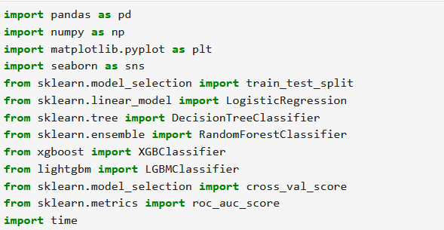
✅ Purpose: To import all the essential libraries used for data preprocessing, visualization, modeling, evaluation, and tracking execution time.
⚙️ Technical Explanation:
- pandas, numpy: for structured data handling
- matplotlib, seaborn: for graphs, trends, and charts
- Scikit-learn models: classic ML algorithms
- XGBoost & LightGBM: optimized gradient boosting classifiers
- time: track model training duration
💼 Business Justification:
- These tools enable banks to identify customers likely to default using behavior-based scoring.
- Helps prevent financial loss and supports decision-making in credit policy.

🔹 Section: Load Datasets
✅ Purpose: Load the cleaned and preprocessed training and validation datasets.
⚙️ Technical Explanation:
- train_df: used for training the model (includes target variable)
- validate_df: used to test model generalizability (no target included)
💼 Business Justification:
- Separation ensures fair evaluation.
- Mirrors how the model will behave in real financial deployments (predicting default risk of new applicants).

🔹 Section: Initial Data Preview
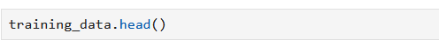
✅Purpose: Preview the first few rows of the dataset.
⚙️ Technical Explanation:
- Shows data structure: columns, values, formats.
- Quick sanity check post-loading.
💼 Business Justification:
- Allows analysts to spot any anomalies early.
- Ensures target variable next_month_default is present and well-defined.

🔹 Section: Check Missing Values

✅ Purpose: Identify missing values across columns.
⚙️ Technical Explanation:
- Important step before modeling to decide on imputation or dropping features.
💼 Business Justification:
- Missing values in financial datasets (like age or credit limit) can skew predictions.
- Ensures that customer risk is assessed based on complete and consistent data.

🔹 Section: Dataset Structure

✅ Purpose: View dataset's structure including data types and non-null counts.
⚙️ Technical Explanation:
- Helps verify categorical vs. numerical features.
- Essential for data preprocessing and encoding steps.
💼 Business Justification:
- Ensures correct handling of each variable.
- Misclassified data types can lead to faulty financial insights or model errors.
🔎 Key Observations:
- The training dataset has 24 columns including the target, while the validation dataset has 23.
- Most features are numerical, with a mix of int64 and float64 types.
- Only the age column has missing values (276 entries).
➡️ We handled this using median imputation, which is robust to outliers and preserves the central tendency of age distribution.
Exploratory Data Analysis :
Exploratory Data Analysis (EDA) helps identify patterns, trends, and insights that can guide feature engineering and modelling decisions. In this section, we explore demographic and financial features and their relationship with customer default behaviour.

📊 EDA 1: Percentage of Defaults
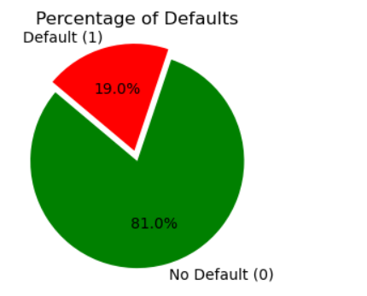
✅ Explanation:
- This pie chart visualizes the distribution of the target variable next_month_default, showing the percentage of customers who defaulted vs. those who did not.
📌 Observation:
- The dataset is imbalanced, with approximately 19.04% of customers labeled as defaulters and 81.0% as non-defaulters.
- This imbalance needs to be addressed before model training using techniques such as SMOTE or class weighting.

📊 EDA 2: Education Level vs. Default Rate
The education variable records the highest educational qualification of each customer. However, the raw data contains some invalid or ambiguous codes (0, 5, 6) that do not correspond to known education levels. As part of data cleaning, these values were grouped under a unified category labeled as “Others” (4). The resulting four education categories are:
• 1 → Graduate School
• 2 → University
• 3 → High School
• 4 → Others (including invalid/missing entries)
Two plots were generated to analyze this feature:
1. A count plot showing the distribution of customers across the four education
categories
2. A stacked bar chart showing the proportion of defaulters vs non-defaulters within each education group
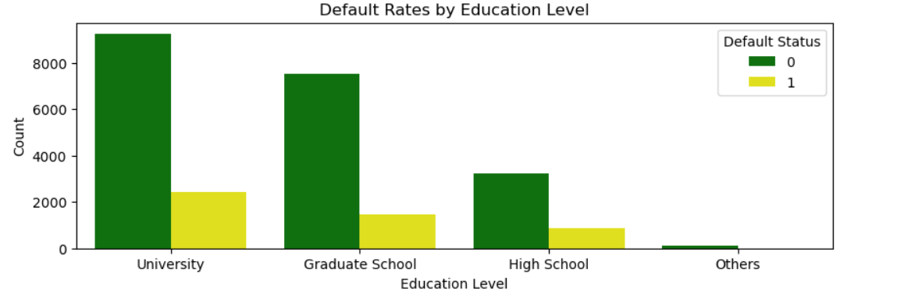
These visualizations help us understand both the representation of each group and their default risk profile.
📌 Observation:
The majority of customers are university graduates, followed by graduate school and high school customers.
• The Others category is the smallest group, which includes recoded invalid values.
In terms of default risk:
- High school–educated customers have the highest default rate (~22–30%)
- The Others category also shows relatively high risk (~28%)
- Graduate school customers exhibit the lowest default rate (~17–20%)
• These trends suggest a negative correlation between education level and likelihood of default — i.e., higher education levels are associated with lower default risk.
This insight supports the inclusion of education as a predictive feature in the modelling phase, possibly using one-hot encoding or target encoding depending on the algorithm.💡 Insight:
- Education is a strong proxy for financial literacy and repayment behaviour. It should be retained as a key input feature in the model.

📊 EDA 3: Marital Status vs. Default Rate
The marriage variable records each customer’s marital status and is originally coded as:
- 1 → Married
- 2 → Single
- 3 → Others (e.g., divorced, separated)
- 0 → Invalid or missing (recoded as 3 to group with “Others”)
To ensure consistency and interpretability, the invalid code 0 was recoded into the "Others" category, and the column was treated as categorical for analysis. Two key visualizations were created:
- A bar plot to show the distribution of customers across the three marital status categories.
- A stacked bar chart to illustrate the proportion of defaults and non-defaults within each group.
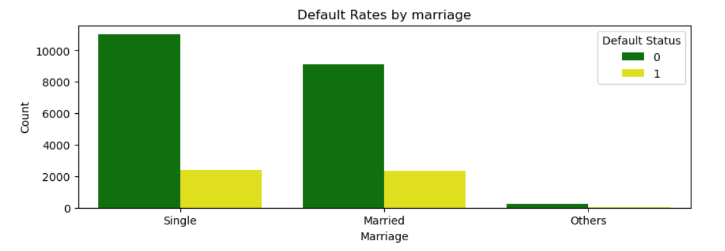
📊 EDA 4: Age Distribution

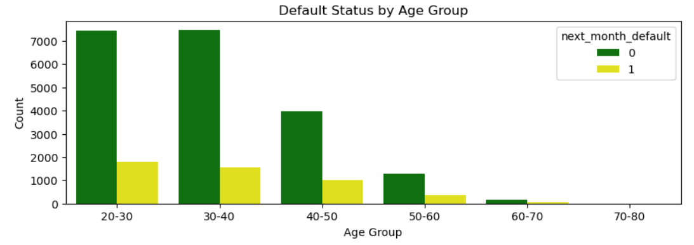
📊 What it shows: Default behavior across age bands.
🔎 Observation:
- Customers aged 20–30 have a higher likelihood of default.
- Risk decreases slightly with age.
💼 Business Insight: Age reflects financial maturity and stability. Binning enhances interpretability and model accuracy in decision trees.
📊 EDA 5: Sex Distribution
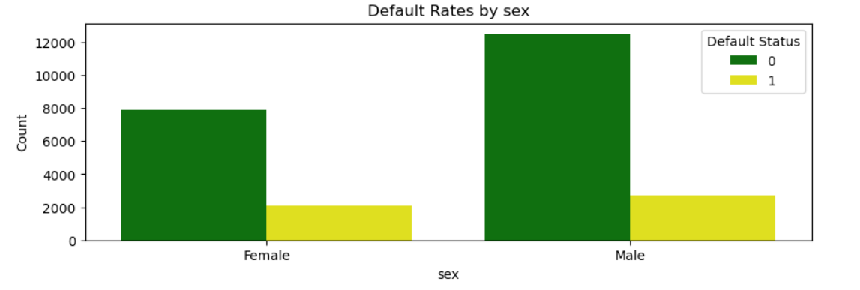
📊 What it shows: Distribution of defaults among male and female customers.
🔎 Observation:
- Males form a larger portion of the dataset.
- Default rate appears slightly higher in males, but not dramatically so.
💼 Business Insight: While not highly predictive alone, gender may combine meaningfully with other demographics like age or marital status.
💰 EDA 6: Credit Limit (LIMIT_BAL) vs. Default
The LIMIT_BAL feature represents the maximum credit limit assigned to each customer (in NT dollars). This is one of the core financial indicators in the dataset, and understanding its distribution is important for identifying customer risk profiles.
🧪 What the Analysis Covers:
- We begin by calculating descriptive statistics (mean, median, standard deviation) to understand the spread and central tendency of credit limits.
- A histogram with KDE (Kernel Density Estimate) is plotted to visualize the overall distribution.
- The distribution is found to be right-skewed, indicating that while most customers have modest credit limits, a small group has very high limits.
- A boxplot is then created to compare credit limits between defaulters vs. non-defaulters.

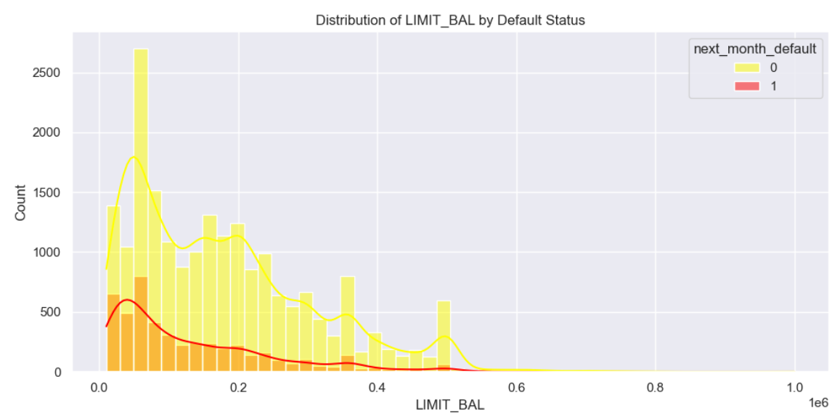
📌 Key Observations:
- The average credit limit is moderate, but a few customers have extremely high limits (e.g., above 500,000 NT), which contributes to skewness.
- The boxplot reveals that:
  - Defaulters tend to have lower credit limits, with a wider interquartile range concentrated in lower values.
  - Non-defaulters have a higher median limit and include extreme high-limit outliers.
- There is significant overlap in credit limit distributions between defaulters and non-defaulters, suggesting that LIMIT_BAL alone is not sufficient to distinguish risk.
- Due to this skewed nature, a log transformation is applied later during preprocessing to reduce the impact of outliers and improve model performance.
💼 Business Insight:
Customers with higher credit limits tend to default less frequently, likely due to stronger creditworthiness or better financial management. However, because of the overlap and noise in raw values, this feature is more useful when used in derived ratios like:
- Credit Utilization Ratio = (Total Bill Amount / Credit Limit)
- Combined with behavioral features like repayment streaks, LIMIT_BAL becomes a valuable input in the final model.
🧾 EDA 7: Repayment History (PAY_0 to PAY_6)
The PAY_0 to PAY_6 features capture the repayment status of each customer for the past 6 billing cycles. These are among the most critical variables in predicting credit card default, as they reflect past behavior in managing due payments.
🧪 What the Analysis Covers:
- Each PAY_i column (where i = 0 to 6) denotes how promptly the customer repaid their dues for that month.
  - -2: No bill generated (no card usage)
  - -1: Paid in full on time
  - 0: Paid minimum due (revolving credit)
  - 1 or more: Months of payment delay (e.g., 2 = two months late)
- A bar plot was generated to display how each repayment month correlates with next_month_default.
- The focus was on identifying which repayment months were most predictive of future default.

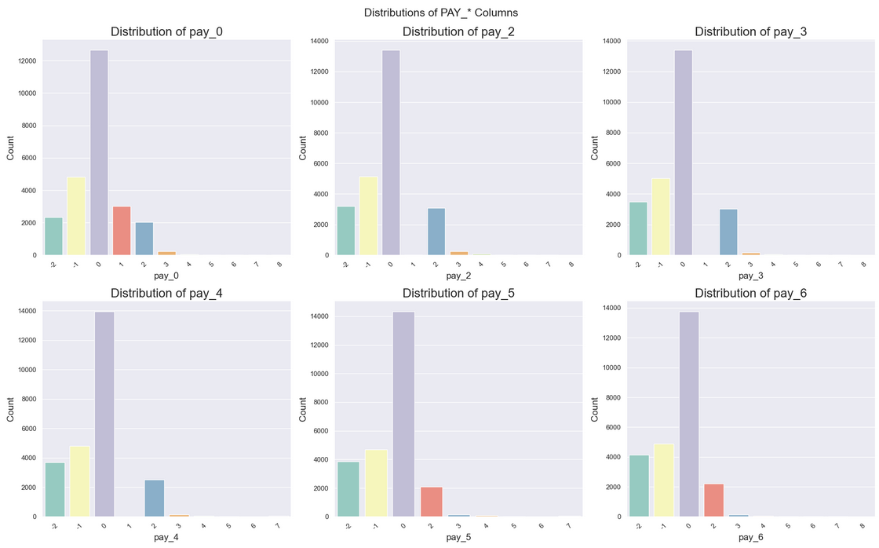
📌 Key Observations :
- Across all repayment months (PAY_0 to PAY_6):
  - ~80% of customers are either on-time or using revolving credit (PAY_i <= 0).
  - A consistent 10–15% are 1–2 months late, and very few are delayed beyond 3 months.
  - The proportion of 1+ month delinquencies slightly increases from PAY_6 to PAY_0, hinting at growing financial pressure leading up to default.
- Insights from Default Rate Patterns:
  - Customers with PAY_0 = 1 have about a 30% probability of defaulting.
  - When PAY_0 ≥ 2, the default probability increases sharply to over 60%.
  - Customers using revolving credit (PAY_0 = 0) show a moderate default rate of ~15%.
  - On-time payers (PAY_0 ≤ -1) exhibit the lowest default rate, typically below 2%.
- Temporal Importance:
  - Older months (e.g., PAY_3 to PAY_6) also carry some predictive value.
  - However, recency matters — recent delinquencies (especially PAY_0, PAY_1) are stronger indicators of upcoming default.
- Correlation Analysis:
  - All PAY_X features are strongly correlated with each other (~0.6 to 0.8), suggesting that delinquency tends to persist over time.
  - PAY_0 has the highest correlation with the target variable (~0.52), followed by PAY_2 and PAY_3.

💼 Business Insight:
- While raw billing values don’t show strong linear correlation with default risk, they are useful when transformed into:
  - Utilization ratios: bill / credit limit
  - Volatility metrics: standard deviation or range across months
  - Spending slope: upward or downward trends in bill amounts
- These engineered features can better reflect a customer’s spending behaviour, repayment capability, and financial discipline — key indicators in credit risk modelling.
Repayment patterns directly reflect financial stress or irresponsibility, making them top predictors of default.
- This insight motivates engineering new behavioral features such as:
  - Delinquency Count: Number of months with delay ≥1
  - Max Late Streak: Longest continuous period of late payment
  - Recency of Delay: How recent the last delay was (e.g., PAY_0 = 3)
- These repayment trends are reliable for real-time credit scoring and risk-adjusted credit limit decisions.

🧮 EDA 8: Billing Amount Trends (BILL_AMT1 to BILL_AMT6)

The BILL_AMT1 to BILL_AMT6 features represent the total bill amount generated at the end of each of the past 6 months. These values help capture the customer's credit usage behaviour and financial activity patterns over time.

🧪 What the Analysis Covers:
- We compute an average bill amount across the 6 months to smooth out month-to-month fluctuations.
- A Kernel Density Estimate (KDE) plot is created to compare the distribution of average bill amounts for defaulters vs. non-defaulters.
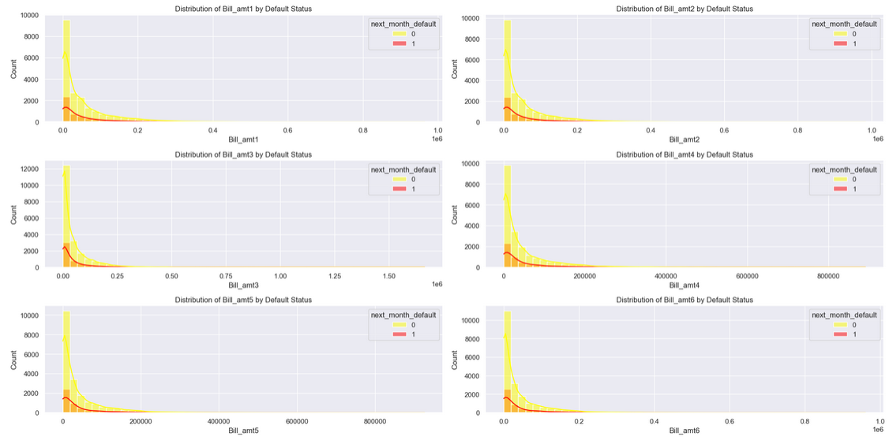
- We also investigate the potential skewness and variability in spending across these periods.
📌 Key Observations:
- Bill amounts are heavily right-skewed, with most customers having moderate bills and a long tail of high spenders.
- Defaulters tend to have slightly lower or more inconsistent average bill amounts than non-defaulters.
- The KDE plot shows partial overlap between the two groups, indicating that bill amount alone has limited predictive power.
- The spread of billing activity is higher in recent months, possibly reflecting financial stress closer to the default event.
💼 Business Insight:
- While raw billing values don’t show strong linear correlation with default risk, they are useful when transformed into:
  - Utilization ratios: bill / credit limit
  - Volatility metrics: standard deviation or range across months
  - Spending slope: upward or downward trends in bill amounts
- These engineered features can better reflect a customer’s spending behaviour, repayment capability, and financial discipline — key indicators in credit risk modelling.

📦 EDA 10: Payment Amount History — pay_amt1 to pay_amt6
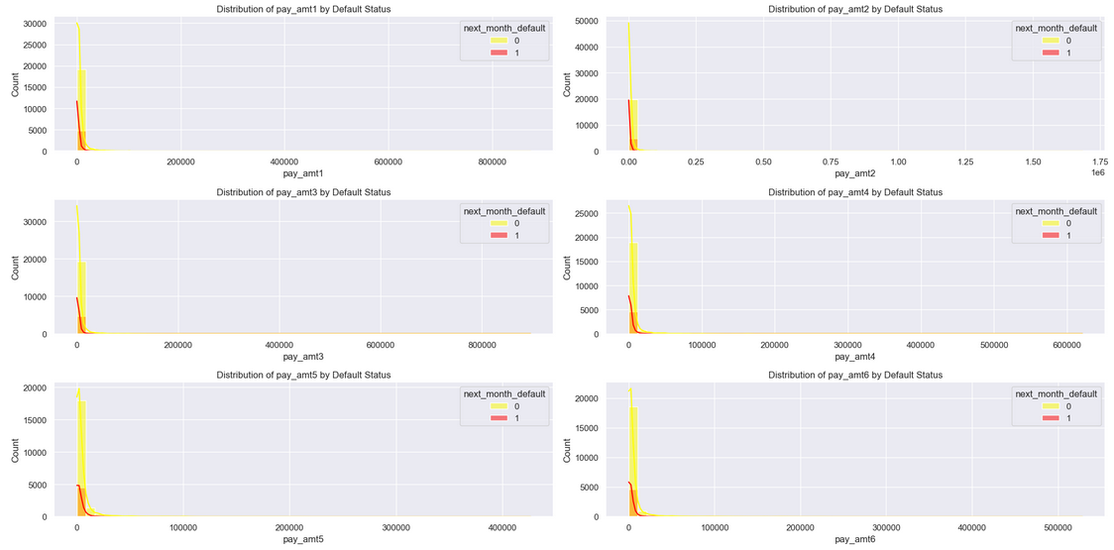
This section explores the payment behaviour of customers using the variables pay_amt1 to pay_amt6, which represent the actual amounts paid by a customer for the last six billing cycles.

📊 What it shows:
- Histograms with KDE lines for each pay_amtX variable (X = 1 to 6), visualizing the distribution of payment amounts among defaulters and non-defaulters.
- These plots help us understand how much customers typically pay and how payment size may relate to default behaviour.
🔎 Observations:
- Across all months, most payments are heavily skewed toward lower values, especially for defaulters.
- Non-defaulters show a broader spread with more consistent higher payments.
- Payment activity spikes below NT 20,000 and drops off significantly beyond that.
💼 Business Insight:
- Regular, higher payment amounts are associated with better repayment discipline and lower risk.
- These raw values may benefit from transformation (e.g., log scale) due to skewness.
- Derived features such as:
  - Total Payment Over 6 Months
  - Average Monthly Payment
  - Payment-to-Bill Ratio could enhance predictive power when combined with bill and limit features.

📉 EDA 11: Bill Amount Trend Analysis — BILL_AMT1 to BILL_AMT6

To understand how customer billing behaviour changes over time, we analyze the temporal trend of bill amounts across the six most recent months (BILL_AMT1 being the most recent).

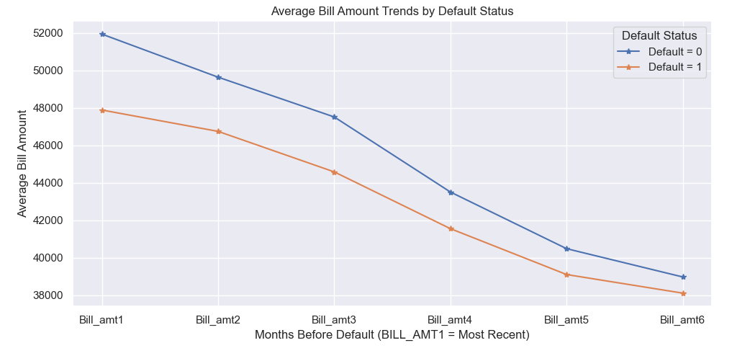
📊 What it shows:
- A line chart comparing the average monthly bill amounts between defaulters and non-defaulters across six months.
- Helps capture spending behaviour patterns over time.

🔎 Key Observations:
- Non-defaulters consistently maintain higher billing activity than defaulters across all months.
- Defaulters exhibit a flatter or more erratic billing trend, with lower average values.
- Both groups show minor fluctuations, but non-defaulters maintain a more stable and elevated billing profile.
- No sharp decline is observed prior to default, suggesting that lower bill activity could be due to underutilization or conservative spending from at-risk customers.

💼 Business Insight:
- Trend consistency in billing is a strong indicator of healthy financial activity.
- Defaulters may exhibit sporadic usage patterns or reduced activity due to credit constraints.
- Feature engineering ideas:
  - Bill Trend Slope: Positive or negative change in billing over time
  - Billing Volatility: Standard deviation of bills
  - Recent vs. Old Billing Ratio
- These temporal billing trends offer valuable behavioral insight that can improve risk classification accuracy.

Feature Correlation Analysis

To understand how the numerical features relate to each other and to the target variable(next_month_default), we computed the Pearson correlation matrix for all continuous and ordinal variables. This matrix helps identify:
- Highly correlated features (potential for multicollinearity)
- Weak or non-informative features
- Features with strong association with default behaviour

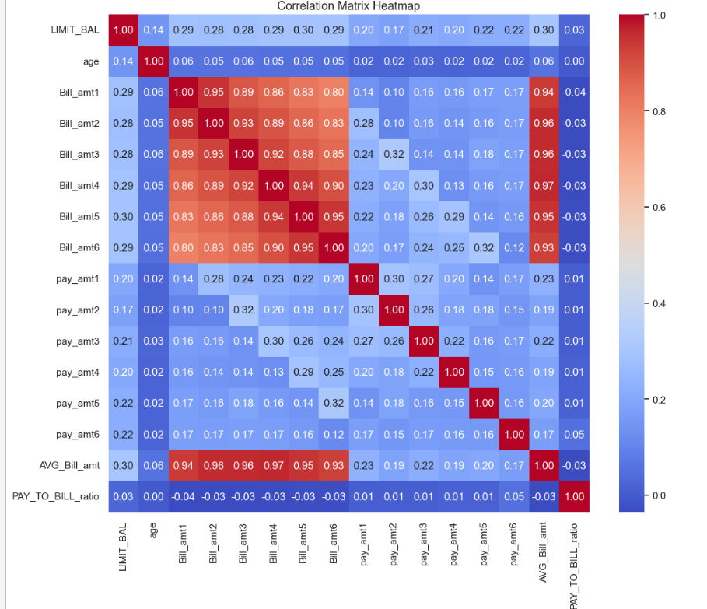
A heatmap was generated to visualize these pairwise correlations

Observations & Insights:
- Billing Amount Features (Bill_amt1 to Bill_amt6):
  - These features exhibit very strong correlations with each other (ranging from 0.80 to 0.97), indicating that billing amounts are highly consistent across consecutive months. This suggests multicollinearity, which may require dimensionality reduction (e.g., using PCA or retaining only one representative feature like AVG_Bill_amt).
  - They also show moderate positive correlations with LIMIT_BAL (~0.28–0.30), implying that higher credit limits are associated with higher billing amounts.
- Payment Amount Features (pay_amt1 to pay_amt6):
  - These features have weak to moderate correlations among themselves (0.14–0.32), suggesting that payment behaviors vary more month-to-month compared to billing amounts.
  - Their correlations with billing amounts are generally weak (0.10–0.32), indicating that payment amounts do not strongly depend on the billed amounts.
- Engineered Features (AVG_Bill_amt and PAY_TO_BILL_ratio):
  - AVG_Bill_amt is very strongly correlated with individual billing amounts (0.93–0.97), as expected, since it is derived from them.
  - PAY_TO_BILL_ratio shows negligible correlations with all other features (close to 0), suggesting it captures unique variance unrelated to billing/payment amounts or credit limits.
- Demographic Features (LIMIT_BAL and age):
  - LIMIT_BAL has weak positive correlations with billing/payment amounts (0.14–0.30), indicating that higher credit limits are loosely associated with higher spending/payments.
  - age shows almost no correlation with any other feature (all values ≤ 0.06), implying it is independent of spending/payment behaviors in this dataset.
- Potential Implications for Modeling:
  - The high multicollinearity among billing amounts suggests using aggregated features (e.g., AVG_Bill_amt) or regularization techniques to avoid overfitting.
  - The weak correlations of PAY_TO_BILL_ratio and age with other features imply they may contribute unique predictive power in nonlinear models (e.g., decision trees) despite their low linear correlations.
  - The lack of strong linear relationships between payment amounts and billing amounts highlights potential nonlinear dynamics (e.g., customers may pay fixed amounts regardless of bills).

Handling Class Imbalance with SMOTE
In credit default prediction, class imbalance is a major challenge — only a small portion of customers actually default (~22%), while the rest do not. This can lead to biased models that favor the majority class and underperform when it comes to identifying defaulters.
To address this, we applied SMOTE (Synthetic Minority Oversampling Technique) using the imblearn library. SMOTE generates synthetic samples for the minority class (defaulters) by interpolating between real examples, allowing the model to learn patterns more effectively.
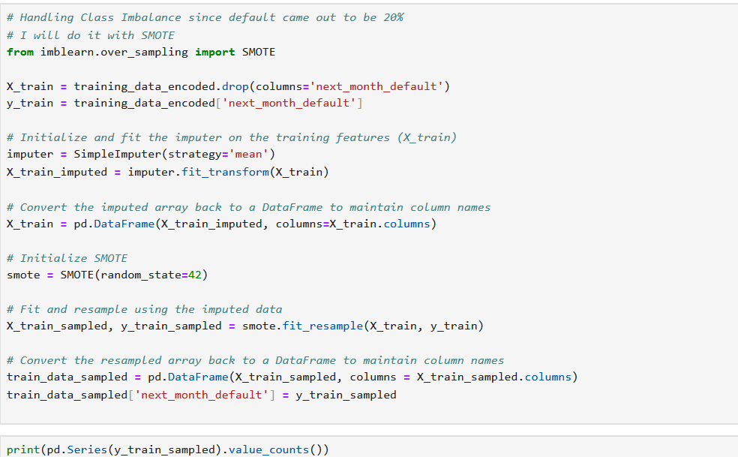
🧪 SMOTE Implementation Steps:
- The original dataset was split into training and testing sets using stratified sampling to maintain target proportions.
- SMOTE was applied only to the training data, ensuring that the test set remains untouched and represents real-world default proportions.
- The result is a balanced training set with nearly equal instances of defaulters and non-defaulters.
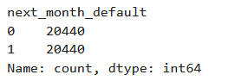
📊 Before SMOTE: ~22% defaulters and 78% non-defaulters
📊 After SMOTE: ~50% defaulters and 50% non-defaulters in training data
💼 Business Insight:
- SMOTE allows the model to better capture the minority class patterns, improving recall and F2-score.
- Despite balancing, we retained class weights during model training (especially for Logistic Regression) to provide additional sensitivity to default cases, making the models more effective in high-stakes financial applications.

